CARL MATTHEW ONGKIT

DCPET 1-2

Abstract

Bytebay is an online business website that retails laptops from industry-leading brand from Acer, Dell, Lenovo, and MSI. This website is created using HTML, CSS, and JavaScript.

ByteBAY

Website Documentation

**Table of Contents**

**1 Introduction to the Portfolio1**

1.1 Introduction1

1.2 Business Background1

**2 Website Screens2**

2.1 Home2

2.2 About Us 3

2.3 Shop4

2.4 Contact Us5

2.5 Partners6

**3 Functionalities**8

3.1 Search Function8

3.2 Shopping Cart8

3.3 Database8

3.3a Categories8

3.3b Product Page8

3.3c Related Products8

3.4 Translator8

# Introduction to the Portfolio

# Introduction

ByteBay is an online store where you can buy laptops. When you visit ByteBay, you'll see a website with different pages that help you find and buy the laptop you want. This website was made using Hypertext Markup Language (HTML), JavaScript (JS), and Cascading Style Sheets (CSS), this helped me deliver a dynamic and great immersive user experience. With the already existing template “Zay Shop Template” from templatemo.com that utilizes Bootstrap 5 beta 1 I was able to ensure the responsiveness and compatibility of my website across various devices and web browsers.

The hosting infrastructure of my website is supported by GitHub, leveraging the GitHub Pages feature for deployment. This is free and accessible to everyone and is good option for a student like me whose studying HTML and other coding languages. I was able to successfully create and add more features to websites thanks to the widely available resources online like GitHub, YouTube Videos, Reddit, and Stack Overflow. This resources that I mention greatly benefited me in debugging and fixing bugs that I encountered in creating this website.

## Business Background

ByteBay offers an online platform dedicated to laptop sales, providing a convenient avenue for customers to browse and purchase their desired devices. It's all about making it easy for people to find and get the laptops they need. I chose the name “ByteBay” because I think the name itself is catchy and shows that the website is all about technology. I picked this part of the industry because laptops are everywhere, they are used for work, school, and even play. Also, this field is very related to my course, so it feels like a perfect fit whenever I wanted to start a real business in the future.

# Website Screens

## Home

When you land on ByteBay's homepage, you're greeted by a captivating display of products, each sliding into view one after another. These products showcase the latest and most sought-after items in the market. As you scroll down, you'll encounter the 'Brands of the Month' section, featuring three prominent brands currently in the spotlight. Further down the page, the 'Featured Products' section highlights the top three products with the highest reviews on the website. This layout ensures that visitors can easily spot the trendiest and most recommended products available on ByteBay. The homepage is designed to engage users and streamline the process of discovering the best offerings from the website.

# About Us

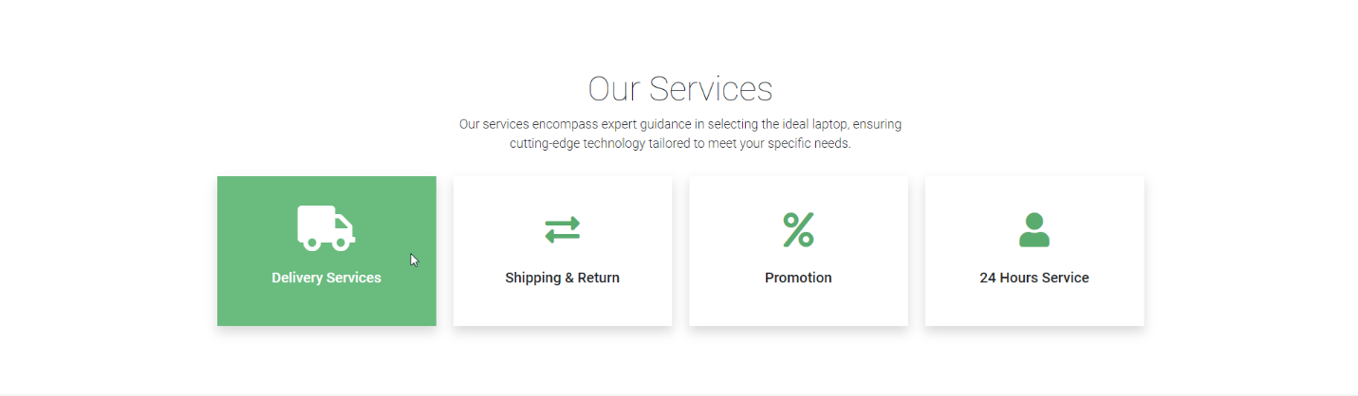

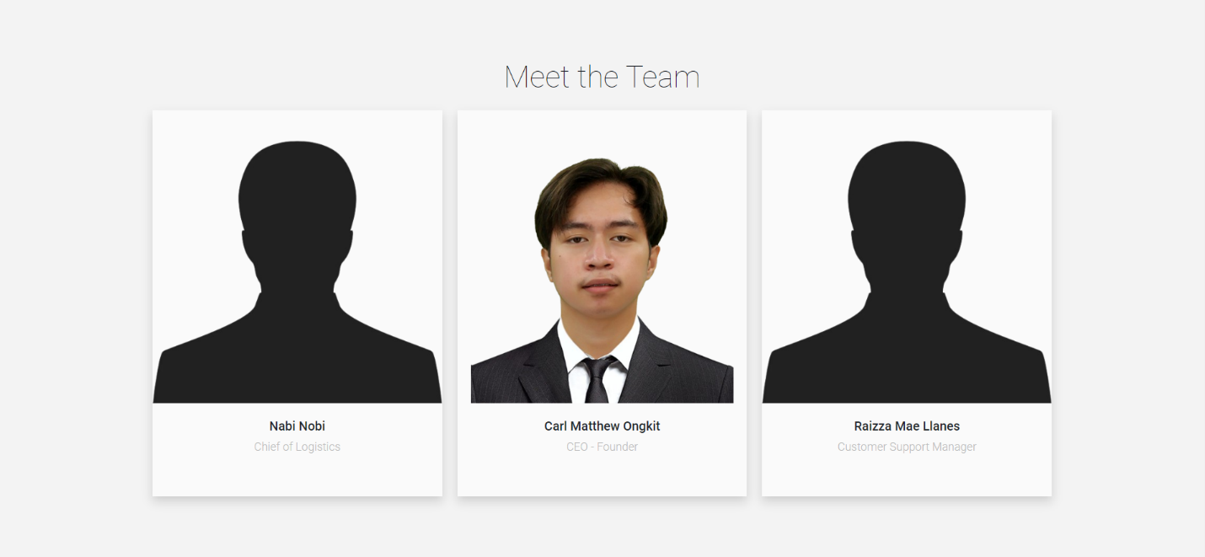

At ByteBay's "About Us" page, you'll find a brief story about our company and what we stand for. As you scroll down, you'll see the different services we offer, and if you hover over each service, it'll turn green to catch your eye. Towards the end, you'll meet our team: Nabi Nobi, our Logistics Chief, me, the CEO and Founder, and Raizza Mae Llanes, our Customer Support Manager.

## Shop

On ByteBay's "Shop" page, you'll find an extensive collection of products available for purchase, complete with star ratings, images, brand names, and prices, making it easy to find the perfect laptop. Navigate through different categories to filter products by brand, ensuring you discover exactly what you're looking for. As you explore the last section of the website, you’ll encounter the "Partnerships" section, showcasing the brands we've partnered with to ensure the buyers that they are buying from reputable brands.

# Contact Us

ByteBay's "Contact Us" section provides a convenient map displaying our physical store's precise location and address, courtesy of an embedded Google Map. Scroll down to view our operating hours and utilize HTML forms to input your details and address any inquiries or concerns you may have.

## Partners

Upon entering ByteBay's "Partners" page, visitors are greeted with a lineup of logo pictures representing the reputable brands we've partnered with. These brands, including Lenovo, Asus, Acer, MSI, and Dell, are esteemed suppliers renowned worldwide for their quality products.

# Functionalities

## Search Function

For my Search Function, I use JavaScript and a separate HTML file for the results of my search term. In this JavaScript below, I use .addEventListener at the 1st line of my script. The purpose of this script is to wait for the content of the pages to load before scripting the script itself so my script can properly get the attributes and elements from the contents of my html website. So how this script works is when a submit button is clicked it changes the link or URL of my website to add ‘search?q= + the input from the search bar” and then after that it uses modal.hide() where it closes the search bar after triggering it.

After that, the website will now go to another HTML website where it processes the result of my JavaScript. I added a script under my html website where whenever a search term is present it will update the content of searched products in the website. This part of my script uses fetch function where it gets the information for the information to load when a search term and information in database matched it will show the product details.

Now I will show you another function that I created where the purpose of this function is that it updates the product details in the website. This function is then called whenever a search function is used.

E

Example of Search Function being used:

## Shopping Cart

## Database

## Translator