CARL MATTHEW ONGKIT

DCPET 1-2

Abstract

Bytebay is an online business website that retails laptops from industry-leading brand from Acer, Dell, Lenovo, and MSI. This website is created using HTML, CSS, and JavaScript.

ByteBAY

Website Documentation

**Table of Contents**

**1 Introduction to the Portfolio1**

1.1 Introduction1

1.2 Business Background1

**2 Website Screens2**

2.1 Home2

2.2 About Us 3

2.3 Shop4

2.4 Contact Us5

2.5 Partners6

**3 Functionalities**8

3.1 Search Function8

3.2 Shopping Cart10

3.3 Database13

3.4 Update Product Details14

3.5 Translator15

# Introduction to the Portfolio

# Introduction

ByteBay is an online store where you can buy laptops. When you visit ByteBay, you'll see a website with different pages that help you find and buy the laptop you want. This website was made using Hypertext Markup Language (HTML), JavaScript (JS), and Cascading Style Sheets (CSS), this helped me deliver a dynamic and great immersive user experience. With the already existing template “Zay Shop Template” from templatemo.com that utilizes Bootstrap 5 beta 1 I was able to ensure the responsiveness and compatibility of my website across various devices and web browsers.

The hosting infrastructure of my website is supported by GitHub, leveraging the GitHub Pages feature for deployment. This is free and accessible to everyone and is good option for a student like me whose studying HTML and other coding languages. I was able to successfully create and add more features to websites thanks to the widely available resources online like GitHub, YouTube Videos, Reddit, and Stack Overflow. This resources that I mention greatly benefited me in debugging and fixing bugs that I encountered in creating this website.

## Business Background

ByteBay offers an online platform dedicated to laptop sales, providing a convenient avenue for customers to browse and purchase their desired devices. It's all about making it easy for people to find and get the laptops they need. I chose the name “ByteBay” because I think the name itself is catchy and shows that the website is all about technology. I picked this part of the industry because laptops are everywhere, they are used for work, school, and even play. Also, this field is very related to my course, so it feels like a perfect fit whenever I wanted to start a real business in the future.

# Website Screens

## Home

When you land on ByteBay's homepage, you're greeted by a captivating display of products, each sliding into view one after another. These products showcase the latest and most sought-after items in the market. As you scroll down, you'll encounter the 'Brands of the Month' section, featuring three prominent brands currently in the spotlight. Further down the page, the 'Featured Products' section highlights the top three products with the highest reviews on the website. This layout ensures that visitors can easily spot the trendiest and most recommended products available on ByteBay. The homepage is designed to engage users and streamline the process of discovering the best offerings from the website.

# About Us

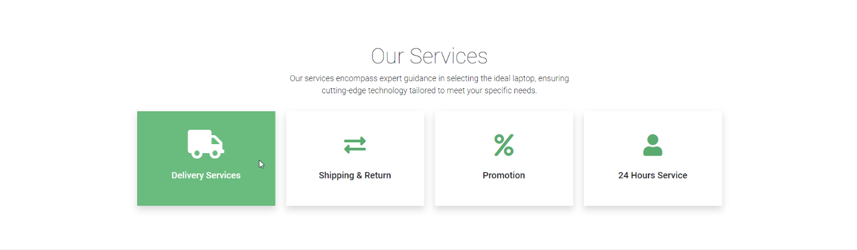

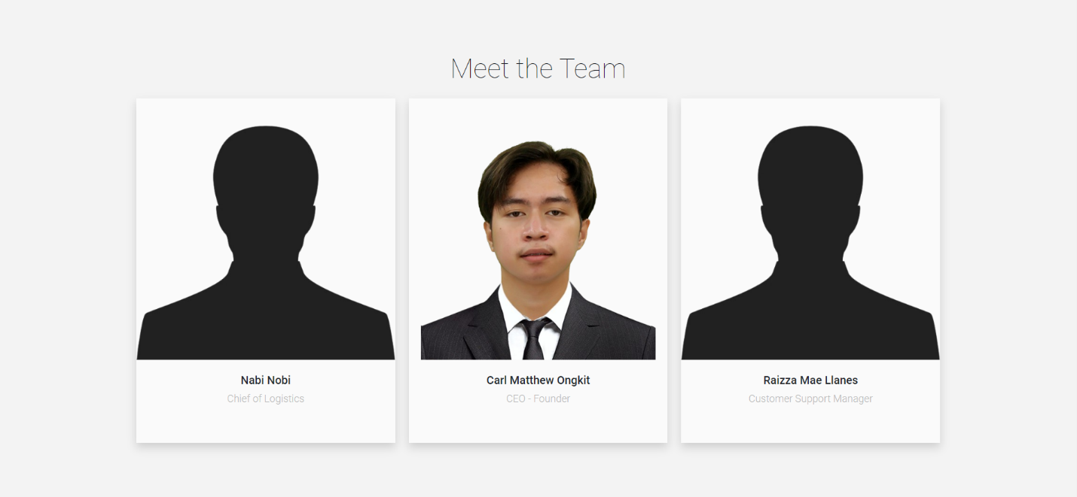

At ByteBay's "About Us" page, you'll find a brief story about our company and what we stand for. As you scroll down, you'll see the different services we offer, and if you hover over each service, it'll turn green to catch your eye. Towards the end, you'll meet our team: Nabi Nobi, our Logistics Chief, me, the CEO and Founder, and Raizza Mae Llanes, our Customer Support Manager.

## Shop

On ByteBay's "Shop" page, you'll find an extensive collection of products available for purchase, complete with star ratings, images, brand names, and prices, making it easy to find the perfect laptop. Navigate through different categories to filter products by brand, ensuring you discover exactly what you're looking for. As you explore the last section of the website, you’ll encounter the "Partnerships" section, showcasing the brands we've partnered with to ensure the buyers that they are buying from reputable brands.

# Contact Us

ByteBay's "Contact Us" section provides a convenient map displaying our physical store's precise location and address, courtesy of an embedded Google Map. Scroll down to view our operating hours and utilize HTML forms to input your details and address any inquiries or concerns you may have.

## Partners

Upon entering ByteBay's "Partners" page, visitors are greeted with a lineup of logo pictures representing the reputable brands we've partnered with. These brands, including Lenovo, Asus, Acer, MSI, and Dell, are esteemed suppliers renowned worldwide for their quality products.

# Functionalities

## Search Function

For my Search Function, I use JavaScript and a separate HTML file for the results of my search term. In this JavaScript below, I use .addEventListener at the 1st line of my script. The purpose of this script is to wait for the content of the pages to load before scripting the script itself so my script can properly get the attributes and elements from the contents of my html website. So how this script works is when a submit button is clicked it changes the link or URL of my website to add ‘search?q= + the input from the search bar” and then after that it uses modal.hide() where it closes the search bar after triggering it.

After that, the website will now go to another HTML website where it processes the result of my JavaScript. I added a script under my html website where whenever a search term is present it will update the content of searched products on the website. This part of my script uses fetch function where it gets the information for the information to load when a search term and information in database matched it will show the product details.

Now I will show you another function that I created where the purpose of this function is that it updates the product details on the website. This function is then called whenever a search function is used.

Example of Search Function being used:

## Shopping Cart

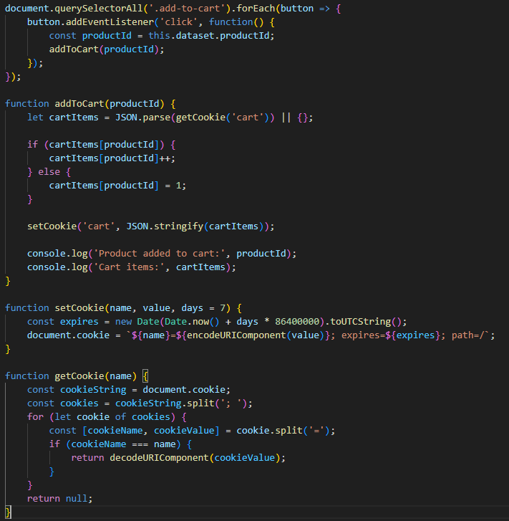For Shopping Cart of my website, I also use HTML and JavaScript to display the products and calculate the total price of the products added in the Shopping Cart. I also used Cookies to temporarily store Product IDs for my website so that the JavaScript and HTML can show the products and calculate it for the customer. Starting with Cookies, this is how I store the Product IDs using cookies through JavaScript. I have multiple functions retrieving and setting data in my cookie. The way it works is it checks if the Product ID is in the cookie already if it is it add an increment to that product therefore increase the quantity of that product. If not, it adds the Product ID inside the cookie and add a default quantity of 1.

After that I also have another JavaScript where it processes the data from the Cookie for it to properly display in my HTML. It gets the cookie from the user and searched through the contents of that cookie and then display it using another function. 

Also, this is the last part of my script for Shopping Cart. The way this script works is it calculates and display the Total, Subtotal, and Price of the Products in real time. I achieved this by using again .addEventListener so whenever a quantity is changed from the dropdown it also adjusts automatically.

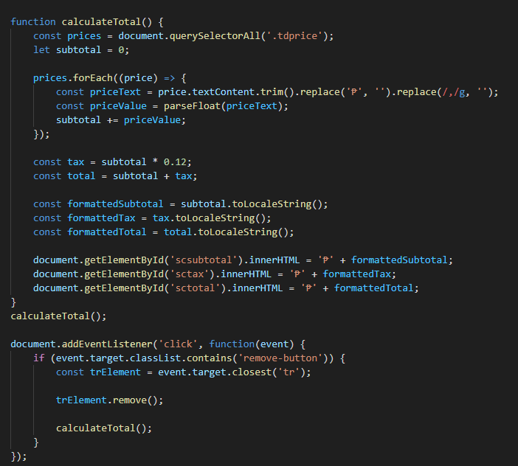

## Database

The Database is the most crucial and important part of my website. It plays a vital role in how my website function and works. Because all the information of every product on the website is stored in this JavaScript Object Notation (JSON) file. Almost every script that I made in this website fetches data like Product Name or Prices from this file for it to properly process data and provide user experience for the customer.

Image of the structure of the data from my JSON file:

## Update Product Details

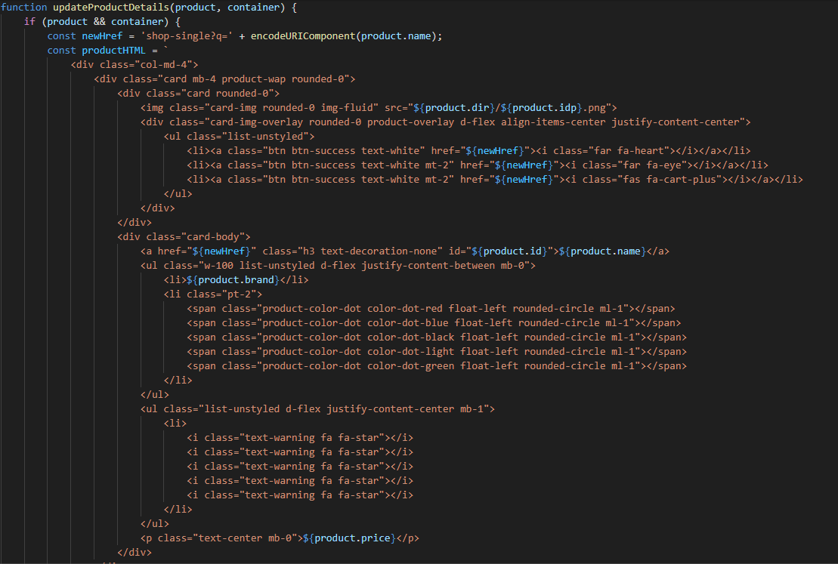Like how I emphasized Database above, this function also plays a very important part in my website. This function is the one responsible for displaying and showing information to the HTML Website. It’s a function widely used across my JavaScript because it works by fetching data from the database and using that data to insert a part of HTML code to my website.

So, the way it works is it creates a constant variable then inside that variable I create a part of html code that I need for that part of my website and uses variables from fetched data from my database.json file. After that it uses .insertAdjacentHTML method to add HTML content to the document.

## Translation

For this part of my website, I simply followed a tutorial from W3Schools.com on how to easily add a Google Translate Button on my page. I achieved this by adding a division with a unique id in my footer and by adding Google Translate API in my Website.



Image of Google Translate functioning properly in my website:

