Assignment 7
CODE:
ArithmeticOperations.java
package com.calc;

import java.io.*;
import javax.servlet.*;
import javax.servlet.annotation.WebServlet;
import javax.servlet.http.*;

@WebServlet("/ArithmeticOperations")
public class ArithmeticOperations extends HttpServlet {
protected void doPost(HttpServletRequest request, HttpServletResponse response)
throws ServletException, IOException {

response.setContentType("text/html");
PrintWriter pw = response.getWriter();

try {
int no1 = Integer.parseInt(request.getParameter("No1"));
int no2 = Integer.parseInt(request.getParameter("No2"));
String operation = request.getParameter("operation");

pw.println("<html><head><title>Result</title></head><body>");
pw.println("<h2>Result:</h2>");

switch (operation) {
case "add":
pw.println("Addition: " + (no1 + no2));
break;
case "sub":
pw.println("Subtraction: " + (no1 - no2));
break;
case "mul":
pw.println("Multiplication: " + (no1 * no2));
break;
case "div":
if (no2 != 0)
pw.println("Division: " + (no1 / no2));
else
pw.println("Division: Cannot divide by zero");
break;
default:
pw.println("Invalid operation selected.");
}

pw.println("</body></html>");
} catch (NumberFormatException e) {
pw.println("<html><body><h2>Error: Please enter valid numbers!</h2></body></html>");
}
}
}
index.html

<!DOCTYPE html>
<html>
<head><title>Arithmetic Operations</title></head>
<body>
<h2>Arithmetic Operation</h2>
<form method="post" action="ArithmeticOperations">
Number 1: <input type="text" name="No1"><br><br>
Number 2: <input type="text" name="No2"><br><br>
Select Operation:<br>
<input type="radio" name="operation" value="add" checked> Addition<br>
<input type="radio" name="operation" value="sub"> Subtraction<br>
<input type="radio" name="operation" value="mul"> Multiplication<br>
<input type="radio" name="operation" value="div"> Division<br><br>

<input type="submit" value="Calculate">
</form>
</body>
</html>

OUTPUT:
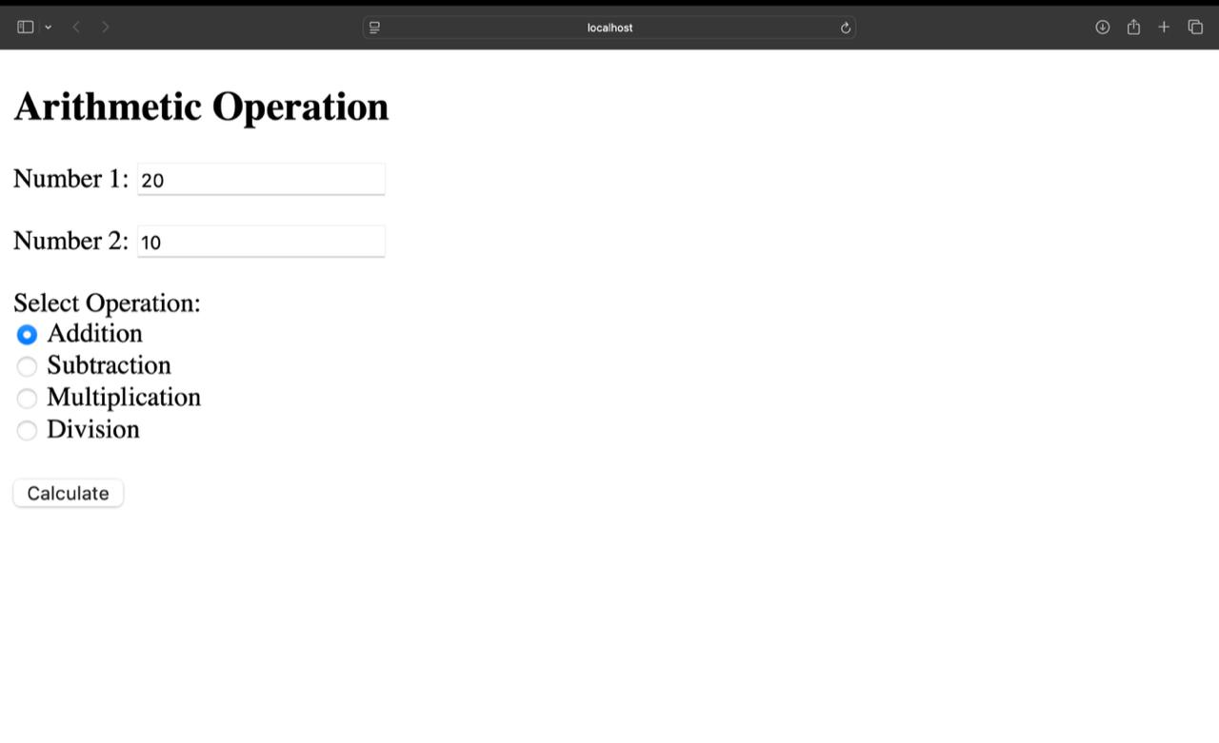
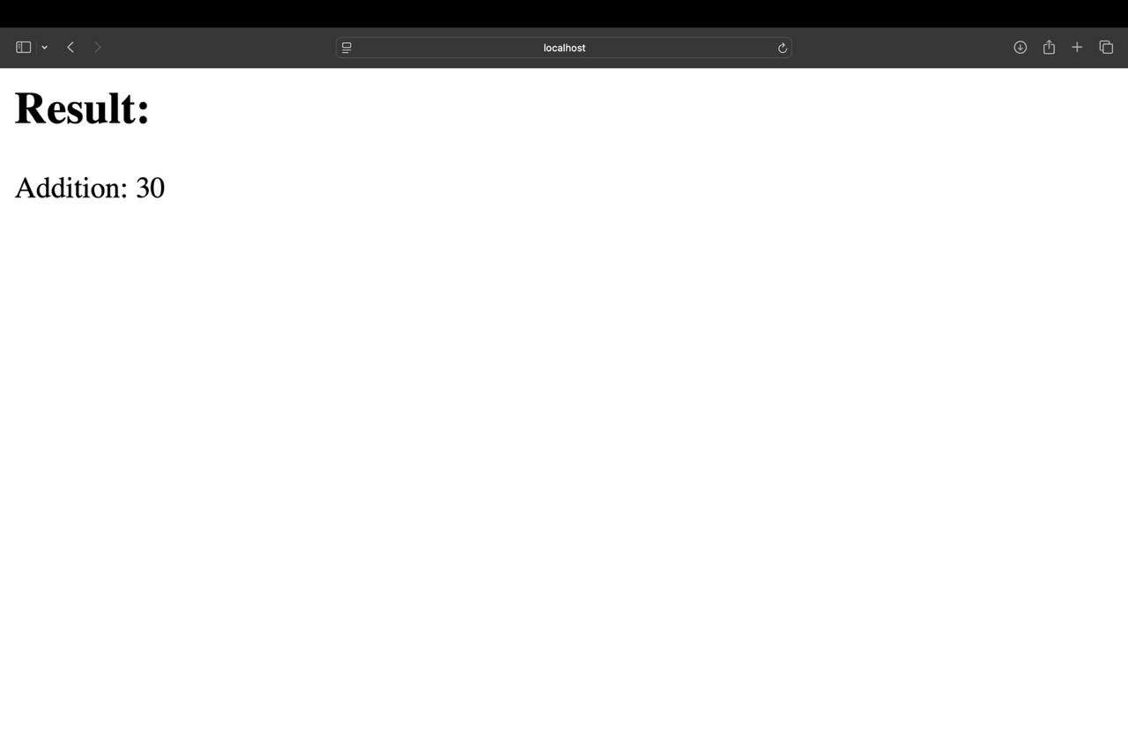
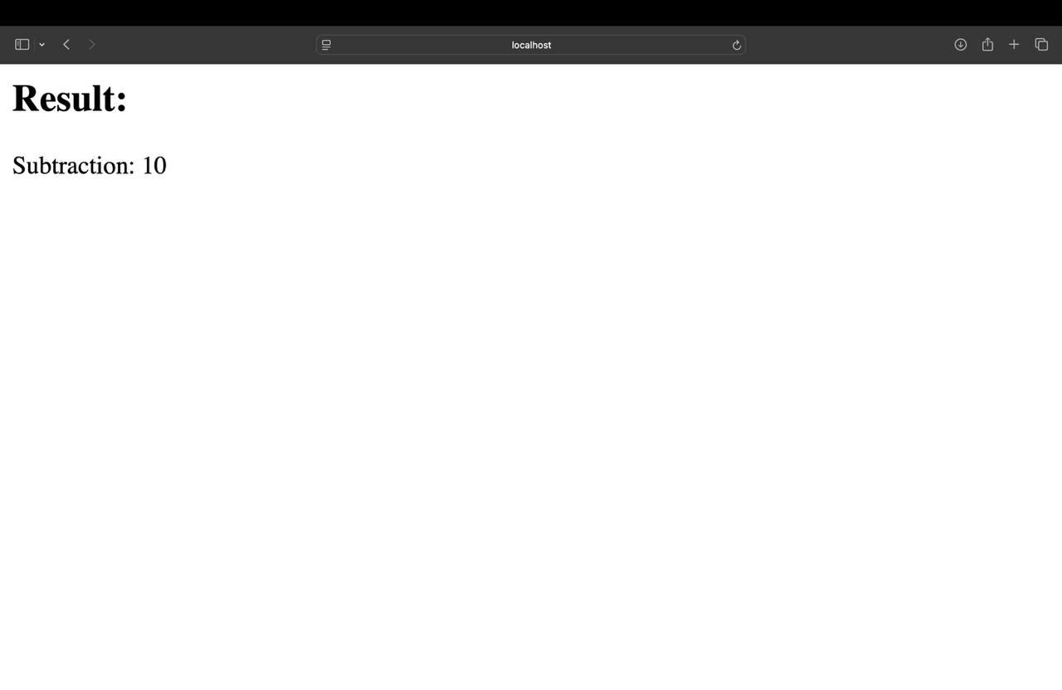
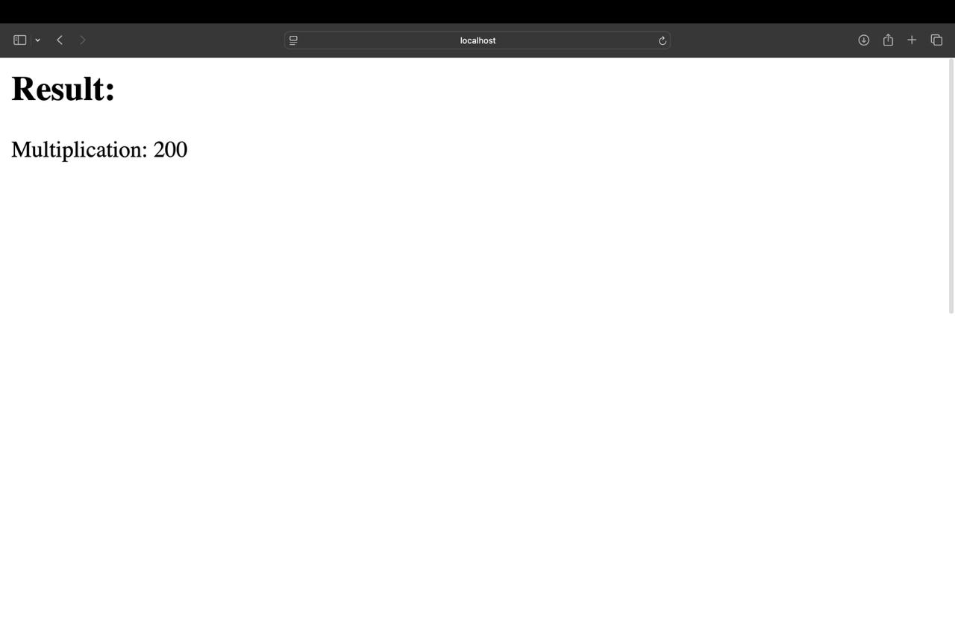
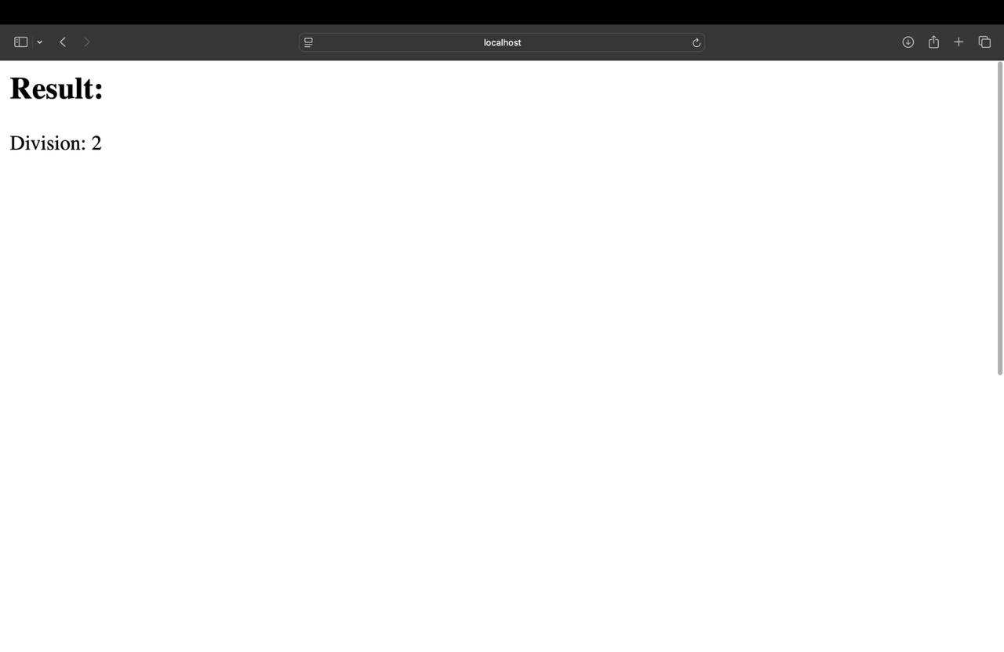
CalculatorWSClient.java

import java.io.*;
import java.net.*;
import java.util.Scanner;

public class CalculatorWSClient {
public static void main(String[] args) {
Scanner scanner = new Scanner(System.in);

// Accept input from user
System.out.print("Enter first number: ");
int num1 = scanner.nextInt();
System.out.print("Enter second number: ");
int num2 = scanner.nextInt();
System.out.print("Enter operation (add, sub, mul, div): ");
String operation = scanner.next();

try {
// Construct the URL for the POST request
String serviceUrl = "http://localhost:8080/CalculatorWSApplication/ArithmeticOperations";

// Establish the connection
URL url = new URL(serviceUrl);
HttpURLConnection conn = (HttpURLConnection) url.openConnection();
conn.setRequestMethod("POST"); // Use POST method
conn.setDoOutput(true); // Allow sending data in the request body

// Prepare the data to send in the body of the POST request
String data = "No1=" + num1 + "&No2=" + num2 + "&operation=" + operation;

// Send data
try (OutputStream os = conn.getOutputStream()) {
byte[] input = data.getBytes("utf-8");
os.write(input, 0, input.length);
}

// Get the input stream and read the response
BufferedReader in = new BufferedReader(new InputStreamReader(conn.getInputStream()));
String inputLine;
StringBuilder response = new StringBuilder();

while ((inputLine = in.readLine()) != null) {
response.append(inputLine);
}
in.close();

// Extract the result from the HTML response
String result = response.toString();
String operationResult = result.split("<h2>Result:</h2>")[1].split("</body>")[0].replaceAll("<[^>]*>", "").trim();

// Print the result
System.out.println("Result: " + operationResult);

} catch (Exception e) {
e.printStackTrace();
}
}
}

OUTPUT:

