Kenneth Lee 2101313

Lab 3

1. SELECT email FROM student;

1. Select distinct email from student;

1. Select name from student order by name desc;

1. select name from student where name in (select name from student group by name having count(\*) > 1);



No duplicate names.

1. Select distinct name from student order by name;

1. select name from loan join student on loan.borrower = student.email where book = "978-0321474049";

1. select name from student join copy on student.email = copy.owner join book on copy.book = book.ISBN13 where book.pages > 100 AND book.title like "%Photoshop%";

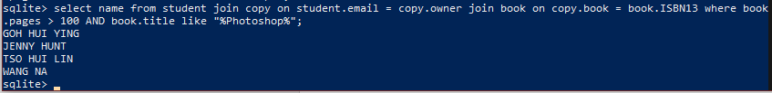

1. select sum(pages/2) from book where ISBN13 ="978-0321474049" OR ISBN13 = "978-0684801520";



1. select name from student join copy on student.email = copy.owner where book != "978-0321474049";

1. select name from student join loan on student.email = loan.borrower where book = "978-0321474049";Text

   Description automatically generated
2. select name from student inner join loan on student.email = loan.borrower where book = "978-0321474049" union select name from student inner join copy on student.email = copy.owner where book = "978-0321474049"; Text

   Description automatically generated with medium confidence
3. select name from student left join loan on student.email = loan.borrower left join copy on student.email = copy.owner where loan.book = "978-0321474049" or copy.book = "978-0321474049"; 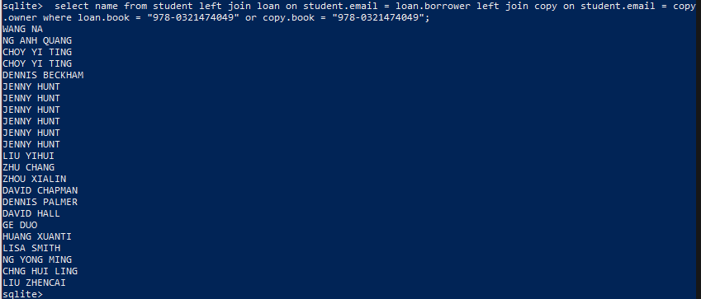
4. Question 11 execution time

Question 12 execution time

The results are different as question 12 does not remove the duplicates. Using union is also slightly faster compared to question 12.

1. Delete from loan
2. Text

   Description automatically generated