Install node.js 16.15.0 first before running

Open the ExemptionChecker/ExemptionChecker-NOSQL folder

Open the project in vscode [!important]

Open NPM scripts in view

First time running:

* Run start on client/package.json
* Run start on package.json

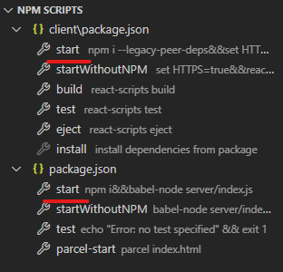

Subsequent time's running

* Run startWithoutNPM on client/package.json
* Run startWithoutNPM on package.json

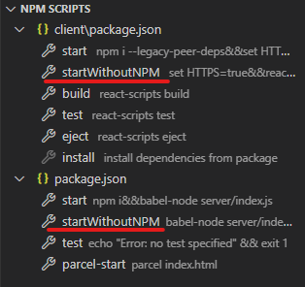

**To Run the webapp on mobile**

Ensure

ipconfig on the device running the project both mobile and the device the project is running on are connected to the same network.

Key in https://[ip the device the project is running on]:3000 on google chrome mobile

**To test out all the features**

use the login credentials:

username: student password: student