

UNIVERSITI TUNKU ABDUL RAHMAN

FACULTY OF INFORMATION AND COMMUNICATION TECHNOLOGY (PERAK)

BACHELOR OF COMPUTER SCIENCE (HONS)
BACHELOR OF INFORMATION RECHNOLOGY (HONS) COMMUNICATIONS AND NETWORKING
JANUARY 2021 TRIMESTER

UCCD3243 SERVER-SIDE WEB APPLICATION DEVELOPMENT

GROUP ASSIGNMENT
P4_1
Online Order Management Monitoring System

No | Name | Student ID | Programme | Practical
1 | Alfred Teh Hao Xian | 18ACB06187 | CS | P4
2 | Kenneth Foong Kok Chun | 18ACB06161 | CS | P4
3 | Leong Wai Chun | 18ACB06442 | CS | P4
4 | Ng Miao Xuan | 17ACB01924 | CN | P4

MARKING RUBRIC

Attribute | Actual Marks | Alfred Teh Hao Xian | Kenneth Foong Kok Chun | Leong Wai Chun | Ng Miao Xuan
Report Section (Group) | 20
Analysis – Application Level – Functional charts | 15
Analysis – Application Level – UML diagrams
Design – Functional Requirements
Strengths and Limitations | 5
Application Section (Individual) | 60
Application – Functional Requirements | 20
Application – Design/Architecture | 20
Application – Technologies | 20
Application Section (Group) | 20
Professional Outlook (Front End and Back End) | 5
Overall Quantity and Quality | 15
Total | 100

Checked by,

_________________
(Ts. Dr Anbuselvan Sangodiah)

TABLE OF CONTENTS
1 Analysis 4
1.1 Functional Hierarchy Chart 4
1.2 UML Diagrams 5
1.2.1 Use-Case Diagram 5
1.2.2 Activity Diagram 6
1.2.3 Analysis Class Diagram 7
1.2.4 Design Class Diagram 8
1.2.5 Database Diagram 9
1.2.6 Package Diagram 10
1.3 Other Diagrams 11
1.3.1 Model-View-Controller (MVC) Architecture Diagram 11
1.4 Functional Requirement 12
1.4.1 Product Module 12
1.4.2 Order Module 12
1.4.3 Payment Module 12
1.4.4 Staff Module 13
1.5 Strengths and Limitations 14
1.6 Operational Requirements 16

1 Analysis
  - Functional Hierarchy Chart
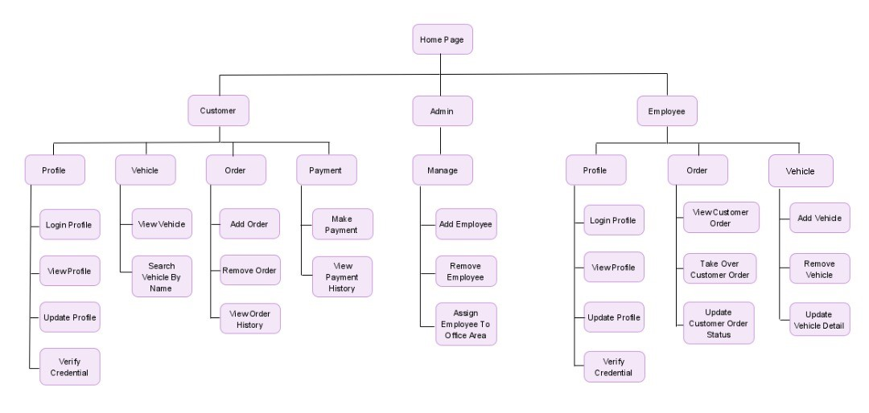
Figure 1. Functional Hierarchy Chart

  - UML Diagrams
    - Use-Case Diagram
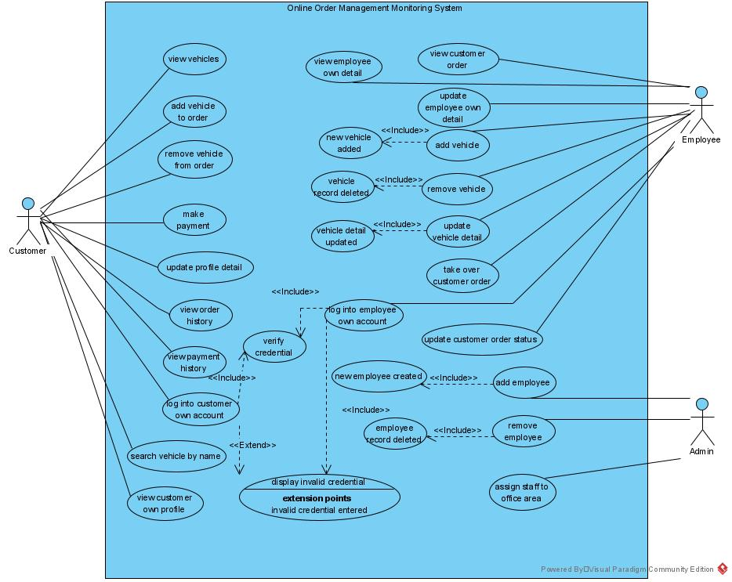
Figure 2. Use Case Diagram

    - Activity Diagram
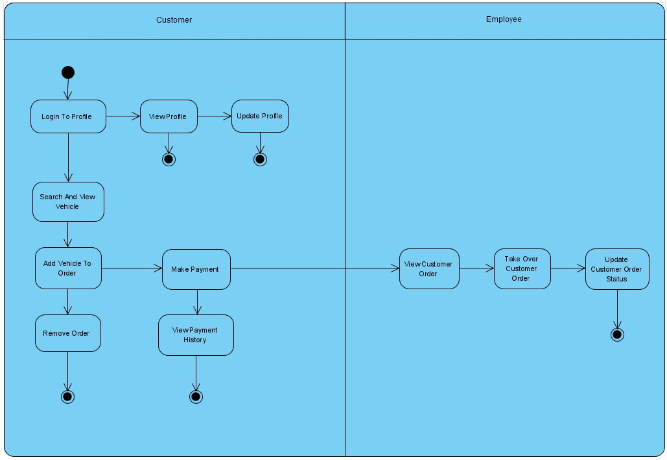
Figure 3. Activity Diagram

    - Analysis Class Diagram
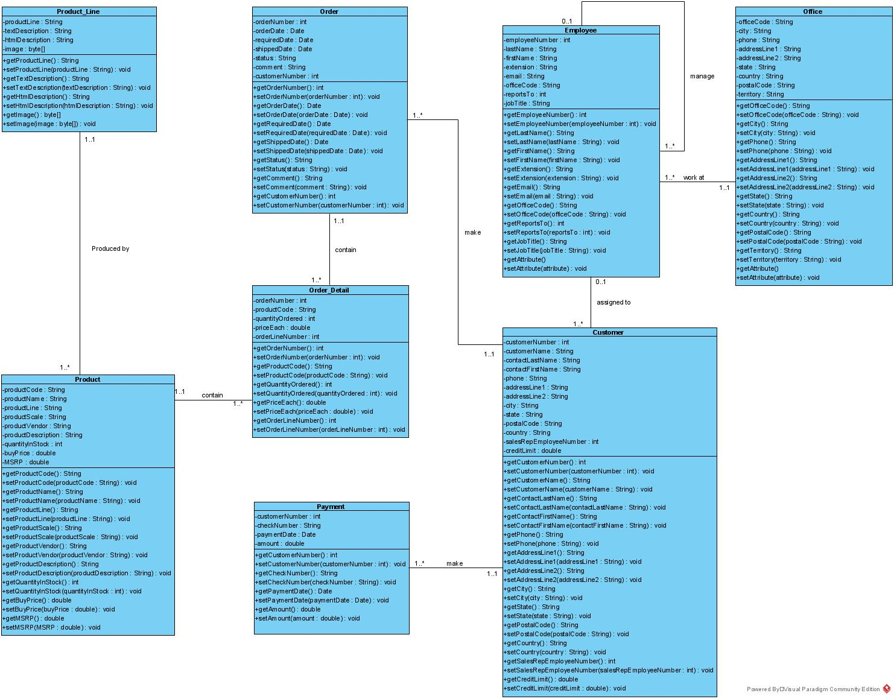
Figure 4. Analysis Class Diagram
    - Design Class Diagram
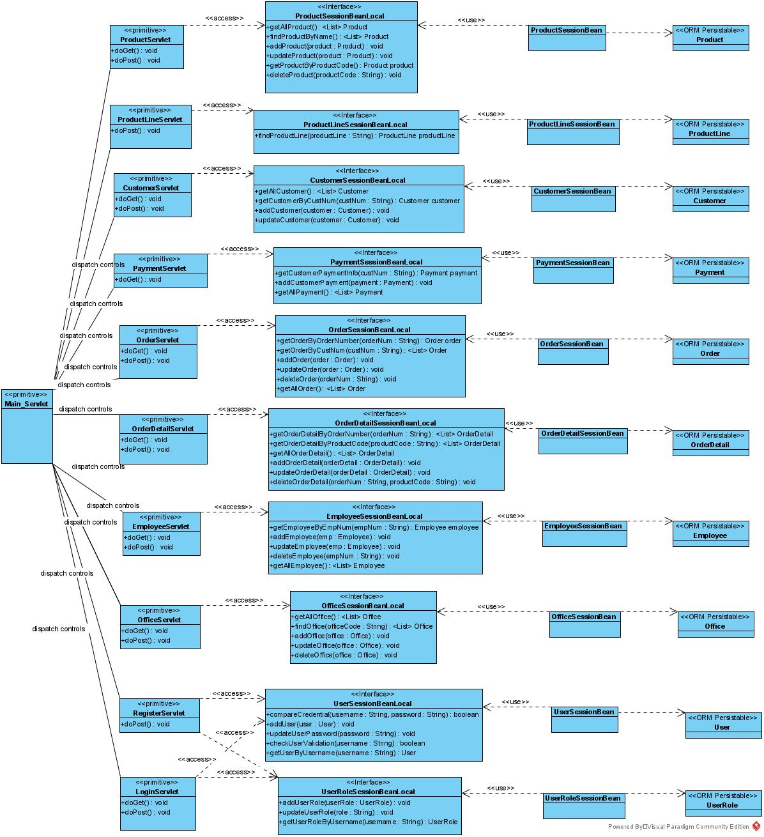
Figure 5. Design Class Diagram

    - Database Diagram
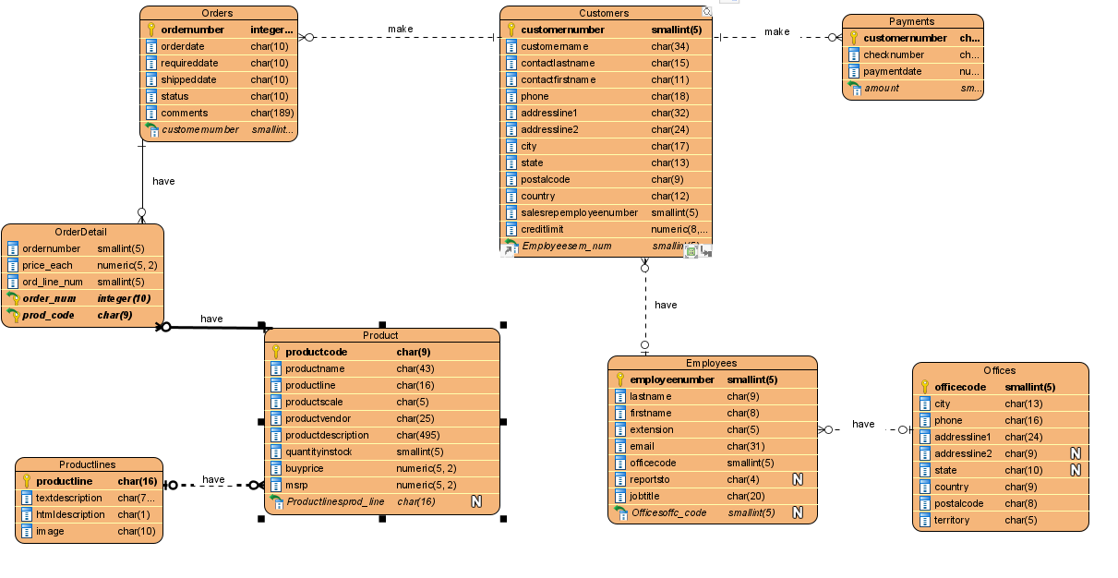
Figure 6. Database Diagram
    - Package Diagram
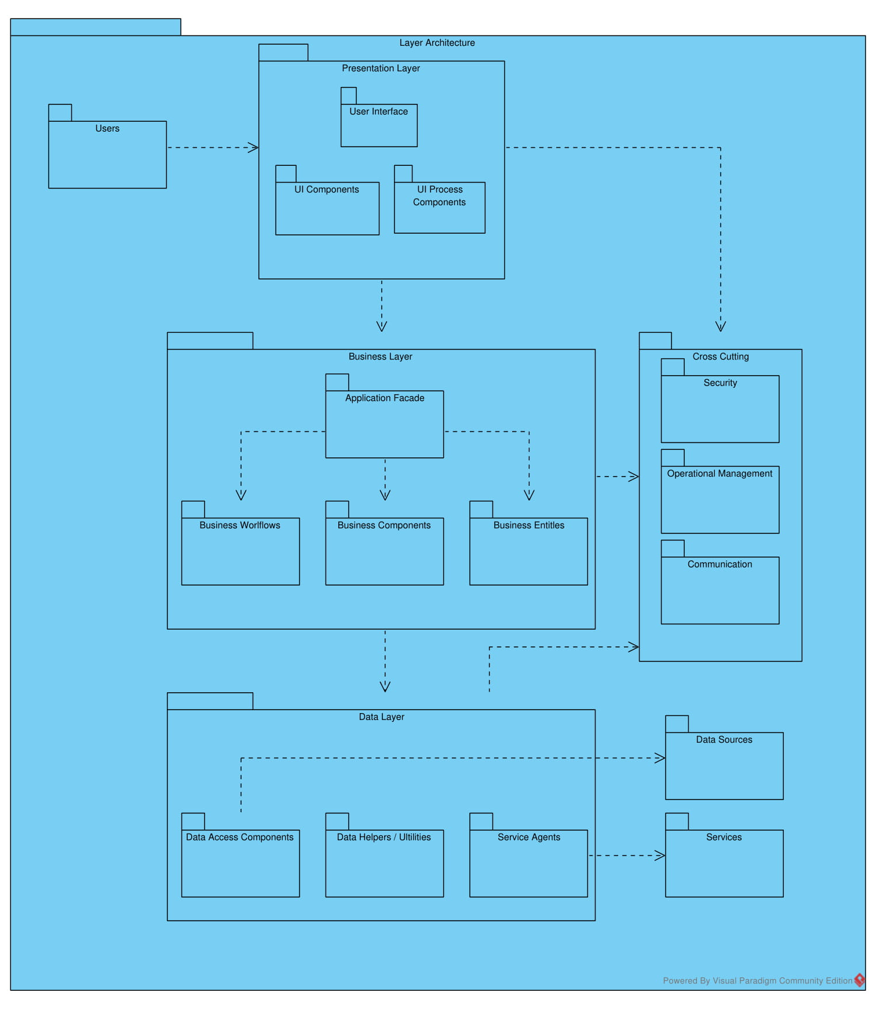
Figure 7. Package Diagram

  - Other Diagrams
    - Model-View-Controller (MVC) Architecture Diagram
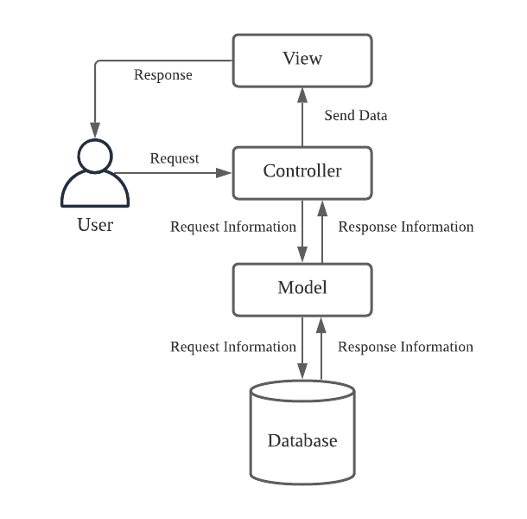
Figure 8. Model-View-Controller (MVC) Architecture Diagram

  - Functional Requirement
    - Product Module
- Customer shall be able to view list of vehicles and details.
- Customer shall be able to search for vehicles by names.
- Employee shall be able to add vehicles into database by inserting code, name, line, scale, vendor, description and price.
- Employee shall be able to update details of vehicle in database.
- Employee shall be able to delete vehicles in database.
    - Order Module
- The customer shall be able to view the selected vehicles to buy stored from the cart.
- The customer shall be able to delete the selected vehicle from the cart.
- The system shall be able to calculate the total price that customer should pay for after selecting desired vehicles to buy.
- The customer shall be able to view the total price in the cart before proceed to checkout.
- The customer shall be able to view the order history that they made previously.
- The employee shall be able to view the customer order.
- The employee shall be able to take over the customer order by assigning himself to handle the customer order.
- The employee shall be able to update the customer order status.
    - Payment Module
- Financial calculator to calculate vehicle loan monthly instalment.
- Customer must log in to be able to proceed to payment.
- Customer shall be able to choose whether to save payment details.
- The system shall encrypt payment details before storing to database.
- Customer shall be able to view the order confirmation page and the payment number generated after success payment, else, will show order failed to be processed.
- Customer shall be able to generate receipt in PDF form.
- Customer shall be able to view the payment history made in the past, and how many months of instalment left to complete the full amount of payment for the vehicle.

    - Staff Module
- Admin able to add new staff.
- Admin able to remove staff.
- Admin able to assign staff to other office area.
- Admin able to update their particulars online.
- Admin able to update employee personal information detail.
- Admin able to view Employee detail.

  - Strengths and Limitations
The overall architecture pattern that this project adopts is the Model-View-Controller (MVC). The components of MVC is Model, View and Controller, whereby Model is Session Bean, View is JSP, and Controller is Servlet. The strength of this architecture pattern is that it supports faster development process. It separates the task between three of the layers to achieve high cohesion and low coupling. This allows a better designed web application that is easier to maintain. The three components will have lower dependency from each other, as each of the components has its own function. For example, Model (Session Bean) encapsulates business logic that works directly with the database. A user can perform fetch, insert, update and delete data by invoking the Session Bean programmatically. View (JSP) is the user interface whereby the user can view the data and perform some action. Controller (Servlet) can process data after receiving request from view, and invoke the method to send request to the model to alter or retrieve the database information.
In terms of security, this project implements authentication methods. Strong password will be needed to create a user account. Besides, for example, before performing complicated and confidential process such as ordering and making payment for the vehicle, the customer may need to log into their account to continue. This is to ensure that only eligible users can make payment and track their own payment history. For employee, they will have their own username and password to be able to access to the employee portal. Non-authorised users will be prohibited to access the employee portal and customer portal. Besides, this project implements the function to validate user input. It can prevent input validation attacks such as buffer overflow and SQL injection. It can also reduce security loopholes and reduce the need to sanitise the database due to incorrect inputs.
In terms of user experience, this web application also has a simple yet appealing user interface. The usability principles will be applied to increase user experience. For visibility, pictures and videos will be used adequately to attract the user and provide precise information. For consistency, the navigation buttons for every pages will be placed in consistent order, to reduce the confusion of the user. For feedback, on every button click in the web application, it will show some alert message to the user to notify the user that the button is successfully clicked to perform necessary functions. If the function fail to proceed, it will also notify the user about the failure.
In the other hand, there are also some limitations for this project. In terms of payment module, the development for the module will be limited, because this project does not plan to sell legit vehicles. It is only for learning purposes only, therefore, payment does not charge real money from the customer using the web application. Besides, there are also some disadvantages by using servlet. It is a limitation that a Java Runtime Environment is needed on the server to run servlets. Special servlet containers are also needed to run servlets, and it is not easy to perform testing with servlets.

  - Operational Requirements
Business domain specification and configuration are as follows:
JNDI – java:/classicmodels;
JDBC Connection Pool –classicmodelsPool;
database name – classicmodels;
schema name – classicmodels;
postgresql - username:postgres; password:postgresql

Username and password for staff module:
Username: admin
Password: Admin@1234

