GUJARAT COUNCIL ON SCIENCE AND TECHNOLOGY
Dept. of Science and Technology, Govt. of Gujarat
Application format for the
IDEATION STAGE FOR ROBOT MAKING COMPETITION
ROBOFEST GUJARAT-6.0
TECHNICAL DETAILS FOR HACKATHON

1. Level of Robot Making
Hackathon

2. Type of Robot
AERIS — AI-Powered Autonomous Disaster-Response & Emergency-Logistics UAV.
An autonomous flying robot (quadcopter) that searches a disaster-affected area, detects survivors and hazards using onboard (edge) AI, geo-tags every detection, reports live to a ground station, and — once flight-validated — delivers a small emergency package to a human-authorized location.

3. Type
Both — Hardware Prototype + Simulation (Digital Twin).
A physical F450-class quadcopter prototype will be flown to demonstrate the core mission chain within the ₹55,000–₹65,000 budget. A parallel digital twin, built in Gazebo/ArduPilot SITL, reproduces the same mission logic, detection pipeline and dispatch workflow on a larger conceptual hexacopter platform with 5 kg payload capacity — showing the architecture scales without redesigning the perception or mission-control software.

4. List of Software to be Used
Layer | Software / Tool | Purpose
Flight firmware | ArduPilot Copter (open-source) | Autonomous flight, waypoint missions, stabilization, return-to-home, failsafes
Flight protocol | MAVLink | Communication between flight controller, companion computer and ground station
Ground control station | Mission Planner (primary), QGroundControl (backup) | Mission planning, live telemetry, map, parameters, AI alerts
Companion OS | Raspberry Pi OS (64-bit, Linux) | Operating system for the onboard AI computer
Programming language | Python 3 | AI orchestration, MAVLink integration, geo-tagging, mission logic
Computer vision | OpenCV + Picamera2 / rpicam | Camera capture and image pre-processing
AI detection model | Ultralytics YOLO (edge-optimized), compiled to Hailo HEF | Real-time person / vehicle / hazard detection
AI runtime | HailoRT (Raspberry Pi AI HAT+ software stack) | Hardware-accelerated neural inference on the Hailo-8L NPU
Model training / tuning | PyTorch + Ultralytics (on development PC) | Fine-tuning the detector on selected disaster-relevant classes
Telemetry / command | pymavlink / MAVSDK-Python | Programmatic access to position, status and commands
Simulation / digital twin | Gazebo with ArduPilot SITL | Full-scale 5-kg hexacopter mission simulation and repeatable virtual testing
CAD / mechanical design | FreeCAD (open-source) | Frame, mounts and payload-bay design; digital-twin geometry
Version control | Git + GitHub | Source code and configuration tracking
Logging / analytics | ArduPilot flight logs + JSON / CSV / SQLite | Flight-data and AI-event record keeping
All items above are free/open-source or freeware, in line with the competition's licensing requirement.

5. Robot Assembly Design (Proposed Diagram)
AERIS is an F450-class quadcopter in X-configuration, carrying a dedicated electronics bay (flight controller, companion computer, battery and status indicator), a forward-facing perception module, and a bottom-mounted payload-release bay. The conceptual top-view layout and the complete system architecture / data-flow — including the buzzer/LED failsafe indicator and the human-authorization branch before payload release — are shown below. Detailed CAD drawings will be produced during the build phase.
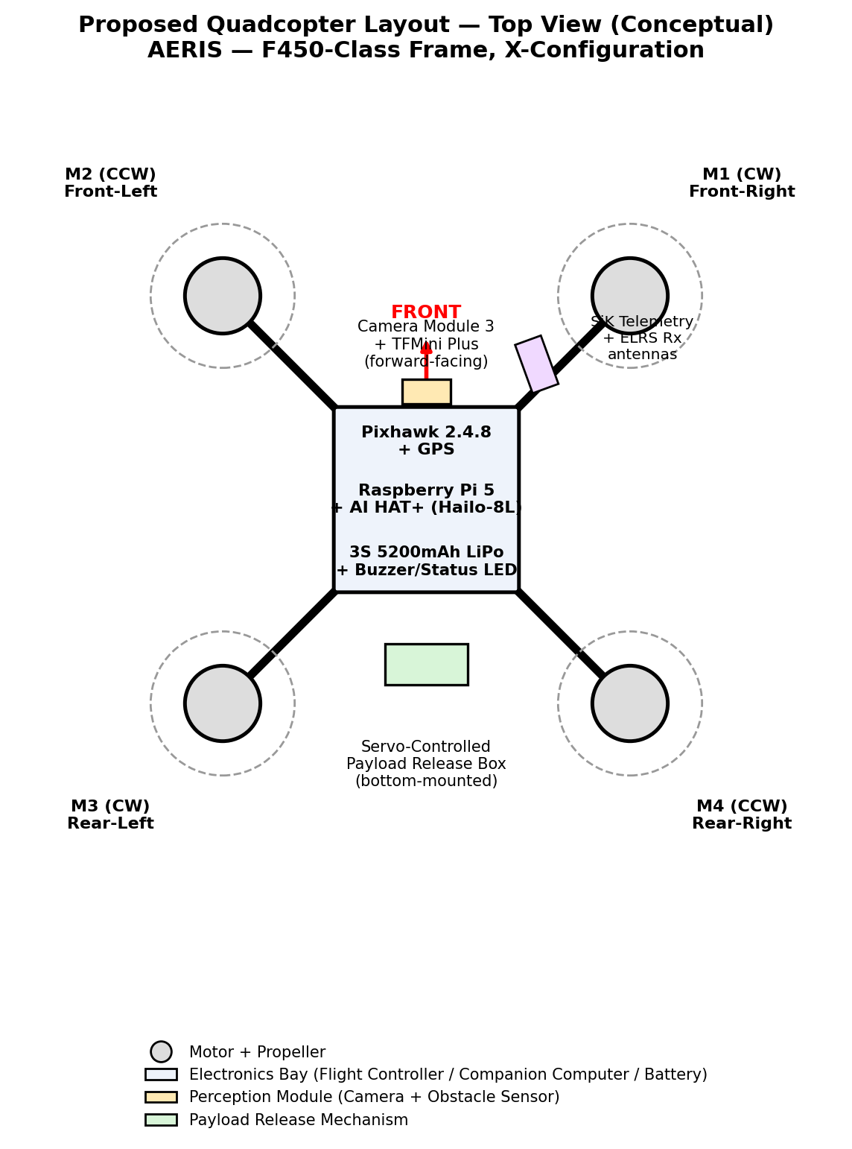
Fig. 1 — Proposed quadcopter component layout (top view, conceptual)
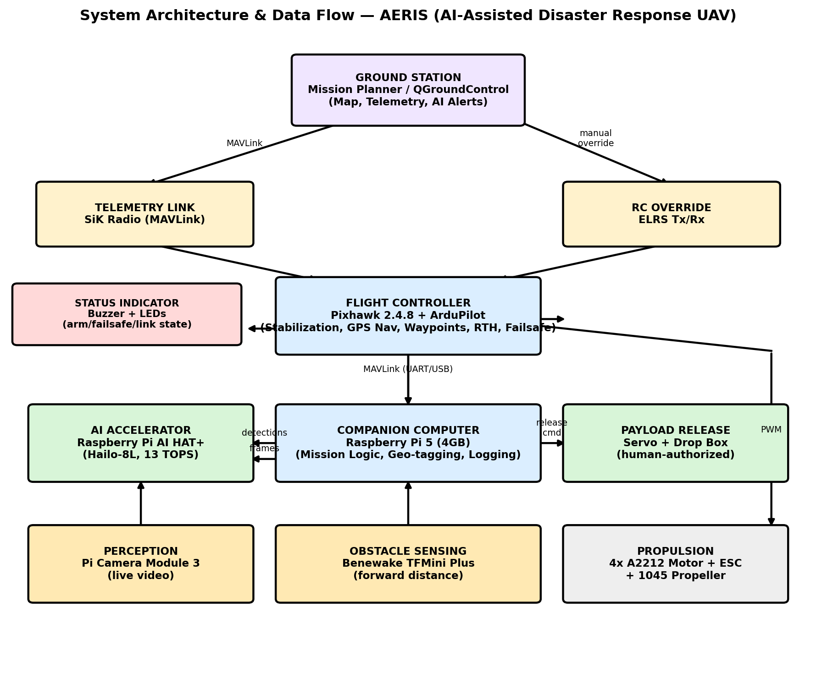
Fig. 2 — System architecture and data-flow block diagram

6. Components to be Used

6(a). Structure Components
Component | Make / Specification | Qty | Purpose
Airframe | F450-class quadcopter frame (450 mm wheelbase) | 1 | Main structural chassis
Motors | A2212, 1000KV brushless DC | 4 | Primary lift / propulsion
Main battery | 3S 11.1V 5200mAh LiPo (40C–80C) | 1 | Primary flight power source
Landing gear / mounts | Standard F450 legs + bolt-on sensor/electronics mounts | 1 set | Ground clearance; sensor and payload mounting
Fasteners & battery straps | M2.5/M3 nylon and steel hardware, LiPo straps | As req. | Structural assembly and secure battery mounting
Payload mount/box | Lightweight bracket + drop box | 1 | Carries and secures the small emergency-kit demonstration

6(b). Motion Components
Note: AERIS is a fixed-rotor quadcopter and has no chain/sprocket drivetrain — attitude and thrust vectoring are achieved purely through differential motor RPM, commanded by the flight controller. The components below are the ones that directly produce or actuate motion on the airframe.
Component | Make / Specification | Qty | Purpose
Electronic Speed Controllers | 30A brushless ESC (BLHeli/SimonK-compatible) | 4 | Converts flight-controller PWM signal into motor drive current
Propellers | 1045-class, 2×CW + 2×CCW | 4 | Thrust generation for lift and manoeuvring
Payload-release actuator | Micro servo (SG90/MG90S-class), drop latch | 1 | Releases the emergency-kit payload on ground-station command

6(c). Electronics Components
Component | Make / Specification | Qty | Purpose
Flight controller | Pixhawk 2.4.8 running ArduPilot Copter | 1 | Stabilization, GPS navigation, waypoint missions, RTH, failsafes
GPS + compass module | u-blox M8N-class, bundled with Pixhawk kit | 1 | Absolute positioning for autonomous navigation and geo-tagging
Companion computer | Raspberry Pi 5 (4GB) | 1 | Runs the AI pipeline, mission logic, geo-tagging and logging
AI accelerator | Raspberry Pi AI HAT+ (Hailo-8L NPU, 13 TOPS) | 1 | Hardware-accelerated real-time object detection, off-loaded from the Pi CPU
Camera | Raspberry Pi Camera Module 3 | 1 | Primary visual sensor for AI perception
Obstacle sensor | Benewake TFMini Plus (LiDAR/ToF, 12 m class) | 1 | Forward distance sensing for obstacle-aware flight
Telemetry radio | SiK telemetry, 433/915 MHz | 1 pair | MAVLink link between aircraft and ground station
RC transmitter | RadioMaster Pocket (ELRS) | 1 | Manual pilot override — safety-critical link
RC receiver | RadioMaster RP1/RP2 Nano (ELRS) | 1 | Aircraft-side receiver for manual override
Status indicator | Buzzer + status LEDs (arm/failsafe/link-loss states) | 1 set | Gives the pilot and judges an immediate, visible/audible readout of vehicle state
Power module | BEC/regulator + power distribution board | 1 | Regulated power distribution and voltage/current monitoring
Cooling | Raspberry Pi Active Cooler | 1 | Prevents thermal throttling of the companion computer under sustained AI load
Storage | 64/128 GB high-endurance microSD | 1 | Onboard OS, AI model and mission-log storage
Ground station laptop | Any laptop running Mission Planner / QGroundControl | 1 | Mission planning, live telemetry, video and incident dashboard

6(d). Other Accessories
Note: AERIS is a functional aerial platform rather than a costumed/humanoid robot, so this category does not apply in the traditional sense (clothes, plastic eyes, etc.). The items below are the closest functional equivalent — external components that protect the platform or aid its field identification and reliability.
Component | Make / Specification | Purpose
Sensor mounting brackets | 3D-printed / bolt-on brackets for camera and TFMini Plus | Correct, stable positioning of perception sensors
Vibration-damping mounts | Rubber/foam isolation grommets under flight controller and camera | Protects electronics and improves sensor/IMU stability
Protective electronics enclosure | Lightweight shell over the Pi 5 / AI HAT+ stack | Mechanical and light electrical protection in the field
High-visibility markers | Fluorescent orange/yellow frame-arm markers | Visual identification of the UAV during search operations
Prop guards (demo/indoor use) | Lightweight clip-on guards | Safety during indoor test flights, per event flight-safety rules
Field consumables | Cable ties, heat-shrink, spare propellers | Quick turnaround and reliability between demo runs

7. Methodology of Making the Robot

7.1 Design Philosophy
AERIS separates flight-critical control from AI perception by design. The Pixhawk/ArduPilot loop is hard real-time and owns everything safety-critical — stabilization, navigation, failsafes. The Raspberry Pi 5 AI pipeline is best-effort and owns everything intelligence-related — detection, geo-tagging, decision logic — connected over MAVLink. A delay or fault in the AI pipeline can never destabilize the aircraft's flight, because the flight controller does not depend on the companion computer to fly safely.

7.2 Mission Chain
Mission assigned → autonomous takeoff → GPS/waypoint navigation → obstacle sensing → camera/AI perception → event detection → geo-tagging → confidence check → priority classification/alert → continue mission or respond → return-to-home/failsafe.

7.3 Subsystem-Level Working
- Flight control (Pixhawk + ArduPilot): executes GPS-guided waypoint missions, holds stable attitude, monitors battery/GPS/link health, and automatically triggers return-to-home or land-now failsafes if any safety threshold is breached.
- Perception (Camera + AI HAT+): the Pi Camera streams live video to the Raspberry Pi 5; frames are handed to the Hailo-8L NPU running a compiled YOLO model, which returns real-time detections (person, vehicle, selected hazard indicators) without loading the Pi's CPU.
- Obstacle sensing (TFMini Plus): continuously reports forward distance; the companion computer uses this to slow, stop, or trigger a re-route/avoid manoeuvre before the flight controller resumes the mission.
- Geo-tagging and decision layer: every AI detection is timestamped and stamped with the aircraft's live GPS position (read over MAVLink), then assigned a confidence score and priority level (normal / high / critical). Low-confidence detections are queued for human confirmation rather than auto-escalated, keeping the false-positive rate under human control.
- Status indicator: onboard buzzer and LEDs give an immediate, visible/audible readout of arm state, failsafe state and link health — useful both as a safety aid and as a live, judge-visible signal that the failsafe system is genuinely active.
- Ground station: displays the live map, aircraft telemetry, video, and incoming AI alerts, and lets the operator authorize a response (payload) mission with a single command.
- Payload release: strictly human-authorized — the aircraft never releases a package autonomously. The companion computer only arms the servo after an explicit operator command.
- Communication: SiK telemetry carries MAVLink for autonomous operation; the ELRS RC link remains live throughout every flight purely as a manual-override safety channel.
- Digital twin: the same mission logic, detection pipeline and dispatch workflow are reproduced in Gazebo/ArduPilot SITL on a conceptual 5-kg hexacopter, demonstrating that the architecture scales to a larger emergency-logistics platform without redesigning the perception or mission-control software.

7.4 Build Sequence
Phase | Activity | Deliverable
1 | Procurement + bench setup | All hardware verified; battery/charger safety checked
2 | Frame & propulsion assembly | Motors/ESCs tested; correct rotation and prop orientation confirmed
3 | Flight controller setup | Stable manual/assisted flight, GPS lock, RTH and failsafes configured
4 | Companion computer + AI HAT+ | Camera pipeline and Hailo NPU running a test detection model
5 | MAVLink integration | Companion computer reliably reads telemetry and sends high-level commands
6 | Ground station setup | Mission planning, live telemetry and AI alerts working end-to-end
7 | Geo-tagging + decision layer | Incident record created with GPS tag, confidence score, priority and map marker
8 | Obstacle sensor + status indicator | Distance sensing and safe stop/avoid logic; buzzer/LED failsafe states validated
9 | Payload mechanism | Bench-tested release; flight-tested only once thrust margin is confirmed
10 | Digital twin (SITL/Gazebo) | Full-scale 5-kg hexacopter mission scenario simulated
11 | Integrated flight testing | Repeated autonomous missions with logged metrics
12 | Demo hardening | Fallback scripts, spare parts, rehearsed final demonstration

7.5 Safety Architecture
- Independent manual-override RC link active on every flight.
- Automatic battery, GPS, and communication-loss failsafes configured in ArduPilot before any autonomous flight, with buzzer/LED indication of current state.
- Payload release always requires explicit human authorization — no autonomous life-critical decisions are made by the aircraft.
- Low-confidence AI detections are queued for human review rather than auto-escalated, reducing false-positive-driven responses.
- Aircraft is flight-tested and thrust-margin-verified before any AI or payload complexity is added, so every capability shown at the demo has already been reproduced in testing.

8. Application of Proposed Robot in a Societal Context
AERIS speeds disaster search, geo-tagged survivor detection and emergency aid delivery.
(87 characters)

9. Size of Robot
Dimension | Value
a. Length (with propellers) | ≈ 45 cm
b. Width (with propellers) | ≈ 45 cm
c. Height | ≈ 20–25 cm
Figures are planning estimates for an F450-class diagonal (450 mm motor-to-motor) frame with 1045 propellers and standard landing gear; exact dimensions will be confirmed against the assembled prototype.

10. Timeline for Robot Making with Milestones
No. | Activity / Milestone | Days
1 | System architecture, CAD and component procurement | 1–4
2 | Frame / motor / ESC assembly | 5–7
3 | Pixhawk + GPS + ArduPilot setup, first manual test flights | 8–12
4 | Autonomous flight, waypoint navigation + RTH testing | 13–16
5 | Raspberry Pi 5 + AI HAT+ + camera integration | 17–20
6 | YOLO model bench-testing and integration | 21–24
7 | MAVLink + geo-tagging + status indicator + ground station | 25–29
8 | TFMini Plus obstacle-sensing integration | 30–32
9 | Payload mechanism (bench, then flight-test if safe) | 33–35
10 | Digital twin — Gazebo / ArduPilot SITL (5 kg hexacopter) | 30–40 (parallel track)
11 | Integrated flight and mission testing (repeated runs) | 41–48
12 | Optimization, failure-mode checks, documentation and demo rehearsal | 49–55

10.1 On-Site 36-Hour Hackathon Schedule
The pre-event work above ensures the on-site 36 hours are used for the final assembly, integration and code-activation the event rules require — not for building the system for the first time.
Hours | On-Site Activity
0–8 | Hardware assembly and verification (frame, propulsion, wiring, sensor mounting)
8–20 | Software integration and calibration (flight controller parameters, AI pipeline, MAVLink links, ground station)
20–30 | End-to-end mission testing and debugging (search mission, detection, geo-tagging, obstacle response, payload)
30–36 | Final demonstration run-through, fallback checks and documentation

11. Proposed Outline (Photograph) for Evaluation Committee
As the hardware prototype is not yet assembled at the proposal stage, the layout and system-architecture diagrams in Section 5 (Fig. 1 and Fig. 2) are submitted in place of a photograph. A photograph of the assembled prototype will be attached separately once the physical build is complete.
