AERIS
AI-ASSISTED AUTONOMOUS DISASTER RESPONSE & EMERGENCY LOGISTICS UAV
Prototype Master Build Specification
Revision 2.0 | Engineering-Frozen Physical Prototype Specification
Prepared 26 September 2026
This specification consolidates the supplied AERIS concept, Robofest application, application forms, and final hackathon build plan, then applies the engineering refinements identified during validation.
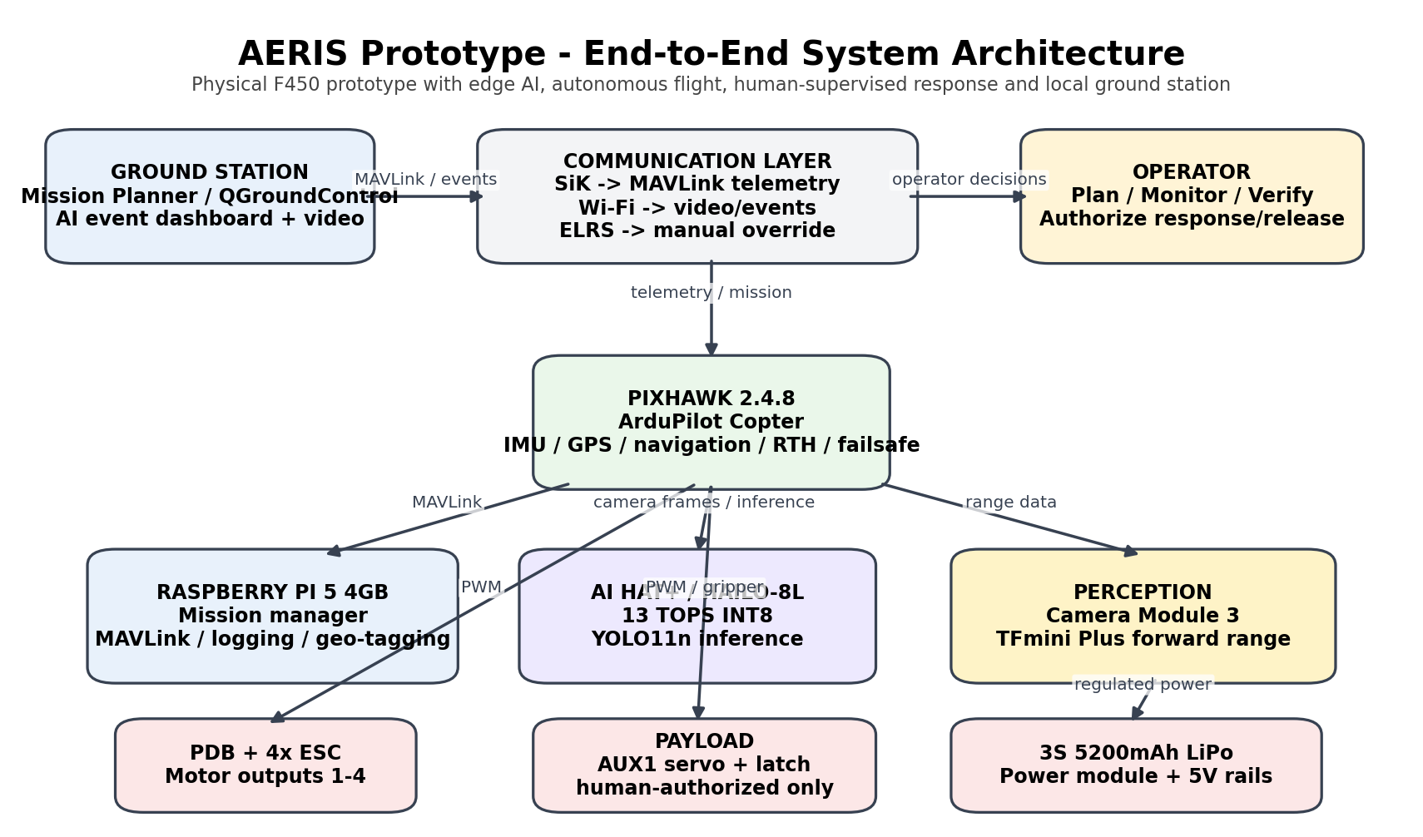
Figure 1. Final prototype system architecture.
PROTOTYPE BOUNDARY: The physical aircraft is an F450-class quadcopter. The 5-kg emergency-logistics platform is a digital-twin target only. The physical payload is a small demonstration payload and is permitted only after measured thrust margin and flight validation.
SAFETY BOUNDARY: AERIS is a research/hackathon prototype, not a production search-and-rescue aircraft. Human supervision remains mandatory for consequential response and payload release.

Document Control and Engineering Freeze
Field | Frozen value
Project | AERIS - AI-Assisted Autonomous Disaster Response & Emergency Logistics UAV
Prototype vehicle | F450 X-configuration quadcopter
Revision | 2.0 - prototype engineering freeze
Date | 26 September 2026
Primary flight controller | Pixhawk 2.4.8 / FMUv2-class, ArduPilot Copter
Companion computer | Raspberry Pi 5, 4GB
AI accelerator | Raspberry Pi AI HAT+ 13 TOPS, Hailo-8L
Primary AI model | Custom YOLO11n detector exported as Hailo HEF
Ground station | Mission Planner primary; QGroundControl backup; local AI/video dashboard
Communication | SiK telemetry for MAVLink; Wi-Fi for local video/events; ELRS for manual override
Payload | Human-authorized servo gripper/drop latch; small demonstration load only
Digital twin | Gazebo + ArduPilot SITL, conceptual 5-kg hexacopter only

Change Log From the Supplied Build Plan
Change | Reason | Disposition
Corrected Quad-X motor map | Original conceptual drawing was ambiguous versus standard ArduPilot mapping. | Frozen in Sections 9 and 15.
Dedicated Pi 5 5.1V >= 5A rail | Generic BEC wording was insufficient for Pi 5 + AI HAT+ operation. | Frozen in power tree and BOM.
Dedicated servo BEC | Do not depend on flight-controller rail for the payload servo. | Frozen in Section 15.
Explicit UART plan | GPS, SiK, ELRS, TFmini and companion link must coexist. | Frozen in pin map.
USB-UART for Pi <-> Pixhawk | Separates Pi mission link from TFmini UART and avoids interface contention. | Frozen as 3.3V-logic USB-UART.
Wi-Fi video path | SiK is treated as MAVLink telemetry, not video transport. | Frozen in communication architecture.
YOLO11n baseline | Provides a small current Hailo-compatible detector; custom classes are trained. | Frozen baseline; exact trained weights are a build artifact.
ByteTrack + event de-duplication | Prevents repeated alerts from the same target across frames. | Frozen.
Ground-projection geo-tagging | Drone GPS alone is aircraft position, not target position. | Frozen as approximate target geolocation with fallback.
Forward-only obstacle behavior | One TFmini cannot provide 360-degree perception. | Frozen as warning/hold first; reroute is optional after validation.
Explicit mission state machine | Turns features into deterministic, testable mission behavior. | Frozen in Section 13.
Budget normalization | Multiple supplied documents used different budget figures. | Planning budget is presented as a refined engineering estimate with sourcing caveat.

Source Basis
The system architecture and naming are derived from the supplied AERIS Concept & Prototype document, Robofest technical application, R620260083 application materials, AERIS GUJCOST technical details, and the Final Hackathon Build Plan. The technical validation layer additionally uses current official documentation for Raspberry Pi, ArduPilot, Benewake, Hailo/Ultralytics, and selected research literature.

Contents
1. Idea, Mission and Societal Application
2. Prototype Scope and Capability Boundary
3. System Requirements and Success Criteria
4. Final Hardware Bill of Materials
5. Hardware Technical Design
6. Power, Weight, Thrust and Energy Engineering
7. Final Software Technical Stack
8. AI Model, Data, Mathematics and Algorithms
9. Full Hardware-Software Architecture
10. Electrical and Communication Interface Specification
11. Pin-by-Pin Wiring and Connection Tables
12. Software Repository and Runtime Structure
13. Mission State Machine and Decision Logic
14. Full Implementation Roadmap
15. Hardware Build Procedure
16. Software Build and Integration Procedure
17. Integration, Calibration and Validation Gates
18. End-to-End Working of the Built Prototype
19. Digital Twin / SITL Implementation
20. Test Cases, Metrics, Logging and Acceptance
21. Calculations and Engineering Checks
22. Failure Modes and Recovery Logic
23. Deployment/Demo Procedure
24. Known Limits and Remaining Measured Quantities
25. Final Validation and Summary
26. Technical References
NAVIGATION: The document is intentionally organized as an engineering build specification. Hardware interfaces are defined before the implementation sections so that the software is implemented against stable physical interfaces.

1. Idea, Mission and Societal Application
AERIS is an AI-assisted autonomous disaster-response UAV intended to improve the speed and quality of initial aerial reconnaissance. The core idea is not simply to fly a camera over a disaster zone. AERIS turns aerial observations into structured, time-stamped and location-associated incident information, presents that information to a human operator, and then connects a verified incident to a supervised response mission. This combines autonomous flight, edge AI, forward obstacle awareness, localization, event prioritization, telemetry, operator supervision and an optional small payload release into one closed-loop prototype.
The supplied concept document describes use in floods, earthquakes, landslides, cyclones or severe storms, urban emergencies and remote/hard-to-reach areas. The same architecture also applies to post-disaster inspection, missing-person search support, blocked-road reconnaissance, visible-debris surveys and rapid situational awareness where ground access is difficult [D1].

1.1 The problem
During a disaster, responders may have incomplete situational awareness, unsafe or blocked access routes, and a large area to inspect. Aerial platforms can cover ground faster than a person walking the same area, but a manually piloted camera drone still leaves the operator to watch the video continuously, notice important events, estimate locations, decide whether observations are actionable, and coordinate the response. AERIS adds machine perception and structured incident handling while keeping the operator responsible for consequential actions.

1.2 The proposed response loop
Mission definition -> autonomous takeoff -> coverage search -> camera capture -> edge AI -> detection
-> tracking / confirmation -> geo-location -> priority -> ground alert -> human verification
-> response waypoint -> supervised payload release (optional) -> return or resume search

1.3 What makes the prototype useful
• It reduces the cognitive burden of continuously inspecting aerial video by producing explicit detection events rather than relying only on a video stream.
• It preserves human authority. The AI proposes an incident; the operator verifies it before a consequential response action.
• It provides a repeatable search method through grid/lawnmower coverage instead of ad-hoc manual flight.
• It creates a machine-readable incident record that can be reviewed after the mission, replayed in the digital twin, and used to compare field runs.
• It separates safety-critical stabilization and failsafes from best-effort AI so an AI software fault is not required for the aircraft to remain flyable.
• It is intentionally scalable: the perception and mission-management interfaces can be reused on a larger vehicle, while the physical F450 is treated as the prototype implementation.

1.4 Applications
Application | How AERIS contributes
Flood reconnaissance | Scan exposed areas, identify visible people/vehicles/debris, and provide location-associated leads to responders.
Earthquake reconnaissance | Inspect blocked roads, damaged open areas, building-adjacent zones and visible survivor locations without initially sending personnel into unknown areas.
Landslide/terrain inspection | Provide aerial situational awareness over unstable or inaccessible ground.
Cyclone/post-storm assessment | Inspect affected sectors and identify visible people, vehicles or debris requiring follow-up.
Urban emergency support | Search a controlled area where roads or structures make immediate ground reconnaissance difficult.
Remote-area reconnaissance | Cover a pre-defined search area where ground access is slow or fragmented.
Emergency logistics demonstration | Travel to a verified target coordinate and release a small demonstration package after thrust, payload and flight validation.

1.5 Example mission scenarios
Scenario A - Search and report. The operator draws Search Area A. AERIS takes off, follows the generated coverage route, receives camera frames, detects a person, confirms the track, calculates an approximate target coordinate, assigns a priority, and sends an event to the ground station. The aircraft can continue the search while the operator reviews the event.
Scenario B - Point-to-point response. The operator supplies a target coordinate. AERIS navigates there using ArduPilot, maintains its configured response altitude, pauses for operator authorization, and releases only the small validated demonstration payload. It then returns home.
Scenario C - Search, respond, resume. AERIS searches Sector A, generates an incident, waits for human verification, performs a response mission, returns to the original mission context, and resumes from a predefined or regenerated waypoint rather than inventing a new route.

2. Prototype Scope and Capability Boundary
The supplied final build plan is intentionally conservative: the physical system is one small quadcopter, not a claimed 5-kg aircraft. The physical prototype demonstrates the software/mission architecture and limited flight functions; the 5-kg emergency logistics concept is represented in the digital twin only [D5].
Capability | Physical prototype | Digital twin / future
Autonomous takeoff/landing | Yes, after manual flight gate | Yes
GPS waypoint mission | Yes | Yes
Lawnmower/grid search | Yes | Yes
Person detection | Yes | Yes
Vehicle detection | Yes if trained/validated | Yes
Debris detection | Yes if trained/validated | Yes
Fire/smoke detection | Not a frozen primary claim; requires dedicated model validation | Can be simulated
Geo-tagging | Approximate target location with ground projection; fallback to aircraft position | Full simulated pipeline
Priority/decision layer | Rule-based | Rule-based / extensible
Forward obstacle sensing | Yes | Yes / simulated
360-degree obstacle avoidance | No | Possible future research
Payload | Small human-authorized demo only | 5-kg target model only
Return-to-home / failsafe | Yes | Yes
Ground station | Yes | Yes
Live video | Local Wi-Fi demonstration | Simulated/replayed

NON-CLAIMS: The prototype is not a production search-and-rescue aircraft, not an all-weather platform, not a 5-kg heavy-lift aircraft, and not an autonomous life-critical decision maker [D5].

3. System Requirements and Success Criteria

3.1 Functional requirements
ID | Requirement | Implementation
FR-01 | Mission input | Operator can define a target coordinate or a polygonal search area.
FR-02 | Flight autonomy | ArduPilot executes takeoff/waypoint/landing behavior under configured limits.
FR-03 | Manual override | Pilot can immediately override through the ELRS link.
FR-04 | Telemetry | Ground station receives position, altitude, speed, battery, mode and mission status.
FR-05 | Vision | Camera supplies frames to the Pi; detector runs locally on the Hailo NPU.
FR-06 | Detection | Detector outputs class, confidence and bounding box.
FR-07 | Tracking | Repeated frames are associated to tracks to prevent alert storms.
FR-08 | Geo-tag | Each confirmed event receives timestamp and approximate target position.
FR-09 | Priority | Event receives normal/high/critical rule-based priority.
FR-10 | Alert | Ground dashboard displays the event and location.
FR-11 | Obstacle | TFmini distance is filtered and used for warning/hold behavior.
FR-12 | Response | Operator can convert a verified incident into a response waypoint.
FR-13 | Payload | Release requires explicit human authorization and safe-state checks.
FR-14 | Logging | Flight and AI events are stored locally with synchronized timestamps.
FR-15 | SITL | The mission manager/event schema can run against ArduPilot SITL.

3.2 Non-functional requirements
ID | Area | Acceptance statement
NFR-01 | Safety | Flight controller must remain capable of stable flight without the Pi or AI process.
NFR-02 | Determinism | Mission state transitions must be explicit and logged.
NFR-03 | Recoverability | Software processes must restart without silently changing mission state.
NFR-04 | Traceability | Every incident must have a unique event_id and mission_id.
NFR-05 | Reproducibility | Model file, software versions, configuration and parameters are frozen in Git.
NFR-06 | Thermal | Pi temperature and throttling state are logged during AI flight tests.
NFR-07 | Electrical | All regulated rails are verified under worst expected load before flight.

3.3 Acceptance philosophy
A feature is considered implemented only when it passes a repeatable test. A feature that works once but has no log, no test procedure, or no defined failure behavior is treated as experimental, not accepted. This rule prevents the documentation from over-claiming capabilities simply because a component is installed.

4. Final Hardware Bill of Materials
The BOM below is the refined prototype BOM. Planning prices are based on the supplied final build plan and are intended for budgeting rather than a guaranteed retail quotation. Current retail prices vary by seller, GST/shipping, stock and exact board revision. The final purchase order should record the exact part number and supplier.
# | Item | Specification | Qty | Role | Planning price
1 | F450 frame kit | 450 mm X-frame; include 4x A2212 1000KV, 4x 30A ESC and 1045 prop set | 1 kit | Airframe + propulsion | ₹4,149
2 | Pixhawk 2.4.8 + GPS/power | FMUv2-class board; M8N-class GPS/compass; power module | 1 set | Flight control | ₹12,000 budget
3 | Raspberry Pi 5 4GB | 4GB RAM; USB-C input; CSI camera; UART/USB | 1 | Companion computer | ₹11,000 budget
4 | Raspberry Pi AI HAT+ 13 TOPS | Hailo-8L, 13 TOPS INT8 | 1 | AI accelerator | ₹6,854
5 | Camera Module 3 standard | 12MP IMX708; standard 75-degree diagonal FoV | 1 | Primary perception | ₹2,389
6 | TFmini Plus | 0.1-12 m class; UART/I2C; forward range | 1 | Obstacle sensing | ₹3,500 budget
7 | 3S 11.1V 5200mAh LiPo | 40-80C planning specification, XT60 | 1 | Main battery | ₹2,561
8 | RadioMaster Pocket ELRS | 2.4 GHz ELRS transmitter | 1 | Manual override | ₹6,899
9 | RadioMaster RP2 ELRS receiver | 2.4 GHz CRSF receiver | 1 | Aircraft-side RC | ₹1,200 budget
10 | SiK telemetry pair | 433/915 MHz legal/available for site; MAVLink | 1 pair | GCS telemetry | ₹3,940 budget
11 | Raspberry Pi Active Cooler | Pi 5 compatible | 1 | Thermal management | ₹600 budget
12 | 128GB high-endurance microSD | A2/U3 class or equivalent | 1 | OS/model/log storage | ₹600 budget
13 | 3S balance charger | Balance charge, storage charge, correct chemistry | 1 | Battery charging | ₹1,500
14 | 5.1V >=5A buck converter | Dedicated Pi rail from 3S battery/PDB; regulated output | 1 | Pi power | ₹1,200 budget
15 | 5V 3A servo BEC | Dedicated servo rail | 1 | Payload servo power | ₹400 budget
16 | CP2102N/FTDI 3.3V USB-UART | True 3.3V logic; USB side to Pi | 1 | Pi-Pixhawk MAVLink | ₹300 budget
17 | Micro servo + mechanical latch | SG90/MG90S-class or stronger; lightweight latch | 1 | Payload release | ₹600 budget
18 | Buzzer + status LED set | Pixhawk-compatible audible/visual indicators | 1 set | State indication | ₹250 budget
19 | Sensor/mount hardware | 3D printed/bolt-on mounts; vibration isolation | 1 set | Mechanical integration | ₹1,000 budget
20 | Wiring/integration kit | XT60, wire, connectors, heat-shrink, fuse/protection, cable ties | 1 lot | Electrical integration | ₹1,200 budget
21 | Propeller spares | 2-4 extra sets + fasteners | 1 lot | Field reliability | ₹1,000 budget
22 | Transmitter batteries | 2x 18650 Li-ion cells | 1 set | Pocket power | ₹400 budget

PLANNING TOTAL: Approximately ₹63,542 for the refined engineering BOM. This is a planning figure; retail procurement can be higher. A laptop/ground-station computer is assumed already available and is not included in this subtotal.
PROCUREMENT RULE: The exact Pixhawk board, exact ESC model, exact BEC/buck model, exact receiver and exact telemetry radio must be recorded with manufacturer and revision. Do not substitute an electrically different part merely because the name is similar.

4.1 Optional / future items not required for the first flight
Item | Why it is optional | Reason for exclusion from frozen prototype
Second camera | Could add rear/nadir redundancy | Adds mass, power and software complexity; first prototype uses one calibrated camera.
Optical-flow sensor | Useful when GPS is unreliable | Not required for the primary outdoor GPS mission.
360-degree lidar | Would improve obstacle perception | Incompatible with the current budget and weight/compute targets.
Thermal camera | Useful for night/search applications | Not part of the frozen first prototype.
AI HAT+ 26 TOPS | More compute headroom | 13 TOPS is sufficient for the selected baseline object detector.

5. Hardware Technical Design

5.1 Airframe and propulsion
The airframe is an F450-class X quadcopter. The vehicle uses four A2212 1000KV brushless motors, four 30A ESCs, and two CW plus two CCW 1045 propellers. Attitude control is achieved by differential motor speed; there is no mechanical drivetrain. The supplied technical documents explicitly describe the aircraft as a fixed-rotor quadcopter with no chain or sprocket drivetrain [D3].
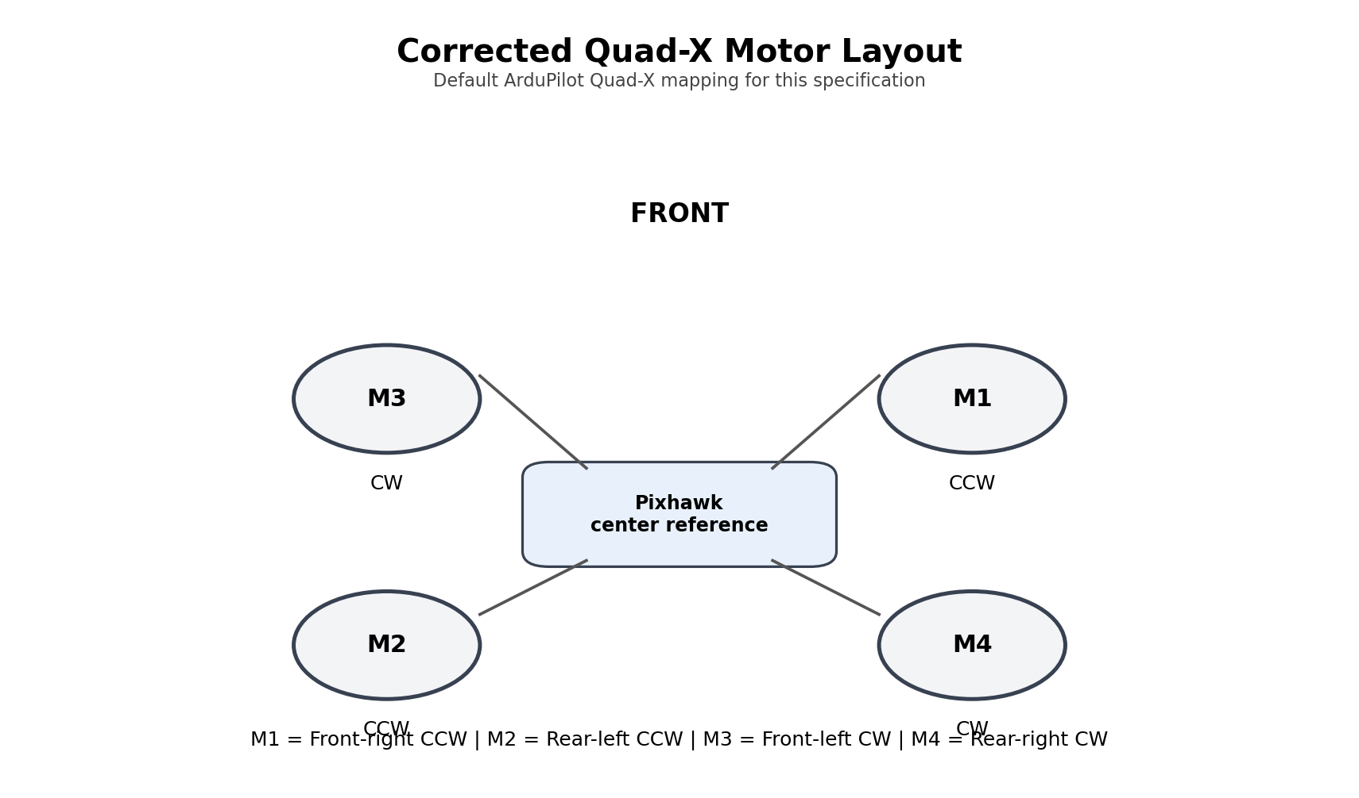
Figure 2. Corrected standard Quad-X motor numbering and rotation. Verify the purchased motor/prop pair before flight.

5.2 Flight controller
Pixhawk is the safety-critical controller. It performs IMU processing, attitude stabilization, GPS navigation, waypoint execution, flight-mode control, battery/GPS/communication failsafes and actuator output. The companion computer is not allowed to be a hard dependency for basic stable flight.

5.3 GPS and compass
Use the bundled M8N-class GPS/compass module with the highest practical physical separation from high-current ESC/motor wiring. Place the GPS/compass above the central electronics on a small mast and route the cable away from the PDB and motor leads where practical. Perform compass calibration only after final wiring and mechanical placement are complete.

5.4 Companion computer
The Raspberry Pi 5 is the mission and AI host. It receives images from the CSI camera, range samples from TFmini, MAVLink telemetry from Pixhawk, and operator commands via the local network/dashboard. It owns high-level decisions but must not replace the flight controller safety loop.

5.5 AI accelerator
The Raspberry Pi AI HAT+ provides the Hailo-8L NPU and is available in a 13 TOPS variant. Raspberry Pi states that AI HAT+ hardware-accelerates supported AI workloads locally on Raspberry Pi 5 and integrates with the camera/vision stack [W1][W2].

5.6 Camera
The final prototype uses the standard Camera Module 3 rather than the wide model. Raspberry Pi specifies a 12MP IMX708 sensor with a 75-degree diagonal field of view for the standard variant; the Wide variant is 120 degrees [W3]. The standard lens is preferred for the first prototype because excessive width can reduce the pixel footprint of a small person at altitude. The camera should be mounted near-nadir or with a small, repeatable forward tilt for the search mission.

5.7 Obstacle sensor
TFmini Plus is used as a lightweight forward range sensor. Its role is deliberately limited to forward obstacle awareness. The prototype first implements warning/slow/hold behavior. Automatic rerouting is not considered a guaranteed capability until the hold/stop behavior is repeatedly demonstrated in flight.

5.8 RC override
The RadioMaster Pocket and RP2 ELRS receiver form an independent manual override path. ELRS/CRSF is a UART-based digital protocol, so the receiver is connected to a true Pixhawk UART rather than pretending it is an RC PWM input. The receiver remains live during every flight.

5.9 Telemetry
SiK telemetry carries MAVLink between Pixhawk and the ground station. It is intentionally not used as the live-video transport. The local Wi-Fi link is used for video and AI event dashboard traffic. This separation prevents the low-bandwidth telemetry link from being overloaded by video.

5.10 Payload actuator
The servo latch is driven from an AUX output through the Pixhawk gripper function. ArduPilot supports a servo gripper on an AUX output with SERVOx_FUNCTION=28 and control through MAV_CMD_DO_GRIPPER [W7]. The servo receives power from a dedicated 5V/3A BEC. The physical release remains human-authorized and is blocked unless the mission state, position and safety checks permit it.

6. Power, Weight, Thrust and Energy Engineering

6.1 Battery energy
Nominal battery energy = V_nominal x Ah = 11.1 V x 5.2 Ah = 57.72 Wh
80% usable energy = 57.72 x 0.80 = 46.18 Wh
75% usable energy = 57.72 x 0.75 = 43.29 Wh
Average electrical power | Time at 80% usable | Time at 75% usable
250 W | 11.08 min | 10.39 min
275 W | 10.07 min | 9.44 min
300 W | 9.24 min | 8.66 min
325 W | 8.53 min | 7.99 min
350 W | 7.92 min | 7.42 min

INTERPRETATION: The physical plan uses an 8-10 minute planning estimate, but exact flight time must be measured on the purchased aircraft. Camera, Pi, AI HAT, payload, wind, battery age and the actual hover power all change the result.

6.2 Thrust-to-weight check
Available thrust depends strongly on the purchased A2212 motor, propeller, battery voltage and test conditions. The planning range below uses a conservative 700 g to 800 g per motor to show feasibility rather than promise a specific result. Four motors therefore represent approximately 2.8 kg to 3.2 kg of total static thrust before losses and without accounting for maneuver reserve.
Scenario | Assumed total mass | Total thrust at 700 g/motor | T/W | Total thrust at 800 g/motor | T/W
Prototype, no payload | 1.45 kg | 2.80 kg | 1.93 | 3.20 kg | 2.21
Prototype + 0.25 kg demo load | 1.70 kg | 2.80 kg | 1.65 | 3.20 kg | 1.88
Prototype + 0.40 kg demo load | 1.85 kg | 2.80 kg | 1.51 | 3.20 kg | 1.73

PAYLOAD GATE: The payload is not approved by calculation alone. We require a measured static thrust test, measured all-up mass, hover-current test and flight test. The release mechanism remains optional until those measurements pass.

6.3 Electrical current envelope
Example short-duration motor current envelope (planning): 12 A x 4 motors = 48 A
At 12.6 V full battery: 12.6 V x 48 A = 604.8 W electrical input before ESC/motor efficiency losses
This is not a claim that the aircraft will draw 48 A continuously. It is a sizing check showing why the PDB, XT60, wiring and ESC paths need adequate current margin.

6.4 Pi power budget
Pi design rail = 5.1 V, 5 A continuous-capable
Maximum rail power capability = 5.1 V x 5 A = 25.5 W
At 90% buck efficiency from 11.1 V nominal battery:
Battery current at 25.5 W output = 25.5 / (11.1 x 0.90) = 2.55 A
Raspberry Pi documentation recommends 5V at 5A for Raspberry Pi 5; a 3A supply constrains available peripheral current [W4]. The dedicated buck therefore avoids the ambiguous “generic BEC” problem in the earlier document.

6.5 Search geometry
The standard Camera Module 3 has a 75-degree diagonal FoV. For planning, a horizontal FoV around 66 degrees is used. The approximate ground swath width is W = 2 h tan(FOV_h/2). With 20% lane overlap, lane spacing is S = W x (1 - 0.20).
At h = 8 m, FOV_h = 66 deg:
W ~= 2 x 8 x tan(33 deg) ~= 10.39 m
Lane spacing ~= 10.39 x 0.80 = 8.31 m
At h = 10 m:
W ~= 12.98 m
Lane spacing ~= 10.38 m
These are geometric coverage estimates, not detection guarantees. The real minimum usable altitude must be selected from actual person-pixel size, detector performance, safe flight rules, camera exposure and environmental conditions.

6.6 Obstacle stopping-distance calculation
The first TFmini behavior uses a conservative speed of 3 m/s. A planning safety distance is calculated from reaction latency, deceleration and a margin.
Reaction distance = v x t = 3.0 x 0.20 = 0.60 m
Stopping distance = v^2 / (2a) = 9 / (2 x 1.0) = 4.50 m
Safety margin = 1.50 m
Total = 0.60 + 4.50 + 1.50 = 6.60 m
The initial firmware/software configuration therefore uses a warning zone around 8 m and a hold/stop action around 6.5 m, subject to outdoor flight test. These numbers are engineering starting values, not guaranteed stopping performance. They must be re-tuned from measured braking response.

6.7 Geo-location error budget
Target geo-location is the sum of GPS error, attitude error, altitude error, camera calibration error, object-centroid error and local ground-height error. If these errors were independent, a root-sum-square estimate can show the scale, but it should never be presented as a guarantee.
Illustrative open-sky target: GPS 2.0 m, camera/centroid 1.0 m, attitude projection 0.5 m, altitude/ground 0.7 m
RSS ~= sqrt(2.0^2 + 1.0^2 + 0.5^2 + 0.7^2) ~= 2.4 m
MEASUREMENT REQUIREMENT: The prototype acceptance target should be stated as a measured 95th-percentile or similar field error, not the illustrative calculation above. Use surveyed markers at known coordinates during calibration.

7. Final Software Technical Stack
Layer | Technology | Where | Job
Flight firmware | ArduPilot Copter | Pixhawk | Stabilization, GPS navigation, modes, mission execution, failsafe, actuator control
Protocol | MAVLink | Pixhawk <-> Pi <-> GCS | Telemetry, mission commands, status, gripper commands
GCS | Mission Planner | Ground laptop | Parameter setup, mission planning, logs, telemetry
Backup GCS | QGroundControl | Ground laptop | Secondary mission/telemetry interface
Companion OS | Raspberry Pi OS 64-bit | Pi 5 | System runtime
Language | Python 3 | Pi 5 | Mission logic, event manager, geo-tagging, dashboard services
Camera | Picamera2 / rpicam | Pi 5 | CSI camera capture and frame control
CV | OpenCV | Pi 5 | Resize, color, drawing, calibration, image transforms
AI runtime | HailoRT + Hailo software | AI HAT+ | NPU inference
Detector | Custom YOLO11n -> Hailo HEF | AI HAT+ | Person/vehicle/debris detection
Tracker | ByteTrack | Pi CPU | Track IDs and temporal association
Coverage planning | Polygon clipping + lawnmower sweep | Pi or GCS | Generate systematic search waypoints
Obstacle logic | Median filter + threshold state machine | Pi | TFmini warning/hold behavior
Geo-tagging | Camera model + pose transform + ground-plane intersection | Pi | Approximate target coordinate
Priority | Rule-based weighted score | Pi | Normal/high/critical triage
Data store | SQLite + JSONL | Pi | Mission/event logging
Dashboard | FastAPI + WebSocket + Leaflet/OpenStreetMap | Ground laptop | Events, map, telemetry subset, video UI
Video | Local Wi-Fi; MJPEG/RTP/WebRTC implementation selected at build | Pi -> laptop | Live perception feed
Simulation | Gazebo + ArduPilot SITL | Dev PC | Digital-twin testing
Version control | Git + GitHub | Dev PC | Code/config/version traceability
CAD | FreeCAD | Dev PC | Mounts, payload box, physical geometry
Training | PyTorch + Ultralytics | Development PC | Custom detector training and evaluation

7.1 Current Hailo deployment rule
Ultralytics currently documents Hailo export for YOLOv8/YOLO11 detection on Hailo-8/Hailo-8L. The model is compiled to a hardware-specific HEF on a Linux x86_64 workstation, while inference occurs on the Raspberry Pi through HailoRT. The input shape is fixed at export time; custom models should be calibrated with representative production-domain images [W10].

7.2 Software version freeze
Artifact | Freeze rule
ArduPilot firmware | Record exact stable build and firmware hash/version used in the flight controller.
Raspberry Pi OS | Record image release and SHA/manifest; current Raspberry Pi AI documentation targets 64-bit Raspberry Pi OS Trixie for AI on Pi 5 [W5].
Python | Record exact major/minor and pip lock/requirements.txt.
HailoRT | Record exact package version and accelerator identification output.
Ultralytics | Record exact package version and commit/package hash.
YOLO HEF | Store HEF plus metadata in Git LFS or release artifact store; record DFC version.
Mission parameters | Store complete ArduPilot parameter file as an immutable release artifact.
Dashboard | Pin dependencies and store a reproducible requirements lock.

8. AI Model, Data, Mathematics and Algorithms

8.1 Detection model
The first physical detector is a custom-trained YOLO11n object detector with three frozen primary classes: person, vehicle and debris. A fire/smoke class is not claimed in the first physical system unless a dedicated dataset and evaluation prove it sufficiently. This keeps the prototype aligned with what the trained model can actually recognize.
YOLO-style detection formulates object localization and classification in a unified neural network. The original YOLO paper introduced the approach as a unified real-time detection system [R1]. The implementation here uses the current YOLO11n family because current Ultralytics documentation validates YOLO11 detection export to Hailo-8L/8 [W10].

8.2 Training dataset strategy
• Collect or source license-compatible imagery that resembles the prototype: aerial/downward or oblique views, small people, partially occluded people, vehicles, rubble/debris and mixed backgrounds.
• Create train/validation/test splits by scene or location where possible so nearly identical frames do not leak across the splits.
• Apply realistic augmentation: scale, crop, brightness/contrast, blur, mild rotation and sensor-noise variations. Do not over-augment beyond the camera physics.
• Calibrate the Hailo model using representative production-like images rather than generic images. Ultralytics recommends a large, diverse calibration set for Hailo export; its current guide recommends at least 1,024 calibration images for best accuracy [W10].
• Freeze dataset version, licenses, class names and label format before training a release model.

8.3 Baseline model configuration
Parameter | Initial value | Why
Model | YOLO11n detector | Small edge baseline compatible with Hailo-8L
Input | 640x640 | Balanced edge accuracy/compute; fixed at Hailo export
Classes | person, vehicle, debris | Frozen physical claims
Detector confidence | 0.35 baseline | Retains candidate detections for tracking
Event confidence | 0.60 baseline | Higher bar for ground alert
NMS IoU | 0.45 baseline | Suppress duplicate boxes
Inference target | 15-20 FPS if measured feasible | Leaves CPU for mission logic
Tracker | ByteTrack | Temporal association and track IDs
Event confirmation | 3 of last 5 frames | Reduces single-frame false alarms
Cooldown | 10 s + spatial cell check | Prevents repeated incident spam

TUNING RULE: The values above are starting configurations. The release threshold is the value measured on the actual model/scene test set, not a number chosen only because it looks reasonable.

8.4 ByteTrack role
ByteTrack associates detections across frames so the system can distinguish a persistent object from a one-frame false positive. The original ByteTrack paper reports an association strategy that also uses lower-score detections to recover fragmented trajectories [R2]. In AERIS, the main benefit is operational: stable track IDs make event confirmation and de-duplication possible.

8.5 Detection/event pipeline mathematics
For each detection d_i = (class, confidence, bbox), keep a candidate if confidence >= 0.35.
Use the tracker to associate boxes to track k.
Confirm a track if detections are present in >= 3 of the last 5 inference frames.
Generate one event per confirmed track unless cooldown/spatial suppression permits another event.

8.6 Priority scoring
Use a transparent weighted rule instead of a black-box learned triage model. Let c be detector confidence in [0,1], t be persistence score in [0,1], s be class severity in [0,1], and m be mission-context severity in [0,1].
priority_score = 100 * (0.55*c + 0.20*t + 0.15*s + 0.10*m)
Class | Severity s | Reason
person | 1.00 | Direct life-safety relevance for the demo
vehicle | 0.70 | Potential incident/supporting evidence
debris | 0.50 | Hazard/context indicator

Score | Priority | Ground action
>= 80 | CRITICAL | Immediate visual/audible attention; response still requires human authorization.
60-79 | HIGH | Operator review / potential response.
40-59 | NORMAL | Record and continue search.
< 40 | LOG ONLY | Store but do not escalate.

8.7 Coverage path planning
AERIS uses a lawnmower/grid coverage pattern. Coverage path planning is the task of generating a path that covers an area under vehicle constraints; survey literature identifies path length, coverage, obstacles, and energy as key factors [R3][R4]. The first implementation is intentionally deterministic: polygon -> parallel sweep lines -> lane clipping -> alternating direction -> entry/exit waypoints.
Given search polygon P, altitude h and horizontal FoV theta:
W = 2*h*tan(theta/2)
S = W*(1-overlap)
Generate parallel lanes spaced S, clip each lane to P, alternate direction, add turn waypoints.
A 20% overlap is the initial planning value. The mission speed is 2.5-3.0 m/s for a controlled demonstration. The route generator should reduce lane spacing if actual detection quality requires it, even if the resulting path is longer.

8.8 Geo-tagging mathematics
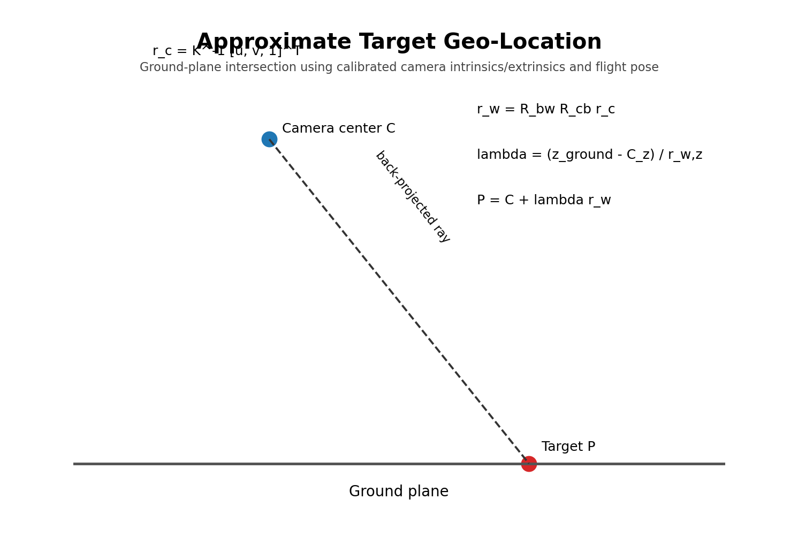
Figure 7. Approximate target geo-location geometry.
Camera ray: r_c = K^-1 [u, v, 1]^T
World ray: r_w = R_bw * R_cb * r_c
Ground intersection: lambda = (z_ground - C_z) / r_w,z
Target point: P = C + lambda*r_w
Here K is the camera intrinsic matrix, R_cb is the fixed camera-to-body rotation, R_bw is the vehicle/body-to-world rotation derived from flight attitude, C is the camera position in the world frame, and z_ground is the local ground-plane height. The prototype uses this to estimate a target coordinate. When the geometric solution is invalid or poorly conditioned (for example, the ray points toward the horizon), the system records the aircraft GPS position as a fallback and explicitly labels the location as approximate.

8.9 Obstacle filter
Let d_k be the TFmini distance samples.
Filtered distance = median(d_(k-2), ..., d_(k+2))
Reject samples outside the physical sensor range or obvious jumps.
State: NORMAL if d > 8.0m
WARNING if 6.5m < d <= 8.0m
HOLD if d <= 6.5m
The exact thresholds are tuned after observing real stopping distance and false detections. The first safe behavior is hold/pause, not a complex autonomous reroute.

8.10 Quadrotor dynamics model
The controller itself is ArduPilot, not a custom controller developed inside this prototype. The mathematics below explains the physical system and is useful for the digital twin and validation. A simplified rigid-body model is:
m*v_dot = m*g + R*f_b
R_dot = R*skew(Omega)
J*Omega_dot + Omega x (J*Omega) = tau
m is vehicle mass, v is inertial velocity, R is body-to-world rotation, f_b is total thrust in body coordinates, J is inertia, Omega is body angular velocity, and tau is the control moment. Each motor contributes thrust and reaction torque; the net roll/pitch/yaw moments arise from differential motor force and drag torque. These equations are used to reason about thrust margin and to set realistic SITL/digital-twin parameters.

9. Full Hardware-Software Architecture
Figure 1 (repeated for reference). Final end-to-end architecture.

9.1 Hardware responsibility split
Layer | Hardware | Responsibility | Failure behavior
Energy | LiPo + PDB + power module + regulators | Provide independent rails to flight, Pi and payload | Undervoltage is detected; battery failsafe acts through Pixhawk.
Propulsion | Motors + ESCs + props | Generate thrust and control moments | Lost actuator is a flight fault; no AI process can safely repair it.
Flight | Pixhawk + IMU + barometer + GPS | Stabilization, navigation, RTH, failsafe | Continues basic flight control without Pi.
Companion | Pi 5 | Mission orchestration, event processing, logs | Watchdog restarts process; aircraft remains under Pixhawk control.
AI | AI HAT+ Hailo-8L | Low-latency object inference | AI can stop; flight remains safe.
Vision | Camera Module 3 | Image acquisition | AI event pipeline reports camera fault.
Range | TFmini Plus | Forward distance | Fails safe to conservative hold behavior when sensor invalid.
Communication | SiK + Wi-Fi + ELRS | Telemetry, video/events, pilot override | ELRS remains the independent manual channel.
Payload | Servo + latch | Physical demo release | Release is blocked unless authorized and preconditions pass.

9.2 Data ownership rule
Each data item has one authoritative owner. Flight attitude, mode, GPS position and battery state come from Pixhawk. Raw camera frames come from the camera/Pi stack. AI detections come from the Hailo inference process. Mission state is owned by the Pi mission manager but must never command the flight controller outside an allowed command set. Ground-station authorization is authoritative for payload release.

9.3 End-to-end data flow
Camera -> Pi capture -> Hailo YOLO -> detections -> ByteTrack -> confirmed track
-> geo-tag -> priority -> incident event -> Wi-Fi dashboard + JSONL/SQLite
Pixhawk -> MAVLink -> Pi telemetry cache -> mission/event association -> dashboard
Pixhawk -> SiK -> Mission Planner/QGC
ELRS TX -> RP2 -> Pixhawk -> manual override
TFmini -> Pi -> obstacle state -> mission manager -> pause/hold
Operator -> dashboard -> response authorization -> Pi -> MAVLink -> Pixhawk -> AUX1 servo

10. Electrical and Communication Interface Specification

10.1 Pixhawk port plan
Interface | Use | Connection | Notes
POWER | Power module | Power module to Pixhawk POWER port | Carries regulated 5V plus current/voltage sense; verify exact board connector pinout.
MAIN OUT 1 | Motor 1 | ESC1 signal + GND | ArduPilot Motor 1.
MAIN OUT 2 | Motor 2 | ESC2 signal + GND | ArduPilot Motor 2.
MAIN OUT 3 | Motor 3 | ESC3 signal + GND | ArduPilot Motor 3.
MAIN OUT 4 | Motor 4 | ESC4 signal + GND | ArduPilot Motor 4.
TELEM1 / SERIAL1 | SiK telemetry | Pixhawk UART <-> air SiK radio | MAVLink; hardware flow control if radio supports it.
TELEM2 / SERIAL2 | Companion link | Pixhawk UART <-> 3.3V USB-UART <-> Pi USB | MAVLink; use dedicated adapter.
GPS | M8N GPS | GPS UART + compass harness | GPS position; compass may use I2C within bundled harness.
SERIAL4 | ELRS CRSF | Pixhawk UART <-> RP2 | Full-duplex CRSF; true UART.
AUX OUT 1 / SERVO9 | Payload servo | Servo signal + external 5V/3A BEC + GND | SERVO9_FUNCTION=28 for ArduPilot gripper.
BUZZER | Buzzer | Pixhawk buzzer port | State/failsafe audible output.
SAFETY SWITCH | External switch | Pixhawk safety switch port | Follow exact board/harness instructions.

BOARD-SPECIFIC CAUTION: Pixhawk 2.4.8 products are not all identical. The pin tables below describe the standard FMUv2-style logical connection; verify the exact purchased board manual/silkscreen before applying power. Never rely on a photo of another Pixhawk clone as a wiring authority.

10.2 Raspberry Pi interfaces
Pi interface | Pin | Signal / endpoint | Purpose
5V power | Pin 4 | 5.1V buck output | Primary Pi power
GND | Pin 6 | Common ground | Power/reference
UART TXD | GPIO14, physical pin 8 | Pi TX -> TFmini RX | TFmini command/configuration if required
UART RXD | GPIO15, physical pin 10 | TFmini TX -> Pi RX | TFmini range data
USB | USB port | 3.3V-logic USB-UART adapter | Pixhawk MAVLink link
CSI camera | Camera connector | Camera Module 3 ribbon | Vision input
PCIe/HAT | AI HAT+ stack interface | Hailo-8L | AI inference
Wi-Fi | Onboard radio | Local network | Video + event dashboard

11. Pin-by-Pin Wiring and Connection Tables
WIRING PRINCIPLE: Make all signal connections with the battery disconnected. Use continuity and polarity checks before energizing a new rail. For UARTs, remember that TX connects to RX and RX connects to TX.

11.1 LiPo to power tree
From | Pin/wire | To | Pin/wire | Signal
3S LiPo XT60 + | Positive | PDB + | Battery + | Main positive bus
3S LiPo XT60 - | Negative | PDB - | Battery - | Main ground bus
PDB battery bus | Positive | Power module IN+ | IN+ | Voltage/current monitor input
PDB battery bus | Negative | Power module IN- | IN- | Monitor ground
PDB battery bus | Positive | 5.1V buck IN+ | IN+ | Pi regulator input
PDB battery bus | Negative | 5.1V buck IN- | IN- | Pi regulator ground
PDB battery bus | Positive | 5V servo BEC IN+ | IN+ | Servo regulator input
PDB battery bus | Negative | 5V servo BEC IN- | IN- | Servo regulator ground

11.2 Pixhawk POWER port
Pixhawk POWER pin | Electrical role | Connect to
Pin 1 | +5V | Power module regulated +5V
Pin 2 | +5V | Power module regulated +5V
Pin 3 | CURRENT analog | Power module current-sense output
Pin 4 | VOLTAGE analog | Power module voltage-sense output
Pin 5 | GND | Power module ground

VERIFY: Use the exact power-module harness shipped with the exact Pixhawk board. Do not cut/re-pin a connector unless the board manual confirms the same pinout.

11.3 Motor/ESC signal wiring
Pixhawk output | ESC | Motor position | Motor rotation | Prop
MAIN OUT 1 | ESC1 | Front-right | CCW | 1045 CCW
MAIN OUT 2 | ESC2 | Rear-left | CCW | 1045 CCW
MAIN OUT 3 | ESC3 | Front-left | CW | 1045 CW
MAIN OUT 4 | ESC4 | Rear-right | CW | 1045 CW

Each ESC signal lead connects to the assigned Pixhawk output signal and its signal ground. With the dedicated servo BEC architecture, do not parallel multiple ESC BEC outputs onto the servo rail. Follow the purchased ESC manual for its three motor phase wires and battery-side connections. Brushless motor direction is corrected by swapping two of the three motor phase wires or by a supported ESC direction setting, then re-tested without propellers.

11.4 GPS/compass
Signal | Pixhawk GPS-side pin | M8N side | Purpose
+5V | GPS pin 1 | GPS VCC | Module power
TX | Pixhawk RX (GPS pin 3) | GPS TX | GPS data into Pixhawk
RX | Pixhawk TX (GPS pin 2) | GPS RX | GPS configuration/data back to module
GND | GPS pin 6 | GPS GND | Reference
I2C SDA | I2C SDA pin | Compass SDA | Compass data if separate
I2C SCL | I2C SCL pin | Compass SCL | Compass clock if separate

If the purchased M8N module uses a combined harness, use the manufacturer-supplied harness and verify continuity rather than assuming the wire order from another M8N board.

11.5 TFmini Plus to Raspberry Pi UART
TFmini Plus | Wire / logical pin | Raspberry Pi | Purpose
Pin 1 | +5V | Physical pin 4 (5V) | Sensor power
Pin 2 | RXD / SDA | GPIO14 / physical pin 8 TXD | Pi -> sensor commands
Pin 3 | TXD / SCL | GPIO15 / physical pin 10 RXD | Sensor -> Pi distance
Pin 4 | GND | Physical pin 6 GND | Reference

LOGIC LEVEL: TFmini Plus uses a 5V supply and 3.3V logic. Do not feed the sensor UART directly from a 5V-TTL adapter. Keep the Pi GPIO at 3.3V logic.

11.6 Pi to Pixhawk MAVLink via 3.3V USB-UART
Pixhawk TELEM2 | USB-UART adapter | Raspberry Pi | Signal
Pin 2 TX | RX | USB RX | Pixhawk -> Pi
Pin 3 RX | TX | USB TX | Pi -> Pixhawk
Pin 6 GND | GND | USB GND | Common reference
Pin 1 +5V | DO NOT USE for adapter power | USB power from Pi | Avoid accidental parallel power rails

Set the Pixhawk serial port used by TELEM2 to MAVLink2 at the selected baud. The Pi opens the corresponding `/dev/ttyUSB*` device. The adapter must be a 3.3V-logic device.

11.7 SiK telemetry pair
Pixhawk TELEM1 | SiK air radio | Direction
Pin 1 +5V | 5V/VCC | Power
Pin 2 TX | Radio RX | Pixhawk -> radio
Pin 3 RX | Radio TX | Radio -> Pixhawk
Pin 4 CTS | CTS | Optional hardware flow control
Pin 5 RTS | RTS | Optional hardware flow control
Pin 6 GND | GND | Reference

If the selected SiK radio cable exposes no flow control, use only TX/RX/5V/GND. The exact cable/pinout supplied with the radio pair is authoritative.

11.8 ELRS receiver on SERIAL4
Pixhawk SERIAL4 | RP2 ELRS receiver | Signal
Pin 1 +5V | 5V | Receiver power
Pin 2 TX4 | Receiver RX | CRSF telemetry/control to receiver
Pin 3 RX4 | Receiver TX | CRSF receiver data to Pixhawk
Pin 6 GND | GND | Reference

PARAMETER: Configure SERIAL4 for the CRSF/ELRS protocol according to the current ArduPilot documentation and the exact firmware version used. Do not use an RC input pin as a substitute for the required full UART connection.

11.9 AUX1 servo / gripper
AUX1 servo rail | Connection | Electrical detail
Signal S | Servo signal wire | Pixhawk AUX1 / SERVO9 signal
+5V + | 5V servo BEC output | Dedicated 5V/3A rail
GND - | Servo BEC ground | Common ground with Pixhawk signal ground

SERVO9_FUNCTION = 28
GRIP_ENABLE = 1
GRIP_TYPE = 1 (servo)
GRIP_GRAB / GRIP_RELEASE / GRIP_NEUTRAL = measured safe PWM values
Release command = MAV_CMD_DO_GRIPPER (after operator authorization and safety gates)

11.10 Buzzer and status indication
Connect the buzzer and safety switch using the exact Pixhawk harness supplied with the flight controller. Mount the buzzer so it is audible, but use appropriate mechanical isolation and placement; do not place noisy vibration sources directly on the flight-controller IMU mount.

11.11 Full hardware I/O flow
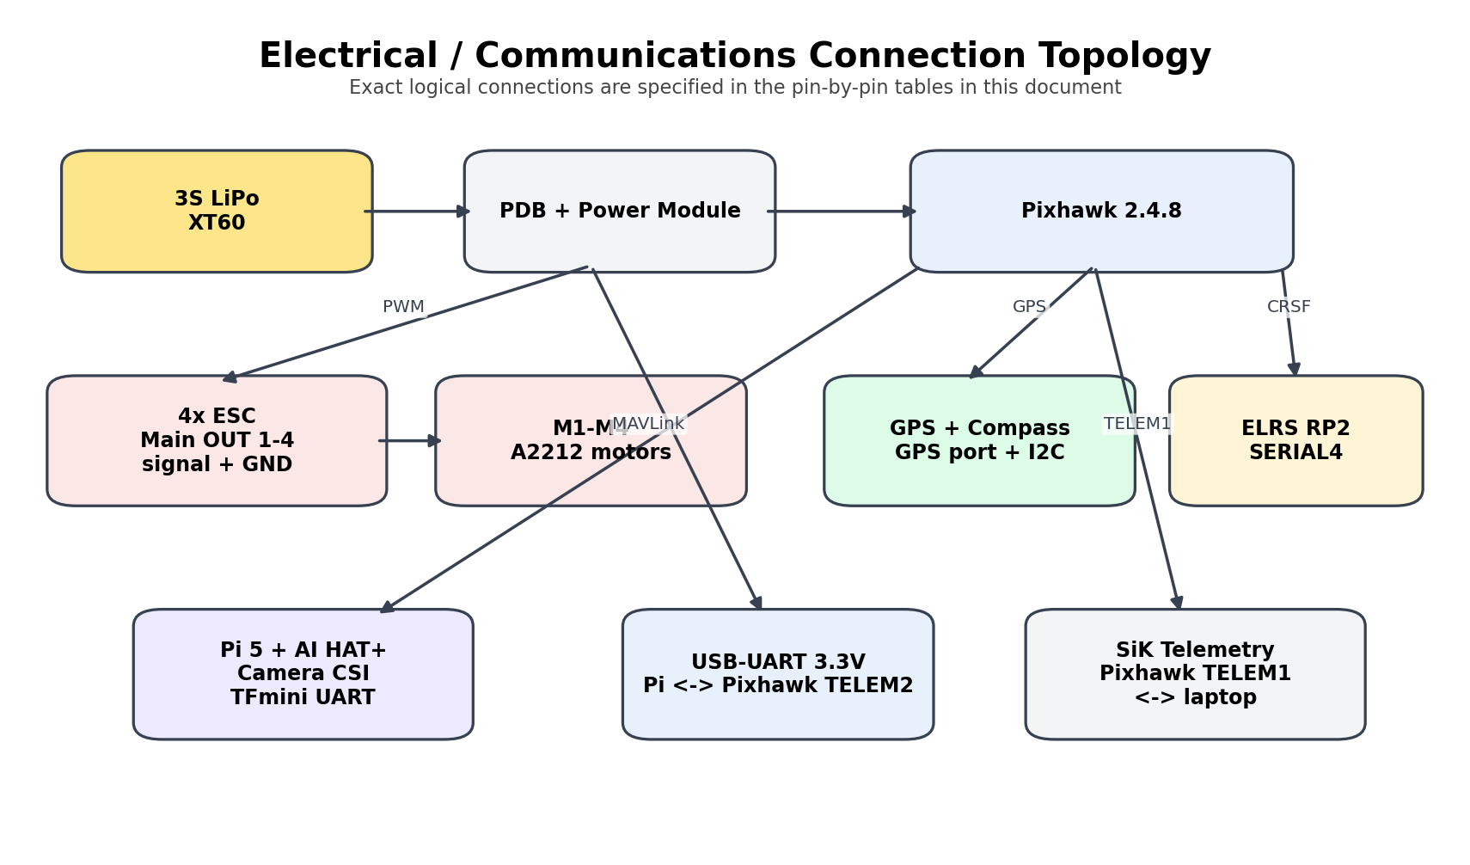
Figure 9. Connection topology.

12. Software Repository and Runtime Structure
aeris/
firmware/
ardupilot/
parameters/
prototype.param
companion/
vision/
capture.py
preprocess.py
infer.py
tracker.py
sensors/
tfmini.py
telemetry.py
geo/
camera_model.py
projection.py
mission/
state_machine.py
coverage.py
response.py
events/
event_manager.py
priority.py
schemas.py
comms/
mavlink.py
websocket.py
video.py
logging/
db.py
jsonl.py
health/
watchdog.py
main.py
dashboard/
app.py
static/
templates/
models/
yolo11n_aeris_hailo/
model.hef
metadata.yaml
classes.txt
configs/
mission.yaml
ai.yaml
sensor.yaml
network.yaml
sim/
sitl/
gazebo/
scenarios/
tests/
unit/
integration/
hardware/
cad/
frame_mounts/
payload/
docs/
pinmap.csv
test_reports/

12.1 Processes and threads
Runtime component | Suggested cadence / trigger | Inputs | Outputs
Camera capture process | 15-20 FPS | Camera | Latest-frame ring buffer
Hailo inference process | As fast as validated | Frames | Detections
Telemetry task | 5-10 Hz | MAVLink | Vehicle state cache
TFmini task | Sensor rate / >=20 Hz sampled | UART range | Filtered distance
Mission manager | 10 Hz | State + telemetry + obstacle + operator | Allowed flight commands
Event manager | On detection/track update | Detections + telemetry + pose | Incident records
GCS server | WebSocket event driven | Telemetry/events/video | Dashboard state
Logger | Buffered asynchronous | All important messages | SQLite + JSONL
Watchdog | 1 Hz | Process/heartbeat/temperature | Restart/escalation

Use multiprocessing for camera/inference separation if needed; the Hailo pipeline can do the heavy neural work outside the Python CPU path. The objective is to keep the mission manager responsive even when an inference frame takes longer than expected.

13. Mission State Machine and Decision Logic
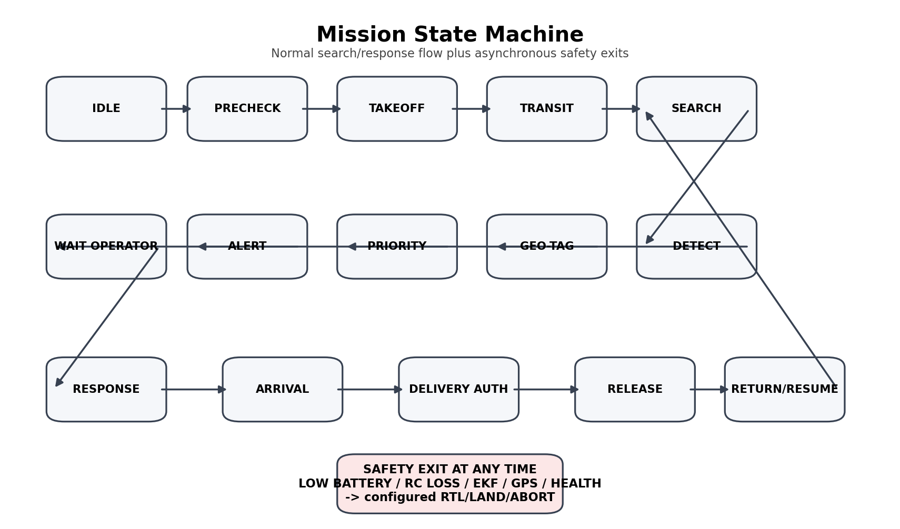
Figure 5. Final mission state machine.
State | Entry condition | Behavior
IDLE | No mission | Wait for operator mission and valid telemetry.
PRECHECK | Mission accepted | Battery, GPS, EKF, RC, compass, camera, TFmini and payload status checks.
TAKEOFF | Armed + authorized | Perform controlled takeoff to configured altitude.
TRANSIT | En route | Fly to search start / response waypoint.
SEARCH | Coverage route | Execute lawnmower waypoints; process perception.
DETECT_CONFIRM | Track detected | Apply 3-of-5 confirmation and confidence rules.
GEO_TAG | Confirmed incident | Calculate approximate target coordinate and error/status.
PRIORITIZE | Incident record | Compute rule-based priority score.
ALERT | Operator review | Send event to dashboard and log.
WAIT_OPERATOR | Verified/unverified | Ignore, mark, or authorize response.
RESPONSE | Authorized response | Fly to target under mission constraints.
ARRIVAL | At target | Check position, altitude, obstacle and safety state.
DELIVERY_AUTH | Release gate | Require explicit operator release and valid payload state.
RELEASE | Actuate | Command Pixhawk gripper; verify servo/release feedback if available.
RETURN/RESUME | After response | Return home or resume search from a known mission context.
ABORT | Any critical failure | Do not release; execute configured safety action.

13.1 Response authorization interlocks
• Operator authorization must be explicit, not inferred from a detection confidence score.
• Current vehicle mode must be one of the permitted response modes.
• Battery must be above the response reserve threshold and the return path must remain feasible.
• GPS/EKF health must pass the configured threshold.
• TFmini must not be in the obstacle HOLD state.
• Payload must be mechanically latched and servo position known.
• Only the mission manager may request the release command; random dashboard clicks must not directly pulse the servo.

13.2 Failsafe precedence
CRITICAL VEHICLE SAFETY > RC OVERRIDE > FLIGHT CONTROLLER FAILSAFE > MISSION ABORT > AI DECISION
The exact ArduPilot failsafe behavior is configured on the flight controller. The Pi can request RTL or abort, but it should not attempt to override a stronger flight-controller failsafe.

14. Full Implementation Roadmap
Phase | Work package | Primary work | Exit criterion
P0 | Document and procurement freeze | Complete master spec, part numbers, parameter template, software version manifest and pin map. | Signed configuration baseline.
P1 | Bench power | Verify battery, PDB, power module, Pi buck, servo BEC and all rails. | Measured voltage/current table.
P2 | Frame/propulsion | Assemble frame, mount motors, ESCs, wiring, corrected Quad-X labels. | Dry motor test passed.
P3 | Pixhawk manual flight | Install ArduPilot, calibrate, configure modes/failsafes, perform no-payload manual flight. | Stable manual/assist flight.
P4 | Pi + AI HAT | Install Pi OS, HAT, cooler, camera, Hailo runtime and test image inference. | Stable bench inference.
P5 | MAVLink | Connect Pi via USB-UART; read telemetry and send safe non-flight commands. | Live telemetry cache.
P6 | Ground station | SiK link, Mission Planner, local Wi-Fi dashboard and video. | Operator view working.
P7 | AI event layer | Custom model, tracking, de-duplication, event schema and logs. | Repeatable event generation.
P8 | Geo-tag | Calibrate camera/pose transform and test surveyed targets. | Measured target error report.
P9 | Coverage planner | Generate and upload lawnmower mission from polygon. | Search mission repeatability.
P10 | Obstacle | TFmini filter, warning, hold, fault behavior. | Controlled obstacle test passed.
P11 | Payload bench | Servo + latch, AUX1, human authorization state machine. | Bench release passed.
P12 | Integrated flight | AI + telemetry + search + event + obstacle + RTH in controlled flights. | Mission acceptance tests passed.
P13 | Digital twin | Gazebo + SITL + replay + same event schema. | Repeatable simulation scenarios.
P14 | Hardening | Spare parts, boot scripts, log extraction, rehearsals, documentation. | Demo-ready release.

14.1 Strict build order
POWER -> PROPULSION -> FLIGHT -> COMPANION -> AI -> MAVLink -> GCS -> EVENTS -> GEO -> SEARCH
-> OBSTACLE -> PAYLOAD -> INTEGRATED MISSION -> DIGITAL TWIN -> DEMO HARDENING
DO NOT REVERSE SAFETY ORDER: Do not attach the payload or begin autonomous search flights before stable manual flight, GPS, RTH and battery failsafe tests are complete.

15. Hardware Build Procedure

15.1 Step-by-step mechanical assembly
1. Inspect the F450 frame plates, arms, screws and landing legs. Confirm no cracked carbon/plastic or stripped threads.
2. Mount the four motors at the four arm ends. Mark the physical positions permanently as M1 front-right, M2 rear-left, M3 front-left, M4 rear-right.
3. Mount the ESCs close enough to the motors to keep phase wires short but far enough from the Pixhawk compass area. Secure them against vibration and chafing.
4. Mount the PDB centrally and keep the high-current battery wiring short and mechanically supported.
5. Mount Pixhawk on vibration isolation near the center of gravity. Align the arrow/orientation exactly with the frame forward direction selected in software.
6. Mount the GPS/compass on a raised mast with clear sky view and physical separation from the battery/PDB/ESC wiring.
7. Mount the Raspberry Pi + AI HAT+ on a protected plate with cooling airflow; keep the camera ribbon cable radius gentle and protected.
8. Mount the Camera Module 3 on a rigid repeatable bracket near-nadir or at the selected fixed tilt. Record the physical pitch/roll/yaw offset.
9. Mount TFmini Plus parallel to the intended forward body direction. Ensure the propeller disc does not occlude its beam.
10. Mount the ELRS receiver antenna in a safe location away from high-current wires and carbon shadowing as far as practical.
11. Mount SiK telemetry air radio and route its antenna according to the radio manufacturer guidance.
12. Mount the payload latch low and centrally enough that it does not shift the center of gravity beyond the flight-test envelope.
13. Secure all battery straps, electronics fasteners and cable paths. Add strain relief to every cable crossing a moving/vibrating section.

15.2 Electrical bench sequence
1. With no battery connected, use a multimeter to confirm no short between battery positive and ground.
2. Connect the charger to the battery only according to the battery/charger manual and verify cell count and balance charging.
3. Connect the battery to the PDB through the XT60 and verify the PDB output voltage before connecting sensitive electronics.
4. Connect the power module to Pixhawk and confirm the Pixhawk powers without the motors enabled.
5. Configure and measure the dedicated Pi buck output at 5.1V under no-load and dummy-load conditions. Do not exceed the Pi input limit.
6. Configure and measure the servo BEC at 5V under a dummy load before attaching the servo.
7. Power the Pi and verify stable boot, AI HAT detection and camera detection.
8. Power the Pixhawk and verify GPS lock, compass status and pre-arm health flags.
9. Only after the above pass should the ESC signal wires be connected for motor dry testing.

15.3 Motor dry-test procedure
1. Remove all propellers.
2. Connect each ESC signal and signal ground to its assigned Pixhawk output.
3. Run motor test from Mission Planner at the minimum level needed to identify each motor.
4. Confirm M1/M2/M3/M4 physical positions match the corrected diagram.
5. Confirm each motor rotates in the required direction.
6. If an individual brushless motor direction is wrong, correct it at the ESC phase wiring or approved ESC direction setting, then repeat the test.
7. Perform an arming/failsafe test with no props and an emergency disarm action.

15.4 First flight procedure
1. Fly only in the approved controlled test area and only under the event/site safety rules that govern the prototype.
2. Use a manual/assisted mode first. Do not start with an autonomous mission.
3. Confirm stable hover, yaw control, pitch/roll response, GPS position hold and landing.
4. Test RTL at a low-risk condition while maintaining pilot readiness.
5. Log the flight and inspect EKF/GPS/battery data before the next flight.
6. Repeat until the flight controller baseline is stable. Only then add the Pi AI stack to the integrated flight.

16. Software Build and Integration Procedure

16.1 Pi OS and AI HAT setup
1. Install a current 64-bit Raspberry Pi OS release validated for Pi 5 AI workflows and record the exact release/build identifier.
2. Install system updates, then install the Raspberry Pi AI HAT software packages appropriate to the Hailo-8L device.
3. Confirm the accelerator is detected with the Hailo command-line identification tool.
4. Connect Camera Module 3 before completing the HAT installation sequence, following the current Raspberry Pi hardware order.
5. Install Picamera2/rpicam, OpenCV and the Python environment.
6. Run a camera-only preview and capture test before running AI.
7. Run a simple Hailo-compatible object-detection sample before loading the custom model.

16.2 Model training and export
1. Create the class taxonomy: person, vehicle, debris.
2. Collect license-compatible images and annotate bounding boxes.
3. Split the dataset into train/validation/test at the scene level.
4. Train YOLO11n on the development computer.
5. Evaluate precision, recall, mAP50 and mAP50-95 and inspect failure examples.
6. Export to Hailo using the Hailo target matching Hailo-8L and a fixed 640x640 input shape.
7. Use a representative calibration dataset and record the DFC/compiler version.
8. Copy the complete HEF export directory including metadata to the Pi.
9. Benchmark inference latency/FPS and thermal behavior before flight.

16.3 MAVLink integration
1. Connect Pixhawk TELEM2 to the 3.3V USB-UART adapter, then the adapter to the Pi.
2. Open the serial device with pymavlink and wait for heartbeat.
3. Request a minimal telemetry set and build a local vehicle-state cache.
4. Add command wrappers for GUIDED/mission interactions but keep a strict allow-list of commands.
5. Implement link-loss detection and a watchdog that stops sending commands if MAVLink becomes stale.
6. Test command handling in SITL before using the physical aircraft.

16.4 Event manager
1. Normalize detector output to a common bounding-box schema.
2. Pass candidate detections into ByteTrack.
3. Confirm tracks using the 3-of-5 rule.
4. Run the geo-tag calculation against the latest synchronized pose.
5. Calculate priority score and assign the incident ID.
6. Write to SQLite/JSONL and publish to the dashboard.
7. Apply duplicate suppression by time and spatial cell.
8. Expose the event to the mission manager without directly releasing the payload.

16.5 Dashboard
The dashboard should be local-first. Use FastAPI for the local API, WebSocket for event/telemetry pushes, Leaflet/OpenStreetMap for mapping, and a simple MJPEG or RTP/WebRTC video path selected during integration. The dashboard is not the flight controller; it is an operator interface and an authorization source.

17. Integration, Calibration and Validation Gates
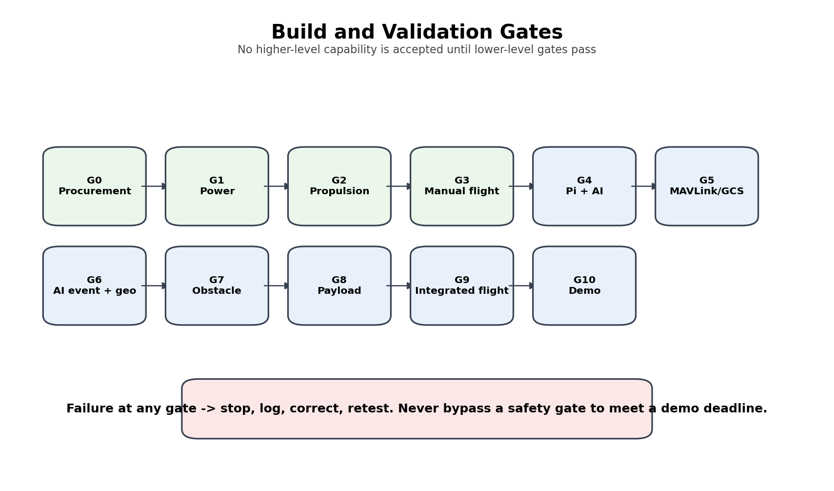
Figure 10. Ordered validation gates.
Gate | Area | Pass criterion
V1 | Power | All rails measured at nominal and loaded conditions; no polarity error.
V2 | Motor mapping | All motors on correct outputs and rotations; no propellers during dry test.
V3 | Manual flight | Stable hover, control response, GPS, landing and logs.
V4 | Failsafe | RC loss, battery low/critical, GCS/telemetry loss and GPS/EKF safety behavior tested.
V5 | AI bench | Camera, Hailo and model inference are stable for >=30 minutes without thermal failure.
V6 | MAVLink | Heartbeat, telemetry and allowed command path reliable in SITL and bench test.
V7 | Geo-tag | Surveyed target coordinates produce measured error within the chosen acceptance band.
V8 | Search | Generated lawnmower route stays inside the polygon and returns to home as configured.
V9 | Obstacle | TFmini detects controlled test obstacles and produces warning/hold behavior.
V10 | Payload | Servo release passes bench tests; flight payload allowed only after thrust margin.
V11 | Integrated mission | Search -> detection -> alert -> response -> return/resume passes without safety faults.
V12 | Demo repeatability | At least three representative end-to-end runs are logged with no critical regression.

17.1 ArduPilot battery failsafe baseline
ArduPilot documents a two-layer battery failsafe. The default low-voltage threshold is 10.5V, a 20% capacity threshold is a common starting point, and a reasonable action pair is low battery -> RTL and critical -> Land [W11]. For this prototype, use an initial parameter set such as: low 10.8V / 1040mAh -> RTL; critical 10.5V / 520mAh -> Land, then retune from measured battery sag and the exact cell chemistry. The parameter ordering must always satisfy low > critical [W12].
Parameter | Prototype initial value | Action / note
BATT_LOW_VOLT | 10.8 V | Initial low-battery test threshold; validate sag.
BATT_LOW_MAH | 1040 mAh | 20% of 5200mAh planning capacity.
BATT_FS_LOW_ACT | 2 = RTL | Low battery returns to home.
BATT_CRT_VOLT | 10.5 V | Critical low-voltage test threshold.
BATT_CRT_MAH | 520 mAh | 10% of planning capacity.
BATT_FS_CRT_ACT | 1 = Land | Critical battery forces landing.
BATT_FS_VOLTSRC | 1 = sag compensated, if supported/validated | Avoid nuisance triggers from load sag; verify in actual firmware.

PARAMETER RULE: These are initial test values, not a substitute for the battery manufacturer safe operating limits or the actual measured voltage-sag profile.

17.2 Geofence
Use an inclusion geofence for the controlled demonstration and configure the fence action to a safe response such as RTL, subject to the flight site. The exact radius and altitude are site-specific; a 50m-radius, 30m-height example is a test parameter, not a statement of regulatory permission [W13].

18. End-to-End Working of the Built Prototype
This section describes what a successfully built AERIS does from power-on to mission completion. It is the operational story that should be used for demonstrations and for writing test scripts.
1. Battery is connected. The power module reports voltage/current to Pixhawk while the PDB feeds the propulsion branch and the dedicated regulators feed Pi and servo rails.
2. Pixhawk boots ArduPilot and runs pre-arm checks. The Pi boots Raspberry Pi OS, starts the watchdog, connects the camera, detects the Hailo NPU, initializes TFmini and opens the MAVLink connection.
3. The pilot confirms the aircraft has GPS/EKF/RC/battery health and arms using the normal ArduPilot procedure.
4. The operator selects a polygon search area or target coordinate on the ground station/dashboard.
5. The mission manager validates the route, battery reserve, geofence and vehicle state. If checks fail, the mission remains in PRECHECK.
6. Pixhawk performs the takeoff and follows the first waypoint. The Pi only supervises the mission context and reads telemetry.
7. During SEARCH, the Camera Module 3 streams frames. The Hailo-8L runs the compiled YOLO11n detector on a 640x640 representation.
8. Detections are associated into tracks with ByteTrack. A candidate becomes an event only after the temporal confirmation rule is met.
9. The event manager synchronizes the detection timestamp with the nearest valid vehicle telemetry sample and projects the detected image point onto the ground plane using the calibrated camera model and aircraft pose.
10. The incident is assigned confidence, track persistence, class severity and mission-context priority. It is written to SQLite/JSONL and sent to the ground dashboard.
11. The operator reviews the event. The drone can continue its search, or the operator can authorize a response mission to the incident coordinate.
12. During RESPONSE the Pixhawk controls flight. The Pi watches the mission state, battery reserve, obstacle state and telemetry freshness.
13. If TFmini detects an obstacle inside the stop band, the mission manager requests a pause/hold and the operator can decide whether to continue, reroute or abort.
14. At the target, the aircraft reaches a configured response state. Payload release is not automatic. The operator explicitly authorizes release after all interlocks pass.
15. The Pi sends the release command through MAVLink. Pixhawk actuates AUX1/Servo9 through the gripper function and the servo releases the small demonstration package.
16. After the response action, the mission manager requests RETURN or RESUME. Pixhawk continues to own the actual flight control.
17. At any time, critical battery, RC loss, geofence, GPS/EKF or other failsafes can override the mission. The buzzer/LED state provides local indication.
18. At mission completion, the system lands/returns according to the configured plan, flushes logs, stores the AI event list and preserves the flight log for post-flight analysis.

19. Digital Twin / SITL Implementation
The digital twin is not the physical F450 in disguise. It is a separate 5-kg-class hexacopter simulation target used to test mission software, route generation, event handling and response workflow before or alongside physical flights. The architecture intentionally keeps the perception and mission-manager interfaces the same while changing the simulated vehicle and dynamics model [D2][D5].
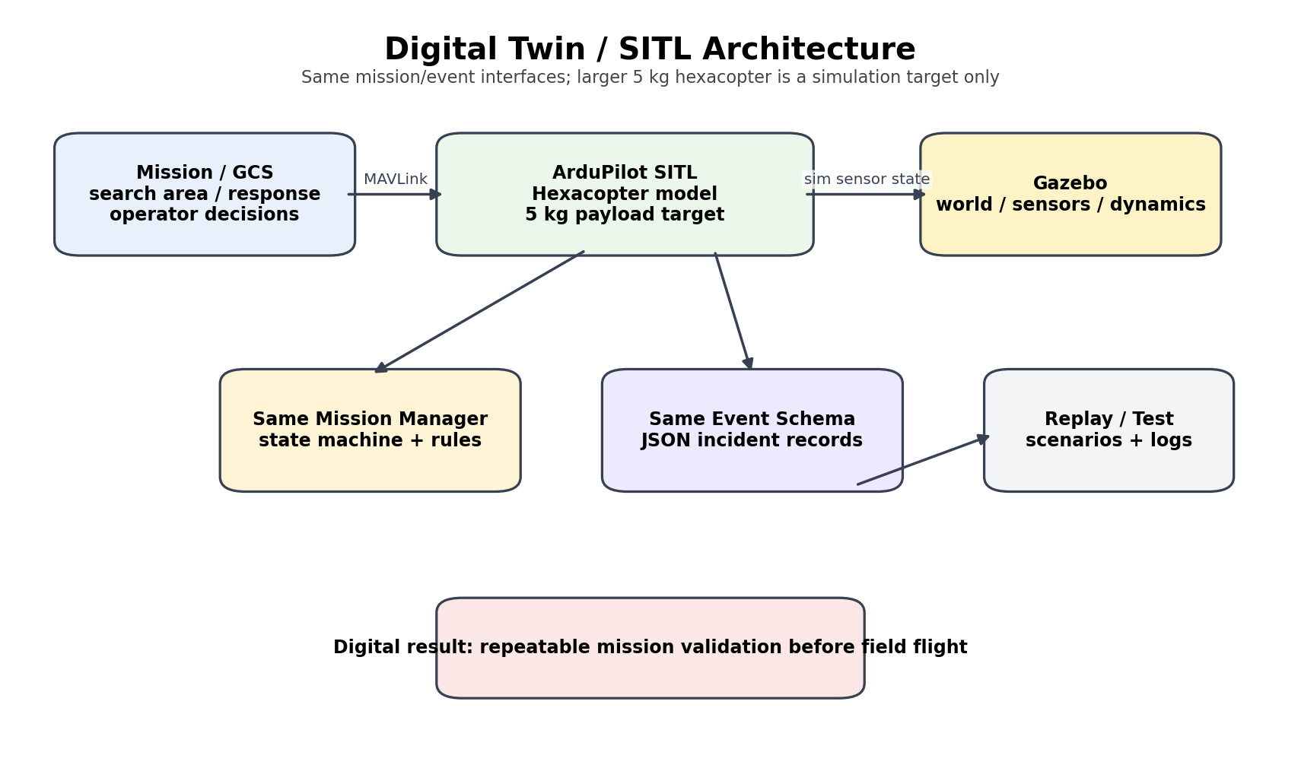
Figure 8. Digital-twin architecture.

19.1 SITL components
• ArduPilot SITL for the simulated flight controller.
• Gazebo world for vehicle, terrain and sensor simulation.
• MAVLink bridge for mission manager interaction.
• Simulated camera or recorded-video injector to exercise the detection pipeline.
• Simulated range sensor messages for obstacle tests.
• The same JSON incident schema used by physical flights.
• Replay scripts that feed known sequences of detections and telemetry to the state machine.

19.2 Simulation test scenarios
Scenario | Purpose | Pass condition
S01 normal search | Verify route execution | Coverage polygon completed.
S02 person detection | Verify event creation | One incident after confirmation; no duplicates.
S03 low-confidence detection | Verify human review | No autonomous response.
S04 obstacle | Verify pause/hold | Mission pauses and logs reason.
S05 battery low | Verify failsafe response | RTL/LAND state according to configured action.
S06 response | Verify target mission | Target waypoint reached and release gate shown.
S07 return/resume | Verify mission continuity | Search resumes from known context.
S08 communications loss | Verify safety | Flight controller owns configured failsafe.

20. Test Cases, Metrics, Logging and Acceptance

20.1 Hardware test matrix
ID | Test | Condition | Where | Pass
HW-001 | Power polarity | No-load | Bench | No short; correct 5.1V/5V rails
HW-002 | Pi rail load | Load at 25%/50%/100% test | Bench | Stable voltage; no brownout
HW-003 | Motor mapping | Props removed | Bench | M1-M4 correct position/direction
HW-004 | ESC thermal | 5-minute staged run | Bench | No excessive heating or desync
HW-005 | GPS/compass | Open sky | Bench | Healthy fix and compass status
HW-006 | ELRS | Range/override test per site | Ground | Manual override reliable
HW-007 | SiK | Bench/field link | Ground | Telemetry stable
HW-008 | TFmini | Known distances | Ground | Range within expected tolerance
HW-009 | Payload | Bench | Bench | Latch release reliable
HW-010 | Flight | Controlled flight | Field | Stable hover and RTL

20.2 Software metrics
Metric | How measured | Target / interpretation
Inference latency | Timestamp frame before/after Hailo inference | Record p50/p95; low enough for search-speed choice.
Inference FPS | Processed frames / second | 15-20 FPS target if achievable on release model.
Detection precision/recall | Held-out test set | Report actual measured values; no fixed claim before training.
Event false-alert rate | Controlled search runs | Minimize repeated/incorrect incidents; report count per run.
Geo error | Surveyed targets | Report median and 95th percentile in meters.
Mission route error | Compare commanded vs actual | No waypoint outside configured tolerance except safety diversion.
Telemetry freshness | Heartbeat/state timestamps | Trigger stale-state handling when timeout exceeded.
Pi temperature | CPU/thermal data | No thermal throttling during 30-minute bench AI soak.
Log completeness | Compare expected vs logged events | Every flight gets flight log + incident log + software release ID.

20.3 Event schema
{
"mission_id": "M-2026-001",
"event_id": "INC-0001",
"timestamp_utc": "...",
"class": "person",
"confidence": 0.87,
"track_id": 12,
"drone_lat": 0.0,
"drone_lon": 0.0,
"target_lat": 0.0,
"target_lon": 0.0,
"altitude_m": 8.0,
"priority": "HIGH",
"geo_quality": "APPROXIMATE",
"flight_mode": "AUTO",
"operator_status": "UNVERIFIED"
}

20.4 Logging rules
• Use UTC timestamps for all event records; convert only at the UI.
• Keep the Pixhawk flight log and companion logs as separate source-of-truth artifacts but include a common mission_id.
• Flush the incident log after every confirmed event and again at mission completion.
• Log sensor health changes, not just successful samples.
• Never overwrite a previous flight log; use immutable mission IDs.
• Log exact software/config/model release identifiers in the mission header.

21. Calculations and Engineering Checks

21.1 Weight budget template
Mass item | Planning mass | Measured mass required
F450 frame + landing gear | 300 g placeholder | Weigh actual
4x motors | 200-240 g class placeholder | Weigh actual
4x ESCs | 100-140 g class placeholder | Weigh actual
Propellers | 20-30 g | Weigh actual
Pixhawk + GPS + wiring | 100-140 g | Weigh actual
Pi 5 + HAT + cooler + SD + wiring | 120-170 g | Weigh actual
Battery | 400-500 g depending on pack | Weigh actual
Camera + TFmini + mounts | 50-100 g | Weigh actual
Telemetry + ELRS | 20-40 g | Weigh actual
Payload mechanism | 30-60 g | Weigh actual
Reserve | 100 g | Keep margin

MASS GATE: Do not approve the payload using the placeholder mass table. The final all-up weight must be measured with the exact production wiring, camera mount, battery and payload installed.

21.2 Center of gravity check
CG_x = sum(m_i*x_i) / sum(m_i)
CG_y = sum(m_i*y_i) / sum(m_i)
CG_z = sum(m_i*z_i) / sum(m_i)
The target is a center of gravity near the frame center and near the propeller plane used in the flight-controller tuning configuration. The battery is the primary mass-balancing component and should be mounted so that small payload changes do not shift the CG excessively.

21.3 Flight-time measurement method
1. Charge battery to the correct full voltage according to the battery/charger manual.
2. Zero/reset flight log and record initial voltage/current/remaining capacity.
3. Fly a repeatable hover or mission profile at the selected test altitude.
4. Log average electrical power and motor throttle.
5. End the test at the configured low-battery failsafe threshold or earlier as required by the safety plan.
6. Calculate measured mission duration and energy used.
7. Repeat with payload and without payload to estimate the impact of the release mechanism.

21.4 Search-area timing examples
Search area | Altitude | Lane spacing | Approx straight-line distance | Approx straight-line time at 3m/s
30 x 30 m | 8 m | 8.3 m | ~120 m plus turns | ~40 s plus turns
50 x 50 m | 8 m | 8.3 m | ~350 m plus turns | ~117 s plus turns
50 x 50 m | 10 m | 10.4 m | ~260 m plus turns | ~87 s plus turns

The mission should always include takeoff, transit, turn, response and return reserve; therefore these sweep-only estimates are not the mission flight-time budget.

22. Failure Modes and Recovery Logic
ID | Failure | Detection | Action | System consequence
F-01 | Battery low | Voltage/capacity threshold | RTL | Do not release; log event
F-02 | Battery critical | Critical threshold | LAND | Abort all AI response actions
F-03 | RC loss | ArduPilot RC failsafe | Configured RTL/LAND | Pilot link health is independent
F-04 | GCS/SiK loss | Telemetry heartbeat timeout | Flight controller continues | No payload release
F-05 | Pi crash | Watchdog/heartbeat missing | Pixhawk continues | AI unavailable; mission abort/return according to policy
F-06 | Hailo failure | No inference heartbeat | Mission can continue only as configured | No false “AI healthy” status
F-07 | Camera disconnected | Capture health failure | Event pipeline disabled | Flight remains controlled
F-08 | TFmini invalid | Range invalid/stale | Conservative HOLD when needed | Operator can inspect
F-09 | GPS/EKF unhealthy | Pre-arm/flight health | No autonomous response | Use pilot-controlled safety
F-10 | Wrong motor direction | Dry test mismatch | Do not arm for flight | Correct wiring first
F-11 | Servo jam | Release command no expected state | Abort release / return | Never repeat release blindly
F-12 | Duplicate AI alerts | Track/dedup failure | Suppress event storm | Reprocess logs
F-13 | Geo-tag invalid | Ray/pose geometry invalid | Fallback to aircraft position labeled approximate | No high-confidence target navigation based on invalid geometry
F-14 | Wi-Fi video loss | Video heartbeat timeout | Continue telemetry/flight | Operator relies on GCS/SiK or aborts
F-15 | Thermal throttle | Pi temperature threshold | Reduce AI load / abort mission | Land/return if required

23. Deployment and Demonstration Procedure

23.1 Pre-demo checklist
• Battery charged and physically inspected; no swelling or damage.
• Propellers correct, undamaged and installed in the documented rotation pattern.
• Pixhawk firmware/version/parameters match the release manifest.
• GPS lock and EKF state healthy.
• ELRS transmitter/receiver link healthy and manual override tested.
• SiK telemetry healthy.
• Pi boot complete; AI HAT detected; camera detected; TFmini detected.
• AI model hash matches the release artifact.
• Mission polygon validated inside geofence.
• Battery reserve sufficient for search + return + contingency.
• Payload empty/secured until the payload gate is explicitly passed.
• Operator and spotter roles assigned.

23.2 Recommended demo sequence
1. Show the architecture and explain the safety split: Pixhawk flies; Pi interprets.
2. Show the live ground station with telemetry and local video.
3. Arm and perform a short manual/assisted takeoff and hover.
4. Execute a small autonomous search polygon.
5. Allow the detector to generate a person/vehicle/debris event in a controlled scenario.
6. Show the event on the map with confidence, timestamp and approximate coordinates.
7. Demonstrate the operator verification step.
8. If payload has passed flight validation, demonstrate a small release; otherwise show the gripper on the bench and keep the flight mission non-payload.
9. Complete RTL and show the post-flight event/flight logs.

24. Known Limits and Remaining Measured Quantities
The architecture is frozen, but some quantities cannot honestly be made exact in a document before the real hardware is assembled. These are not missing architecture; they are empirical quantities that must be measured.
Quantity | Why it remains empirical
Exact all-up mass | Depends on purchased board, wiring, mounts, battery lot and payload latch.
Actual motor thrust | Depends on exact motor/prop/battery combination and motor condition.
Actual hover power | Depends on mass, prop balance, battery voltage and flight tune.
Actual flight time | Must be measured under the selected mission profile.
Actual AI precision/recall | Depends on the trained dataset/model and deployment conditions.
Actual Hailo FPS/latency | Depends on exact HEF, runtime and pipeline configuration.
Actual geo-tag error | Depends on camera calibration, GNSS environment, attitude and ground-plane assumptions.
Actual obstacle stopping distance | Depends on airspeed, inertia, controller response and surface conditions.
Actual radio range | Depends on legal transmit power, antennas, RF environment and site.
Exact Pixhawk connector pinout | Must be verified on the purchased board/clone revision.

ENGINEERING STATUS: These are the correct remaining unknowns. The system does not need a different architecture to resolve them; it needs measurements and calibration runs.

25. Final Validation and Summary

25.1 Final engineering validation
Area | Status | Comment
Concept | PASS | Clear disaster-response mission and societal application.
Physical architecture | PASS WITH GATES | F450 + Pixhawk + Pi + Hailo + camera + TFmini is coherent; build must pass thrust/power tests.
Power architecture | FIXED | Dedicated 5.1V >=5A Pi rail and dedicated servo BEC added.
Motor mapping | FIXED | Standard Quad-X map explicitly frozen.
Communication | FIXED | SiK for MAVLink, Wi-Fi for video/events, ELRS for manual override.
AI pipeline | FIXED | YOLO11n + Hailo-8L + ByteTrack + event manager.
Geo-tagging | FIXED | Ground-plane projection with approximate fallback.
Obstacle behavior | FIXED | Forward sensing; warning/hold first; no 360-degree claim.
Mission logic | FIXED | Explicit state machine and fail-safe precedence.
Payload | FIXED WITH VALIDATION GATE | Human-authorized only; small payload only after measured flight margin.
Digital twin | PASS | Gazebo + ArduPilot SITL with shared mission/event interfaces.
Documentation | PASS FOR BUILD START | Exact pin map, BOM, software stack, procedures and test gates are defined here. Board-specific pin verification remains mandatory.

25.2 The complete prototype in one statement
When built to this specification, AERIS will be a small F450 autonomous quadcopter that can be assigned a controlled search area or target coordinate, autonomously navigate under ArduPilot, capture live camera data, perform edge object detection on the Raspberry Pi AI HAT+ using a custom YOLO11n model, track and confirm detections, associate them with an approximate target location using GPS/pose/camera geometry, classify them by transparent rules, alert a ground operator, use forward TFmini sensing for conservative obstacle-aware behavior, accept human-supervised response commands, optionally release a small validated demonstration payload through an ArduPilot gripper output, and return or resume the mission while maintaining independent manual override and flight-controller failsafes.

25.3 What is already complete in this document
• Idea, mission, applications, use cases and capability boundary.
• Final hardware BOM, quantities, technical roles and planning prices.
• Power topology, thrust/energy calculations and weight/thrust checks.
• Full software stack, AI model choice, data strategy, mathematical methods and algorithms.
• End-to-end hardware/software architecture and ownership boundaries.
• Electrical interface plan, pin-by-pin connection tables and data-flow diagrams.
• Full implementation order for hardware and software, including small runtime processes.
• Operational explanation of the fully built prototype.
• Digital-twin/SITL design, test cases, metrics, FMEA and demo procedure.
• Known empirical quantities and the exact remaining measurements needed before final claims.

25.4 Remaining checklist before procurement is irreversible
• Confirm exact Pixhawk board manufacturer/revision and compare its connector pinout with this specification.
• Confirm the selected RP2/ELRS receiver firmware and CRSF wiring.
• Confirm the selected SiK telemetry band is legal/appropriate for the deployment location and event.
• Confirm the exact buck converter and servo BEC models meet the current/thermal specifications.
• Confirm the exact battery model and its safe current/charging limits.
• Finalize the CAD mounts and verify center of gravity with the real parts.
• Create the final parameter file from the exact ArduPilot firmware release and perform a pre-arm audit.
• Create the actual trained YOLO11n model and Hailo HEF; update the release manifest with hashes.
• Run the hardware acceptance gates before attempting the integrated mission.
FINAL STATUS: The architecture is ready to build. The remaining items are component-lot verification, configuration freeze and measurement gates - not a redesign of the system.

26. Technical References
The following references were used for the refinement layer. The supplied AERIS documents remain the primary source for the project concept, prototype scope and original component intent; official vendor/flight-controller documentation was used to resolve interfaces and current capabilities.
Ref | Source | Location
[D1] | AERIS - AI-Powered Autonomous Disaster-Response UAV | Concept & Prototype Document | Supplied project document, 7 pages.
[D2] | AERIS / GUJCOST Technical Details for Hackathon | Supplied project document, hardware/software tables and assembly diagrams.
[D3] | AERIS GUJCOST Robofest Technical Application Final | Supplied project application, 8 pages.
[D4] | R620260083 All Details | Supplied Robofest application record.
[D5] | AI-Assisted Autonomous Disaster Response UAV - Final Hackathon Build Plan, Revision 1 | Supplied project document, 19 pages.
[W1] | Raspberry Pi Documentation - AI HATs | https://www.raspberrypi.com/documentation/accessories/ai-hat-plus.html
[W2] | Raspberry Pi - AI HAT+ product page | https://www.raspberrypi.com/products/ai-hat/
[W3] | Raspberry Pi - Camera Module 3 | https://www.raspberrypi.com/products/camera-module-3/
[W4] | Raspberry Pi - Getting Started / Power | https://www.raspberrypi.com/documentation/computers/getting-started.html
[W5] | Raspberry Pi Documentation - AI software | https://www.raspberrypi.com/documentation/computers/ai.html
[W6] | ArduPilot - Quad/Output mapping documentation | https://ardupilot.org/copter/docs/common-rcoutput-mapping.html
[W7] | ArduPilot - Servo Gripper | https://ardupilot.org/copter/docs/common-gripper-servo.html
[W8] | ArduPilot - Battery Failsafe | https://ardupilot.org/copter/docs/failsafe-battery.html
[W9] | ArduPilot - Pre-Arm Safety Checks | https://ardupilot.org/copter/docs/common-prearm-safety-checks.html
[W10] | Ultralytics - Hailo export | https://docs.ultralytics.com/integrations/hailo
[W11] | Benewake - TFmini Plus product/manual family | https://www.benewake.com/TFminiPlus/index.html
[R1] | Redmon et al., You Only Look Once: Unified, Real-Time Object Detection | https://arxiv.org/abs/1506.02640
[R2] | Zhang et al., ByteTrack: Multi-Object Tracking by Associating Every Detection Box | https://arxiv.org/abs/2110.06864
[R3] | Galceran and Carreras, A survey on coverage path planning for robotics | https://www.sciencedirect.com/science/article/pii/S092188901300167X
[R4] | Kumar and Kumar, Region coverage-aware path planning for unmanned aerial vehicles: A systematic review | https://www.sciencedirect.com/science/article/pii/S1874490723000769

REFERENCE USE: Technical specifications in this document are deliberately phrased as planning values, official vendor properties, or measured quantities to avoid converting a component datasheet into a guarantee about the final assembled aircraft.

Appendix A - Master Configuration Snapshot
Parameter | Frozen baseline
Frame | F450, Quad-X
Motor mapping | M1 FR CCW / M2 RL CCW / M3 FL CW / M4 RR CW
Motor | A2212 1000KV x4
ESC | 30A x4
Prop | 1045, 2 CW + 2 CCW
Battery | 3S 11.1V 5200mAh
Flight controller | Pixhawk 2.4.8 / FMUv2-class
Firmware | ArduCopter stable release, exact version frozen at build
GPS | M8N-class GPS + compass
Companion | Raspberry Pi 5 4GB
AI | AI HAT+ Hailo-8L 13 TOPS
Camera | Camera Module 3 Standard
Range | TFmini Plus
RC | RadioMaster Pocket ELRS + RP2
Telemetry | SiK pair
Pi power | 5.1V >=5A dedicated buck
Servo power | 5V 3A dedicated BEC
MAVLink Pi link | TELEM2 -> 3.3V USB-UART -> Pi
ELRS link | SERIAL4 CRSF
Telemetry link | TELEM1 MAVLink
Payload | AUX1/Servo9 gripper; human-authorized
AI classes | person / vehicle / debris
AI input | 640x640
AI confidence baseline | 0.35 candidate / 0.60 event
Tracking | ByteTrack
Event confirm | 3 of 5 frames
Event cooldown | 10 s + spatial suppression
Search altitude | 8-10m AGL nominal controlled demo; tune from detection tests
Search speed | 2.5-3.0 m/s baseline
Overlap | 20%
Obstacle warning | 8.0m
Obstacle hold | 6.5m initial
Obstacle critical | 5.5m initial/future refinement
Battery low | 10.8V / 1040mAh -> RTL initial test values
Battery critical | 10.5V / 520mAh -> Land initial test values
Geofence | Site-specific; example 50m radius / 30m height for controlled demo
Physical payload | Small demo only after thrust and flight validation
5kg payload | Digital-twin target only

Appendix B - Final Go/No-Go Checklist
Check | YES/NO | Verified by | Date
Exact Pixhawk board/revision verified
Power rails measured under load
Motor map and rotations verified
Props installed correctly
GPS/compass calibrated
RC override verified
SiK telemetry verified
Pi/Hailo/camera healthy
TFmini valid
YOLO HEF hash verified
MAVLink heartbeat stable
Mission route validated
Geo-tag calibration measured
Battery failsafe tested
Payload bench tested
Integrated mission repeated 3 times
Logs archived

END OF SPECIFICATION: This master document is the reference build baseline. Any later hardware, pin, model, parameter or mission-logic change should create a new revision rather than being silently changed in the workshop.

