Formatted Printing to the Console
Be able to answer the following questions:
- Explain the interface between printf.c and console.c. Specifically, what function does console.c export? How is this function used by printf.c?
- Explain the following from console.c:
1 if (crt_pos >= CRT_SIZE) {
2 int i;
3 memmove(crt_buf, crt_buf + CRT_COLS, (CRT_SIZE - CRT_COLS) * sizeof(uint16_t));
4 for (i = CRT_SIZE - CRT_COLS; i < CRT_SIZE; i++)
5 crt_buf[i] = 0x0700 | ' ';
6 crt_pos -= CRT_COLS;
7 }
- For the following questions you might wish to consult the notes for Lecture 2. These notes cover GCC's calling convention on the x86.
Trace the execution of the following code step-by-step:
int x = 1, y = 3, z = 4;
cprintf("x %d, y %x, z %d\n", x, y, z);
  - In the call to cprintf(), to what does fmt point? To what does ap point?

Fmt point to the string("x %d, y %x, z %d\n")
ap point to the second paramater(x) ‘s addres (which on the stack)

  - List (in order of execution) each call to cons_putc, va_arg, and vcprintf. For cons_putc, list its argument as well. For va_arg, list what ap points to before and after the call. For vcprintf list the values of its two arguments.
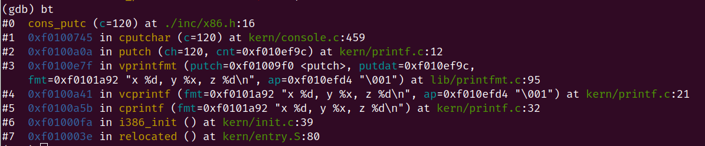
1
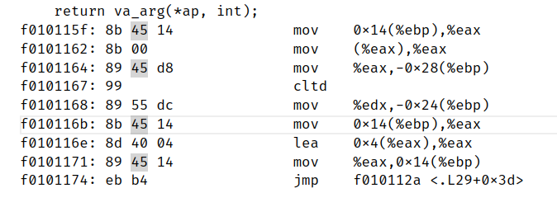
the va_arg return the value (which ap point to), and set ap += 4(to le ap point to the next argument on the stack)

- Run the following code.
unsigned int i = 0x00646c72;
cprintf("H%x Wo%s", 57616, &i);
What is the output? He110 World
Explain how this output is arrived at in the step-by-step manner of the previous exercise. Here's an ASCII table that maps bytes to characters.
The output depends on that fact that the x86 is little-endian. If the x86 were instead big-endian what would you set i to in order to yield the same output? Would you need to change 57616 to a different value?
Here's a description of little- and big-endian and a more whimsical description.
- In the following code, what is going to be printed after 'y='? (note: the answer is not a specific value.) Why does this happen?
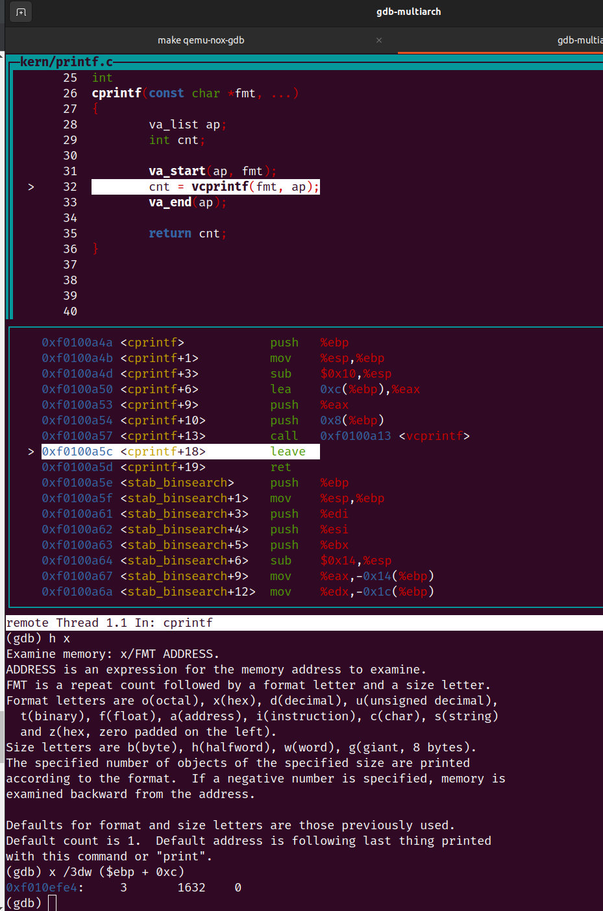
cprintf("x=%d y=%d", 3);
- Let's say that GCC changed its calling convention so that it pushed arguments on the stack in declaration order, so that the last argument is pushed last. How would you have to change cprintf or its interface so that it would still be possible to pass it a variable number of arguments?

Exercise 9. Determine where the kernel initializes its stack, and exactly where in memory its stack is located. How does the kernel reserve space for its stack? And at which "end" of this reserved area is the stack pointer initialized to point to?
The stack is located from 0xf0107000 - 0xf010f000

the kernel reserve space for its stack by declare a variable
use .space KSTKSIZE in entry.S
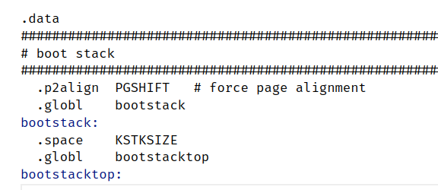

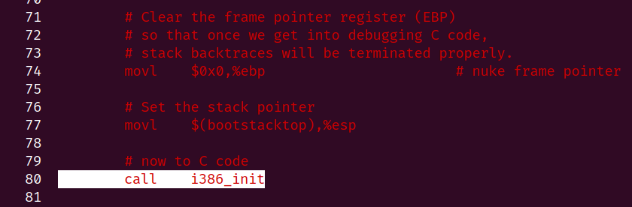
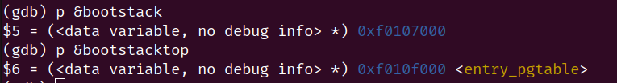
The stack pointer point to the high “end” of the reserved area.(bootstacktop)
Exercise 10. To become familiar with the C calling conventions on the x86, find the address of the test_backtrace function in obj/kern/kernel.asm, set a breakpoint there, and examine what happens each time it gets called after the kernel starts. How many 32-bit words does each recursive nesting level of test_backtrace push on the stack, and what are those words?
8 32-bit words each recursive nesting level of test_backtrace push on the stack
they are
1. return addr
2. caller’s ebp
3. esi
4. ebx
5. esi
6.
7.
8. arguments
