# Günther Wasser

**Head of information technology (ICT)**

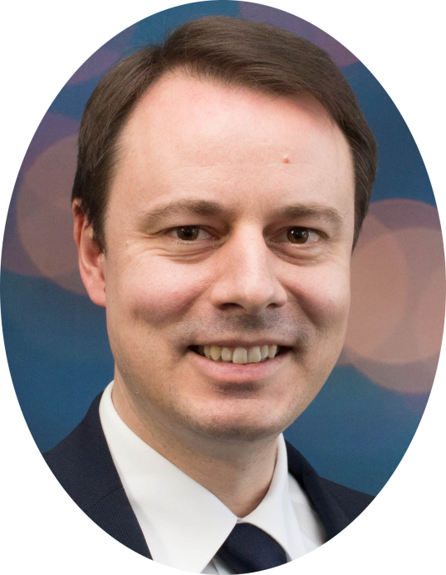

🏠

**Kornweg 7**

**5502 Hunzenschwil**

**Aargau / Schweiz**

✆ / 🖂

**Mobile: +41 (78) 692 72 06**

[**guenther.wasser@gmail.com**](mailto:guenther.wasser@gmail.com)

**Profile:**

* Performance-oriented, very experienced and professional ICT manager
* My strength: implementing complex IT projects within the given security requirements, costs and time limits
* 9 years technical management of 5 Swiss Casinos Group locations in the technical area and training of employees in various areas
* Characteristics: Understanding business requirements, developing optimal strategic architectures, realizing planning
* I love managing projects and leading teams through direct and balanced communication to very good results.
* My goal is to lead an ICT team directly and realize ambitious and forward-looking projects and information security concepts for the business.

**——— Work experience ————————————————————————**

|  |  |
| --- | --- |
| **10/2008  until  12/2017** | **Head of information technology (ICT)**  Swiss Casinos Service AG Zurich, Switzerland  Leading, extensions and support of the IT Infrastructure (160 Server, 200 Clients, 90 VLANs, 300 User) of the Swiss Casinos Group in 6 locations in Switzerland.  Coordination of the outsourcing-partners in the office and ERP areas  Heading annual operating budget of 1’500’000 CHF  Conception and project management of all IT-relevant group-wide activities as well as  Information security officer for the Swiss Casinos Group  **Selected IT-Projects:**   * Conceptual design, evaluation and implementation of hardware replacement of network, server & SAN for 5 casino locations, without interruption of business operations, by careful control of all preconfigured devices and scheduling of the entire exchange process. * Design, planning and coordination of the change of two outsourcing partners. * Develop, cleanup and merge 6 Active Directory domains into one central AD domain while maintaining reliability and simplifying administration. * Conceptual design and implementation of the operational and security concept for the newly opened Swiss Casino Zurich (2012) * Staff training on information security and password protection * Designing the migration and upgrade of the Citrix environment from 6.5 to 7.6, including testing the extension of functionalities such as ShareFile and mobile use. * Introduction of a ticket system for centralized administration and optimization of the internal IT support service for the Swiss Casinos Group * Elaboration and realization of a long-term archiving solution for database data including subsequent optimization of the database. * Conducting an internal audit of the outsourcing partner and the Swiss Casinos Group * Introduction of a contract management solution for the entire Swiss Casinos Group, including review and approval process |
| **08/2005  until  08/2008** | **ICT-Manager** (Member of the Executive Board)  Casinos Austria International Brussels, Belgium  Monitoring, maintenance and remote support of the online casino system: OCM Open Casino Manager from Bally Gaming Technologies.  Direction, design, expansion and maintenance of the complete casino information and communication landscape, including server environment, multimedia information and sound system, as well as the equipment in the conference and event rooms.   * Managed all technical matters up to the opening of the "Grand Casino Brussels" (now VIAGE), which opened in the time and the set IT budget of 1.5 million Euros. * Responsibility for an annual budget of 400,000 Euros |
| **06/2002  until  07/2005** | **Customer Support Engineer; Installer; Trainer**  IGT (GRIPS Electronics) Penang; Malaysia (06/2004 - 07/2005)  Installation and implementation of new casino projects in the Asian region, mainly Singapore and the Philippines.   * Preparation and execution of product presentations at casino fairs in Macau, Singapore and Sydney. * Execution of customer-oriented, specialized trainings on the installed system as well as the "go-live" support. All the casinos (responsible for 3 casinos) were opened on time with well-trained staff.   **Customer Support Engineer**  IGT (GRIPS Electronics) Graz; Austria 06/2002 - 06/2004   * Telephone or remote support of the Casino Management System "GALAXIS" including slot, table and cash desk. |
| **07/2001  until  06/2002** | **Language study abroad Australia** |
| **09/1996  until  06/2001** | **Construction engineer**  CIVIL ENGINEER G.K. SCHINDLER Graz, Austria   * Drawing of technical plans for residential and industrial buildings |

**——— Certificate ———————————————————————————**

1. **CISM** – Certified Information Security Manager by ISACA
2. **ITIL V2** – Information Technology Infrastructure Library Foundation
3. **NPP** – Nutanix Platform Professional V4.5
4. **Software Development Certification** from WIFI-Austria

**——— Training ———————————————————————————**

|  |  |
| --- | --- |
| 05/2017 | **Nutanix Certification Course** BCD-Sintrag AG, Zurich, Switzerland |
| 02/2014 | **MCP – Win7, Enterprise Desktop Support Technician** NewHorizon AG, Zurich, Switzerland |
| 2009 | **CISM Certification Course** ITACS, Zurich, Switzerland |
| 2006 | **ITIL – Foundation Course** Brussels, Belgium |
| 2001 | **English Language Course** Embassy CES, Cairns, Australia |
| 2000–2001 | **Software Development Training** Wirtschaftsförderungsinstitut, Graz, Austria |
| 1994–1995 | Telematics studies (not completed)  Technical University of Graz, Austria |
| 1989–1994 | **Training as civil engineer** College of Technology, Graz, Austria |

**——— Military service —————————————————————————**

|  |  |
| --- | --- |
| 1995–1996 | **Austrian Armed Forces – Pioneer** Honorary dismissal after completion of training as a troop leader |

**——— Civilian service activities ————————————————————**

|  |  |
| --- | --- |
| 1994–1995 | Member of the Board of Directors of the Youth Centre |
| 1992–1994 | Head of a Catholic Youth Group (Graz - Puntigam, Austria) |

**——— Interests & Hobbies ——————————————————————**

|  |  |
| --- | --- |
| * *Listen to Podcasts*   + TWIT Episodes [Technik News]     - Security Now [Security News]     - AAA [Android News]     - TWET [Enterprise News]     - WW [Windows News]     - TWIG [Google News]   + Manager Tools [Management]   + Robin Sharma Master Session [Management]   + Tim Ferries Show [Management] | * Aikido Trainer (Lenzburg) * Family activities * Reading & Audio Books   + Leadership & Management   + Fantasy & Science Fiction |

**——— Personal ————————————————————————————**

🏠 Kornweg 7, 5502 Hunzenschwil ✆ +41 (78) 692 72 06 🖂 [guenther.wasser@gmail.com](mailto:guenther.wasser@gmail.com)

 [www.linkedin.com/in/guenther-wasser](https://www.linkedin.com/in/guenther-wasser-0a75627/)  [www.xing.com/profile/Guenther_Wasser](http://www.xing.com/profile/Guenther_Wasser)

Born August 8th 1974 in Graz / Austria

Nationality: Austrian Marital status: Married

Mobility: Driving licence B

**——— Language und Skills ———————————————————————**

***——— Language ———***

**German**

mother tongue

Orally fluent

Writing fluent

**English**

Orally excellent

Writing excellent

***——— Leadership experience ———***

|  |  |  |
| --- | --- | --- |
| **Experience** | **Number of Years** | **Number of employees** |
| Project management | 13 | 4-8 |
| Group and team management | 13 | 4-8 |
| Head of department, division management | 12 | 4-8 |

**——— Technical skills —————————————————————————**

|  |  |
| --- | --- |
| * **E-Government Architecture:**   + ITIL Foundation Exam   + CISM Exam of ISACA * **Software:**   + GALAXIS Solution for Casinos from IGT   + Open Casino Manager from Bally Technologies   + Microsoft Office 2000-2016   + MS Dynamics AX   + Libre Office, Lotus Notes   + Veeam Backup & Replication   + vRanger Backup & Replication * **Hardware:**   + Nutanix, DELL, HP, IBM Server   + IBM Storage, EMC Storage Systems, NetAPP, Nutanix   + HP Managed Network Switches DELL Managed Network Switches * **Operating systems:**    + DOS / Windows 3.0 – Win10   + Unix, SuSE Linux, HP-UX, FreeBSD   + MAC OS X | * **Programming languages:**    + HTML 5, Java Script, CSS   + Python, Perl, SQL, Java   + C++, Visual Basic   + XML, XSLT * **Databases:**   + Oracle 8i – 11g Administration   + MS SQL Server 2000 – 2008R2 Administration,   + DB2 Version 7 Administration   + MySQL/Maria DB, PostgreSQL * **Server:**    + MS Windows NT4 – 2008R2   + Implementation, Maintenance * **Internet & Network Technologies:**   + Basic knowledge of L.A.M.P.   + Exchange 2010   + Lotus Notes, MS Outlook 2003-2016 |

**——— References ———————————————————————————**

|  |  |
| --- | --- |
| * **Peter Ammann** Kunden- & Sourcingberater achermann ict-services ag Grabenhofstrasse 4, CH-6010 Kriens Mobile: +41 79 336 14 02 [pam@achermann.ch](mailto:pam@achermann.ch) * **Marco Krättli** Cyber Security Specialist Cisco Systems Switzerland GmbH Richtistrasse 7, 8304 Wallisellen / Zürich Mobile: +41 79 200 44 66 [mkraettli@cisco.com](mailto:mkraettli@cisco.com) | * **Stefan Meyer** CFO / Leiter Finanzen Swiss Casinos Gruppe Swiss Casinos Services AG Albisriederstrasse 164, 8040 Zürich Mobile: +41 79 242 74 58 [stefan.meyer@scgroup.ch](mailto:stefan.meyer@scgroup.ch) * **Thomas Götti** CEO Comicro-Netsys AG Pünten 4, CH-8602 Wangen Office/Mobile: +41 44 835 75 13 [thomas.goetti@comicro.ch](mailto:thomas.goetti@comicro.ch) |