React Component Types: Objectives and Outcomes
In this lesson you will learn about various types of React components: Presentational, Container and Functional components. At the end of this lesson you will be able to:
- Identify the salient features and uses for the various types of components
- Create presentational, container and functional components in your React application

React Component Types: Additional Resources

PDFs of Presentations
1-Component-Types-Part1.pdfPDF File
2-Component-Types-Part2.pdfPDF File

Other Resources
- Presentational and Container Components
- Presentational and Container Components (Redux Perspective)
- React Component Patterns
- Functional Stateless Components in React

React Router: Objectives and Outcomes
In this lesson we cover the basics of React router. We examine how the router enables the navigation among views of various components that form part of a React application. At the end of this lesson you will be able to:
- Set up the router module to enable navigation among multiple component views
- Set up the routes to enable the navigation

React Router: Additional Resources

PDFs of Presentations
3-VirtualDOM.pdfPDF File
4-React-Router.pdfPDF File

React Resources
- react-router
- react-router-dom
- React Router Documentation
- React Router Dom Documentation

Other Resources
- React Router DOM: set-up, essential components, & parameterized routes
- Basic intro to React Router v4
- A Simple React Router v4 Tutorial

Single Page Applications: Objectives and Outcomes
In this lesson you will explore single page applications (SPA) and React support for SPA. You will learn to use the routes and React router that enables the development of SPAs. At the end of this lesson, you will be able to:
- Design SPA using React
- Use the React router to construct SPA

Single Page Applications: Additional Resources

PDFs of Presentations
5-Single-Page-Apps.pdfPDF File
6-React-Router-Parameters.pdfPDF File

React Resources
- react-router
- react-router-dom
- React Router Documentation
- React Router Dom Documentation

Other Resources
- Arrow Functions
- Single Page Applications (Wikipedia)
- Deep linking
- Single Page Apps in depth
- SPA and the Single Page Myth
In this assignment you will continue working with the React application by adding a new component named AboutComponent to serve up the details of the corporate leaders, and you will then integrate the AboutComponent into the single page application.

Step-By-Step Assignment Instructions
Assignment Resources
AboutComponent.js
Objectives and Outcomes
At the end of this assignment, you should have completed the following tasks:
- Integrated the AboutComponent given above into the single page application.
- Added a new functional component named <RenderLeader> through the RenderLeader() function to AboutComponent.js that renders the details of a given leader using the reactstrap <Media> component.
- Construct and render the list of leaders in the About Us page using the <RenderLeader> component implemented above.
Assignment Requirements
This assignment requires you to complete the following tasks. Detailed instructions for each task are given below. The picture of the completed web page included below indicates the location within the web page that will be updated by the three tasks.
Task 1
In this task you will be integrating the AboutComponent into the single page application:
- First, download the AboutComponent.js given above and move it to the components folder, and
- Update the MainComponent.js file to integrate the AboutComponent into the single page application. You should be able to navigate to the AboutComponent by clicking the links in the navigation bar and the footer.
Task 2
In this task you will implement a new functional component named <RenderLeader> through the RenderLeader() function:
- The RenderLeader() function receives the details of a leader as its parameter,
- Implement RenderLeader() function to use the Leader information received as a parameter and render the leader information as shown in the screenshot below using the reactstrap <Media> component. Recall how we used the <Media> component in the first module to render the details of a dish in the MenuComponent.
- This will make available the <RenderLeader> component for use within your AboutComponent.
Task 3
In this task you will use the <RenderLeader> component created in the previous task to render a list of leaders within your AboutComponent:
- Update the leaders variable within the AboutComponent() function to make use of the <RenderLeader> component to render the list of leaders.
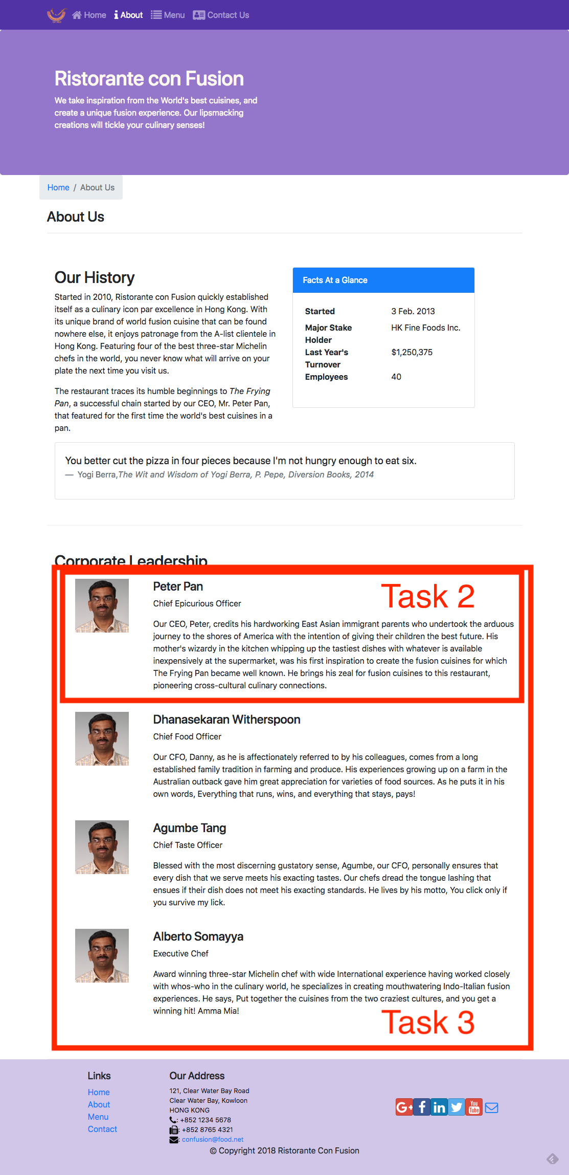

Review criteria
Upon completion of the assignment, your submission will be reviewed based on the following criteria:
Task 1:
- The AboutComponent.js file has been downloaded and integrated into our React application.
- The React application has been appropriately updated to enable navigation to the About Us page of our application.
Task 2:
- Implemented a new <RenderLeader> functional component in your application.
- Used the reactstrap <Media> component to render the details of a leader.
Task 3:
- Updated the leaders variable within the AboutComponent() function to make use of the <RenderLeader> component to render the list of leaders.

Assignment 2: React Router and Single Page Applications: Additional Resources

Assignment Resources
AboutComponent.js

Screenshots
React Resources
- react-router
- react-router-dom
- React Router Documentation
- React Router Dom Documentation
- reactstrap <Media> component

