Controlled Forms: Objectives and Outcomes
In this lesson you will learn about controlled components and how they can be used to design controlled forms in your React application. At the end of this exercise you will be able to:
- Design a controlled form in your React application.

Controlled Forms: Additional Resources

PDFs of Presentations
1-Controlled-Components-Forms.pdfPDF File

React Resources
- Controlled Components
- reactstrap Form

Other Resources
- Controlled / Uncontrolled React Components
- Controlled and Uncontrolled Input Values in React
- Controlled and uncontrolled form inputs in React don't have to be complicated
- How to Work with Forms, Inputs and Events in React
- Some Thoughts On Forms in React
- Instant form field validation with React's controlled inputs

Uncontrolled Forms: Objectives and Outcomes
Forms in React can be approached in two ways, either through uncontrolled components, or controlled components. In this lesson we will deal with uncontrolled forms. At the end of this lesson you will be able to:
- Create uncontrolled forms through uncontrolled components in React
- Handle the form submission in the React application

Uncontrolled Forms: Additional Resources

PDFs of Presentations
2-Uncontrolled-Components-Forms.pdfPDF File

React Resources
- Uncontrolled Components
- reactstrap Form
- reactstrap Modal Component

Other Resources
- Controlled / Uncontrolled React Components
- Controlled and Uncontrolled Input Values in React
- Controlled and uncontrolled form inputs in React don't have to be complicated
- How to Work with Forms, Inputs and Events in React
- Some Thoughts On Forms in React

Introduction to Redux: Objectives and Outcomes
In this lesson you will learn about the Flux architecture as a way of structuring your React application. You will also be introduced to Redux, a realization of the flux architecture. At the end of this lesson you will be able to:
- Install and Configure Redux in your application
- Enable your React app to make use of Redux
Introduction to Redux: Additional Resources

PDFs of Presentations
3-MVC.pdfPDF File
4-Flux-Arch.pdfPDF File
5-Intro-Redux.pdfPDF File

React Resources
- Redux
- Redux on Github
- React and Redux
- Redux Basics Documentation
- The Flux Architecture

Other Resources
- Redux Tutorials
- Flux Architecture In Depth Overview

React Redux Form: Objectives and Outcomes
In this lesson we will learn to create forms using react-redux-form that enables us to store form information in the Redux store, and brings additional benefits. At the end of this lesson you will be able to:
- Configure and use react-redux-form to create Controlled forms
- Store the form state in the Redux store

React Redux Form: Additional Resources

PDFs of Presentations
6-React-Redux-Form.pdfPDF File

React Resources
- React Redux Form Documentation

Other Resources
- The boring React Redux forms
- How to populate react-redux-form with dynamic default values
- Should you store your form state in Redux?
In this assignment you will be updating the React application with a react-redux-form based local form and do the form validation in code.

Step-By-Step Assignment Instructions
Assignment Overview
In this assignment you will update the DishdetailComponent.js to include a form and do the form validation in code. At the end of this assignment, you should have completed the following tasks to update the page:
- Added a new class component named CommentForm to DishdetailComponent.js.
- Provide a form to enable users to submit their comments
- Validate the information entered by the users in the form
Assignment Requirements
Task 1
In this task you will add a new class component named CommentForm. You need to complete the following:
- Add a new class component named CommentForm that will add a button to the view as shown in the image below.
- When the button is clicked, it toggles a modal that will display the comment form.
- The CommentForm component is used by the RenderComments function to display the button for toggling the modal.
Task 2
In this task you will construct the form for users to submit their comments as shown in the image below. You need to complete the following:
- Set up the form as a local form using the react-redux-form with the three fields: author, rating and comment.
- The rating field in the comment form is implemented using a select, the author is implemented using a text field, while the comment uses a textarea with six rows.
Task 3
In this task, you will enable form validation as shown in the images below. You need to complete the following:
- The author field should at least be three characters long.
- The author field should be less than or equal to 15 characters.
- The user should be alerted by showing the invalid message displayed at the bottom of the field.
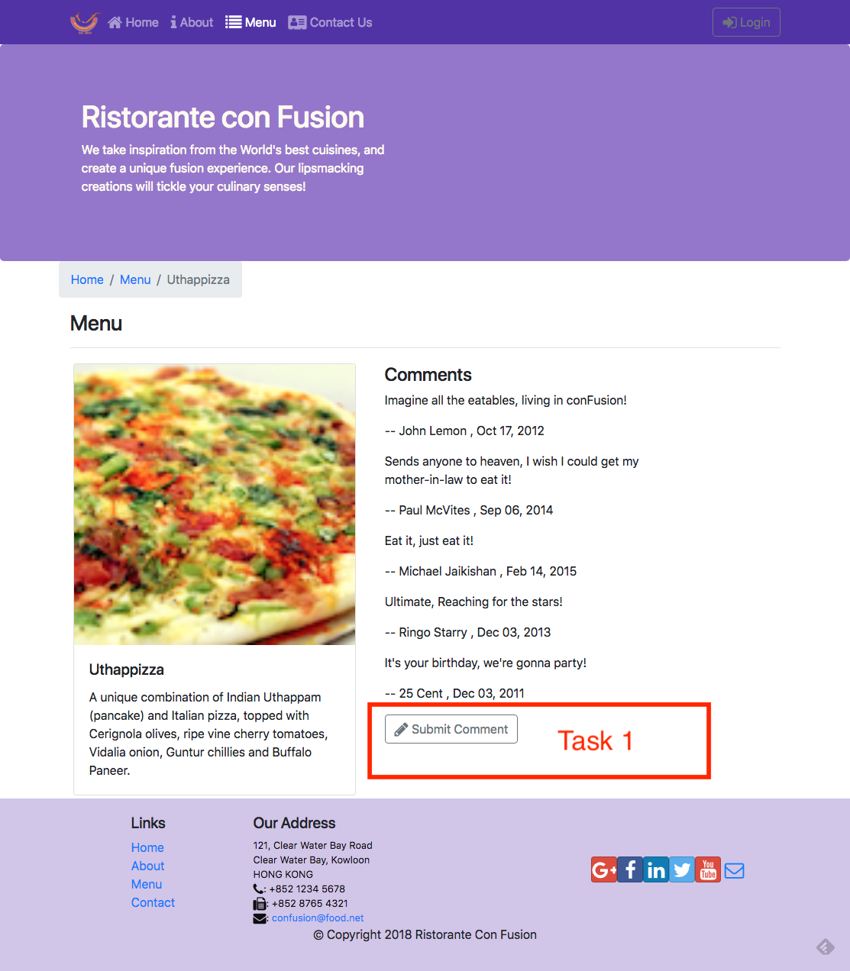
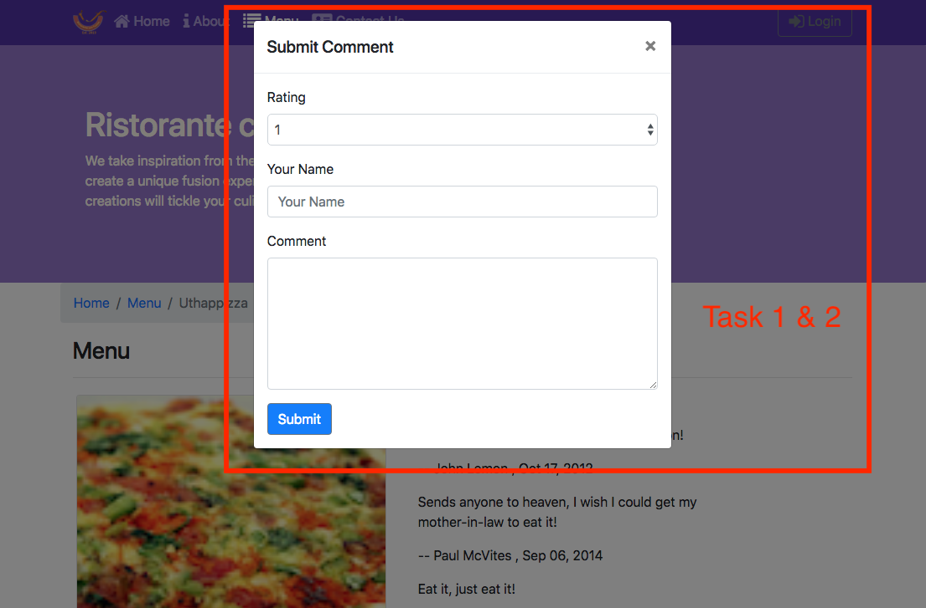
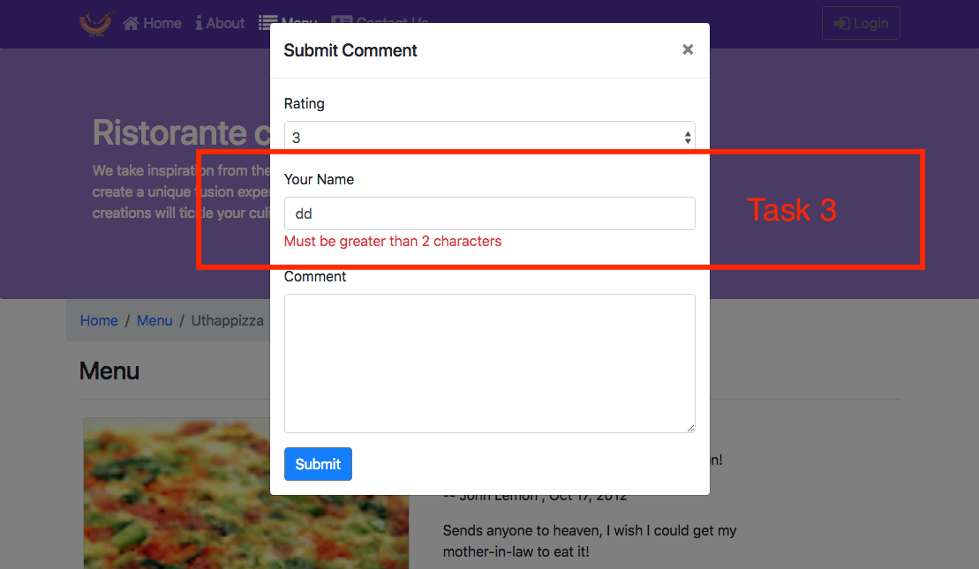
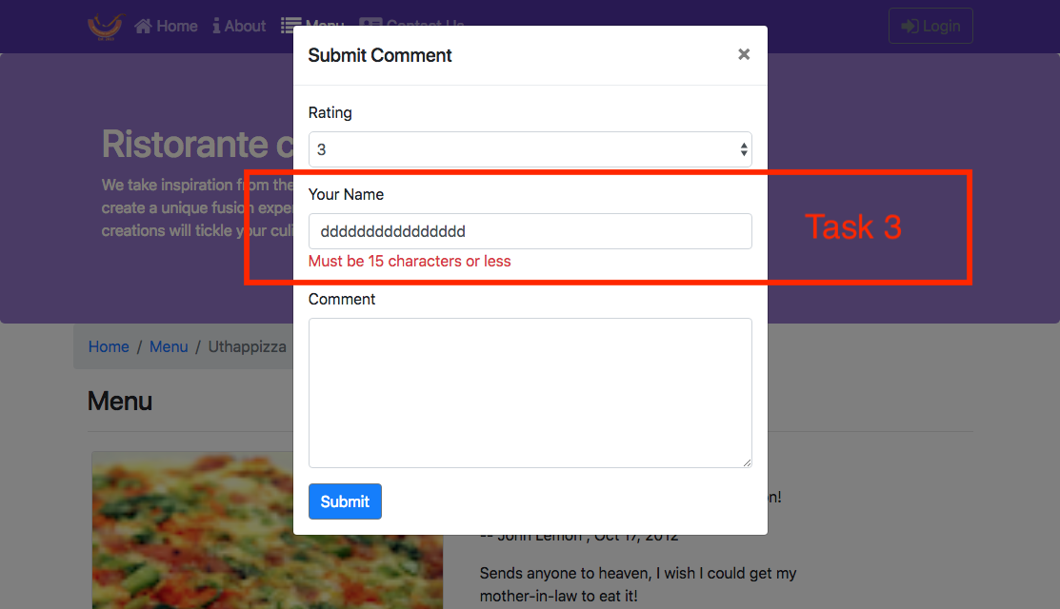

Review criteria
Upon completion of the assignment, your submission will be reviewed based on the following criteria:
Task 1:
- A CommentForm component is implemented that adds a button to the view, which when clicked will toggle a modal containing the form.
Task 2:
- The form is set up with the three fields correctly.
- A select is included in the form to enable users to submit the rating, a text field for author and a text area for the comment.
Task 3:
- The author field is being properly validated. If incorrect, the user is alerted.

Assignment 3: React Forms and Redux: Additional Resources
React Resources
- reactstrap Modal Component
- React Redux Form Documentation

