Module 4 Quiz
,
People are making progress
105 learners have recently completed this assignment
Submit your assignment
Due DateJan 4, 12:59 AM MST
Attempts3 every 8 hours
Receive grade
To Pass70% or higher
Grade
—

Module 4 Quiz
Graded Quiz • 30 min
Due Jan 4, 12:59 AM MST

Module 4 Quiz
Total points 10
1.
Question 1
What is a potential downside of the shown getAndAdd() function, which employs optimistic concurrency in the following code block?
getAndAdd(int delta) {
while (true) {
cur = this.get();
next = cur + delta;
if (this.compareAndSet(cur, next) return cur;
}
}
1 point
A. It may perform many unused computations.
B. It requires the use of expensive locks.
C. It may deadlock.
D. It may livelock.
2.
Question 2
Under what circumstances might optimistic concurrency be a good strategy when designing a concurrent algorithm?
1 point
A. Computation on the shared object is very expensive compared to the overhead of locks.
B. You expect very low contention.
C. The optimistically computed operation has side effects.
3.
Question 3
Which variables in an implementation of a sequential queue would need to be handled differently in a concurrent implementation?
1 point
A. Since not all variables would be part of a data race, only those that would be part of a data race.
B. Since all variables would be part of a data race, all variables.
C. All variables that are used in an enqueue operation.
D. All variables that are used in a dequeue operation.
E. None of the above.
4.
Question 4
What's the best way to modify TAIL.NEXT in a concurrent implementation of ENQ(X)?
1 point
A. LOCK(X) { TAIL.NEXT = X }
B. ISOLATED(X) {TAIL.NEXT = X }
C. TAIL.NEXT.COMPAREANDSET(TAIL, X)
D. TAIL.NEXT.COMPAREANDSET(NULL, X)
E. Both A and B
5.
Question 5
Consider the following timeline. Assuming the enqueue operations are linearizable, which of the below are possible results from a sequence of dequeue operations?
Please choose all options that are correct.
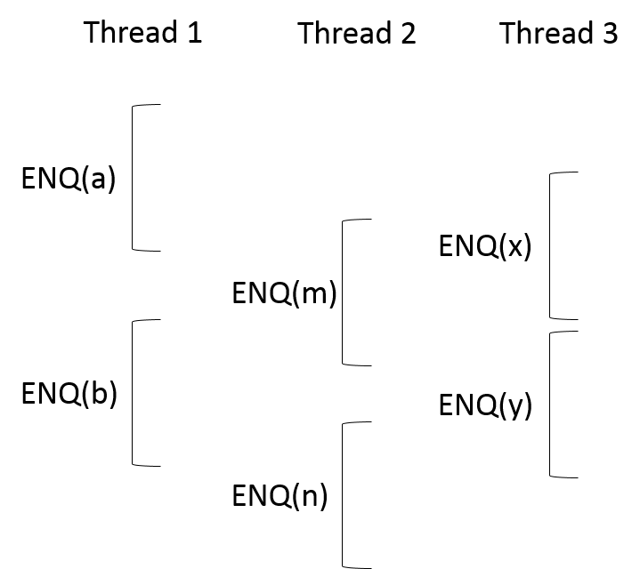
1 point
A. a, m, x, b, n, y
B. m, x, a, n, b, y
C. m, x, y, a, b, n
D. x, a, b, m, n, y
E. x, a, y, m, n, b
F. x, a, y, b, m, n
6.
Question 6
Consider the scenario where threads T1 and T2 (and no other threads) are attempting to obtain a lock on L1. Which of the following are linearizable orderings of statements executed?
Please choose all options that are correct.
1 point
A. 1) T1 calls L1.lock(). 2) T2 calls L1.lock(). 3) T2 is unable to obtain lock. 4) T1 successfully obtains lock.
B. 1) T1 calls L1.lock(). 2) T2 calls L1.lock(). 3) T1 is unable to obtain lock. 4) T2 successfully obtains lock.
C. 1) T1 calls L1.lock(). 2) T2 calls L1.lock(). 3) T1 successfully obtains lock. 4) T2 is unable to obtain lock.
D. 1) T1 calls L1.lock(). 2) T2 calls L1.lock(). 3) T2 successfully obtains lock. 4) T1 is unable to obtain lock.
E) 1) T1 calls L1.lock(). 2) T2 calls L1.lock(). 3) T2 successfully obtains lock. 4) T1 successfully obtains lock.
F. 1) T1 calls L1.lock(). 2) T2 calls L1.lock(). 3) T1 is unable to obtain lock. 4) T2 is unable to obtain lock.
7.
Question 7
If multiple threads are trying to write a value in the map for the same key using PUTIFABSENT(key, value), only one of the threads will succeed.
1 point
True
False
8.
Question 8
Which of the following operations are not linearizable?
Please choose all options that are correct.
1 point
A. PUT(key, value)
B. PUTIFABSENT(key, value)
C. PUTALL()
D. CLEAR()
E. GET (key)
9.
Question 9
What is a possible downside of using locks to transform a sequential MST algorithm into a concurrent algorithm?
1 point
A. As our merged tree gets smaller, we have more collisions when using trylock, thus reducing performance.
B. This method may not account for all data races.
C. It results in a deadlock.
D. The merging step could result in two processes attempting to merge the same nodes and thus result in a bug.
E. There would be more code, which would hurt our brains.
10.
Question 10
Is it possible for a minimum spanning tree to have the same total weight as its original graph?
1 point
A. Yes
B. No
Honor Code Agreement

