Independent evolution of a living bridge in the Old World army ant lineage

Nobuaki Mizumoto^{1,2,3*}, Clement Het Kaliang⁴, Taisuke Kanao^{3,5}
1. Department of Entomology & Plant Pathology, Auburn University, Auburn, AL, 36849, USA
2. Okinawa Institute of Science & Technology Graduate University, Onna-son, Okinawa, 904-0495 Japan
3. Japan Research Consortium for Tropical Forests in Sarawak
4. Sarawak Forestry Corporation, Kuching, Sarawak, Malaysia
5. Faculty of Science, Yamagata University, Yamagata, 990-8560, Japan
*: Correspondence: nzm0095@auburn.edu

ORCID: NM: 0000-0002-6731-8684; T.K.: 0000-0002-7934-4011

Abstract
Living bridges formed by army ants are among the most striking examples of collective behavior in social insects, previously known only from New World Eciton species. Here, we report the observation of living bridge formation in an Old World army ant, Aenictus. During field observations, workers formed bridges across small gaps on foraging trails by linking their bodies, allowing traffic to resume. Bridges were maintained while traffic was high but spontaneously disassembled as flow declined, suggesting a similar behavioral algorithm to that of Eciton self-assembly behavior. This finding indicates that bridge-formation has evolved convergently in army ants and provides new insight into the diversity of self-assembly in social insects.

Keywords:
Collective motion, Natural history, self-organization, traffic regulation, tropical biology

Introduction
Collective behavior enables a group of animals to perform tasks that single individuals cannot accomplish (Camazine et al., 2001). One striking example is self-assembly, in which individuals physically link their bodies to create dynamic and flexible three-dimensional structures on the spot (Anderson et al., 2002; Carlesso and Reid, 2023). Such structures provide functional advantages, otherwise impossible for single individuals, such as forming temporary shelters, bridging gaps to facilitate movements, or combining forces to achieve greater strength. Self-assembly is rare across animals and is largely restricted to several derived social Hymenopteran species, e.g., fire ant rafts, honey bee swarms, weaver ant chains, and army ant bivouacs (reviewed in (Carlesso and Reid, 2023)). Although these are system-specific phenomena, similar ecological pressures may promote the convergent evolution of self-assembly behaviors across unrelated taxa.
Army ants represent a particularly charismatic example of collective behavior, exhibiting a suite of traits known as the “army ant syndrome”, including obligate group foraging and nomadic colony cycles (Gotwald, 1995; Kronauer, 2020; Schneirla, 1971). This syndrome has evolved convergently in two different lineages: the New World army ants and the Old World army ants (Borowiec, 2019). Among these, the genera Eciton (New World) and Aenictus (Old World) are especially surface-adapted, typically foraging and migrating on open ground, rather than within leaf litter or subterranean tunnels (Gotwald, 1995). As terrestrial animals, army ant movements depend on the continuity of the ground surface, potentially disrupted by the small gap (Mizumoto and Reid, 2024). The New World army ant, Eciton, is well known for its ability to overcome such spatial discontinuities through collective behavior. These ants form living bridges that span gaps, and the behavioral mechanisms have been well documented (McCreery et al., 2022; Reid et al., 2015). In contrast, in the Old World army ant, Aenictus, behavioral and life history information remain scarce. Different from other army ant groups, Aenictus does not have polymorphic workers and forms a more simplified collective foraging compared to Eciton ants (Gotwald, 1995; Schneirla, 1971), yet their surface-adapted lifestyle suggests that they might also employ similar bridging behaviors.
Here, we report observations of living bridges in Aenictus ants. This finding provides rare insight into collective behavior in the Old World army ants and suggests that comparable ecological challenges may have driven the convergent evolution of self-assembly behaviors across independent lineages of army ants.

Methods
All observations were performed at the Lambir Hills National Park, Miri, Sarawak, Malaysia. Between May 31 and June 12, 2023, we conducted daily field surveys of marching termites (Hospitalitermes spp. and Longipeditermes longipes) along the ~4 km trail (Inoue-Pantu-Main trail), walking the route once or twice per day to search for the termite trail formations. During these surveys, we occasionally encountered foraging or emigration trails of the Old World army ants, Aenictus spp., both during the day and at night. On June 6, while returning to the chalet after observations on Hospitalitermes lividipes, we encountered the tail of an Aenictus ant at 10:20 pm local time (4.2023437° N, 114.0302110° E). The trail crossed a narrow twig of dead wood on the forest floor, providing a natural opportunity to test whether this species could form a living bridge when the substrate was interrupted.
We cut the twig bridge with scissors and recorded the ant responses using the 4K video camera (HC-X1500-K, Panasonic) at 30 fps, illuminated by an LED video light (Pixel G1s). The resulting gap was about 5.3 mm wide, slightly larger than the body length of ants. Preliminary observations indicated that LED lights at night did not disturb ant activity on the trail. Recording lasted for about 400 s, limited by battery capacity and safety considerations for returning from the field site.
To quantify traffic dynamics during bridge formation, we analyzed the video using the open-source event-logging software BORIS (Friard and Gamba, 2016). The observation area was defined as a 50 × 50 mm square centered on the twig gap (Fig. S1). We counted the number of ants entering and leaving the area each second and binned the data accordingly. The traffic flow was defined as the number of individuals entering or leaving the area per second, and the estimated number of ants present was derived from cumulative entry and exit counts over the observation period (410 s total). These data were used to describe the temporal dynamics of collective bridge formation.
The autocorrelation function of the traffic flow data shows that there was no detectable correlation with a lag ≧ of 11 seconds. Thus, we summarized the data for every 11 seconds by getting the mean of the traffic flow and the number of ants near the gap. Then, we investigated the effect of the number of ants near the gap, bridge formation, and their interactions on the traffic flow, using a linear model (LM). All analyses were performed using R (R Core Team, 2024).

Results
During the observation period, we observed three bridge formation events and two spontaneous collapses (Fig. 1, Video S1). After the gap was created in the middle of the trail on a twig, traffic became congested, and ants accumulated near the opening. As the accumulation increased, some individuals were pushed toward the gap and began exploring the air space with their legs and antennae (Fig. 1). When ants from opposite sides made contact, they interlinked their bodies to form a living bridge. Once the bridge was established, traffic flow resumed, and the local density of ants around the gap decreased. The bridge persisted as long as ants continued to cross, but collapsed spontaneously when traffic declined (Fig. 1).
During bridge formation, the minimum number of ants present in the gap area was seven, indicating that at least seven individuals were required to span the 5.3 mm gap. The number of ants near the gap was positively correlated with traffic flow (linear model: F₁ = 45.3, P < 0.001, Fig. S2), and the slope of this relationship was significantly steeper when the bridge was present (F₁ = 5.0, P = 0.032, Fig. S2).

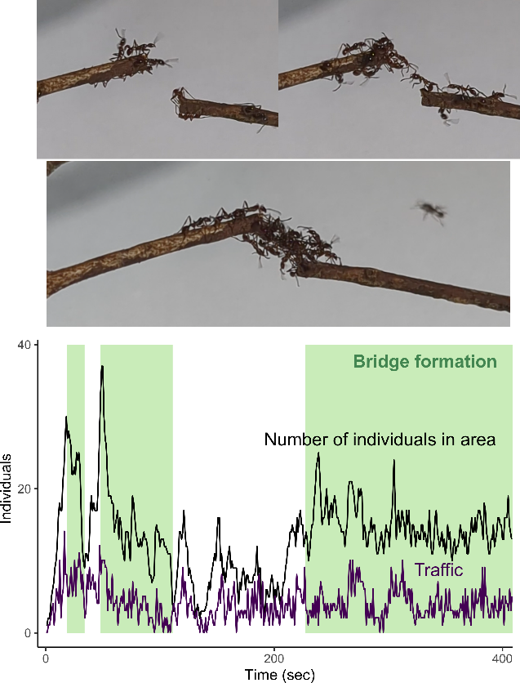
Figure 1. Living bridge formation by Aenictus sp. Time development of the number of individuals around the gap (25 mm) was recorded. Also, traffic was measured as the number of individuals who enter or leave this area per second.

Discussion
Old World and New World army ants show many convergent traits, yet also display key differences in their collective behaviors. Both Aenictus and Eciton are surface-adapted foragers (Gotwald, 1995), but Eciton species typically form larger and more complex raid networks, while Aenictus raids tend to be simpler (Gotwald, 1995; Schneirla, 1971). Our observations reveal that Aenictus ants can also form living bridges as in Eciton, indicating that this behavior evolved convergently. However, bridge formation in Aenictus appears more limited, typically spanning only small gaps and often breaking down spontaneously when traffic decreases (Fig. 1). This likely reflects the lower overall traffic intensity in Aenictus trails (Schneirla and Reyes, 1966), as in our observed trail. Observations on larger-scale trials could further clarify the extent of this behavior.
Living bridge formation in Eciton workers can emerge from simple behavioral rules. Individual ants track the rate of traffic passing over them and leave the bridge when tactile stimulation drops below a certain threshold (Garnier et al., 2013; McCreery et al., 2022; Powell and Franks, 2007), which could be used in other contexts as well (Baudier and Pavlic, 2020; Lutz et al., 2021). Our observations suggest that Aenictus employs a similar mechanism. We recorded two spontaneous bridge collapses coinciding with declines in local traffic and ant density (Fig. 1). This could be consistent across other lineages (e.g., (Mlot et al., 2011)). Among self-assembly behaviors in social Hymenoptera, bivouac formation is the most widespread, providing a temporary shelter for colony members (Anderson et al., 2002; Carlesso and Reid, 2023). Both Old World and New World army ants form bivouacs, including several Aenictus species (Gotwald, 1995). We also observed clustering behavior at our field site (Fig. S3). The underlying behavioral rules that govern bivouac and bridge formation are likely related, suggesting that Aenictus may have co-opted a common self-assembly mechanism for different contexts.
In conclusion, we document the first evidence of living bridge formation in Old World army ants. Although this behavior is well known in Eciton, its evolutionary origin remains unclear. Unique foraging behavior in army ants, such as mass raiding, is suggested to have continuously evolved from group foraging (Chandra et al., 2021). Yet, behavioral information within the subfamily Dorylinae remains scarce. Our findings underscore the continuing importance of natural history observations in revealing behavioral diversity and convergence among social insects.

Acknowledgments
This study was conducted in accordance with three Memoranda of Understanding (MOU) signed between the Sarawak Forestry Corporation and the Japan Research Consortium for Tropical Forests in Sarawak (JRCTS) in February 2021, and under research permission issued by SFC for "The Project on Development of Management Systems for Multiple Utilization of Biodiversity in the Tropical Rainforests at the Protected Areas in Sarawak" (PUBS-SATREPS (JST/JICA). We thank the staff of the Lambir Hills National Park for supporting our field surveys in the park. We also thank Datin Runi Silvester Pungga, Takafumi Mizuno and Takao Itioka for help in obtaining permission to conduct this study. The work was supported by a Grant-in-Aid for Early-Career Scientists (21K15168), an IPSF fellowship from OIST, the USDA National Institute of Food and Agriculture, Hatch project number 7007938 to NM, and JST/JICA, SATREPS (JPMJSA1902).

Author contributions
N.M.: conceptualization, data curation, formal analysis, funding acquisition, investigation, methodology, project administration, validation, visualization, writing-original draft
C.H.K.: resources, supervision
T.K.: investigation, writing-edit

References
Anderson C, Theraulaz G, Deneubourg J-L. 2002. Self-assemblages in insect societies. Insectes Sociaux 49:99–110. DOI: https://doi.org/10.1007/s00040-002-8286-y
Baudier KM, Pavlic TP. 2020. Incidental interactions among Neotropical army-ant colonies are met with self-organized walls of ants (Hymeno ptera: Formicidae). Myrmecological News 10:4136.
Borowiec ML. 2019. Convergent evolution of the army ant syndrome and congruence in big-data phylogenetics. Systematic Biology 68:642–656. DOI: https://doi.org/10.1093/sysbio/syy088, PMID: 30605547
Camazine S, Deneubourg J-L, Franks NR, Sneyd J, Theraulaz G, Bonabeau E. 2001. Self-organization in Biological Systems. Princeton University Press.
Carlesso D, Reid CR. 2023. How to become one: the proximate mechanisms of self-assembly behaviour in social insects (Hymenoptera: Formicidae, Apidae). Myrmecological News 33:149–168. DOI: https://doi.org/10.25849/MYRMECOL.NEWS_033:149
Chandra V, Gal A, Kronauer DJC. 2021. Colony expansions underlie the evolution of army ant mass raiding. Proceedings of the National Academy of Sciences of the United States of America 118:1–10. DOI: https://doi.org/10.1073/pnas.2026534118, PMID: 34035172
Friard O, Gamba M. 2016. BORIS: a free, versatile open-source event-logging software for video/audio coding and live observations. Methods in Ecology and Evolution 7:1325–1330. DOI: https://doi.org/10.1111/2041-210X.12584
Garnier S, Murphy T, Lutz M, Hurme E, Leblanc S, Couzin ID. 2013. Stability and Responsiveness in a Self-Organized Living Architecture. PLOS Computational Biology 9:e1002984. DOI: https://doi.org/10.1371/journal.pcbi.1002984
Gotwald WH. 1995. Army Ants: The Biology of Social Predation. Cornell University Press. DOI: https://doi.org/10.7591/9781501736711
Kronauer DJC. 2020. Army Ants: Nature’s Ultimate Social Hunters. Harvard University Press.
Lutz MJ, Reid CR, Lustri CJ, Kao AB, Garnier S, Couzin ID. 2021. Individual error correction drives responsive self-assembly of army ant scaffolds. Proceedings of the National Academy of Sciences 118:e2013741118. DOI: https://doi.org/10.1073/pnas.2013741118
McCreery HF, Gemayel G, Pais AI, Garnier S, Nagpal R. 2022. Hysteresis stabilizes dynamic control of self-assembled army ant constructions. Nature Communications 13:1160. DOI: https://doi.org/10.1038/s41467-022-28773-z
Mizumoto N, Reid CR. 2024. Ant and termite collective behavior: Group‐level similarity arising from individual‐level diversity. Ecological Research 39:646–658. DOI: https://doi.org/10.1111/1440-1703.12510
Mlot NJ, Tovey CA, Hu DL. 2011. Fire ants self-assemble into waterproof rafts to survive floods. Proceedings of the National Academy of Sciences 108:7669–7673. DOI: https://doi.org/10.1073/pnas.1016658108
Powell S, Franks NR. 2007. How a few help all: living pothole plugs speed prey delivery in the army ant Eciton burchellii. Animal Behaviour 73:1067–1076. DOI: https://doi.org/10.1016/j.anbehav.2006.11.005
R Core Team. 2024. R: A language and environment for statistical computing.
Reid CR, Lutz MJ, Powell S, Kao AB, Couzin ID, Garnier S. 2015. Army ants dynamically adjust living bridges in response to a cost–benefit trade-off. Proceedings of the National Academy of Sciences of the United States of America 112:15113–15118. DOI: https://doi.org/10.1073/pnas.1512241112, PMID: 26598673
Schneirla TC. 1971. Army ants: A study in social organization. Army ants: A study in social organizationW. H. Freeman.
Schneirla TC, Reyes AY. 1966. Raiding and related behaviour in two surface-adapted species of the Old World Doryline ant, Aenictus. Animal Behaviour 14:132–148. DOI: https://doi.org/10.1016/S0003-3472(66)80022-2

