Supplementary materials for

Independent evolution of a living bridge in the Old World army ant lineage

Nobuaki Mizumoto^{1,2,3*}, Clement Het Kaliang⁴, Taisuke Kanao^{3,5}
1. Department of Entomology & Plant Pathology, Auburn University, Auburn, AL, 36849, USA
2. Okinawa Institute of Science & Technology Graduate University, Onna-son, Okinawa, 904-0495 Japan
3. Japan Research Consortium for Tropical Forests in Sarawak
4. Sarawak Forestry Corporation, Kuching, Sarawak, Malaysia
5. Faculty of Science, Yamagata University, Yamagata, 990-8560, Japan
*: Correspondence: nzm0095@auburn.edu

ORCID: NM: 0000-0002-6731-8684; T.K.: 0000-0002-7934-4011

This file includes
Table S1
Figure S1-4
The legend for Video S1

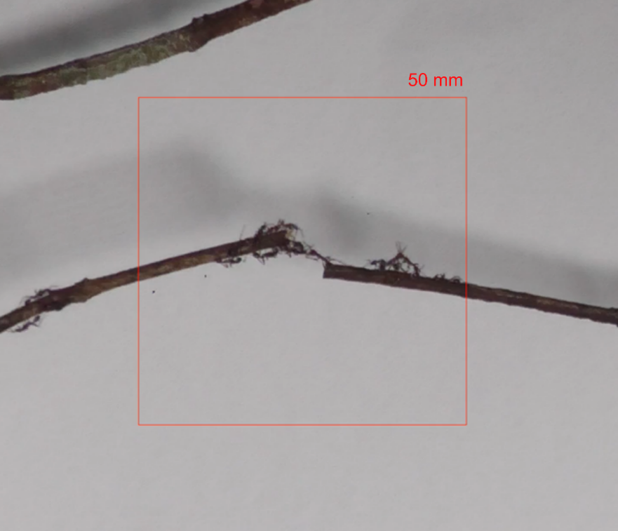
Figure S1. Observation area as a square area surrounding the gap of the twigs in 50 x 50 mm.

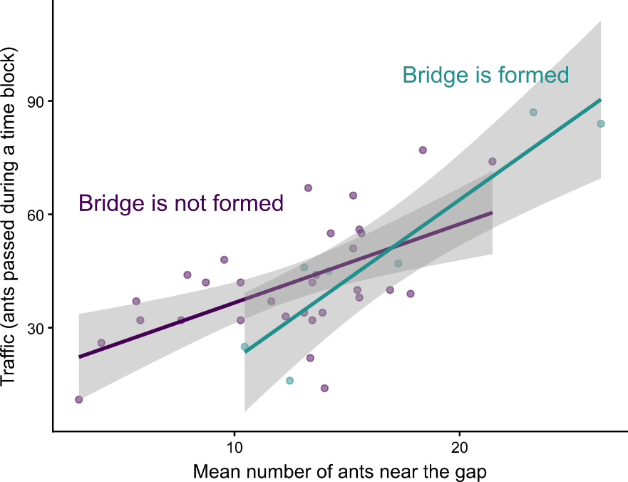
Figure S2. Relationship between the number of ants near the gap and traffic flow. Each data point represents the observation while 11 seconds time block (See also Figure S4).

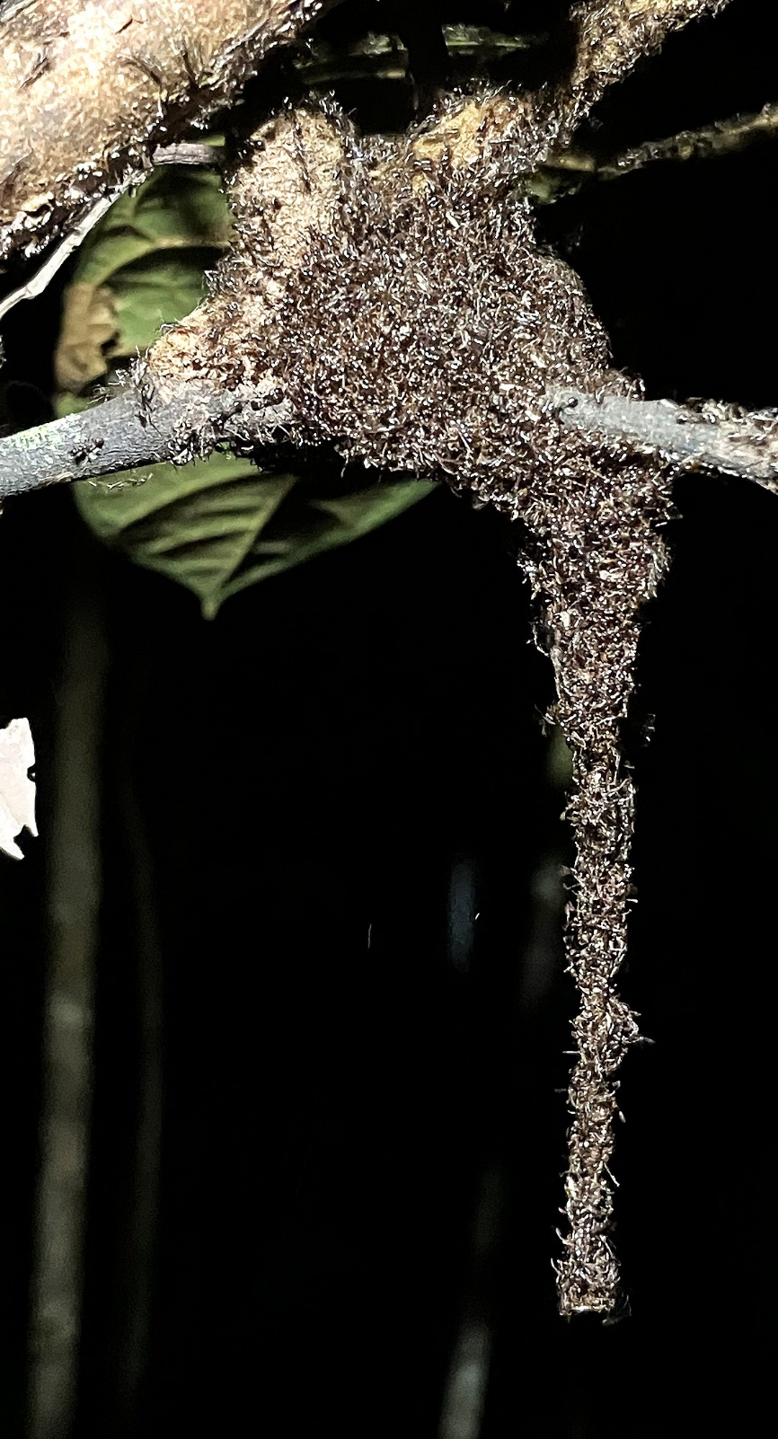
Figure S3. Clustering behavior, including a chain formation, by Aenictus sp. The photo was taken on June 6, 2023, on the same day as the bridge observations in the same field locality.

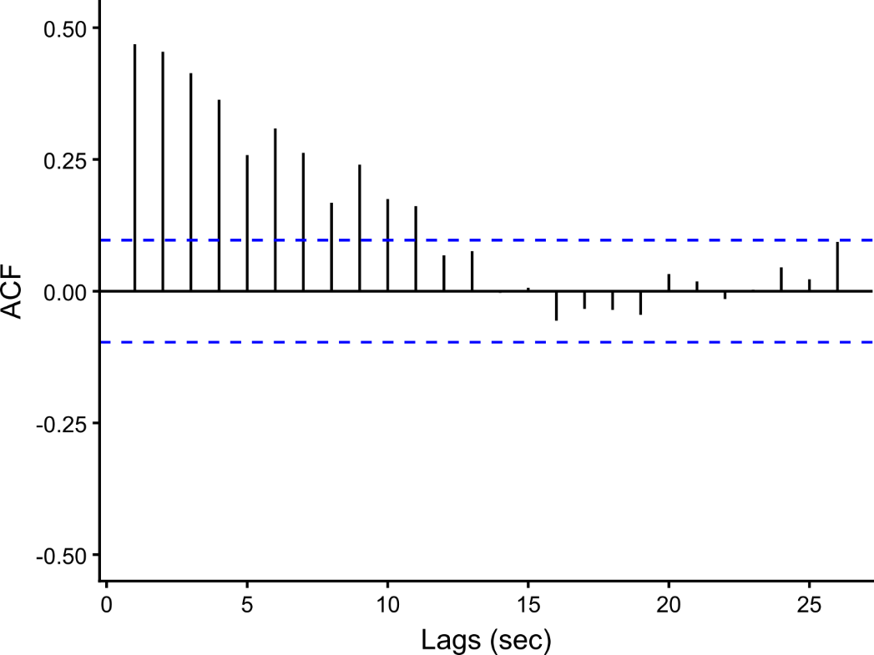
Figure S4. The autocorrelation function for the traffic flow. The traffic flow was obtained by summing the number of ants entering and leaving the area near the gap. Blue dashed lines indicate the 95% Confidence Interval, within which the signal cannot be distinguished from the noise.

Table S1
glm(traffic flow ~ Mean number of ants near the gap * Bridge formed)
Poisson, log link
 | Estimate | SE | z | P (z score)
(Intercept) | 3.06 | 0.10 | 31.75 | < 0.001
Mean number of ants near the gap | 0.05 | 0.01 | 7.59 | < 0.001
Bridge formed | -0.53 | 0.21 | -2.56 | 0.01
Interaction | 0.02 | 0.01 | 2.17 | 0.03

