**Evaluating mate encounter and walking dispersal dynamics of termites using posture tracking and behavioral simulation**

**Nobuaki Mizumoto**

Department of Entomology & Plant Pathology, Auburn University, Auburn, AL, 36849, USA

Correspondence: [nzm0095@auburn.edu](mailto:nzm0095@auburn.edu)

**Abstract**

Several termite species are problematic to human society as urban structural pests. Although mature termite colonies with thousands to millions of individuals damage human properties, all these massive colonies have to start from a mating encounter of a female and a male. After seasonal dispersal flights, the termite dealates walk to search for a mating partner and a potential nest site. This very initial phase of the termite colony cycle plays an essential role in dispersal ability, initial infestation, and invasion success; yet, the searching dynamics and success of these walking termites are poorly understood across the environmental factors. In this study, I investigate mate-searching and post-pairing dispersal behavior in *Coptotermes formosanus*, one of the most damaging termites, by reanalyzing observations in the experimental arena with the deep-learning posture tracking approach. I estimated that termites can walk up to X m and disperse up to Y m within 15 minutes, with nest-searching tandem pairs expected to disperse more than mate-searching single termites because of the movement coordination. The simulations parameterized by termite observations quantified that urban light attraction greatly contributed to the pairing success of termites, even with the low termite population density. Thus, in the urban context, termites can effectively find a partner near the light, and then tandem coordination helps them disperse from the encounter place. The comparative quantitative behavioral studies across species may provide a prediction about movement characteristics relating to the invasive and pest status in termite diversity.

**Keywords**

Alate behavior, colony foundation, nest establishment, movement ecology, urban entomology, light pollution, subterranean termites, pairing courtship

**Introduction**

Among more than 3,000 species of diversity, some termites are serious structural pests, causing damage of $40 billion annually across the world as of 2010 (Rust and Su, 2012). Invasive termite species, especially, have a strong impact, e.g., *Coptotermes formosanus* is listed as one of the top 10 costliest invasive species (Cuthbert et al., 2022). Termite studies have traditionally focused on the mature colonies, as structural damage to buildings arises only after colonies reach the developed stage (Gordon et al., 2022; SU and Scheffrahn, 1998) However, even though the mature colony is made up of millions of individuals, all colonies of termites begin with a monogamous mating pair of a female and a male (Nutting, 1969), with a few exceptions (Perdereau et al., 2015). Such a mate-pairing stage is highly mobile and can be a determinant of initial infestation, population dynamics, and invasion success. Yet, this critical stage has been understudied compared to the mature colonies. In this study, I explore the mate-finding and dispersal dynamics of a termite, *Coptotermes formosanus*, especially focusing on their walking behaviors.

In a season of the year, a large number of alates (winged reproductive individuals) fly off from their parental colony nests. There are three immediate tasks for the alates: 1) disperse from their original place, 2) find a mating partner, and 3) find a nest-site to start a colony. This information on *C. formosanus* is well summarized in a chapter of a book on this species (Chouvenc, 2023), where dispersal flight is relatively well-described. The duration of a single active flight can last for as little as 15 min for relatively small density flights but can last for up to an hour for dense flight events (Chouvenc et al., 2017a). Each alate may fly for 20–30 min to disperse in the environment (Ikehara, 1966; Raina et al., 2003c) for distances that can be relatively short (< 50 m), to a record distance of ~1,300 m, and with an average flight distance of 621 m, prior to falling onto the ground or landing on trees (Mullins et al., 2015). This indicates that alates of C. fomorsanus have a decent ability to disperse and expand their distribution ranges. However, as a socially monogamous insect, females and males of C. formosanus have to find a partner after dispersion and shedding their wings. Contrary to social Hymenoptera, all important mating processes happen during walking, i.e., finding a mating partner, engaging in pairing courtship, and finding a nest site. Thus, it is essential to quantitatively estimate the dynamics after shedding their wings to evaluate their mating success.

After landing on the ground and shedding their wings, both females and males engage in a mate search by walking. This mate search is assumed to be a random search (Mizumoto and Dobata, 2019), indicating that termites do not know where their partner is until they encounter it, because *C. formosanus* termites do not rely on vision (Mizumoto and Bourguignon, 2022) or long-distance attracting chemicals for locating a partner (Chouvenc et al., 2020; Raina et al., 2003). Before encountering a partner, both females and males actively move to search for a partner to maximize the searching areas (Mizumoto and Dobata, 2019). Once encountered, a pair of a female and a male performs tandem running behavior, with the leader female and the follower male coordinating motion, while searching for a suitable nest site. In tandem running, a female leader determines the course of the movement (Mizumoto et al., 2021; Valentini et al., 2020), while the follower male maintains contact with his antennae and pulps to maintain the coordination (Mizumoto and Reiter, 2025; Raina et al., 2003). In case of accidental separation between partners, a leader female pauses to wait for the partner, and a follower male engages in are-restricted search, which is effective reunion strategy for the strayed partner (Mizumoto et al., 2020; Mizumoto and Dobata, 2019). Encounters of the same-sex may result in tandem runs (Mizumoto et al., 2024) but rarer than other species (Mizumoto et al., 2022). Therefore, on the ground, termites dealates dynamically alternative mate search and nest search until they settle in an available space for colony foundation (Chouvenc, 2023; Su et al., 1989). These observations provide important behavioral rules used by termite dealates. However, the dispersion-encounter dynamics of dealates remains unknown, e.g., how far termites can travel after shedding their wings or the effective density required for mate searchers to encounter their partner.

In this study, I open up this research direction by reanalyzing termite searching strategies studied in a previous study and building a behavioral simulation. Especially, Mizumoto and Dobata 2019 used body center. Current advancement in posture tracking this last 10 years. By updating the analysis, I estimate and evaluate the termite dispersion by walking in an open space. Furthermore, by using the movement parameters of termites, I develop a mate searching simulation and tested the effect of density and urban lights on mating encounter dynamics.

Based on these results I provide testable hypotheses in the future studies. Furthermore, I discuss the other species.

**Figure 1.** Life cycle of subterranean termites, as an example of *Coptotermes formosanus*. In a season of the year, many alates (winged individuals) fly to disperse. After dispersal, females and males look for a mating partner. Encountered pair performs a tandem run to seek a nest site for colony foundation. The established colony grows into the mature colony, which produces alates again. Among these, only mature colonies can damage human property with a large number of colony members.

**Methods**

*Behavioral data*

I used the videos obtained in a previous study (Mizumoto and Dobata, 2019). In this study, experiments with *C. formosanus* were performed to study the adaptive mate search strategy used in termites. Alates were collected using light trapping, or from 2 colonies of *C. formosanus* with nesting wood in Wakayama, Japan, in June 2017. After dispersal flights in the lab, termites that shed their wings were selected and used for the observations. Experiments were performed in a Petri dish (145 mm Ø) filled with moistened plaster whose surface was scraped before each trial. They observed termites in two different conditions; in single searching experiments, they introduced a female or a male to the experimental arena and recorded their movement for 30 minutes, while in tandem running observations, they introduced one female and one male together to the arena and recorded for 60 minutes. A total of 22 single females, 21 single males, and 20 tandem running pairs were observed.

All videos were analyzed using SLEAP v 1.4.0 (Pereira et al., 2022) to estimate the movement of body parts of each individual. The model was based on that developed for *C. formosanus* in a previous study (Mizumoto and Reiter, 2025), with a 17-node skeleton: antenna tips (LR), antenna middle (LR), antenna base (LR), head (middle of mouth parts), head-pronotum boundary, pronotum-mesonotum boundary, metanotum-abdomen boundary, abdomen-tip, fore legs (LR), mid legs (LR), and the hind legs (LR). I only used the data of the head and the abdomen-tip for movement analysis. Due to the video quality, detection accuracy of legs or antennae was very low, but including these improve the tracking accuracy of head and abdomen-tips. We trained a U-Net-based model with a multi-animal top-down approach, with a receptive field size of 76 pixels for the centroid and 316 pixels for the centered instance, on Nvidia GeForce RTX 4090, where augmentation is done by rotating images from -180 to 180 degrees. The video analysis was performed for tandem running and single termites separately because of the setup difference between these two experiments, where I finished tandem running first and then used the model developed for tandem running to develop the model for single termites. I labeled 65 frames from 15 videos in tandem running, while 61 frames from 25 videos in single termites. While tracking after the inference, we used the instance similarity method with the greedy matching method. All pose estimation data were converted to HDF5 files for further analysis. We used Python to format all HDF5 files for further analysis and converted them into FEATHER files for analysis in R (R Core Team, 2024). We employed a linear interpolation method to address missing values in the dataset. After scaling all data from pixels to mm, we used a median filter with a kernel size of 5 to reduce noise. All analyses were performed after downsampling at 5 FPS.

From the trajectories, I obtained several kinetic variables as follows. First, I determined the body center as the middle position between the head and the abdomen tip. Displacements of body center positions were computed for every frame to obtain the instantaneous movement speed. The change of the movement speed (acceleration/deceleration) and movement direction were also computed using the displacements. Independent of the movement direction, I also computed termite heading directions as the vector from the abdomen tip to the head.

*Unwrapping movements in a dish to open space*

In the dish arena, termite movements are bounded by the arena wall, making it impossible to investigate their dispersal behavior (Nagaya et al., 2017). In this study, however, to grasp the dispersal ability by walking in termite dealates, I converted the movement trajectories recorded in a circular dish into the approximated open-space movements by applying a series of corrections to movements bounded by a constrained space. The conversions addressed two main artifacts: wall-following behavior and mismatches between heading and movement directions caused by the dish walls. Note that these conversions do not completely reflect their motion in the open space; instead, I aimed to approximate how far termites could disperse if there were no boundaries in a dish.

First, termites in a dish often exhibit wall-following behavior, moving along the perimeter of the dish in a smooth and curved trajectory (Miramontes et al., 2014; Paiva et al., 2020; Shimoji et al., 2019). I assume that termite movements were biased due to the wall, and termites would maintain their heading direction rather than curving along a dish wall in an open space. Thus, I considered that termites are forced to turn at angles that require them to rotate along the wall. To correct this, I converted the x-y coordinates into polar coordinates relative to the center of the arena. I searched for sequences of frames, where termites moved for more than 10 mm in the same direction of angular coordinates. For each of these events, I obtained how many angles the termite rotated and then adjusted the trajectory by rotating positions to extend the path outward, unwrapping the wall-following sequences (Figure).

Second, near the wall, termite movements are often bounded by the wall, creating many discrepancies between the heading direction (direction from the abdomen tip to the head) and the actual movement direction. I fixed all of these discrepancies near the wall

as frames in which the angle between the heading direction and movement direction was larger than 0.5 radians. For these frames, I interpreted that the trajectory was distorted and adjusted the termite position by rotating it around the previous location to align with the heading direction. This assumes that the termite attempts to move forward along its body axis without redirection arising from the dish or tracking artifacts.

Finally, I addressed the sharp turns that occur near the arena wall, where the wall interrupts the straight motion while they are approaching or bump the dish wall. I identified the turning point that occurred within

Finally, I addressed sharp, abrupt turns that occurred near the arena wall—distinct from smooth wall-following. These are likely behavioral artifacts introduced by collision with the boundary, which would not occur in open space. I searched for turning points that occurred within [-rad_near_wall-] units of the edge and where the change in movement direction was large and sudden. To distinguish between voluntary turns and wall-induced deflections, I examined the radial distance before and after each turning point over a window of [-aframe-] frames. If the mean radial distance decreased after the turn, suggesting a rebound from the edge, I interpreted the event as a wall-induced deflection. I then corrected the trajectory by rotating subsequent positions to smooth out the turn and extend the previous movement direction forward. This adjustment assumes that the termite would have continued moving straight had it not encountered the boundary.

These virtual modifications allowed me to reconstruct trajectories that more accurately represent termite movement in an unconstrained, open environment. By reducing artifacts introduced by the dish, the resulting paths better reflect the dealates’ intrinsic movement tendencies and provide a more realistic foundation for analyzing their dispersal potential.

*Comparison with the servosphere movement*

**Results**

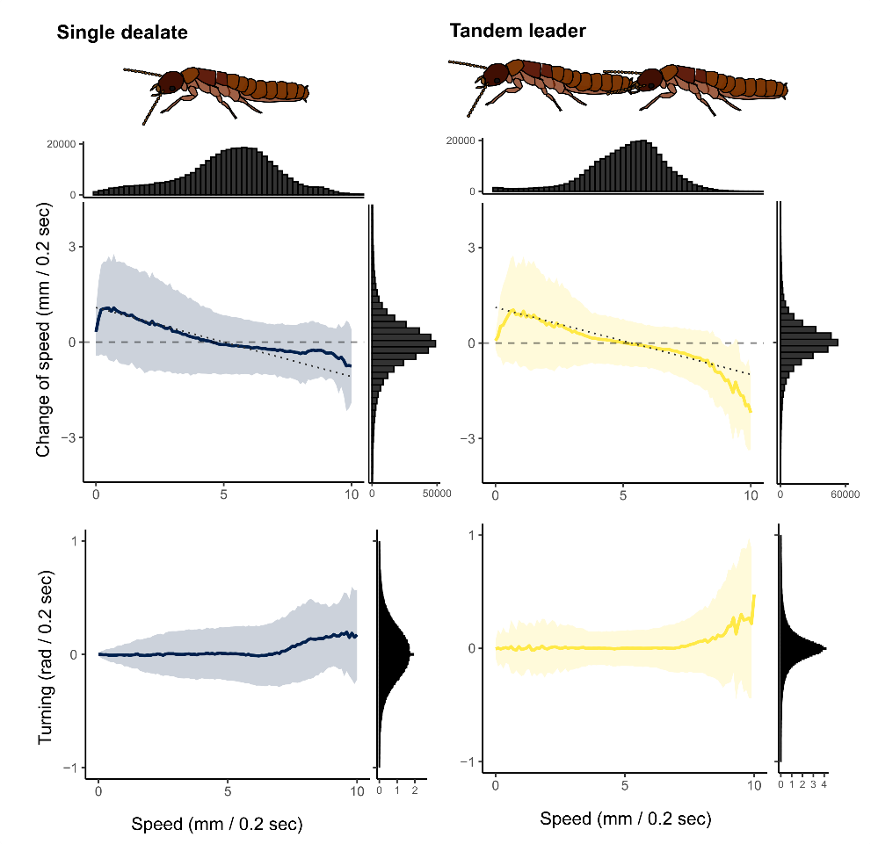

**Figure 2.** Movement parameters for termite dealates. The lines and colored area indicate the mean ± sd, which was calculated by binning the speed by 0.1. For the change of the speed (acceleration/deceleration), the dashed regression lines by LMM were drawn. The histogram of each kinetic parameter was also shown.

In both single dealates and tandem leaders,

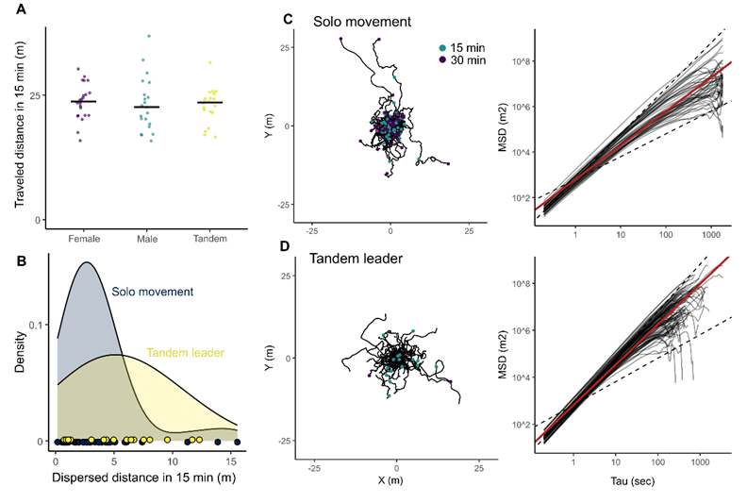

**Figure 3.** Dispersion patterns of termite dealates. (A) The comparison of traveled distance between different dealate units. The traveled distance for 15 minutes was obtained from the mean traveled distance in 0.2 seconds for each individual. (B) The distribution of dispersed distances from the starting point after 15 minutes in the unwrapped trajectories. Unwrapped trajectories and mean square displacements in (C) single individuals and (D) tandem leaders. Red regression lines are generated using LMM. Data of females and males are pooled in (B-C).

*Simulations*

I used an individual-based model to examine the mating encounter dynamics of termites with the estimated movements in the open space. Termites search for a mating partner in a periodic boundary condition of size, *L*area x *L*area. There are two different scenarios for mate search: i) without light, where all individuals are randomly located in the area, ii) with light, where all individuals are attracted by light before shedding their wings, and thus start from the concentrated area with size, *L*light x *L*light. In each condition, females and males walking until encountering another individual of the other sex. When the distance between the centers of a female and a male became smaller than φ (= 10 mm), they were regarded to encounter.

Individuals perform correlated random walks in terms of both speed and turning angles. The current individual movement speed is correlated with the previous speed as the acceleration correlates with the speed (Fig. 2), which is determined as follows:

,

where parameter values were obtained by fitting the empirical datasets, a =, b = , σ =. Turning angles also followed Laplace distribution with scale parameter σ =. I used Laplce distribution instead of common angular distributions, such as wrapped Cauchy or von Mises distributions because the distribution of empirically oserved turning angles was more skewed (Fig.), where Laplace distribution showed better fit.

In the simulation, one time step corresponds to 0.2 second, consistent with the frequency of data analysis of 5FPS. The simulation lasted for 30 minutes (9,000 steps), and the number of pairs produced was recorded for every frame. I set the initial number of individuals as 100, 1,000, and 10,000, corresponding to small, middle, and large swarming events (ref). The whole area size *L*area was 30m, and alates are attraced to the are with *L*light = 3m. The results of sensitivity analysis of these parameters are in the supplementary materials.

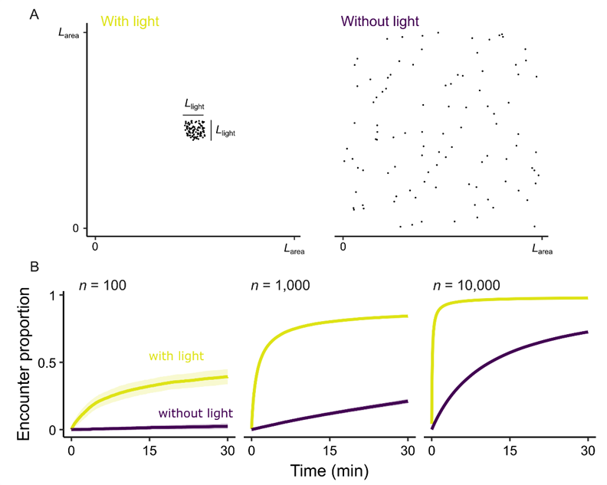

**Figure 4.** Termite movement simulations. (A)

**Discussion**

Tandem running pair showed more diffusion than single (go futher and show less sinuous motion). This makes sense ultimately and proximately

Urban light has influenced a lot. The effect is usually negative due to disruption. However, the urban light can contribute to the success of the termite colony foundation. Many invasive species are night flying.

Need caution. Wall affects behavior.

Because eradicating established colonies is challenging and expensive, prevention of initial infestation is the most economical management strategy. In this project, I aim to develop a trap to capture mating pairs, the unit of infestation. Mating pairs of drywood termites walk to search for a nesting site to found colonies. I will investigate the physical properties of incipient nests in natural conditions to detect favorable environments as nest sites. Then, I will computationally analyze their nest-site searching behavior. Based on these results, I will design a trapping system that catches mating pairs by providing more attractive nest sites than nearby human properties. By providing another approach to preventing drywood termite infestation, this study seeks to establish a new pest control service that is chemical-free and based on termite nesting biology.

**Acknowledgments**

Thank you for the nomination.

Thank you for all the collaborators relating to the series of projects.

HATCH project number.

**References**

Chouvenc T. 2023. A primer to termite biology: *Coptotermes* colony life cycle, development, and demographicsBiology and Management of the Formosan Subterranean Termite and Related Species. GB: CABI. pp. 40–81.

Chouvenc T, Sillam-Dussès D, Robert A. 2020. Courtship behavior confusion in two subterranean termite species that evolved in allopatry (Blattodea, Rhinotermitidae, *Coptotermes*). *Journal of Chemical Ecology* **46**:461–474. doi:10.1007/s10886-020-01178-2

Cuthbert RN, Diagne C, Haubrock PJ, Turbelin AJ, Courchamp F. 2022. Are the “100 of the world’s worst” invasive species also the costliest? *Biol Invasions* **24**:1895–1904. doi:10.1007/s10530-021-02568-7

Gordon JM, Velenovsky JF, Chouvenc T. 2022. Subterranean termite colony elimination can be achieved even when only a small proportion of foragers feed upon a CSI bait. *J Pest Sci* **95**:1207–1216. doi:10.1007/s10340-021-01446-4

Miramontes O, DeSouza O, Paiva LR, Marins A, Orozco S. 2014. Lévy flights and self-similar exploratory behaviour of termite workers: beyond model fitting. *PloS one* **9**:e111183. doi:10.1371/journal.pone.0111183

Mizumoto N, Bourguignon T. 2022. Light alters activity but does not disturb tandem coordination of termite mating pairs. *Ecological Entomology* een.13209. doi:10.1111/een.13209

Mizumoto N, Bourguignon T, Bailey NW. 2022. Ancestral sex-role plasticity facilitates the evolution of same-sex sexual behavior. *Proceedings of the National Academy of Sciences of the United States of America* **119**:e2212401119. doi:10.1073/pnas.2212401119

Mizumoto N, Dobata S. 2019. Adaptive switch to sexually dimorphic movements by partner-seeking termites. *Science Advances* **5**:eaau6108. doi:10.1126/sciadv.aau6108

Mizumoto N, Lee S-B, Chouvenc T. 2024. The strength of sexual signals predicts same-sex pairing in two *Coptotermes* termites. *Behavioral Ecology* arae067. doi:10.1093/beheco/arae067

Mizumoto N, Lee SB, Valentini G, Chouvenc T, Pratt SC. 2021. Coordination of movement via complementary interactions of leaders and followers in termite mating pairs. *Proceedings of the Royal Society B: Biological Sciences* **288**:20210998. doi:10.1098/rspb.2021.0998

Mizumoto N, Reiter S. 2025. Maintaining tandem movement cohesion through antennal movements in termites. doi:10.1101/2025.02.13.638054

Mizumoto N, Rizo A, Pratt SC, Chouvenc T. 2020. Termite males enhance mating encounters by changing speed according to density. *Journal of Animal Ecology* **89**:2542–2552. doi:10.1111/1365-2656.13320

Nagaya N, Mizumoto N, Abe MS, Dobata S, Sato R, Fujisawa R. 2017. Anomalous diffusion on the servosphere : A potential tool for detecting inherent organismal movement patterns. *PLoS ONE* **12**:e0177480. doi:10.1371/journal.pone.0177480

Nutting WL. 1969. Flight and colony foundation. In: Krishna K, Weesner FM, editors. Biology of Termites. New York: Academic Press. pp. 233–282. doi:10.1016/B978-0-12-395529-6.50012-X

Paiva LRD, Marins A, Cristaldo PF, Ribeiro D, Alves SG, Reynolds A. 2020. Scale-free movement patterns in termites emerge from social interactions and preferential attachments 1–39. doi:10.1073/pnas.2004369118/-/DCSupplemental.y

Perdereau E, Bagnères A-G, Vargo E l., Baudouin G, Xu Y, Labadie P, Dupont S, Dedeine F. 2015. Relationship between invasion success and colony breeding structure in a subterranean termite. *Molecular Ecology* **24**:2125–2142. doi:10.1111/mec.13094

Raina AK, Bland JM, Dickens JC, Park YI, Hollister B. 2003. Premating behavior of dealates of the Formosan subterranean termite and evidence for the presence of a contact sex pheromone. *Journal of Insect Behavior* **16**:233–245. doi:10.1023/A:1023967818906

Rust MK, Su NY. 2012. Managing social insects of urban importance. *Annual Review of Entomology* **57**:355–375. doi:10.1146/annurev-ento-120710-100634

Shimoji H, Mizumoto N, Oguchi K, Dobata S. 2019. Caste-biased locomotor activities in isolated termites. *Physiological Entomology* **45**:50–59. doi:10.1111/phen.12315

SU N-Y, Scheffrahn RH. 1998. A review of subterranean termite control practices and prospects for integrated pest management programmes. *Integrated Pest Management Reviews* **3**:1–13. doi:10.1023/A:1009684821954

Su N-Y, Scheffrahn RH, Ban PM. 1989. Method to Monitor Initiation of Aerial Infestations by Alates of the Formosan Subterranean Termite (Isoptera: Rhinotermitidae) in High-Rise Buildings. *Journal of Economic Entomology* **82**:1643–1645. doi:10.1093/jee/82.6.1643

Valentini G, Mizumoto N, Pratt SC, Pavlic TP, Walker SI. 2020. Revealing the structure of information flows discriminates similar animal social behaviors. *eLife* **9**:e55395. doi:10.7554/eLife.55395

**Supplement materials**