**Evaluating termite dealate dispersal using posture tracking dataset**

**Nobuaki Mizumoto**

Department of Entomology & Plant Pathology, Auburn University, Auburn, AL, 36849, USA

Correspondence: [nzm0095@auburn.edu](mailto:nzm0095@auburn.edu)

**Abstract**

Termites have two distinct phases in their life cycle: a stable mature colony and mobile mating dispersers.

Mature colonies are important as it directly damage the human property.

At the same time, mating dispersers determine the initial infestation, invasion success, and colony establishment.

Termite dispersers have to overcome a facet of challenges.

However, it is poorly understood how the success of mating termites is affected by the environmental factors.

In this study, I study the walking searching behavior of termites to evaluate the area covered by walking and the searching efficiency across different urban environments.

By reanalyzing experiments in the experimental arena with the deep-learning posture tracking approach, I estimated termite searching movement in an open space. Then, I simulated termite mate search dynamics under a variety of density conditions after different swarming events, and evaluate the effect of urban lighting environments on mating success.

I demonstrate that termite mating success is highly based on the local termite density, where urban lighting can greatly contribute to their success even in the low density population.

New lens to the termite biology.

**Keywords**

**Introduction**

1. Termite: mating pair is an important unit to think about pest management. However, termites damage human property when they are in the mature colony, so less attention has been paid to the mating partners. However, even though the mature colony is made up of millions of individuals, all colonies need to start from a mating pair (with a few exceptions).

About the termite tandem running. It is a critical life stage for colony establishments, biological invasion, and pest management. But this is not well appreciated.

Termite management strategies have traditionally focused on controlling mature colonies, as structural damage to buildings typically arises only after colonies reach an advanced developmental stage. However, every colony begins with a founding pair, and the behaviors surrounding colony initiation—particularly those occurring immediately after dispersal—represent a critical yet understudied phase in termite biology. In this study, I reanalyze previously published video data on termite mating behavior using deep-learning-based posture tracking to extract quantitative metrics of movement and interaction. Focusing on the dispersal dynamics of dealates, I aim to provide new insights into the early stages of colony founding and discuss the potential implications of these behaviors for termite population ecology and, ultimately, for early-stage pest intervention strategies.

2. mate pairing termites. how far they can go? Answer question C. formosanus how far they can go after attracted by light trap?

I study tandem running behavior of a termite.

Here I estimate how much tandem running pair can walk to look for nest site.

Here I summarize and reanalyze all published information about tandem running behavior in pest termite species (Reticulitermes speratus, Coptotermes formosanus, Coptotermes gestroi). Based on the data, I modeled their movement patterns to simulate how much they can disperse over time and how termites encounter partners. I also evaluated the effects of light trapping on their encounter process and colony foundation.

3. Mizumoto and Dobata 2019 evaluated searching strategies. They use body center. Current advancement in posture tracking this last 10 years.

4. In this study

**Figure 1.** Life cycle of subterranean termites, as an example of *Coptotermes formosanus*. In a season of the year, many alates (winged individuals) fly to disperse. After dispersal, females and males look for a mating partner. Encountered pair performs a tandem run to seek a nest site for colony foundation. The established colony grows into the mature colony, which produces alates again. Among these, only mature colonies can damage human property with a large number of colony members.

**Methods**

*Behavioral data*

I used the videos obtained in a previous study (Mizumoto and Dobata, 2019). In this study, experiments with *C. formosanus* were performed to study the adaptive mate search strategy used in termites. Alates from 2 colonies of *C. formosanus* were collected in Wakayama, Japan, in June 2017. After controlled nuptial flight experiments, termites that shed their wings were selected and used for tandem run experiments. Experiments were performed in a Petri dish (145 mm Ø) filled with moistened plaster whose surface was scraped before each trial. They observed termites in two different conditions; in single searching experiments, they introduced a female or a male termite to the experimental arena and recorded their movement for 30 minutes, while in tandem running observations, they introduced one female and one male together to the arena and recorded for 60 minutes. A total of X single females, Y single males, and Z tandem running pairs were observed. The videos were recorded at 30 frames per second using a video camera with a resolution of 640 by 480 pixels. All videos were cropped ~~.

All videos were analyzed using SLEAP v 1.4.0 (Pereira et al., 2022) to estimate the movement of body parts of each individual. The model was based on that developed for *Reticulitermes speratus* and *Coptotermes formosanus* in a previous study (Mizumoto and Reiter, 2025), with a 17-node skeleton: antenna tips (LR), antenna middle (LR), antenna base (LR), head (middle of mouth parts), head-pronotum boundary, pronotum-mesonotum boundary, metanotum-abdomen boundary, abdomen-tip, fore legs (LR), mid legs (LR), and the hind legs (LR). We trained a U-Net-based model with a multi-animal top-down approach, with a receptive field size of X pixels for the centroid and 156 pixels for the centered instance, on Nvidia GeForce RTX 4090, where augmentation is done by rotating images from -180 to 180 degrees. The mean Average Precision (mAP) and mean Average Recall (mAR) of this model were 0.36 and 0.49, respectively. While tracking after the inference, we used the instance similarity method with the greedy matching method. All pose estimation data were converted to HDF5 files for further analysis. We used Python to format all HDF5 files for further analysis and converted them into FEATHER files for analysis in R (R Core Team, 2024). We employed a linear interpolation method to address missing values in the dataset. After scaling all data from pixels to mm (1200 pixels = arena size), we used a median filter with a kernel size of 5 to reduce noise. All analyses were performed after downsampling at 5 FPS.

*Unwrapping movements in a dish to open space*

Termites walked ~~m in 30 minutes during our observations, suggesting that they can move by walking long distances even after shedding their wings. To evaluate the dispersal ability by walking in termite dealates, I converted the movement trajectories recorded in a circular dish into the approximated open-space movements by applying a series of corrections to movements bounded by a constrained space. The conversions addressed three main artifacts: wall-following behavior, mismatches between heading and movement directions, and sharp turns caused by the dish walls. Note that these conversions do not completely reflect their motion in the open space; instead, I aimed to approximate how far termites could disperse if there were no boundaries in a dish.

First, termites in a dish often exhibit wall-following behavior, moving along the perimeter of the dish in a smooth and curved trajectory (refs). I assume that termites would maintain their heading direction rather than curving along a dish wall. Thus, I considered that termites are forced to turn at angles that require them to rotate along the wall. To correct this, I searched for sequences of frames, where termites remained near the edge (defined as the outer half region in area) and moved for more than 10 mm. For each wall-following sequence, I obtained how many angles the termite rotated by converting their x-y coordinates into polar coordinates relative to the center of the arena. I then adjusted the trajectory by rotating positions to extend the path outward, unwrapping the wall-following sequences (Figure).

Second, especially near the wall, there were many discrepancies between the heading direction (direction from the abdomen tip to the head) and the actual movement direction. These discrepancies could occur due to movement such as body swinging, trying to overcome the wall, and tracking errors, not by actual turning behaviors. I identified the discrepancies as frames in which the angle between the heading direction and movement direction was larger than 0.5 radians. For these frames, I interpreted that the trajectory was distorted and adjusted the termite position by rotating it around the previous location to align with the heading direction. This assumes that the termite attempts to move forward along its body axis without redirection arising from the dish or tracking artifacts.

Finally, I addressed the sharp turns that occur near the arena wall, where the wall interrupts the straight motion while they are approaching or bump the dish wall. I identified the turning point that occurred within

I searched for turning points that occurred within [-rad_near_wall-] units of the edge and where the change in movement direction was large and sudden. To distinguish between voluntary turns and wall-induced deflections, I examined the radial distance before and after each turning point over a window of [-aframe-] frames. If the mean radial distance decreased after the turn, suggesting a rebound from the edge, I interpreted the event as a wall-induced deflection. I then corrected the trajectory by rotating subsequent positions to smooth out the turn and extend the previous movement direction forward. This adjustment assumes that the termite would have continued moving straight had it not encountered the boundary.

These virtual modifications allowed me to reconstruct trajectories that more accurately represent termite movement in an unconstrained, open environment. By reducing artifacts introduced by the dish, the resulting paths better reflect the dealates’ intrinsic movement tendencies and provide a more realistic foundation for analyzing their dispersal potential.

*Comparison with servospherar movement*

*Simulations*

I used an individual-based model to examine the mating encounter dynamics of termites with the estimated movements in the open space. Termites search for a mating partner in a periodic boundary condition of size, *L*area x *L*area. There are two different scenarios for mate search: i) without light, where all individuals are randomly located in the area, ii) with light, where all individuals are attracted by light before shedding their wings, and thus start from the concentrated area with size, *L*light x *L*light. In each condition, females and males walking until encountering another individual of the other sex. When the distance between the centers of a female and a male became smaller than φ (= 10 mm), they were regarded to encounter.

Individuals perform correlated random walks in terms of both speed and turning angles. The current individual movement speed is correlated with the previous speed as the acceleration correlates with the speed (Fig. 2), which is determined as follows:

,

where parameter values were obtained by fitting the empirical datasets, a =, b = , σ =. Turning angles also followed Laplace distribution with scale parameter σ =. I used Laplce distribution instead of common angular distributions, such as wrapped Cauchy or von Mises distributions because the distribution of empirically oserved turning angles was more skewed (Fig.), where Laplace distribution showed better fit.

In the simulation, one time step corresponds to 0.2 second, consistent with the frequency of data analysis of 5FPS. The simulation lasted for 30 minutes (9,000 steps), and the number of pairs produced was recorded for every frame. I set the initial number of individuals as 100, 1,000, and 10,000, corresponding to small, middle, and large swarming events (ref). The whole area size *L*area was 30m, and alates are attraced to the are with *L*light = 3m. The results of sensitivity analysis of these parameters are in the supplementary materials.

**Results**

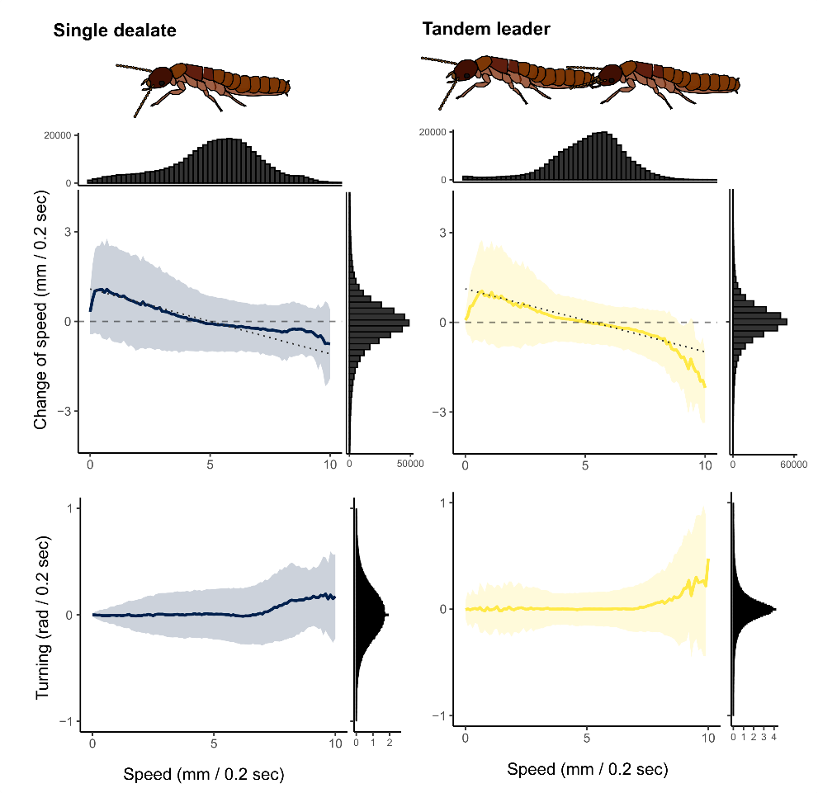

**Figure 2.** Movement parameters for termite dealates. The lines and colored area indicate the mean ± sd, which was calculated by binning the speed by 0.1. For the change of the speed (acceleration/deceleration), the dashed regression lines by LMM were drawn. The histogram of each kinetic parameter was also shown.

In both single dealates and tandem leaders,

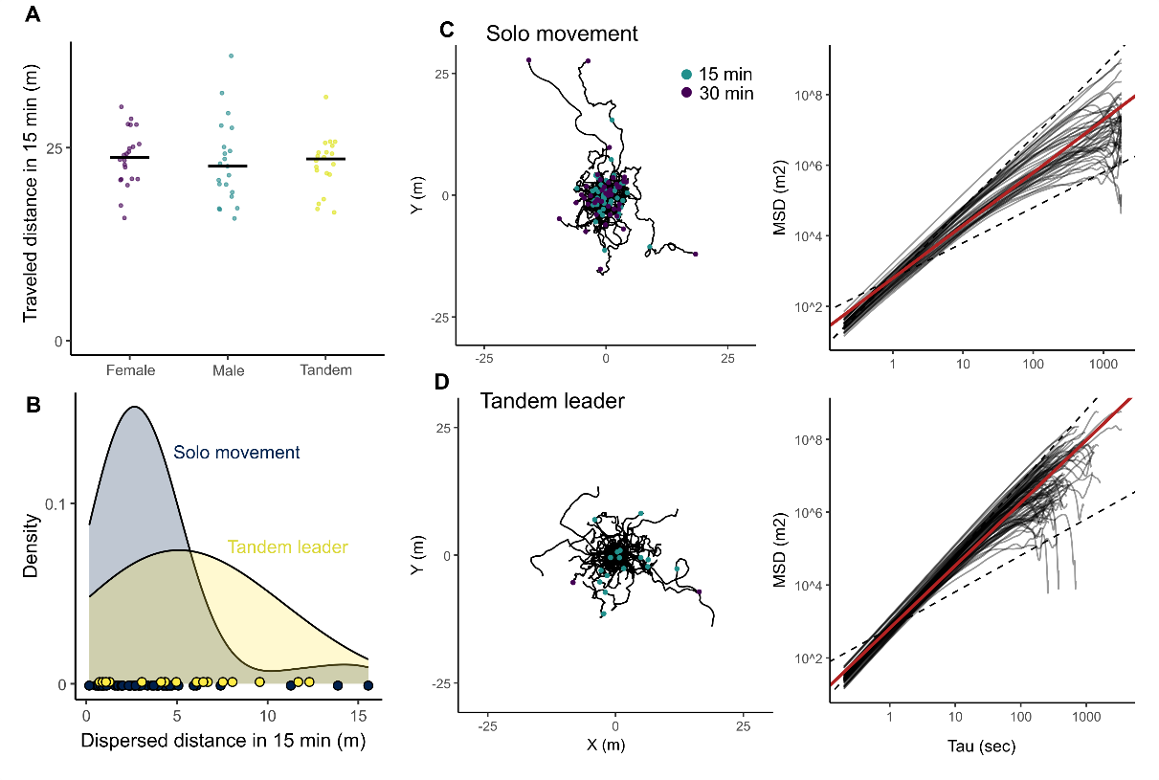

**Figure 3.** Dispersion patterns of termite dealates. (A) The comparison of traveled distance between different dealate units. The traveled distance for 15 minutes was obtained from the mean traveled distance in 0.2 seconds for each individual. (B) The distribution of dispersed distances from the starting point after 15 minutes in the unwrapped trajectories. Unwrapped trajectories and mean square displacements in (C) single individuals and (D) tandem leaders. Red regression lines are generated using LMM. Data of females and males are pooled in (B-C).

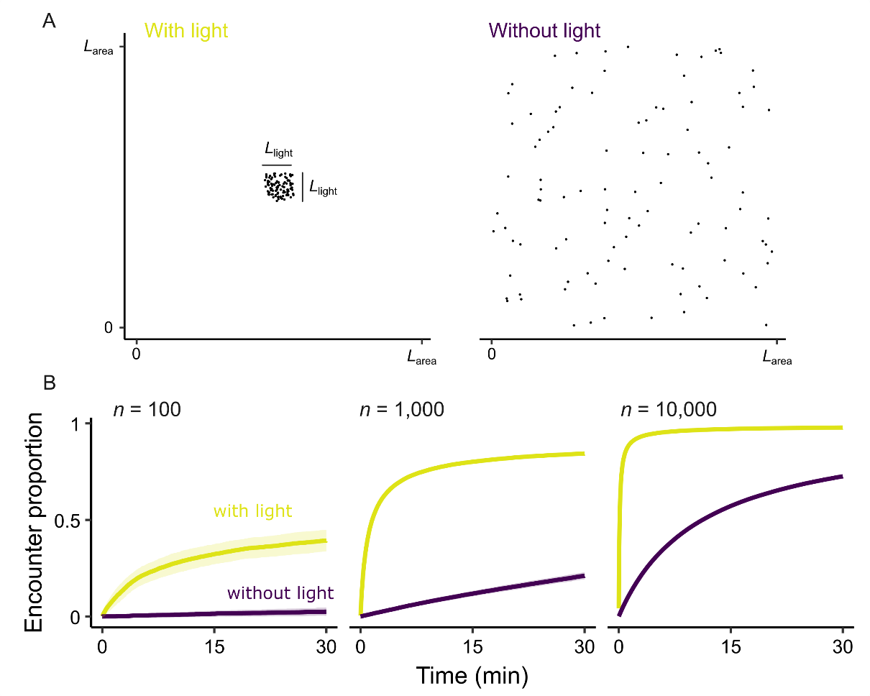

**Figure 4.** Termite movement simulations. (A)

**Discussion**

**Acknowledgments**

Thank you for the nomination.

Thank you for all the collaborators relating to the series of projects.

HATCH project number.

**References**

**Supplement materials**