Four decades of inland invasion by Formosan subterranean termite in Alabama: expansion associated with transportation infrastructure

Xing Ping Hu¹ and Nobuaki Mizumoto^{1,2*}

1. Department of Entomology & Plant Pathology, Auburn University, Auburn, AL, 36849, USA
*: Correspondence: nzm0095@auburn.edu

ORCID: XPH: 0000-0002-2334-037X; NM: 0000-0002-6731-8684
Short title: Distribution of C. formosanus in Alabama

Abstract
Invasive termite species pose ecological and economic concerns due to their eusociality and large colony size. The Formosan subterranean termite, Coptotermes formosanus Shiraki, is listed among the world's worst invasive species and has established invasive populations across continents. Most studies have emphasized their transoceanic international dispersal and establishment in the coastal areas. However, inland expansion at the local and regional scales within the terrestrial landscape has rarely been tracked. Here, we show that expansion of C. formosanus is strongly associated with road transportation infrastructure, particularly the interstate highway system in Alabama, USA. We compiled 40 years of distribution records, primarily reported from the Alabama Cooperative Extension Service and the Alabama Pest Control Association. Since its first detection at the Port of Mobile in 1985, C. formosanus has been recorded in 32 of 67 counties, with an ongoing increase in detections. Time-to-detection models indicated that climate, human population density, and the presence of interstate highways were associated with county-level C. formosanus infestation, whereas small roads or railway density were not. These results illustrate a steady northward progression of the species’ established range, highlighting the importance of continued monitoring of inland invasion pathways.

Keywords: Invasive species phenology, human-mediated dispersal (HMD), urban entomology

Introduction

The Formosan subterranean termite (Coptotermes formosanus Shiraki; Blattodea, Heterotermitidae) has spread significantly since its U.S. introduction approximately 70 years ago (La Fage 1985). Native to mainland China (Kistner 1985), it was first recorded in the Port of Huston, Texas in 1965 (Ref.). Though likely introduced via military cargo from the Pacific theater after World War II, its arrival is not linked to a specific commodity. Since then, C. formosanus has expanded rapidly – primarily through human transport rather than natural dispersal (Hu and Oil 2002, Woodson et al. 2001). By the mid-2000s, the species established a contiguous presence from Texas to Louisiana, with various isolated populations across the coastal southeast (Fig.). The range expansion in Alabama and across the U.S. has primarily involved “filling in” the gaps between isolated populations established during the initial 50 years. These infestations resulted from termite populations “hitchhiking” on wooden materials – most notably recycles railroad ties, landscaping timbers, potted plants, and wood debris after hurricane – transported throughout the Southeast. Interestingly, the southern latitudinal limits in South America (~ 32ºS) roughly mirror the northern limits in the U.S. (34ºN).
Predicting the ultimate range of C. formosanus remains contentious and hinges on specific biological assumptions. Lacking true hibernation, its northward expansion is likely limited by winter temperatures or growing seasons too short for colony development. While northern Alabama was previously considered uninhabitable, established colonies were detected there, suggesting it is approaching its thermal limit (Hu and Appel 2004). The duration of cold season may be more critical than a single temperature minimum, as these termites employ behavioral and physiological strategies to survive short-term cold. However, the exact mechanisms of these limitations remain poorly understood.
The ultimate distribution will likely be determined by the intersection of climate, physiological, and biotic factors. In less favorable areas or along the margins of its eventual range, the species is expected to be a less dominant component of the local termite fauna, facing increased competition from native species better adapted to those specific environmental stressors.
Impact of FST in the U.S.
C. formosanus forms large colonies, forages more aggressively, and consumes wood at a significantly higher rate than native subterranean species (Su & Scheffrahn 1988). The species is easily identified by the unique morphology and behavior of its solider and alate (winged) castes. Soldiers are distinguished by their tear-drop shaped head and their defensive behavior; they appear in large numbers when a colony is disturbed, typically comprising about 20% of the total population (Haverty 1977). The alates are brownish in color, with wings covered in fine, microscopic hairs. In Alabama, it is known for their massive evening swarms, typically after rainfall between May and June, where they are attracted to artificial lights.
Initial public alarm-often termed a “parade of horrors”-and political pressure led to a federal funded “Formosan Termite Full-Stop” program, from 1995 – 2012, jointed by a selected few infested state. The human response to FST is often deeply emotional, a sentiment symbolically mirrored by the” tear-shaped” heads of the soldier castes. Compared to other termites, FST maintain significantly larger colonies with high populations; they are more aggressive and exhibit a greater ability to forage without direct ground contact. This behavior leaves a trail of devastation, including structural collapses and the loss of mature trees.
As of 2001, FST had been officially reported in 11 U.S. states, including California Hawaii, Alabama, Florida, Georgia, Louisiana, Mississippi, South Carolina, North Carolina, Texas, Tennessee. Range expansion has been reported in each state since then (Su 2003a, Ray 2003, Structural Pest Control Division 2003, Hathorne et al. 2000, Howell et al. 2001, Messenger et al. 2002). Its worldwide distribution remains primarily in areas between about 35º north and south of the equator (Su 2003b).
Alabama is located between the longitude 84° 51' W to 88° 28' W, and the latitude 30° 13' N to 35° N. Because of the destructive nature and economic importance of C. formosanus, the public has been concerned about its northward and inland spread into Alabama. C. formosanus was first found in Alabama (Su and Scheffrahn. 1986, Sponsler et al. 1988) during the 1980’s. Since then, Alabama Cooperative Extension System has been documenting C. formosanus spread, by county, with the help of research entomologists, the pest management industry, state Department of Agriculture and Industries inspectors, homeowners, and the general public. This paper presents the results of 18 years of work.

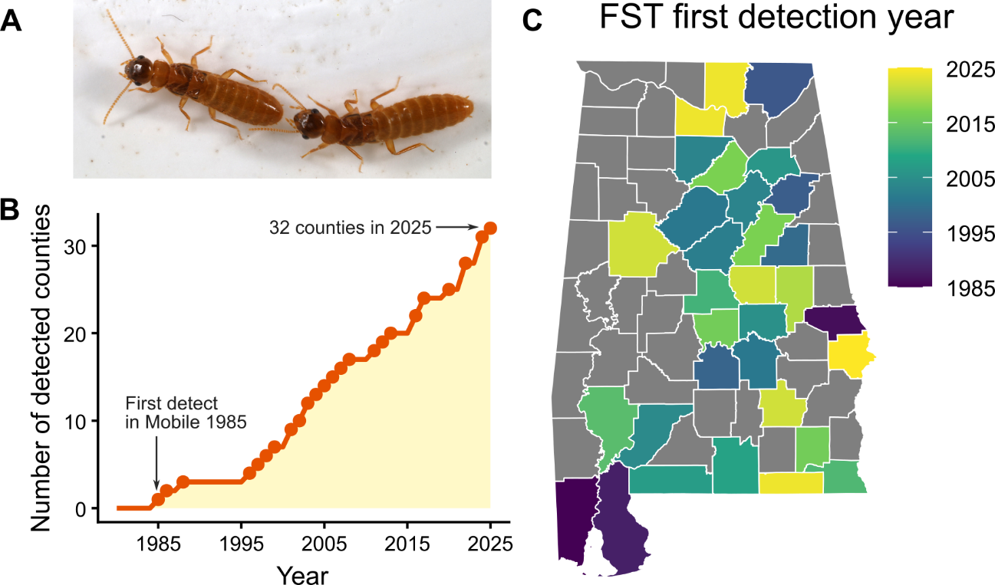
Figure 1. The expansion of the detection of C. fomorsanus termites in Alabama. (A) A mating pair of C. formosanus in tandem running, which is the most commonly observed form for the general public after the seasonal swarming flight. (B) The time development of the cumulative number of counties with C. formosanus detection. (C) County map of Alabama with the first detection year of Formosan subterranean termites (FST).

Materials and Methods
Data collection
All data were collected through multiple survey efforts, mostly via samples submitted to the authors or to the Auburn University Plant Diagnostic Laboratory by residents, professional pest control operators, and Extension agents in Alabama. Submitted samples were identified using dichotomous keys (1, 2). To facilitate the submission, Alabama Cooperative Extension System initiated two series of Formosan Subterranean Termite Awareness educational programs: 1) a train-the-trainer program focused on educating county extension agents, who in turn made the information and educational materials available to clients of each county; 2) collaboration with Alabama Pest Control Association, focusing on pest management professionals. In addition, publications on termite biology and management methods were developed and disseminated to homeowners and residents across the state. In 2025, In summary, intensive field collections were made in cooperation with county extension agents and pest management professionals in counties with C. formosanus records.
All of the voucher specimens after 2000 are deposited in the Extension Collection at Auburn University. Most of the infestations were reviewed by interviews conducted by the authors with property owners or by inspecting the sites and adjacent areas within days after an infestation was reported. In total, we obtained XXX samples of C. formosanus. In addition, data from the Auburn University Insect Collection were examined, and state inspectors were consulted about cases they had encountered.
Most samples and records of C. formosanus termites are alates during the seasonal mass dispersal events. In Alabama, it is usually from April to June, depending on the latitude and temperature. The presence of alates is considered to represent an established infestation of C. formosanus (Su & Scheffrahn 1986). First detection events are typically associated with the swarming dispersal flights that are attracted by urban lights near human property or even inside the building. This leads to the seasonal surge of phone calls to the Extension agency. Thus, the first detection year based on the reports from homeowners, pest professional agents, and Extension agencies is considered to reflect the year established in the area, rather than the temporal changes in sampling efforts.

Data analysis
To investigate the biotic and abiotic factors associated with the county-level first detection year of C. formosanus, we used the Cox proportional hazard model (3). In 1985, the first report of C. formosanus in Alabama in Mobile, as a starting year, we measured the years until detection for every county. We treated the county without any records in 2025 as a censored observation. As factors potentially affecting the detection year, we included the latitude (proxy of climate), human population density (/km²), the density of primary and secondary roads (/km²), the density of railroads, and the presence of an Interstate highway (Fig. 2). County-level information of these variables was obtained using the “sf” package v1.0-24 (4) and the “tigris” package v.2.2.1 (5) in R. The information was based on data from 2024, except for railroads, which are based on 2011 data. The primary and secondary roads include the Federal interstate highway system, main arteries, usually in the U.S. highway, state highway, or county highway system, according to the Census Bureau (5). All the variables were scaled using the z-value transformation. We used the coxph() function of the “survival” package (6) of R, where we did not consider the interactions between variables. We used the likelihood ratio (type II) test to investigate each explanatory variable’s statistical significance, using the Anova() function in the package ‘car’, while the effect size was evaluated based on the hazard ratio. Both covariants of any variables and the global model did not violate the assumption of the proportional hazards assumption, according to the function cox.zph() (all p > 0.1; global test p = 0.40). Pairwise correlations among variables also confirmed that most correlations were low to moderate (Spearman’s ρ < 0.45), although population density and road density showed a strong positive correlation (ρ ≈ 0.81). All analyses were performed using R v4.5.2 (7).

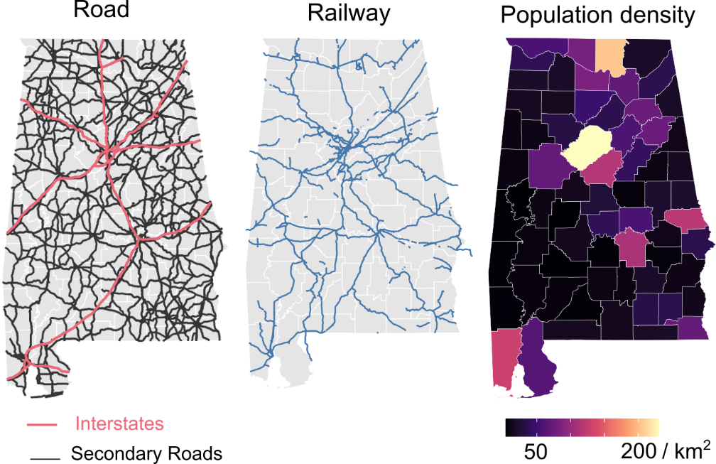
Figure 2. Human transportation infrastructure and population densities in Alabama, as the potential factors affecting the expansion of C. formosanus. We investigated the effect of road and railway density (km/km²) for each county, the presence of an Interstate highway, the human population density, and the latitude.

Results
The first confirmed C. formosanus infestation was identified from a termite collection in Mobile made in 1985 and reported by Su and Scheffrahn (1986). Over the past 40 years, a collective effort has identified many C. formosanus infestations. As of 2025, the number of counties with verified C. formosanus infestations has increased to 32 (Fig. 1B). Jackson and Madison counties represent the northernmost inland range in Alabama (Fig. 1C), and thus that all counties in Alabama can be infested by C. formosanus. The increase in the number of reported counties has not clearly saturated yet (Fig.1B).
Our Cox proportional hazard model estimated that the latitude, human population density, and the presence of Interstate highways (i.e., I-10, I-20, I-59, I-65, I-85, and their Auxiliary Highways) had significant effects on the early detection of C. formosanus in each county. The presence of the interstate highways had the largest effect on detection timing (Hazard ratio: HR = 2.65; 95% confidence interval: CI = 1.16-6.07; χ²₁ = 5.31, P = 0.021; Fig. 3), where counties with interstates were 2.65 times more likely to detect C. formosanus compared to counties without an interstate. Latitude also showed a large effect as the most significant factor (HR = 0.44; 95% CI = 0.28-0.69; χ²₁ = 13.22, P < 0.001; Fig. 3). Higher latitude reduced the hazard of detection by 56%. Finally, human population density significantly increased the hazard of detection (HR = 1.74; 95% CI = 1.12-2.71; χ²₁ = 5.26, P = 0.022, Fig. 3). On the other hand, we did not the signficant effects of rail density (HR = 1.08; χ²₁ = 0.12, P = 0.73, Fig. 3) or road density (HR = 1.23; χ²₁ = 0.64, P = 0.42, Fig. 3).
Using the Cox proportional hazard model, we estimated the counties without C. formosanus records so far, but the highest risk of detection (Fig. SX). The 10 counties with the highest risks are as follows: Conecuh, Butler, Coffee, Macon, Sumter, Greene, Chambres, Limestone, Henry, and Crenshaw, where the probabilities of detecting C. formosanus in 2025 were from 77.1% (Conecuh) to 45.4% (Crenshaw).

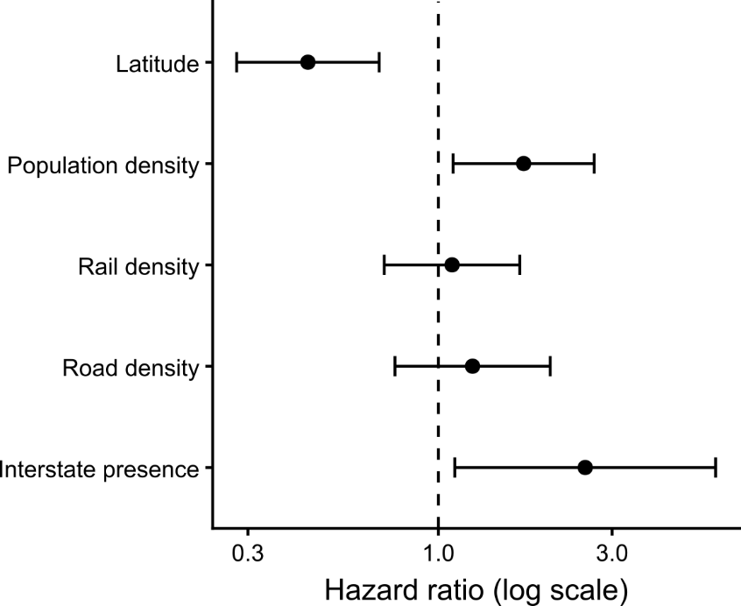
Figure 3. The forest plot of hazard ratios ± 95% CI from the Cox proportional hazards model for factors affecting county detection of C. formosanus. HR values > 1 indicate increased hazard.

Discussion
Records show that the Formosan subterranean termite infestations have occurred in and around structures or trees in residential areas, and are often associated with introduction of used railroad crossties as landscaping timber. In a few cases, infested construction timber obtained from Louisiana was thought to have been associated with the infestations.
A review of records shows a clear pattern of the range expansion along main interstate highways, possibly indicating that the spread was/is transported by human commercial activity via infested materials. All of the infested counties lie either across or close to the five main interstate highways (I-10, I-65, I-85, I-20, and I-59) (Fig. 2). Records also show that all the initial infestations in inland cities are not contiguous, indicating multiple introductions rather than the slow migration of the population. The alates are weak fliers and do not spread rapidly on their own (Su & Tamashiro 1987).
Moisture and temperature are environmental factors affecting termite distribution. However, annual precipitation and daily relative humidity levels have less effect on C. formosanus infestation and establishment in Alabama because soil moisture requirements can be satisfied in almost all coastal areas and inland areas with the irrigation of lawns and gardens.
The limiting factor on C. formosanus distribution might have been winter temperature, but it has established in colder climates in Alabama than previously reported. C. formosanus is more abundant and more widely distributed in two southern coastal counties, Mobile and Baldwin, which have warmer winter temperature than inland counties. In inland counties, this termite remains a spotty and highly localized pest, but numbers of infestations and customer claims increasing every year. It was reported that under natural conditions in China, C. formosanus could survive in coastal areas with mean January air temperatures ≥ 4ºC and mean minimum air temperatures ≥ -5ºC (Li 1991). Also in Japan, C. formosanus is generally limited to the area with a mean January temperature ≥ 4ºC (Abe 1937). It had been estimated that C. formosanus might not become established in the northern climates of Alabama because of its vulnerability to cold (Appel & Sponsler 1989). Strikingly, the well-established infestation (34º14’N, 86º51’W) in Cullman county is 290 miles inland where the mean air temperature in January 2003 was 2.11ºC, and the lowest -15.00ºC (Alabama Mesonet Weather Data). Insect development and survival are functions of temperature and exposure time (Tamaki et al. 1980). One explanation of the establishment of C. formosanus in this cold area is that only prolonged low temperature can limit its distribution. The other explanation is that its protected colonies and avoidance behaviors (moving downward in the ground where temperature is more uniform) beside their association with the more or less controlled temperatures in man-built structures might allow termite to exist in colder climates than previously reported (Strack and Myles 1997). In addition, the lower critical temperature minima and the physiological capabilities of temperature acclimatization also contribute to the establishment C. formosanus in areas having snow and ice in winter (Hu and Appel, unpublished)
The C. formosanus has been rapidly expanding its distribution in Alabama. Our educational programs have had positive impact on public awareness of this termite. Our extension clients are serving as the public surveillance and helping to update the expansion of this termite. However, there is no governmental effort to mitigate the expansion of C. formosanus in Alabama. Individual property owners are encouraged to contract with pest management companies for treatment, but this is not always an affordable option. Coordination of a statewide Formosan termite control effort is in great need. Preventing the spread of this destructive exotic insect should not rely on private citizens, but rather, will require founding and organized management from other sources.

Acknowledgment
This work could not have been completed without continuous collaborative effort from all the field agents of Alabama Cooperative Extension System (ACES), Agriculture Research Station, Alabama Pest Control Association, Alabama Department of Agriculture and Industries, and our invaluable clients all over the state. Our gratitude also extends to: Arthur G. Appel (Auburn University), Debra K. Carey (Plant Diagnostic Laboratory technician), Renee Andersons (former Ph.D. student at Auburn University), Marla Favor (Baldwin County extension gent), Guy Karr (Alabama Department of Agriculture and Industries), members of Fairhope Termite Committee, and all the pest control professionals. This project was supported by Auburn University Hatch Program.

Author contributions
XPH:
N.M.:

Data accessibility
The data and codes for this study are available in .

References

Abe, Y. 1937. On the distribution of the Oriental termite, Coptotermes formosanus Shiraki, in Japan. Tohoku Imp. Univ. 4th series. Biolgoy XI. 4: 463-472.

Alabama Mesonet Weather Data. http://www.awis.com/mesonet/index.html.

Hathorne, K. T., P. A. Zungoli, E. P. Benson, and W. C. Bridges. 2000. The termite (Isoptera) fauna of South Carolina. Journal of Agricultural and Urban Entomology. 17(4): 219-229.

Haverty, M. I. 1977. The proportion of soldiers in termite colonies: a list and a bibliography (Isoptera). Sociobiology. (15)2: 199-216.

Howell, H. N., R. E. Gold, and G. J. Glenn. 2001. Coptotermes distribution in Texas (Isoptera: Rhinotermitidae). Sociobiology. 37(3B): 687-697.

Kistner, D. G. 1985. A new genus and species of termitophilous Aleocharinae from mainland China associated with Coptotermes formosanus and its zoogeographical significance (Coleoptera: Staphylinidae). Sociobiology. 10: 93-104.

Kofoid, C. A. 1934. Climate factors affecting the local occurrence of termite and their geographical distribution, pp. 13-21. In C. A. Kofoid, et al. [eds.], Termites and termite control. Berkeley, University of California Press.

La Fage, J. P. 1985. Practical considerations of the Formosan subterranean termite in Louisiana: one 30-year-old problem. pp. 37-42. In M. Tamashiro and N.-Y. Su [eds.], Biology and Control of the Formosan Subterranean Termite, Hawaii Institute of Tropical Agriculture and Human Resources, Honolulu.

Li, Y.-H. 1991. The influence of temperature on the survival and activity of Coptotermes formosanus Shiraki. Acta. Entomological. Sinica. 34(1): 126-128.
Messenger, M. T., N.-Y. Su, and R. H. Scheffrahn, 2002. Current distribution of the Formosan subterranean termite and other termite species (Isoptera: Rhinotermitidae, Kalotermitidae) in Louisiana. Florida Entomologist. 85(4): 580-587.

Ray, R. 2000. New Breed of termite moves into Mississippi. http://msucares.com/news/print/fwnews/000124dv.htm.

Sponsler, R. C., K. S. Jordan, and A. G. Appel. 1988. New distribution record of the Formosan subterranean termite, Coptotermes formosanus (Isoptera: Rhinotermitidae), in Auburn, AL. Entomologist News. 99(2): 87-89.

Strack, B. H. and T. G. Myles. 1997. Behavioral responses of the eastern subterranean termite to falling temperatures (Isoptera: Rhinotermitidae). Proc. Entomol. Soc. Ontario. 128: 13-17.
Structural Pest Control Division. 2003. North Carolina PCOs warned about Formosan termites. Pest Control Technology. March 22-23.

Su, N.-Y. 2003a. Formosan Termites spreading throughout SW Florida. St. Petersburg Times, July 15.

Su, N.-Y. 2003b. Overview of the global distribution and control of the Formosan subterranean termite. Sociobiology. 41(1): 7-16.

Su, N.-Y., and R. H. Scheffrahn. 1986. The Formosan subterranean termite, Coptotermes formosanus (Isoptera: Rhinotermitidae), in the United States: 1970-1985. pp. 31-38. In P.A. Zungoli [ed.], Proc. 1st Natl. Urban Entomol. Conf., College Park, Maryland.

Su, N.-Y., and R. H. Scheffrahn. 1988. Foraging population and territory of the Formosan subterranean termite (Isoptera: Rhinotermitidae) in an urban environment. Sociobiology. 14: 353-359.

Su, N.-Y., and M. Tamashiro. 1987. An overview of the Formosan subterranean termite in the world. pp. 3-15. In M. Tamashiro and N.-Y. Su [eds.], Biology and control of the Formosan subterranean termite. College of Tropical Agriculture and Human Resources, Univ. Honolulu, Hawaii.

Tamaki, G., M. A. Weiss, and G. E. Long. 1980. Impact of high temperature on the population dynamics of the green peach aphid in field cages. Environ. Entomol. 9: 331-337.

Wayne Cline, Alabama Railroads (cover the states’s rail history from its earliest beginnings to its heifht of service.

Weesner, F. M. 1965. Termites of the United States, a handbook. National Pest Control Association. Elizabeth, New Jersey. 70 pp.

Woodson, W. D., B. A. Wiltz, and A. R. Lax. 2001. Current distribution of the Formosan subterranean termite (Isoptera: Rhinotermitidae) in the United States. Sociobiology. 37(3B): 662-671

Appendix
County-by-county history of invasion records of Coptotermes formosanus

Listed below are the dynamics of the C. formosanus spread in Alabama counties in chronological order.

1. Mobile (1985)
Su and Scheffrahn (1986) documented the first appearance of C. formosanus in Alabama. A termite collection made in 1985 was identified by Ray Beal and the voucher samples deposited at the USDA Forest Service, Gulfport. Two years later, alate samples were identified by Appel & Sponsler (1989) (8) from mosquito light traps in many locations. Since then, this termite has continued to spread across this coastal county. From 1995 to 1998, one pest management company reported at least 39 homes and one subdivision in the Mobile-city area infested with C. formosanus based on their contract information and as verified by an experienced pest management professional who worked closely with Extension. In 2002 alone, 28 incidents were reported to Extension; 23 were new reports, and 5 already had contracts with pest management companies who treated those houses 3-5 years before, with either Dursban (a.i. chlorpyrifos, Dow AgroSciences, Indianpolis, IN) or Prevail (a.i. cypermethrin; FMC Corporation, Philadelphia, PA).
Mobile is the 1st capital of colonial French Louisiana in 1702, Port of Mobile had been a key trading center and a key shipbuilding city before the WWII. After WWII, it became a key paper industry city. The Gulf of Mexico offers it a mild subtropical climate. Mobile is served by four Class I railroads, including the Canadian National Railway (CNR) which has small US railways carry extensive trackage along Missisippi River valley from the Great Lakes to the Gulf of Mexico, CSX Transportation (CSX) which operates the CSX Railroad from Florida passing Mobile, the Kansas City Southern Railway (KCS) which , and the Norfolk Southern Railway (NS).^{[133]} The Alabama and Gulf Coast Railway, a Class III railroad, links Mobile to the Burlington Northern and Santa Fe Railway at Amory, Mississippi. These converge at the Port of Mobile, which provides intermodal freight transport service to companies engaged in importing and exporting. Other railroads include the Terminal Railway of Alabama State Docks (TASD), a switching railroad, and the CG Railway, a rail ship service to Coatzacoalcos, Veracruz.^{[133]} The city was served by Amtrak's Sunset Limited passenger train service until 2005, when the service was suspended because of the effects of Hurricane Katrina. There are plans for the service to be resumed.^{[134][135]}
Two major interstate highways and a spur converge in Mobile. Interstate 10 runs northeast to southwest across the city while Interstate 65 starts in Mobile at Interstate 10 and runs north. Interstate 165 connects to Interstate 65 north of the city in Prichard and joins Interstate 10 in downtown Mobile.^{[136]} Mobile is well served by many major highway systems. United States Highways US 31, US 43, US 45, US 90 and US 98 radiate from Mobile traveling east, west, and north. Mobile has three routes east across the Mobile River and Mobile Bay into neighboring Baldwin County, Alabama. Interstate 10 leaves downtown through the George Wallace Tunnel under the river and then over the bay across the Jubilee Parkway to Spanish Fort/Daphne. US 98 leaves downtown through the Bankhead Tunnel under the river onto Blakeley Island and then over the bay across the Battleship Parkway into Spanish Fort, Alabama. US 90 travels over the Cochrane-Africatown USA Bridge to the north of downtown onto Blakeley Island where it becomes co-routed with US 98.^{[136]}
Infestation cases are reported every year with increasing numbers.

2. Lee (1986)
In 1986, a total renovation of the County Courthouse revealed destructive damage by Formosan subterranean termites. The Courthouse was radically rebuilt for the most parts of ground-above. (Lee County Judge, English 2011 personal communication). However, the first published record was an alate swarming on June 4th 1987 and the discovery of active infestation of old railroad crossties that was placed on the ground as flower bed borders near the reported swarm site on the campus of Auburn University (Sponsler et al. 1988) (9).
Chronicle: 2001: swarming in courthouse and downtown Opelica; 2004: 4 ft diameter Percan tree swarmed out FST; 2004 Collapse of Renfro Opera-House collapsed due to FST; 2006: 4 historic buildings in Downtown Opelica had swarming inside; 2007: Night-Club for sale was hunted by FST; 2011: In January, the Judge noticed sprinklers head came down from ceiling while he was at the meeting, a following inspection revealed 2 out of the 5 roof trusses are severely damaged, rending the structure integrity not safe to occupants. Roof framing members and beams in the attic are hollowed, insulation styroform in walls filled with tunnels, resulting in the close of the 2nd floor of the Courthouse for restoration. 2011 Opelika Termite Program Initiative. 2011 Auburn High School swarming from ceiling.
Formosan subterranean termites have comfortable made home in Lee County. Infestations have been detected in numerous locations in all the cities every year. Six infestations were documented in 1990’s, and 6 since 2001. Six infestations were in living trees or tree stumps around houses and 6 were in structures.
Of the 6 infestations that occurred from 2001-2003, 5 were associated with recycled railroad crossties. One infestation is believed to have been brought in building material (construction timber) obtained from Louisiana. All the infestations were treated using either baits or liquid termiticides by pest management professionals, except for 1 tree infestation which is monitored closely to determine termite population level, and will be treated after the termite population level is determined.
Opelika is listed on the National Register of Historic Places, a historical town full with rich heritage and delightfully different beauty than New Orleans. Opelika became a commercial center, in late 1840s, with the coming of the railroad that is the only direct rail route between New Orleans and the Eastern Seaboard (this lies the answer on how and when Formosan settled in Opelika). After 1851, it rapidly became on the primary trade lines for shipments of agricultural products (raw cotton) from Southern plantations to the North, and almost overnight, Opelika became a regional hub for commerce. The 2nd heyday of Opelika was between 1930 and 1970 as rapid industrial growth turned Opelika into a regional economic powerhouse. It features Historic Railroad Avenue, where you can hear the whistles blow and enjoy the rumblings of trains as they travel through the city.
In 2011. The second and third floors of the building are rid of the termite infestation that was discovered last summer as two new wooden columns support the roof. Steel girders are being put in place to run along the existing trusses to permanently take the load of the roof. "Basically, the entire roof sits on these five trusses," said Roger H. Rendelman, Lee County administrator. "And the trusses hold up the roof along with all the mechanical stuff like the sprinkler system." The termite problem has forced repairs that have totaled an estimated $400,000. Those costs are covered under the bond of the building, according to Rendelman. The trusses in the attic of Lee County Courthouse were slowly being eaten away by the infamous Formosan Termite.
The second and third floors of the building are rid of the termite infestation that was discovered last summer as two new wooden columns support the roof. Steel girders are being put in place to run along the existing trusses to permanently take the load of the roof.
Auburn: 2005 5-y new subdivisions found FST damage (heavy), then each year. 2011 May 12 Auburn High School infested by swarm from ceiling (night crew).
In 2025, ACES specialist received 29 calls from residents reporting FST swarming inside homes in Auburn; 43 calls from Opelika, and amount 50 calls from other cities/towns.

3. Baldwin (1988)
Widespread occurrence of alates captured from mosquito light traps by Appel & Sponsler (1989) (8) could indicate that this termite has been established for many years in this county. 2002 Several city trees infested and treated. Fairhope City Formosan Termite Watch Program in 2003 reveals that about 70% of the selected areas throughout the city are infested by C. formosanus. Some of the sticky cards were covered with >200 Formosan termite alates, which indicates that the termite population is large, or cards were very near a swarm site. 2011: extremely high FST population, city requested educational program again.
>20 cases every year since 2011
In 2003, Fairhope City in Baldwin County sponsored a Formosan Termite Watch program to estimate current distribution of C. formosanus within the city limits. This program integrated a sticky trap collection program and surveillance through public relations activities. Volunteers positioned sticky traps (Bell Laboratories, Inc. Madison WS, and Trece Incorporated, Salinas, CA) near light sources at 109 selected locations throughout the city. Traps were replaced every other week from May through July and sent to the Extension System for examination.

4. Jackson (1996)
Only one infestation was reported from this county in 1996. The only evidence of C. formosanus was alates collected in a windowsill in Scottsboro, AL, submitted by a pest management professional who was doing an annual inspection. Scottsboro is in the northeastern-most county of Alabama, on the Tennessee border at latitude 34.67N and longitude 86.03W. The house was approximately 150 m from a railroad track with railroad ties. A one-year follow-up monitoring using in-ground wood stakes did not detect termites in the soil and there has been no new incident since then.
New infestations were detected in 2023 and 2025.

5. Calhoun (1997)
The first infestation was reported from a house in Anniston by a pest management professional. The property was nicely landscaped with railroad ties, although no active termites were found in them during the site inspection. It is suspected that C. formosanus was present about 3 years because a neighbor indicated that they had a swarm 3 years ago, but it was not recognized as the Formosan subterranean termite. We observed the treatment of the infestation in 1997, using baits and a thorough soil treatment by a licensed pest management company. While the infestation at that home is believed to be eradicated many new infestations from this county have been identified by the Extension System. Five incidents, 4 houses and 1 tree, were reported from different locations within Oxford city limit in 2002 alone. 2011 reported by David Thornton at 706 6th Ave. Ne., Jacksonville, AL. He is an asst. professor of computer science at the Jacksonville State University. He found 5 termites in the bathtub over a course of 5 days (May 20-25, 2011, 2 winged, 3 without). One of the winged and all of the unwinged termites were alive when I found them. Additionally, I found 2 dead unwinged termites just inside the kitchen doorway, which opens to the garage. Lastly, I found one winged termite alive outside my front door. Thus, I have found 8 in total. I have not found any damage, and Robbie Champion (currently Guaranty Pest Control) found no signs of them in the crawlspace.
Urban sprawl quickly in this County, so have been FST infestations each year.

6. Lowndes (1998)
Two samples were sent to the extension service in 1998 and 2001, both identified as C. formosanus. The second sample contained dried alates sent by a homeowner. The homeowner was advised to have a professional inspection and immediate treatment if an active infestation was found. No site inspection was done in this county. Lowndes is adjacent to Montgomery County where C. formosanus was recovered in 2001.

7. Clay (1999)
A homeowner reported termite swarming inside a house to a pest management company that has an existing subterranean termite contract for that house. An alate sample was sent to Extension for identification. That house was re-treated with Termidor (a.i. fipronil; BASF, Research Triangle Park, NC) and since treatment no termite activity has been detected. It is the only infestation known in this county at this time. A incidence occurred in end of May, 2012. The recent incidence happened to a residence at 97 Old Oxford. Rd, Delta AL. Homeowners, Marie and Charles Geeson, reported swarming outside and inside their house on June 20, 2015. I and Mr. Pat Markey, the technician with Orkin Pest Control Company, did a thorough inspection of the premise. It was a nice one-story brick house with crawlspace. The bushes around the house are maintained about 1 ft away from foundation and wall, but all the bushes and flower beds in the landscape are retained by used railroad ties. In the back of the house is a wooden deck attached to the kitchen wall and upported by half-in-ground railroad pillars. Removal of the deck reveals serious termite damage in the railroad pillars. Termite damages are also evidenced in all most all the railroad ties in the landscape. The vented crawlspace ground is fully covered with plastic vapor barrier, and all the pipes and floor above are coated with spay foam. A thorough inspection found no termite evidence in the crawlspace and exterior foundation. A few swarmers found in the kitchen were invaders attracted inside by light. FST infesting oak tree on a residential yard was identified in June 21, 2016. Then 2020, 2024.

8. Montgomery (2001)
Alate samples sent by a homeowner through Extension System were verified. Active mud tubes were found on exterior wall of the house. That house was treated with baits by a pest management professional soon after verification of the infestation. Another pest management professional reported a second infestation in a house and treated it with a liquid termiticide in 2002. The second infestation is at least 3 miles away from the first infested house. Follow-up inspections showed damaged railroad ties at both sites, but no termite activity was found in the ties. No further activity has been detected at either house following treatment.
Then 2015, 2022, 2025.

9. Jefferson (2001)
Six infestations from different cities have been identified since the first report by a pest management professional on June 6 2001. In 2002, one infested house was damaged so badly that the entire floor and a large portion of a wall had to be replaced. The homeowner recalled that, several years ago a neighbor had to remove a pile of used railroad ties in his backyard by order of the Alabama Dept of Agriculture and Industry because a termite infestation was found. The termite had not been identified to species, and the termite sample was not sent to Extension System. The current location of these ties is unknown and the property owner had changed. Pest management professionals using either a liquid or bait control strategy have treated all 6 infestations. To date, no complaints have been registered by the homeowners of these infested houses.
2012, 0602: Birmingham: A homeowner sent video and picture to Katelyn Kesheimer. He called me the next day. His house is a 3-story structure (basement, the 2nd floor and the 3rd floor). He first found them several years ago near the kitchen sink and called pest control, who told him that the termites had left. Since then, he has found them in bathroom doorframe in the 3rd story of the house (directly above the kitchen sink). He has a bound with Terminix who will do the repair. He will inform me the date when Terminix does repair.
Specimens confirmed: 2006, 2011,2012, 2019, 2021, 2024

10. Shelby (2002)
Three Formosan subterranean termite complaints were received by state inspectors in 2001-2002. All the samples were confirmed to be C. formosanus. The pest control companies have treated those 3 houses. More incidents were identified later on in relatively newer subdivisions, including the one from “Residential structure in North Shelby County in the Meadow Brook area off of Highway 119" in 2016.
Specimen confirmed: 2024, 2010, 2019, 2022, 2024

11. Cullman (2003)
In the evening of June 13, 2003, a large swarm was encountered in a house by homeowners who had just returned from a vacation. They called a pest management professional who reported the incident to Extension the next day. The house is on the northern border of Cullman County and is about 12 y old. The homeowner had used railroad crossties bought 4 years ago from a local store to build a retaining wall. A later inspection revealed old damage of the railroad ties and active infestation of Formosan subterranean termites in 2 tree stumps adjacent to that retaining wall. That house has been treated with Sentricon in later June 2003 and we are keeping close watch of it. The geographical location of this house is 34º14’N, 86º51’W, where the mean air temperature in the January 2003 was 2.11ºC, and the lowest air temperature -15ºC.
Confirmed: 2010, 2019, 2021, 2025

12. St. Clair (2003)
On June 21, alate swarmers were observed flying around lights on the deck and porch of pier-foundation mobile home on concrete block in Odenville city. The homeowner called a pest management professional for an inspection. No active termite infestation was found inside or outside of that house. A follow-up inspection of the area revealed 2 infested tree stumps infested with Formosan subterranean termites. No treatment has been made.
2018, 2020, 2023
13. Monroe (2004)
Alates, soldiers and workers were confirmed in 2004. However, the owner of the house had reported a swarming to a PCO in 2002. The PCO sprayed the swarmers but walked away from the customer after being warned that it could be the Formosan subterranean termites. Another PCO took over the contract. The house was installed in-ground Sentricon only, without above-ground stations or supplemental liquid spot treatment. Two swarmings occurred inside the same house, 2 weeks apart in April 2003. The house received liquid treatment via a different PCO that year. The homeowner had bought truck load of railroad ties from Mobile in 1992 for landscape use.
2016, 2020
14. Elmore (2005)
A homeowner sent alate samples to me June 5th 2005. The samples were confirmed to be Formosan subterranean termite swarmers. A follow-up visit to the house revealed severe damage of windows and numerous alate exiting holes in drywalls. There were piles of timbers cross the structure but was not infested.
In 2017 July, a property owner reported termites infesting a dying oak on his lakefront property (N32.710752 W085.938221) that is neither near a city of any size nor near a highway of any size. Dr. Charles Ray identified as FSA and think it is somewhat unusually in Alabama because most previous finds have been in urban areas or near major highways. (see pdf file from Ray showing the location).
2020, 2021, 2024
15. Etowah (2006)
2017, 2024
16. Escambia (2007)
A house located north of Atmore and is a 20-25 year old ranch-style home. Treated with Premise over a year ago, contracted with a PCO. Sample sent in is carton nest, discovered a solder head but no alive termite.
2016, 2024
17. Covington (2008)
Covington (2008) Collected by Mark’s Aggressive Termite Control (334-222-6650, 17908 Beaver Dam Rd. Andalusia, AL 36420. Swarming in early June, find no activity inside the building, suspected from dead tree stumps in neighbor that posted “no trespass”.
2014, 2017, 2020
18. Chilton (2011). PCO submitted to Charles Ray alates swarmed inside a house of his termite clients in June ??, 2011. This house has been under his contract for ?? years, and this is the first time he noticed swarming inside.
2017, 2023
19. Huston County (2012). Tabor Pest Control (334-793-7471, Mike or Jeff Tabor, jtabor@sw.rr.com, or mtabor@sw.rr.com) in Dothan submitted simple to County office (Phillip Carter) on June 5, 2012. We IDed as FST. (June 9, 2016) Phillip Carter, AL A&M University, submitted both winged and solders on behalf of Mike from Tabor Pest Control of Dothan (334-687-2082) to Charles Ray, who IDed the sample as FST (ID#080) on June 9th, 2016.
2019, 2024
20. Clarke County (2013 May). Jack Brewer, the technical director of Lewis Pest Control emailed Joe Debrow that they found evidence of a Formosan Subterranean Termite swarm in Clarke County, AL. Believe this is a first for Lewis Pest Control away from the Coastal Counties of Mobile & Baldwin and a first in our traditional coverage areas (Clarke, Washington, Choctaw, Marengo, Monroe, Escambia, Sumter, Hale, Greene, Wilcox, Butler, Dallas, Conecuh, Covington, Perry, etc) since 1963 - approximately 10,000 termite contracts or so. We are not sure if this needs to be documented somewhere or not. Here are the specifics: The address for the Swarm event was: Billy & Nell McConnell, 56 Mock Orange Lane, Whatley, AL 36482.
Homeowner called for a termite estimate last week after seeing a swarm.
The home is in Whatley, AL located on Hwy 84 in Clarke County - approximately 100 miles inland from the Gulf of Mexico.
Steven (Scooter) Williams, as the Branch Manager, visited the home last Thursday, May 23, 2013, thinking it was a normal request for an estimate.
Homeowner reported the swarm occurred at night when Williams asked questions.
Williams found large yellow brown swarmer at the home. He collected samples - the swarmer and the wings.
Williams and I looked at the alates and the wings - confirmed they are indeed Formosan Subterranean Termites.
As a side note, this swarm occurred the same time that Peter Ford, Manager for Critter Gitter Pest Control in Pensacola, was reporting Formosan swarms along the Gulf Coast.
There appeared to be no active infestation in the home - no structural damage. This was a swarm event outside, in an area with forest and a north and south railroad, but the swarmer congregated around doors, etc. State sent inspectors there for confirmation in early June.

2020

21. Autauga County (June 17, 2016)

Charles IDed sample from 1697 Childers Lane, Booth (Case #16155) from Steve Segrest (Steve.Segrest@agi.albama.gov) as Formosan termites.

22. Dale County (July 25, 2016). Soldier samples and damaged wood with workers submitted to me in mail. Confirmed, called a PCO and connected him with the homeowner.
23. Tuscaloosa: samples submitted by Denise Shirley on behalf of Scientific Pest Control of Tuscaloosa June 12, 2022. Live swarming inside a residential home. A local exterminator brought alate specimen to ACES office (Drew Thompson, Dale County extension coordinator) and wanted to know if they were Formosan. Drew took images and sent samples to me. Confirmed the case.
24. Blount County (August 15, 2017)
From City Warrior 2017 August 15, 2017.
Charles Ray collected a light trap from Highland Lake on August 20, 2018.
25. Talladega County (August 6, 2017)
Superior Pest Control reported Formosans swarming from a living oak tree at Somerset Bed & Breakfast in the city of Talladega, AL. The address is 701 N St. E. Talladega, AL, 35160. The swarming occurred around 4:15 pm on ????. The tree is about 25-28 inch in diameter and 40 ft from the house. The homeowner doesn’t want to treat the tree. The FST was swarming out of the tree truck, see videos from Ray. FST usually swarm in June, this is the first time swarming in August.

26. Tallapoosa. June 23, 2020. Alate specimen from county office. Confirmed.
27. Pike. 2022 Samples from a PCO and an extension agent. Confirmed alates
28. Coosa. June 17, 2022. Soldiers and alates submitted from a homeowner. confirmed
29. Geneva. May 8, 2024. Damaged wood panel and soldiers/workers from PCO. Confirmed
30. Marshall. June 21, 2024. Extension forwarded alate and infested piece of wood from a house. Confirmed
31. Morgan 2024: July, Cooks reported FSA damaging a 3-floor building. Forwarded the case to Nobu, who went there confirmed.
32. Russell 2025. Nobu field collected?

1. F. M. Weesner, Termites of the United States, a handbook (National Pest Control Association, 1965).
2. R. H. Scheffrahn, N.-Y. Su, Keys to soldier and winged adult termites (Isoptera) of Florida. The Florida Entomologist 77, 460 (1994).
3. L. Reino, J. Moya-Laraño, A. Cláudio Heitor, Using survival regression to study patterns of expansion of invasive species: will the common waxbill expand with global warming? Ecography 32, 237–246 (2009).
4. E. Pebesma, Simple Features for R: Standardized Support for Spatial Vector Data. The R Journal 10, 439–446 (2018).
5. K. Walker, tigris: An R Package to Access and Work with Geographic Data from the US Census Bureau. The R Journal 8, 231 (2016).
6. T. M. Therneau, survival: Survival Analysis. https://doi.org/10.32614/CRAN.package.survival. Deposited 22 June 2001.
7. R Core Team, R: A language and environment for statistical computing. (2025). Deposited 2025.
8. A. G. Appel, R. C. Sponsler, Formosan termites now in Alabama. Highlights of Agricultural Research 36, 9 (1989).
9. R. C. Sponsler, K. S. Jordan, A. G. Appel, New distribution record of the Formosan subterranean termite, Coptotermes formosanus (Isoptera, Rhinotermitidae), in Auburn, Alabama. Entomological news 99 (1988).

