**Supplementary materials of**

**Loss of pair formation predates the evolution of male-less society in *Glyptotermes* termites**

**Nobuaki Mizumoto, Toshihisa Yashiro, Simon Hellemans**

Nobuaki Mizumoto

Email: [nzm0095@auburn.edu](mailto:nzm0095@auburn.edu)

This file includes

Figure S1

Table S1-S2

References for supplementary materials

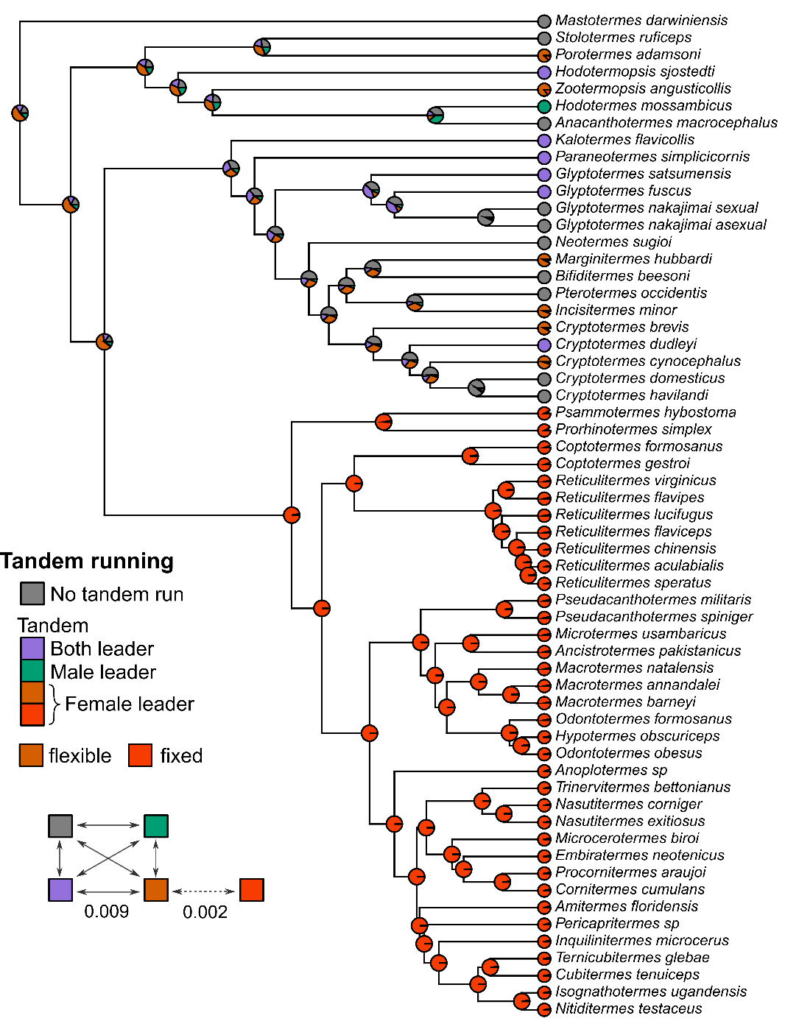

**Figure S1.** The full ancestral state reconstruction of tandem running behavior. We used the hidden rate model, where the female leader has two hidden states: a flexible state that can change to another state and a fixed state that cannot change to another state. For female-leader species, we estimated the state of female leaders of the extant species, too.

**Table 1. Composition of reproductives in *G. fuscus* and *G. satsumensis*.**

|  |  |  |  |  |  |  |
| --- | --- | --- | --- | --- | --- | --- |
| Mature colony |  |  |  |  |  |  |
| **Species** | **Colony** | **Location** | **PQ** | **PK** | **SQ** | **SK** |
| *Glyptotermes* *fuscus* | GPS253B | Ashizuri, Kochi | 0 | 1 | 1 | 0 |
|  | GPS329-1 | Toi, Miyazaki | 2 | 2 | 0 | 0 |
|  | GPS332 | Shibushi, Kagoshima | 2 | 1 | 0 | 0 |
|  | GPS313 | Issou, Yakushima, Kagoshima | 2 | 2 | 0 | 0 |
|  | GPS324 | Setouchi, Kagoshima | 2 | 2 | 0 | 0 |
|  | GPS063 | Setouchi, Kagoshima | 9 | 8 | 0 | 0 |
|  | GPS283-1 | Oku, Kunigami, Okinawa | 2 | 1 | 0 | 0 |
|  | GPS264 | Tanodake, Nago, Okinawa | 3 | 3 | 0 | 0 |
|  | GPS268 | Tanodake, Nago, Okinawa | 2 | 1 | 0 | 0 |
| *Glyptotermes* *satsumensis* | GPS253C | Ashizuri, Kochi | 2 | 3 | 0 | 0 |
|  |  |  |  |  |  |  |
| Incipient colony |  |  |  |  |  |  |
| **Species** | **Colony** | **Location** | **PQ** | **PK** | **SQ** | **SK** |
| *Glyptotermes* *fuscus* | GPS283-2 | Oku, Kunigami, Okinawa | 1 | 1 | 0 | 0 |
|  | GPS275 | Tanodake, Nago, Okinawa | 1 | 1 | 0 | 0 |
| *Glyptotermes* *satsumensis* | GPS329 | Toi, Miyazaki | 1 | 1 | 0 | 0 |
|  | GPS407-5 | Sata, Kagoshima | 1 | 1 | 0 | 0 |

PQ: primary queen, PK: primary king, SQ: secondary queen, SK: secondary king. Primary indicates alate derived. Secondary indicates neotenic.

**Table S2. Information on mating types in termites with available tandem running data.**

|  |  |  |  |  |  |
| --- | --- | --- | --- | --- | --- |
| Genus | Species | Incipient | Mature | Source | Ref |
| *Zootermopsis* | *angusticollis* | monogamous | monogamous | genetics | [1] |
| *Anacanthotermes* | *ochraceus* | NA | NA | NA | NA |
| *Anacanthotermes* | *macrocephalus* | multiple | NA | field | [2] |
| *Hodotermes* | *mossambicus* | monogamous | NA | behavior | [3] |
| *Porotermes* | *adamsoni* | monogamous | monogamous | field | [4] |
| *Stolotermes* | *ruficeps* | monogamous | monogamous | field | [5] |
| *Hodotermopsis* | *sjostedti* | monogamous | NA | field | NA1 |
| *Mastotermes* | *darwiniensis* | NA | NA | NA | NA |
| *Bifiditermes* | *beesoni* | NA | NA | NA | NA |
| *Cryptotermes* | *brevis* | monogamous2 | NA | behavior | [6] |
| *Cryptotermes* | *havilandi* | monogamous | NA | behavior | [7] |
| *Cryptotermes* | *domesticus* | NA | NA | NA | NA |
| *Cryptotermes* | *cynocephalus* | NA | NA | NA | NA |
| *Cryptotermes* | *dudleyi* | monogamous | NA | field | [8] |
| *Incisitermes* | *minor* | NA | monogamous | field | [9] |
| *Kalotermes* | *flavicollis* | NA | NA | NA | NA |
| *Marginitermes* | *hubbardi* | NA | monogamous | field | [9] |
| *Neotermes* | *sugioi* | monogamous | monogamous | field | [10] |
| *Paraneotermes* | *simplicicornis* | monogamous | monogamous | field/behavior | [11,12] |
| *Pterotermes* | *occidentis* | NA | monogamous | field | [9] |
| *Glyptotermes* | *satsumensis* | monogamous | multiple | field | Table S1 |
| *Glyptotermes* | *nakajimai_sexual* | NA | multiple | field | [13] |
| *Glyptotermes* | *nakajimai_asexual* | multiple | multiple | field | [13] |
| *Glyptotermes* | *fuscus* | monogamous | multiple | field | Table S1 |
| *Coptotermes* | *formosanus* | monogamous | monogamous | genetics | [14] |
| *Coptotermes* | *gestroi* | monogamous | monogamous | genetics | [14] |
| *Prorhinotermes* | *simplex* | NA | NA | NA | NA |
| *Psammotermes* | *hybostoma* | NA | NA | NA | NA |
| *Reticulitermes* | *speratus* | monogamous | monogamous | field | [15] |
| *Reticulitermes* | *flavipes* | monogamous | monogamous | genetics | [16] |
| *Reticulitermes* | *virginicus* | monogamous | monogamous | genetics | [16] |
| *Reticulitermes* | *flaviceps* | NA | NA | NA | NA |
| *Reticulitermes* | *chinensis* | monogamous | monogamous | genetics | [17] |
| *Reticulitermes* | *aculabialis* | monogamous | monogamous | genetics | [18] |
| *Reticulitermes* | *lucifugus* | monogamous | monogamous | genetics | [19] |
| *Ancistrotermes* | *dimorphus* | NA | monogamous/multiple | field | [20] |
| *Ancistrotermes* | *pakistanicus* | NA | NA | NA | NA |
| *Hypotermes* | *obscuriceps* | NA | NA | NA | NA |
| *Macrotermes* | *natalensis* | monogamous | NA | behavior | [21] |
| *Macrotermes* | *annandalei* | NA | NA | NA | NA |
| *Macrotermes* | *barneyi* | monogamous | monogamous/multiple | unclear3 | [22] |
| *Macrotermes* | *convulsionarius* | NA | NA | NA | NA |
| *Microtermes* | *usambaricus* | NA | NA | NA | NA |
| *Microtermes* | *unicolor* | NA | NA | NA | NA |
| *Odontotermes* | *formosanus* | monogamous/multiple | monogamous/multiple | field | [23] |
| *Odontotermes* | *obesus* | monogamous | Monogamous4 | field | [24] |
| *Odontotermes* | *distans* | NA | Monogamous2 | field | [25] |
| *Odontotermes* | *brunneus* | NA | monogamous | field | [26] |
| *Odontotermes* | *assmuthi* | NA | NA | NA | NA |
| *Pseudacanthotermes* | *spiniger* | NA | multiple2 | field | [27] |
| *Pseudacanthotermes* | *militaris* | NA | NA | NA | NA |
| *Anoplotermes* | *sp* | NA | monogamous | field | [28] |
| *Cubitermes* | *tenuiceps* | NA | NA | NA | NA |
| *Isognathotermes* | *ugandensis* | NA | NA | NA | NA |
| *Nitiditermes* | *testaceus* | NA | NA | NA | NA |
| *Ternicubitermes* | *glebae* | NA | NA | NA | NA |
| *Cornitermes* | *bequarerti* | NA | NA | NA | NA |
| *Cornitermes* | *cumulans* | monogamous | monogamous5 | field | [29] |
| *Embiratermes* | *neotenicus* | monogamous | monogamous | genetics | [30] |
| *Procornitermes* | *araujoi* | NA | NA | NA | NA |
| *Nasutitermes* | *corniger* | monogamous | monogamous/multiple | genetics | [31] |
| *Nasutitermes* | *nigriceps* | monogamous | monogamous | field/genetics | [32,33] |
| *Nasutitermes* | *ephratae* | NA | monogamous | field | [34] |
| *Nasutitermes* | *costalis* | NA | monogamous/multiple | field | [35,36] |
| *Nasutitermes* | *exitiosus* | NA | monogamous/multiple | field/genetics | [37,38] |
| *Trinervitermes* | *suspensus* | NA | NA | NA | NA |
| *Trinervitermes* | *bettonianus* | NA | NA | NA | NA |
| *Amitermes* | *floridensis* | NA | NA | NA | NA |
| *Amitermes* | *atlanticus* | monogamous | monogamous | field | [39] |
| *Amitermes* | *wheeleri* | NA | NA | NA | NA |
| *Inquilinitermes* | *microcerus* | NA | NA | NA | NA |
| *Microcerotermes* | *biroi* | NA | monogamous | field | [40] |
| *Microcerotermes* | *edentatus* | NA | NA | NA | NA |
| *Pericapritermes* | *sp* | NA | onogamous2,6 | field | [41] |

1 NM personal observations;

2 limited sample size;

3 based on the citation of a previous study, “Li, G.X., Z.R. Dai & D. Li 1989. Termite and Its Control in China. Science Press, Beijing (in Chinese)”, which observed the reproductive composition. But we could not locate the original article.

4 but exceptionally multiple reproductives, see [42].

5 occasionally multiple reproductives

6 *nitobei*

**References for supplementary materials**

1. Booth W, Brent CS, Calleri DV, Rosengaus RB, Traniello JFA, Vargo EL. 2012 Population genetic structure and colony breeding system in dampwood termites (*Zootermopsis angusticollis* and *Z. nevadensis nuttingi*). *Insectes Sociaux* **59**, 127–137. (doi:10.1007/s00040-011-0198-2)

2. Roonwal ML, Rathore NS. 1975 Swarming, Egg-Laying and Hatching in the Indian Desert Harvester Termite, Anacanthotermes Macrocephalus (Hodotermitidae). *Annals of Arid Zone* **14**, 37–55.

3. Hewitt PH, Watson JAL, Nel JJC, Schoeman I. 1972 Control of the change from group to pair behaviour by Hodotermes mossambicus reproductives. *Journal of Insect Physiology* **18**, 143–150. (doi:10.1016/0022-1910(72)90072-8)

4. Nkunika POY. 1988 The Bology and ecology of the dampwood termite, *Porotermes adamson* (Froggati) (Isoptera: Termopsidae) in South Australia. University of Adelaide.

5. Morgan FD. 1959 The ecology and external morphology of Stolotermes ruficeps Brauer (Isoptera: Hodotermitidae). *Transactions of the Royal Society of New Zealand* **86**, 155–195.

6. McMahan EA. 1960 Laboratory studies of *Cryptotermes brevis* (Walker) (Isoptera: Kalotermitidae): with special reference to colony development and behaviors. U niversity of Hawaii.

7. Wilkinson W. 1962 Dispersal of alates and establishment of new colonies in *Cryptotermes havilandi* (Sjöstedt) (Isoptera, Kalotermitidae). *Bulletin of Entomological Research* **53**, 265–286. (doi:10.1017/S0007485300048124)

8. Neoh K-B, Lee C-Y. 2011 Developmental Stages and Caste Composition of a Mature and Incipient Colony of the Drywood Termite, Cryptotermes dudleyi (Isoptera: Kalotermitidae). *Journal of Economic Entomology* **104**, 622–628. (doi:10.1603/EC10346)

9. Nutting WL. 1970 Composition and size of some termite colonies in Arizona and Mexico. *Annals of the Entomological Society of America* **63**, 1105–1110. (doi:10.1093/aesa/63.4.1105)

10. Sugio K, Miyaguni Y, Yoshimura T. 2020 Colony structure and caste distribution in living trees of the Ryukyu drywood termite, Neotermes sugioi (Blattodea: Kalotermitidae) in Okinawa Island. *Journal of Asia-Pacific Entomology* **23**, 853–862. (doi:10.1016/j.aspen.2020.07.013)

11. Light SF. 1937 Contributions to the biology and taxonomy of *Kalotermes* (*Paraneotermes*) *simplicicornis* Bank (Isoptera),. *University of California Publications in Entomology* **6**, 423–464.

12. Mizumoto N, Gile GH, Pratt SC. 2021 Behavioral rules for soil excavation by colony founders and workers in termites. *Annals of the Entomological Society of America* **114**, 654–661. (doi:10.1093/aesa/saaa017)

13. Yashiro T, Lo N, Kobayashi K, Nozaki T, Fuchikawa T, Mizumoto N, Namba Y, Matsuura K. 2018 Loss of males from mixed-sex societies in termites. *BMC Biology* **16**, 96. (doi:10.1186/s12915-018-0563-y)

14. Su N-Y, Lee C-Y, editors. 2023 *Biology and Management of the Formosan Subterranean Termite and Related Species*. GB: CABI. (doi:10.1079/9781800621596.0000)

15. Matsuura K, Mizumoto N, Kobayashi K, Nozaki T, Fujita T, Yashiro T, Fuchikawa T, Mitaka Y, Vargo EL. 2018 A genomic imprinting model of termite caste determination: Not genetic but epigenetic inheritance influences offspring caste fate. *American Naturalist* **191**, 677–690. (doi:10.1086/697238)

16. Vargo EL, Juba TR, Deheer CJ. 2006 Relative Abundance and Comparative Breeding Structure of Subterranean Termite Colonies (Reticulitermes flavipes, Reticulitermes hageni, Reticulitermes virginicus, and Coptotermes formosanus) in a South Carolina Lowcountry Site as Revealed by Molecular Markers. *Annals of the Entomological Society of America* **99**, 1101–1109. (doi:10.1603/0013-8746(2006)99[1101:RAACBS]2.0.CO;2)

17. Huang Q, Li G, Husseneder C, Lei C. 2013 Genetic Analysis of Population Structure and Reproductive Mode of the Termite Reticulitermes chinensis Snyder. *PLOS ONE* **8**, e69070. (doi:10.1371/journal.pone.0069070)

18. Khan Z, Haroon, Sha Z, Xing L-X. 2025 Asexual queen succession in the subterranean termite Reticulitermes aculabialis Tsai et Hwang (Blattodea: Heterotermitidae). *Bulletin of Entomological Research* , 1–11. (doi:10.1017/S000748532500001X)

19. Luchetti A, Velonà A, Mueller M, Mantovani B. 2013 Breeding systems and reproductive strategies in Italian Reticulitermes colonies (Isoptera: Rhinotermitidae). *Insect. Soc.* **60**, 203–211. (doi:10.1007/s00040-013-0284-8)

20. Jia B, Wei G, Chen Z, Lu H, Zheng X, Han R-Q, Lu W. 2016 Nest structure of Ancistrotermes dimorphus Tsai et Chen. *Chinese Journal of Applied Entomology* **53**, 1124–1129. (doi:10.7679/j.issn.2095-1353.2016.138)

21. Mitchell JD. 2008 Swarming flights of the fungus-growing termite, *Macrotermes natalensis* (Haviland) (Isoptera : Macrotermitinae), and the environmental factors affecting their timing and duration. *African Entomology* **16**, 143–152. (doi:10.10520/EJC32788)

22. Wang Z, Mo J, Lu Y. 2009 Biology and Ecology of Macrotermes barneyi (Isoptera: Termitidae). *Sociobiology* **54**, 777–785.

23. Chiu C-I, Neoh K-B, Li H-F. 2018 Colony-founding success of pleometrosis in a fungus-growing termite Odontotermes formosanus. *Behavioral Ecology and Sociobiology* **72**, 13. (doi:10.1007/s00265-017-2429-7)

24. Veeranna G, Basalingappa S. 1989 Nesting pattern of the termites Odontotermes obesus Rambur and Odontotermes wallonensis Wasmann (Isoptera: Termitidae). *International Journal of Tropical Insect Science* **10**, 169–180. (doi:10.1017/S1742758400010328)

25. McMahan EA, Kumar S, Sen-Sarma PK. 1984 Male/Female (Size) Polyethism in Workers of Odontotermes distans Holmgren and Holmgren (Isoptera: Termitidae: Macrotermitinae). *Annals of the Entomological Society of America* **77**, 429–434. (doi:10.1093/aesa/77.4.429)

26. Farzana J, Sangamma I, Rajashekhar M, Vijaykumar K, Burli P, Chimkod VN. 2010 Nesting pattern of the termites *Odontotermes brunneus* and *Odontotermes wallonensis* (Isoptera: Termitidae). *Electronic Journal of Environmental Sciences* **3**, 00–00.

27. Darlington JPEC. 1994 Mound Structure and Nest Population of the Termite, Pseudacanthotermes Spiniger (Sjostedt) in Kenya. *Int J Trop Insect Sci* **15**, 445–452. (doi:10.1017/S1742758400015800)

28. Martius C, d’Arc Ribeiro J. 1996 Colony Populations and Biomass in Nests of the Amazonian Forest Termite Anoplotermes banksi Emerson (Isoptera: Termitidae). *Studies on Neotropical Fauna and Environment* **31**, 82–86. (doi:10.1076/snfe.31.2.82.13328)

29. Da Silva LHB, Jost C, Vargo EL, Costa-Leonardo AM, Haifig I. 2022 Incipient colonies of the neotropical termite Cornitermes cumulans (Isoptera: Termitidae): comparing monogamy and polygamy as reproductive strategies. *Insect. Soc.* **69**, 99–104. (doi:10.1007/s00040-022-00852-w)

30. Fougeyrollas R, Dolejšová K, Křivánek J, Sillam-Dussès D, Roisin Y, Hanus R, Roy V. 2018 Dispersal and mating strategies in two neotropical soil-feeding termites, Embiratermes neotenicus and Silvestritermes minutus (Termitidae, Syntermitinae). *Insect. Soc.* **65**, 251–262. (doi:10.1007/s00040-018-0606-y)

31. Atkinson L, Adams ES. 1997 The origins and relatedness of multiple reproductives in colonies of the termite *Nasutitermes corniger*. *Proc. R. Soc. Lond. B* **264**, 1131–1136. (doi:10.1098/rspb.1997.0156)

32. Thompson GJ, Hebert PDN. 1998 Population genetic structure of the Neotropical termite Nasutitermes nigriceps (Isoptera: Termitidae). *Heredity* **80**, 48–55. (doi:10.1046/j.1365-2540.1998.00277.x)

33. Clarke PA, Garraway E. 1994 Development of nests and composition of colonies of *Nasutitermes nigriceps* (Isoptera: Termitidae) in the Mangroves of Jamaica. *Florida Entomologist* , 272–272.

34. Thorne BL. 1985 Numerical and biomass caste proportions in colonies of the termites Nasutitermes corniger and N. ephratae (Isoptera; Termitidae). *Ins. Soc* **32**, 411–426. (doi:10.1007/BF02224018)

35. Clarke P. 1991 Biology of Nasutitermes nigriceps (Haldeman) and Nasutitermes costalis (Helmgren) (Isoptera: Termitidae). The University of the West Indies.

36. Roisin Y, Pasteels JM. 1986 Reproductive mechanisms in termites: Polycalism and polygyny in Nasutitermes polygynus and N. costalis. *Insectes Sociaux* **33**, 149–167. (doi:10.1007/BF02224595)

37. Gay FJ, Calaby JH. 1970 9 Termites of the Australian region. *Biology of termites II* **2**, 393–448.

38. Montagu A, Lee TRC, Ujvari B, McCarl V, Evans TA, Lo N. 2020 High numbers of unrelated reproductives in the Australian ‘higher’ termite Nasutitermes exitiosus (Blattodea: Termitidae). *Insect. Soc.* **67**, 281–294. (doi:10.1007/s00040-020-00764-7)

39. Skaife SH. 1954 The black-mound termite of the cape, Amitermes atlanticus Fuller. *Transactions of the royal society of South Africa* **34**, 251–281. (doi:10.1080/00359195409518986)

40. Leponce M, Roisin Y, Pasteels JM. 1996 Reproductive mechanisms and dynamics of habitat colonization in Microcerotermes biroi (Isoptera: Termitidae). *Ecological Entomology* **21**, 178–184. (doi:10.1111/j.1365-2311.1996.tb01185.x)

41. Chiu CI, Yang MM, Li HF. 2015 Structure and function of subterranean gallery systems of soil-feeding termites Pericapritermes nitobei and Sinocapritermes mushae. *Insectes Sociaux* **62**, 393–400. (doi:10.1007/s00040-015-0416-4)

42. Roonwal ML, Gupta SD. 1952 An unusual royal chamber with two kings and two queens in the Indian mound’ building termite, *Odontotermes obesus* (Rambur) [Isoptera: Family Termitidae]. *The journal of the Bombay Natural History Society* **51**, 293–295.