**Loss of pair formation predates the evolution of male-less society in *Glyptotermes* termites**

**Nobuaki Mizumoto1*, Toshihisa Yashiro2, Simon Hellemans3**

1. Department of Entomology & Plant Pathology, Auburn University, Auburn, AL, 36849, USA

2. Koshi Campus, Institute for Plant Protection, National Agriculture and Food Research Organization (NARO), Kumamoto, 861-1192, Japan

3. Okinawa Institute of Science & Technology Graduate University, Onna-son, Okinawa, 904-0495 Japan

*: Correspondence: [nzm0095@auburn.edu](mailto:nzm0095@auburn.edu)

**Abstract**

Parthenogenesis and the loss of males have occurred repeatedly across diverse organisms. Asexually reproducing lineages are not usually associated with social animals that exhibit biparental care because such care is inherently linked to the behavioral sequence of mate pairing and sexual reproduction. The male-less lineages of the termite, *Glyptotermes nakajimai*, provide a rare opportunity to study how sexual reproduction can be lost in social animals with parental care. Here we demonstrate that modification of the mate-pairing process predated the evolution of asexual lineages. Termite colonies are typically founded by a mating pair, with many species forming a tandem courtship pair while searching for a nest site. Our comparative analysis of tandem running in *Glyptotermes* termites revealed that two related species, *G. fuscus* and *G. satsumensis*, exhibited both female-leader and male-leader tandem runs, estimated to be the ancestral state in this genus. On the other hand, tandem running was rare and ephemeral in both sexual and asexual lineages of *G. nakajimai*. These results suggest that *G. nakajimai* employs an alternative colony foundation strategy, as further supported by their colony structures. Our study highlights the tight link between the evolution of asexuality and behavioral preadaptation, contributing to our understanding of the evolution of complex phenotypes.

**Keywords:** Asexual reproduction, Movement coordination, Parental care, Same-sex sexual behavior, Social insects

**Introduction**

Sexual reproduction is the norm for multicellular organisms despite the costs of producing males [1,2]. Many studies have revealed the advantages of sexual reproduction in short and long periods (e.g., [3]). Furthermore, in established sexual species, there are developmental and genetic constraints, such as egg activation and inbreeding depression, to prevent the evolution of asexuality by maintaining a low transition rate from sexual to asexual reproduction [4]. Therefore, although asexual lineages evolved across the diversity of taxa, the evolution of the asexual population is relatively rare. In addition to genetic mechanisms, specific behaviors of sexual organisms can prevent the evolution of asexual lineages, such as sexual conflicts [5] (but see [6]). Among behavioral traits, the evolution of asexuality is challenging in social animals with biparental care because sexual reproduction is associated with the sequence of mate pairing and biparental care, where males contribute to fitness more than sperm [1,7].

Termites evolved from the ancestor of wood-feeding cockroaches, whose colonies are also initiated from subsocial pairs [8,9]. Mature termite colonies release alates (winged reproductives) once per year in most species. Alates fly off to disperse and find a mating partner [10]. After shedding wings, many termite species form tandem pairing; a female and a male walk together while searching for a nest site [11]. During the initial phases of colony foundation, males significantly contribute to the offspring energetically and through physical labor [12,13]. Also, survival and successful colony foundation only stem from pair formation because termites require a partner for allogrooming [14,15]. Therefore, although termite queens with parthenogenetic ability could, in theory, reproduce alone [16–18], they need a partner for colony foundation.

One Japanese drywood termite, *Glyptotermes nakajimai* Morimoto (Isoptera: Kalotermitidae) [19,20], provides a unique opportunity to study the evolution of asexual lineages in animals with biparental care. In several populations, this species completely lost males, and all colonies are comprised only of females (i.e., all-female asexual societies) [21]. For the evolutionary lost of males from the termite society, there are several hurdles to be cleared. First, the sexual ancestor needs to have a potential to do parthenogenetic reproduction as a preadaptation. The evolution of (tycho)parthenogenesis xxxx. Furthermore, the evolution of such population requires the modification of a typical monogamous colony foundation in termites.

Two potential behavioral preadaptations enable the evolution of a male-less colony foundation in termites. (*i*) First, colonies can be established by female-female pairs following same-sex tandem runs (hereafter referred to as “tandems”). In *Reticulitermes* termites, such same-sex tandems are functionally identical to heterosexual tandems [11,22], and homosexual pairs initiate a colony through parthenogenetic reproduction [15,23] —although they are not very successful in the long term [24–26]. One may postulate the ancestor of all *G. nakajimai* lineages to have exhibited strong tandem running behavior with same-sex pairing. Under this first scenario, the asexually-reproducing population could evolve without substantially changing mate pairing behaviors. (*ii*) Second, pleometrosis (colony foundation by multiple kings and queens) can also facilitate the evolution of an asexual society by securing the number of colony foundation partners [27]. Under field conditions, colonies of *G. nakajimai* are often headed by multiple reproductive [21]. However, conditions under which pleometrosis is achieved remains unknown; do they use ancestral tandem running to form multiple pairs or completely modify the pairing process as preadaptation?

In this study, we investigated the mate-pairing process of three different *Glyptotermes* species (*G. nakajimai, G. fuscus, G. satsumensis*). These three species can be found sympatrically and relatively related to each other [19,28], but asexual society only arose in *G. nakajimai*. We especially focused on tandem running behavior by automatically quantifying it using the deep-leaning automated posture-tracking software [29]. We also estimated their phylogenetic relationships and divergence times from mitochondrial genomes. By mapping their ecological and colony structure information on the phylogeny, we reconstruct the evolution of male-less societies through the lens of behaviour.

**Results and Discussion**

*The tandem pairing behavior in* Glyptotermes *species is diverse*

Tandem running behavior was clearly observed in *G. fuscus* and *G. satsumensis*, while it was unclear in *G. nakajimai* from both sexual and asexual populations (Figs. 1 and 2).

First, these species showed distinct patterns in pair positioning when we observed behavioral interactions of mating pairs (or female-female pairs in asexual populations) in a pest dish arena. When species-specific datasets were pooled, pairs were often found to be within two body length distances across all species, where data distribution seemed to follow different patterns within or beyond two body lengths (Fig. 1AC). It follows that termite dealates interact when at within two body lengths.

Second, when termites were within two body lengths, the spatial orientations of pairs differed. In *G. satsumensis*, pairs were often positioned in a single file, with the female either in front or behind of the male (Fig. 1AB) —*i.e.*, they exhibit both female-led and male-led tandems. In *G. fuscus*, similarly positioned in a single file; tandems were more frequently male-led (Fig. 1AC). In contrast, we could not observe a clear positioning in *G. nakajimai*, with neither a leader nor a follower, in either sexual or asexual populations (Fig. 1AB). We used these observations for defining tandem runs; partners were in interaction when the distance was within two body lengths, and during interactions, pairs were in tandem runs when the female was in front of the male and the male was behind the female (and vice versa).

Next, we looked into the details of the pairwise interactions for each pair. Tandem running behavior was highly variable across different pairs, even within species (Fig. 2A); some pairs showed tandem runs during entire observations, while some did not form tandem runs during the observation period. However, long tandem running (e.g., more than 40% of the observational time) was only observed in *G. satsumensis* (7/21) and *G. fuscus* (8/46), not in *G. nakajimai*. There was no significant difference in the proportion of the time for tandem running behavior among species (GLMM, χ23 = 3.74, *P* = 0.291). Within each species, there were differences in the proportion of time spent in tandem runs, where the female-led tandem run was more common than male-led in *G. satsumensis* (GLMM, χ21 = 22.92, *P* < 0.001), while male-led tandem runnings were more common than female-led tandem runnings in *G. fuscus* (χ21 = 26118, *P* < 0.001) or *G. nakajimai* (χ21 = 497.38, *P* < 0.001). Thus, the male is the more active sex (i.e., the follower) for pairing in *G. satsumensis*, while the female is the more active sex for pairing in *G. fuscus* and *G. nakajimai*.

*Sexual and asexual lineages of* G. nakajimai *do not maintain tandem runs*

The function of tandem running behavior is to maintain pair cohesion while exploring the environments for finding a nesting site. Therefore, it should be evaluated as the distance a pair moved during a continuous interacting event rather than the duration they spent in the posture of following the other. When we compared the traveled distance, we found that *G. satsumensis* and *G. fuscus* traveled a longer distance than *G. nakajimai* (Fig. 2; Cox mixed effect model, male leader, χ23 = 30.19, *P* < 0.001, female leader, χ23 = 17.56, *P* < 0.001). In this sense, although *G. nakajimai* showed ephemeral tandem runs, their functionality is questioned —with their longest tandem breaking up after running only 185 mm (sexual) and 260 mm (asexual). Given that these species initiate their nest in tree branches, they cannot explore many options during pair maintenance. On the other hand, tandem running of *G. satsumensis* and *G. fuscus* can travel for more than 1 m long in 24 events continuously (15: *G. fuscus*, 9: *G. satsumensis*, from 16 pairs, 11: *G. fuscus*, 5: *G. satsumensis*). This allows them to explore the tree branches thoroughly. Within these species, there were no significant functional differences between female-led and male-led tandem runs (Cox mixed effect model, *G. fuscus*; χ21 = 2.41, *P* = 0.121, *G. satsumensis*; χ21 = 0.14, *P* = 0.704).

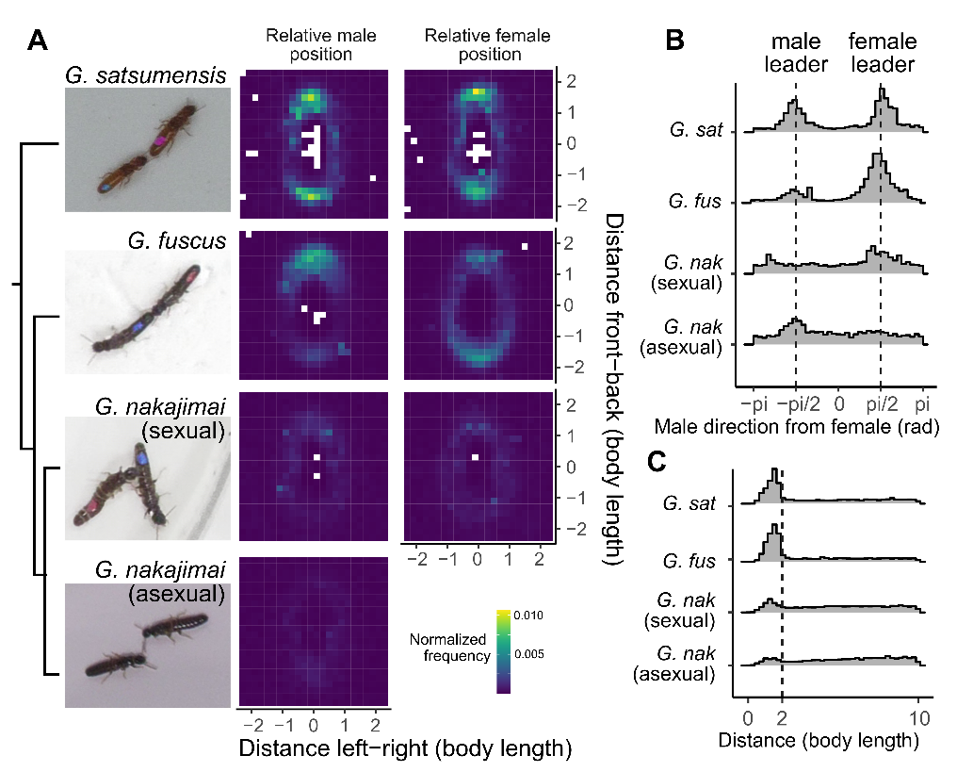

**Figure 1.** Spatial positioning between partners in *Glyptotermes* termites. (A) Comparison of the relative position of the partner, given that female (left) or male (right) heading towards the top at the center. Simplified phylogenetic relationship based on [21] is also provided. (B) Distributions of the partner's position relative to the female's heading direction in angles when the pair is within two body lengths. (C) Distributions of the distance between partners.

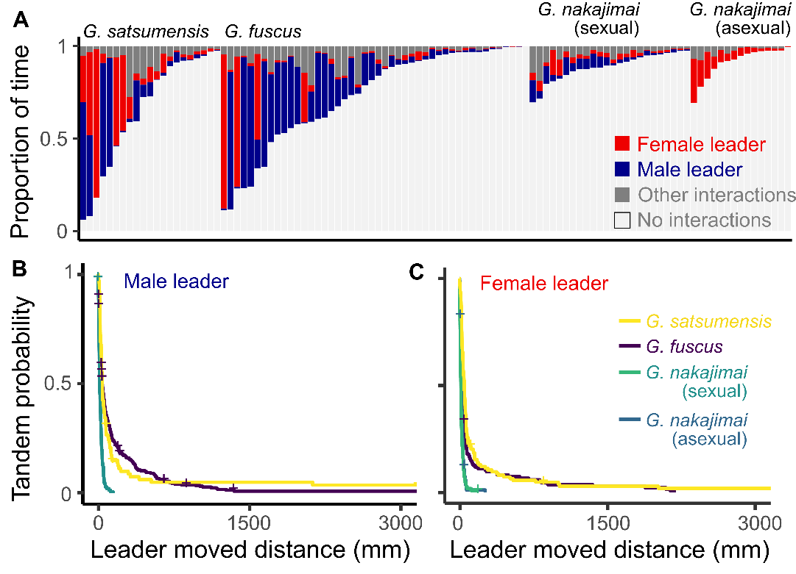

**Figure 2.** Tandem running behavior of each species. (A) Proportion of time in each state during observation. Each bar represents one pair. (B-C) Interspecific comparison of the traveled distance during each tandem running event.

*Ancestral state of tandem running behavior*

*Include here a paragraph on the divergence times of sexual lineages?*

Previous studies on genus level ancestral state reconstruction and fossil record suggested that the ancestor of Kalotermitidae exhibited tandem running behavior [11,30]. At the same time, tandem running is highly variable within Kalotermitidae, where some showed tandem running, but some do not even within the same genus [11]. To reconstruct the evolutionary process of tandem running, we performed the species level ancestral state reconstruction, using the mitochondrial genome phylogeny and published datasets.

We estimated that the ancestor of Glyptotermes tandem running as follows:

Both leader -> active role of female in pairing -> loss of tandem running ->loss of males

Sexually active males prevent the evolution of asexuality

*The coexistence of several primary pairs in one nest is common in* Glyptotermes *species*

In *G. nakajimai*, colonies often include many alate-derived reproductives in both sexual and asexual populations [21]. Colony foundation by multiple queens has been observed in asexual populations, while no data is available in sexual populations [21]. Such pleometrosis (colony foundation by more reproductives than a pair) may have contributed to removing a barrier to the evolution of asexuality as they can achieve alloparental care without males. Among termite species, pleometrosis has been observed in several species of Termitidae [31–33]. However, in Kalotermitidae, colonies are commonly headed by a monogamous reproductive pair (e.g., [34,35]). Thus, we checked the colony structure of *G. satsumensis* and *G. fuscus* to further investigate the origin of pleometrosis as a preadaptation of asexuality.

Although our records are limited, mature colonies of *G. fuscus* and *G. satsumensis* often included multiple reproductives (Table 1), with sexual populations of *G. nakajimai* having more reproductives than asexual populations or *G. fuscus* (GLM, χ22 = 140, *P* < 0.001, *G. satsumensis* was excluded from statistical analyses due to limited sample size). However, the source of such multiple reproductives in mature colonies could have differed from *G. nakajimai* and the other two species. A previous study showed that incipient colonies of *G. nakajimai* already had multiple queens [21] (pair: 1/4), while incipient colonies of *G. fuscus* or *G. satsumensis* were monogamous pairs (pair: 4/4, Table 1). Colony fusion could be a mechanism explaining the occurrence of multiple reproductives in mature nests after initial colony foundations by independent monogamous pairs in the same branch. However, colony fusion often causes competition between reproductives and results in the elimination of surnumerary pairs in many other species (e.g., [14,36,37]). In this sense, *Glyptotermes* termites might be tolerant to the presence of other reproductive, which may have played a role in facilitating the evolution of pleometrosis in this group.

We detected the correlation between pair formation behavior and colony foundation unit in the studied species; *G. fuscus* and *G. satsumensis* exhibited tandem running and monogamous colony foundation (Fig. 2, Table 1), while *G. nakajimai* lacked them (Fig. 2). However, it remains unclear whether tandem pair formation necessarily leads to monogamous pairing. For example, although some other Kalotermitidae species (e.g., *Neotermes* and *Pterotermes*) lack tandem running behavior [38,39], these showed stricter monogamous pairing [34,35]. On the other hand, *Odontotermes* or *Macrotermes* termites show tandem running (summarized in [11]), but they show pleometrosis relatively frequently [31]. Instead, resource availability should facilitate pleometrosis [27]. When the nesting site is a limited and valuable resource, termite dealates must concentrate and be forced to start a colony with many individuals. Actually, the distribution of *G. nakajimai* is highly localized within a specific area compared to the other two species. Pleometrosis observed in *G. nakajimai* may have been due to their particular requirements as a site of colony foundation,

***Conclusion***

Parthenogenesis ability has evolved independently many times in termites [17,18,40], but asexual society only happens in *G. nakajimai* as far as we know. We attributed this rarity to the complex combination of required preadaptations, including females being active sex (Fig. 1), lack of tandem running (Fig. 2), and pleometrosis. For example, *Reticulitermes* termites and several other termites incorporate facultative parthenogenesis into their colony reproductive system and life history [40,41]. Also, these species show female-female pairing and colony foundation [42], although female-female pairs do not result in functional colonies in a long timeline [24,25]. These species ultimately use strict social monogamy, where the presence of multiple kings or queens leads to competition and a monogamous pair. Also, male is the active sex of tandem pairing, which might hinder the evolution of asexuality. Similarly, *Neotermes sugioi* shows facultative parthenogenesis and even lacks tandem running behavior [38,43]. However, this species also shows strict monogamous pairing.

Sexual reproduction is the norm in animal kingdoms, and the evolution of asexuality does not happen randomly across lineages because each group has a specific unique hurdle to overcome during male loss [2,4]. Many theoretical studies of the evolution of sexuality have acknowledged that parental care by males can minimize the cost of sexual reproduction. Thus, evolutionary change of behavior should accompany such species. In this study, we showed that mate pairing behavior went through several steps of preadaptations in the course of the evolutionary loss of males in a termite, *G. nakajimai*. This highlights the importance of behavioral preadaptation as a prerequisite for the evolution of sexuality in social animals. By focusing on the behavioral aspects of sexual and asexual evolution, our results shed light on the integrative approach to the evolution of the sex.

**Methods**

*Termite collection*

We collected all termite colonies with a piece of nesting wood from the field. We collected three colonies of *G. fuscus* in Okinawa Prefecture (one in January 2021 and one in March 2022 in Nago; one in March 2023, Iriomote Is.), three colonies of *G. satsumensis* in March 2021 (two in Minamiosumi, Kagoshima, one in Kushima, Miyazaki), and four colonies of *G. nakajimai* (two in March 2021, Wakasa, Fukui, one in April 2023, Tokunoshima Is. Kagoshima, one in March 2021 in Cape Toi, Miyazaki). The populations of *G. nakajimai* from Fukui and Tokunoshima Island are sexually-reproducing [44], while the Cape Toi population is asexually-reproducing [21]. The field collection was performed before the swarming season occurring in XXX-XXX (REF); each colony contained nymphs but not alates. All colonies were maintained within the nesting wood at 22°C until the experiments. Before each experiment, we transferred nests to a room at 27 °C, which promoted alates to emerge and fly. Nest were also forcibly opened with axes, and flying alates were collected. Alates were induced to shed their wings by manually pinching their wings with forceps. Dealates were maintained in Petri dishes containing moist, unwoven cloth in the light and used for the experiments within one day of flight. Dealates were separated by sex and color-marked with one dot of paint (PX-20; Mitsubishi) on the abdomen to distinguish sex identities.

*Behavioral observations*

We introduced a female-male pair of termite dealates (female-female pair for an asexual population of *G. nakajimai*) to the experimental arena, consisting of a petri dish (φ = 90 mm) covered with a layer of moistened plaster. All pairs were prepared using nestmates. The effect of intracolonial and intercolonial pairing on tandem running behavior is not known for *Glyptotermes* species. We consistently used nest mate pairing for valid cross-species comparisons. Note that tandem running is not different between nestmate and non-nestmate pairing in another species [11]. We recorded their behavior for up to 60 minutes at 30 frames per second. Videos were cropped to 1200x1200 pixels to include only the arena in the frame before the video analysis. In total, we observed 21 pairs of *G. satsumensis* (340:16, 347:2, JP21-06:3), 46 pairs of *G. fuscus* (21A:16, G05:18, NM2325:12), 25 pairs of *G. nakajimai* sexual populations (356:6, 367:3, NM2344:16), and 15 pairs of asexual populations.

All videos were analyzed using SLEAP v 1.4.0 [29] to estimate the movement of body parts of each individual. We used a 6-node skeleton: antenna tips (LR), head (middle of mouth parts), head-pronotum boundary, body center, abdomen-tip, and a dot of a color-painted marker. We built a model for one species and then used it as a starting point to build another for the next species sequentially. First, we labeled 342 individuals from 23 videos for training in *G. satsumensis*. We trained a U-Net-based model with a multi-animal top-down approach, with a receptive field size of 76 pixels for the centroid and 156 pixels for the centered instance, on Nvidia GeForce RTX 4090, where augmentation is done by rotating images from -180 to 180 degrees. The mean Average Precision (mAP) and mean Average Recall (mAR) of this model were 0.36 and 0.49, respectively. While tracking after the inference, we used the instance similarity method with the greedy matching method. All pose estimation data were converted to HDF5 files for further analysis. Then, we used the model for *G. satsumensis* as a starting point and developed a model for *G. fuscus* with 956 individuals from 37 videos. This model was further fine-tuned by only using labels for each colony. Similarly, the models of *G. nakajimai* were trained based on this *G. fuscus* model for each colony. All these models are available at XXX.

We used Python to format all HDF5 files for further analysis and converted them into FEATHER files for analysis in R [45]. We employed a linear interpolation method to address missing values in the dataset. After scaling all data from pixels to mm (1200 pixels = arena size), we used a median filter with a kernel size of 5 to reduce noise.

To compare tandem running behaviors among species, we automatically determined whether pairs were in tandem based on the postures and spatial position of partners. First, we regarded as two individuals being in interaction when the distance between the body centers of partners was less than two body lengths, based on the frequency distribution of this distance (Fig. 1C). In this process, we ignored the short interaction events or non-interaction events less than 2 seconds to smooth the data. Second, during interactions, we classified termite heading orientation as female-leader and male-leader. We obtained the heading directions of females and males as vectors from the abdomen tips to the head front. Then, a pair was in the female leader when the male was behind relative to the female heading direction, and the female was front relative to the male heading direction, and vice versa (Fig. 1AB). If a pair spent more than half of the time in a female-leader position during an interaction event, we regarded the interaction event as a female-leader tandem run. This classified all frames into female-leader tandem, male-leader tandem, other interactions (including tandem runs where they switch leader-follower roles), and non-interactions. We obtained the traveled distance for which the leader walked during each tandem running event. Then, we compared this traveled distance, using mixed-effects Cox models, with species being treated as a fixed effect and each pair id as a random effect. We used the coxme() function in the coxme package in R [46]. Note that we used distance instead of duration to evaluate how much tandem running pair could explore the environments by removing pausing time during interactions.

*Ancestral state reconstruction*

How we obtained the phylogeny is here.

Methods for ace here.

**Acknowledgments**

We thank Kensei Kikuchi and Esra Kaymak for field collection, Aoi Mizumoto for assisting in video formatting, Dr. Thomas Bourguignon for lab space, and members of the Mizumoto lab for helpful discussion. We thank the Sequencing Section (SQC) and the Scientific Computing & Data Analysis Section (SCDA) of OIST for assistance with sequencing and providing access to the OIST computing cluster, respectively. The work was supported by a JSPS Research Fellowship for Young Scientists CPD to NM (20J00660), a Grant-in-Aid for Early-Career Scientists (21K15168), USDA National Institute of Food and Agriculture, Hatch projects number 7007938 to NM.

**References**

1. Smith JM. 1978 *The Evolution of Sex*. CUP Archive.

2. Lehtonen J, Jennions MD, Kokko H. 2012 The many costs of sex. *Trends in Ecology & Evolution* **27**, 172–178. (doi:10.1016/j.tree.2011.09.016)

3. West, Lively, Read. 1999 A pluralist approach to sex and recombination. *Journal of Evolutionary Biology* **12**, 1003–1012. (doi:10.1046/j.1420-9101.1999.00119.x)

4. Engelstädter J. 2008 Constraints on the evolution of asexual reproduction. *BioEssays* **30**, 1138–1150. (doi:10.1002/bies.20833)

5. Kawatsu K. 2013 Sexually Antagonistic Coevolution for Sexual Harassment Can Act as a Barrier to Further Invasions by Parthenogenesis. *The American Naturalist* **181**, 223–234. (doi:10.1086/668832)

6. Burke NW, Crean AJ, Bonduriansky R. 2015 The role of sexual conflict in the evolution of facultative parthenogenesis: a study on the spiny leaf stick insect. *Animal Behaviour* **101**, 117–127. (doi:10.1016/j.anbehav.2014.12.017)

7. Michiels, Beukeboom, Greeff, Pemberton. 1999 Individual control over reproduction: an underestimated element in the maintenance of sex? *Journal of Evolutionary Biology* **12**, 1036–1039. (doi:10.1046/j.1420-9101.1999.00120.x)

8. Bell WJ, Roth LM, Nalepa CA. 2007 *Cockroaches Ecology, Behavior and Natural History*. JHU Press.

9. Chouvenc T. 2022 Eusociality and the transition from biparental to alloparental care in termites. *Functional Ecology* **36**, 3049–3059. (doi:10.1111/1365-2435.14183)

10. Nutting WL. 1969 Flight and colony foundation. In *Biology of termites* (eds K Krishna, FM Weesner), pp. 233–282. New York: Academic Press. (doi:10.1016/B978-0-12-395529-6.50012-X)

11. Mizumoto N, Bourguignon T, Bailey NW. 2022 Ancestral sex-role plasticity facilitates the evolution of same-sex sexual behavior. *Proceedings of the National Academy of Sciences of the United States of America* **119**, e2212401119. (doi:10.1073/pnas.2212401119)

12. Chouvenc T. 2019 The relative importance of queen and king initial weights in termite colony foundation success. *Insectes Sociaux* **66**, 177–184. (doi:10.1007/s00040-019-00690-3)

13. Inagaki T, Yanagihara S, Fuchikawa T, Matsuura K. 2020 Gut microbial pulse provides nutrition for parental provisioning in incipient termite colonies. *Behav Ecol Sociobiol* **74**, 64. (doi:10.1007/s00265-020-02843-y)

14. Mizumoto N, Yashiro T, Matsuura K. 2016 Male same-sex pairing as an adaptive strategy for future reproduction in termites. *Animal Behaviour* **119**, 179–187. (doi:10.1016/j.anbehav.2016.07.007)

15. Matsuura K, Fujimoto M, Goka K. 2004 Sexual and asexual colony foundation and the mechanism of facultative parthenogenesis in the termite *Reticulitermes speratus* (Isoptera, Rhinotermitidae). *Insectes Sociaux* **51**, 325–332. (doi:10.1007/s00040-004-0746-0)

16. Hellemans S, Dolejšová K, Křivánek J, Fournier D, Hanus R, Roisin Y. 2019 Widespread occurrence of asexual reproduction in higher termites of the Termes group (Termitidae: Termitinae). *BMC Evolutionary Biology* **19**, 131. (doi:10.1186/s12862-019-1459-3)

17. Yashiro T. 2024 Evolution of obligate asexuality in termites with mixed-sex societies. *Population Ecology* **66**, 219–231. (doi:10.1002/1438-390X.12195)

18. Matsuura K. 2010 Sexual and Asexual Reproduction in Termites. In *Biology of Termites: a Modern Synthesis*, pp. 255–277. Dordrecht: Springer Netherlands. (doi:10.1007/978-90-481-3977-4_10)

19. Takematsu Y, Yamaoka R. 1997 Taxonomy of *Glyptotermes* (Isoptera, Kalotermitidae) in Japan with reference to cuticular hydrocarbon analysis as chemotaxonomic characters. *Esakia* **37**, 1–14.

20. Morimoto K. 1973 *Glyptotermes nakajimai*, a new termite from Japan (Isoptera: Kalotermitidae). *Kontyu* **41**, 470–474.

21. Yashiro T, Lo N, Kobayashi K, Nozaki T, Fuchikawa T, Mizumoto N, Namba Y, Matsuura K. 2018 Loss of males from mixed-sex societies in termites. *BMC Biology* **16**, 96. (doi:10.1186/s12915-018-0563-y)

22. Matsuura K, Kuno E, Nishida T. 2002 Homosexual Tandem Running as Selfish Herd in *Reticulitermes speratus*: Novel Antipredatory Behavior in Termites. *Journal of Theoretical Biology* **214**, 63–70. (doi:10.1006/jtbi.2001.2447)

23. Tamaki C, Takata M, Matsuura K. 2021 The lose-to-win strategy of the weak: intraspecific parasitism via egg abduction in a termite. *Biol. Lett.* **17**, 20210540. (doi:10.1098/rsbl.2021.0540)

24. Morooka F, Maekawa K, Kitade O. 2025 Intraspecific variation of sex ratio and body size along latitude in the termite Reticulitermes speratus (Isoptera: Heterotermitidae). *Insect. Soc.* (doi:10.1007/s00040-024-01017-7)

25. Matsuura K, Mizumoto N, Kobayashi K, Nozaki T, Fujita T, Yashiro T, Fuchikawa T, Mitaka Y, Vargo EL. 2018 A genomic imprinting model of termite caste determination: Not genetic but epigenetic inheritance influences offspring caste fate. *American Naturalist* **191**, 677–690. (doi:10.1086/697238)

26. Wu Y, Fujita T, Namba Y, Kobayashi K, Takata M, Vargo EL, Matsuura K. 2024 Inter-clonal competition over queen succession imposes a cost of parthenogenesis on termite colonies. *Proceedings of the Royal Society B: Biological Sciences* **291**, 20232711. (doi:10.1098/rspb.2023.2711)

27. Timmermans J, Hellemans S, Křivánek J, Kaymak E, Fontaine N, Bourguignon T, Hanus R, Roisin Y. 2024 How inquilinism shaped breeding systems in a termite host-inquiline relationship. *Molecular Ecology* **33**, e17494. (doi:10.1111/mec.17494)

28. Ikehara S. 1966 Distribution of termites in the Ryukyu Archipelago. *Bulletin of Arts and Science Division University of the Ryukyus Mathematics and Natural Science* **9**, 49–178.

29. Pereira TD *et al.* 2022 SLEAP: A deep learning system for multi-animal pose tracking. *Nature Methods* **19**, 486–495. (doi:10.1038/s41592-022-01426-1)

30. Mizumoto N, Hellemans S, Engel MS, Bourguignon T, Buček A. 2024 Extinct and extant termites reveal the fidelity of behavior fossilization in amber. *Proc. Natl. Acad. Sci. U.S.A.* **121**, e2308922121. (doi:10.1073/pnas.2308922121)

31. Chiu C-I, Neoh K-B, Li H-F. 2018 Colony-founding success of pleometrosis in a fungus-growing termite Odontotermes formosanus. *Behavioral Ecology and Sociobiology* **72**, 13. (doi:10.1007/s00265-017-2429-7)

32. Thorne BL. 1984 Polygyny in the Neotropical termite Nasutitermes corniger: life history consequences of queen mutualism. *Behav Ecol Sociobiol* **14**, 117–136. (doi:10.1007/BF00291903)

33. Darlington J. 1985 Multiple primary reproductives in the termite *Macrotermes michaelseni* (Sjöstedt). In *Caste differentiation in social insects*, pp. 187–200. Oxford: Pergamon Press.

34. Sugio K, Miyaguni Y, Yoshimura T. 2020 Colony structure and caste distribution in living trees of the Ryukyu drywood termite, Neotermes sugioi (Blattodea: Kalotermitidae) in Okinawa Island. *Journal of Asia-Pacific Entomology* **23**, 853–862. (doi:10.1016/j.aspen.2020.07.013)

35. Nutting WL. 1970 Composition and Size of Some Termite Colonies in Arizona and Mexico. *Annals of the Entomological Society of America* **63**, 1105–1110. (doi:10.1093/aesa/63.4.1105)

36. Howard KJ, Johns PM, Breisch NL, Thorne BL. 2013 Frequent colony fusions provide opportunities for helpers to become reproductives in the termite Zootermopsis nevadensis. *Behavioral Ecology and Sociobiology* **67**, 1575–1585. (doi:10.1007/s00265-013-1569-7)

37. Kalshoven LGE. 1959 Observations on the nests of initial colonies ofNeotermes tectonae Damm. in teak trees. *Ins. Soc* **6**, 231–242. (doi:10.1007/BF02224407)

38. Sugio K, Miyaguni Y, Tayasu I. 2018 Characteristics of dispersal flight and disperser production in an Asian dry-wood termite, *Neotermes koshunensis* (Isoptera, Kalotermitidae). *Insectes Sociaux* **65**, 323–330. (doi:10.1007/s00040-018-0616-9)

39. Carr RV. 1972 The tergal grand and coutship behavior in the termites *Pterotermes occidentis*, *Marginitermes hubbardi* and *Paraneotermes simplicicornis* (Isoptera: Kalotermitidae). The university of Arizona.

40. Hellemans S, Roisin Y. 2020 Asexual Queen Succession in Termites. In *eLS* (ed John Wiley & Sons, Ltd), pp. 13–20. Wiley. (doi:10.1002/9780470015902.a0029115)

41. Matsuura K, Vargo EL, Kawatsu K, Labadie PE, Nakano H, Yashiro T, Tsuji K. 2009 Queen succession through asexual reproduction in termites. *Science* **323**, 1687. (doi:10.1126/science.1169702)

42. Matsuura K, Nishida T. 2001 Comparison of colony foundation success between sexual pairs and female asexual units in the termite *Reticulitermes speratus* (Isoptera: Rhinotermitidae). *Population Ecology* **43**, 119–124. (doi:10.1007/PL00012022)

43. Kobayashi K, Miyaguni Y. 2016 Facultative parthenogenesis in the Ryukyu drywood termite *Neotermes koshunensis*. *Sci Rep* **6**, 30712. (doi:10.1038/srep30712)

44. Nishiharu S, Sasaji H. 1994 Discovery of *Glyptotermes nakajimai* Morimoto (Isoptera) from Is. Aoshima, Fukui Pref., off the coast of the Japan Sea. *Entomological Journal of Fukui* **15**, 61–62.

45. R Core Team. 2023 R: A language and environment for statistical computing.

46. Therneau TM. 2015 coxme: mixed effects Cox models.

**Table 1. Composition of reproductives in *G. fuscus* and *G. satsumensis*.**

|  |  |  |  |  |  |  |
| --- | --- | --- | --- | --- | --- | --- |
| Mature colony |  |  |  |  |  |  |
| **Species** | **Colony** | **Location** | **PQ** | **PK** | **SQ** | **SK** |
| *Glyptotermes* *fuscus* | GPS253B | Ashizuri, Kochi | 0 | 1 | 1 | 0 |
|  | GPS329-1 | Toi, Miyazaki | 2 | 2 | 0 | 0 |
|  | GPS332 | Shibushi, Kagoshima | 2 | 1 | 0 | 0 |
|  | GPS313 | Issou, Yakushima, Kagoshima | 2 | 2 | 0 | 0 |
|  | GPS324 | Setouchi, Kagoshima | 2 | 2 | 0 | 0 |
|  | GPS063 | Setouchi, Kagoshima | 9 | 8 | 0 | 0 |
|  | GPS283-1 | Oku, Kunigami, Okinawa | 2 | 1 | 0 | 0 |
|  | GPS264 | Tanodake, Nago, Okinawa | 3 | 3 | 0 | 0 |
|  | GPS268 | Tanodake, Nago, Okinawa | 2 | 1 | 0 | 0 |
| *Glyptotermes* *satsumensis* | GPS253C | Ashizuri, Kochi | 2 | 3 | 0 | 0 |
|  |  |  |  |  |  |  |
| Incipient colony |  |  |  |  |  |  |
| **Species** | **Colony** | **Location** | **PQ** | **PK** | **SQ** | **SK** |
| *Glyptotermes* *fuscus* | GPS283-2 | Oku, Kunigami, Okinawa | 1 | 1 | 0 | 0 |
|  | GPS275 | Tanodake, Nago, Okinawa | 1 | 1 | 0 | 0 |
| *Glyptotermes* *satsumensis* | GPS329 | Toi, Miyazaki | 1 | 1 | 0 | 0 |
|  | GPS407-5 | Sata, Kagoshima | 1 | 1 | 0 | 0 |

PQ: primary queen, PK: primary king, SQ: secondary queen, SK: secondary king. Primary indicates alate derived. Secondary indicates neotenic.