**Loss of pair formation predates the evolution of male-less society in *Glyptotermes* termites**

**Nobuaki Mizumoto1*, Simon Hellemans2**

1. Department of Entomology & Plant Pathology, Auburn University, Auburn, AL, 36849, USA

2. Okinawa Institute of Science & Technology Graduate University, Onna-son, Okinawa, 904-0495 Japan

*: Correspondence: [nzm0095@auburn.edu](mailto:nzm0095@auburn.edu)

**Abstract**

Parthenogenesis and the loss of males have occurred repeatedly across diverse organisms. However, asexual reproduction is not usually associated with social animals that exhibit biparental care because such care is inherently linked to the behavioral sequence of mate pairing and sexual reproduction. The male-less termite, *Glyptotermes nakajimai*, provides a rare opportunity to study how sexual reproduction can be lost in social animals with parental care. Here we demonstrate that modification of the mate-pairing process impeded the evolution of asexual lineages. Termite colonies are typically founded by a mating pair, with many species forming a tandem courtship pair while searching for a nest site. Our comparative analysis of tandem running in *Glyptotermes* termites revealed that two related species, *G. fuscus* and *G. satsumensis*, exhibited both female-leader and male-leader tandem runs, estimated to be the ancestral state in this genus. On the other hand, tandem running was rare and ephemeral in both sexual and asexual lineages of *G. nakajimai*. These results suggest that *G. nakajimai* employs an alternative colony foundation strategy, as further supported by their colony structures. Our study highlights the close link between the evolution of asexuality and behavioral preadaptation, contributing to our understanding of the evolution of complex phenotypes.

**Keywords:** Asexual reproduction, Movement coordination, Parental care, Same-sex sexual behavior, Social insects

**Memo for introduction**

There are two different potential behavioral preadaptations that enable the evolution of a male-less colony foundation in termites.

1. Same-sex tandem runs, female-female tandem runs

2. Colony foundation by multiple individuals, pairing not based on tandem running.

**Memo for methods**

G. fuscus colonies: 21A (210128-2, Nago), NM2325 (230303, Taketomi), G05 (220311, Onna)

G. satsumensis colonies: 340 (210302, Minamiosumi), 347 (210303, Kushima), JP2106 (210302, Minamiosumi)

G. nakajimai sexual: 356 (210329, Wakasa Fukui), 357 (210329, Wakasa Fukui), NM2344 (230405, Tokunoshima) Fukui population (Mizumoto in press). Tokunoshima population (new record reported in this paper)

G. nakajimai asexual: JP2107 (210303 Cape Toi)

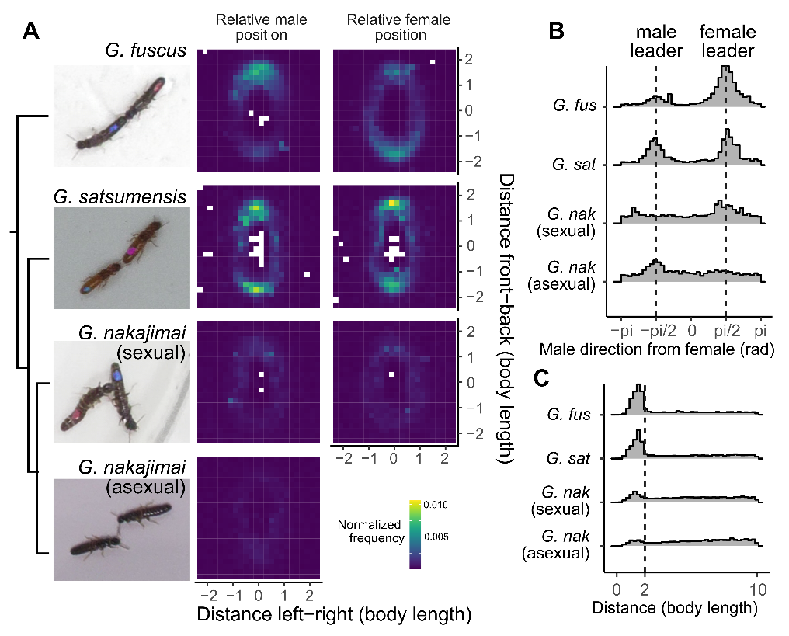

**Figure 1.** Spatial positioning between partners in *Glyptotermes* termites. (A) Comparison of the relative position of the partner, given that female (left) or male (right) heading towards the top at the center. Simplified phylogenetic relationship based on [1] is also provided. (B) Distributions of the partner's position relative to the female's heading direction in angles when the pair is within 2 body lengths. (C) Distributions of the distance between partners.

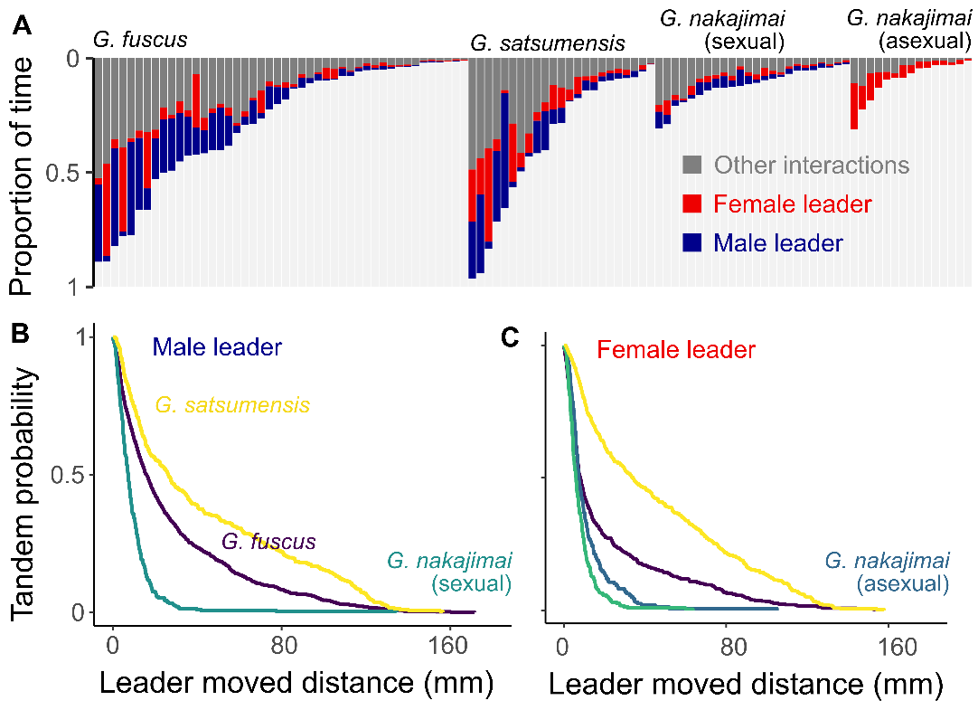

**Figure 2.** Tandem running behavior of each species. (A) Proportion of time in each state during observation. Each bar indicates each pair. (B-C) Interspecific comparison of the traveled distance during each tandem running event.

**Idea of another result to be shown.**

I want to show that the colonies of G. nakajimai include many reproductives (not a pair) [1], while colonies of G. fuscus and G. satsumensis often have just monogamous pairs (often physogastric). This is consistent with my observation, but my data is minimal as I have not recorded it properly. The former is shown in the paper [1], but we do not have published information on the latter.

Here are some possible approaches:

Based on this project report (you can read this in English from this link: <https://koara.lib.keio.ac.jp/xoonips/modules/xoonips/detail.php?koara_id=2018000005-20180253>), G. satsumensis keeps monogamous pairing. However, this report is not published (or looks like will not be published in the future). We may reach out Hayashi-san to ask if he has any data about colony structures in G. satsumensis. If so, we can ask if he can join this paper.

We can also reach out Yashiro-san if he have data.

Do you have any thoughts/ideas?

**Acknowledgments**

We thank Kensei and Esra for field collection, Aoi for assist in video recording.

The work was supported by a JSPS Research Fellowship for Young Scientists CPD to NM (20J00660), a Grant-in-Aid for Early-Career Scientists (21K15168) to NM.

HATCH project number.

**References**

1. Yashiro T, Lo N, Kobayashi K, Nozaki T, Fuchikawa T, Mizumoto N, Namba Y, Matsuura K. 2018 Loss of males from mixed-sex societies in termites. *BMC Biology* **16**, 96. (doi:10.1186/s12915-018-0563-y)