**Loss of pair formation predates the evolution of male-less society in *Glyptotermes* termites**

**Nobuaki Mizumoto1,3*, Toshihisa Yashiro2, Simon Hellemans3**

1. Department of Entomology & Plant Pathology, Auburn University, Auburn, AL, 36849, USA

2. Koshi Campus, Institute for Plant Protection, National Agriculture and Food Research Organization (NARO), Kumamoto, 861-1192, Japan

3. Okinawa Institute of Science & Technology Graduate University, Onna-son, Okinawa, 904-0495 Japan

*: Correspondence: [nzm0095@auburn.edu](mailto:nzm0095@auburn.edu)

**Abstract**

Parthenogenesis and the loss of males have occurred repeatedly across diverse organisms. Yet, asexually reproducing lineages are not usually associated with social animals that exhibit biparental care because such care is inherently linked to the behavioral sequence of mate pairing and sexual reproduction. The male-less lineages of the termite, *Glyptotermes nakajimai*, provide a rare opportunity to study how sexual reproduction can be lost in social animals with parental care. Here we demonstrate that modification of the mate-pairing process predated the evolution of asexual lineages. Termite colonies are typically founded by a mating pair, with many species forming a tandem courtship pair while searching for a nest site. Our comparative analysis of tandem running in *Glyptotermes* termites revealed that two related species, *G. fuscus* and *G. satsumensis*, exhibited both female-leader and male-leader tandem runs, estimated to be the ancestral state in this genus. On the other hand, tandem running was rare and ephemeral in both sexual and asexual lineages of *G. nakajimai*. These results suggest that *G. nakajimai* employs an alternative colony foundation strategy, as further supported by their colony structures. Our study highlights the tight link between the evolution of asexuality and behavioral preadaptation, contributing to our understanding of the evolution of complex phenotypes.

**Keywords:** Asexual reproduction, Movement coordination, Parental care, Same-sex sexual behavior, Social insects

**Introduction**

Sexual reproduction is the norm for multicellular organisms despite the costs of producing males (1, 2). Many studies have revealed the advantages of sexual reproduction in short and long periods (e.g., (3)). Furthermore, in established sexual species, there are developmental and genetic constraints, such as egg activation and inbreeding depression, to prevent the evolution of asexuality by maintaining a low transition rate from sexual to asexual reproduction (4). Therefore, although asexual lineages evolved across the diversity of taxa, the evolution of the asexual population is relatively rare. In addition to genetic mechanisms, specific behaviors of sexual organisms can prevent the evolution of asexual lineages, such as sexual conflicts (5) (but see (6)). Among behavioral traits, the evolution of asexuality is challenging in social animals with biparental care, where both males contribute to parental care beyond providing sperm (1, 7). In such a mating system, sexual reproduction is closely associated with the sequence of mate pairing and parental care.

Termites evolved from the ancestor of wood-feeding cockroaches, whose colonies are also initiated from subsocial pairs (8, 9). Mature termite colonies synchronizedly release alates (winged reproductives), and alates fly off to disperse and find a mating partner (10). After shedding wings, many termite species form tandem pairing; a female and a male walk together while searching for a nest site (11). During the initial phases of colony foundation, males significantly contribute to the offspring energetically and through physical labor (12, 13). Also, survival and successful colony foundation only stem from pair formation because termites require a partner for allogrooming (14, 15). Therefore, although termite queens with parthenogenetic ability could, in theory, reproduce alone (16–18), they need a partner for colony foundation.

One Japanese drywood termite, *Glyptotermes nakajimai* Morimoto (Isoptera: Kalotermitidae) (19, 20), provides a rare opportunity to study the evolution of asexual lineages in animals with biparental care. In several populations, males have been completely lost, resulting in all-female asexual societies (21), where the ancestral hybridization of two sexual lineages gave rise to the asexual lineages (22). The evolutionary loss of males in termite societies requires overcoming several challenges. First, the ancestral sexual population must have had the capacity for parthenogenesis (or tychoparthenogenesis—occasional egg development without fertilization) as a preadaptation (23). While tychoparthenogenesis is a canonical precursor to asexuality, it is not sufficient on its own, given that many other termite species exhibit parthenogenesis (or tychoparthenogenesis) without evolving into fully asexual lineages (17, 24). Additionally, because biparental care is integral to termite colony cycles, the transition to an asexual population likely required modifications to the typical monogamous colony foundation observed in termites.

Two potential behavioral preadaptations enable the evolution of a male-less colony foundation in termites. (*i*) Same-sex tandem runs: female-female pairs can establish colonies following same-sex tandem running. In *Reticulitermes* termites, for example, such same-sex tandems are as stable as heterosexual pairs (11, 25), and they can initiate colonies via parthenogenesis (15, 26) though their long-term success is limited (27–29). Same-sex tandem running varies widely across species (30), implying that the ancestor of *G. nakajimai* lineages might have exhibited strong tandem running behavior, including same-sex pairing. Under this scenario, a transition of asexuality could have occurred without changing mate pairing behaviors. (*ii*) Pleometrosis: Colony foundation by multiple kings and queens can also facilitate the evolution of an asexual society by securing sufficient colony foundation partners (31). Under field conditions, *G. nakajimai* colonies are often headed by multiple reproductives (21). However, the behavioral mechanism of pleometrosis is unknown; do they use ancestral tandem running to form multiple pairs, or do they modify the pairing process entirely as preadaptation? If the latter, *G. nakajimai* may have lost tandem running before the evolutionary loss of males. A comparative analysis of tandem running behavior across *Glyptotermes* species can test these ideas.

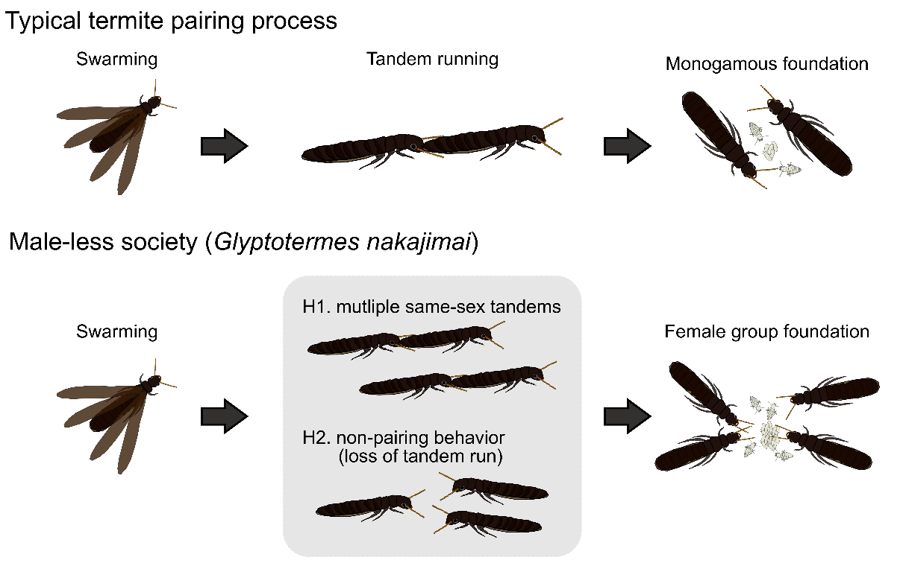

**Figure 1.** Comparison of typical termite mate pairing process and potential behavioral changes for the evolution of male-less society. Unlike monogamous pairing in typical termites, the male-less society of *G. nakajimai* is headed by multiple females. This could be achieved by two behavioral models: H1. use of multiple same-sex tandem running, requiring minimum behavioral changes, and H2. use of a non-pairing mechanism following the evolutionary loss of tandem running behavior.

In this study, we investigated the mate-pairing process of three different *Glyptotermes* species (*G. nakajimai, G. fuscus, G. satsumensis*). These three species can be found sympatrically and relatively related to each other (19, 32), but asexual society only arose in *G. nakajimai*. We especially focused on tandem running behavior by automatically quantifying it using the deep-leaning automated posture-tracking software (33). We also estimated their phylogenetic relationships and divergence times from mitochondrial genomes. By mapping their ecological and colony structure information on the phylogeny, we reconstruct the evolution of male-less societies through the lens of behavior.

**Results and Discussion**

*The tandem pairing behavior in* Glyptotermes *species is diverse*

Tandem running behavior was clearly observed in *G. fuscus* and *G. satsumensis*, while it was unclear in *G. nakajimai* from both sexual and asexual populations (Figs. 1 and 2).

First, these species showed distinct patterns in pair positioning when we observed behavioral interactions of mating pairs (or female-female pairs in asexual populations) in a pest dish arena. When species-specific datasets were pooled, pairs were often found to be within two body length distances across all species, where data distribution seemed to follow different patterns within or beyond two body lengths (Fig. 1AC). It follows that termite dealates interact when within two body lengths.

Second, when termites were within two body lengths, the spatial orientations of pairs differed. In *G. satsumensis*, pairs were often positioned in a line, with the female either in front or behind the male (Fig. 1AB) —*i.e.*, they exhibit both female-led and male-led tandems. In *G. fuscus*, similarly positioned in a line, tandems were more frequently male-led (Fig. 1AC). In contrast, we could not observe a clear positioning in *G. nakajimai*, with neither a leader nor a follower, in either sexual or asexual populations (Fig. 1AB). We used these observations for defining tandem runs; partners were in interaction when the distance was within two body lengths, and during interactions, pairs were in tandem runs when the female was in front of the male and the male was behind the female (and vice versa).

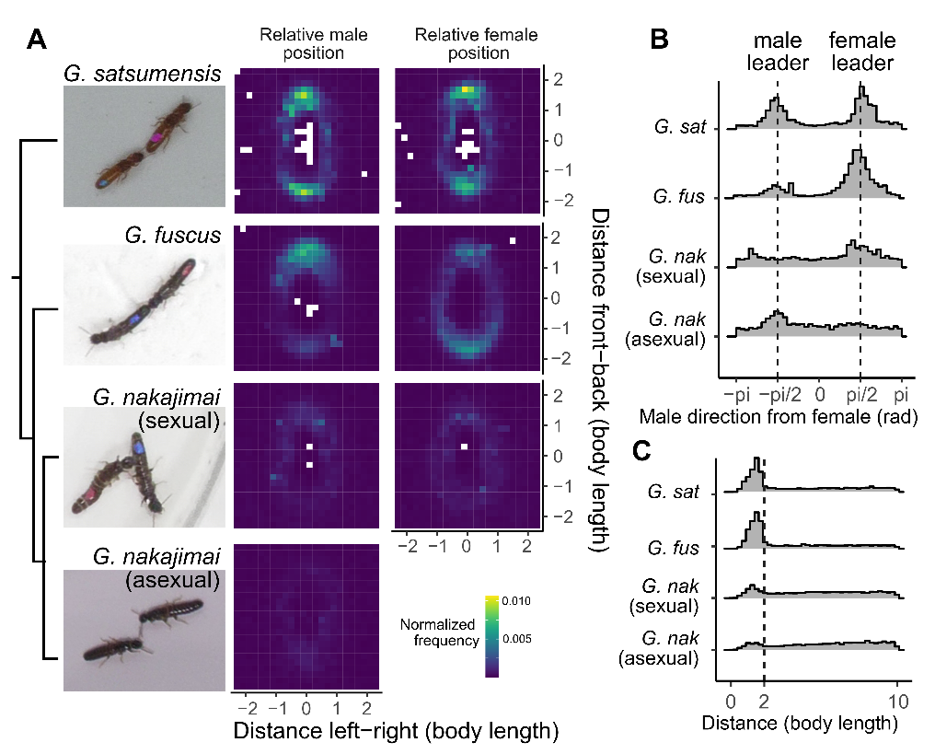

**Figure 2.** Spatial positioning between partners in *Glyptotermes* termites. (A) Comparison of the relative position of the partner, given that female (left) or male (right) heading towards the top at the center. Simplified phylogenetic relationship is also provided. (B) Distributions of the partner's position relative to the female's heading direction in angles when the pair is within two body lengths. (C) Distributions of the distance between partners.

Next, we looked into the details of the pairwise interactions for each pair. Tandem running behavior was highly variable across different pairs, even within species (Fig. 2A); some pairs showed tandem runs during entire observations, while some did not form tandem runs during the observation period. However, long tandem running (e.g., more than 40% of the observational time) was only observed in *G. satsumensis* (7/21) and *G. fuscus* (8/46), not in *G. nakajimai*. There was no significant difference in the proportion of the time for tandem running behavior among species (GLMM, χ23 = 3.74, *P* = 0.291). Within each species, there were differences in the proportion of time spent in tandem runs, where the female-led tandem run was more common than male-led in *G. satsumensis* (GLMM, χ21 = 22.92, *P* < 0.001), while male-led tandem runnings were more common than female-led tandem runnings in *G. fuscus* (χ21 = 26118, *P* < 0.001) or *G. nakajimai* (χ21 = 497.38, *P* < 0.001). Thus, the male is the more active sex (i.e., the follower) for pairing in *G. satsumensis*, while the female is the more active sex for pairing in *G. fuscus* and *G. nakajimai*.

*Sexual and asexual lineages of* G. nakajimai *do not maintain tandem runs*

The function of tandem running behavior is to maintain pair cohesion while exploring the environments for finding a nesting site. Therefore, it should be evaluated as the distance a pair moved during a continuous interacting event rather than the duration they spent in the posture of following the other. When we compared the traveled distance, we found that *G. satsumensis* and *G. fuscus* traveled a longer distance than *G. nakajimai* (Fig. 2; Cox mixed effect model, male leader, χ23 = 30.19, *P* < 0.001, female leader, χ23 = 17.56, *P* < 0.001). In this sense, although *G. nakajimai* showed ephemeral tandem runs, their functionality is questioned —with their longest tandem breaking up after running only 185 mm (sexual) and 260 mm (asexual). Given that these species initiate their nest in tree branches, they cannot explore many options during tandem running. On the other hand, tandem running of *G. satsumensis* and *G. fuscus* can travel for more than 1000 mm long in 24 events continuously (15: *G. fuscus*, 9: *G. satsumensis*, from 16 pairs, 11: *G. fuscus*, 5: *G. satsumensis*). This allows them to explore the tree branches thoroughly. Within these species, there were no significant functional differences between female-led and male-led tandem runs (Cox mixed effect model, *G. fuscus*; χ21 = 2.41, *P* = 0.121, *G. satsumensis*; χ21 = 0.14, *P* = 0.704).

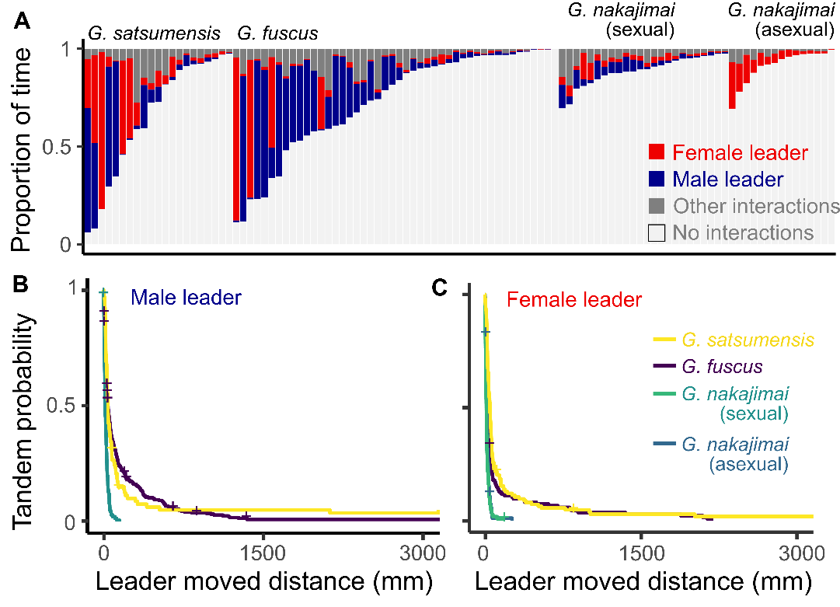

**Figure 3.** Tandem running behavior of each species. (A) Proportion of time in each state during observation. Each bar represents one pair. (B-C) Interspecific comparison of the traveled distance during each tandem running event.

*Ancestral state of tandem running behavior*

Tandem running behavior is highly variable in Kalotermitidae termites (11). Genus-level ancestral state reconstruction and fossil record suggested that the ancestor of Kalotermitidae exhibited tandem running (11, 34). Yet, some species show tandem running, while others, even within the same genus, do not. In *Glyptotermes*, *G. nakajimai* does not show tandem running, while *G. fuscus* and *G. satsumensis* clearly do (Fig. 2 and 3). These suggest two evolutionary scenarios of tandem running behavior; 1) tandem running behavior can exhibit greater evolvability and have evolutionary modifications more readily in Kalotermitidae than the other lineage; 2) even with the high evolvability, tandem pairing was lost before the evolution of male-less society in *G. nakajimai*. We test these hypotheses using a comparative phylogenetic framework. To reconstruct the evolutionary process of tandem running, we performed the species-level ancestral state reconstruction using the mitochondrial genome phylogeny and published datasets.

By fitting various evolutionary models for tandem running evolution, we found that the evolutionary rate of tandem running behavior is distinct between Kalotermitidae (+ other basal lineages) and Neoisoptera, representing two major termite groups in their diversity (Figure S1 and 4). The best-fit model was a hidden rate model (35), where the female-leader state has two states: one can easily change its state, while the other loses evolutionary variability (Figure S1). Although female-leader tandem running can be observed in Kalotermitidae, these female-leader tandems were estimated as an evolutionary variable, while female-leader tandems in Neoisoptera were estimated to be evolutionarily fixed (Figure S1). Thus, the tandem running behavior of Kalotermitidae is indeed variable and readily experiences evolutionary changes, where the ancestral state of Kalotermitidae might have tandem running but cannot be clearly estimated (Figure S1 and 4); it lacked tandem running in 32%, while it could exhibit tandem running in 68% either as female leader (29%), male leader (11%), or both leader (28%). Note that this information may be conservative as this lacks fossil evidence of tandem running behavior of *Electrotermes affinis*, an extinct kalotermitid termite with tandem running behavior (34).

Similar to the ancestor of Kalotermitidae, the ancestral state of *Glyptotermes* was also ambiguous but more likely doing tandems (Figure S1 and 4). The ancestral state was estimated as lacking tandem running at 38%, while exhibiting tandem running at 62% either as female leader (11%), male leader (2%), or both leader (42%). However, the ancestral state of *G. nakajimai* was clearly estimated as lacking tandem running behavior in 93% (Figures S1 and 4). Therefore, we conclude that the loss of tandem pairing should have predated the evolution of male-less society in *G. nakajimai* (Figure 1).

*Include a paragraph here on the divergence times of sexual lineages.*

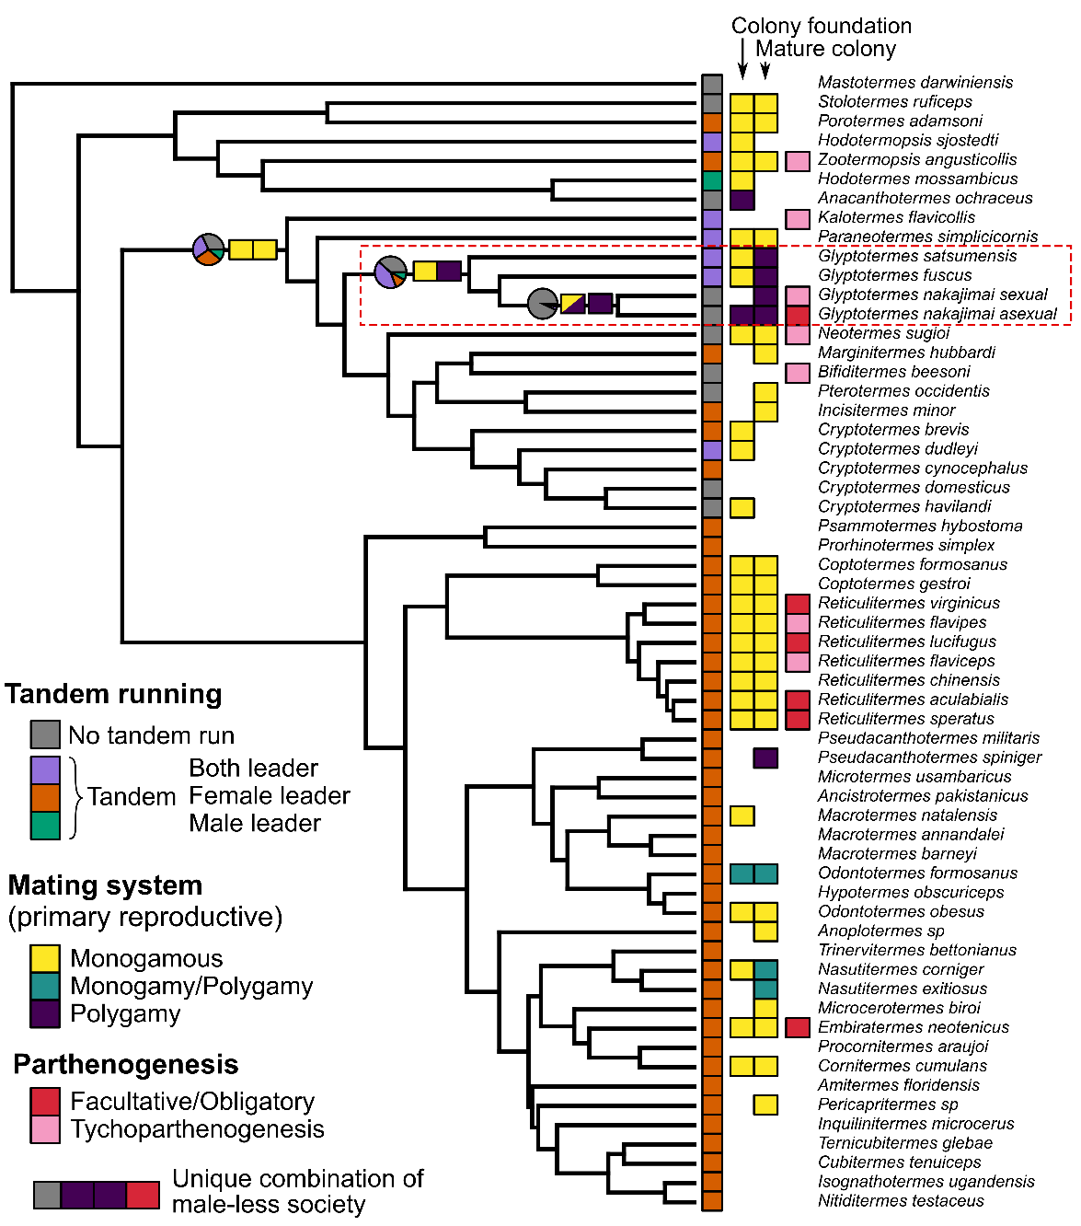

**Figure 4.** The evolution of tandem running behavior with relationship to mating systems in termites. The information on tandem running is from (11), mating system from Table S1-2, and parthenogenesis from (17, 24). The results of ancestral state reconstruction were shown for a few important nodes towards the evolution of a male-less society. Note that we did not perform reconstruction for parthenogenesis as many species lack information of “lacking parthenogenesis.”

*Evolution of the mating system co-work with the loss of tandem running toward a male-less society*

In *G. nakajimai*, colonies often include many alate-derived reproductives in both sexual and asexual populations (21). Colony foundation by multiple queens has been observed in asexual populations (no data is available in sexual populations) (21). Such pleometrosis (colony foundation by more reproductives than a pair) may have contributed to removing a barrier to the evolution of asexuality as they can achieve alloparental care without males (Figure 1). To investigate how such pleometrosis (or having multiple primary reproductives) is distributed among termite diversity and contributes to the evolution of a male-less society, we also performed phylogenetic comparative analyses of the mating systems (Figure 4). We checked the colony structure of *G. fuscus* and *G. satsumensis* from field observations (Table S1). Also, we compiled information about the number of reproductives in the nest for the species with the available tandem running information by performing a systematic search of the literature (Table S2).

First, in *Glyptotermes*, mature colonies of *G. fuscus* and *G. satsumensis* often included multiple reproductives (Table S1), with sexual populations of *G. nakajimai* having more reproductives than asexual populations or *G. fuscus* (GLM, χ22 = 140, *P* < 0.001, *G. satsumensis* was excluded from statistical analyses due to limited sample size). However, the source of such multiple reproductives in mature colonies could have differed from *G. nakajimai* and the other two species. A previous study showed that incipient colonies of *G. nakajimai* already had multiple queens (21) (pair: 1/4), while incipient colonies of *G. fuscus* or *G. satsumensis* were monogamous pairs (pair: 4/4, Table 1). Colony fusion could explain the occurrence of multiple reproductives in mature nests after initial colony foundations by independent monogamous pairs in the same branch. However, colony fusion often causes competition between reproductives and results in pair formation in many other species (e.g., (14, 36, 37)). In this sense, *Glyptotermes* termites might be tolerant to the presence of other reproductive, which may have played a role in facilitating the evolution of pleometrosis in this group.

Next, this observation in *Glyptotermes* species is further supported by a large-scale comparative analysis of the mating systems (Figure 4 and Table S2). Having multiple reproductives in the colony is actually rare across termite diversity. Pleometrosis has been observed in several species of Termitidae (38–40). However, even in these species, both monogamous and pleometrosis can be observed in a mixed way, highlighting the uniqueness of *Glyptotermes* which has multiple primary reproductives in most colonies. In Kalotermitidae, the available records show that primary reproductives were usually in monogamous pairs (e.g., (41, 42)) (Figure 4), and the ancestral state of Kalotermitidae was estimated as monogamous in both the colony foundation stage and mature colonies (Figure 4). On the other hand, the ancestral state of *Glyptotermes* was estimated to have multiple primary reproductives in mature colonies (Figure 4). So, within *Glyptotermes* termites, there was a correlation between pair formation behavior and colony foundation unit in the studied species; *G. fuscus* and *G. satsumensis* exhibited tandem running and monogamous colony foundation (Fig. 2, Table 1), while *G. nakajimai* lacked them (Fig. 2). The combination of characteristics of tandem running and the mating system was unique in *G. nakajimai*, which lacked tandem running, started colonies from multiple reproductives, and had the ability of parthenogenesis (Fig. 4). In this group. The modification of pair formation (lack of tandem run and pleometrosis) should have predated the male-less society (Figs 1 and 4).

It remains unclear whether tandem pair formation necessarily leads to monogamous pairing. For example, although some other Kalotermitidae species (e.g., *Neotermes, Pterotermes, Cryptotermes*) lack tandem running behavior (43–45), these showed strict monogamous pairing (41, 42). On the other hand, we speculate that loss of tandem running should be the prerequisite to achieving pleometrosis as a default unit as in *G. nakajimai*. Tandem running behavior is essentially a pairing behavior and runs with more than three individuals are unstable (11, 25, 46). For example, in Macrotermitinae termites, such as *Odontotermes* or *Macrotermes*, it is relatively common to find colonies with more than two primary reproductives (38) (Table S2). Yet, in these species, monogamous pairing is also common. In either situation, resource limitation should facilitate pleometrosis (31). When the nesting site is a limited and valuable resource, termite dealates must concentrate and be forced to start a colony with many individuals. Actually, the distribution of *G. nakajimai* is highly localized, this species is usually rarer than other species and can be found within the narrow area near the tips of the capes (especially in asexual populations). Pleometrosis observed in *G. nakajimai* may have been due to their particular requirements as a site of colony foundation.

***Conclusion***

Add discussion like with tandem running, it may be difficult to obtain male-less society because males prevent only female pairing.

Parthenogenesis ability has evolved independently many times in termites (17, 18, 24), but asexual society only happens in *G. nakajimai* as far as we know. We attributed this rarity to the complex combination of required preadaptations, including females being active sex (Fig. 1), lack of tandem running (Fig. 2), and pleometrosis. For example, *Reticulitermes* termites and several other termites incorporate facultative parthenogenesis into their colony reproductive system and life history (24, 47). Also, these species show female-female pairing and colony foundation (48), although female-female pairs do not result in functional colonies in a long timeline (27, 28). These species ultimately use strict social monogamy, where the presence of multiple kings or queens leads to competition and a monogamous pair. Also, male is the active sex of tandem pairing, which might hinder the evolution of asexuality. Similarly, *Neotermes sugioi* shows facultative parthenogenesis and even lacks tandem running behavior (43, 49). However, this species also shows strict monogamous pairing.

Sexual reproduction is the norm in animal kingdoms, and the evolution of asexuality does not happen randomly across lineages because each group has a specific unique hurdle to overcome during male loss (2, 4). Many theoretical studies of the evolution of sexuality have acknowledged that parental care by males can minimize the cost of sexual reproduction. Thus, evolutionary change of behavior should accompany such species. In this study, we showed that mate pairing behavior went through several steps of preadaptations in the course of the evolutionary loss of males in a termite, *G. nakajimai*. This highlights the importance of behavioral preadaptation as a prerequisite for the evolution of sexuality in social animals. By focusing on the behavioral aspects of sexual and asexual evolution, our results shed light on the integrative approach to the evolution of the sex.

**Methods**

*Termite collection*

We collected all termite colonies with a piece of nesting wood from the field. We collected three colonies of *G. fuscus* in Okinawa Prefecture (one in January 2021 and one in March 2022 in Nago; one in March 2023, Iriomote Is.), three colonies of *G. satsumensis* in March 2021 (two in Minamiosumi, Kagoshima, one in Kushima, Miyazaki), and four colonies of *G. nakajimai* (two in March 2021, Wakasa, Fukui, one in April 2023, Tokunoshima Is. Kagoshima, one in March 2021 in Cape Toi, Miyazaki). The populations of *G. nakajimai* from Fukui prefecture and Tokunoshima Island are sexually reproducing (50), while the Cape Toi population is asexually reproducing (21). The field collection was performed before the swarming season in March-June, depending on the location (19, 50); each colony contained nymphs but not alates. All colonies were maintained within the nesting wood at 22°C until the experiments. Before each experiment, we transferred nests to a room at 27 °C, which promoted alates to emerge and fly. Nests were also opened with axes, and flying alates were collected. Alates were induced to shed their wings by manually pinching their wings with forceps. Dealates were maintained in Petri dishes containing moist, unwoven cloth in the light and used for the experiments within one day of flight. Dealates were separated by sex and color-marked with one dot of paint (PX-20; Mitsubishi) on the abdomen to distinguish sex identities.

*Behavioral observations*

We introduced a female-male pair of termite dealates (female-female pair for an asexual population of *G. nakajimai*) to the experimental arena, consisting of a petri dish (φ = 90 mm) covered with a layer of moistened plaster. All pairs were prepared using nest-mates. The effect of intracolonial and intercolonial pairing on tandem running behavior is not known for *Glyptotermes* species. We consistently used nest-mate pairing for valid cross-species comparisons. Note that tandem running is not different between nestmate and non-nestmate pairing in *Reticulitermes speratus* (11). This species is not closely related to *Glyptotermes*, so we cannot fully rule out the possibility that the nestmate and non-nest mate showed different tandem running. However, our species comparison is at least consistent across species by using only nest-mate pairing. We recorded their behavior for up to 60 minutes at 30 frames per second. Videos were cropped to 1200x1200 pixels to include only the arena in the frame before the video analysis. In total, we observed 21 pairs of *G. satsumensis* (340:16, 347:2, JP21-06:3), 46 pairs of *G. fuscus* (21A:16, G05:18, NM2325:12), 25 pairs of *G. nakajimai* sexual populations (356:6, 367:3, NM2344:16), and 15 pairs of asexual populations.

All videos were analyzed using SLEAP v 1.4.0 (33) to estimate the movement of body parts of each individual. We used a 6-node skeleton: antenna tips (LR), head (middle of mouth parts), head-pronotum boundary, body center, abdomen-tip, and a dot of a color-painted marker. We built a model for one species and then used it as a starting point to build another for the next species sequentially. First, we labeled 342 individuals from 23 videos for training in *G. satsumensis*. We trained a U-Net-based model with a multi-animal top-down approach, with a receptive field size of 76 pixels for the centroid and 156 pixels for the centered instance, on Nvidia GeForce RTX 4090, where augmentation is done by rotating images from -180 to 180 degrees. The mean Average Precision (mAP) and mean Average Recall (mAR) of this model were 0.36 and 0.49, respectively. While tracking after the inference, we used the instance similarity method with the greedy matching method. All pose estimation data were converted to HDF5 files for further analysis. Then, we used the model for *G. satsumensis* as a starting point and developed a model for *G. fuscus* with 956 individuals from 37 videos. This model was further fine-tuned by only using labels for each colony. Similarly, the models of *G. nakajimai* were trained based on this *G. fuscus* model for each colony.

We used Python to format all HDF5 files for further analysis and converted them into FEATHER files for analysis in R (51). We employed a linear interpolation method to address missing values in the dataset. After scaling all data from pixels to mm (1200 pixels = arena size), we used a median filter with a kernel size of 5 to reduce noise.

To compare tandem running behaviors among species, we automatically determined whether pairs were in tandem based on the postures and spatial position of partners. First, we regarded as two individuals being in interaction when the distance between the body centers of partners was less than two body lengths, based on the frequency distribution of this distance (Fig. 1C). In this process, we ignored the short interaction events or non-interaction events less than 2 seconds to smooth the data. Second, during interactions, we classified termite heading orientation as female-leader and male-leader. We obtained the heading directions of females and males as vectors from the abdomen tips to the head front. Then, a pair was in the female leader when the male was behind relative to the female heading direction, and the female was front relative to the male heading direction, and vice versa (Fig. 1AB). If a pair spent more than half of the time in a female-leader position during an interaction event, we regarded the interaction event as a female-leader tandem run. This classified all frames into female-leader tandem, male-leader tandem, other interactions (including tandem runs where they switch leader-follower roles), and non-interactions. We obtained the traveled distance for which the leader walked during each tandem running event. Then, we compared this traveled distance, using mixed-effects Cox models, with species being treated as a fixed effect and each pair id as a random effect. We used the coxme() function in the coxme package in R (52). Note that we used distance instead of duration to evaluate how much tandem running pair could explore the environments by removing pausing time during interactions.

*Molecular data processing*

We used mitochondrial genomes to reconstruct termites’ calibrated phylogenetic trees with a focus on species and lineages with reviewed data on tandem runs (11), while also encompassing all recognized extant families and subfamilies *sensu* Hellemans *et al*. (53), Most mitochondrial genomes used in this study have been previously published (54–74) (Table S3).

We sequenced six additional samples from species with data on tandem runs (Table SX1). Specimens were collected in Japan and preserved in absolute ethanol stored at -20°C until DNA extraction. DNA was extracted using the DNeasy Blood & Tissue extraction kit (Qiagen). Libraries were prepared using the NEBNext® Ultra™ II FS DNA Library Preparation Kit (New England Biolabs) and the Unique Dual Indexing Kit (New England Biolabs), with reagent volumes reduced to one-fifteenth of the recommended volumes. Libraries were pooled in equimolar concentration, and paired-end sequenced on the Novaseq platform at a read length of 150 bp.

Raw reads were trimmed from adapters and low-quality bases using fastp *v*0.20.1 (75). Trimmed reads were assembled using metaSPAdes *v*3.13 (76), and mitochondrial scaffolds were identified and annotated using MitoFinder *v*1.4 (77). The six mitogenomes produced herein were deposited in GenBank under accessions XXX-XXX.

*Phylogenetic reconstructions*

Annotated mitochondrial features were separately aligned. For the 13 mitochondrial protein-coding genes, we translated DNA sequences into the corresponding amino acid sequences using the transeq function from EMBOSS *v*6.6.0 (78) and aligned protein sequences with MAFFT *v*7.305 (79). Protein alignments were back-translated into codon alignments using PAL2NAL *v*14 (80). The two rRNA and 22 tRNA mitochondrial genes were aligned as DNA sequences. All alignments were concatenated in a supermatrix using FASconCAT-G_v1.04.pl (81). The mitochondrial supermatrix was separated into five distinct partitions: combined rRNAs, combined tRNAs, and combined first, second, and third codon positions of protein-coding genes.

Time-calibrated phylogenetic trees (~~with and~~ without the third codon positions partition) were reconstructed using BEAST v2.6.2 (82). Trees and clock models were set as linked, while site models were kept unlinked. A GTR+G model of nucleotide substitution was selected for all partitions. The trees were given a Yule speciation process as prior. An uncorrelated lognormal relaxed clock was used to model rate variation among branches (83). We used 12 fossils as minimum age constraints (Table S4). Fossil calibrations were implemented as exponential priors on node time with a 97.5% soft maximum bound (84). Minimum age constraints and soft maximum bounds were obtained from PaleoBioDB (<https://paleobiodb.org>; last accessed: 25/02/12). Additionally, we constrained the (i) monophyly of Macrotermitinae + Sphaerotermitinae and non-Macrotermitinae non-Sphaerotermitinae Termitidae, (ii) the sistership of Stylotermitidae to all extant Neoisoptera, to match the topology retrieved by genome-scale reconstructions (53, 62, 85). Markov Chain Monte Carlo analyses were run for a total of 500 million generations. Trees and parameters were sampled every 50,000 steps. We visually inspected the trace file with Tracer v1.7 (86) and accordingly used a burn-in of 20%. Maximum clade credibility trees with median heights were obtained using TreeAnnotator (Supplementary Data 2 and 3).

*Ancestral state reconstruction of tandem running*

A previous study performed the ancestral state reconstruction of tandem running behavior at the genus level (11). In this study, we extended this reconstruction to the species level to infer the evolutionary history of tandem running in *Glyptotermes*. We basically used the dataset summarized in the previous study (11) with new information on *Glyptotermes* species observed here (Figure X) but included several modifications. First, we included *Hodotermopsis sjostedti*, which exhibited tandem running with both females and males being leaders. Second, we treated *Mastotermes darwiniensis* as lacking tandem running. The tandem running of this species is based on the observation of workers, which is not the same as the sexual behavior. Also, dealates of this species does not show tandem running behavior. Note that treating this species as tandem running with both female and male doing leader did not change our conclusion. Finally, in the dataset of the previous study (11), some species show tandem running but lack the information of the leader. We gave arbitrary values for these taxa, female-leader for neoisopteran termites, and both-leader for other termites. The former is based on the fact that all other neoisopteran termites show female-leader tandem running. The later is rather arbitrary, but treating these as female-leader tandem running (which is more common in termites in general) did not change our conclusions.

We carried out ancestral-state reconstructions by coding tandem running behavior in four different states, without tandem running, female-leader tandem running, male-leader tandem running, and tandem running with both sexes being a leader. Another potential approach is to consider the two different characteristics of female and male leaders. However, our preliminary analysis with the function pageltest() shows that these two characters are dependent (result here). In this case, the combination of these two different states can be regarded as the same as the four-state model, and thus, we stick with the four-state model.

Observing the diversity of termite tandem running behavior, a clear pattern is that all neoisopteran termites exhibit female-leader tandem runs, while tandem running is variable in other lineages (Fig.) (11). This can be because neoisopteran termites developed a female-specific sex pheromone that may make the evolutionary change of the sexual leader role less likely. On the other hand, in other lineages, sex roles can easily evolutionarily change, or tandem can even sometimes lose, as they do not have sex-specific pheromones (ref). Therefore, we assume that female-leader state has a hidden state (35), where one can easily change their state, while the other loses evolutionary variability. We used a hidden rate model to account for this issue (35).

We fitted a variety of models to examine the most feasible evolutionary scenario. We fitted simple models without any hidden states, and with different state transition patterns, all rates different model (‘ARD’ model) to allow independent estimates for transitions to and from the three states; the all rates equal model (‘ER’ model), and a model assuming symmetrical transition rates between states (“SYM” model’) to estimate the ancestral state of this discrete trait. We used the fitMk() function (pi = fitzjohn) of the R package “phytools” (87). In addition, we developed two hidden rate models, one with only female leader tandem having hidden states and one with all traits having hidden states. We used the ER model for the pattern of state transition. We used the function fitHRM (pi = fitzjohn) in the same “phytools” package. The Akaike information criterion (AICc) was used to compare models.

*Mating system*

Although termite colonies typically started from a monogamous pair, *G. nakajimai* colonies often include multiple reproductives (21). To relate the evolutionary process of tandem running with colony foundation strategies, we performed the phylogenetic comparative analysis of mating systems. We investigated if colonies of each termite species have a monogamous pair (a king and a queen) or multiple reproductives. Even if termite colonies started from a monogamous pair, the number of reproductives can change over time due to, e.g., colony fusion. Thus, we investigated the number of reproductives at two stages: during colony foundation (or incipient colony) and mature colonies.

In termite colonies, there are two types of reproductives: adult reproductives derived from alates, and neotenic, supplementary reproductives only differentiated from the offspring of colony founders. Adult reproductives usually originate from the colony founders. Thus, we only focus on the number of adult reproductives in the colonies. Note that there are several exceptional examples of adultoids, which are supplemental reproductives derived from alates (88). Therefore, multiple reproductives in mature colonies can either reflect pleometrosis (colony foundation by multiple reproductives), colony fusion, or supplementary adultoids.

We obtained the number of reproductives of *G. satsumensis* and *G. fuscus* from the field observations in the same method as the previous study (21). Colonies were collected ~~~. In addition, we conducted a literature survey on the species whose information on tandem running is available (11). On the 15th and 16th of March 2025, we used the online reference platform Google Scholar with the simple string function and search strings: (Genus-name Species-name) AND (reproductives OR king OR queen OR foundation). We used Google Scholar to collect as much observational information on the number of reproductives as possible. We focused on the field observations reporting the number of alate-based (or primarily) reproductives, either in the incipient colony or mature colony. However, we also included indirect information based on the genetic marker of workers if the conclusion was monogamous pairing (e.g., (89)). This is because the estimation of potentially multiple reproductives from genetic markers cannot rule out the possibility of colony fusion of workers but not for reproductives (90). We also included the behavioral observation of colony foundation behavior, where some described the behavioral changes facilitating monogamy, such as aggression or sealing the nest entrance (e.g., (91, 92)). If most information was one type (monogamous or multiple reproductives) and the other was very rare or exceptional, we treated this species as the majority type. On the other hand, if both modes were observed equally, we recorded the species as both monogamous and multiple reproductives. All information is summarized in Table S2.

We performed the ancestral state reconstruction for a mating system of the incipient colony and mature colony separately, using only the taxa with available information. We used a method similar to the reconstruction of tandem running behavior described above. In both cases, a simple ER model was the best fit.

**Acknowledgments**

We thank Kensei Kikuchi and Esra Kaymak for field collection, Aoi Mizumoto for assisting in video formatting, Dr. Thomas Bourguignon for lab space, and members of the Mizumoto lab for helpful discussion. We thank the Sequencing Section (SQC) and the Scientific Computing & Data Analysis Section (SCDA) of OIST for assistance with sequencing and providing access to the OIST computing cluster, respectively. We acknowledge the use of ChatGPT, a language model developed by OpenAI, for minor suggestions with respect to the texts and codings. The work was supported by a JSPS Research Fellowship for Young Scientists CPD to NM (20J00660), a Grant-in-Aid for Early-Career Scientists (21K15168), USDA National Institute of Food and Agriculture, Hatch projects number 7007938 to NM.

**Author contributions**

N.M.: conceptualization, data curation, formal analysis, funding acquisition, investigation, methodology, project administration, validation, visualization, writing-original draft

T.Y.: resources, writing-review and edit

S.H.: conceptualization, data curation, formal analysis, investigation, methodology, validation, supervision, writing-review and edit

**References**

1. J. M. Smith, *The Evolution of Sex* (CUP Archive, 1978).

2. J. Lehtonen, M. D. Jennions, H. Kokko, The many costs of sex. *Trends in Ecology & Evolution* **27**, 172–178 (2012).

3. West, Lively, Read, A pluralist approach to sex and recombination. *Journal of Evolutionary Biology* **12**, 1003–1012 (1999).

4. J. Engelstädter, Constraints on the evolution of asexual reproduction. *BioEssays* **30**, 1138–1150 (2008).

5. K. Kawatsu, Sexually Antagonistic Coevolution for Sexual Harassment Can Act as a Barrier to Further Invasions by Parthenogenesis. *The American Naturalist* **181**, 223–234 (2013).

6. N. W. Burke, A. J. Crean, R. Bonduriansky, The role of sexual conflict in the evolution of facultative parthenogenesis: a study on the spiny leaf stick insect. *Animal Behaviour* **101**, 117–127 (2015).

7. Michiels, Beukeboom, Greeff, Pemberton, Individual control over reproduction: an underestimated element in the maintenance of sex? *Journal of Evolutionary Biology* **12**, 1036–1039 (1999).

8. W. J. Bell, L. M. Roth, C. A. Nalepa, *Cockroaches Ecology, Behavior and Natural History* (JHU Press, 2007).

9. T. Chouvenc, Eusociality and the transition from biparental to alloparental care in termites. *Functional Ecology* **36**, 3049–3059 (2022).

10. W. L. Nutting, “Flight and colony foundation.” in *Biology of Termites*, K. Krishna, F. M. Weesner, Eds. (Academic Press, 1969), pp. 233–282.

11. N. Mizumoto, T. Bourguignon, N. W. Bailey, Ancestral sex-role plasticity facilitates the evolution of same-sex sexual behavior. *Proceedings of the National Academy of Sciences of the United States of America* **119**, e2212401119 (2022).

12. T. Chouvenc, The relative importance of queen and king initial weights in termite colony foundation success. *Insectes Sociaux* **66**, 177–184 (2019).

13. T. Inagaki, S. Yanagihara, T. Fuchikawa, K. Matsuura, Gut microbial pulse provides nutrition for parental provisioning in incipient termite colonies. *Behav Ecol Sociobiol* **74**, 64 (2020).

14. N. Mizumoto, T. Yashiro, K. Matsuura, Male same-sex pairing as an adaptive strategy for future reproduction in termites. *Animal Behaviour* **119**, 179–187 (2016).

15. K. Matsuura, M. Fujimoto, K. Goka, Sexual and asexual colony foundation and the mechanism of facultative parthenogenesis in the termite *Reticulitermes speratus* (Isoptera, Rhinotermitidae). *Insectes Sociaux* **51**, 325–332 (2004).

16. S. Hellemans, *et al.*, Widespread occurrence of asexual reproduction in higher termites of the Termes group (Termitidae: Termitinae). *BMC Evolutionary Biology* **19**, 131 (2019).

17. T. Yashiro, Evolution of obligate asexuality in termites with mixed-sex societies. *Population Ecology* **66**, 219–231 (2024).

18. K. Matsuura, “Sexual and Asexual Reproduction in Termites” in *Biology of Termites: A Modern Synthesis*, (Springer Netherlands, 2010), pp. 255–277.

19. Y. Takematsu, R. Yamaoka, Taxonomy of *Glyptotermes* (Isoptera, Kalotermitidae) in Japan with reference to cuticular hydrocarbon analysis as chemotaxonomic characters. *Esakia* **37**, 1–14 (1997).

20. K. Morimoto, *Glyptotermes nakajimai*, a new termite from Japan (Isoptera: Kalotermitidae). *Kontyu* **41**, 470–474 (1973).

21. T. Yashiro, *et al.*, Loss of males from mixed-sex societies in termites. *BMC Biology* **16**, 96 (2018).

22. T. Yashiro, *et al.*, Enhanced heterozygosity from male meiotic chromosome chains is superseded by hybrid female asexuality in termites. *Proceedings of the National Academy of Sciences of the United States of America* **118**, 1–9 (2021).

23. T. Nozaki, T. Yashiro, K. Matsuura, Preadaptation for asexual queen succession: queen tychoparthenogenesis produces neotenic queens in the termite Reticulitermes okinawanus. *Insectes Sociaux* 1–7 (2018). https://doi.org/10.1007/s00040-018-0603-1.

24. S. Hellemans, Y. Roisin, “Asexual Queen Succession in Termites” in *eLS*, 1st Ed., John Wiley & Sons, Ltd, Ed. (Wiley, 2020), pp. 13–20.

25. K. Matsuura, E. Kuno, T. Nishida, Homosexual Tandem Running as Selfish Herd in *Reticulitermes speratus*: Novel Antipredatory Behavior in Termites. *Journal of Theoretical Biology* **214**, 63–70 (2002).

26. C. Tamaki, M. Takata, K. Matsuura, The lose-to-win strategy of the weak: intraspecific parasitism via egg abduction in a termite. *Biol. Lett.* **17**, 20210540 (2021).

27. F. Morooka, K. Maekawa, O. Kitade, Intraspecific variation of sex ratio and body size along latitude in the termite Reticulitermes speratus (Isoptera: Heterotermitidae). *Insect. Soc.* (2025). https://doi.org/10.1007/s00040-024-01017-7.

28. K. Matsuura, *et al.*, A genomic imprinting model of termite caste determination: Not genetic but epigenetic inheritance influences offspring caste fate. *American Naturalist* **191**, 677–690 (2018).

29. Y. Wu, *et al.*, Inter-clonal competition over queen succession imposes a cost of parthenogenesis on termite colonies. *Proceedings of the Royal Society B: Biological Sciences* **291**, 20232711 (2024).

30. N. Mizumoto, S.-B. Lee, T. Chouvenc, The strength of sexual signals predicts same-sex pairing in two *Coptotermes* termites. *Behavioral Ecology* arae067 (2024). https://doi.org/10.1093/beheco/arae067.

31. J. Timmermans, *et al.*, How inquilinism shaped breeding systems in a termite host-inquiline relationship. *Molecular Ecology* **33**, e17494 (2024).

32. S. Ikehara, Distribution of termites in the Ryukyu Archipelago. *Bulletin of Arts and Science Division University of the Ryukyus Mathematics and Natural Science* **9**, 49–178 (1966).

33. T. D. Pereira, *et al.*, SLEAP: A deep learning system for multi-animal pose tracking. *Nature Methods* **19**, 486–495 (2022).

34. N. Mizumoto, S. Hellemans, M. S. Engel, T. Bourguignon, A. Buček, Extinct and extant termites reveal the fidelity of behavior fossilization in amber. *Proc. Natl. Acad. Sci. U.S.A.* **121**, e2308922121 (2024).

35. J. M. Beaulieu, B. C. O’Meara, M. J. Donoghue, Identifying Hidden Rate Changes in the Evolution of a Binary Morphological Character: The Evolution of Plant Habit in Campanulid Angiosperms. *Systematic Biology* **62**, 725–737 (2013).

36. K. J. Howard, P. M. Johns, N. L. Breisch, B. L. Thorne, Frequent colony fusions provide opportunities for helpers to become reproductives in the termite Zootermopsis nevadensis. *Behavioral Ecology and Sociobiology* **67**, 1575–1585 (2013).

37. L. G. E. Kalshoven, Observations on the nests of initial colonies ofNeotermes tectonae Damm. in teak trees. *Ins. Soc* **6**, 231–242 (1959).

38. C.-I. Chiu, K.-B. Neoh, H.-F. Li, Colony-founding success of pleometrosis in a fungus-growing termite Odontotermes formosanus. *Behavioral Ecology and Sociobiology* **72**, 13 (2018).

39. B. L. Thorne, Polygyny in the Neotropical termite Nasutitermes corniger: life history consequences of queen mutualism. *Behav Ecol Sociobiol* **14**, 117–136 (1984).

40. J. Darlington, “Multiple primary reproductives in the termite *Macrotermes michaelseni* (Sjöstedt).” in *Caste Differentiation in Social Insects*, (Pergamon Press, 1985), pp. 187–200.

41. K. Sugio, Y. Miyaguni, T. Yoshimura, Colony structure and caste distribution in living trees of the Ryukyu drywood termite, Neotermes sugioi (Blattodea: Kalotermitidae) in Okinawa Island. *Journal of Asia-Pacific Entomology* **23**, 853–862 (2020).

42. W. L. Nutting, Composition and size of some termite colonies in Arizona and Mexico. *Annals of the Entomological Society of America* **63**, 1105–1110 (1970).

43. K. Sugio, Y. Miyaguni, I. Tayasu, Characteristics of dispersal flight and disperser production in an Asian dry-wood termite, *Neotermes koshunensis* (Isoptera, Kalotermitidae). *Insectes Sociaux* **65**, 323–330 (2018).

44. R. V. Carr, “The tergal grand and coutship behavior in the termites *Pterotermes occidentis*, *Marginitermes hubbardi* and *Paraneotermes simplicicornis* (Isoptera: Kalotermitidae),” The university of Arizona. (1972).

45. W. Wilkinson, Dispersal of alates and establishment of new colonies in *Cryptotermes havilandi* (Sjöstedt) (Isoptera, Kalotermitidae). *Bulletin of Entomological Research* **53**, 265–286 (1962).

46. N. Mizumoto, S. B. Lee, G. Valentini, T. Chouvenc, S. C. Pratt, Coordination of movement via complementary interactions of leaders and followers in termite mating pairs. *Proceedings of the Royal Society B: Biological Sciences* **288**, 20210998 (2021).

47. K. Matsuura, *et al.*, Queen succession through asexual reproduction in termites. *Science* **323**, 1687 (2009).

48. K. Matsuura, T. Nishida, Comparison of colony foundation success between sexual pairs and female asexual units in the termite *Reticulitermes speratus* (Isoptera: Rhinotermitidae). *Population Ecology* **43**, 119–124 (2001).

49. K. Kobayashi, Y. Miyaguni, Facultative parthenogenesis in the Ryukyu drywood termite *Neotermes koshunensis*. *Sci Rep* **6**, 30712 (2016).

50. S. Nishiharu, H. Sasaji, Discovery of *Glyptotermes nakajimai* Morimoto (Isoptera) from Is. Aoshima, Fukui Pref., off the coast of the Japan Sea. *Entomological Journal of Fukui* **15**, 61–62 (1994).

51. R Core Team, R: A language and environment for statistical computing. (2023). Deposited 2023.

52. T. M. Therneau, coxme: mixed effects Cox models. (2015). Deposited 2015.

53. S. Hellemans, *et al.*, Genomic data provide insights into the classification of extant termites. *Nature Communications* **15**, 6724 (2024).

54. J. Arora, *et al.*, Evidence of cospeciation between termites and their gut bacteria on a geological time scale. *Proceedings of the Royal Society B* **290**, 20230619 (2023).

55. T. Bourguignon, *et al.*, The evolutionary history of termites as inferred from 66 mitochondrial genomes. *Molecular Biology and Evolution* **32**, 406–421 (2015).

56. T. Bourguignon, *et al.*, Oceanic dispersal, vicariance and human introduction shaped the modern distribution of the termites *Reticulitermes*, *Heterotermes* and *Coptotermes*. *Proceedings of the Royal Society B* **283**, 20160179 (2016).

57. T. Bourguignon, *et al.*, Mitochondrial phylogenomics resolves the global spread of higher termites, ecosystem engineers of the tropics. *Molecular Biology and Evolution* **34**, 589–597 (2017).

58. A. Buček, *et al.*, Molecular phylogeny reveals the past transoceanic voyages of drywood termites (Isoptera, Kalotermitidae). *Molecular Biology and Evolution* **39**, msac093 (2022).

59. Q. Chen, K. Wang, Y. L. Tan, L. X. Xing, The complete mitochondrial genome of the subterranean termite, *Reticulitermes chinensis* Snyder (Isoptera: Rhinotermitidae). *Mitochondrial DNA Part A* **27**, 1428–1429 (2014).

60. C. Dietrich, A. Brune, The complete mitogenomes of six higher termite species reconstructed from metagenomic datasets (Cornitermes sp., Cubitermes ugandensis, Microcerotermes parvus, Nasutitermes corniger, Neocapritermes taracua, and Termes hospes). *Mitochondrial DNA Part A* **27**, 3903–3904 (2016).

61. G. Forni, *et al.*, Complete mitochondrial genomes from transcriptomes: assessing pros and cons of data mining for assembling new mitogenomes. *Scientific reports* **9**, 14806 (2019).

62. S. Hellemans, *et al.*, Using ultraconserved elements to reconstruct the termite tree of life. *Molecular Phylogenetics and Evolution* **173**, 107520 (2022).

63. S. Hellemans, *et al.*, Termite dispersal is influenced by their diet. *Proceedings of the Royal Society B* **289**, 20220246 (2022).

64. W. Kai, *et al.*, Complete mitochondrial genome of a parthenogenetic subterranean termite, *Reticulitermes aculabialis* Tsai et Hwang (Isoptera: Rhinotermitidae). *Mitochondrial DNA* **27**, 3133–3134 (2015).

65. T. Han, *et al.*, The complete mitochondrial genome of the subterranean termite, *Reticulitermes kanmonensis* Takematsu, 1999 (Isoptera: Rhinotermitidae). *Mitochondrial DNA Part B* **2**, 508–509 (2017).

66. W. Lee, T. Han, J. H. Lee, K. J. Hong, J. Park, The complete mitochondrial genome of the subterranean termite, *Reticulitermes speratus kyushuensis* Morimoto, 1968 (Isoptera: Rhinotermitidae). *Mitochondrial DNA Part B* **2**, 178–179 (2017).

67. Z. Meng, S. Jiang, X. Chen, C. Lei, The complete mitochondrial genome of fungus-growing termite, *Macrotermes natalensis* (Isoptera: Macrotermitinae). *Mitochondrial DNA Part A* **27**, 1728–1729 (2016).

68. J. Romero Arias, *et al.*, Mitochondrial phylogenetics position a new Afrotropical termite species into its own subfamily, the Engelitermitinae (Blattodea: Termitidae). *Systematic Entomology* **49**, 72–83 (2024).

69. S. J. Wei, J. F. Ni, M. L. Yu, B. C. Shi, The complete mitochondrial genome of *Macrotermes barneyi* Light (Isoptera: Termitidae). *Mitochondrial DNA* **23**, 426–428 (2012).

70. L. W. Wu, *et al.*, Phylogenetic position of the enigmatic termite family Stylotermitidae (Insecta: Blattodea). *Invertebrate Systematics* **32**, 1111–1117 (2018).

71. M. Wang, *et al.*, Phylogeny, biogeography and classification of Teletisoptera (Blattaria: Isoptera). *Systematic Entomology* **47**, 581–590 (2022).

72. M. Wang, *et al.*, Neoisoptera repeatedly colonised Madagascar after the Middle Miocene climatic optimum. *Ecography* **2023**, e06463 (2023).

73. M. M. Yamauchi, M. U. Miya, M. Nishida, Use of a PCR-based approach for sequencing whole mitochondrial genomes of insects: two examples (cockroach and dragonfly) based on the method developed for decapod crustaceans. *Insect Molecular Biology* **13**, 435–442 (2004).

74. S. Zhao, *et al.*, The complete mitochondrial genome of the subterranean termite *Reticulitermes flaviceps* (Isoptera: Rhinotermitidae). *Conservation Genetics Resources* **8**, 451–453 (2016).

75. S. Chen, Y. Zhou, Y. Chen, J. Gu, Fastp: an ultra-fast all-in-one FASTQ preprocessor. *Bioinformatics* **34**, i884–i890 (2018).

76. S. Nurk, D. Meleshko, A. Korobeynikov, P. A. Pevzner, metaSPAdes: a new versatile metagenomic assembler. *Genome Research* **27**, 824–834 (2017).

77. R. Allio, *et al.*, MitoFinder: Efficient automated large‐scale extraction of mitogenomic data in target enrichment phylogenomics. *Molecular Ecology Resources* **20**, 892–905 (2020).

78. P. Rice, L. Longden, A. Bleasby, EMBOSS: the European Molecular Biology Open Software Suite. *Trends in Genetics* **16**, 276–277 (2000).

79. K. Katoh, D. M. Standley, MAFFT multiple sequence alignment software version 7: improvements in performance and usability. *Molecular Biology and Evolution* **30**, 772–780 (2013).

80. M. Suyama, D. Torrents, P. Bork, PAL2NAL: robust conversion of protein sequence alignments into the corresponding codon alignments. *Nucleic Acids Research* **34**, W609–W612 (2006).

81. P. Kück, G. C. Longo, FASconCAT-G: extensive functions for multiple sequence alignment preparations concerning phylogenetic studies. *Frontiers in Zoology* **11**, 81 (2014).

82. R. Bouckaert, *et al.*, BEAST 2.5: an advanced software platform for Bayesian evolutionary analysis. *PLoS computational biology* **15**, e1006650 (2019).

83. A. J. Drummond, S. Y. W. Ho, M. J. Phillips, A. Rambaut, Relaxed phylogenetics and dating with confidence. *PLoS Biology* **4**, e88 (2006).

84. S. Y. W. Ho, M. J. Phillips, Accounting for calibration uncertainty in phylogenetic estimation of evolutionary divergence times. *Systematic Biology* **58**, 367–380 (2009).

85. A. Bucek, *et al.*, Evolution of termite symbiosis informed by transcriptome-based phylogenies. *Current Biology* **29**, 3728-3734.e4 (2019).

86. A. Rambaut, A. J. Drummond, D. Xie, G. Baele, M. A. Suchard, Posterior Summarization in Bayesian Phylogenetics Using Tracer 1.7. *Systematic Biology* **67**, 901–904 (2018).

87. L. J. Revell, phytools: An R package for phylogenetic comparative biology (and other things). *Methods in Ecology and Evolution* **3**, 217–223 (2012).

88. T. G. Myles, Review of secondary reproduction in termites (Insecta: Isoptera) with comments on its role in termite ecology and social evolution. *Sociobiology* **33**, 1–43 (1999).

89. W. Booth, *et al.*, Population genetic structure and colony breeding system in dampwood termites (*Zootermopsis angusticollis* and *Z. nevadensis nuttingi*). *Insectes Sociaux* **59**, 127–137 (2012).

90. E. L. Vargo, T. R. Juba, C. J. Deheer, Relative Abundance and Comparative Breeding Structure of Subterranean Termite Colonies (Reticulitermes flavipes, Reticulitermes hageni, Reticulitermes virginicus, and Coptotermes formosanus) in a South Carolina Lowcountry Site as Revealed by Molecular Markers. *Annals of the Entomological Society of America* **99**, 1101–1109 (2006).

91. P. H. Hewitt, J. A. L. Watson, J. J. C. Nel, I. Schoeman, Control of the change from group to pair behaviour by Hodotermes mossambicus reproductives. *Journal of Insect Physiology* **18**, 143–150 (1972).

92. E. A. McMahan, “Laboratory studies of *Cryptotermes brevis* (Walker) (Isoptera: Kalotermitidae): with special reference to colony development and behaviors,” U niversity of Hawaii. (1960).