**Strength of sex pheromone predicts same-sex paring behavior**

**Nobuaki Mizumoto**1#**, Sang-Bin Lee**2#**, Thomas Chouvenc**2

1: Okinawa Institute of Science & Technology Graduate University, Onna-son, Okinawa, 904-0495, Japan

2: Entomology and Nematology Department, Ft. Lauderdale Research and Education Center, Institute of Food and Agricultural Sciences, University of Florida, Ft. Lauderdale, FL 33314, USA

*: Correspondence: Nobuaki Mizumoto; [nobuaki.mzmt@gmail.com](mailto:nobuaki.mzmt@gmail.com)

#: These authors contributed equally.

Email

NM: [nobuaki.mzmt@gmail.com](mailto:nobuaki.mzmt@gmail.com); SBL: [lsb5162@ufl.edu](mailto:lsb5162@ufl.edu); TC: [tomchouv@ufl.edu](mailto:tomchouv@ufl.edu)

ORCID: NM: 0000-0002-6731-8684; SBL: 0000-0001-7982-0842; TC: 0000-0003-3154-2489

**Abstract**

**Keywords**:

**Introduction**

**Methods**

**Results**

**Discussion**

**Data accessibility**

Data that support the findings of this study are available in XXX

**Authors’ contributions**

Conceptualization: N.M.; Methodology: N.M. and S.B.L, Investigation: S.B.L, Formal analysis: N.M., Resources: T.C., Data curation: N.M. and S.B.L; Writing – original draft, N.M.; Writing – review & editing: S.B.L, T.C.

**Competing interests**

The authors declare no competing interest.

**Acknowledgments**

This work was supported by two JSPS Research Fellowships for Young Scientists, SPD and CPD, to N.M. (20J00660), and a Grant-in-Aid for Early-Career Scientists (21K15168) to N.M.

**References**

Abe, T. 1987. Evolution of life types in termites. Pp. 125–148 *in* S. Kawano, J. Connell, and T. Hidaka, eds. Evolution and Coadaptation in Biotic Communities. University of Tokyo Press, Tokyo.

Bourguignon, T., R. A. Chisholm, and T. A. Evans. 2016. The termite worker phenotype evolved as a dispersal strategy for fertile wingless individuals before eusociality. Am. Nat. 187:372–387.

Bourguignon, T., N. Lo, S. L. Cameron, J. Sobotnik, Y. Hayashi, S. Shigenobu, D. Watanabe, Y. Roisin, T. Miura, and T. A. Evans. 2015. The evolutionary history of termites as inferred from 66 mitochondrial genomes. Mol. Biol. Evol. 32:406–421.

Bourguignon, T., N. Lo, J. Sobotnik, S. Y. W. Ho, N. Iqbal, E. Coissac, M. Lee, M. M. Jendryka, D. Sillam-Dussès, B. Krizkova, Y. Roisin, and T. A. Evans. 2017. Mitochondrial phylogenomics resolves the global spread of higher termites, ecosystem engineers of the tropics. Mol. Biol. Evol. 34:589–597.

Bucek, A., J. Šobotník, S. He, M. Shi, D. P. McMahon, E. C. Holmes, Y. Roisin, N. Lo, and T. Bourguignon. 2019. Evolution of termite symbiosis informed by transcriptome-based phylogenies. Curr. Biol. 29:3728-3734.e4.

Cai, C., D. Huang, A. F. Newton, K. T. Eldredge, and M. S. Engel. 2017. Early evolution of specialized termitophily in cretaceous rove beetles. Curr. Biol. 27:1229–1235. Elsevier Ltd.

Chouvenc, T., J. Šobotník, M. S. Engel, and T. Bourguignon. 2021. Termite evolution : mutualistic associations , key innovations , and the rise of Termitidae. Cell. Mol. Life Sci., doi: 10.1007/s00018-020-03728-z. Springer International Publishing.

Constantino, R. 2016. Termite Database.

Emerson, A. E. 1955. Geographical origins and dispersions of termite genera. Fieldiana Zool. 37:465–521.

Emerson, E. A. 1938. Termite nests: a study of the phylogeny of behavior. Ecol. Monogr. 8:247–284.

Engel, M. S., P. Barden, M. L. Riccio, and D. A. Grimaldi. 2016. Morphologically specialized termite castes and advanced sociality in the early cretaceous. Curr. Biol. 26:522–530. Cell Press.

Fiedler, K. 2001. Ants that associate with Lycaeninae butterfly larvae: Diversity, ecology and biogeography. Divers. Distrib. 7:45–60.

Fielding, A. H., and J. F. Bell. 1997. A review of methods for the assessment of prediction errors in conservation presence/absence models. Environ. Conserv. 24:38–49.

Geiselhardt, S. F., K. Peschke, and P. Nagel. 2007. A review of myrmecophily in ant nest beetles (Coleoptera: Carabidae: Paussinae): Linking early observations with recent findings. Naturwissenschaften 94:871–894.

Hethcote, H. W. 1989. Three basic epidemiological models. Pp. 119–144 *in* Applied Mathematical Ecology.

Inward, D. J. G., A. P. Vogler, and P. Eggleton. 2007. A comprehensive phylogenetic analysis of termites (Isoptera) illuminates key aspects of their evolutionary biology. Mol. Phylogenet. Evol. 44:953–967.

Jiang, R.-X., H.-R. Zhang, K. T. Eldredge, X.-B. Song, Y.-D. Li, E. Tihelka, D. Huang, S. Wang, M. S. Engel, and C.-Y. Cai. 2021. Further evidence of Cretaceous termitophily: Description of new termite hosts of the trichopseniine Cretotrichopsenius (Coleoptera: Staphylinidae), with emendations to the classification of lower termites (Isoptera). Palaeoentomology 4.

Kistner, D. H. 1998. New species of termitophilous Trichopseniinae (Coleoptera: Staphylinidae) found with Mastotermes darwiniensis in Australia and in Dominican Amber. Sociobiology 31:51–76.

Kistner, D. H. 1979. Social and Evolutionary Significance of Social Insect Symbionts. Pp. 339–413 *in* Social insects.

Kistner, D. H. 1969. The Biology of Termitophiles. Pp. 525–557 *in* Biology of termites.

Kistner, D. H. 1982. The Social Insects’ Bestiary.

Kitade, O., Y. Hayashi, and K. Takatsuto. 2012. Variation and diversity of symbiotic protist composition in the damp-wood termite *Hodotermopsis sjoestedti*. Japanese J. Protozool. 45:29–36.

Korb, J. 2008. The Ecology of Social Evolution in Termites. Pp. 151–174 *in* Ecology of Social Evolution. Springer Berlin Heidelberg.

Korb, J., and M. Lenz. 2004. Reproductive decision-making in the termite, *Cryptotermes secundus* (Kalotermitidae), under variable food conditions. Behav. Ecol. 15:390–395.

Krishna, K., D. A. Grimaldi, V. Krishna, and M. S. Engel. 2013. Treatise on the Isoptera of the world: Vol 1, Introduction. Bull. Am. Museum Nat. Hist. 377:1–200.

Kronauer, D. J. C. 2020. Army Ants: Nature’s Ultimate Social Hunters.

Maruyama, M., T. Kanao, and R. Iwata. 2012. Discovery of two aleocharine staphylinid species (Coleoptera) associated with *Coptotermes formosanus* (Isoptera: Rhinotermitidae) from Central Japan, with a review of the possible natural distribution of *C. formosanus* in Japan and surrounding. Sociobiology 59:605–616.

Maruyama, M., and J. Parker. 2017. Deep-time convergence in rove beetle symbionts of army ants. Curr. Biol. 27:920–926. Elsevier Ltd.

Mizumoto, N., and T. Bourguignon. 2020. Modern termites inherited the potential of collective construction from their common ancestor. Ecol. Evol. ece3.6381. John Wiley & Sons, Ltd.

Mizumoto, N., and T. Bourguignon. 2021. The history of body size evolution in termites. bioRxiv.

Pagel, M. 1994. Detecting correlated evolution on phylogenies: A general method for the comparative analysis of discrete characters. Proc. R. Soc. B Biol. Sci. 255:37–45.

Päivinen, J., P. Ahlroth, V. Kaitala, J. S. Kotiaho, J. Suhonen, and T. Virola. 2003. Species richness and regional distribution of myrmecophilous beetles. Oecologia 134:587–595.

Parker, J. 2016. Myrmecophily in beetles (Coleoptera): Evolutionary patterns and biological mechanisms. Myrmecological News 22:65–108.

R Core Team. 2020. R: A language and environment for statistical computing. R Foundation for Statistical Computing, Vienna, Austria. URL http://www.R-project.org/.

Revell, L. J. 2012. phytools: An R package for phylogenetic comparative biology (and other things). Methods Ecol. Evol. 3:217–223.

Rupf, T., and Y. Roisin. 2008. Coming out of the woods: Do termites need a specialized worker caste to search for new food sources? Naturwissenschaften 95:811–819.

Seevers, C. H. 1957. A monograph on the termitophilous Staphylinidae (Coleoptera). Fieldiana, Zool. 40:1–334.

Seevers, C. H. 1971. Fossil Staphylinidae in Tertiary Mexican amber (Coleoptera). Univ. Calif. Publ. Entomol. 63:77–86.

Tuma, J., P. Eggleton, and T. M. Fayle. 2019. Ant-termite interactions: an important but under-explored ecological linkage. Biol. Rev. brv.12577. Blackwell Publishing Ltd.

Tung Ho, L. S., and C. Ané. 2014. A linear-time algorithm for gaussian and non-gaussian trait evolution models. Syst. Biol. 63:397–408.

Waterhouse, D. F., and K. R. Norris. 1993. Biological Control: Pacific prospects - Supplement 2. Australian Centre for International Agricultural Research, Canberra.

Wilson, E. O. 1971. The Insect Societies. Harvard University Press, Cambridge.

Yamamoto, S., M. Maruyama, and J. Parker. 2016. Evidence for social parasitism of early insect societies by Cretaceous rove beetles. Nat. Commun. 7:1–9.

**Supplemental materials for**

“Termite nest evolution fostered social parasitism by termitophilous rove beetles”

**Nobuaki Mizumoto**1\***, Thomas Bourguignon**1**, Taisuke Kanao**2

1: Okinawa Institute of Science & Technology Graduate University, Onna-son, Okinawa, 904-0495, Japan

2: Faculty of Science, Yamagata University, Yamagata, Japan

*. Correspondence: Nobuaki Mizumoto; [nobuaki.mzmt@gmail.com](mailto:nobuaki.mzmt@gmail.com)

The file includes

**Fig. S1**. Full time-calibrated phylogenetic tree of termites used in this study alongside their nesting behavior and recorded presence of associated termitophilous rove beetles.

**Fig. S2**. Relationship between research effort on termite host genera and records of associated termitophilous rove beetles. The absence/presence of termitophiles is recorded as 0/1.

**Fig. S3**. Relationship between the species richness of termite genera and the species richness of their associated termitophilous rove beetle communities. (A) The absence/presence of termitophiles is recorded as 0/1.

The list of other materials

**Data S1**. List of papers used in this study to establish the termitophilous rove beetle dataset.

**Data S2**. List of termite genera and their association with termitophilous rove beetle.

**Data S3.** R code and Rdata for the analysis

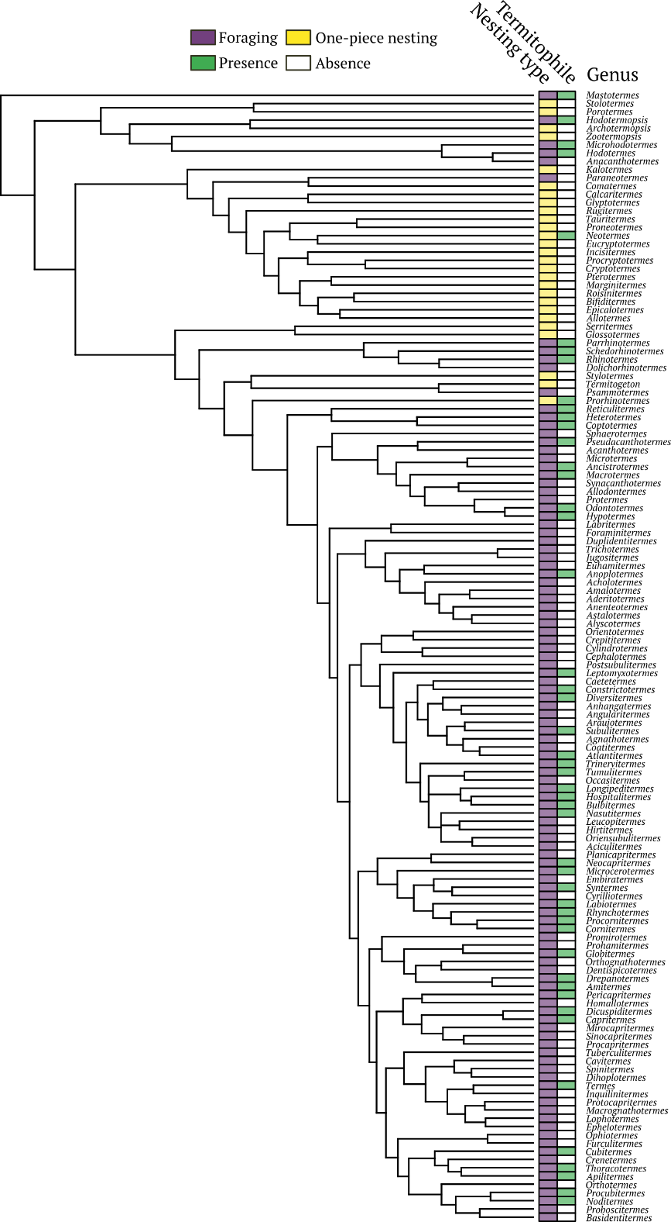

**Fig. S1**. Full time-calibrated phylogenetic tree of termites used in this study alongside their nesting behavior and recorded presence of associated termitophilous rove beetles.

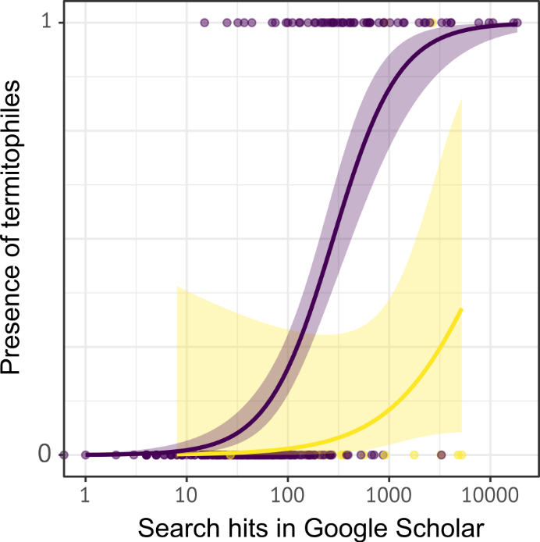

**Fig. S2**. Relationship between research effort on termite host genera and records of associated termitophilous rove beetles. The absence/presence of termitophiles is recorded as 0/1.

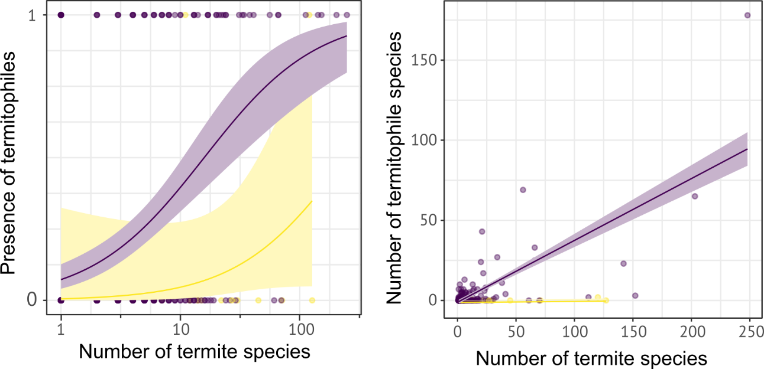

**Fig. S3**. Relationship between the species richness of termite genera and the species richness of their associated termitophilous rove beetle communities. (A) The absence/presence of termitophiles is recorded as 0/1.