**Strength of sexual signals predicts same-sex paring in termites**

**Nobuaki Mizumoto**1#\***, Sang-Bin Lee**2#**, Thomas Chouvenc**2

1: Okinawa Institute of Science & Technology Graduate University, Onna-son, Okinawa, 904-0495, Japan

2: Entomology and Nematology Department, Ft. Lauderdale Research and Education Center, Institute of Food and Agricultural Sciences, University of Florida, Ft. Lauderdale, FL 33314, USA

#: These authors contributed equally.

*: Correspondence: Nobuaki Mizumoto; [nobuaki.mzmt@gmail.com](mailto:nobuaki.mzmt@gmail.com)

Email

NM: [nobuaki.mzmt@gmail.com](mailto:nobuaki.mzmt@gmail.com); SBL: [lsb5162@ufl.edu](mailto:lsb5162@ufl.edu); TC: [tomchouv@ufl.edu](mailto:tomchouv@ufl.edu)

ORCID: NM: 0000-0002-6731-8684; SBL: 0000-0001-7982-0842; TC: 0000-0003-3154-2489

**Abstract**

The occurrence of same-sex sexual behavior (SSB) is an enigma in behavioral ecology as it does not result in reproduction, contrasting with normal heterosexual behavior. Proximately, previous studies considered that the loss of sexual signals is critical in the evolution of SSB as smaller sex differences may lead to indiscriminate mating. However, if animals engage in SSB even after they realize that the partner is the same-sex, sexual signal can enhance SSB as in heterosexual pairing. Here we show that the strength of sex pheromone is associated with the frequency of same-sex pairing in *Coptotermes* termites. In termites, mating pairs engage in tandem runs, where a male follows a female that produces sex pheromones. We found that the female-female tandem is more common in *C. formosanus*, whose females have more pheromone than *C. gestroi*. Furthermore, female-female tandem was more common than male-male tandem in *C. formosanus*, while female-female and male-male tandem were equally observed in *C. gestroi*. These results suggest that sexual signals can facilitate even same-sex pairing, as same-sex pairing is more advantageous than being alone in termites. The proximate mechanism of same-sex pairing can be diverse, reflecting their mating behaviors and life history.

**Keywords**: homosexual behavior, movement coordination, pheromone, same-sex sexual behavior, social insects

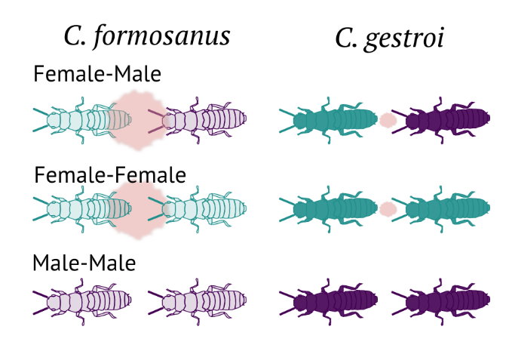

**Figure 1.** Experimental scheme.

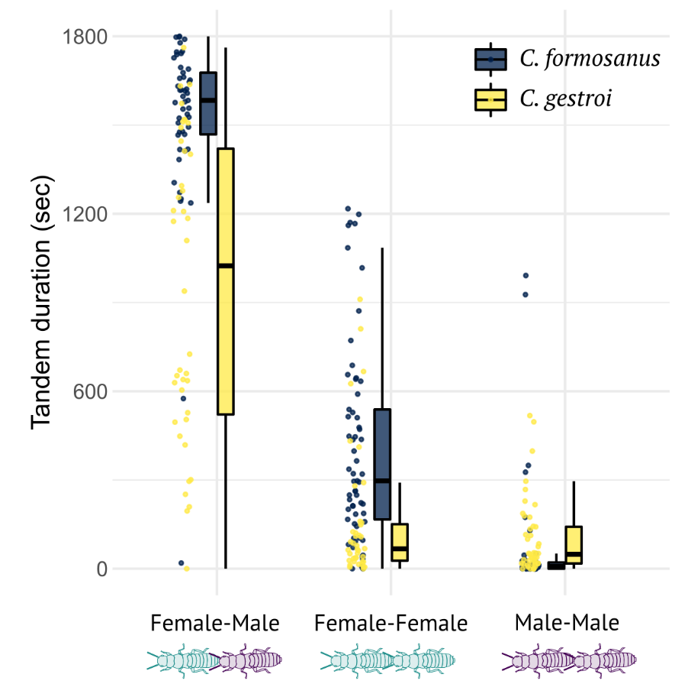

**Figure 2.** Comparison of the tandem duration among pair combinations and species.

**Introduction**

**Methods**

*Termites and experimental arena*

We collected alates of *C. formosanus* and *C. gestroi* using a light-trapping system at dusk between X and Y April 2021 in Broward County (Florida, USA) during synchronized dispersal flights. All alates were collected at a single site. We brought the alates to the laboratory and maintained them on wet cardboard at 28°C. We used individuals who shed their wings by themselves and observed their behaviour within 12 h after the flight. Each individual was used only once.

We performed all observations in an experimental arena made by filling a Petri dish (ø = 140 mm) with moistened plaster. The Petri dish had a clear lid during observations. A video camera above the arena was adjusted so that the arena filled the camera frame. We extracted the coordinates of termite move- ments from all obtained video, using the video-tracking system UMATracker [27]. All data analyses were performed using R v. 4.0.1 [28].

**Results**

**Discussion**

**Data accessibility**

Data that support the findings of this study are available in XXX

**Authors’ contributions**

NM: Conceptualization, Methodology, Formal analysis, Data curation, Writing – original draft

SBL: Methodology, Investigation, Data curation, Writing – review & editing

TC: Resources, Writing – review & editing

**Competing interests**

The authors declare no competing interest.

**Acknowledgments**

This work was supported by two JSPS Research Fellowships for Young Scientists, CPD, to NM (20J00660), and a Grant-in-Aid for Early-Career Scientists (21K15168) to NM.

**References**