**Strength of sexual signals predicts same-sex paring in termites**

**Nobuaki Mizumoto**1#\***, Sang-Bin Lee**2#**, Thomas Chouvenc**2

1: Okinawa Institute of Science & Technology Graduate University, Onna-son, Okinawa, 904-0495, Japan

2: Entomology and Nematology Department, Ft. Lauderdale Research and Education Center, Institute of Food and Agricultural Sciences, University of Florida, Ft. Lauderdale, FL 33314, USA

#: These authors contributed equally.

*: Correspondence: Nobuaki Mizumoto; [nobuaki.mzmt@gmail.com](mailto:nobuaki.mzmt@gmail.com)

Email

NM: [nobuaki.mzmt@gmail.com](mailto:nobuaki.mzmt@gmail.com); SBL: [lsb5162@ufl.edu](mailto:lsb5162@ufl.edu); TC: [tomchouv@ufl.edu](mailto:tomchouv@ufl.edu)

ORCID: NM: 0000-0002-6731-8684; SBL: 0000-0001-7982-0842; TC: 0000-0003-3154-2489

**Abstract**

Same-sex sexual behavior (SSB) is an enigma in behavioral ecology as it does not result in reproduction, contrasting with normal heterosexual behavior. Proximately, the loss of sexual signals is thought to be critical in the evolution of SSB as smaller sex differences may lead to indiscriminate mating. However, if animals engage in SSB even after recognizing the partner as the same-sex, sexual signal can enhance SSB as in heterosexual pairing. Here we show that the strength of sex pheromone is associated with the frequency of same-sex pairing in two *Coptotermes* termites. In termites, mating pairs engage in tandem runs, where a male follows a female that produces sex pheromones. We found that the female-female tandem was more common in *C. formosanus* whose females produce more pheromones. On the other hand, male-male tandem was more common in *C. gestroi*, whose males usually follow females with less pheromone. Furthermore, female-female tandem was more common than male-male tandem in *C. formosanus*, while female-female and male-male tandem were equally observed in *C. gestroi*. These results suggest that the strength of sexual signals predicts the same-sex pairing in a sex-specific manner. The proximate mechanism of SSB can be diverse, reflecting their heterosexual context.

**Keywords**: homosexual behavior, movement coordination, pheromone, same-sex sexual behavior, social insects

**Introduction**

Same-sex sexual behavior is widespread in animals. In most cases, the evolution of SSB is considered as the results of mistaken identity, while in some cases, there are adaptive value of SSB. In either case, mating behavior is often mediated by sexual communication via sex specific signals (e.g., sex pheromones), and thus, the strength of sex specific signals is expected to strongly affect the consequence of SSB. For example, in some species, SSB is the result of mistaken identity, where weak sex specific signals can enhance the occurrence of SSB. On the other hand, if individuals intentionally engage in SSB after recognizing the partner as the opposite sex, strong signals can help pairing even in same-sex context. However, the role of sex specific signals in SSB has not studied.

Mate pairing in neoisopetran termites (termites here after) provides an ideal model system to study the evolution of SSB. Termites form life-long monogamous pairs to establish colonies. During a brief period, alates (winged adults) disperse from their nests. Both females and males land on the ground, shed their wings, and run to search for a mating partner. Upon joining, a pair performs a tandem run. The male follows the female, maintaining contact in a highly coordinated manner while seeking a suitable site for colony foundation. As soon as they find a suitable site, pairs establish a nest, and thus tandem pairing is not a temporary relationship but leads to a long-term pairing. Tandem running involves communication via sex pheromones. During this process, same-sex tandem run can be observed in either sex.

In termite SSB, sex pheromone plays different roles between female-female pairs and male-male pairs. In male-male pairs, same-sex tandem can happen once one male started to follow another male. Thus, SSB can happen as a result of mistaken identity. Therefore, species with weak sex pheromones often result in mistaken identity and SSB. Note that, to maintain stable same-sex tandems, leader males have to play the role of females. On the other hand, female-female tandem cannot happen as a result of mistaken identity. Previous studies observed that sex role is fixed, and females do not follow males in Reticulitermes and Coptotermes (see Factors affecting post-flight behavior in primary reproductives of the Formosan subterranean termite, Coptotermes formosanus (Isoptera: Rhinotermitidae)) termites. Therefore, to initiate female-female tandem runs, one female change sex role in advance. In this situation, sex pheromones of females rather facilitate same-sex tandems because females can easily follow another female.

In this study, we compared the same-sex tandem running behavior in Coptotermes formosanus and Coptotermes gestroi. These two species share the same chemical for sex pairing pheromones. However, the quantity of pheromones are different between these two species, where C. formosanus has 10 times more pheormones than C. gestroi. Therefore, we predict that male-male tandem is more frequent in C. gestroi, while female-female tandem is more frequent in C. formosanus.

**Methods**

*Termites and experimental arena*

We collected alates of *C. formosanus* and *C. gestroi* using a light-trapping system at dusk between X and Y April 2021 in Broward County (Florida, USA) during synchronized dispersal flights. All alates were collected at a single site. We brought the alates to the laboratory and maintained them on wet cardboard at 28°C. We used individuals who shed their wings by themselves and observed their behaviour within 12 h after the flight. Each individual was used only once.

We performed all observations in an experimental arena made by filling a Petri dish (ø = 140 mm) with moistened plaster. The Petri dish had a clear lid during observations. A video camera above the arena was adjusted so that the arena filled the camera frame. We extracted the coordinates of termite move- ments from all obtained video, using the video-tracking system UMATracker [27]. All data analyses were performed using R v. 4.0.1 [28].

**Results**

**Discussion**

Furthermore, all of the previous studies in same-sex in tandem in termites focus on Retiuclitermes termites. Our study illustrates the different pattern in Coptotermes termites.

Therefore, we conclude that same-sex tandem in Coptotermes termites is less functional than Reticulitermes termites. Nevertheless, by clarifying the interspecific variation of non-adaptive tandem in Coptotermes, our study shows the proximate explanation of the diversity in SSB.

**Data accessibility**

Data that support the findings of this study are available in XXX

**Authors’ contributions**

NM: Conceptualization, Methodology, Formal analysis, Data curation, Writing – original draft

SBL: Methodology, Investigation, Data curation, Writing – review & editing

TC: Resources, Writing – review & editing

**Competing interests**

The authors declare no competing interest.

**Acknowledgments**

This work was supported by two JSPS Research Fellowships for Young Scientists, CPD, to NM (20J00660), and a Grant-in-Aid for Early-Career Scientists (21K15168) to NM.

**References**

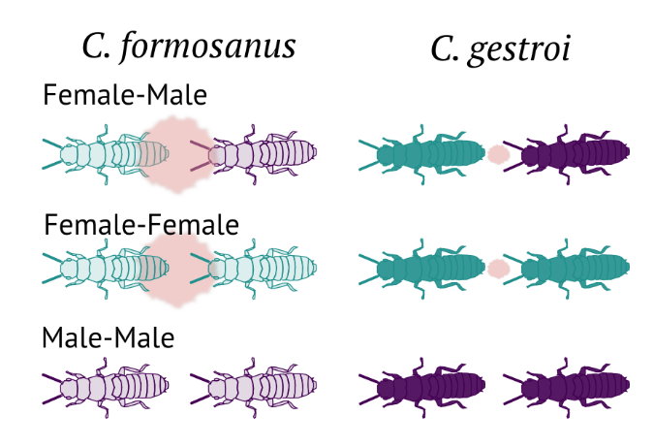

**Figure 1.** Experimental scheme.

**Figure 2.** Comparison of the tandem duration among pair combinations and species.