**Strength of sexual signals predicts same-sex paring in termites**

**Nobuaki Mizumoto**1#\***, Sang-Bin Lee**2#**, Thomas Chouvenc**2

1: Okinawa Institute of Science & Technology Graduate University, Onna-son, Okinawa, 904-0495, Japan

2: Entomology and Nematology Department, Ft. Lauderdale Research and Education Center, Institute of Food and Agricultural Sciences, University of Florida, Ft. Lauderdale, FL 33314, USA

#: These authors contributed equally.

*: Correspondence: Nobuaki Mizumoto; [nobuaki.mzmt@gmail.com](mailto:nobuaki.mzmt@gmail.com)

Email

NM: [nobuaki.mzmt@gmail.com](mailto:nobuaki.mzmt@gmail.com); SBL: [lsb5162@ufl.edu](mailto:lsb5162@ufl.edu); TC: [tomchouv@ufl.edu](mailto:tomchouv@ufl.edu)

ORCID: NM: 0000-0002-6731-8684; SBL: 0000-0001-7982-0842; TC: 0000-0003-3154-2489

**Abstract**

Same-sex sexual behavior (SSB) is an enigma in behavioral ecology as it does not result in reproduction, contrasting with normal heterosexual behavior. Proximately, the loss of sexual signals is thought to be critical in the evolution of SSB as smaller sex differences may lead to indiscriminate mating. However, if animals engage in SSB even after recognizing the partner as the same-sex, sexual signal can enhance SSB as in heterosexual pairing. Here we show that the strength of sex pheromone is associated with the frequency of same-sex pairing in two *Coptotermes* termites. In termites, mating pairs engage in tandem runs, where a male follows a female that produces sex pheromones. We found that the female-female tandem was more common in *C. formosanus* whose females produce more pheromones. On the other hand, male-male tandem was more common in *C. gestroi*, whose males usually follow females with less pheromone. Furthermore, female-female tandem was more common than male-male tandem in *C. formosanus*, while female-female and male-male tandem were equally observed in *C. gestroi*. These results suggest that the strength of sexual signals predicts the same-sex pairing in a sex-specific manner. The proximate mechanism of SSB can be diverse, reflecting their heterosexual context.

**Keywords**: homosexual behavior, movement coordination, pheromone, same-sex sexual behavior, social insects

**Introduction**

Same-sex sexual behavior is widespread in animals (Bagemihl, 1999; Bailey and Zuk, 2009; Scharf and Martin, 2013). In most cases, the evolution of SSB is considered as the result of mistaken identity (Lerch and Servedio, 2021; Monk et al., 2019; Scharf and Martin, 2013), while in some cases, SSB provides adaptive value as making the best of a bad job with the shortage of heterosexual partner (Mizumoto et al., 2016; Young and VanderWerf, 2013). In either case, successful mate pairing depends on the sexual communication which is mediated via sex specific signals (e.g., sex pheromones) (Yoshida and Iwasa, 2013), and the strength of sex specific signals is expected to strongly affect the consequence of SSB. For example, weak signals may provoke mistaken identity of the sex of partner, resulting in frequent SSB (Pfau et al., 2021). However, the role of the evolution of sex-specific signals in the evolution SSB has remained unexplored.

Mate pairing in neoisopetran termites (termites here after) provides an ideal model system to study the evolution of SSB. Termites form life-long monogamous pairs to establish colonies (Nutting, 1969, p. 19). During a brief period, alates (winged adults) disperse from their nests. Both females and males land on the ground, shed their wings, and run to search for a mating partner. Upon joining, a pair performs a tandem run. The male follows the female, maintaining contact in a highly coordinated manner while seeking a suitable site for colony foundation. Although tandem running often involves communication via sex pheromones, same-sex tandem run can be observed in either sex (Matsuura et al., 2002; Mizumoto et al., 2022). Sex pheromone should play different roles between female-female pairs and male-male pairs. In male-male pairs, same-sex tandem can happen once one male started to follow another male. Thus, SSB can happen as a result of mistaken identity. Therefore, species with weak sex pheromones often result in mistaken identity and SSB. Note that, to maintain stable same-sex tandems, leader males have to play the role of females. On the other hand, female-female tandem cannot happen as a result of mistaken identity. Previous studies observed that sex role is fixed, and females do not follow males in *Reticulitermes* (Mizumoto et al., 2022) and *Coptotermes* (Park et al., 2004) termites. Therefore, to initiate female-female tandem runs, one female change sex role in advance. In this situation, sex pheromones of females rather facilitate same-sex tandems because females can easily follow another female.

In this study, we compared the same-sex tandem running behavior in Coptotermes formosanus and Coptotermes gestroi. These two species share the same chemical for sex pairing pheromones. However, the quantity of pheromones are different between these two species, where C. formosanus has 10 times more pheormones than C. gestroi. Therefore, we predict that male-male tandem is more frequent in C. gestroi, while female-female tandem is more frequent in C. formosanus.

**Methods**

*Termites and experimental arena*

We collected alates of *C. formosanus* and *C. gestroi* using a light-trapping system at dusk between X and Y April 2021 in Broward County (Florida, USA) during synchronized dispersal flights. All alates were collected at a single site. We brought the alates to the laboratory and maintained them on wet cardboard at 28°C. We used individuals who shed their wings by themselves and observed their behaviour within 12 h after the flight. Each individual was used only once.

We performed all observations in an experimental arena made by filling a Petri dish (ø = 140 mm) with moistened plaster. The Petri dish had a clear lid during observations. A video camera above the arena was adjusted so that the arena filled the camera frame. We extracted the coordinates of termite move- ments from all obtained video, using the video-tracking system UMATracker [27]. All data analyses were performed using R v. 4.0.1 [28].

**Results**

**Discussion**

Furthermore, all of the previous studies in same-sex in tandem in termites focus on *Reticulitermes* termites. Our study illustrates the different pattern in *Coptotermes* termites.

Therefore, we conclude that same-sex tandem in Coptotermes termites is less functional than Reticulitermes termites. Nevertheless, by clarifying the interspecific variation of non-adaptive tandem in Coptotermes, our study shows the proximate explanation of the diversity in SSB.

**Data accessibility**

Data that support the findings of this study are available in XXX

**Authors’ contributions**

NM: Conceptualization, Methodology, Formal analysis, Data curation, Writing – original draft

SBL: Methodology, Investigation, Data curation, Writing – review & editing

TC: Resources, Writing – review & editing

**Competing interests**

The authors declare no competing interest.

**Acknowledgments**

This work was supported by two JSPS Research Fellowships for Young Scientists, CPD, to NM (20J00660), and a Grant-in-Aid for Early-Career Scientists (21K15168) to NM.

**References**

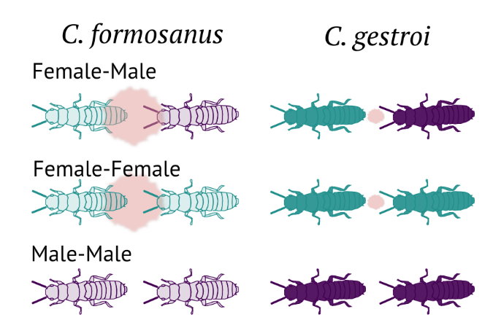

**Figure 1.** Experimental scheme.

**Figure 2.** Comparison of the tandem duration among pair combinations and species.