SCHOOL OF COMPUTING
PHENIKAA UNIVERSITY
o0o

PROJECT REPORT
COURSE: SOFTWARE ARCHITECTURE

PROJECT TITLE: CINEMA MANAGEMENT
Group 14
Student Name | ID
Hoàng Tuấn Kiệt | 23010517

Course Instructor: Vu Quang Dung
Ha Noi, February 5, 2026

Contents
1. Cover Page & Info 3
2. Executive Summary 3
3. Architectural Design & Implementation 3
3.1. Use Case Modeling 3
3.1.1. System Boundary 3
3.1.2. Actors 3
3.1.3. Top-Level Use Cases 4
3.1.4. Detailed Analysis of Critical Use Case: Book Ticket 4
3.1.5. UML Use Case Diagram Description 5
3.2. API Design 7
3.2.1. User / Authentication 7
3.2.2 Movies 7
3.2.3 Showtimes 8
3.2.4 Booking 8
3.2.5 Seats 9
3.2.6 Admin 10

Cover Page & Info
- Project Title: Cinema Management
- Assigned Tasks: C4 model, Detailed Architecture
- Course Name: Software Architecture
- Student Info: [Hoàng Tuấn Kiệt], [23010517]
- Date: February 5, 2026

Executive Summary
This project report focuses on the foundational design and interface specifications of the Cinema Management System, with a primary emphasis on Use Case Modeling and the definition of API Endpoints. These two core components serve as the blueprint for translating functional business requirements into a concrete technical implementation.
The Use Case Modeling section identifies the essential interactions between the system's primary actors specifically Customers and Administrators ensuring that the end to end journey, from movie discovery to ticket booking, is logically sound. Complementing this, the API Endpoints documentation establishes a standardized communication protocol between the system's front-end and back-end layers. By detailing the RESTful routes for critical services such as showtime scheduling, seat allocation, and transaction processing, this work ensures a robust framework for data exchange and system consistency.
Collectively, these architectural artifacts provide a clear, structured roadmap that supports both the development phase and the long-term maintainability of the platform.

Architectural Design & Implementation

Use Case Modeling

System Boundary
The System Boundary defines the scope of the "MovieTicket Online Booking System." It acts as a logical perimeter that distinguishes the internal functionalities of the Laravel-based platform from the external entities interacting with it. All core processes—from movie cataloging to transaction management—reside within this boundary, ensuring that the system's responsibilities are clearly delineated for the architectural design phase.

Actors
The system interacts with three primary external entities, each holding distinct roles and responsibilities:
- Customer : An end-user who interacts with the system to discover movies and perform booking transactions.
- Administrator : A privileged user responsible for managing the back-office operations, including movie data and system configurations.
- Payment Gateway : An external service provider that handles secure financial transactions, providing the system with payment confirmation or rejection status.

Top-Level Use Cases
The functional requirements are categorized based on the actor's objectives to ensure a streamlined user journey:
Customer-Facing:
- Search Movies: Enables users to browse the cinema's catalog using various filters such as genre or release date.
- View Showtimes: Provides real-time information on available screening times and theater locations.
- Book Ticket: The central business process involving seat selection and payment.
- Manage Account: Allows users to maintain personal profiles and view their booking history.
Administrator Management:
- Manage Movies: CRUD operations for the movie database (Add, Edit, Delete,…).
- Manage Showtimes: Coordination of movie schedules across different cinema halls.
- Manage Bookings: Oversight of all ticket transactions and seat occupancy reports.
- Payment Gateway interacts with: Secure Payment.

Detailed Analysis of Critical Use Case: Book Ticket
The "Book Ticket" use case is the most complex and critical function of the system. Its architecture is defined by several relationships:
- Include Relationships: To complete a booking, the system must execute Select Seats (to ensure inventory consistency) and Secure Payment (to authorize the transaction). These are mandatory sub-processes.
- Extend Relationships: The Add Food Combo use case is an optional enhancement. It provides the customer with supplementary choices without being a prerequisite for the basic ticket purchase.

UML Use Case Diagram Description
To visualize these interactions, the UML Use Case Diagram is structured as follows:
- Layout: The Customer is positioned on the left (initiator), while the Administrator and Payment Gateway are on the right/bottom as supporting or management actors.
- Visual Structure: All use cases are encapsulated within the "MovieTicket Online Booking System" boundary box.
- Logic Flow: Lines (associations) connect actors to their respective use cases, with clear dashed arrows representing the <<include>> and <<extend>> dependencies for the booking flow, illustrating a cohesive and robust functional architecture.

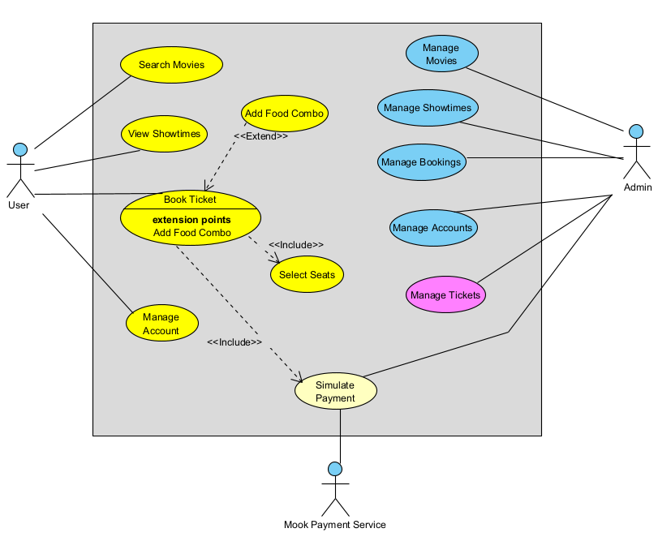
Figure 1: Use Case Diagram

API Design
The Cinema Management System utilizes a RESTful API architecture to ensure standardized communication between the frontend (Laravel Blade) and the backend services. The endpoints are designed following stateless principles, where each request contains all the information necessary for the server to fulfill it. Key characteristics of the API design include:
- Standardized Methods: Use of GET for data retrieval and POST for data submission (e.g., creating bookings).
- Resource-Oriented URLs: Clear and intuitive path structures such as /movies or /bookings.
- JSON Response Format: Ensuring compatibility for future mobile application integration or third-party service connections.

User / Authentication
These endpoints manage the security layer of the system, handling user onboarding and session control.
Method | Endpoint | Description
POST | /api/register | Registers a new customer account in the system database.
POST | /api/login | Authenticates user credentials and initializes a secure session/token.
POST | /api/logout | Terminates the current user session and clears authentication data.
Table 1: User API

3.2.2 Movies
This module serves as the primary entry point for user engagement, providing a comprehensive database of cinematic content. The design of this interface focuses on categorized data retrieval to enhance the user's browsing experience.
- Categorized Filtering: The system logic separates movies into coming-soon and showing categories. This distinction allows the front-end to dynamically adjust the user interface, prioritizing active screenings while building anticipation for future releases.
- Rich Metadata Support: Each movie record includes extensive metadata such as genre, duration, and detailed synopses. This data is delivered via RESTful endpoints, ensuring that the Presentation Layer remains decoupled from the data storage logic.
Method | Endpoint | Description
GET | /api/movies | Retrieves the full list of available movies in the catalog.
GET | /api/movies/coming-soon | Filters and displays movies scheduled for future release.
GET | /api/movies/showing | Lists movies currently being screened in cinema halls.
GET | /api/movies/{id} | Fetches in-depth metadata for a specific movie title.
Table 2: Movie API

3.2.3 Showtimes
Showtime Management acts as the temporal link between the movie catalog and the physical cinema infrastructure. It is responsible for organizing when and where a movie can be viewed.
- Scheduling Logic: This component synchronizes movie IDs with specific cinema halls and time slots. It ensures that the system can handle complex scheduling across multiple screens without conflicts.
- Availability Context: The showtime endpoints provide the necessary context (date and time) that a user needs before they can proceed to the seat selection phase, acting as a mandatory step in the booking workflow.
Method | Endpoint | Description
GET | /api/showtimes | Provides a comprehensive schedule of all movie screenings.
Get | /api/showtimes/{id} | Retrieves real-time occupancy status for all seats in a specific hall.
Table 3: Showtime API

3.2.4 Booking
This module represents the core business logic of the system, where user selections are transformed into valid financial and legal transactions.
- Atomic Transaction Logic: The booking process follows the "Atomic" principle. When a request is submitted, the system simultaneously validates seat availability and creates a record in a single database transaction to eliminate the risk of double-booking.
- Supplementary Service Integration: The architecture allows for transaction expansion through the combo feature. Customers can integrate food and beverage purchases directly into the booking flow, optimizing revenue and enhancing user convenience.
- Confirmation & Archiving: Upon completion, the system provides endpoints to retrieve detailed booking summaries, which are essential for ticket verification at the theater and long-term transaction history storage.
Method | Endpoint | Description
POST | /api/bookings | Initializes a new ticket reservation for the selected seats.
GET | /api/bookings/combo | Create a new booking for selected seats along with combo items (e.g., popcorn, drinks).
GET | /api/booking/{id} | Get details of a booking
Table 4: Booking API

3.2.5 Seats
The Seat Inventory module is responsible for monitoring the physical status of cinema halls at any given time. This layer serves as the data foundation before any booking transaction can be initiated.
- Real-time Availability Tracking: The system provides the ability to query the live status of each seat (e.g., available, selected, or sold). This ensures the Presentation Layer can accurately disable occupied seats, preventing data conflicts at the earliest stage of the user journey.
- Showtime-Specific Mapping: Each seat map is strictly bound to a showtime_id. This ensures data integrity, allowing the same physical cinema hall to maintain different seat occupancy states across various screening schedules.
Method | Endpoint | Description
GET | /api/showtimes/{id}/seats | List all seats for a showtime with availability status
Table 6: Seat API

3.2.6 Admin
The Administrative module provides a secure back-office interface for authorized personnel to oversee and manage the system’s core data. These privileged endpoints ensure that the cinema's operations, from content updates to schedule coordination, remain accurate and synchronized with physical theater availability.
- System Governance: Administrators have the authority to monitor all user activities and booking transactions. The /api/admin/bookings and /api/admin/users endpoints allow for real-time oversight of the platform's commercial performance and user management.
- Dynamic Content Control: The system enables full CRUD (Create, Read, Update, Delete) capabilities for the movie catalog. Through POST and PUT operations, administrators can introduce new film titles or modify existing metadata, ensuring the database reflects the current cinema offerings.
- Operational Scheduling: Beyond content, the administrative layer manages the temporal aspects of the cinema via showtime configuration. This ensures that screening slots are efficiently allocated across different cinema halls, preventing scheduling conflicts.
Method | EndPoint | Description
GET | /api/admin/bookings | Allows administrators to monitor and review all system transactions.
GET | /api/admin/users | Lists all registered users for account and security management.
GET | /api/admin/movies | Retrieves all movies for backend management and auditing.
POST | /api/admin/movies | Enables the creation of new movie records within the database.
PUT | /api/admin/movies/{id} | Updates existing movie details, including ratings and descriptions.
GET | /api/admin/showtimes | Provides a comprehensive list of all scheduled screenings.
POST | /api/admin/showtimes | Schedules new movie screenings within specific cinema halls.
Table 7: Admin API

