Paper 2 figures and tables: prespecified analyses, design of the improvements, results after them
Results of paper 2 (Pulse Wave Database, 4,374 virtual subjects; the frozen pulse decomposition failed the prespecified criterion, fiducial-point analysis of the same waveforms passed) arranged in three parts: A, the prespecified analyses; B, how the analyses led to the design of the improvements; C, whether the improvements changed the result. 7 figures and 18 tables.
Numbering is provisional to this set (manuscript v2 has three figures and four tables; the mapping is to be decided). Every number is read at run time from data/paper2_numbers.json, a mechanical parse of ../02_tables.md; none is typed by hand (the only exception is the synthetic-beat illustration of figure 4, which says so in the figure).
Verdicts (pass or fail) are those of docs/research/roadmap_v1.md §9 and are not changed. The contents of table 4 onward and of figures 3 to 7 (improved fits, waveform types, tier B, noise, wave separation) are exploratory, post hoc descriptions made after the prespecified decision and are not used for it. Using an improved fit as a primary analysis would require a new preregistration.
Tier note: Tier A, subjects accepted by the method itself; tier B, subjects accepted by every compared method; tier C, all subjects regardless of acceptance. A gain in tier A alone with no gain in tier C means that difficult beats were discarded, not that the index improved.

Part A. Prespecified analyses
What was tested, under which frozen criterion, and what came out. Verdicts are those of docs/research/roadmap_v1.md §9.

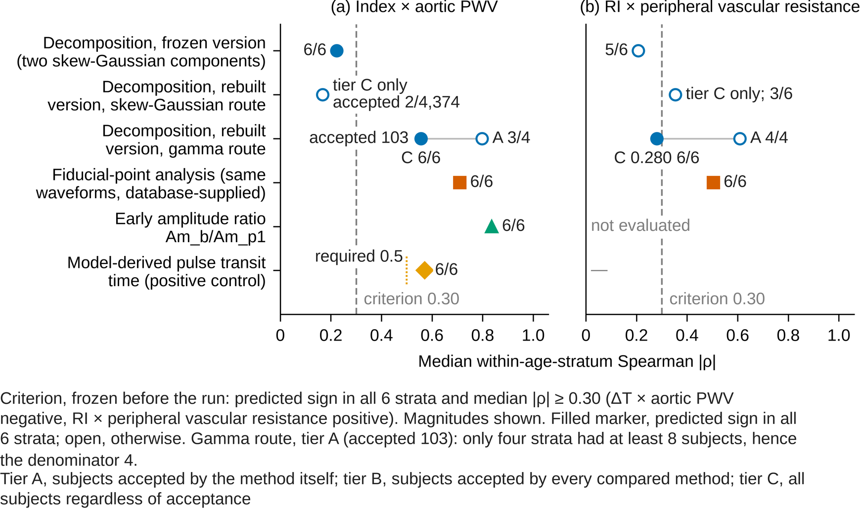
Figure 1. Decision figure: median within-age-stratum Spearman |ρ| of table 2 (table 1 of 02_tables.md) against the criterion line 0.30.
What is shown: for the decision test (PWDB, 4,374 virtual subjects, six age strata) and each of the six index constructions of table 2, the median across strata of the absolute within-stratum Spearman rank correlation of ΔT with aortic PWV (a) and of RI with peripheral vascular resistance (b). The dashed line is the criterion frozen before the run (predicted sign in all 6 strata and median |ρ| ≥ 0.30; ΔT × aortic PWV negative, RI × peripheral vascular resistance positive; magnitudes shown). Filled markers have the predicted sign in all 6 strata required by the criterion; open markers do not. The x/y beside a marker is the number of strata with the predicted sign over the number of strata with at least 8 subjects. The rebuilt skew-Gaussian route accepted 2 of 4,374 subjects, so tiers A and B could not be evaluated and only tier C is plotted; for the rebuilt gamma route tier A (accepted 103) and tier C are joined by a thin line. In tier A of the gamma route only four strata had at least 8 subjects, hence the denominator 4, and the 6-stratum criterion cannot be met there (lab_log entry 12). The positive control (model-derived pulse transit time × aortic PWV) tests whether the table is valid at all; its own requirement is median |ρ| ≥ 0.5 with the predicted sign in every stratum (gate0_rules_v2.md), which it met (short dotted line on its row in (a)). The positive control has no RI entry (—) and the RI of the early amplitude ratio was not evaluated. Verdicts (pass or fail) are not written in the figure; they are given in table 2. The positive control stays at its value because 22.2% (972 subjects) of the supplied transit times are one period short; corrected, it is 0.986 (post hoc; the table stays valid; lab_log entry 120). Of the fits accepted by the gamma route, 87.4% lie on a search bound and widening the bounds gives 0.119 for ΔT in tier A (script 27; roadmap_v1.md §9).
Source: table 1 of 02_tables.md (the decision table of docs/research/roadmap_v1.md §9; lab_log entry 12). Frozen version: script 20 20_pwdb_validity.py (data/pwdb/pwdb_indices.csv; lab_log 2026-09-03, results of study 0). Fiducial-point analysis and positive control: script 23 23_pwdb_landmarks.py (lab_log 2026-09-03, correction of the verdict). Rebuilt version and early amplitude ratio: script 26 26_pwdb_compare.py (data/pwdb/pwdb_compare.csv, pwdb_compare_report.txt; lab_log entry 12); script 27 27_threshold_sensitivity.py gives the threshold sensitivity, not the values of the decision table. All numbers are read from data/paper2_numbers.json by build_fig_judgement.py.
Tier note: Tier A, subjects accepted by the method itself; tier B, subjects accepted by every compared method; tier C, all subjects regardless of acceptance

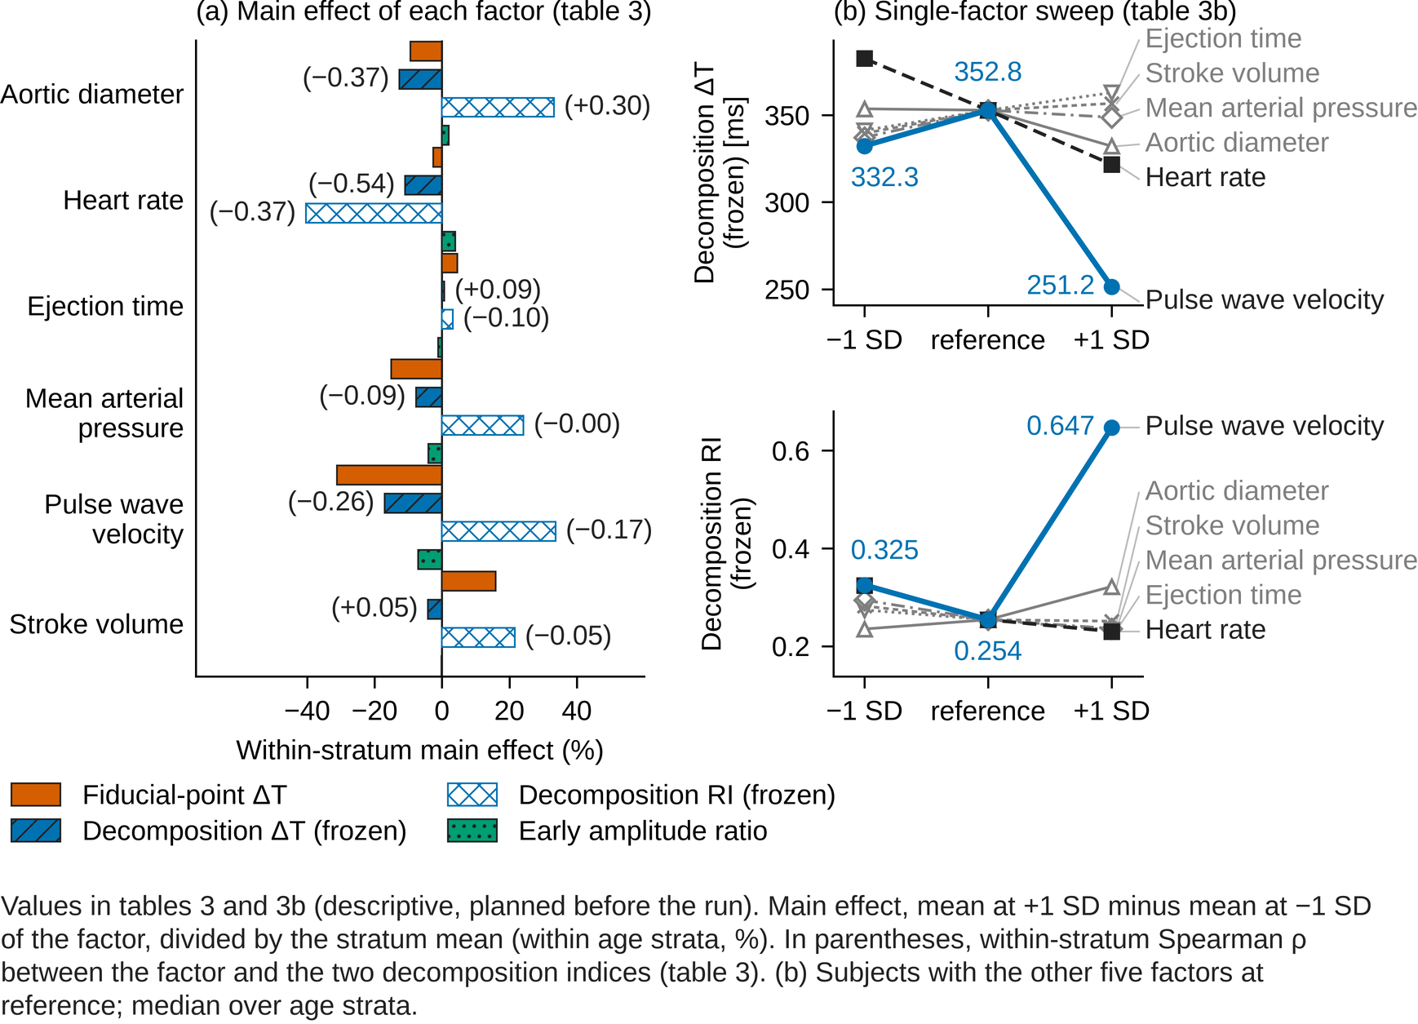
Figure 2. Within-stratum main effect of each varied factor (table 3) and single-factor sweeps (table 3b): descriptive analyses planned before the run.
What is shown: (a) main effect of each of the 6 factors (Aortic diameter, Heart rate, Ejection time, Mean arterial pressure, Pulse wave velocity, Stroke volume) on 4 indices (Fiducial-point ΔT, Decomposition ΔT (frozen), Decomposition RI (frozen), Early amplitude ratio), computed within each age stratum as the mean at +1 SD minus the mean at −1 SD of the factor, divided by the stratum mean (%). Fill and hatch distinguish the indices; for the two decomposition indices the within-stratum Spearman ρ between factor and index, as given in table 3, is written in parentheses at the end of the bar. (b) Single-factor sweeps: the stratum median of decomposition ΔT (ms, top) and RI (bottom) when one factor is moved across −1 SD, reference and +1 SD while the other five are held at reference. The response to pulse wave velocity (blue) folds back most: ΔT moves opposite to the prediction on the −1 SD side (332.3 → 352.8 → 251.2) and RI is U-shaped (0.325 → 0.254 → 0.647). For ΔT the mean arterial pressure row also folds back slightly (337.2 → 352.8 → 348.7; lab_log entry 113). The blue numbers are the three values for pulse wave velocity.
Source: tables 2 and 2b of 02_tables.md (tables 3 and 3b of this set; docs/research/roadmap_v1.md §9). Script 20 20_pwdb_validity.py (data/pwdb/pwdb_indices.csv; lab_log 2026-09-03, results of study 0, tables of main effects and single-factor sweeps); the fiducial-point ΔT column from script 23 23_pwdb_landmarks.py (lab_log 2026-09-03, correction of the verdict); the early amplitude ratio column from script 26 26_pwdb_compare.py (lab_log entry 12, table 3). All numbers are read from data/paper2_numbers.json by build_fig_effects.py.
Descriptive, planned before the run (the row 'mechanism (descriptive)' of the prespecified criteria of 2026-09-03); not used for the decision.

Table 1. Prespecified analysis items: rule, date frozen, result, verdict and sourceª. Criterion frozen before the run: within-stratum Spearman ρ with the predicted sign in all 6 strata and median |ρ| ≥ 0.30.
Item | Role | Rule (date frozen) | Result | Verdict^{b} | Source
Frozen decomposition (two skew-Gaussian components): ΔT × aortic PWV (Q1), RI × peripheral vascular resistance (Q2) | Primary questions Q1 and Q2 (table 2, row 1) | Within-stratum (six strata) Spearman ρ with the predicted sign in every stratum (ΔT negative, RI positive) and median |ρ| ≥ 0.3; strata of at least 8 subjects; pooled correlations are reference values only [frozen 2026-09-03 (before script 20 was run); the question itself on 2026-08-30 (roadmap §3, study 0)] | ΔT 0.223 (6/6); RI 0.207 (5/6) | fail | lab_log 2026-09-03 (prespecified criteria of study 0; results of study 0); roadmap §8, §9; reproduced in entry 12
Rebuilt decomposition, skew-Gaussian route (primary route; src/pda2.py) | Primary question: was the failure of the frozen version an implementation problem? (table 2, row 2) | Definition of 'pass' 1–3: both questions pass in all three tiers A, B and C, without an asterisk; if script 27 splits the verdict, 'pass' is not written [frozen 2026-09-04 (gate0_rules_v2, pda2_thresholds_v2); pda2 version 048d2b43bb05 fixed on 2026-09-05] | ΔT: accepted 2/4,374; tiers A and B not evaluable; tier C 0.167. RI: tiers A and B not evaluable; tier C 0.354 (3/6) | fail (tiers A and B not evaluable; tier C fails). Decomposition is not adopted as a vascular index | gate0_rules_v2.md; pda2_final_summary.md §1–2; entry 12 §1–3; roadmap §9
Rebuilt decomposition, gamma route (reported alongside) | Robustness check (table 2, row 3) | 'A pass of the gamma route alone is not written as a pass of PDA'; the proportion of parameters on a bound and the script-27 part-B (refitting) 'widen the search bounds' verdict are reported alongside [frozen 2026-09-04] | ΔT: accepted 103; tier A 0.798 (3/4 strata); tier C 0.556 (6/6). RI: tier A 0.609 (4/4); tier C 0.280 (6/6) | fail (the verdict splits across thresholds and conditions in script 27) | gate0_rules_v2.md; entries 12, 13
Fiducial-point analysis (indices supplied with PWDB, same waveforms): ΔT, RI; secondary SI, AGI_mod, AI, ΔT × carotid–femoral PWV | Control: only the index construction differs (table 2, row 4) | Same criterion imported from script 20. Reading fixed before the run: 'fiducial-point analysis also fails → the failure is not specific to PDA'; 'only fiducial-point analysis passes → the failure is specific to PDA'; 'model-derived PTT not strongly negative → doubt the comparison itself' [frozen 2026-09-03 (before script 23 was run)] | ΔT 0.710 (6/6); RI 0.504 (6/6). Secondary: SI 0.710 and AGI_mod 0.885 pass, AI 0.143 fails | pass (AI alone fails). The failure is specific to decomposition; the full withdrawal was retracted | lab_log 2026-09-03 (control experiment; correction of the verdict); roadmap §8; reproduced in entry 12
Early amplitude ratio Am_b/Am_p1 (Hellqvist 2024) × aortic PWV | Fourth method, exploratory (table 2, row 5) | 'If it passes and is at least equal to the median of fiducial-point ΔT (a difference within 0.05 counts as equal), the candidate primary index of study 2 switches to Am_b/Am_p1 and ΔT becomes secondary'; 'a 5–95% width below 0.05 is read as no discrimination' [frozen 2026-09-04] | 0.836 (6/6); against carotid–femoral PWV 0.758 (5/6), a fail | pass (fails against carotid–femoral PWV). Candidate primary index of study 2 switched to Am_b/Am_p1 | gate0_rules_v2.md; entry 12 §3-4
Positive control: model-derived pulse transit time × aortic PWV | Check of the analysis pipeline (table 2, row 6) | 2026-09-03: if not strongly negative, doubt the comparison itself. 2026-09-04: the whole table is void unless median |ρ| ≥ 0.50 with every stratum negative [frozen 2026-09-03 (script 23); 2026-09-04 (quantified in gate0_rules_v2)] | 0.571 (6/6); 22.2% (972) of the supplied transit times are off by one period; corrected, 0.986 (post hoc; the table stays valid) | passed; the table is valid | lab_log 2026-09-03 (correction of the verdict); gate0_rules_v2.md; entries 11, 12 §0
ΔT with p1 (Hellqvist's systolic peak) as the systolic reference | Exploratory (note to table 2) | 'If p1-based ΔT and our own fiducial-point ΔT differ greatly in type 3, replace the systolic reference of fiducial-point ΔT by p1' [frozen 2026-09-04] | 0.423 (5/6); in the same 4,269 subjects, below our own fiducial-point ΔT 0.536 | fail; p1 is not adopted (the rule's row does not apply) | gate0_rules_v2.md; entry 12 §3-5
DPS (difference of component widths, Goswami 2010) | Descriptive | 'If the DPS of the rebuilt skew-Gaussian route is monotonic in the true value, add it as a secondary index of study 2 (sign not decided post hoc; reported as description)' [frozen 2026-09-04] | The primary (skew-Gaussian) route accepted 2 beats, so tier A is not evaluable; tier-C values are reported as description only | descriptive only (the rule presupposes an accepted decomposition, so it is not applied) | gate0_rules_v2.md; entry 12 §3-7
Waveform-type distribution (script 26, table 2) and handling of types 3 and 4 | Condition for reading the verdict | 'If type 3 is frequent, the PDA verdict rests on type-1 beats and type 3 is read with fiducial points, p1 and the early amplitude ratio; report n of type 3 and the script-27 part-A "include type 3" verdict'; 'no ΔT-type index can be defined for type 4; report its n and discuss it with the early amplitude ratio only' [frozen 2026-09-04] | type 1 891 (20.4%); type 3 3,378 (77.2%); type 4 105 (2.4%) | read as the rule prescribes: the decomposition verdict rests on type-1 beats; type 3 read with fiducial points, p1 and the early amplitude ratio; type 4 with the early amplitude ratio only | gate0_rules_v2.md; entry 12 §1, §3-6
Threshold sensitivity analysis (script 27): part A, acceptance recomputed without refitting; part B, refitted on a fixed subset of 624 subjects under 14 conditions | Check that the conclusion is not a product of the thresholds | 'If every threshold gives the same answer, the conclusion is not a product of the thresholds; if it splits, write the range and do not write pass'. The part-B subset is fixed to subj_no % 7 == 0 and is not re-chosen after seeing results [frozen 2026-09-04 (lab_log: thresholds frozen before the decision test)] | The skew-Gaussian route fails at every threshold; the gamma route splits in both part A and part B (87.4% of its accepted fits lie on a search bound; widening the bounds gives 0.119 for ΔT in tier A) | reflected in the two rebuilt-version rows of table 2 | pda2_thresholds_v2.md; entry 12 §2
Table 3: within-stratum main effect of each varied factor (descriptive) | Mechanism, descriptive | 'If the main factor moving ΔT is PWV and the main factor moving RI is MBP, the concept holds' [frozen 2026-09-03] | Decomposition ΔT: PWV −17.0 (−0.26), heart rate −10.9 (−0.54), aortic diameter −12.6 (−0.37)%. Fiducial-point ΔT: PWV −31.2, heart rate −2.6%. Decomposition RI: heart rate −40.3 (−0.37), PWV +33.7 (−0.17), mean arterial pressure +24.2 (−0.00)% | not as conceived: for decomposition ΔT the heart-rate effect is of the same order as that of pulse wave velocity, and the main factor of RI is not mean arterial pressure (MBP) | lab_log 2026-09-03 (results of study 0; correction of the verdict); entry 12; table 3 (02_tables table 2)
Table 3b: one-factor-at-a-time sweep (descriptive) | Mechanism, descriptive | As above (values of the subjects in which one factor alone is varied) [frozen 2026-09-03] | The PWV row reverses most: ΔT 332.3 → 352.8 → 251.2 ms, RI 0.325 → 0.254 → 0.647 | the response is not monotonic (the correspondence of the components exchanges) | lab_log 2026-09-03 (results of study 0); table 3b (02_tables table 2b)
Table 3c: true transit times from the model onset-time table (descriptive) | True values, descriptive | 'Compare the width of the true radial→finger transit time with the within-case SD of T2−T1 in VitalDB (≈18 ms)' [frozen 2026-09-03] | Aortic root→finger 96 ms (66–120 ms), radial→finger 8 ms (4–16 ms). ρ(aortic PWV, root→finger) −0.99 (6/6); ρ(decomposition ΔT, same) +0.19 (6/6) | the width of the true radial→finger transit time is narrower than the VitalDB within-case SD; decomposition ΔT barely tracks the true transit time | lab_log 2026-09-03 (results of study 0); table 3c (02_tables table 2c)
ª Rule texts from lab_log 2026-09-03 (prespecified criteria of study 0), docs/research/gate0_rules_v2.md (2026-09-04) and lab_log 2026-09-04 (thresholds frozen before the decision test). Verdicts are identical to docs/research/roadmap_v1.md §9. Result values are read from tables 1, 2, 2b and 2c of 02_tables.md (data/paper2_numbers.json). 'Entry n' is a numbered addendum of lab_log. The random-beat invariants (script 28) are an implementation check, not an analysis item, and are omitted.
^{b} Tier A, subjects accepted by the method itself; tier B, subjects accepted by every compared method; tier C, all subjects regardless of acceptance

Table 2. Median within-age-stratum Spearman rank correlation (decision test, 4,374 subjects, 6 strata)ª. Criterion frozen before the run: predicted sign in all 6 strata and median |ρ| ≥ 0.30 (ΔT × aortic PWV negative, RI × peripheral vascular resistance positive). Magnitudes are shown; the number in parentheses is the number of strata with the predicted sign^{b}.
Index construction | ΔT × aortic PWV | RI × peripheral vascular resistance | Verdict
Decomposition, frozen version (two skew-Gaussian components) | 0.223 (6/6) | 0.207 (5/6) | fail
Decomposition, rebuilt version, skew-Gaussian route^{c} | accepted 2/4,374; tiers A and B not evaluable; tier C 0.167 | tiers A and B not evaluable; tier C 0.354 (3/6) | fail
Decomposition, rebuilt version, gamma route^{c} | accepted 103; tier A 0.798 (3/4 strata); tier C 0.556 (6/6) | tier A 0.609 (4/4); tier C 0.280 (6/6) | fail
Fiducial-point analysis (same waveforms, database-supplied) | 0.710 (6/6) | 0.504 (6/6) | pass
Early amplitude ratio Am_b/Am_p1 | 0.836 (6/6) | not evaluated | pass
Model-derived pulse transit time (positive control)^{d} | 0.571 (6/6) | — | passed
ª Source: table 1 of 02_tables.md (docs/research/roadmap_v1.md §9; lab_log entry 12). Frozen version: script 20 20_pwdb_validity.py; fiducial-point analysis and positive control: script 23 23_pwdb_landmarks.py; rebuilt version and early amplitude ratio: scripts 26 26_pwdb_compare.py and 27 27_threshold_sensitivity.py (data/pwdb/pwdb_compare.csv, pwdb_compare_report.txt).
^{b} Bold, criterion met (median |ρ| ≥ 0.30 with the predicted sign in every stratum). 'Not evaluated', the index was not evaluated; —, no such index.
^{c} The two rebuilt-version rows accepted few beats and are given by tier. Tier A, subjects accepted by the method itself; tier B, subjects accepted by every compared method; tier C, all subjects regardless of acceptance
^{d} The positive control stays at 0.571 because 22.2% (972 subjects) of the supplied transit times are one period short; corrected, it is 0.986 (post hoc, exploratory; the table stays valid; lab_log entry 120). Of the fits accepted by the rebuilt gamma route, 87.4% lie on a search bound; widening the bounds gives 0.119 for ΔT in tier A (script 27; docs/research/roadmap_v1.md §9).

Table 3. Within-stratum main effect of each varied factor (difference between the +1 SD and −1 SD means ÷ stratum mean, %)ª. In parentheses, the within-stratum Spearman rank correlation of the factor with the index^{b}.
Factor | Fiducial-point ΔT | Decomposition ΔT (frozen) | Decomposition RI (frozen) | Early amplitude ratio
Aortic diameter | −9.4 | −12.6 (−0.37) | +33.2 (+0.30) | +2.0
Heart rate | −2.6 | −10.9 (−0.54) | −40.3 (−0.37) | +4.0
Ejection time | +4.6 | +0.7 (+0.09) | +3.2 (−0.10) | −1.1
Mean arterial pressure | −15.1 | −7.7 (−0.09) | +24.2 (−0.00) | −4.0
Pulse wave velocity | −31.2 | −17.0 (−0.26) | +33.7 (−0.17) | −7.1
Stroke volume | +15.9 | −4.1 (+0.05) | +21.6 (−0.05) | −0.2
ª Source: table 2 of 02_tables.md (docs/research/roadmap_v1.md §9; lab_log entry 12; factor tables of scripts 20, 23 and 26).
^{b} Bold, the rows and columns contrasted in the text (pulse wave velocity and heart rate). For fiducial-point ΔT the pulse-wave-velocity row is 12 times the heart-rate row; for decomposition ΔT only 1.6 times. In rank terms decomposition ΔT follows heart rate (−0.54) more than pulse wave velocity (−0.26).

Table 3b. One-factor-at-a-time sweep (other factors at their reference values; median over age strata; ΔT in ms)^{a, b}.
Factor | ΔT, −1 SD | ΔT, reference | ΔT, +1 SD | RI, −1 SD | RI, reference | RI, +1 SD
Pulse wave velocity | 332.3 | 352.8 | 251.2 | 0.325 | 0.254 | 0.647
Heart rate | 382.5 | 352.8 | 321.6 | 0.324 | 0.254 | 0.230
Aortic diameter | 353.6 | 352.8 | 332.1 | 0.235 | 0.254 | 0.322
Ejection time | 341.2 | 352.8 | 362.9 | 0.274 | 0.254 | 0.233
Mean arterial pressure | 337.2 | 352.8 | 348.7 | 0.294 | 0.254 | 0.236
Stroke volume | 339.5 | 352.8 | 356.7 | 0.282 | 0.254 | 0.251
ª Source: table 2b of 02_tables.md (lab_log 2026-09-03, results of study 0; entry 12; script 20). Values of the frozen decomposition.
^{b} Bold, the row with the largest reversal (pulse wave velocity): ΔT moves against the prediction on the −1 SD side and RI is U-shaped. In ΔT the mean-arterial-pressure row also reverses slightly (337.2 → 352.8 → 348.7; lab_log entry 113).

Table 3c. True transit times from the model onset-time table^{a, b}.
Segment | Median | 5th–95th percentile
Aortic root → finger | 96 ms | 66–120 ms
Radial → finger | 8 ms | 4–16 ms
ª Source: table 2c of 02_tables.md (lab_log 2026-09-03, results of study 0; script 20; PWDB file pwdb_onset_times.csv).
^{b} Within-stratum ρ(aortic PWV, root→finger transit time) = −0.99 (6/6); ρ(decomposition ΔT, same) = +0.19 (6/6).

Table 4. Basis function and number of components, exhaustive sweep (exploratory, post hoc)^{a, b, c, d}.
Basis | Components | Wang pass | Errx median [ms] | NRMSE median | Parameters on a bound | ΔT × PWV |ρ|
Skew-Gaussian, α∈[0,8] (frozen) | 2 | 0.0% | 40 | 0.0212 | 2% | 0.14 (2/4)
Skew-Gaussian, α∈[0,8] (frozen) | 3 | 2.0% | 24 | 0.0110 | 0% | 0.08 (4/4)
Gaussian (no skew) | 2 | 0.0% | 30 | 0.0491 | 4% | 0.54 (4/4)
Gaussian (no skew) | 3 | 0.0% | 14 | 0.0191 | 86% | 0.55 (3/4)
Gaussian (no skew) | 4 | 1.0% | 15 | 0.0145 | 94% | 0.28 (3/4)
Gaussian (no skew) | 5 | 1.0% | 13 | 0.0084 | 92% | 0.52 (3/4)
Skew-Gaussian, α∈[−8,8] (Basso) | 2 | 0.0% | 40 | 0.0212 | 2% | 0.14 (2/4)
Skew-Gaussian, α∈[−8,8] (Basso) | 3 | 2.0% | 23 | 0.0111 | 0% | 0.12 (3/4)
Gamma (frozen search bounds) | 3 | 15.3% | 12 | 0.0071 | 93% | 0.56 (4/4)
Gamma (frozen search bounds) | 4 | 22.4% | 10 | 0.0051 | 99% | 0.35 (3/4)
Gamma (wide search bounds) | 3 | 10.2% | 12 | 0.0068 | 89% | 0.55 (4/4)
Gamma (wide search bounds) | 4 | 31.6% | 8 | 0.0047 | 99% | 0.38 (3/4)
ª Exploratory, post hoc analysis; not used for the prespecified decision. Using an improved fit as a primary analysis would require a new preregistration.
^{b} Source: table 3 of 02_tables.md; lab_log entry 13. Script 31 31_pwdb_basis_explore.py (data/pwdb/pwdb_basis_explore.csv).
^{c} Subjects: 98 notched beats taken from 120 subjects, in 4 strata of at least 8 beats (smaller than the 4,374 subjects and 6 strata of the decision test, so the values are wider). Preprocessing and Wang's acceptance criterion identical to the decision test. |ρ| is the within-stratum median over all beats (acceptance ignored); in parentheses, the number of strata with the predicted sign.
^{d} Bold, the two best-tracking rows among the decompositions.

Table 5a. Published fitting conditions applied unchanged (exploratory, post hoc)^{a, b, c, d, e}.
Source of the conditions | ΔT × aortic PWV | RI × peripheral vascular resistance
Tigges 2017 (recommended gamma, M = 3) | 0.578 (6/6) | —
Fleischhauer 2020 (two kernels) | 0.505 (5/6) | 0.314 (5/6)
Couceiro 2015 | 0.500 (6/6) | R1_d 0.585 (6/6)
Wang 2013 (all beats) | 0.457 (5/6) | —
Basso 2024 (L = 3) | — | 0.314 (6/6)
Goswami 2010 | — | 0.343 (5/6)
Reference: fiducial-point indices supplied with PWDB (Charlton) | 0.705 | 0.501
ª Exploratory, post hoc analysis; not used for the prespecified decision. Using an improved fit as a primary analysis would require a new preregistration.
^{b} Source: table 4 of 02_tables.md; lab_log entry 18. Script 33 33_pwdb_literature_replica.py (docs/research/results/33_literature_replica_report.txt; lab_log entries 16–18).
^{c} Subjects: 624 chosen systematically (subject number modulo 7 equal to 0). In the same subset the fiducial-point indices supplied with PWDB (Charlton) give ΔT 0.705 and RI 0.501. In parentheses, the number of strata with the predicted sign.
^{d} Bold, the best condition for ΔT and the only condition whose RI exceeded the fiducial-point value.
^{e} For RI only Couceiro's R1_d exceeds the fiducial-point value (0.585 versus 0.501). Under the prespecified rule this row is not taken into the verdict. Three caveats: in this model peripheral vascular resistance determines the diastolic decay, so part of the association is built in; measured waveforms often lack a diastolic peak; and deviations remain in our replication.

Table 5b. Deviations from the published conditions in the replication (supplement to table 5a)^{a, b}.
Source | Deviation
All conditions | The optimiser was that of our environment (SciPy), not identical to the originals
Wang 2013 | The weight search step was set to 1
Couceiro 2015 | For the 1% of beats whose fifth-component initial value could not be formed from table 1 of the original, the default was used
Tigges 2017 | Resampling to 40 Hz for the corrected Akaike information criterion used a Kaiser window, as the original describes
Common | PWDB gives one noise-free beat per subject; the conditions differ from the measured waveforms of the originals
ª Exploratory, post hoc analysis; not used for the prespecified decision. Using an improved fit as a primary analysis would require a new preregistration.
^{b} Source: the deviation table under table 4 of 02_tables.md; lab_log entry 18. Deviation table of script 33 (lab_log entries 17, 18).

Part B. Design of the improvements
What the analyses showed, what was changed, and what was predicted before each run. Table 4 onward is exploratory and post hoc and is not used for the decision.

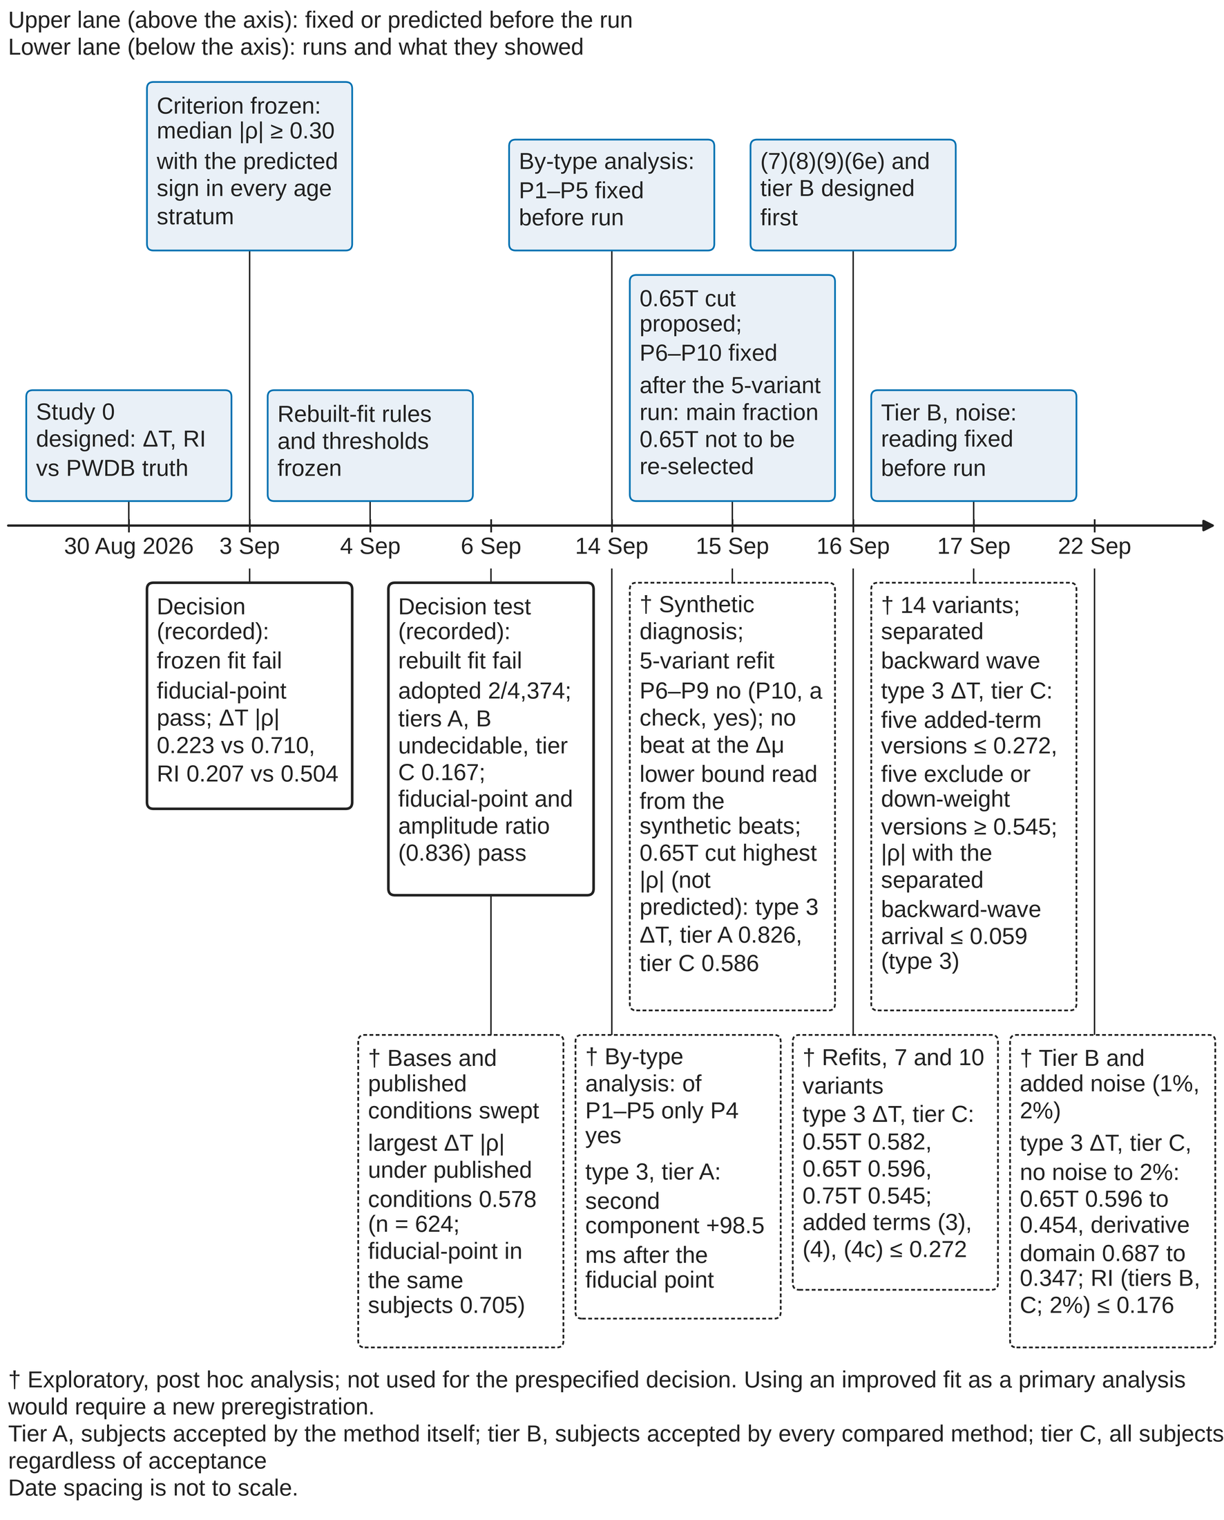
Figure 3. Course of the study from Study 0 (PWDB decision test) to the exploratory search for an improved fit. Upper lane: what was fixed or predicted before each run; lower lane: the runs and what they showed.
What is shown: dated milestones (7 in the upper lane, 8 in the lower lane). Upper boxes record rules, thresholds and predictions fixed before the run; lower boxes record the result of that run, with the numbers that show it from the second line on. The lower boxes on 3 and 6 September 2026 report the prespecified decisions as recorded ('pass' / 'fail' are copied from the record; the figure makes no new judgement). Boxes marked † are exploratory, post hoc analyses run after the decision test and are not used for the decision. Date spacing is not to scale.
Order on 15 September 2026 (the five records of that day that bear on this figure, in the order of the lab-log entries): entry 139 listed candidate remedies for the diastolic decline, of which (3) was 'truncate the fit at 0.65T, or fit in the first-derivative domain' (before any real data were fitted). Entry 141 diagnosed the frozen fit on synthetic beats and read the Δμ lower bound as the main cause. Entry 143 fixed the predictions P6–P10 for the refit (part C). Entry 144 fitted five variants to the 4,374 subjects: P6–P9 no (P10, a wiring check, yes); no beat sat at the Δμ lower bound, so the reading from the synthetic beats was refuted; the unpredicted variant (6), the 0.65T truncation combined with a Δμ lower bound of 0.01 s, gave the highest |ρ|. Entry 145 agreed that the main fraction stays at 0.65T and is not re-selected (0.55T and 0.75T only as a sensitivity description); the second line of the upper box on 15 September is this agreement, written after the 5-variant run and before the 9-variant run. The value 0.65 comes from candidate (3) of entry 139; the same value is the notch search limit NOTCH_MAX_FRAC (analysis/src/pda2.py) of the rebuilt fiducial-point detection. Entries 144 and 145 gave its source as 'script 24 and entry 139', but script 24 (24_pwdb_pda_ablation.py) contains 0.60·T and not 0.65 (corrected in lab-log entry 162).
Optimism from selection: the better versions in the boxes of 16–17 September were chosen post hoc from the 14 versions fitted, so their values are optimistic.
Scripts and result files: scripts 20 (20_pwdb_validity.py), 23 (23_pwdb_landmarks.py), 26 (26_pwdb_compare.py), 27, 31, 33, 48 (48_pwdb_by_waveform_type.py), 50 (50_reservoir_bench.py, sections A, B, C) and 51 (51_pwdb_wave_separation.py). Results in docs/research/results/: 33_literature_replica_report.txt, 48_pwdb_by_waveform_type.txt, 50_reservoir_bench.txt, 50_reservoir_bench_C.txt, 50_reservoir_bench_BC.txt, 50_reservoir_bench_C14.txt, 50_reservoir_bench_B3.txt, 50_reservoir_bench_noise0.01.txt, 50_reservoir_bench_noise0.02.txt, 51_wave_separation.txt. Of these, 48_pwdb_by_waveform_type.txt, 50_reservoir_bench.txt, 50_reservoir_bench_C14.txt, 50_reservoir_bench_B3.txt, 50_reservoir_bench_noise0.01.txt, 50_reservoir_bench_noise0.02.txt, 51_wave_separation.txt are not in the present working tree (lab-log entries 137, 144, 152 and 158 record them as output on Mac 1; the numbers in the figure were taken through 02_tables.md).
Tier note: Tier A, subjects accepted by the method itself; tier B, subjects accepted by every compared method; tier C, all subjects regardless of acceptance Post-hoc note: Exploratory, post hoc analysis; not used for the prespecified decision. Using an improved fit as a primary analysis would require a new preregistration.
Script: docs/manuscript/paper2/figtab/build_fig_timeline.py (reads data/timeline.json, data/paper2_numbers.json and data/labels.json).

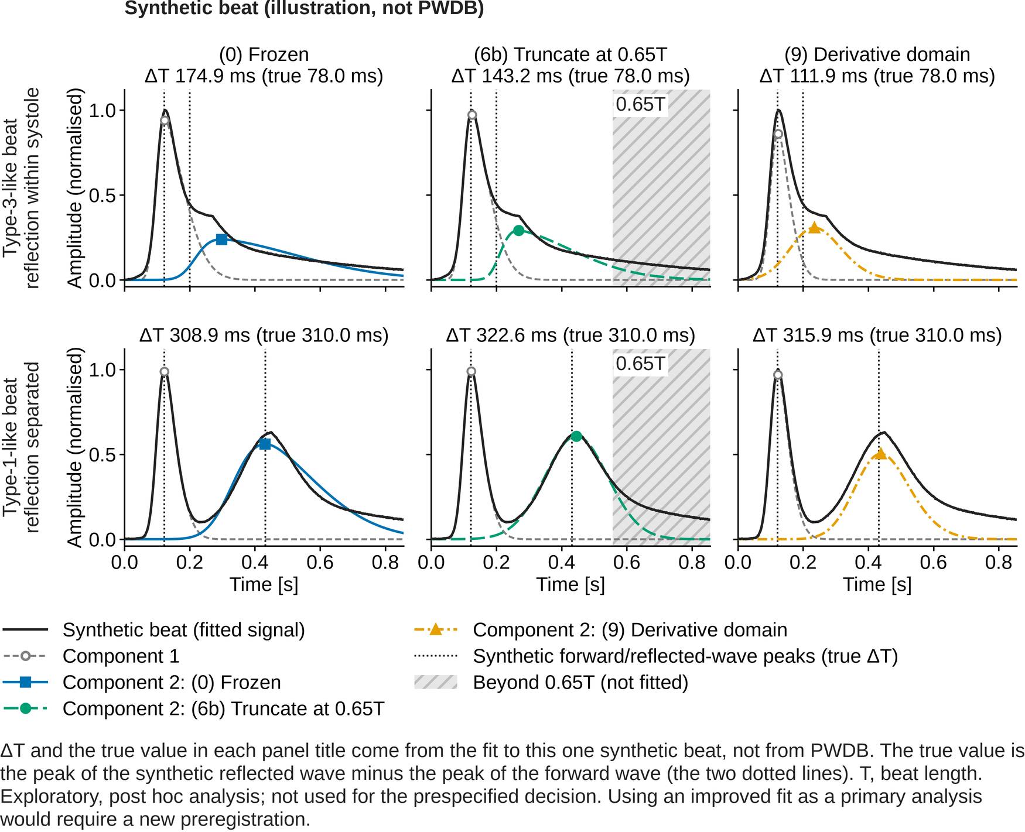
Figure 4. Three fits superimposed on one synthetic beat (illustration, not PWDB): position of the second component relative to the peak of the synthetic reflected wave.
What is shown: rows are synthetic beats (top: type-3-like, reflected-wave arrival parameter 0.10 s, overlapping systole; bottom: type-1-like, arrival parameter 0.28 s, separated; reservoir time constant 0.45 s in both), columns are the fit variants of table 8 ((0) frozen; (6b) truncated at 0.65 of the beat length T; (9) residual taken in the first-derivative domain). Each panel shows the fitted signal (normalised synthetic beat, thick black line), component 1 (short grey dashes, open circle at its peak), component 2 (colour and line style per column: (0) solid, (6b) long dashes, (9) dash-dot; marker at its peak) and the peaks of the synthetic forward and reflected waves (two dotted lines). In the truncation column the region beyond 0.65T is hatched (not fitted). T, beat length. The panel title gives ΔT = peak of component 2 − peak of component 1, and the true value = peak of the synthetic reflected wave − peak of the forward wave (the spacing of the two dotted lines).
The arrival parameter (0.10 and 0.28 s) and the true value (78.0 and 310.0 ms) differ because, in the generator, the width and skewness of the reflected wave change with its arrival, and the true value is defined as a difference of peaks, not of the position parameters (docstring of synth_beat in script 50; lab-log entry 141).
The numbers in the panel titles come from the synthetic beat only, not from the 4,374 PWDB subjects. The reading drawn from the synthetic beats, that the lower bound on the position of the frozen fit's second component (Δμ ≥ 0.08 s) was the main cause (lab-log entry 141), was refuted when the 4,374 PWDB subjects were refitted: not a single beat sat at that bound (entry 144; note to table 8). Even in the synthetic type-3-like beats, all 7 beats at the edge of the search range had the second component's skewness at its upper limit, and only 2 of the 7 were at the Δμ bound (continuation of entry 144). The figure illustrates where the two versions that exclude the diastolic decline from the fit place the second component; it does not establish the mechanism.
The frozen column was drawn with variant (1) of script 50, a copy of the frozen implementation (0) in src/pda.py with the same search range, starts and solution rule; the self-test checks its result against (0).
Fitted values (ms; the self-test checks agreement with fit_kind of script 50 within 0.5 ms): type-3-like: true 78.0; (0) Frozen 174.9; (6b) Truncate at 0.65T 143.2; (9) Derivative domain 111.9 type-1-like: true 310.0; (0) Frozen 308.9; (6b) Truncate at 0.65T 322.6; (9) Derivative domain 315.9
Source: analysis/scripts/50_reservoir_bench.py section A (synth_beat, _bounds, _frozen_starts, _model, _components and the solution rule of fit_kind). Design and findings of the synthetic beats: lab-log entry 141; alignment of starts and solution rule with the frozen fit: entry 143; refutation on real data: entry 144. Results of (6b) and (9) on PWDB: tables 6 and 6c of 02_tables.md (table 8 and table 9 of this set; script 50 section C; docs/research/results/50_reservoir_bench_C14.txt and others; entries 146, 152, 158). This file is not in the present working tree (lab-log entry 152 records it as output on Mac 1; the numbers were taken through 02_tables.md).
Post-hoc note: Exploratory, post hoc analysis; not used for the prespecified decision. Using an improved fit as a primary analysis would require a new preregistration.
Script: docs/manuscript/paper2/figtab/build_fig_synthetic.py.

Table 6a. Within-age-stratum Spearman rank correlation by waveform type (exploratory, post hoc)^{a, b, c, d, e, f, g}.
Waveform type (n) | Fiducial-point ΔT, tier C | Decomposition ΔT (frozen), tier A | Early amplitude ratio, tier C | Fiducial-point RI, tier C | Decomposition RI (frozen), tier A
Type 1, notch present (891) | 0.343 (4/6) | 0.224 (4/6) | 0.326 (4/6) | 0.481 (6/6) | 0.554 (6/6)
Type 3, inflection only (3,378) | 0.430 (6/6) | 0.220 (6/6) | 0.815 (6/6) | 0.550 (6/6) | 0.233 (5/6)
Type 4, neither (105; 3 strata) | 0.796 (3/3) | 0.472 (3/3) | 0.247 (0/3) | 0.888 (3/3) | 0.637 (3/3)
All subjects (4,374) | 0.710 (6/6) | 0.223 (6/6) | 0.836 (6/6) | 0.504 (6/6) | 0.207 (5/6)
ª Exploratory, post hoc analysis; not used for the prespecified decision. Using an improved fit as a primary analysis would require a new preregistration.
^{b} Source: table 5 of 02_tables.md; script 48 (docs/research/results/48_pwdb_by_waveform_type.txt); lab_log entry 137. Section C of script 50 reproduces the fiducial-point values of types 1 and 3 from the same input.
^{c} Tier A, subjects accepted by the method itself; tier B, subjects accepted by every compared method; tier C, all subjects regardless of acceptance. Fiducial-point indices carry no acceptance decision and are therefore always tier C.
^{d} Subjects as in the decision test (4,374); waveform type by pda2.find_landmarks (type 1, dicrotic notch and diastolic peak present as extrema; type 3, no extrema, but the inflection point of the descending limb can stand in; type 4, neither found). Six age strata, at least 8 subjects per stratum. Median |ρ|; in parentheses, the number of strata with the predicted sign. The three left columns are ΔT × aortic PWV (predicted sign negative; positive for the early amplitude ratio), the two right columns RI × peripheral vascular resistance (positive). Fiducial-point values of type 4 are computed on the 72 of 105 subjects with supplied fiducial points (lab_log entries 137, 138).
^{e} Bold, criterion met (median |ρ| ≥ 0.30 with the predicted sign in every stratum).
^{f} The correlation in all subjects includes the mixing of types: fiducial-point ΔT is 0.710 in all subjects but 0.343 in type 1 and 0.430 in type 3. Within an age stratum, type 1 (notch retained) and type 3 (notch lost) separate and the type itself is a function of stiffness, so the difference between types raises the value in all subjects. This is part of the index reflecting stiffness, not a defect, but within a fixed type the association is weaker than in all subjects.
^{g} Predictions fixed before the run (lab_log entry 136): (P1) fiducial-point ΔT × aortic PWV has median |ρ| ≥ 0.30 and a negative sign in every stratum in both types 1 and 3; (P2) frozen ΔT (tier A) differs from fiducial-point ΔT by a median |difference| below 5 ms with |ρ| ≥ 0.30 in type 1, and by at least 20 ms with |ρ| below 0.30 in type 3; (P3) frozen RI (tier A) is within 0.01 of fiducial-point RI with |ρ| within 0.05 in type 1, and does not agree in type 3; (P4) type 4 has at most 3 strata with at least 8 subjects; (P5) the share of type 1 falls monotonically with age. Only P4 was met (P1, P2, P3 and P5 were not; lab_log entry 137).

Table 6b. Within-stratum spread of the true values themselves (restriction of range; exploratory, post hoc, tier C)^{a, b, c, d}.
Waveform type | Width of aortic PWV [m/s] | Width of peripheral vascular resistance [Pa·s/m³] | Strata with ≥ 8 subjects | Smallest stratum n
Type 1, notch present | 0.114 | 3.71×10⁷ | 6 / 6 | 53
Type 3, inflection only | 1.431 | 4.58×10⁷ | 6 / 6 | 405
Type 4, neither | 0.934 | 2.48×10⁷ | 3 / 6 | 29
Type 1 ÷ type 3 | 0.080 | 0.810 | — | —
ª Exploratory, post hoc analysis; not used for the prespecified decision. Using an improved fit as a primary analysis would require a new preregistration.
^{b} Source: table 5b of 02_tables.md; script 50 (docs/research/results/50_reservoir_bench_BC.txt); lab_log entry 147.
^{c} Tier A, subjects accepted by the method itself; tier B, subjects accepted by every compared method; tier C, all subjects regardless of acceptance
^{d} Type-1 values must not be read as a failure of the methods: restricted to type 1, aortic PWV barely varies within an age stratum. The interquartile range was taken per age stratum and its median across strata is shown (units as distributed with PWDB: aortic PWV in m/s, peripheral vascular resistance in Pa·s/m³). This table was made after the weakness of type 1 was seen; no prediction was fixed and no test is made. Bold, the values contrasted in the text.

Table 7. Diagnosis and the corresponding modifications: what was changed, the observation behind it, the prediction fixed before the run, and the result (type 3; exploratory, post hoc)^{a, b, c, d}.
Modification (no.) | What was changed | Observation behind it (source) | Prediction fixed before the run (source) | Result (type 3: ΔT tier C, RI tier C, pass rate) | Reading
(0) Frozen fit (no diastolic term) | Nothing changed: fit_beat of src/pda.py with its default arguments (delay bound 0.08 s) | Control; checks that the replica behaves exactly like the original (entry 142) | P10: ΔT, RI and acceptance match script 26 for all subjects; fiducial-point ρ by type reproduces script 48 (entry 143) | ΔT tier C 0.207 (6/6); RI tier C 0.184 (4/6); pass rate 0.901 | Identical to script 26 for every subject: section C reads the same beats, truth and rules (entry 144)
(2) Second-component delay bound 0.08 → 0.01 s | Only the lower bound of Δμ relaxed from 0.08 to 0.01 s; otherwise the frozen fit | In synthetic beats frozen ΔT piled up at the bound near 150 ms and RI reversed sign (entries 141, 143) | P7: type 3, tier C: fraction at the Δμ bound exceeds (4) by ≥ 0.10 (entry 143) | ΔT tier C 0.206 (6/6); RI tier C 0.180 (5/6); pass rate 0.899 | No beat in any type sits at the bound; the Δμ bound is not the cause (entry 144)
(4) Reservoir term (forward wave convolved, τ ≥ 0.05 s) | Reservoir term added: forward wave convolved with a unit-area exponential kernel (parameters g, τ; τ ≥ 0.05 s) | Candidate (1) of entry 139; two-element Windkessel solution. In synthetic beats ρ 1.00, no degeneracy, accepted (entry 143) | P6, P8, P9: type-3 tier-A ΔT meets criterion; RI positive even at 75 years; type-1 ΔT too (entry 143) | ΔT tier C 0.245 (3/6); RI tier C 0.274 (5/6); pass rate 0.088 | All three 'no'; g at its upper and τ at its lower bound, i.e. degenerate (entries 144, 146)
(4c) Reservoir term, τ ≥ 0.15 s | Same as (4) except the lower bound of the reservoir time constant τ (0.05 → 0.15 s) | Degeneracy diagnosis of entry 146 (kernel → δ as τ → 0); 0.15 s is physiological and 3× forward-wave width | 'Fixed before seeing the result; if it still fails, adding a term fails even when degeneracy is blocked' (entry 146) | ΔT tier C 0.187 (4/6); RI tier C 0.418 (6/6); pass rate 0.035 | The pile-up merely moved to the new bound; degeneracy persists and the pass rate is the lowest (entry 147)
(3) Free exponential decay term | A free exponential decay d·exp(−(t−t0)/τ) added (same form as A1 of script 24; 10 parameters) | Script-24 term, untested on PWDB (entry 139); failed in synthetic beats, but the decline dominates real data (entry 144 §4) | No numerical prediction: 'see how it behaves in real data' (entries 144, 145) | ΔT tier C 0.272 (6/6); RI tier C 0.258 (6/6); pass rate 0.591 | Only slightly better than the frozen fit; τ reaches its lower bound, degenerating like (4) (entry 146)
(7) Output-side convolution of the two-component sum | Two-component sum replaced by its convolution with a unit-area exponential kernel (9 parameters); ΔT, RI from unconvolved peaks | Closest to the generation of the PWDB PPG (Charlton 2019, eq. A1), without the degenerate direction of (4) (entry 149) | Caveat: 'the PWDB PPG is generated in this form, so favoured in silico'; expected to work (entries 149, 152) | ΔT tier C 0.267 (2/6); RI tier C 0.361 (4/6); pass rate 0.728 | Fits waveform best yet ΔT tracks worse than frozen fit; freedom for the decline leaves component 2 undetermined (entry 152)
(8) Two-stage: τ from the last 30%, deconvolve, then frozen fit | τ estimated from the last 30% of the beat, deconvolution x = y + τ·y′, then the frozen fit | Corresponds to reservoir studies that estimate the time constant from late diastole (entry 149) | 'Uses a derivative, so sensitive to noise'; no numerical prediction (entry 149) | ΔT tier C 0.012 (4/6); RI tier C 0.195 (6/6); pass rate 0.086 | Deconvolution overshoots, lifting diastole; the width of component 2 hits its upper bound; pass rate near the lowest (entry 152)
(6b) Fit truncated at 0.65 of the beat length | Residual taken up to 0.65 of the beat only; bounds, starts, peaks use the full beat; Δμ bound unchanged | Candidate (3) of entry 139; 0.65 fixed before fitting real data; equals the notch search limit (entries 139, 145) | 'Main fraction stays 0.65T; not re-chosen after seeing the numbers' (entry 145); (6b) should equal (6) (entry 144) | ΔT tier C 0.596 (6/6); RI tier C 0.107 (6/6); pass rate 0.413 | ΔT meets the criterion in tiers A and C, above fiducial-point analysis; RI only in tier A (entries 146, 147)
(6c) Truncated at 0.55 of the beat | Differs from (6b) only in the truncation fraction (0.55; Δμ bound 0.08 s unchanged) | Descriptive check that the conclusion is insensitive to the chosen fraction (entry 145, rule 2) | 'Even if 0.55 or 0.75 comes out better, the main fraction is written as 0.65T' (entry 145, rule 3) | ΔT tier C 0.582 (6/6); RI tier C 0.182 (3/6); pass rate 0.156 | Tier C at the level of 0.65, all strata in direction; lowest pass rate among the fractions (entry 147)
(6d) Truncated at 0.75 of the beat | Differs from (6b) only in the truncation fraction (0.75) | As above (descriptive sensitivity check; the rules of entry 145) | As above (the rules of entry 145) | ΔT tier C 0.545 (6/6); RI tier C 0.149 (6/6); pass rate 0.726 | Same level in tier C, in direction; the highest pass rate among the fractions (entry 147)
(6e) Truncated at an absolute 0.45 s (at most 0.90 of the beat) | Differs from (6b) only in how the cut is placed: absolute 0.45 s (at most 0.90 of the beat) | W1: cutting at a fraction of the beat makes the cut position a function of heart rate (entries 148, 149) | 'See whether cutting at an absolute time gives the same conclusion' (entry 149) | ΔT tier C 0.724 (6/6); RI tier C 0.110 (3/6); pass rate 0.187 | Same direction, same or higher level than the fractional cut; not a product of heart-rate dependence (entry 152)
(9) Residual taken in the first-derivative domain | Residual taken between d/dt(g1+g2) and y′; model, bounds, starts and solution choice as in the frozen fit | Candidate (3) of entry 139, second half: the decline shrinks under differentiation, pulling component 2 less (entry 149) | 'Pass rate < 0.30 or type-3 tier-C ΔT < 0.30 at 0.01 noise → derivative domain noise-sensitive' (entry 153 §5) | ΔT tier C 0.687 (6/6); RI tier C 0.416 (6/6); pass rate 0.510 | Only version meeting tier-C criterion for both ΔT and RI; degrades at 2% noise, rejects stiff subjects (entries 152, 158)
Fiducial-point analysis (database-supplied; reference) | No fit; ΔT and RI taken from the fiducial points supplied with PWDB (Charlton 2019, table A3 rules) | Control of the decision test (2026-09-03, 2026-09-06) | Settled in the decision test; script-48 P1 (criterion in types 1 and 3) missed for type 1 (entry 137) | ΔT tier C 0.430 (6/6); RI tier C 0.550 (6/6); pass rate — | Reference for type 3; tier B is a subset favourable to decomposition, hence below tier C (entry 158)
(B) Tier B and noise (frozen, (6b), (9)) | Common accepted subset of the three fits (tier B); refit with 1% and 2% white noise added | RI of (6b) met the criterion in tier A only (entry 149, question 1); noise untested (entry 148) | B ≥ 0.30 in all strata: fit quality; < 0.10 above frozen: selection; noise: < 0.30 at 1% (entry 153) | (6b) RI tier B 0.381; 1% 0.266; 2% 0.168. (9) pass rate 0.510, 0.326, 0.290 | RI: fit quality and selection both; not noise-robust. Derivative: rule unmet at 1%, pass rate below at 2% (entry 158)
ª Exploratory, post hoc analysis; not used for the prespecified decision. Using an improved fit as a primary analysis would require a new preregistration.
^{b} Source: table 6 of 02_tables.md; script 50 (docs/research/results/50_reservoir_bench_BC.txt, 50_reservoir_bench_C14.txt); lab_log entries 144, 146, 147, 149, 151, 152. Text columns condense data/prespec_chronology.json (reconstructed from lab_log) to at most 20 words and were checked against the entries cited; the numeric column is identical to table 6 of 02_tables.md (table 8 of this set). 'Entry n' is a numbered addendum of lab_log.
^{c} Tier A, subjects accepted by the method itself; tier B, subjects accepted by every compared method; tier C, all subjects regardless of acceptance
^{d} Bold, criterion met (median |ρ| ≥ 0.30 with the predicted sign in every stratum).

Part C. Did the improvements change the result?
What changed per variant in tiers A, B and C, and what survives noise. All exploratory and post hoc; not used for the decision.

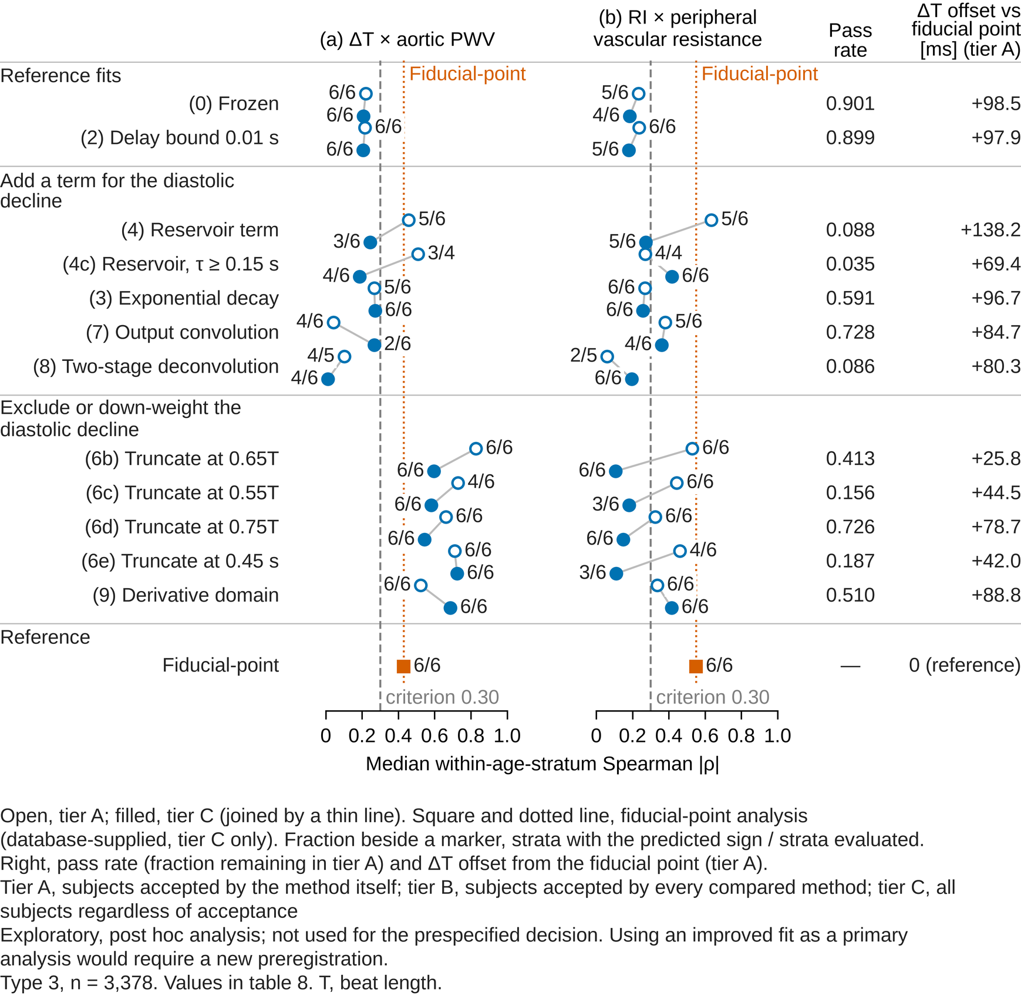
Figure 5. Association by variant: median within-age-stratum Spearman |ρ| of table 8 (table 6 of 02_tables.md; type 3, n = 3,378) in tiers A and C.
What is shown: for the 3,378 type-3 subjects (inflection only) among the 4,374 of the decision test, the 12 decomposition variants that change how the diastolic decline is treated, and the database-supplied fiducial-point analysis as a reference, in the order of table 8 ((4b) and (6) of the 14 versions fitted are omitted). Group headings follow variant_groups of labels.json (reference fits / add a term for the diastolic decline / exclude or down-weight the diastolic decline / reference); row labels are the short names (short_en) of the same file prefixed with the (n) numbering of table 8; T, beat length. (a) ΔT × aortic PWV; (b) RI × peripheral vascular resistance. In each row the open marker is tier A and the filled marker is tier C, joined by a thin line. The fraction beside a marker is the number of strata with the predicted sign over the number of strata evaluated. The dashed line is the criterion 0.30. The fiducial-point analysis has tier C only (square); the dotted vertical line marks its value. The two right columns give the pass rate (fraction accepted by the same convergence checks as the frozen version, i.e. remaining in tier A) and the ΔT offset from the database-supplied fiducial point (ms, tier A). Verdicts are not written in the figure. (4b) and (6), the versions with the delay bound relaxed to 0.01 s, are omitted because relaxing the bound barely changes the values (lab_log entries 144, 146); the better versions were chosen post hoc from 14, so their values are optimistic. The fiducial-point reference of 0.430 is the value within type 3; in all 4,374 subjects fiducial-point analysis gives 0.710 (table 2), and the all-subject values of the truncated fit are in table 8b. The main truncation fraction 0.65 comes from candidate (3) of lab_log entry 139, set before any real data were fitted; the same value is the notch search limit NOTCH_MAX_FRAC of the rebuilt fiducial-point detection.
Source: table 6 of 02_tables.md (table 8 of this set). Script 50 analysis/scripts/50_reservoir_bench.py, part C (docs/research/results/50_reservoir_bench_BC.txt, 50_reservoir_bench_C14.txt; lab_log entries 144, 146, 147, 149, 151, 152). All numbers are read from data/paper2_numbers.json by build_fig_variants.py.
Tier note: Tier A, subjects accepted by the method itself; tier B, subjects accepted by every compared method; tier C, all subjects regardless of acceptance
Post-hoc note: Exploratory, post hoc analysis; not used for the prespecified decision. Using an improved fit as a primary analysis would require a new preregistration.

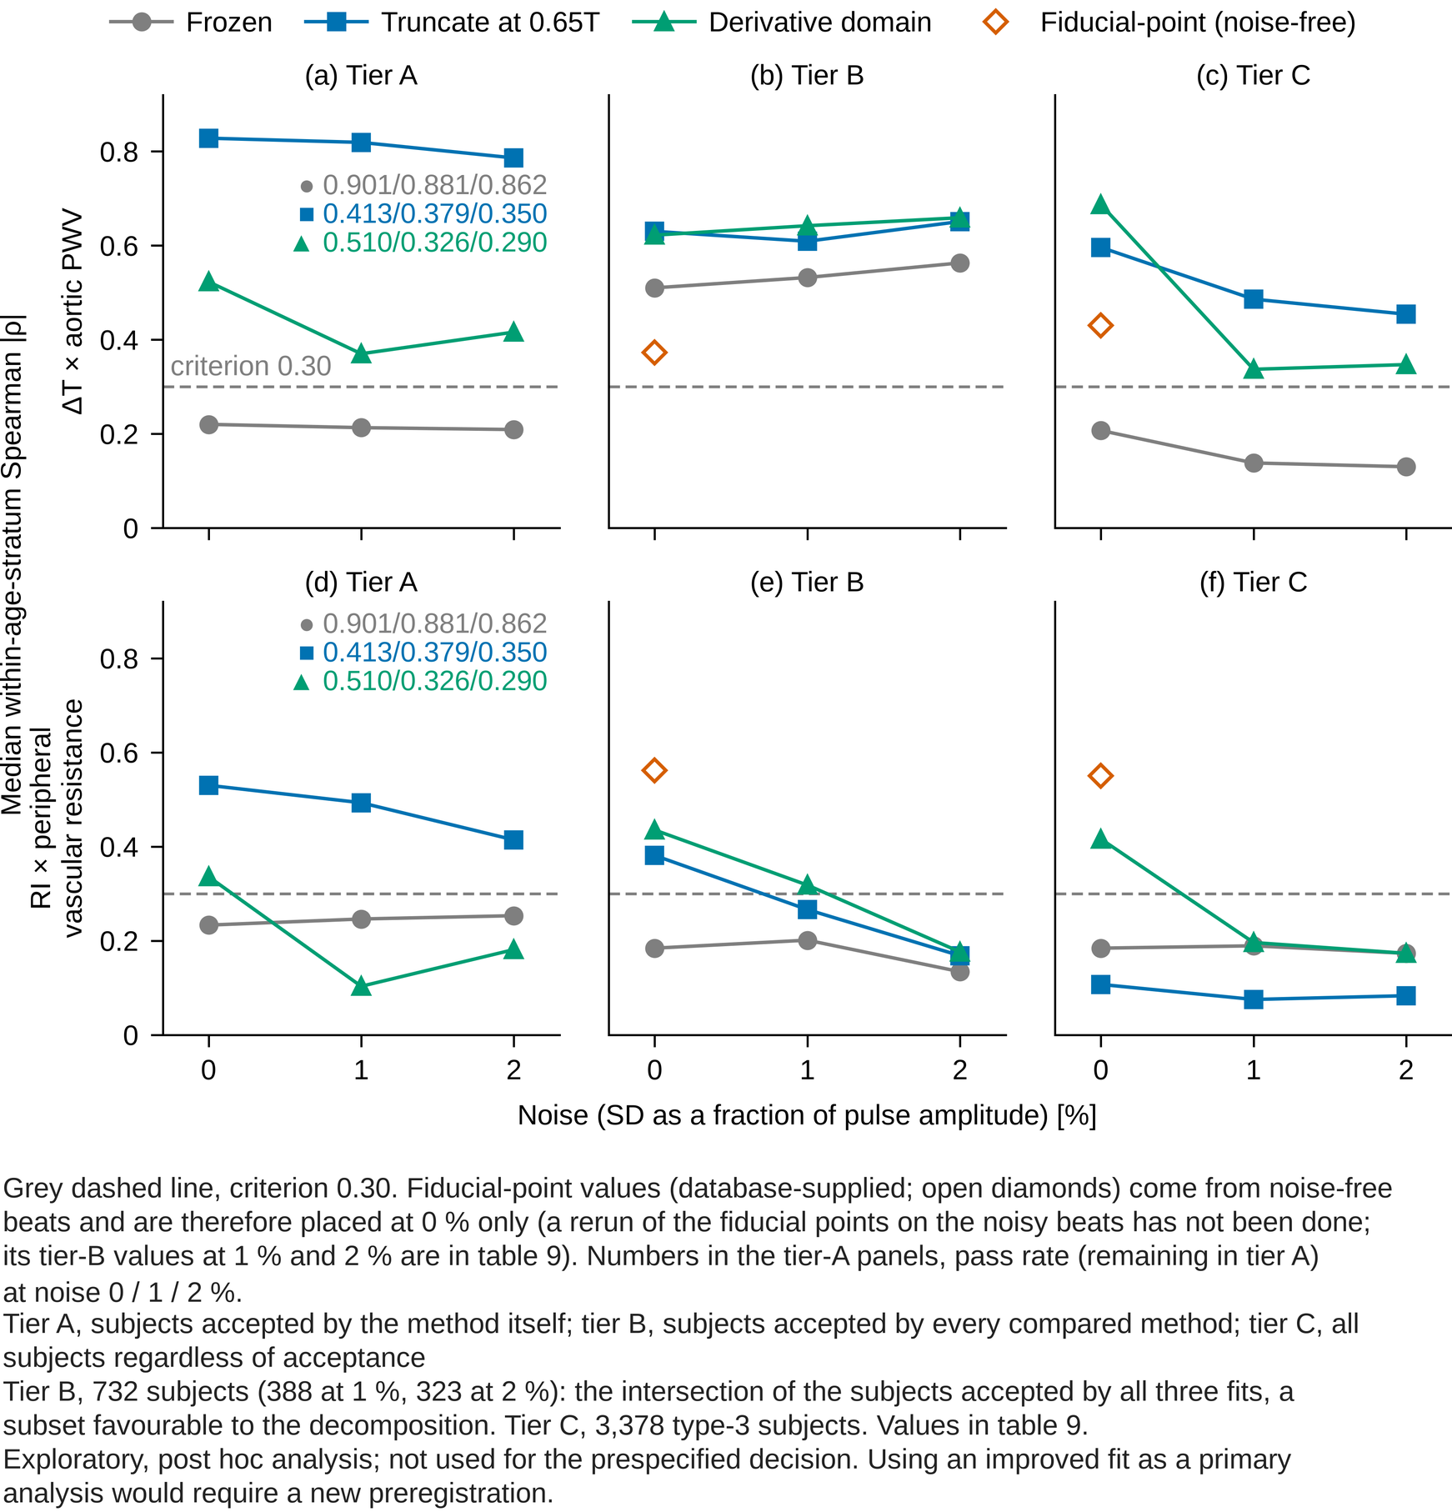
Figure 6. Robustness to noise: the three fits of table 9 (table 6c of 02_tables.md; type 3) in tiers A, B and C at noise 0, 1 and 2 %.
What is shown: for the 3,378 type-3 subjects (inflection only), the median within-age-stratum Spearman |ρ| of the frozen fit, the fit truncated at 0.65 of the beat length and the fit with the residual taken in the first-derivative domain, on beats without added noise and on beats with white Gaussian noise whose SD is 1 % or 2 % of the peak-to-trough pulse amplitude. Top row, ΔT × aortic PWV; bottom row, RI × peripheral vascular resistance. Columns, tiers A, B and C. Frozen fit, grey circles; truncation at 0.65T, blue squares; derivative domain, blue-green triangles. The fiducial-point analysis (database-supplied) exists in tiers B and C only and is computed from noise-free beats, so it is placed at 0 % only, as an open vermilion diamond (a rerun of the fiducial points on the noisy beats has not been done; its tier-B values at 1 % and 2 %, which change only because the common subset changes, are in table 9). The dashed grey line is the criterion 0.30. Numbers in the tier-A panels are the pass rates (fraction remaining in tier A) at noise 0 / 1 / 2 %. Tier B has 732 subjects (388 at 1 %, 323 at 2 %); table 9 describes it as the intersection of the subjects accepted by all three fits, a subset favourable to the decomposition. Tier C has the 3,378 type-3 subjects. Verdicts are not written in the figure.
Source: table 6c of 02_tables.md (table 9 of this set). Script analysis/scripts/50_reservoir_bench.py, part C (options --b-stage fb,trunc08,deriv, --noise 0.01, --noise 0.02); result files docs/research/results/50_reservoir_bench_B3.txt, 50_reservoir_bench_noise0.01.txt, 50_reservoir_bench_noise0.02.txt; lab_log entry 158. All numbers are read from data/paper2_numbers.json by build_fig_noise.py.
Tier note: Tier A, subjects accepted by the method itself; tier B, subjects accepted by every compared method; tier C, all subjects regardless of acceptance
Post-hoc note: Exploratory, post hoc analysis; not used for the prespecified decision. Using an improved fit as a primary analysis would require a new preregistration.

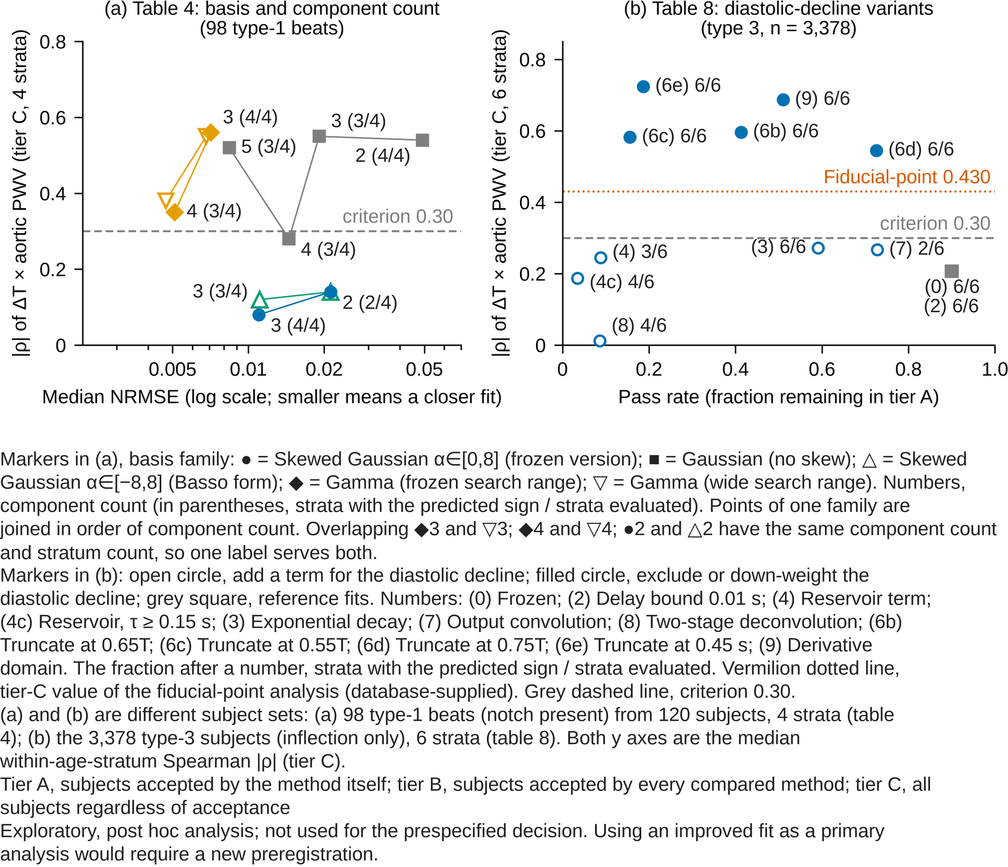
Figure 7. Goodness of fit versus tracking of the reference quantity: (a) NRMSE against |ρ| from table 4; (b) pass rate against tier-C |ρ| from table 8.
What is shown: (a) the sweep of basis functions and component counts (table 4; 98 type-1 beats, notch present, from 120 subjects; 4 strata with at least 8 beats). x, goodness of fit (median NRMSE, log scale; smaller residual to the left); y, median within-age-stratum Spearman |ρ| of ΔT with aortic PWV (all beats, i.e. tier C). Marker shape, basis family (● = Skewed Gaussian α∈[0,8] (frozen version); ■ = Gaussian (no skew); △ = Skewed Gaussian α∈[−8,8] (Basso form); ◆ = Gamma (frozen search range); ▽ = Gamma (wide search range)); number, component count (in parentheses, the number of strata with the predicted sign over the number of strata evaluated); points of one family are joined in order of component count. Overlapping ◆3 and ▽3; ◆4 and ▽4; ●2 and △2 have the same component count and stratum count, so one label serves both. (b) the 12 variants that change how the diastolic decline is treated (table 8; (4b) and (6) of the 14 versions fitted are omitted; the 3,378 type-3 subjects, 6 strata). x, pass rate (fraction accepted by the same convergence checks as the frozen version, i.e. remaining in tier A); y, tier-C |ρ|. Numbers are the (n) of table 8 ((0) Frozen; (2) Delay bound 0.01 s; (4) Reservoir term; (4c) Reservoir, τ ≥ 0.15 s; (3) Exponential decay; (7) Output convolution; (8) Two-stage deconvolution; (6b) Truncate at 0.65T; (6c) Truncate at 0.55T; (6d) Truncate at 0.75T; (6e) Truncate at 0.45 s; (9) Derivative domain), each followed by the number of strata with the predicted sign over the number of strata evaluated. Open circles, add a term for the diastolic decline; filled circles, exclude or down-weight the diastolic decline; grey squares, reference fits. The vermilion dotted line is the tier-C value of the database-supplied fiducial-point analysis (0.430). The grey dashed line in both panels is the criterion 0.30. (a) and (b) are different subject sets, so their values are not compared directly. The better versions were chosen post hoc from 14, so their values are optimistic. Verdicts are not written in the figure.
Source: table 3 of 02_tables.md (table 4 of this set; script 31 analysis/scripts/31_pwdb_basis_explore.py; result CSV data/pwdb/pwdb_basis_explore.csv on the Mac; lab_log entry 13) and table 6 of 02_tables.md (table 8 of this set; script 50 analysis/scripts/50_reservoir_bench.py, part C; docs/research/results/50_reservoir_bench_BC.txt, 50_reservoir_bench_C14.txt; lab_log entries 144, 146, 147, 149, 151, 152). All numbers are read from data/paper2_numbers.json by build_fig_tradeoff.py.
Tier note: Tier A, subjects accepted by the method itself; tier B, subjects accepted by every compared method; tier C, all subjects regardless of acceptance
Post-hoc note: Exploratory, post hoc analysis; not used for the prespecified decision. Using an improved fit as a primary analysis would require a new preregistration.

Table 8. Type-3 correlations when the handling of the diastolic decline is changed (exploratory, post hoc; type 3, 3,378 of the 4,374 subjects refitted)^{a, b, c, d, e, f, g}.
Handling of the diastolic decline | ΔT × PWV, tier A | ΔT × PWV, tier C | RI × resistance, tier A | RI × resistance, tier C | Pass rate | ΔT offset from the supplied fiducial point (tier A)
(0) Frozen fit (no diastolic term) | 0.220 (6/6) | 0.207 (6/6) | 0.233 (5/6) | 0.184 (4/6) | 0.901 | +98.5 ms
(2) Second-component delay bound 0.08 → 0.01 s | 0.216 (6/6) | 0.206 (6/6) | 0.236 (6/6) | 0.180 (5/6) | 0.899 | +97.9 ms
Add a term for the diastolic decline
(4) Reservoir term (forward wave convolved, τ ≥ 0.05 s) | 0.457 (5/6) | 0.245 (3/6) | 0.635 (5/6) | 0.274 (5/6) | 0.088 | +138.2 ms
(4c) Reservoir term, τ ≥ 0.15 s | 0.508 (3/4) | 0.187 (4/6) | 0.270 (4/4) | 0.418 (6/6) | 0.035 | +69.4 ms
(3) Free exponential decay term | 0.267 (5/6) | 0.272 (6/6) | 0.268 (6/6) | 0.258 (6/6) | 0.591 | +96.7 ms
(7) Output-side convolution of the two-component sum | 0.042 (4/6) | 0.267 (2/6) | 0.381 (5/6) | 0.361 (4/6) | 0.728 | +84.7 ms
(8) Two-stage: τ from the last 30%, deconvolve, then frozen fit | 0.102 (4/5) | 0.012 (4/6) | 0.060 (2/5) | 0.195 (6/6) | 0.086 | +80.3 ms
Exclude or down-weight the diastolic decline
(6b) Fit truncated at 0.65 of the beat length | 0.828 (6/6) | 0.596 (6/6) | 0.530 (6/6) | 0.107 (6/6) | 0.413 | +25.8 ms
(6c) Truncated at 0.55 of the beat | 0.728 (4/6) | 0.582 (6/6) | 0.444 (6/6) | 0.182 (3/6) | 0.156 | +44.5 ms
(6d) Truncated at 0.75 of the beat | 0.662 (6/6) | 0.545 (6/6) | 0.326 (6/6) | 0.149 (6/6) | 0.726 | +78.7 ms
(6e) Truncated at an absolute 0.45 s (at most 0.90 of the beat) | 0.711 (6/6) | 0.724 (6/6) | 0.461 (4/6) | 0.110 (3/6) | 0.187 | +42.0 ms
(9) Residual taken in the first-derivative domain | 0.523 (6/6) | 0.687 (6/6) | 0.336 (6/6) | 0.416 (6/6) | 0.510 | +88.8 ms
Fiducial-point analysis (database-supplied; reference) | — | 0.430 (6/6) | — | 0.550 (6/6) | — | 0 (reference)
ª Exploratory, post hoc analysis; not used for the prespecified decision. Using an improved fit as a primary analysis would require a new preregistration.
^{b} Source: table 6 of 02_tables.md; script 50 (docs/research/results/50_reservoir_bench_BC.txt, 50_reservoir_bench_C14.txt); lab_log entries 144, 146, 147, 149, 151, 152.
^{c} Tier A, subjects accepted by the method itself; tier B, subjects accepted by every compared method; tier C, all subjects regardless of acceptance. Pass rate: the fraction accepted under the same convergence checks as the frozen version (parameters on a bound, component height, difference in reflection coefficient between competing solutions), i.e. the fraction remaining in tier A.
^{d} Refits of the same beats of the same 4,374 subjects. The two-kernel model has no term for the diastolic decline, so versions that change only its handling are grouped into those that add a term for the decline and those that exclude it from the fit or down-weight it in the residual. The main fraction 0.65 was fixed before this analysis (candidate (3) of lab_log entry 139, before any real data were fitted; the same value is the upper limit of the notch search, NOTCH_MAX_FRAC, of the rebuilt fiducial-point detection) and was not re-chosen after seeing these numbers (lab_log entry 145). T, beat length. The last column is the median difference between the peak of the second component and the diastolic fiducial point supplied with PWDB (positive, second component later).
^{e} Bold, criterion met (median |ρ| ≥ 0.30 with the predicted sign in every stratum).
^{f} Versions not shown and optimism of the selection. Section C fitted 14 versions. (4b) (reservoir term with the delay bound 0.01 s) and (6) (0.65 truncation with the same bound) are omitted because relaxing the bound barely changes the values (type 3, ΔT × aortic PWV, tier A: (6) 0.826 vs (6b) 0.828; pass rate (4b) 0.092 vs (4) 0.088; lab_log entries 144, 146). The better versions were chosen post hoc from 14, so their values are optimistic.
^{g} The fiducial-point reference of 0.430 is the value within type 3. In all 4,374 subjects fiducial-point analysis gives 0.710 (table 2); it is lower within type 3 because the type itself depends on stiffness and the difference between types raises the value in all subjects (table 6a). Values of the truncated fit in all subjects and in type 1 are in table 8b. Bold is given only to values that meet the criterion.

Table 8b. Truncated and derivative-domain fits in all subjects and in types 1 and 4 (exploratory, post hoc)^{a, b, c, d, e, f}.
Index, fit | Tier | Type 1 (891) | Type 3 (3,378) | Type 4 (105) | All (4,374)
ΔT × aortic PWV, frozen fit | A | 0.224 (4/6) | 0.220 (6/6) | 0.472 (3/3) | 0.223 (6/6)
ΔT × aortic PWV, frozen fit | C | — | 0.207 (6/6) | — | 0.205 (6/6)
ΔT × aortic PWV, truncated at 0.65T (delay bound 0.01 s) | A | 0.193 (3/6) | 0.826 (6/6) | 0.540 (3/3) | 0.808 (5/6)
ΔT × aortic PWV, truncated at 0.65T (delay bound 0.01 s) | C | 0.219 (4/6) | 0.586 (6/6) | 0.598 (3/3) | 0.559 (6/6)
ΔT × aortic PWV, fiducial-point (supplied; reference) | C | 0.343 (4/6) | 0.430 (6/6) | 0.796 (3/3) | 0.710 (6/6)
RI × resistance, frozen fit | C | — | 0.184 (4/6) | — | 0.171 (4/6)
RI × resistance, derivative domain | C | — | 0.416 (6/6) | — | 0.394 (6/6)
RI × resistance, fiducial-point (supplied; reference) | C | 0.481 (6/6) | 0.550 (6/6) | 0.888 (3/3) | 0.504 (6/6)
ª Exploratory, post hoc analysis; not used for the prespecified decision. Using an improved fit as a primary analysis would require a new preregistration.
^{b} Source: table 6d of 02_tables.md; script 50 (docs/research/results/50_reservoir_bench.txt); lab_log entry 144.
^{c} Tier A, subjects accepted by the method itself; tier B, subjects accepted by every compared method; tier C, all subjects regardless of acceptance. —, value not recorded.
^{d} The prespecified decision was made in all subjects, so the recorded values for all subjects and for types 1 and 4 are listed. The truncated fit of this run is version (6), the 0.65 truncation combined with the delay bound 0.01 s, which in type 3 nearly equals (6b) (tier A 0.826 vs 0.828, tier C 0.586 vs 0.596; lab_log entry 146). No all-subject value of (6b) is recorded.
^{e} Bold, criterion met (median |ρ| ≥ 0.30 with the predicted sign in all 6 strata). Type 4 has only 3 strata with at least 8 subjects, so the 6-stratum criterion cannot be evaluated.
^{f} In all subjects the truncated fit gives ΔT 0.559 (6/6) in tier C, above the frozen fit (0.223) but below fiducial-point analysis in the same subjects (0.710). Tier A in all subjects is 0.808 but does not meet the criterion in every stratum. In type 1 truncation stays low (0.193, 0.219): within an age stratum aortic PWV varies about 1/12 as much as in type 3, so every method gives small values (table 6b). Truncation exceeded fiducial-point analysis in type 3 partly because the fiducial-point value within type 3 is lower than in all subjects (table 8, footnote). RI of the derivative domain is 0.394 in all subjects, below fiducial-point analysis (0.504).

Table 9. Tier B and runs with added noise (type 3; exploratory, post hoc)^{a, b, c, d, e, f, g}.
Handling of the diastolic decline | Tier | ΔT × PWV, no noise | 1% | 2% | RI × resistance, no noise | 1% | 2% | Pass rate, none / 1% / 2%
(0) Frozen fit (no diastolic term) | A | 0.220 | 0.213 | 0.209 | 0.233 | 0.246 | 0.253 | 0.901 / 0.881 / 0.862
 | B | 0.510 | 0.532 | 0.563 | 0.184 | 0.201 | 0.134
 | C | 0.207 | 0.138 | 0.130 | 0.184 | 0.189 | 0.173
(6b) Fit truncated at 0.65 of the beat length | A | 0.828 | 0.819 | 0.786 | 0.530 | 0.493 | 0.414 | 0.413 / 0.379 / 0.350
 | B | 0.630 | 0.609 | 0.651 | 0.381 | 0.266 | 0.168
 | C | 0.596 | 0.486 | 0.454 | 0.107 | 0.075 | 0.083
(9) Residual taken in the first-derivative domain | A | 0.523 | 0.370 | 0.416 | 0.336 | 0.103 | 0.181 | 0.510 / 0.326 / 0.290
 | B | 0.622 | 0.642 | 0.659 | 0.435 | 0.318 | 0.176
 | C | 0.687 | 0.337 | 0.347 | 0.416 | 0.196 | 0.173
Fiducial-point analysis (database-supplied; reference) | B | 0.373 | 0.411 | 0.487 | 0.562 | 0.405 | 0.384 | —
 | C | 0.430 | (as at left) | (as at left) | 0.550 | (as at left) | (as at left) | —
ª Exploratory, post hoc analysis; not used for the prespecified decision. Using an improved fit as a primary analysis would require a new preregistration.
^{b} Source: table 6c of 02_tables.md; script 50 (docs/research/results/50_reservoir_bench_B3.txt, 50_reservoir_bench_noise0.01.txt, 50_reservoir_bench_noise0.02.txt); lab_log entry 158.
^{c} Tier A, subjects accepted by the method itself; tier B, subjects accepted by every compared method; tier C, all subjects regardless of acceptance. Tier B here: subjects accepted by all three of the frozen fit, the 0.65T truncation and the derivative-domain version (732; 388 at 1% noise, 323 at 2%); tier C, all type-3 subjects (3,378).
^{d} Noise is white Gaussian noise whose SD is the stated fraction of the peak-to-trough amplitude of the beat; waveform type and fiducial points were assigned on the beat before noise was added.
^{e} The fiducial-point reference (tier C) is computed on the noise-free beats, so in the noise columns it is not a like-for-like comparison (refitting fiducial points on the noisy beats has not been done); its tier-B value moves only because the common subset changes.
^{f} Readings fixed before the run and results (lab_log entries 153 §5, 158). Tier B asks whether the RI of the truncated fit meets the criterion only in tier A because of fit quality or because of selection (entry 149, question 1). Rule: tier B of the truncated fit at least 0.30 in all strata, fit quality; within 0.10 of the frozen fit's tier B, selection; in between, both. Result 0.381 (6/6), 0.197 above the frozen fit: fit quality by the rule, but tier B is a subset favourable to decomposition, tier C is 0.107 and noise lowers it to 0.266 and 0.168, so it was read as both. Noise rule: at 1% noise, a pass rate of the derivative-domain fit below 0.30 or type-3 tier-C ΔT × aortic PWV below 0.30 means fragile; at 1% the values were 0.326 and 0.337 (not met); at 2% the pass rate fell to 0.290, below the same threshold. Bold used the stratum directions in the result files; the stratum counts are not copied into this table.
^{g} Bold, criterion met (median |ρ| ≥ 0.30 with the predicted sign in every stratum).

Table S1. Parameters that reached a search bound (type 3, tier C, top two)^{a, b, c, d, e}.
Handling of the diastolic decline | Fraction of beats at a bound | Breakdown
(0) Frozen fit (no diastolic term) | 0.072 | α1:hi 0.04; σ1:hi 0.03
(4) Reservoir term (forward wave convolved, τ ≥ 0.05 s) | 0.903 | g:hi 0.61; τ:lo 0.21
(4c) Reservoir term, τ ≥ 0.15 s | 0.932 | τ:lo 0.88; g:hi 0.56
(3) Free exponential decay term | 0.372 | τ:lo 0.33
(7) Output-side convolution of the two-component sum | 0.254 | α1:hi 0.25; μ1:lo 0.02 (τ:lo 0.00)
(8) Two-stage: τ from the last 30%, deconvolve, then frozen fit | 0.914 | σ2:hi 0.70; μ1:lo 0.35
(6b) Fit truncated at 0.65 of the beat length | 0.562 | σ2:hi 0.30; α2:hi 0.23
(6e) Truncated at an absolute 0.45 s (at most 0.90 of the beat) | 0.803 | σ2:hi 0.39; α2:hi 0.39
(9) Residual taken in the first-derivative domain | 0.319 | σ2:hi 0.23; Δμ:lo 0.11
ª Exploratory, post hoc analysis; not used for the prespecified decision. Using an improved fit as a primary analysis would require a new preregistration.
^{b} Source: table 6b of 02_tables.md; script 50 (docs/research/results/50_reservoir_bench_BC.txt, 50_reservoir_bench_C14.txt); lab_log entries 144, 146, 147, 149, 151, 152.
^{c} Tier A, subjects accepted by the method itself; tier B, subjects accepted by every compared method; tier C, all subjects regardless of acceptance
^{d} a1, μ1, σ1 and α1 are the height, position, width and skewness of the first component; a2, Δμ, σ2 and α2 the same for the second; g and τ the gain and time constant of the reservoir term. ':lo' lower bound, ':hi' upper bound. A beat can reach bounds in several parameters, so the fractions do not sum to 1.
^{e} Bold, the parameters discussed in the text as the sign of degeneracy.

Table S2a. Difference between each method's ΔT and the arrival time ΔT_true of the linearly separated backward wave (tier C)^{a, b, c, d, e}.
Waveform type | Method | n | Median difference | Pooled Spearman ρ
Type 1 | Decomposition (PPG) | 315 | +257.8 ms | −0.135
Type 1 | Decomposition (pressure) | 315 | +255.4 ms | −0.107
Type 1 | Fiducial-point (supplied) | 315 | +222.0 ms | −0.385
Type 3 | Decomposition (PPG) | 2,771 | +219.0 ms | +0.041
Type 3 | Decomposition (pressure) | 2,771 | +187.6 ms | +0.059
Type 3 | Fiducial-point (supplied) | 2,758 | +114.0 ms | −0.022
Type 4 | Decomposition (PPG) | 105 | +13.1 ms | +0.500
Type 4 | Fiducial-point (supplied) | 72 | +38.2 ms | −0.538
ª Exploratory, post hoc analysis; not used for the prespecified decision. Using an improved fit as a primary analysis would require a new preregistration.
^{b} Source: table 7a of 02_tables.md; script 51 (docs/research/results/51_wave_separation.txt); lab_log entries 150, 152.
^{c} Tier A, subjects accepted by the method itself; tier B, subjects accepted by every compared method; tier C, all subjects regardless of acceptance
^{d} The backward wave was obtained from the digital pressure P and flow velocity U of PWDB by linear wave separation, P_f = (ΔP + ρc·ΔU)/2 and P_b = (ΔP − ρc·ΔU)/2 (ρc, slope of the early-systolic P–U loop; baseline, minimum within the beat); ΔT_true is the difference between the peak times of P_b and P_f.
^{e} n, subjects in which the separation could be evaluated (1,183 excluded because ρc could not be estimated or the backward wave was essentially absent). Difference = (method's ΔT) − (ΔT_true). ρ is the Spearman correlation pooled over age strata.

Table S2b. The same frozen decomposition applied to the digital pressure waveform (within-stratum Spearman; all 4,374 subjects)^{a, b, c, d, e}.
Waveform fitted | ΔT × PWV, tier A | ΔT × PWV, tier C | RI × resistance, tier A | RI × resistance, tier C | Acceptance rate
PPG (primary analysis of this paper) | 0.223 (6/6) | 0.205 (6/6) | 0.207 (5/6) | 0.171 (4/6) | 92.3%
Digital pressure waveform | 0.486 (6/6) | 0.313 (6/6) | 0.225 (6/6) | 0.220 (5/6) | 84.5%
Fiducial-point analysis (supplied; PPG; reference) | — | 0.710 (6/6) | — | 0.504 (6/6) | —
ª Exploratory, post hoc analysis; not used for the prespecified decision. Using an improved fit as a primary analysis would require a new preregistration.
^{b} Source: table 7b of 02_tables.md; script 51 (docs/research/results/51_wave_separation.txt); lab_log entries 150, 152.
^{c} Tier A, subjects accepted by the method itself; tier B, subjects accepted by every compared method; tier C, all subjects regardless of acceptance
^{d} Restricted to type 3, ΔT of the pressure waveform is 0.400 (6/6) in tier A, meeting the criterion, and 0.227 (6/6) in tier C, not meeting it.
^{e} Bold, criterion met (median |ρ| ≥ 0.30 with the predicted sign in every stratum).

Table S3. Additional checks: acceptance bias (C6), position of the first component (C7) and main effects of the factors (C8) (type 3; exploratory, post hoc)^{a, b, c, d, e}.
Check | Reading fixed before the run | Frozen | Truncated at 0.65T (6b) | Derivative domain (9) | Fiducial-point (supplied; reference) | Result
C6 Acceptance × aortic PWV, within-stratum ρ | ρ below −0.10: tier A leans to the low-PWV side | −0.124 | +0.026 (pass rate by PWV tertile 0.595, 0.278, 0.451) | −0.542 (same, 0.777, 0.522, 0.361) | — | Frozen and derivative-domain fits lean; truncation does not
C7a First component minus forward-wave peak (median) | Within 20 ms: the first component is the forward wave | +34 to +50 ms in all 3 fits | same as left | same as left | — | Not met by any fit; the first component sits at the PPG systolic peak (difference −5 to −8 ms, tier C)
C7b Time of the first component × aortic PWV, within-stratum ρ | |ρ| ≥ 0.30: part of the ΔT variation comes from the first component | −0.129 (tier C) | −0.489 (tier C), −0.794 (tier A) | −0.729 (tier C) | — | Met by truncation and the derivative domain; in tier A of truncation the first component is 31 ms before the systolic peak
C8 Main effects of the factors on ΔT | Negative PWV effect and smaller heart-rate and ejection-time effects than the frozen fit: those effects are reduced | PWV −15.9% (−0.23), heart rate −16.8% (−0.58) | PWV −40.9% (−0.56), heart rate −18.3% (−0.41), mean arterial pressure −11.9% | PWV −54.8% (−0.64), heart rate −3.9% (−0.18), mean arterial pressure −13.7%, stroke volume +15.6% | PWV −21.1% (−0.40), heart rate −5.3%, stroke volume +20.4% (+0.60) | Met by the derivative domain; not by truncation (only the PWV effect grew)
C8 Main effects of the factors on RI | Not fixed (descriptive) | PWV largest (value not recorded) | PWV +84% | PWV +86% | PWV +46% | PWV has the largest effect in every fit; mean arterial pressure +24 to 35%
ª Exploratory, post hoc analysis; not used for the prespecified decision. Using an improved fit as a primary analysis would require a new preregistration.
^{b} Source: table 6e of 02_tables.md; script 50 (docs/research/results/50_reservoir_bench_B3.txt); lab_log entries 153, 158.
^{c} Tier A, subjects accepted by the method itself; tier B, subjects accepted by every compared method; tier C, all subjects regardless of acceptance
^{d} The readings were fixed before the run (lab_log entry 153 §5); results from lab_log entry 158 §2. C6 is the within-stratum Spearman ρ between acceptance (1, accepted; 0, not) and aortic PWV over all subjects (tier C). In C7, t1 is the peak time of the first component and the forward-wave peak comes from linear separation of the digital pressure and flow (script 51). C8 uses the main effects of table 3 (difference between the +1 SD and −1 SD means ÷ stratum mean, %; in parentheses the within-stratum ρ), type 3, tier C.
^{e} The ΔT gain of the truncated fit is not explained by movement of the second component alone: the time of the first component also moves with aortic PWV (−0.489). Tier A of the derivative domain leans to the low-PWV side (−0.542), so its tier-A value (0.523) is below its tier-C value (0.687).

Sources and reproduction
Figures are produced by build_fig_<name>.py, tables by build_tables.py, and this document by build_figtab_docx.py (build_all.sh runs everything). Every script has a --selftest that checks the plotted values against the JSON, the 8 pt minimum font size, the tier and post-hoc notes, text overlaps and banned terms (the list of analysis/scripts/check_terminology.py).
The numbers come from ../02_tables.md (tables 1 to 7b), recorded in docs/research/lab_log.md entries 12 (decision test), 13 (basis functions), 18 (published conditions), 137 (waveform types), 139 (0.65T truncation listed as candidate (3)), 141 (synthetic-beat diagnosis), 143 to 147 (refits with 5, 7 and 10 variants), 149 to 153 (14 variants and the design of tier B), 152 (14 variants and wave separation), 158 (tier B and noise) and 162 (corrections made while checking this set, including the stated source of the value 0.65). The prespecified items and the chronology are in data/prespec_chronology.json and notes_prespec_and_chronology.md.
The result files written on Mac 1 (50_reservoir_bench_C14.txt, 50_reservoir_bench_B3.txt, 50_reservoir_bench_noise0.01.txt, 50_reservoir_bench_noise0.02.txt, 51_wave_separation.txt) are not yet in the repository; the corresponding numbers are those recorded in 02_tables.md.
Journal specification applied (Physiological Measurement; IOP-wide rules): figure width 85 mm (single column) or 150 mm (double column), figure text at least 8 pt at final size, vector PDF plus SVG and 600 dpi PNG, text embedded as editable text. Conversion to CMYK is left to submission.

