Text for Site:

Do you enjoy what could be charitably called modern art? Do you enjoy leaving said art strewn about the streets of Shibuya? Do you think the phrase "factoring hectopascals" is an appropriate insult? Then this hat may be perfect for you! You are obviously a reaper or player of discerning tastes and unstable mind, and you need a hat to keep your genius from bursting out of your skull. This lovingly crafted hat is crafted with utility in mind, It’s slick calculated style will make you a zetta math whiz. This is one of the best hats you can get your hands on. Any tree can drop an apple, but with this hat you’ll drop the freaking moon!

<p>WOW, WHAT A HAT! This Gatito signature item displays sleek lines and striking metal accents, sure to go with any outfit you can conceive of. Made in the image of the mad genius Sho Minamimoto’s legendary accessory, it provides essential buffs to help any player survive the Reaper’s Game. It is sure to end up as part of your end game setup, as it provides amazing bonuses with only a reasonable amount of bravery required to wear it. This is one of the best hats you can get your hands on. It boosts your attack by fifteen, your defense by twenty-five, and your health by a whopping 200. But if you want to get the most out of this mighty hat, you’ll need to head over to WildKat and talk to the owner to learn its secrets.</p>

<p>Behold what this hat can do for you! The man above is weak and undesirable. Look into his lifeless eyes and despair. But with the simple addition of Pi-Face’s Cap in the picture below, this pathetic specimen is transformed into a handsome and powerful player, sure to survive the Reaper’s Game with whatever partner is lucky enough to have him.</p>

Raw Images:

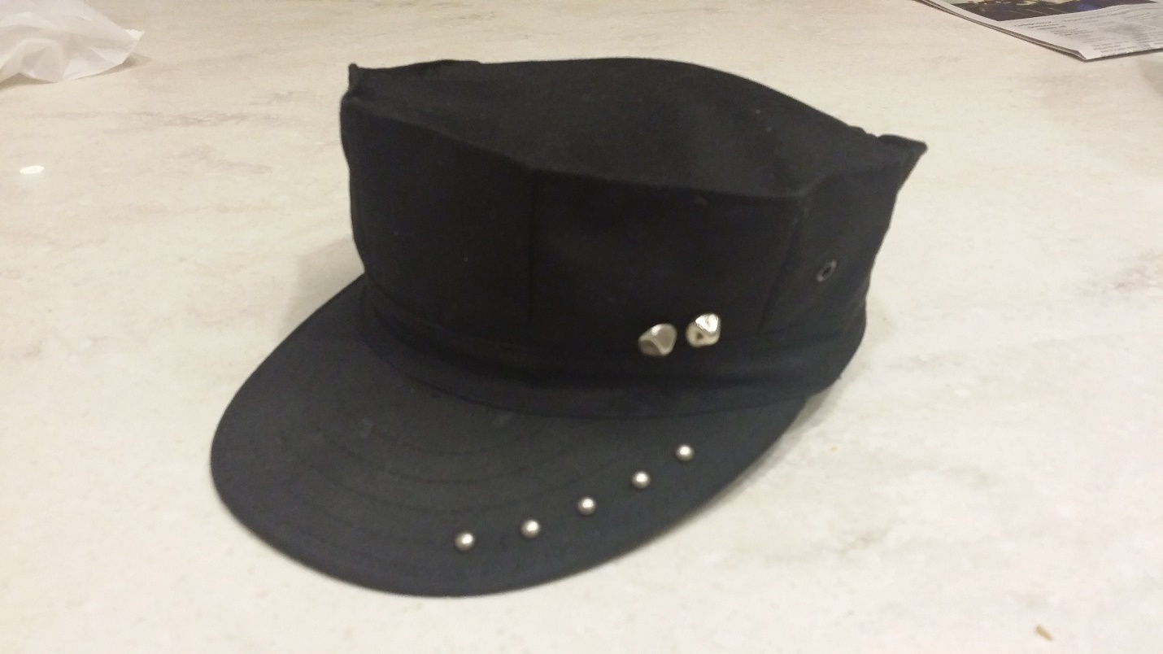





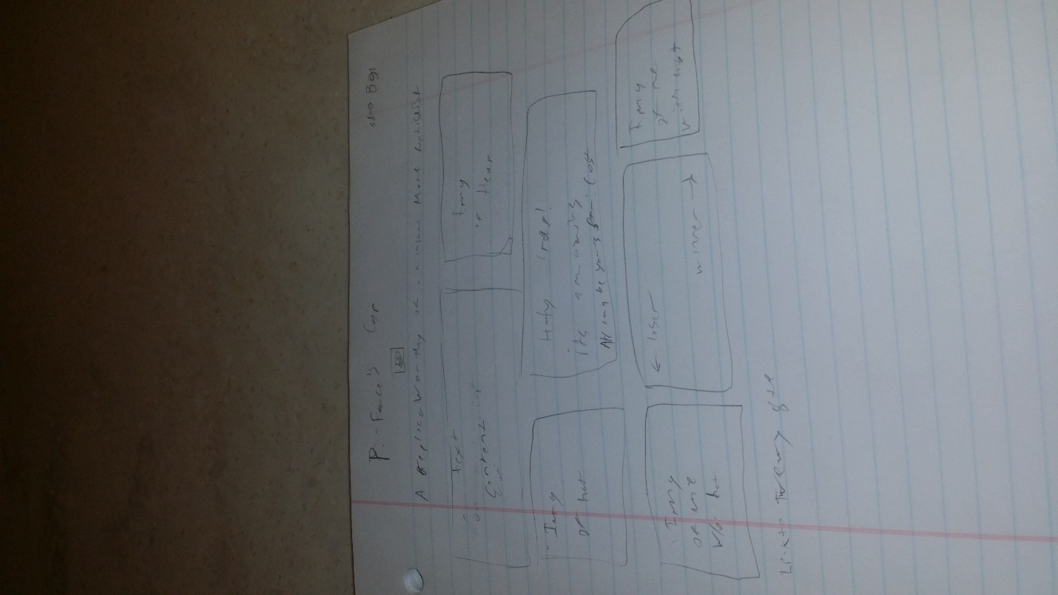

Inspiration:

The character Sho Minamimoto from the Square Enix game The World Ends With You. I included links to what could count as official sites for the game, seeing as it is 8 years old and the official site does not seem to be up anymore.