Example lake-effect cloud patterns over Lake Michigan
Long lake-axis parallel bands (LLAP)
Short lake-axis parallel bands (SLAP)
Type | Date | Time (UTC) | Image
SLAP | 4 January 2017 | 1630 | 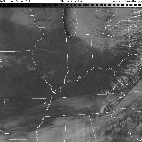
SLAP | 5 January 2017 | 2000 | 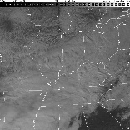
SLAP | 6 January 2017 | 1830 | 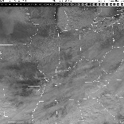
LLAP below high clds | 13 January 2017 | 1830 | 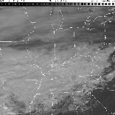
SLAP | 12 December 2017 | 1830
SLAP | 26 December 2017 | 1745 | 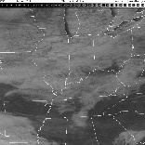
LLAP (vortex, small area of SLAP) | 31 December 2017 | 1730 | 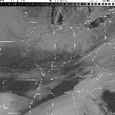
LLAP (with SLAP to the northwest) | 21 January 2014 | 1545 | 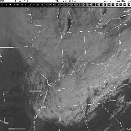
LLAP (with SLAP to the northwest) | 23 January 2014 | 1915 | 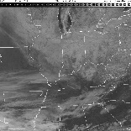
SLAP with ice on lake | 28 January 2014 | 1845 | 