OPC/OPS Dataset Readme

# Dataset Title

The RAW datasets being retrieved from the machine have been initially converted to files.

.csv

When it comes to the naming regime, the files are stored under , categorized based on date .

~/OPC

MMDDYYYY

# Dataset Authors

|  |  |  |  |
| --- | --- | --- | --- |
| Name: | Dr. Junming Wang | Dr. David Kristovich | Dr. April Hiscox |
| Role: | Lead Auther | Corresponding Author | Corresponding Author |
| E-mail: | [wangjim@illinois.edu](mailto:wangjim@illinois.edu) | [dkristo@illinois.edu](mailto:dkristo@illinois.edu) | [hiscox@mailbox.sc.edu](mailto:hiscox@mailbox.sc.edu) |
| Phone: | (217)-300-2529 | (217)-333-7399 | (803)-777-6604 |

1. Time of Interest

As for located at :

OPC 1

Release Tower

|  |  |  |  |
| --- | --- | --- | --- |
| SN | Date | Start Time | End Time |
| 1 | 09/23/2018 |  |  |
| 2 | 10/11/2018 | 21:11:09 | 23:59:59 |
| 3 | 10/12/2018 | 00:00:00 | 07:05:03 |
| 4 | 10/16/2018 | 01:58:19 | 06:31:18 |
| 5 | 10/23/2018 | 22:33:05 | 06:53:05+1 |
| 6 | 10/27/2018 | 19:03:19 | 00:22:43+1 |
| 7 | 10/29/2018 | 18:05:38 | 01:11:41+1 |
| 8 | 11/02/2018 | 17:11:15 | 07:18:23+1 |
| 9 | 11/07/2018 | 21:11:09 | 23:01:27 |
| 10 | 11/10/2018 | 18:04:14 | 20:34:12 |
| 11 | 11/11/2018 | 19:23:59 | 01:15:01+1 |
| 12 | 11/13/2018 | 23:30:44 | 07:50:44+1 |

As for located at :

OPC 2

Lower Convergence Tower

|  |  |  |  |
| --- | --- | --- | --- |
| SN | Date | Start Time | End Time |
| 1 | 09/23/2018 | 22:59:11 | 00:00:42+1 |
| 2 | 10/11/2018 | 23:44:58 | 23:59:59 |
| 3 | 10/12/2018 | 00:00:00 | 07:05:03 |
| 4 | 10/16/2018 | 01:58:19 | 06:31:18 |
| 5 | 10/23/2018 | 22:23:48 | 06:43:48+1 |
| 6 | 10/27/2018 | 19:14:27 | 00:02:05+1 |
| 7 | 10/29/2018 | 17:59:04 | 01:05:41+1 |
| 8 | 11/02/2018 | 18:04:02 | 07:46:18+1 |
| 9 | 11/07/2018 | 20:54:00 | 23:08:33 |
| 10 | 11/10/2018 | 17:32:37 | 20:12:01 |
| 11 | 11/11/2018 | 19:29:38 | 01:15:08+1 |
| 12 | 11/13/2018 | 00:18:21 | 08:01:27 |

Notice that refers to the fact the time is on the next day of the experiment .



+1

Date

# Area of Interest

The experiments were conducted at the test field located at .

Crowley Rd Mahomet Township, IL 61853

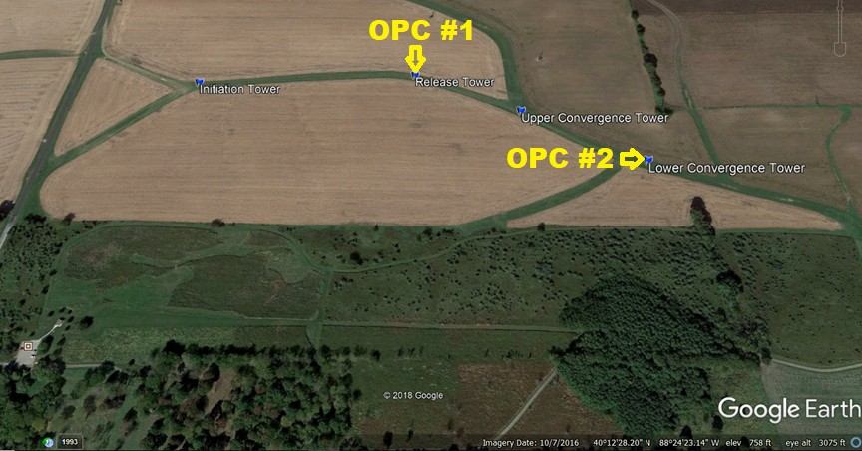

As shown in the picture above, there are 4 towers being constructed in the test field. The OPC #1 was installed at

3 meters

OPC #2

with a height of

Release Tower

meters .

, and

was installed at Lower Convergence Tower with a height of 3

## Device Setup Profile

Tower

Longtitude

Latitude

Device

Initiation

40°12'41.46"N

88°24'37.99"W

Release

40°12'42.04"N

88°24'25.52"W

OPC #1 @ 3M

Upper Convergence

40°12'39.78"N

88°24'19.61"W

Lower Convergence

40°12'36.91"N

88°24'13.26"W

OPC #2 @ 3M

1. Data frequency

|  |  |  |
| --- | --- | --- |
| Time Zone | Log Interval | Type |
| UTC | 0:00:01 [H:MM:SS] | Continuous |

1. Data Spatial Type

The datasets have been converted to

.csv

## BIN File

and

file.

files include the device and firmware status, information, and maintenance record. File stored in ASCII encoding method.

.bin

.bin

## CSV File

files include the experimental data, measuring methods, and plotting information. File stored in tabular form.

.csv

value

comma-separated

## .O30 File

file is native Storage file. Please install AIM Software for processing the files. Files are saved in ASCII

.O30

OPS 3330

encoding method. You can find the software under Dustrack83330-8530ManualsIAIM-Software folder. Or contact TSI for more information.

# General Dataset Description

The device we are using is Optical Particle Sizer 3330 from TSI. Device information can be found at: <https://www.tsi.com/optical-particle-sizer-3330/>

For the measurement, the device separates the molecule counts based on the size of the particle. At the beginning of each data file, you can find out that the machine categorizes particles into 17 bin groups.

|  |  |
| --- | --- |
| Bin | Size |
| Bin 1 Cut Point (um) | 0.3 |
| Bin 2 Cut Point (um) | 0.374 |
| Bin 3 Cut Point (um) | 0.465 |
| Bin 4 Cut Point (um) | 0.579 |
| Bin 5 Cut Point (um) | 0.721 |
| Bin 6 Cut Point (um) | 0.897 |
| Bin 7 Cut Point (um) | 1.117 |
| Bin 8 Cut Point (um) | 1.391 |
| Bin 9 Cut Point (um) | 1.732 |
| Bin 10 Cut Point (um) | 2.156 |
| Bin 11 Cut Point (um) | 2.685 |
| Bin 12 Cut Point (um) | 3.343 |
| Bin 13 Cut Point (um) | 4.162 |
| Bin 14 Cut Point (um) | 5.182 |
| Bin 15 Cut Point (um) | 6.451 |
| Bin 16 Cut Point (um) | 8.031 |
| Bin 17 Cut Point (um) | 10 |

The data was collected with a time interval of as mentioned previously. And Test Start Time and Test Start

1 second

are also included in the dataset. The data points were indexed based on second apart from the Test Start Time .

Date

# File Names

22:33:05

2018_10_23-

The data files are named under the regime of:

YYYY_MM_DD-HH_MM_SS-TEST_00<OPCID>.csv

For example, the data collected from

OPC#1

.

22_33_05-TEST_001.csv

on October 23, starting at

, will have a file name of

# Data Restrictions

Datasets collected from OPC devices are subject to restrictions which applies to Project.

SAVANT

# Digital Object Identifier (DOI)

NCAR/EOL are in charge of DOI management of the datasets.

# GCMD Keywords

Category: EARTH SCIENCE SERVICES Topic: ENVIRONMENTAL ADVISORIES Term: WEATHER/CLIMATE ADVISORIES

Variable_Level_1: DUST/ASH ADVISORIES

UUID: 8f7c2388-24e4-4f90-a833-6dc166693879