“process_NWS_data.bat” is a batch file, which calls matlab functions to process the downloaded NWS data for certain time period. This program asks user to input the start date and end data, and output the solar radiation calculation results and IL weather data with all needed elements for the input period. Here is the step by step tutorial for using this program.

**Note that this program only works for those days whose NWS weather data already are downloaded and stored into the certain folder.

1. The program located on the server PC.

C:\Program Files (x86)\NMSU\RSET\src\Data\Processing\NWS\grib2\src\process_NWS_data.bat.

1. Double click this file, wait for the below matlab window launched.

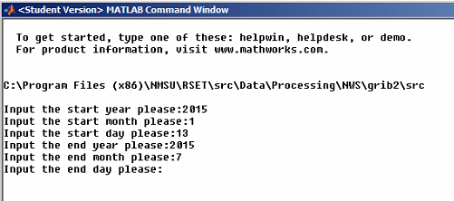

1. In this window, input the start date and end date. Be sure the NWS data during this period are downloaded and stored in the specific location. The location is defined in the config file: “C:\Program Files (x86)\NMSU\RSET\src\Data\Processing\NWS\grib2\config\dirlist.csv”, if the data are stored in the different folder, please update this config file.
2. After the program finishes, the result files will be saved in the same folder as the NWS data. For every day, there are two output files. See the output files for 2015/7/27 in the following figure. The file “2015-07-27.csv” is CONUS grid data, which include “latitude, longitude, elevation, ET_o, ET_r, ET_h” six elements. Another file “2015-07-27-IL.csv” is IL grid weather data, which include “year, day of year, latitude, longitude, elevation, daily minimum temperature, daily maximum temperature, dew point, wind speed, wind direction, daily precipitation, sky cover and solar radiation” totally 13 elements.

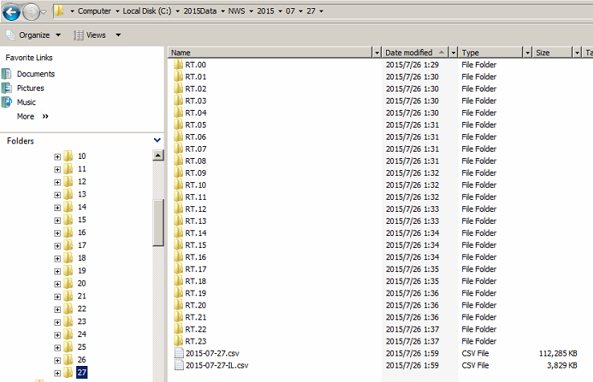

Thank you all for your patience for reading this tutorial. Hope this helps!

If you have any questions regarding this, feel free to contact me at [sophie.cui80@gmail.com](mailto:sophie.cui80@gmail.com)