hpl2vtk.py

Created December 6, 2018

**About**

hpl2vtk.py is a Python script created by Mark Van Moer, NCSA to take the .hpl files from the Halo Lidar to create the files that can be used in ParaView to create views of the lidar data.

**Software Needed**

Python installed on your machine is necessary including the Python module for vtk. The easiest way to install this is by using [Anaconda](https://www.anaconda.com/). Anaconda is an easy way to install Python (or R) and many of the standard modules needed for data science including hpl2vtk.py.

Steps to install Anaconda and the vtk module:

1. Go to this page: <https://www.anaconda.com/distribution/>
2. Click the “Download Now” button
3. Pick the OS you are using and also pick the Python 2.7 version – VTK is only available using Python 2.7 at this time.

The rest of these instructions are for a Windows machine. It may be the same or deviate for other OS machines.

1. The executable file should download immediately. Once it is finished downloading click on the file to start installation. It should be named something like Anaconda2-version#-Windows-x86_64.exe
2. Go through the Setup screens

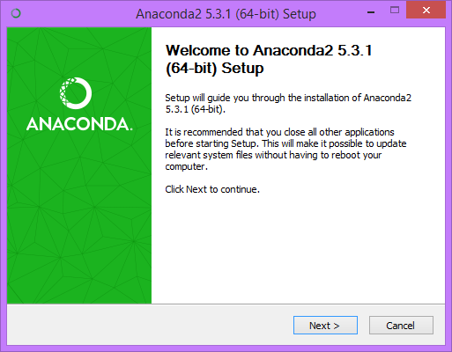

* 1. Click Next from this screen.
  2. Read and Agree to the License Agreement
  3. Select “Just Me” and the programs will only be installed for you on this machine.
  4. Select the Install location. Typically the location that is originally shown will be fine for this.

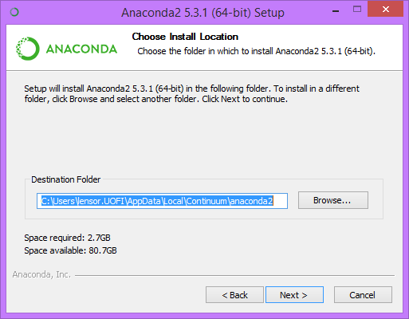

* 1. If you do not have Python on the computer for other purposes, use the following selections. If you do have Python, please read the selections carefully and select the options that work best for your machine. Click Install.

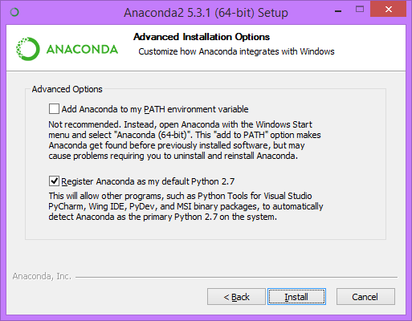

* 1. Once it is completed, click Next, and skip the installation of Microsoft VSCode. Then click Finish.

1. One you are finished with the installation. Open an “Anaconda Prompt” from your list of programs.
2. Now vtk needs to be installed. Information about vtk can be found here: <https://anaconda.org/anaconda/vtk>
   1. Type in “conda install –c anaconda vtk”. This will install the latest version of vtk.
   2. When prompted type “y” to continue with the installation.
3. You are now ready to use hpl2vtk.py

**Usage**

1. Open an “Anaconda Prompt” window
2. Navigate to the directory where hpl2vtk.py is located using the command “cd C:/Directory/to/file”.

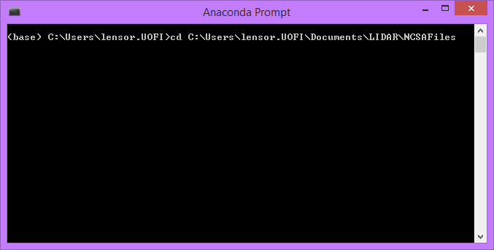

1. To see what arguments are need to run hpl2vtk.py use this command: “python hpl2vtk.py –h”.
2. Three arguments are required:
   1. scanDirectory: The path to the directory where your .hpl files are located.
   2. scanType: This is the type of files you want to plot. The options are RHI, VAD, Stare, or User.
   3. outputGeometry: This specifies the output type. The options for this include gates, rays or sweeps.
      1. gates are VTK polydata vertex cells
      2. rays are VTK polydata poly line cells
      3. sweep are VTK structured grids.
3. There are also 2 optional arguments
   1. --pitch-and-roll: This applies the pitch and roll of the LiDAR to the output geometry.
   2. –no-pitch-and-roll: This ignores the pitch and roll of the LiDAR.
4. The following example will run for VAD files using a sweep geometry. It will also ignore the pitch and roll.
   1. > python hpl2vtk.py C:\Users\lensor.UOFI\Documents\LIDAR\TestCases\20160807 VAD sweep --no-pitch-and-roll
   2. The output files for this are saved in the directory where hpl2vtk.py is located. There is one file for each file located in the passed data directory of that scanType. The directory, C:\Users\lensor.UOFI\Documents\LIDAR\TestCases\20160807, had 10 VAD files, so I now have 10 .vts files located in C:\Users\lensor.UOFI\Documents\LIDAR\NCSAFiles.
5. The created files can be used in ParaView by using File>Open and selecting the entire group of files.