# Testing

## Types of tests

* **Unit tests 🡪** *White box tests*. This means that you can have access to the source code you are creating, and you can look to the different corner cases or returns that your business logic has a given method or function.

They are key as; they not only determine if that part of the application is working or not. They also determine what part of the application is not working after a change is done in that part of the code.

* **Integration tests** 🡪 Tests that test 2 or more different functions that are calling each other. You can have integration between layers. So, integration tests are good for checking that the modules created interact correctly between them
* **Functional tests** 🡪 *Black box tests*. We call it like this because what we are doing is, running the application and performing an operation with an expected response. If the response is OK, the test will pass, if the response returned is different, it will fail…indicating that the behaviour has changed, and something is going wrong

The main difference is that in these tests you don’t why is failing, because there are many factors that could cause this to fail.

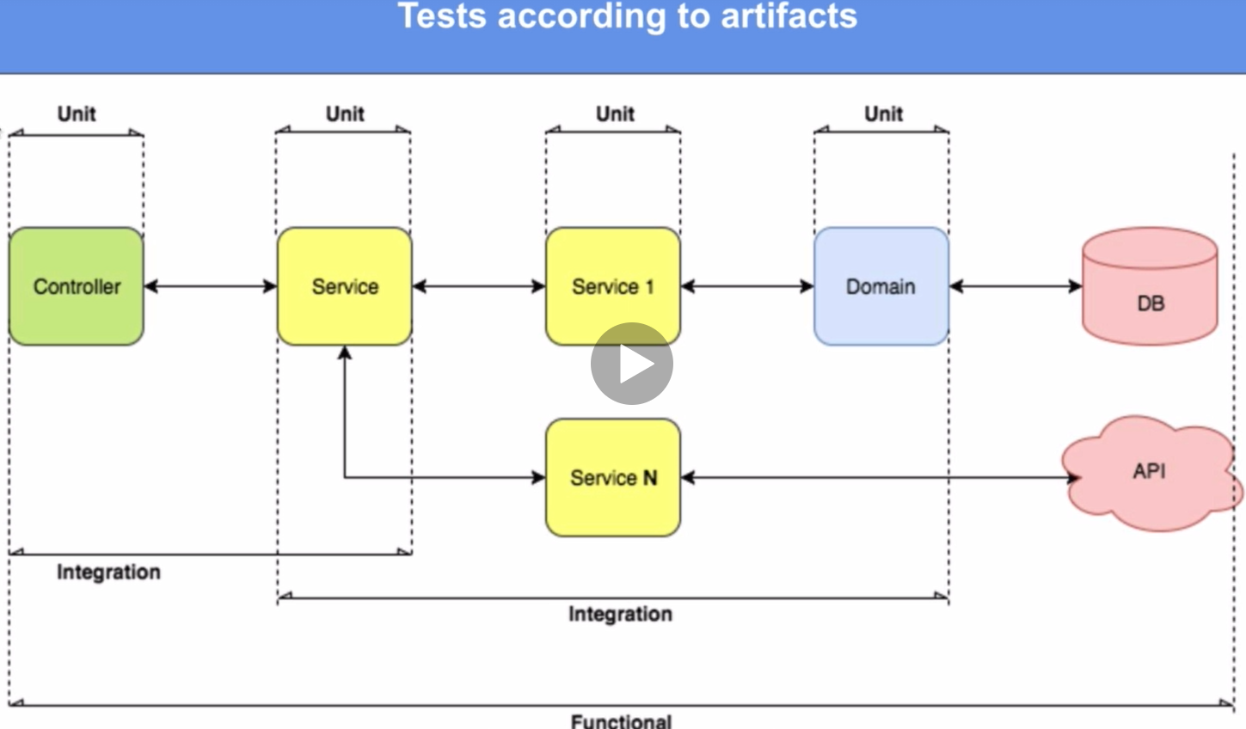

## Pyramid of tests

Rule of 80-15-5:

* 80% of the application tested with unit tests
* 15% of the application tested with integration tests
* 5% of the application tested with functional tests

- In order for Go to know that this is a test 2 things need to be declared:  
 - The name of the class must finalize in "_test"  
 - The name of the test function must start with "Test"