KEY FORMULA

Symbols

Symbol(s) | Meaning | Value / Notes
Architecture (fixed per model)
L, Lₘₒₑ | transformer layers; layers carrying MoE | 43/43, 61/61, 61/58
$$n_{\text{csa}},n_{\text{hca}}$$ | CSA / HCA layer counts | from compress_ratios
e, ι | bytes per KV entry; per CSA indexer key | 576, 68
m, m′ | CSA / HCA compression ratios | 4, 128
nᵥᵢₙ, kₜₒₚ | sliding window; CSA sparse top-k | 128; 512/1024
nₑ, k | routed experts per layer; activated per token | 256/384; 6/8
wₑ, W₀ | parameters per expert; non-expert weight bytes
bₑ, b | bytes per expert param; per stored KV element | 0.53125 (MXFP4) / 1.0
$P_{\text{act}},$ cₘₐₓ | activated params per token; context ceiling
dₖᵥ, dᵣ | MLA latent / decoupled-RoPE dims (dense case) | 512, 64
Workload, persona i
sᵢ, cᵢ, oᵢ | seat share; context tokens; output tokens
rᵢ, hᵢ | requests per active user per day; prefix-cache hit rate
λᵢ, Cᵢ | peak arrival rate; concurrent sessions
Deployment
N, a, φ | seats; daily adoption; peak-hour concentration
ℓ, ψ | planned load factor; idle-KV multiplier | 0.70, 1.0
τ, T₀ | TPOT SLO (s/token); TTFT budget (s) | 0.040, 2.0
ηₘ, ηᵦ, $η_{\text{mfu}}$ | usable HBM; achievable bandwidth; prefill MFU | 0.85, 0.70, 0.40
σ, R, ν | expert routing skew; redundancy; GPUs per node | 1.15, 2, 8
Hardware
H, β, F | HBM bytes; HBM bandwidth; dense FP8 FLOP/s

Formula

Stage 0 — Model constants (deployment-independent)

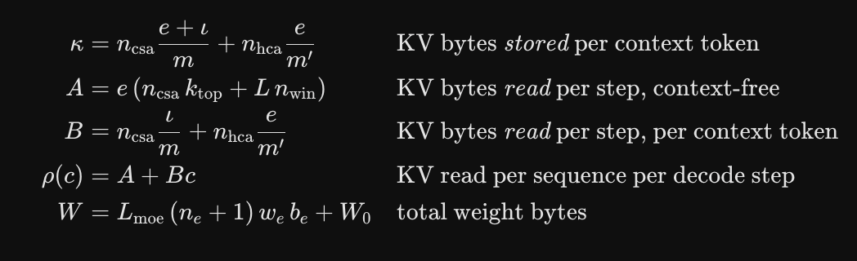

Stage 1 — Demand to concurrency (Little’s Law)

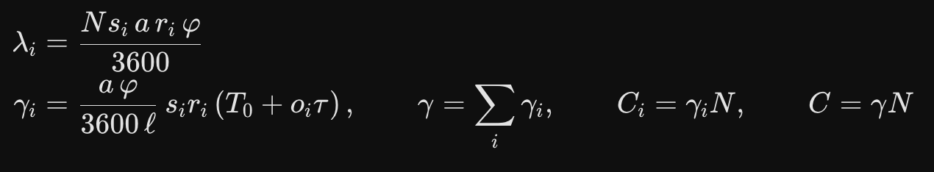
Stage 2 — Capacity

Stage 3 — Decode bandwidth
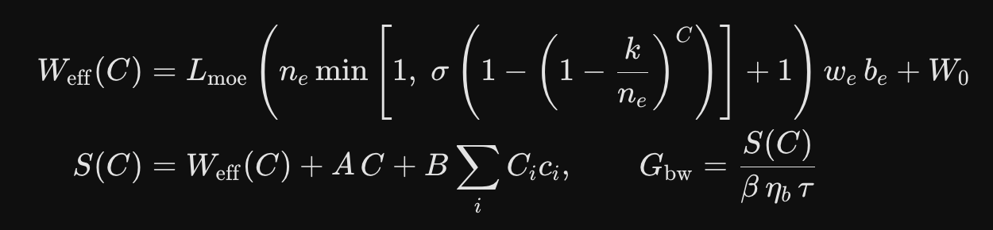
Stage 3b — Prefill
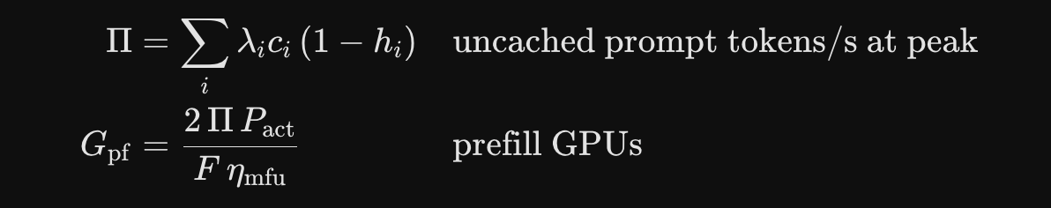
Stage 4 — Feasibility and fleet
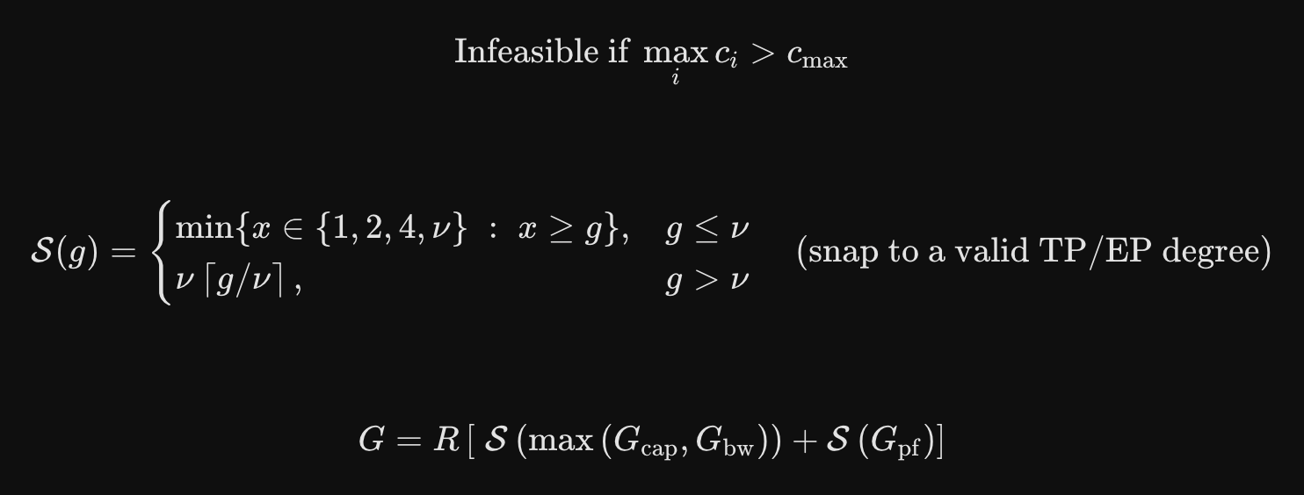
Derived invariants

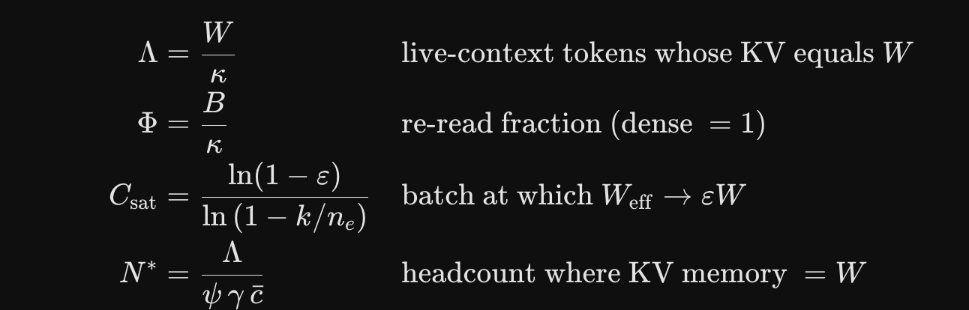

The latex formulas are rendered by google gemini. Not produced by it.

UNCERTAINTY REGISTER

What this register is for:
Explains which numbers are derived and verified, which are absorbed into the tool as parameters, and which are still guesses.
Key disclaimer:
Model constants were derived from architecture and confirmed field-by-field against config.json; workload inputs were invented. Those deserve very different levels of trust and the fleet number alone doesn't distinguish them.
Broadly the rows fall into three classes:
Architectural facts (U1) are binary and resolved by a procurement decision, not by more analysis. Derived model constants (U2, U3, U5, U6) are narrow and verified; collectively they move the fleet by roughly one GPU.
Workload and efficiency assumptions (U4, U7–U11) are wide, unmeasured, and can only be closed by a pilot.

# | Source | Affects | Magnitude | Modelled? | Character
U1 | FP4 hardware path | $$W$$ | +84% Flash, +86% Pro (+727 GB on Pro) | Yes — HW[].fp4_native | Binary. A procurement decision, not an estimate. Dominates all other rows combined.
U8 | GPU FLOPS figures unverified | $$G_{pf}$$ | Unknown; prefill is ~50% of the Hopper fleet | No | Values in HW[] are from memory. Verify against vendor datasheets before spending.
U9 | Prefix-cache hit rates assumed (0.30 / 0.85 / 0.20) | $$G_{pf}$$ | High leverage — sets $Π$directly | Input only | Measurable in a pilot; currently pure assumption.
U4 | Expert routing skew | $$G_{bw}$$ | +10–20% | Yes — $σ=1.15$ | Absorbed, but $σ$itself is unvalidated. Stragglers set step time under EP.
U7 | Arrival burstiness | $$C$$ | Tail exceeds $γN$ | Partly — $l=0.70$ | $φ$and $l$are crude proxies for a real queueing model.
U10 | Prefill MFU $=0.40$ | $$G_{pf}$$ | ±25% plausible | Yes — constant | Absorbed as a fixed parameter; not validated on this architecture.
U11 | Interconnect / EP network limits | $$G_{bw}$$ | May bind at ≥64 GPUs | No | Tech report gives a 6,144 FLOPs/byte balance point for Pro; unmodelled.
U3 | MTP module loaded | $$W$$ | +3.5 / +13.8 / +11.5 GB | Yes — --mtp | Optional. Zero $κ$impact (compress_ratio: 0 confirmed for both MTP blocks).
U5 | V4-Flash config provenance | Flash constants | Low | No | Third-party FlagOS mirror; every field cross-checks against the tech report.
U2 | Indexer keys persisted? | $$κ$$ | −11.5% / −11.4% on $κ$; 0 GPUs on output | Yes — --band | Diagnosed: removing the indexer term reproduces the paper's figures to <0.5% on both models. Immaterial to the fleet.
U6 | Embedding precision | $$W$$ | ±0.5 / ±0.9 GB | No | Negligible.

USING sizing_v2.py :

python3 sizing_v2.py # full report, default assumptions
python3 sizing_v2.py --seats 12000 # your headcount
python3 sizing_v2.py --sweep # scaling curve 500→50,000 seats; B200 only, ignores --seats
python3 sizing_v2.py --band lo # optimistic KV accounting
python3 sizing_v2.py --mtp # include MTP for speculative decoding

The CLI covers four common overrides. Everything else — SLOs, efficiency factors, redundancy, the workload mix, and hardware — is edited in the DEPLOY, MIX, and HW blocks at the foot of the file. Requires Python 3.8+, standard library only. Model constants self-validate on import and raise AssertionError if edited inconsistently.

SOURCE CODE

#!/usr/bin/env python3
"""
GPU sizing for DeepSeek-V4-Flash / V4-Pro / R1-671B. v2

demand --> concurrency --> {capacity, bandwidth, prefill} --> topology

USAGE
-----
python3 sizing_v2.py # full report, default assumptions
python3 sizing_v2.py --seats 12000 # your headcount
python3 sizing_v2.py --sweep # scaling curve 500→50,000 seats; B200 only, ignores --seats
python3 sizing_v2.py --band lo # optimistic KV accounting
python3 sizing_v2.py --mtp # include MTP for speculative decoding

Edit DEPLOY / MIX / HW at the bottom for anything else. Every assumption is
a named constant; nothing is buried in a function.

NOT MODELLED (know these before you trust the output)
-----------------------------------------------------
* queueing dynamics: phi is a crude peak proxy, not a tail model
* prefix-cache hit rates are assumed, not measured
* network/interconnect limits in expert parallelism
* disaggregated prefill/decode scheduling overhead
* cold-start, checkpoint load, model-swap time
* FLOPS figures in HW[] are from memory -- VERIFY against vendor datasheets
"""
import argparse, math

GB, MB, TB = 1e9, 1e6, 1e12

# ===========================================================================
# MODEL CONSTANTS
# Derived from architecture; validated against reported totals to <0.5% and
# confirmed field-by-field against config.json for all three models.
# e = 576 B compressed KV entry (64 RoPE dims BF16 + 448 dims FP8)
# iota= 68 B CSA indexer key (MXFP4, 128 dims + E8M0 scale)
# ===========================================================================
E_ENTRY, IOTA, M_CSA, M_HCA, N_WIN = 576, 68, 4, 128, 128
FP4 = 0.5 + 1/32 # MXFP4 incl. E8M0 scale, confirmed scale_fmt=ue8m0
FP8 = 1.0

class Model:
def __init__(self, name, *, n_csa, n_hca, topk, L, d, d_ff, n_e, k,
W_attn, W_emb, W_dense_ffn=0.0, c_max, dense_mla=False,
L_moe=None, kv_dense=None, P_act):
self.name, self.L, self.n_e, self.k = name, L, n_e, k
self.L_moe = L_moe if L_moe is not None else L
self.c_max, self.P_act = c_max, P_act
self.w_e = 3 * d * d_ff # params per expert
self.n_experts_per_layer = n_e + 1 # routed + shared
self.W_attn, self.W_emb, self.W_dense_ffn = W_attn, W_emb, W_dense_ffn
self.dense_mla = dense_mla

if dense_mla: # R1: full MLA, every layer
self.kappa_hi = self.kappa_lo = L * kv_dense * 2
self.A, self.B = 0.0, L * kv_dense * 2
else:
self.kappa_hi = n_csa*(E_ENTRY+IOTA)/M_CSA + n_hca*E_ENTRY/M_HCA
self.kappa_lo = n_csa*E_ENTRY/M_CSA + n_hca*E_ENTRY/M_HCA
self.A = E_ENTRY * (n_csa*topk + L*N_WIN)
self.B = n_csa*IOTA/M_CSA + n_hca*E_ENTRY/M_HCA

# ---- weights depend on the precision path: uncertainty U1 --------------
def W(self, precision="blackwell", mtp=False):
expert_params = self.L_moe * self.n_experts_per_layer * self.w_e
b = FP4 if (precision == "blackwell" and not self.dense_mla) else FP8
w = expert_params*b + self.W_attn*FP8 + self.W_dense_ffn*FP8 + self.W_emb*2
if mtp: # one extra block, MoE-shaped
w += self.n_experts_per_layer*self.w_e*b + self.W_attn/self.L*FP8
return w

def kappa(self, band="hi"):
return self.kappa_hi if band == "hi" else self.kappa_lo

def rho(self, c): # KV read per decode step
return self.A + self.B * c

def W_eff(self, C, precision, mtp, skew=1.0):
"""Weight bytes touched at batch C. skew>1 models non-uniform routing."""
frac = min(1.0, skew * (1 - (1 - self.k/self.n_e)**C))
b = FP4 if (precision == "blackwell" and not self.dense_mla) else FP8
moe = self.L_moe * (self.n_e*frac + 1) * self.w_e * b
return moe + self.W_attn*FP8 + self.W_dense_ffn*FP8 + self.W_emb*2

# ---- deployment-independent invariants --------------------------------
def Lam(self, precision="blackwell", band="hi"): # tokens where KV == W
return self.W(precision) / self.kappa(band)
def Phi(self, band="hi"): # re-read fraction
return self.B / self.kappa(band)
def C_sat(self, eps=0.95):
return math.log(1-eps) / math.log(1 - self.k/self.n_e)

FLASH = Model("V4-Flash", n_csa=21, n_hca=20, topk=512, L=43, d=4096, d_ff=2048,
n_e=256, k=6, W_attn=4.83e9, W_emb=2*129280*4096,
c_max=1_048_576, P_act=13.6e9)
PRO = Model("V4-Pro", n_csa=30, n_hca=31, topk=1024, L=61, d=7168, d_ff=3072,
n_e=384, k=6, W_attn=19.2e9, W_emb=2*129280*7168,
c_max=1_048_576, P_act=49.3e9)
R1 = Model("R1-671B", n_csa=0, n_hca=0, topk=0, L=61, d=7168, d_ff=2048,
n_e=256, k=8, W_attn=11.41e9, W_emb=2*129280*7168,
W_dense_ffn=3*3*7168*18432, c_max=163_840, dense_mla=True,
L_moe=58, kv_dense=512+64, P_act=37.2e9)
MODELS = [FLASH, PRO, R1]

# ===========================================================================
# VALIDATION -- fail loudly if the constants drift
# ===========================================================================
def _validate():
for m, target in [(FLASH, 284e9), (PRO, 1572e9), (R1, 671e9)]:
p = (m.L_moe*m.n_experts_per_layer*m.w_e + m.W_attn
+ m.W_dense_ffn + m.W_emb)
assert abs(p/target - 1) < 0.01, f"{m.name}: derived {p/1e9:.1f}B vs {target/1e9:.0f}B"
assert abs(FLASH.kappa_hi - 3471) < 1 and abs(PRO.kappa_hi - 4970) < 1
assert abs(R1.kappa_hi - 70272) < 1
_validate()

# ===========================================================================
# TOPOLOGY -- a raw ceiling is not a deployable configuration
# ===========================================================================
def snap(g, node=8):
"""Smallest valid parallelism degree >= g: powers of 2 up to a node,
then whole nodes. Avoids returning e.g. 3 or 14 GPUs."""
if g <= node:
return next(x for x in (1, 2, 4, 8) if x >= g)
return node * math.ceil(g / node)

# ===========================================================================
# STAGES
# ===========================================================================
def concurrency(N, dep, mix):
"""Stage 1: Little's Law. Returns [(name, C_i, c_i, lambda_i, hit_i)]."""
out = []
for name, s, c, o, r, hit in mix:
lam = N * s * dep["a"] * r * dep["phi"] / 3600.0
Wsvc = dep["T0"] + o * dep["tau"]
out.append((name, lam*Wsvc/dep["load_factor"], c, lam, hit))
return out

def size(m, N, dep, mix, hw):
"""Stages 2-4. Returns a dict; None if the model cannot serve the mix."""
label, H, beta, flops, fp4_native = hw
unmet = [n for n, _, c, _, _ in concurrency(N, dep, mix) if c > m.c_max]
if unmet:
return {"model": m.name, "hw": label, "infeasible": unmet}

prec = "blackwell" if fp4_native else "hopper"
Cs = concurrency(N, dep, mix)
C = sum(x[1] for x in Cs)
ctx_load = sum(Ci*c for _, Ci, c, _, _ in Cs) # sum C_i * c_i

W = m.W(prec, dep["mtp"])
M = W + dep["psi"] * m.kappa(dep["band"]) * ctx_load
S = m.W_eff(C, prec, dep["mtp"], dep["skew"]) + m.A*C + m.B*ctx_load

g_cap = M / (H * dep["eta_m"])
g_bw = S / (beta * dep["eta_b"] * dep["tau"])

# prefill: uncached prompt tokens/sec at peak, 2*P_act FLOPs/token
pf_tps = sum(lam*c*(1-hit) for _, _, c, lam, hit in Cs)
g_pf = pf_tps * 2 * m.P_act / (flops * dep["mfu"])

g_dec = snap(math.ceil(max(g_cap, g_bw)))
g_pf_s = snap(math.ceil(g_pf))
bind = "bandwidth" if g_bw > g_cap else "capacity"
return {"model": m.name, "hw": label, "prec": prec, "C": C, "W": W, "M": M,
"S": S, "g_cap": g_cap, "g_bw": g_bw, "bind": bind, "pf_tps": pf_tps,
"g_dec": g_dec, "g_pf": g_pf_s,
"total": dep["R"]*(g_dec + g_pf_s)}

# ===========================================================================
# DEFAULTS
# ===========================================================================
DEPLOY = dict(
a=0.45, # adoption: share of seats active per day
phi=0.20, # peak-hour concentration
psi=1.0, # idle KV multiplier (1.0 = evict at turn end)
tau=0.040, # TPOT SLO, s/token
T0=2.0, # TTFT budget, s
eta_m=0.85, # usable HBM fraction
eta_b=0.70, # achievable bandwidth fraction
mfu=0.40, # prefill model-FLOPs utilisation
skew=1.15, # expert routing skew on bandwidth (U4)
load_factor=0.70, # don't plan past 70% of capacity (U7)
band="hi", # KV accounting: "hi" conservative, "lo" paper-implied
mtp=False, # load MTP module for speculative decoding (U3)
R=2, # redundancy: N+1 / multi-AZ
)
# name share ctx out req/day prefix-cache hit
MIX = [("General chat", 0.60, 4_000, 600, 10, 0.30),
("Agentic coding", 0.25, 60_000, 2500, 40, 0.85),
("Doc analysis", 0.15, 250_000, 1500, 6, 0.20)]

# label, HBM bytes, HBM B/s, dense FP8 FLOP/s, native FP4? <-- VERIFY FLOPS
HW = [("H100 80GB", 80*GB, 3.35*TB, 989e12, False),
("H200 141GB", 141*GB, 4.80*TB, 989e12, False),
("B200 192GB", 192*GB, 8.00*TB, 4500e12, True)]

# ===========================================================================
def report(N, dep, mix, hw_list):
print(f"{'model':10s}{'W_bw (GB)':>11s}{'W_hop (GB)':>12s}"
f"{'kappa lo-hi':>16s}{'Phi':>7s}{'Lambda (Mtok)':>15s}{'C_sat':>7s}")
for m in MODELS:
print(f"{m.name:10s}{m.W('blackwell')/GB:11.0f}{m.W('hopper')/GB:12.0f}"
f"{f'{m.kappa_lo:,.0f}-{m.kappa_hi:,.0f}':>16s}{m.Phi():7.3f}"
f"{m.Lam()/1e6:15.1f}{m.C_sat():7.0f}")

Cs = concurrency(N, dep, mix)
print(f"\nN={N:,} -> C={sum(x[1] for x in Cs):.0f} concurrent "
f"(load factor {dep['load_factor']}), "
f"mean ctx {sum(Ci*c for _,Ci,c,_,_ in Cs)/sum(x[1] for x in Cs):,.0f}")

for hw in hw_list:
print(f"\n--- {hw[0]} ---")
for m in MODELS:
r = size(m, N, dep, mix, hw)
if "infeasible" in r:
print(f" {m.name:10s} INFEASIBLE: context exceeds "
f"{m.c_max:,} for {', '.join(r['infeasible'])}")
continue
print(f" {r['model']:10s} [{r['prec']:9s}] "
f"M={r['M']/GB:6.0f}GB S={r['S']/GB:5.0f}GB/step "
f"| decode {r['g_dec']:3d} ({r['bind']}) "
f"+ prefill {r['g_pf']:3d} ({r['pf_tps']/1e3:.0f}K tok/s) "
f"| x{dep['R']} = {r['total']:3d} GPUs")

if __name__ == "__main__":
ap = argparse.ArgumentParser()
ap.add_argument("--seats", type=int, default=5000)
ap.add_argument("--band", choices=["lo", "hi"], default="hi")
ap.add_argument("--mtp", action="store_true")
ap.add_argument("--sweep", action="store_true")
a = ap.parse_args()
DEPLOY["band"], DEPLOY["mtp"] = a.band, a.mtp

if a.sweep:
print(f"{'seats':>8s}{'C':>8s}" + "".join(f"{m.name:>12s}" for m in MODELS)
+ " (B200, total incl. redundancy + prefill)")
for n in (500, 1000, 2500, 5000, 10000, 25000, 50000):
Cs = concurrency(n, DEPLOY, MIX)
row = f"{n:8,d}{sum(x[1] for x in Cs):8.0f}"
for m in MODELS:
r = size(m, n, DEPLOY, MIX, HW[2])
row += f"{'n/a' if 'infeasible' in r else r['total']:>12}"
print(row)
else:
report(a.seats, DEPLOY, MIX, HW)

