KEY FORMULA

Symbols

Symbol(s) | Meaning | Value / Notes
Architecture (fixed per model)
L, Lₘₒₑ | transformer layers; layers carrying MoE | 43/43, 61/61, 61/58
$$n_{\text{csa}},n_{\text{hca}}$$ | CSA / HCA layer counts | from compress_ratios
e, ι | bytes per KV entry; per CSA indexer key | 576, 68
m, m′ | CSA / HCA compression ratios | 4, 128
nᵥᵢₙ, kₜₒₚ | sliding window; CSA sparse top-k | 128; 512/1024
nₑ, k | routed experts per layer; activated per token | 256/384; 6/8
wₑ, W₀ | parameters per expert; non-expert weight bytes
bₑ, b | bytes per expert param; per stored KV element | 0.53125 (MXFP4) / 1.0
$P_{\text{act}},$ cₘₐₓ | activated params per token; context ceiling
dₖᵥ, dᵣ | MLA latent / decoupled-RoPE dims (dense case) | 512, 64
Workload, persona i
sᵢ, cᵢ, oᵢ | seat share; context tokens; output tokens
rᵢ, hᵢ | requests per active user per day; prefix-cache hit rate
λᵢ, Cᵢ | peak arrival rate; concurrent sessions
Deployment
N, a, φ | seats; daily adoption; peak-hour concentration
ℓ, ψ | planned load factor; idle-KV multiplier | 0.70, 1.0
τ, T₀ | TPOT SLO (s/token); TTFT budget (s) | 0.040, 2.0
ηₘ, ηᵦ, $η_{\text{mfu}}$ | usable HBM; achievable bandwidth; prefill MFU | 0.85, 0.70, 0.40
σ, R, ν | expert routing skew; redundancy; GPUs per node | 1.15, 2, 8
Hardware
H, β, F | HBM bytes; HBM bandwidth; dense FP8 FLOP/s

Formula

Stage 0 — Model constants (deployment-independent)

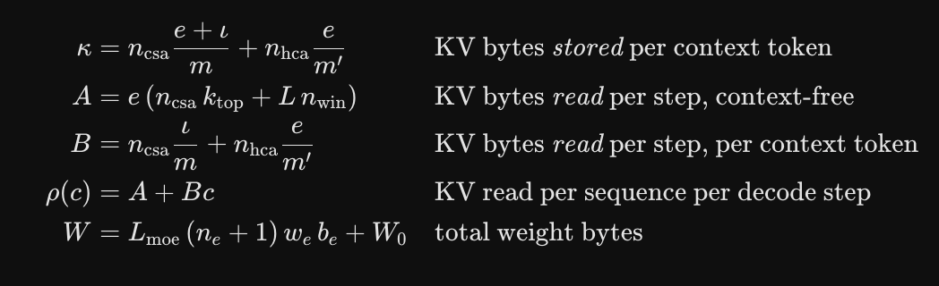

Stage 1 — Demand to concurrency (Little’s Law)

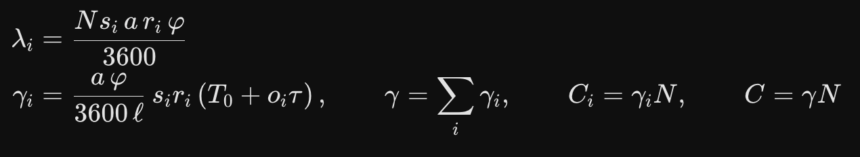
Stage 2 — Capacity

Stage 3 — Decode bandwidth
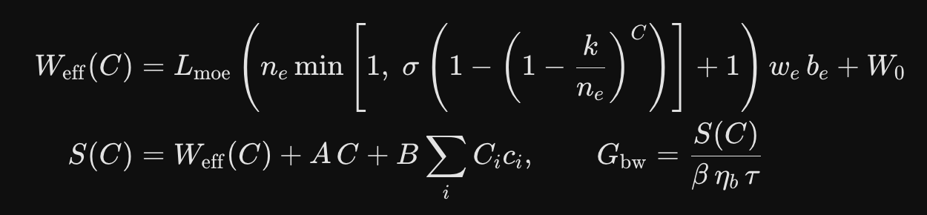
Stage 3b — Prefill
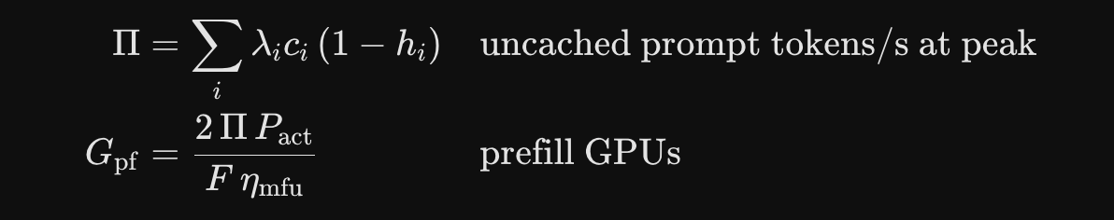

Stage 4 — Feasibility and fleet

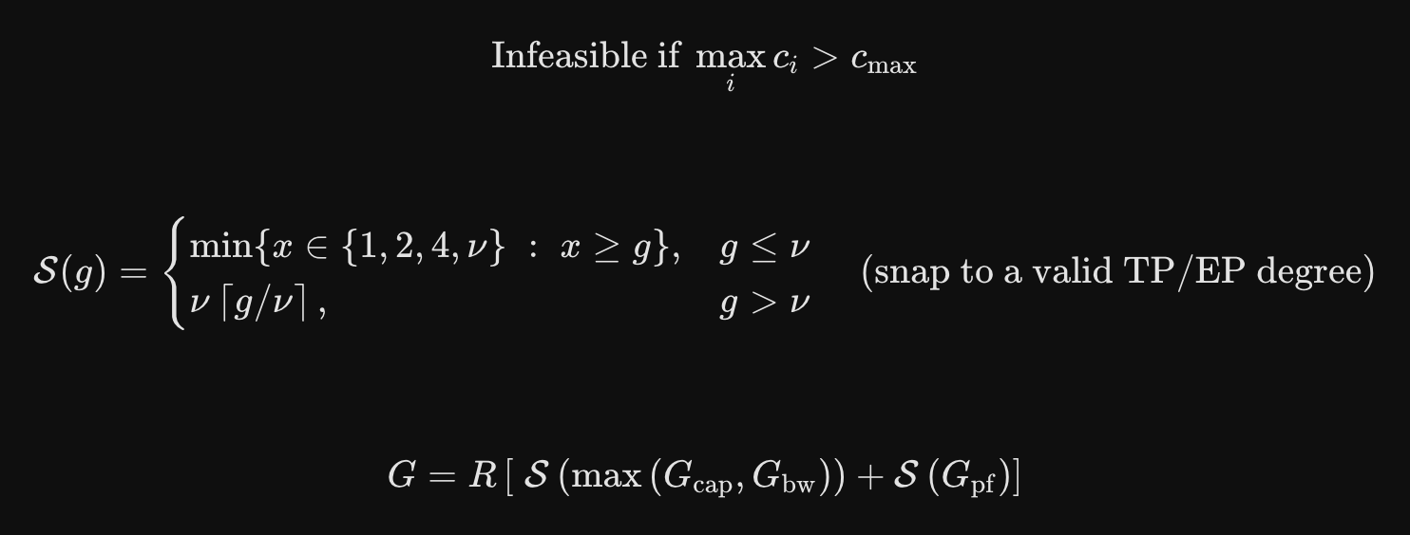

Derived invariants

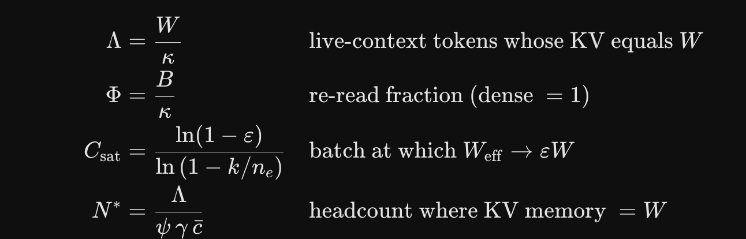

The latex formulas are rendered by google gemini. Not produced by it.

UNCERTAINTY REGISTER

What this register is for:
Explains which numbers are derived and verified, which are absorbed into the tool as parameters, and which are still guesses.
Key disclaimer:
Model constants were derived from architecture and confirmed field-by-field against config.json; workload inputs were invented. Those deserve very different levels of trust and the fleet number alone doesn't distinguish them.
Broadly the rows fall into three classes:
Architectural facts (U1) are binary and resolved by a procurement decision, not by more analysis. Derived model constants (U2, U3, U5, U6) are narrow and verified; collectively they move the fleet by roughly one GPU.
Workload and efficiency assumptions (U4, U7–U11) are wide, unmeasured, and can only be closed by a pilot.

# | Source | Affects | Magnitude | Modelled? | Character
U1 | FP4 hardware path | $$W$$ | +84% Flash, +86% Pro (+727 GB on Pro) | Yes — HW[].fp4_native | Binary. A procurement decision, not an estimate. Dominates all other rows combined.
U8 | GPU FLOPS figures unverified | $$G_{pf}$$ | Unknown; prefill is ~50% of the Hopper fleet | No | Values in HW[] are from memory. Verify against vendor datasheets before spending.
U9 | Prefix-cache hit rates assumed (0.30 / 0.85 / 0.20) | $$G_{pf}$$ | High leverage — sets $Π$directly | Input only | Measurable in a pilot; currently pure assumption.
U4 | Expert routing skew | $$G_{bw}$$ | +10–20% | Yes — $σ=1.15$ | Absorbed, but $σ$itself is unvalidated. Stragglers set step time under EP.
U7 | Arrival burstiness | $$C$$ | Tail exceeds $γN$ | Partly — $l=0.70$ | $φ$and $l$are crude proxies for a real queueing model.
U10 | Prefill MFU $=0.40$ | $$G_{pf}$$ | ±25% plausible | Yes — constant | Absorbed as a fixed parameter; not validated on this architecture.
U11 | Interconnect / EP network limits | $$G_{bw}$$ | May bind at ≥64 GPUs | No | Tech report gives a 6,144 FLOPs/byte balance point for Pro; unmodelled.
U3 | MTP module loaded | $$W$$ | +3.5 / +13.8 / +11.5 GB | Yes — --mtp | Optional. Zero $κ$impact (compress_ratio: 0 confirmed for both MTP blocks).
U5 | V4-Flash config provenance | Flash constants | Low | No | Third-party FlagOS mirror; every field cross-checks against the tech report.
U2 | Indexer keys persisted? | $$κ$$ | −11.5% / −11.4% on $κ$; 0 GPUs on output | Yes — --band | Diagnosed: removing the indexer term reproduces the paper's figures to <0.5% on both models. Immaterial to the fleet.
U6 | Embedding precision | $$W$$ | ±0.5 / ±0.9 GB | No | Negligible.

USING sizing_v2.py :

python3 sizing_v2.py # full report, default assumptions
python3 sizing_v2.py --seats 12000 # your headcount
python3 sizing_v2.py --sweep # scaling curve 500→50,000 seats; B200 only, ignores --seats
python3 sizing_v2.py --band lo # optimistic KV accounting
python3 sizing_v2.py --mtp # include MTP for speculative decoding

The CLI covers four common overrides. Everything else — SLOs, efficiency factors, redundancy, the workload mix, and hardware — is edited in the DEPLOY, MIX, and HW blocks at the foot of the file. Requires Python 3.8+, standard library only. Model constants self-validate on import and raise AssertionError if edited inconsistently.

