**Innovation Fridays**

**HTML <dialog> element**

The HTML 5.2 spec has introduced a dialog element that makes it easy to implement native modals and pop-ups: <dialog>

**Goal**

Reduce reliance on third party libraries by using an element native to HTML for modal and dialog windows.

**Actions**

Create a proof of concept of the dialog element



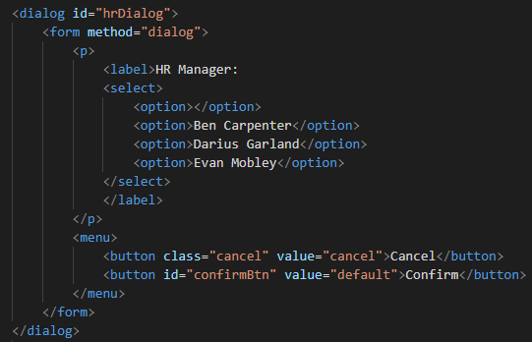

The dialog element has a web API with a showModal() method we can use to open, and close() to close

**NOTE**: Using the method=”dialog” attribute on the form automatically closes the open dialog when clicking Cancel

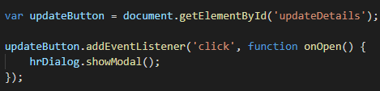

Styling is as simple as using ‘dialog’ as your CSS selector, while the ::backdrop pseudo-selector allows complete customization of the backdrop.

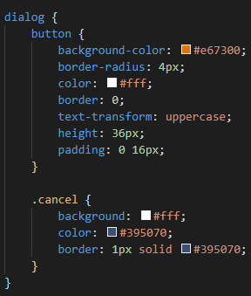

It’s also easy to trigger a dialog’s open/close animations by targeting the [open] attribute of the dialog.

**Results**

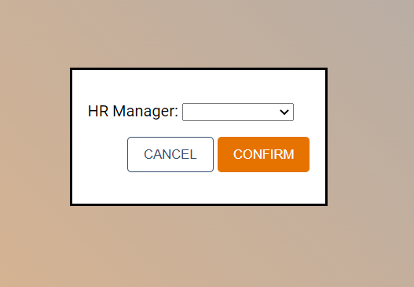



**Next Steps**

Consider usage of the native HTML dialog element within the FormFire application.