## ANALYSIS OF RESTAURANTS IN FARIDABAD

## 3. Foursquare API

Using Foursquare API to explore venue information for each neighborhood in the FARIDABAD city. Some features extracted include ‘Venue’, ‘Venue Category’, ‘Venue Latitude’, ‘Venue Longitude’, etc.

**Methodology**

After extracting the data of FARIDABAD neighborhoods and grouping them by their pin codes I got the following data frame containing **182** neighborhoods.

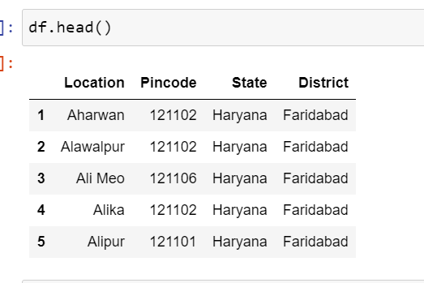

I used the **goepy**library to pass the name to get the latitudes and longitudes and merged the data into the above dataset.

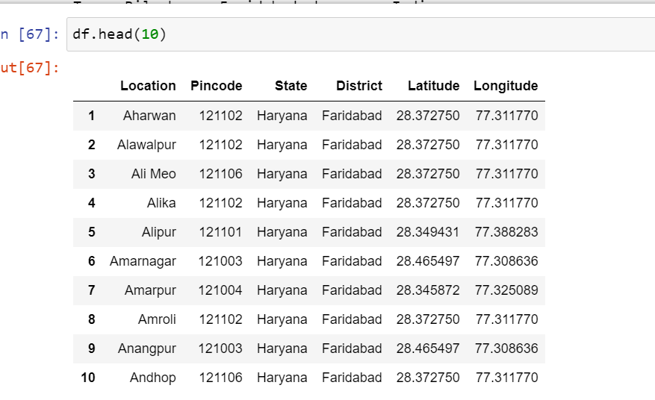

The **folium**library was used to visualize the geographic details of FARIDABAD and superimposed the markers on the map indicating the neighborhoods with a popup text.

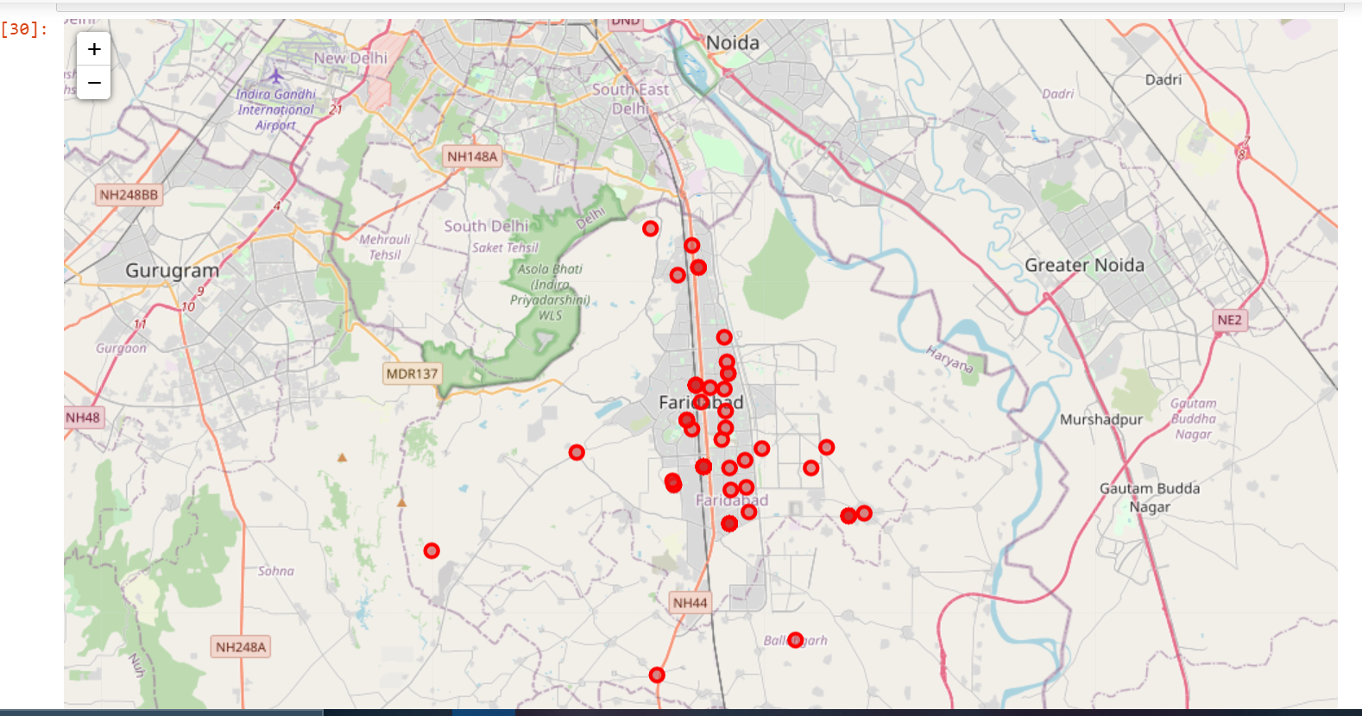

I utilized the Foursquare API to explore the boroughs and segment them. It fetches the venues located nearest to location passed through the URL. I assigned the limit as **200** and the radius as **500** meters for each neighborhood from their given latitude and longitude information. From the data gathered I created the following data frame consisting of **244** venues categorized by the venue type.

With the following we see the venue type distribution in the available data.

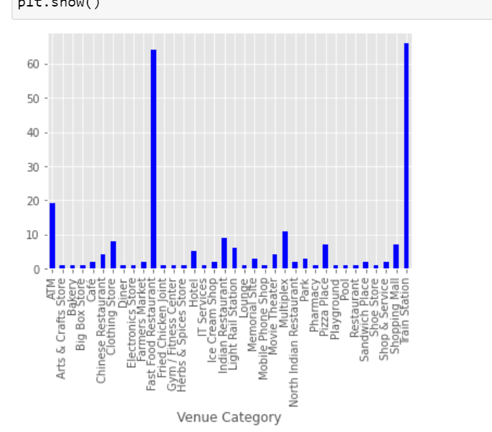

For this study, I used one-hot encoding and standardization to process our categorical variable (venue category) into a form that machine learning algorithms can further classify the data. Since we have some common venue category that is why I decided to choose K -means algorithm for clustering. To decide the optimal number of clusters I used the Elbow method.

## 

Here is my merged table with cluster labels for each Location.

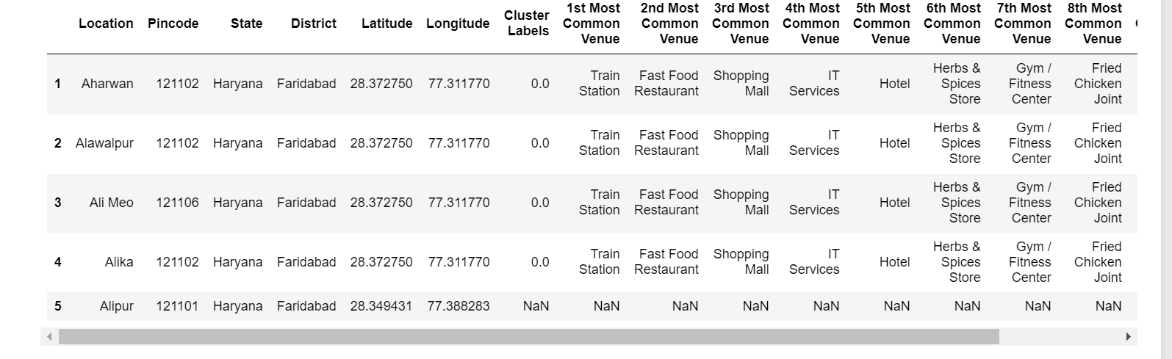

Exploring the dataset to see the distribution of venues among the clusters.

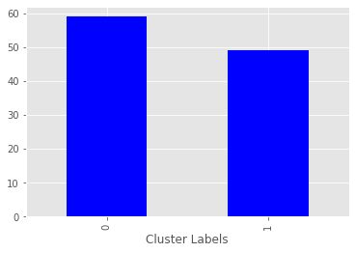

**Result**

## Cluster 1: Neighborhoods where Fast Food Restaurants aren't a common venue

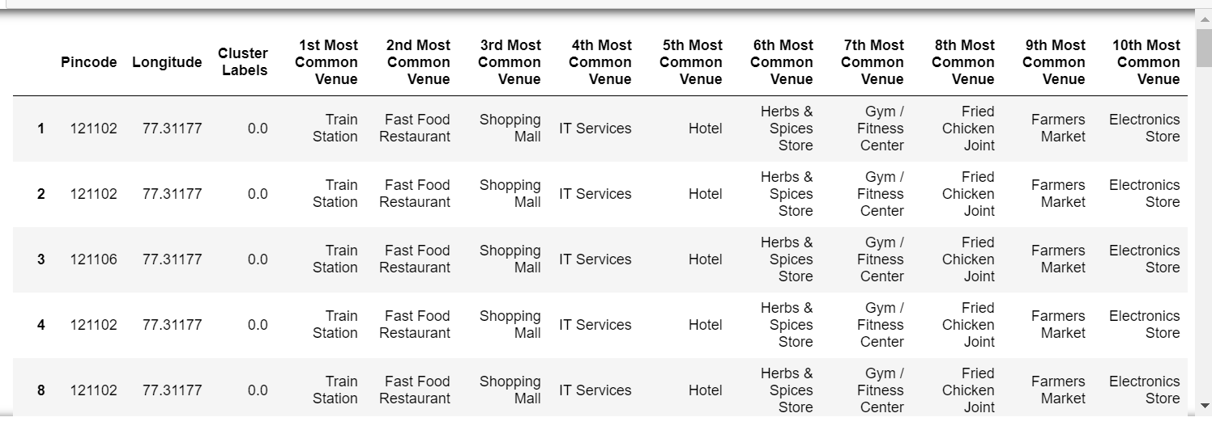

## Cluster 2: Neighborhoods where Fast Food Restaurant are a common venue

## 

## 

In the final section, I created a map to visualize all clusters on the map of FARIDABAD. The results are visualized in the above map with Cluster 1 in red color, Cluster 2 in purple color, and Cluster 3 in light green color.

**Discussion**

The fast-food restaurants' being the most common venue is observed in cluster 2

Therefore, when choosing a neighbourhood to open a fast-food restaurant, it is advisable to consider locations in Cluster 1 because of the lack of competition and the ability to conquer the market. It is also important to be centrally located in the city to cover the maximum radius of potential customers.

**Limitation**

This project can be further improved by adding constraints like **population density**, **nearby train stations, markets for supplies** and so on. This analysis allows the developer to provide information on a more profitable place to set up shop for their services. The **Foursquare API**used had a limit of 200 calls in a radius of 500m, therefore, all the predictions are based on the data gathered by the Foursquare data platform.

**Conclusion**

The data is not exhaustive, but it allows us to identify the areas most feasible to set up shop.

The application of data science techniques gives a good accurate start point to the research for location.

Based on the Clusters formed it would be a good idea to open a restaurant in Clusters 1 since the other clusters already have fast-food restaurants in their vicinities. Also, clusters 0 & 2 have many restaurants in the vicinity (Pizza restaurants, cafe, coffee shop, Indian restaurants) so one will be able to attract a good crowd. Travel and supplies will also affect the ability to run the store.