Security in the Cloud
Assignment 5: Insider attack

A hard disk image was provided, with which the following tasks were required to be done:

1. Load the hard disk image into KVM.
2. Listen to the traffic from the host and identify the IP assigned to the virtual machine.
3. Get the websites (secured and unsecured) running on the virtual machine.
4. Obtain the memory dump of the virtual machine and find the RSA public key of the web server running on the virtual machine.

Before we start, we create a copy of the given disk image and archive it, to use as a reference copy and a failsafe.

Firstly, the hard disk is imported into the KVM using virt-manager, and is set up as a new domain (virtual machine). On booting into the machine, it is apparent that the machine is a Ubuntu VM, and the users of that machine are password protected. To overcome that limitation, we try dropping into a root shell from a basic boot sequence via GRUB, but it is password protected as well. To remove that limitation, we first halt the virtual machine and run a set of commands to understand more about the hard disk image provided.

We try and understand what kind of file the given image file is with the following:

~/Desktop/cloudsec_five
➜ file vm1.img
vm1.img: DOS/MBR boot sector

This tells us that the image file is a hard disk image that contains more than one partition. To understand the partitioning in the hard disk file, we use the following:

~/Desktop/cloudsec_five
➜ sudo fdisk -lu vm1.img
[sudo] password for betrant:
Disk vm1.img: 2 GiB, 2141192192 bytes, 4182016 sectors
Units: sectors of 1 * 512 = 512 bytes
Sector size (logical/physical): 512 bytes / 512 bytes
I/O size (minimum/optimal): 512 bytes / 512 bytes
Disklabel type: dos
Disk identifier: 0x00062334

Device Boot Start End Sectors Size Id Type
vm1.img1 * 2048 2086911 2084864 1018M 83 Linux
vm1.img2 2088958 4179967 2091010 1021M 5 Extended
vm1.img5 2088960 4179967 2091008 1021M 82 Linux swap / Solaris

So we understand that it is possible to mount the root filesystem (vm1.img1) of the virtual machine as a loop device. But we need to calculate the offset to mount the correct partition. To do so, we have to multiply the start offset of the root filesystem with the size of the sector, which results in 2048*512 = 1048576 bytes. So we issue the following command:

~/Desktop/cloudsec_five
➜ sudo mount -o loop,offset=1048576 vm1.img ./test-dir

which successfully mounts into a directory named test-dir. Now it is possible to learn the GRUB user-password combination, and additionally learn more about the given system as well. Now, we copy all the files into a directory for further analysis, using the following:

root in betrant/Desktop/cloudsec_five
➜ cp -r ./test-dir ./extracted

root in betrant/Desktop/cloudsec_five/extracted/test-dir
➜ chown -R betrant .

root in betrant/Desktop/cloudsec_five/extracted/test-dir
➜ chgrp -R betrant .

Using the /etc/passwd and /etc/shadow files, we can see that there are two main accounts to focus on, named root and student. This will prove useful later.

Next, we move to /boot/grub and locate the grub.cfg file. We run the following to find the plain-text username-password combination of GRUB:

~/Desktop/cloudsec_five
➜ cat ./extracted/test-dir/boot/grub/grub.cfg | grep superuser
set superusers="iotadmin"

~/Desktop/cloudsec_five
➜ cat ./extracted/test-dir/boot/grub/grub.cfg | grep password
password iotadmin iot@dm

We obtain the username-password combination, which is "iotadmin" and "iot@dm". Using this, we can edit the boot entry and use it to drop into a root shell (and also making all changes persistent by making the filesystem access into read-write), as shown below:

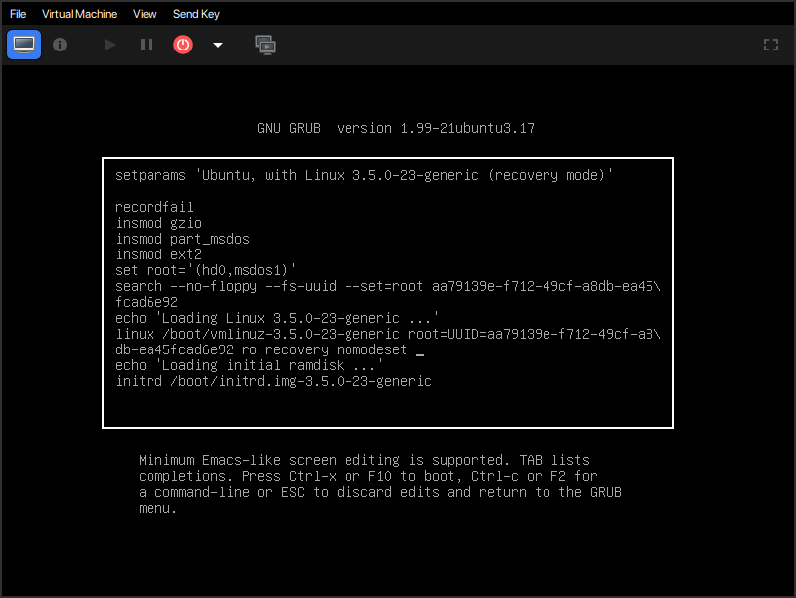
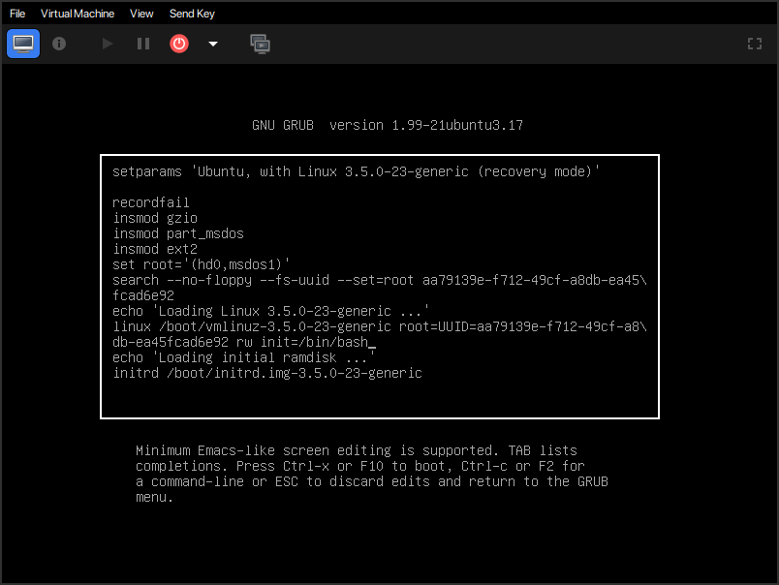

After dropping into a root shell, we change the password of the root account, which is the only account we need, since it grants full access to the system.

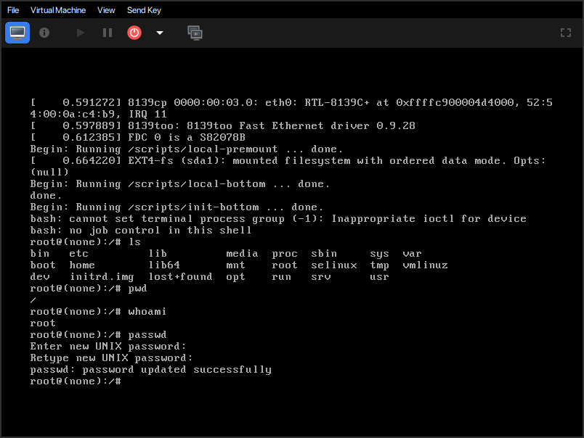

Next, we force halt the virtual machine and restart it to login into the virtual machine with the root account. We can run some commands to understand the processes running on the system, and filter out the open ports on the machine as well. Additionally, we can know about the webpage the webserver serves.

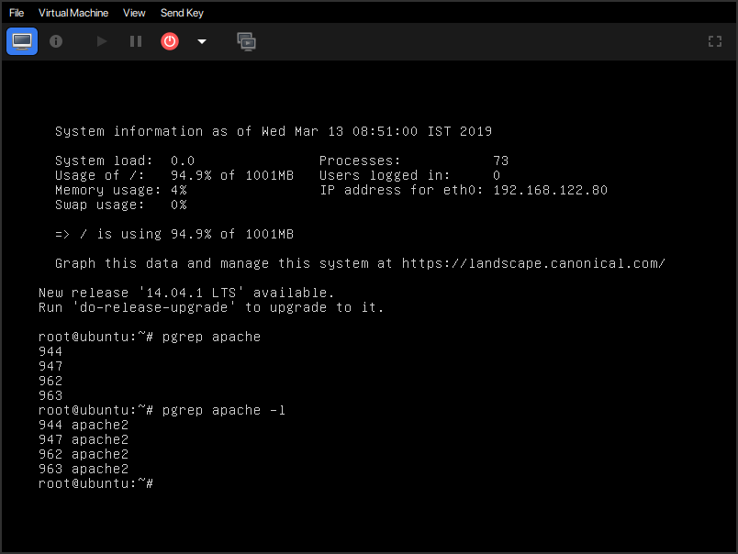

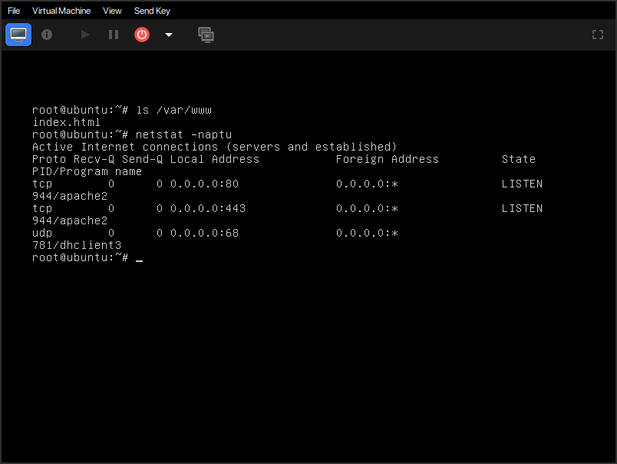
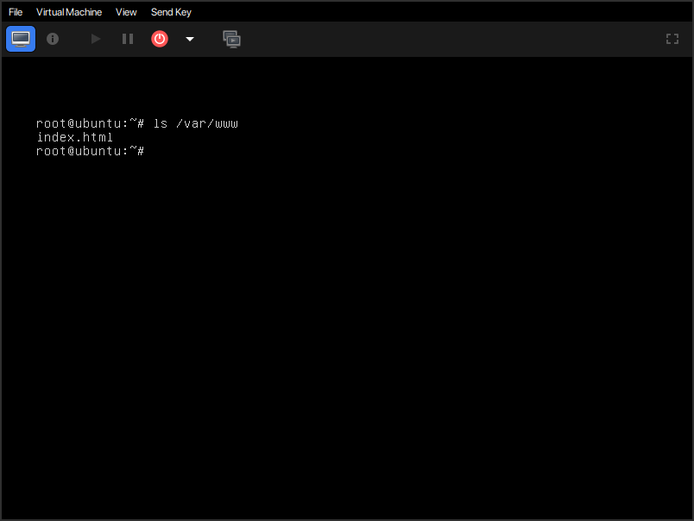

Now, with the virtual machine running, we can run a network scan for the given bridge interface (whose IP is 192.168.122.1). Running scans reveals that the virtual machine is assigned an IP of 192.168.122.80, and that there are two ports open, 80 and 443. This means that the webserver is serving webpages via HTTP and HTTPS.

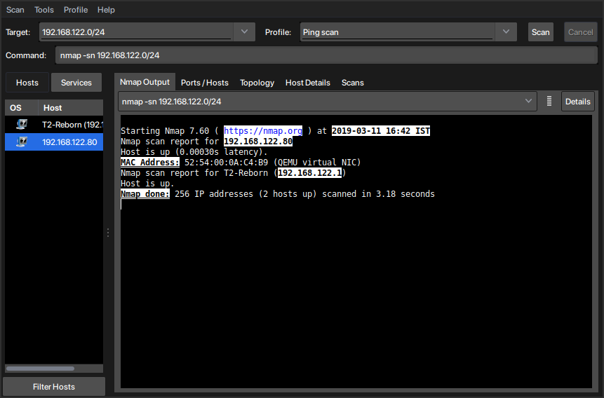

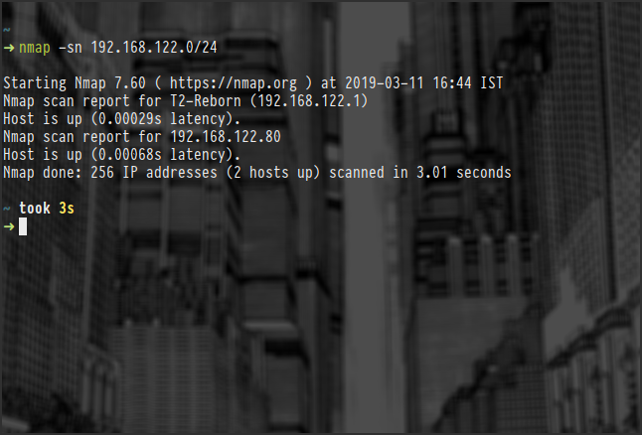

We can then go to respective pages via a browser in the host machine, and see that it exists. Both HTTP and HTTPS versions of the website are shown below:

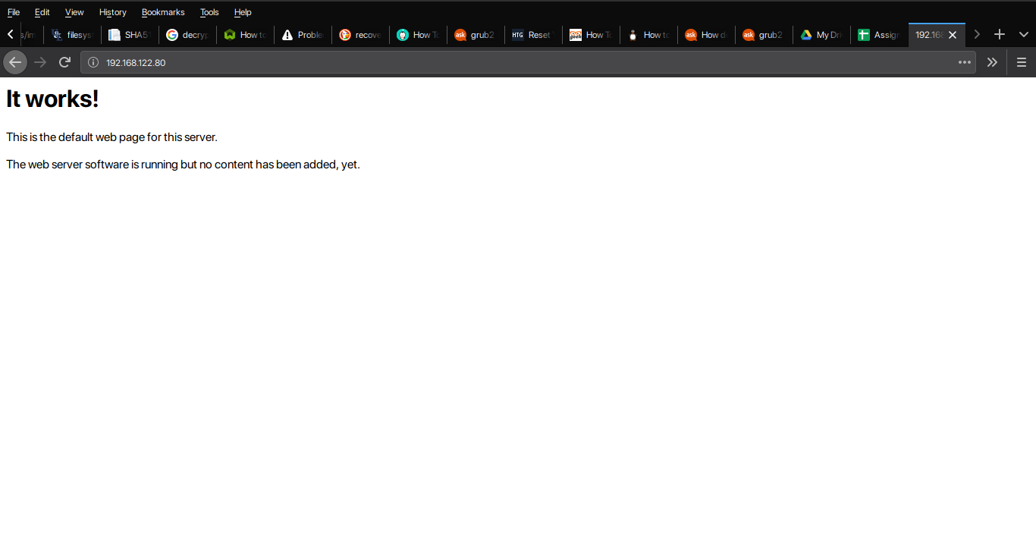

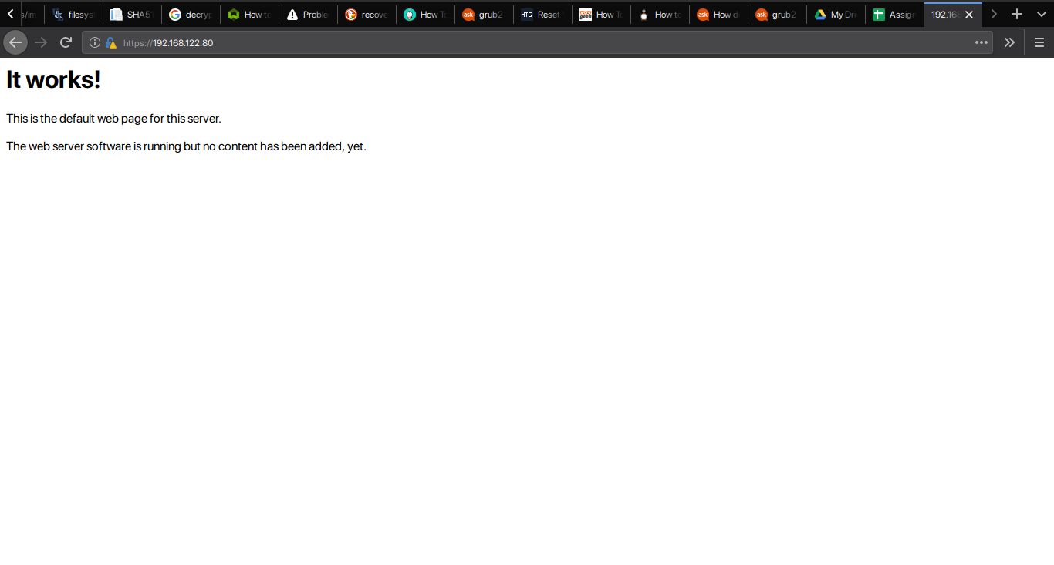

Finally we have all the data we need, save for the RSA public key of the webserver. This is done by first obtaining a memory dump of the virtual machine while it is running. We dump both the core and the physical memory of the virtual machine using virsh, as shown below:

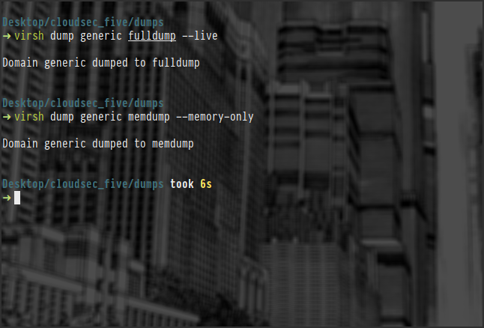

Then, we can extract all the character strings in the dumps obtained using the strings utility, using this command:

~/Desktop/cloudsec_five/dumps
➜ strings ./memdump > all_strings.txt

Now, we can filter the strings for the relevant data using the grep utility, using certain keywords, as shown:

~/Desktop/cloudsec_five/dumps
➜ cat all_strings.txt | grep "key" > key_filtered_strings.txt

~/Desktop/cloudsec_five/dumps
➜ cat all_strings.txt | grep "rsa" > rsa_filtered_strings.txt

Now, on manual inspection of all these files, starting with the filtered ones, we can find the required key. But we find more than that. On inspection, we find not only the required RSA public key of the webserver, but we also find the RSA private key, and the DSA signature private key and public key, thus obtaining four keys in total. The keys are given below:

DSA private key:

p = 00AD7C0025BA1A15F775F3F2D673718391D00456978D347B33D7B49E7F32EDAB 96273899DD8B2BB46CD6ECA263FAF04A28903503D59062A8865D2AE8ADFB5191 CF36FFB562D0E2F5809801A1F675DAE59698A9E01EFE8D7DCFCA084F4C6F5A44 44D499A06FFAEA5E8EF5E01F2FD20A7B7EF3F6968AFBA1FB8D91F1559D52D8777B

q = 00EB7B5751D25EBBB7BD59D920315FD840E19AEBF9

g = 1574363387FDFD1DDF38F4FBE135BB20C7EE4772FB94C337AF86EA8E49666503 AE04B6BE81A2F8DD095311E0217ACA698A11E6C5D33CCDAE71498ED35D13991E B02F09AB40BD8F4C5ED8C75DA779D0AE104BC34C960B002377068AB4B5A1F984 3FBA91F537F1B7CAC4D8DD6D89B0D863AF7025D549F9C765D2FC07EE208F8D15

x = 11D54E4ADBD3034160F2CED4B7CD292A4EBF3EC0

y = 64B11EF8871BE4AB572AA810D5D3CA11A6CDBC637A8014602C72960DB135BF46 A1816A724C34F87330FC9E187C5D66897A04535CC2AC9164A7150ABFA8179827 6E45831AB811EEE848EBB24D9F5F2883B6E5DDC4C659DEF944DCFD80BF4D0A20 42CAA7DC289F0C5A9D155F02D3D551DB741A81695B74D4C8F477F9C7838EB0FB

DSA public key:

p = 00AD7C0025BA1A15F775F3F2D673718391D00456978D347B33D7B49E7F32EDAB 96273899DD8B2BB46CD6ECA263FAF04A28903503D59062A8865D2AE8ADFB5191 CF36FFB562D0E2F5809801A1F675DAE59698A9E01EFE8D7DCFCA084F4C6F5A44 44D499A06FFAEA5E8EF5E01F2FD20A7B7EF3F6968AFBA1FB8D91F1559D52D8777B

q = 00EB7B5751D25EBBB7BD59D920315FD840E19AEBF9

g = 1574363387FDFD1DDF38F4FBE135BB20C7EE4772FB94C337AF86EA8E49666503 AE04B6BE81A2F8DD095311E0217ACA698A11E6C5D33CCDAE71498ED35D13991E B02F09AB40BD8F4C5ED8C75DA779D0AE104BC34C960B002377068AB4B5A1F984 3FBA91F537F1B7CAC4D8DD6D89B0D863AF7025D549F9C765D2FC07EE208F8D15

y = 64B11EF8871BE4AB572AA810D5D3CA11A6CDBC637A8014602C72960DB135BF46 A1816A724C34F87330FC9E187C5D66897A04535CC2AC9164A7150ABFA8179827 6E45831AB811EEE848EBB24D9F5F2883B6E5DDC4C659DEF944DCFD80BF4D0A20 42CAA7DC289F0C5A9D155F02D3D551DB741A81695B74D4C8F477F9C7838EB0FB

RSA private key:

n = 00e0ce96f90b6c9e02f3922beada93fe50a875eac6bcc18bb9a9cf2e84965caa 2d1ff95a7f542465c6c0c19d276e4526ce048868a7a914fd343cc3a87dd74291 ffc565506d5bbb25cbac6a0e2dd1f8bcaab0d4a29c2f37c950f363484bf269f7 891440464baf79827e03a36e70b814938eebdc63e964247be75dc58b014b7ea251

e 010001

d = 046129f2489d71579be0a75fe029bd6cdb574ebf57ea8a5b0fda942cab943b11 7d7bb95e5d28875e0f9fc5fcc06a72f6d502464dabded78ef6b716177b83d5bd c543dc5d3fed932e59f5897e92e6f58a0f33424106a3b6fa2cbf877510e4ac21 c3ee47851e97d12996222ac3566d4ccb0b83d164074abf7de655fc2446da1781

p = 00e861b700e17e8afe6837e7512e35b6ca11d0ae47d8b85161c67baf64377213 fe52d772f2035b3ca830af41d8a4120e1c1c70d12cc22f00d28d31dd48a8d424f1

q = 00f7a7ca5367c661f8e62df34f0d05c10c88e5492348dd7bddc942c9a8f369f9 35a07785d2db805215ed786e4285df1658eed3ce84f469b81b50d358407b4ad361

u = 304559a9ead56d2309d203811a641bb1a09626bc8eb36fffa23c968ec5bd891e ebbafc73ae666e01ba7c8990bae06cc2bbe10b75e69fcacb353a6473079d8e9b

RSA public key:

n = 00e0ce96f90b6c9e02f3922beada93fe50a875eac6bcc18bb9a9cf2e84965caa 2d1ff95a7f542465c6c0c19d276e4526ce048868a7a914fd343cc3a87dd74291 ffc565506d5bbb25cbac6a0e2dd1f8bcaab0d4a29c2f37c950f363484bf269f7 891440464baf79827e03a36e70b814938eebdc63e964247be75dc58b014b7ea251

e = 010001

Thus we have extracted all the required data, which proves that the insider attack is a possibility that is very much present in cloud provisioning.

