Essentials of Cyber Security
Lab Report – OpenSSL

The lab on familiarization with the OpenSSL utility and its various options was completed successfully, and a overall understanding of the usage of the utility and its various applications were made clear.

The steps followed are illustrated with the help of the screenshots given below:

- Encoding a text file’s contents in Base64 format:

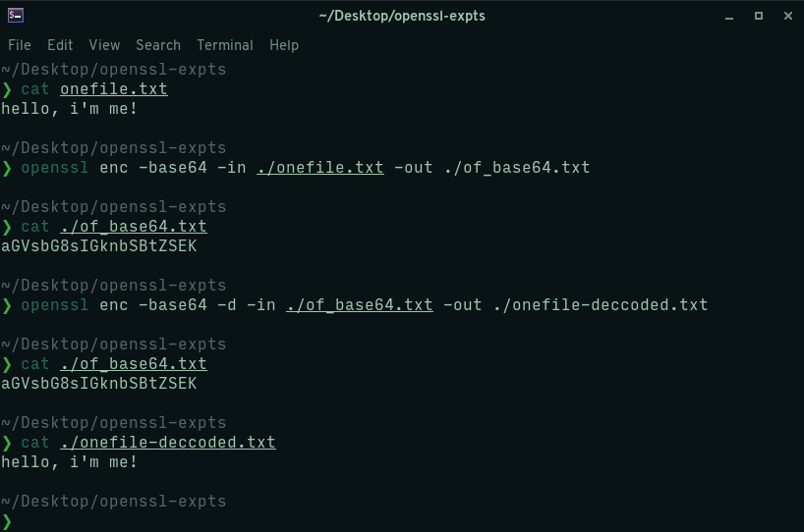

- Reading up on the passwd file and its usage:

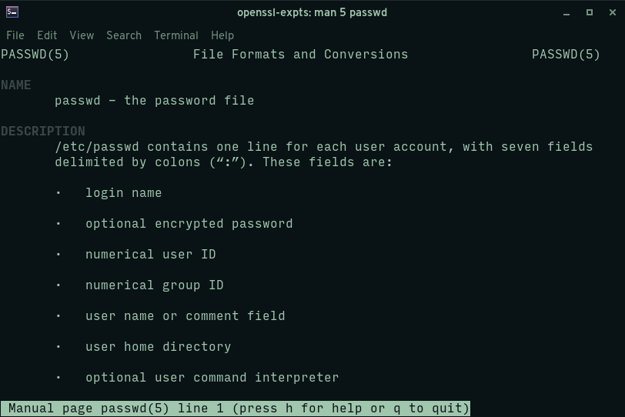
- Adding a user with the ‘useradd’ command:

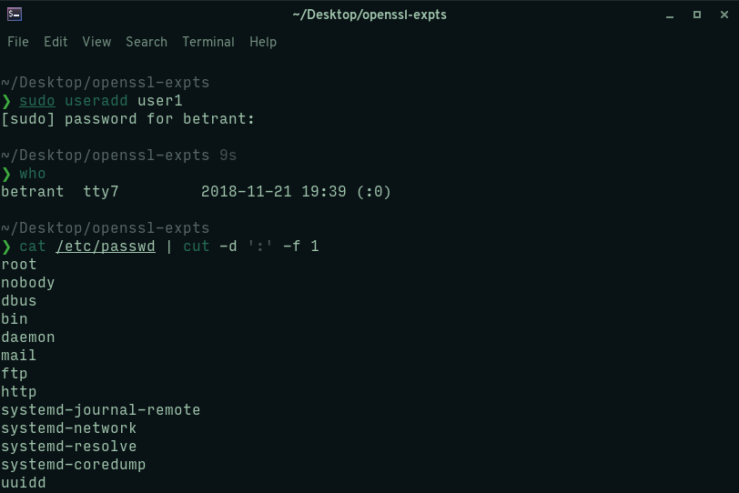
- Getting entry of the new user with the ‘getent’ command:

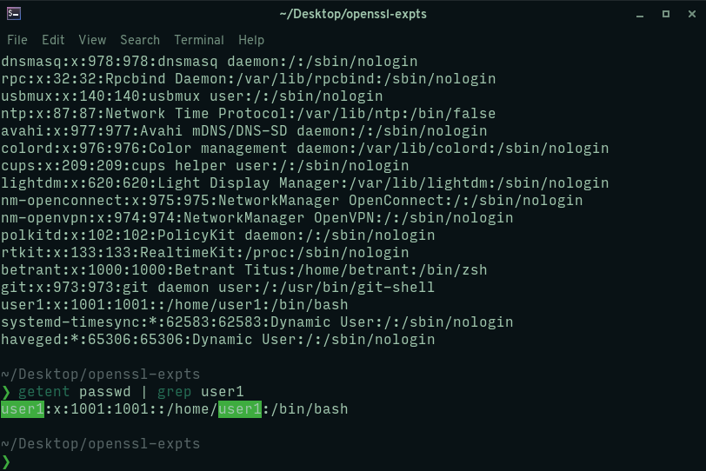
- Setting a password for the new user with the ‘passwd’ command:

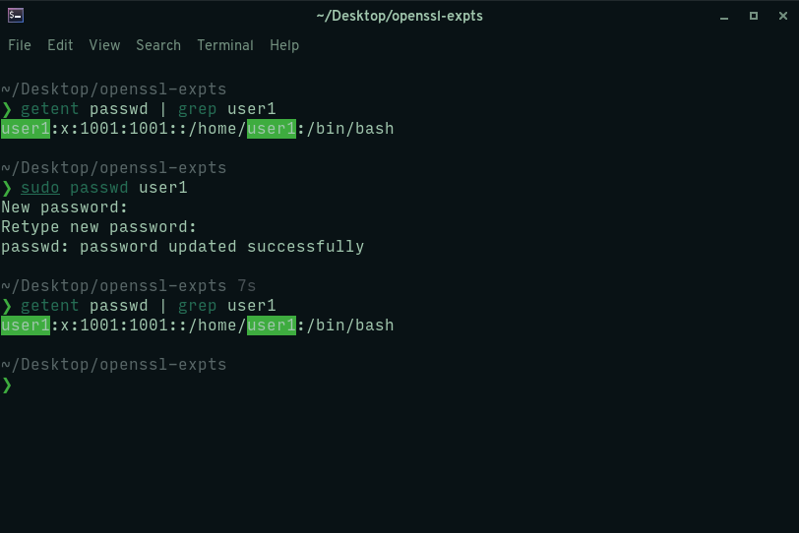

- Deleting the newly made user with the ‘userdel’ command:

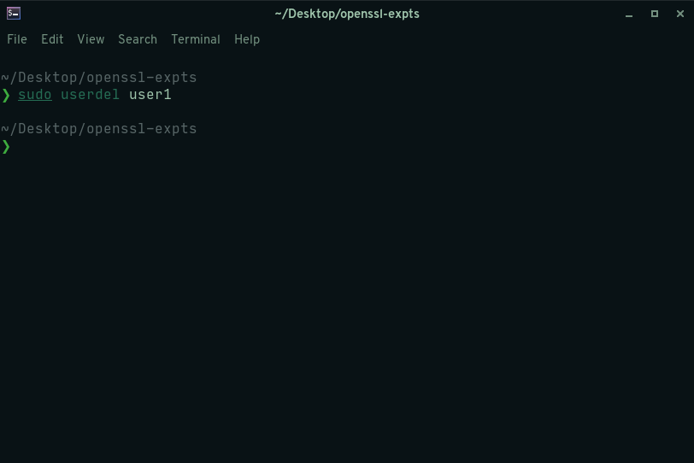

- Getting the password fields from the passwd file for users with passwords set:

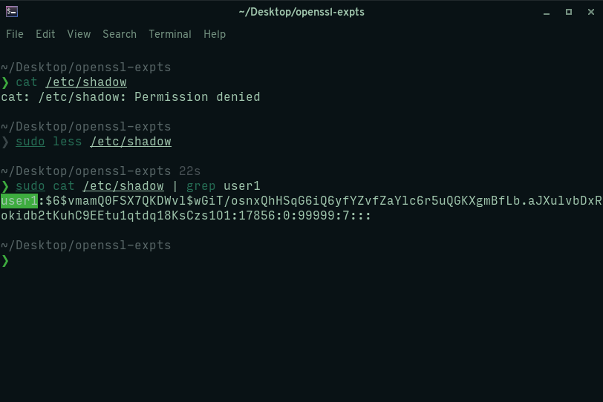
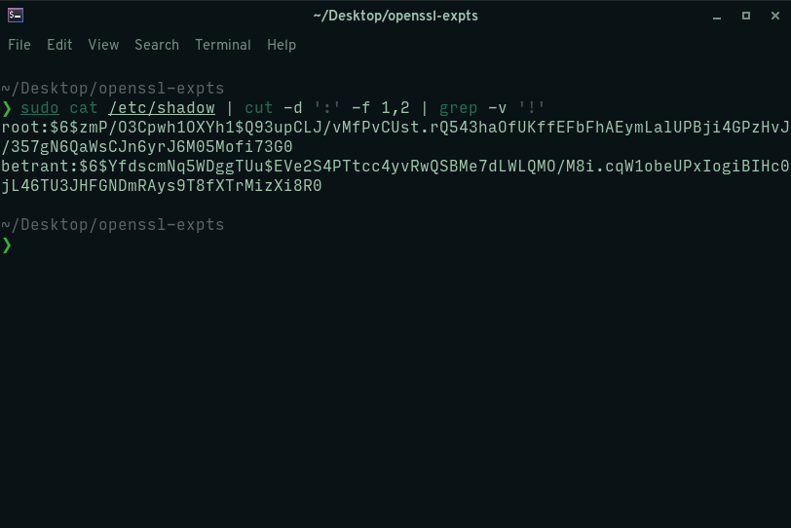
- Encrypting a file with DES, with no salt used and decrypting the encrypted file:

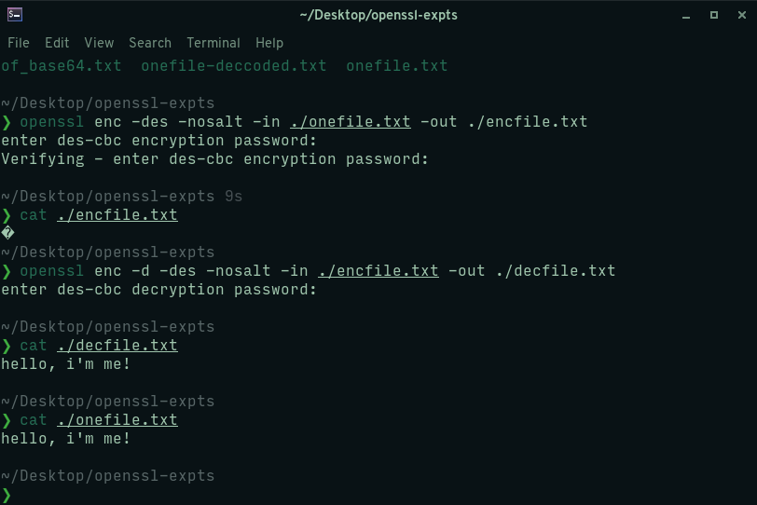
- Testing encryption by encrypting a file with DES and then attempting to decrypt it using a wrong password:

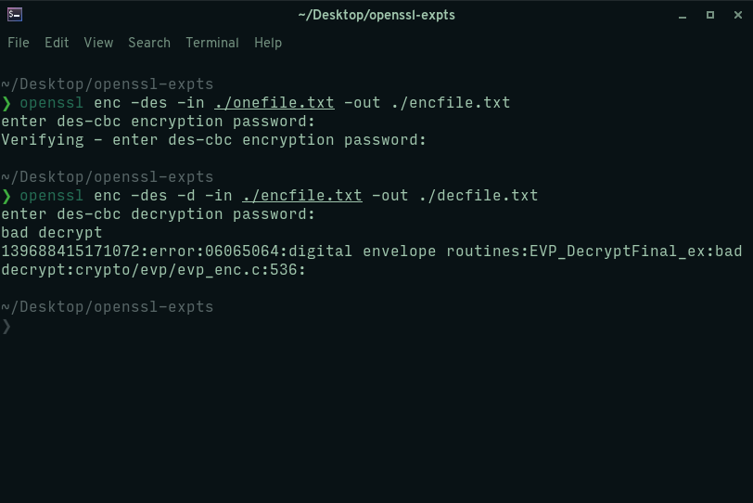

- Generating an RSA key pair using the ‘genrsa’ option:

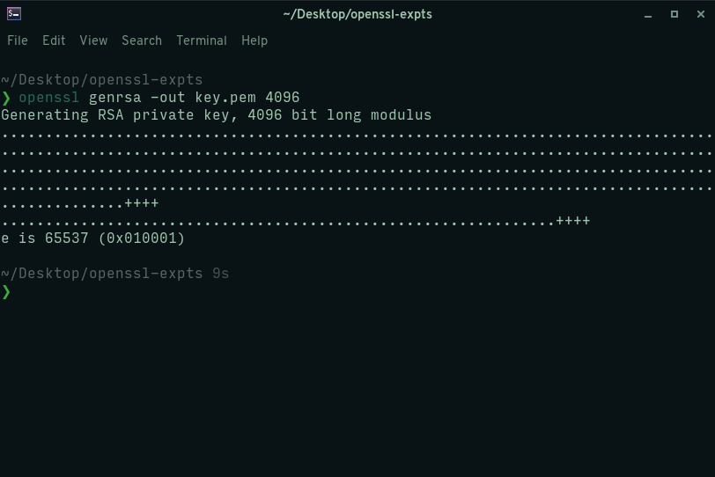
- Displaying the key pair and the related information of the generated RSA key pair:

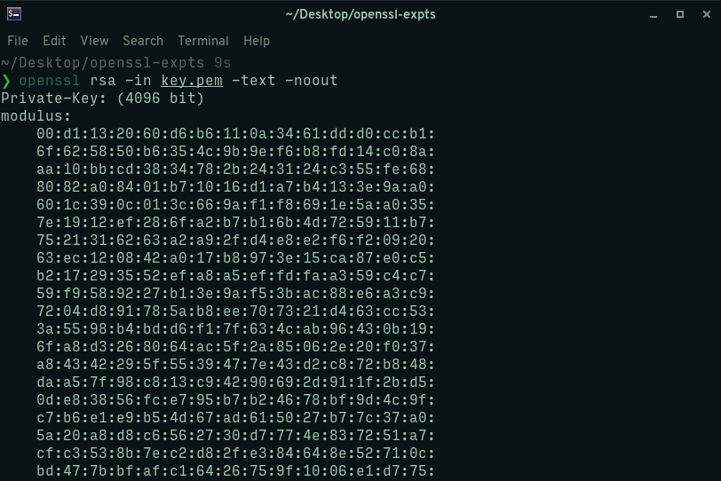

- Generating the public RSA keyfile from the RSA key pair generated before and displaying the contents of the public RSA keyfile:

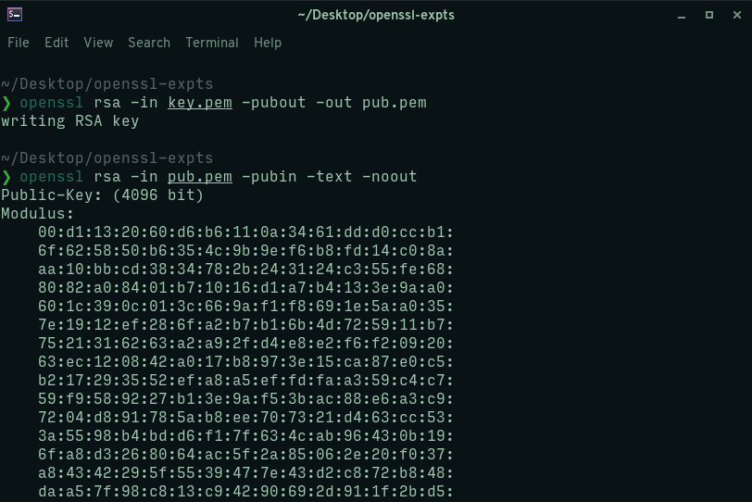

- Encrypting a sample text file with the public key generated earlier:

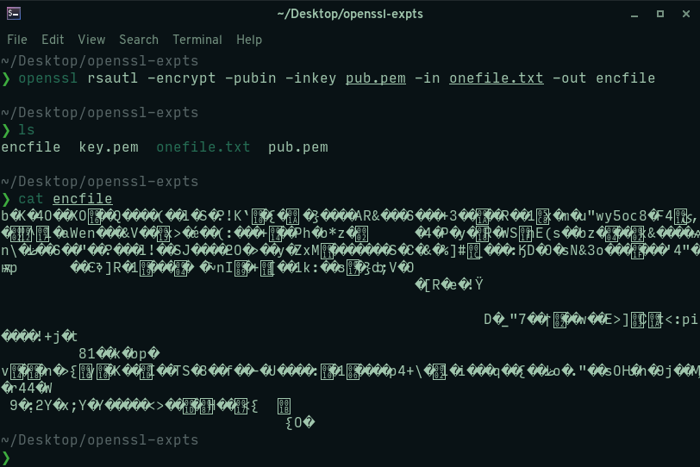
- Decrypting the generated ciphertext file using the private key generated:

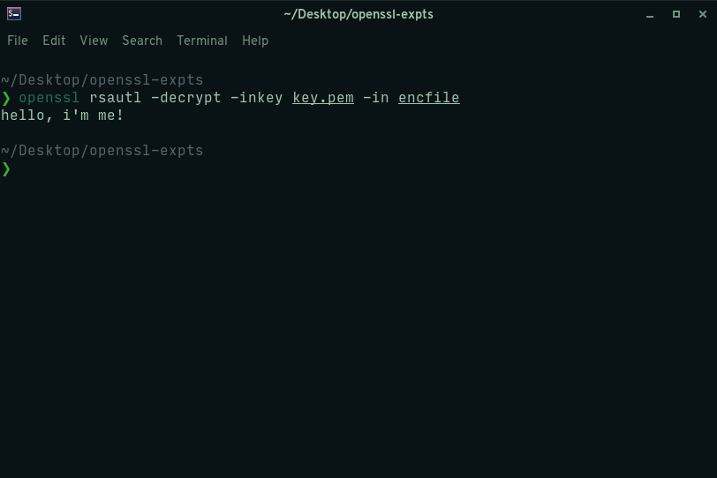
- Testing encryption and decryption using a symmetric cipher method (AES-256-CBC):

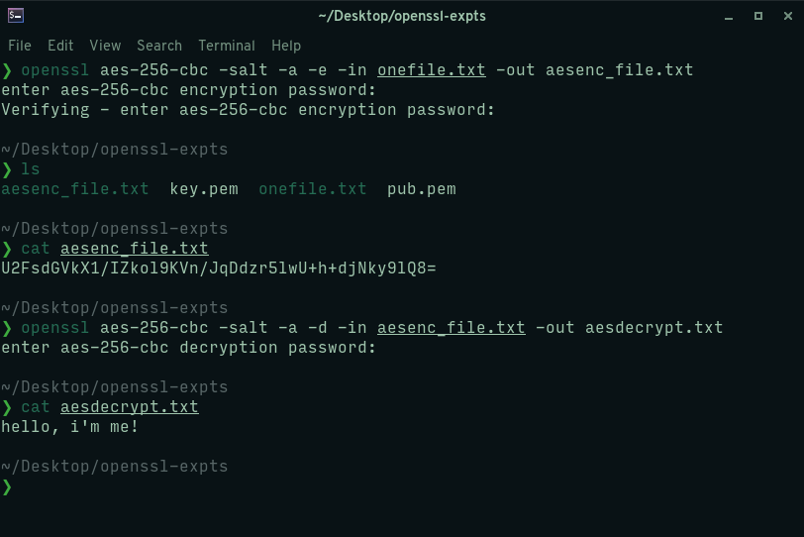
- Generating a MD5 hash of the contents of a text file:

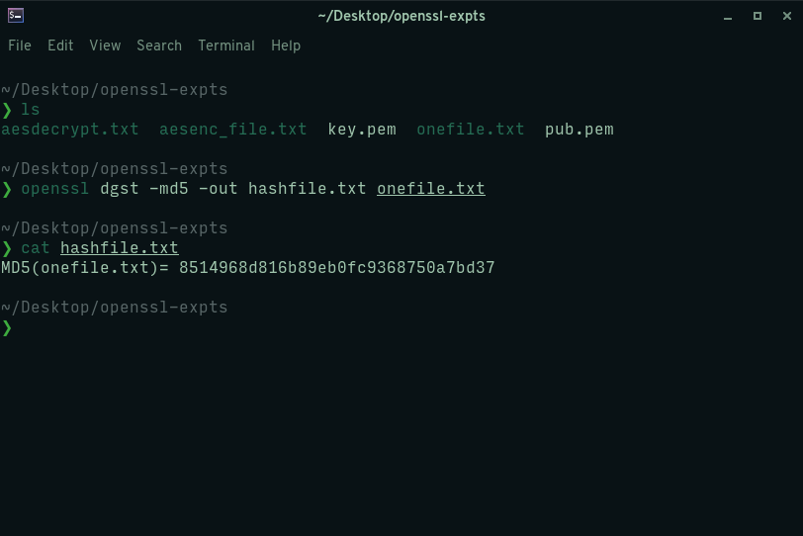

- Generating a signed digest with SHA512 method, using the RSA private key generated before for the signature and verifying the integrity of the file using the signed digest and the public key:

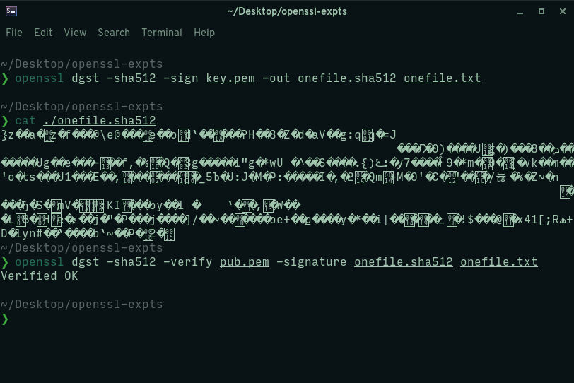

- Generating a new X.509 certificate with the RSA key pair generated earlier:

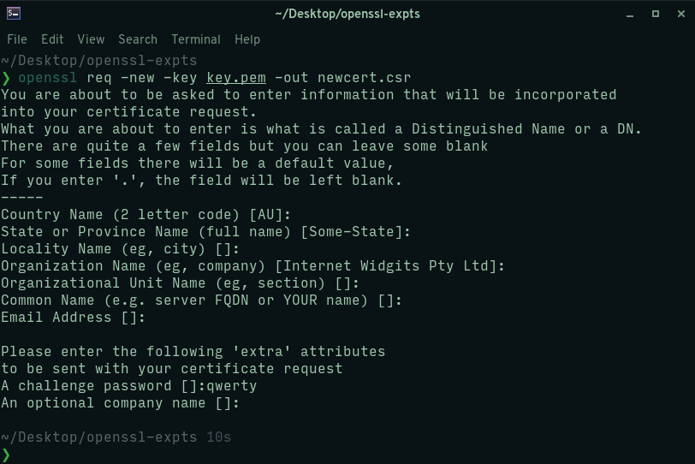
- Viewing the contents of the X.509 certificate:

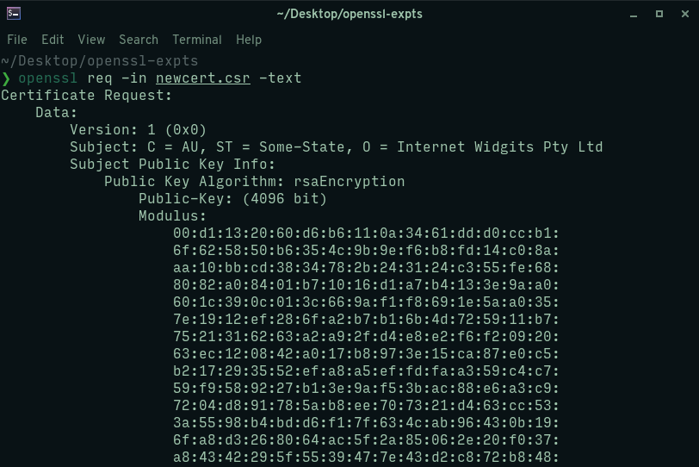

- Automatically signing a certificate request using the newly generated X.509 certificate and the RSA private key:

