IoT Assignment – Packet Analysis
Report

The provided capture contains packets that are based on the IEEE 802.15.4 ZigBee protocol stack. The analysis of the packet capture is split into two sections:

- Statistics
- Technical Analysis

- Statistics
- There are 497 packets transmitted in total, which amounted to a size of 11043 bytes.
- The packet size limit is 128 bytes.
- The total capture time i.e. the time taken between the first and the last packet is exactly 365.772 seconds.
- The speed of transmission amounted to 1.359 packets per second on an average.
- In bytes, this is equal to 30.191 bytes per second.
- Each packet is sized at an average of 22.219 bytes.

- The rate of packet transmission is better explained in the graph given below:

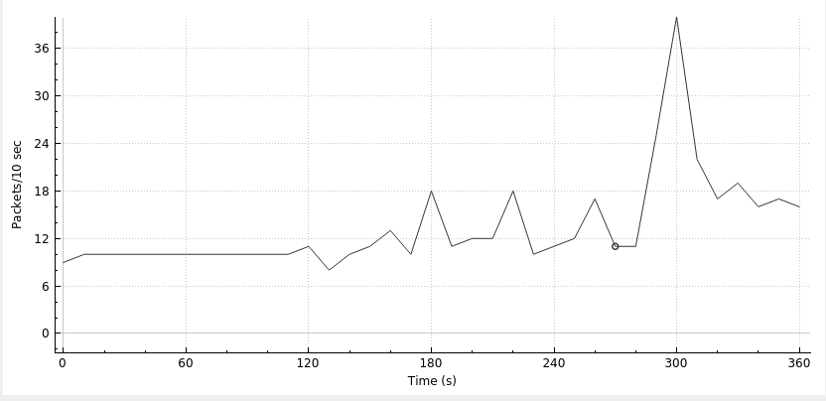

- Technical Analysis
- There are three devices whose communication is captured in the packet capture. Their addresses are 0x0000, 0x9e4b and 0x8007.
- It seems that there are two networks present, however, one seems to be illegitimate and/or inactive (PAN ID: 0x1143) and thus we can conclude that there is only one active network.
- The network’s PAN ID is 0xf9d5.
- There are certain messages, sent with destination address as 0xffff, which are broadcast messages.
- The coordinator of the network with PAN ID 0xf9d5 is 0x0000.
- If we look at the ZigBee Cluster Library layer, we can see that there is some data that is being sent from the device with address 0x9e4b to the coordinator of the network with PAN ID 0xf9d5, which is the device with the address 0x0000.
- This data does not appear to be encrypted with AES-128, which is the standard encryption method of the ZigBee devices.
- The data is shown in Wireshark in the hexadecimal format.
- The extracted data is displayed in the table below:

Sl No. | Hexadecimal Value | Decoded Value
1 | 2a4c5f395f23 | *L_9_#
2 | 2a4c5f395f23 | *L_9_#
3 | 2a4c5f33355f23 | *L_35_#
4 | 2a4c5f33355f23 | *L_35_#
5 | 2a4c5f33325f23 | *L_32_#
6 | 2a4c5f35395f23 | *L_59_#
7 | 2a4c5f34325f23 | *L_42_#
8 | 2a4c5f33365f23 | *L_36_#
9 | 2a4c5f34305f23 | *L_40_#
10 | 2a4c5f36325f23 | *L_62_#
11 | 2a4c5f36305f23 | *L_60_#
12 | 2a4c5f36335f23 | *L_63_#
13 | 2a4c5f36335f23 | *L_63_#
14 | 2a4c5f36335f23 | *L_63_#
15 | 2a4c5f36335f23 | *L_63_#
16 | 2a4c5f36335f23 | *L_63_#
17 | 2a4c5f36335f23 | *L_63_#
18 | 2a4c5f36325f23 | *L_62_#
19 | 2a4c5f36335f23 | *L_63_#
20 | 2a4c5f36325f23 | *L_62_#
21 | 2a4c5f36335f23 | *L_63_#
22 | 2a4c5f36335f23 | *L_63_#
23 | 2a4c5f36325f23 | *L_62_#
24 | 2a4c5f36335f23 | *L_63_#
25 | 2a4c5f36335f23 | *L_63_#
26 | 2a4c5f36325f23 | *L_62_#
27 | 2a4c5f36325f23 | *L_62_#
28 | 2a4c5f36325f23 | *L_62_#
29 | 2a4c5f36325f23 | *L_62_#
30 | 2a4c5f36325f23 | *L_62_#
31 | 2a4c5f36345f23 | *L_64_#
32 | 2a4c5f36335f23 | *L_63_#

