Operating System Security
Assignment 3 – ProcFS

The report is split into four sections:

- The tasks given
- Code description
- The procedure that was done to build and run the module
- Relevant dmesg output

- The tasks given: The assignment entailed a set of tasks that were required to be completed, and the tasks are as listed below:

- Take a string as input from the user by implementing write for the procfs file.
- Have an integer variable 'key' defined as 13.
- Perform a single key XOR on the string with the given key and print the resulting hex encoded string by implementing read for the procfs file.
- Add to Makefile and test.

As the report will convey, the entirety of tasks were completed successfully; the specifics of which are discussed in the coming sections.

- Code description:
The kernel module is explained by each section of the constituent code below:

  - Program header: This section contains the code that adds references to the Linux kernel header files that are required for all the kernel-level functions and structures that are utilized in the program. This section also contains certain variables that are used throughout the program, such as the proc_file name, its size and the key that is used for the XOR cipher. Additionally, the code also contains the metadata about the kernel module such as its description, its author and the license that the code is distributed under.

#include <linux/module.h>
#include <linux/kernel.h>
#include <linux/init.h>
#include <linux/uaccess.h>
#include <linux/proc_fs.h>

#define BUF_SIZ 1024
#define DEV_NAME "xorencdev"
#define XOR_KEY 13

MODULE_DESCRIPTION("ossec-four assignment module");
MODULE_AUTHOR("nocturnalbeast");
MODULE_LICENSE("GPL");

  - Objects used: This section defines the three globally used data objects that include the file entry in /proc, the character buffer used by the proc file and the size of the text that is inserted into the proc file.

static struct proc_dir_entry *proc_file;
static char character_buffer[BUF_SIZ];
static unsigned long buffer_size = 0;

  - The procfile_write function: This section explains the operation that takes place when some text is written to the proc file. Whenever some data i.e. some text is written to the proc file from the console, then the procfile_write function is called. When this happens, the text length is first checked to see if it exceeds the size of the buffer. If yes, then the text is truncated to the maximum length supported by limiting the text length to the maxmimum length. Then the text is copied over to the character buffer using the copy_from_user function, using the length as the limiter. If that runs without any error, it will return the buffer size, else it will return the error code corresponding to -EFAULT.

static ssize_t procfile_write(struct file *file,const char *buffer, size_t count, loff_t *offset)
{
buffer_size = count;
if (buffer_size > BUF_SIZ) {
buffer_size = BUF_SIZ;
}
if (copy_from_user(character_buffer, buffer, buffer_size)) {
return -EFAULT;
}
return buffer_size;
}

  - The procfile_read function: This section explains the operation that takes place when the text is to be read from the proc file. In this specific case, the hexadecimal representation of the string XORed with the key (which is 13) is to be output to the user when the user requests a read from the proc file. In this function, the character buffer is validated for any data, and then a kernel message signifying the read operation is sent. After this step, the buffer that holds the output is added with the hexadecimal representation of the XORed string, one character at a time, by iterating through the string. After this, the size of the buffer is sent back as the return value.

static ssize_t procfile_read(struct file *file, char *buffer, size_t buffer_length, loff_t *offset)
{
static long int i = 0;
static int flag = 0;
if (flag) {
printk(KERN_INFO "Empty file!\n");
flag = 0;
return 0;
}
flag = 1;
printk(KERN_INFO "Reading from proc_file:\n");
for(i = 0; character_buffer[i] != '\0'; i++)
sprintf(buffer+i*2, "%02X", character_buffer[i] ^ XOR_KEY);
return (i-1)*2;
}

  - The file_operations object: This section illustrates the file_operations structure that is used, which references the operations detailed in the previous sections to its object, which then is referenced by the proc file at the time of creation, and is used by the proc file to do the required operations.

static struct file_operations fops_struct = {
.read = procfile_read,
.write = procfile_write,
};

  - Module initialization and termination functions: These functions contain code to handle the creation of the proc file, which is done at startup; and the removal of the proc file, which is done at the removal of the kernel module from the kernel.

static int __init assignment_init(void)
{
proc_file = proc_create(DEV_NAME, 0666, NULL, &fops_struct);
if (proc_file == NULL) {
remove_proc_entry(DEV_NAME, NULL);
printk(KERN_ALERT "Error in creating proc_file!\n");
return -ENOMEM;
}
printk(KERN_INFO "proc_file successfully created!\n");
return 0;
}

static void __exit assignment_exit(void)
{
remove_proc_entry(DEV_NAME, NULL);
printk(KERN_INFO "proc_file removed!\n");
}

module_init(assignment_init);
module_exit(assignment_exit);

- The procedure that was done to build and run the module:
The procedure is better illustrated with the help of the screenshots given below:

  - Creating a clean build environment with the command ‘make clean’:

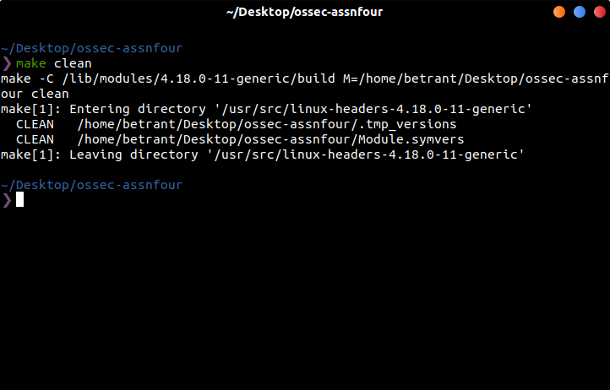

  - Building the kernel module with the command ‘make’:

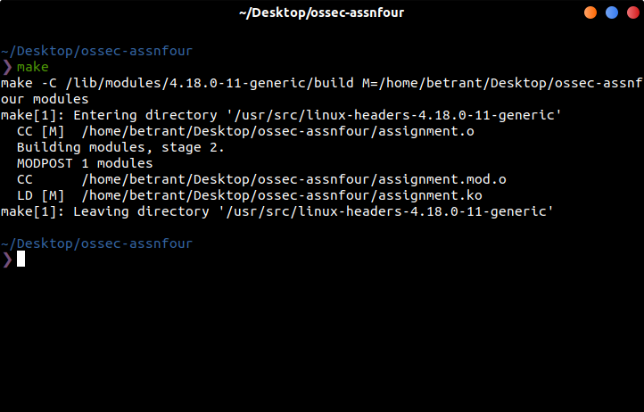

  - Inserting the newly generated module with the command ‘sudo insmod assignment.ko’:

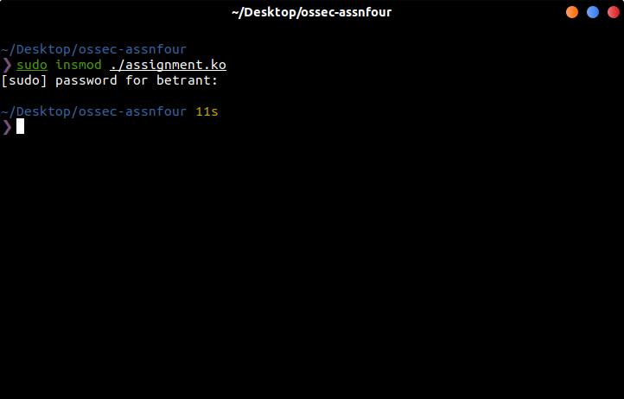

  - Writing to and reading from the proc file with commands ‘echo “string” > /proc/xorencdev’ and ‘cat /proc/xorencdev’:

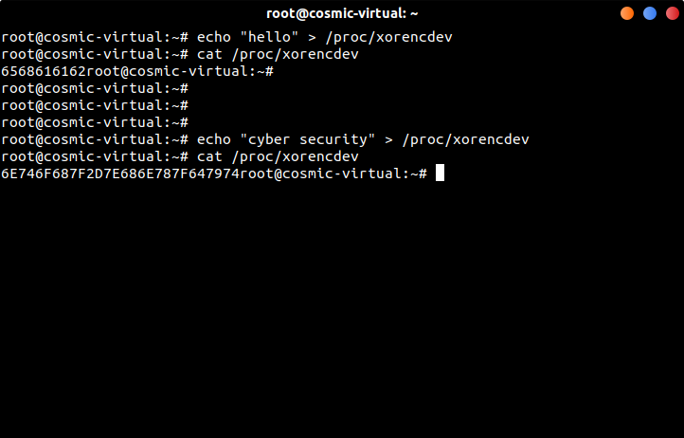

  - Removing the module from the kernel with the command ‘sudo rmmod assignment.ko’:

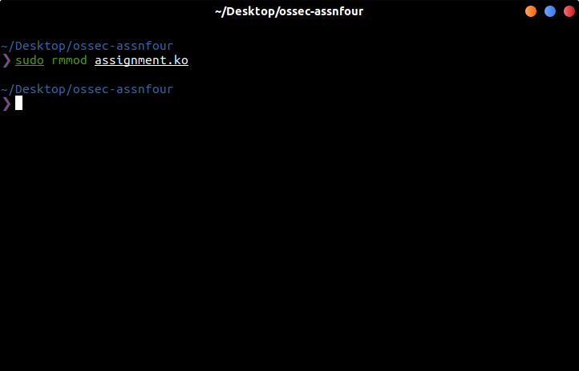

- Relevant dmesg output:
The kernel messages generated by the kernel module is shown in the screenshots below:

