Operating System Security
Assignment 3 – Report

The report is split into four sections:

- The tasks given
- Code description
- The procedure that was done to build and run the module
- Relevant dmesg output

- The tasks given:
Three tasks were assigned to be done. They are:

    - Hook openat system call using ftrace-hook
    - Access the process control block (PCB)
    - Find the address of the System wide File table entry corresponding to the received file descriptor.
In addition, another task to retrieve the status of the process was also mentioned.

- Code description:

The kernel module is explained by each section of the constituent code below:
  - Program header: In this section, the required header files for the functions that run are included into the program. The module is also given some information as to the author of the module, information on what the module does and the license that the module uses. It also uses some macros that are used repetitively in the code.

#define pr_fmt(fmt) "ftrace_hook: " fmt

#include <linux/ftrace.h>
#include <linux/kallsyms.h>
#include <linux/kernel.h>
#include <linux/linkage.h>
#include <linux/module.h>
#include <linux/slab.h>
#include <linux/uaccess.h>
#include <linux/fdtable.h>

MODULE_DESCRIPTION("OSSec assignment module");
MODULE_AUTHOR("nocturnalbeast");
MODULE_LICENSE("GPL");

#define USE_FENTRY_OFFSET 0

  - The ftrace_hook structure: The ftrace_hook structure defines a set of variables that hold relevant information about a program hook that is made by ftrace. In this structure, the name variable holds the name of the hook; the pointer function points to the function that should be executed instead of the function that is hooked; the pointer original points to the function that is hooked; the address is the value of the address of the function entry and ops is another structure that holds information on the state of the operations of the hooking function.

struct ftrace_hook {
const char *name;
void *function;
void *original;

unsigned long address;
struct ftrace_ops ops;
};

  - Functions to manage hooks: This section of the code includes functions to install, remove and preform the actual hooking operations. The functions are used to perform operations such as resolving addresses of the hooked function, install and remove hooks and also contains wrapper functions to handle installing and removing multiple hooks.

static int fh_resolve_hook_address(struct ftrace_hook *hook)
{
hook->address = kallsyms_lookup_name(hook->name);

if (!hook->address) {
pr_debug("unresolved symbol: %s\n", hook->name);
return -ENOENT;
}

#if USE_FENTRY_OFFSET
*((unsigned long*) hook->original) = hook->address + MCOUNT_INSN_SIZE;
#else
*((unsigned long*) hook->original) = hook->address;
#endif

return 0;
}

static void notrace fh_ftrace_thunk(unsigned long ip, unsigned long parent_ip,
struct ftrace_ops *ops, struct pt_regs *regs)
{
struct ftrace_hook *hook = container_of(ops, struct ftrace_hook, ops);

#if USE_FENTRY_OFFSET
regs->ip = (unsigned long) hook->function;
#else
if (!within_module(parent_ip, THIS_MODULE))
regs->ip = (unsigned long) hook->function;
#endif
}

int fh_install_hook(struct ftrace_hook *hook)
{
int err;

err = fh_resolve_hook_address(hook);
if (err)
return err;

hook->ops.func = fh_ftrace_thunk;
hook->ops.flags = FTRACE_OPS_FL_SAVE_REGS
| FTRACE_OPS_FL_RECURSION_SAFE
| FTRACE_OPS_FL_IPMODIFY;

err = ftrace_set_filter_ip(&hook->ops, hook->address, 0, 0);
if (err) {
pr_debug("ftrace_set_filter_ip() failed: %d\n", err);
return err;
}

err = register_ftrace_function(&hook->ops);
if (err) {
pr_debug("register_ftrace_function() failed: %d\n", err);
ftrace_set_filter_ip(&hook->ops, hook->address, 1, 0);
return err;
}

return 0;
}

void fh_remove_hook(struct ftrace_hook *hook)
{
int err;

err = unregister_ftrace_function(&hook->ops);
if (err) {
pr_debug("unregister_ftrace_function() failed: %d\n", err);
}

err = ftrace_set_filter_ip(&hook->ops, hook->address, 1, 0);
if (err) {
pr_debug("ftrace_set_filter_ip() failed: %d\n", err);
}
}

#ifndef CONFIG_X86_64
#error Currently only x86_64 architecture is supported
#endif

#if !USE_FENTRY_OFFSET
#pragma GCC optimize("-fno-optimize-sibling-calls")
#endif

static char *duplicate_filename(const char __user *filename)
{
char *kernel_filename;

kernel_filename = kmalloc(4096, GFP_KERNEL);
if (!kernel_filename)
return NULL;

if (strncpy_from_user(kernel_filename, filename, 4096) < 0) {
kfree(kernel_filename);
return NULL;
}

return kernel_filename;
}

  - Task-specific code: This section contains the code that accomplish the tasks that are required to be done. The code uses a limiter variable to limit the output to dmesg, which if left unchecked, can potentially lead the system to crash. This is followed by the declaration for the actual function pointer to the real openat() function, after which the actual code that handles the hook is written as the fh_sys_openat() function. The fh_sys_openat() function first declares an integer for the return value of the actual openat() function, after which the openat() function is called. Then the PID of the process is printed by referencing the current task_struct object. The status of the process is also printed using an inbuilt function that recieves a task_struct object as an argument and in this case, it is the current task_struct object. The inode number is referenced from the open file table from the current task_struct which has a fd_array which is an array of file descriptors, from which the inode can be found. Finally the fcheck() function returns the file table entry, receiving the return pointer from the actual openat() system call as an argument, which then proceeds to check if the entry exists in the system wide table, and returns the entry if such an entry exists.

static int limiter = 20;

static asmlinkage long (*real_sys_openat)(int dfd, const char __user *filename, int flags, umode_t mode);

static asmlinkage long fh_sys_openat(int dfd, const char __user *filename, int flags, umode_t mode)
{
long ret;
char *kernel_filename;
kernel_filename = duplicate_filename(filename);
kfree(kernel_filename);

ret = real_sys_openat(dfd, filename, flags, mode);
if (limiter > 0)
{
pr_info("The process details are given below:\n");
pr_info("The PID of the process is %d.",current->pid);
pr_info("The status of the process is %c.",task_state_to_char(current));
pr_info("The inode number is %ld.",current->files->fd_array[1]->f_inode);
pr_info("The file table entry is %ld.",fcheck(ret));
//testing limiter to protect kernel from op overflow
limiter--;
}
return ret;
}

#define HOOK(_name, _function, _original) \
{ \
.name = (_name), \
.function = (_function), \
.original = (_original), \
}

static struct ftrace_hook openat_hook = HOOK("sys_openat", fh_sys_openat, &real_sys_openat);

  - Module loading and unloading functions: This section contains functions that unify all the above code and use them on module initalisation and termination.

static int fh_init(void)
{
int err;
err = fh_install_hook(&openat_hook);
if (err)
return err;
pr_info("module loaded\n");
return 0;
}
module_init(fh_init);

static void fh_exit(void)
{
fh_remove_hook(&openat_hook);
pr_info("module unloaded\n");
}
module_exit(fh_exit);

- The procedure that was done to build and run the module:
The following screenshots illustrate the process that was done to build and run the module:

- Cleaning the build directory and removing any previously generated objects using ‘make clean’:

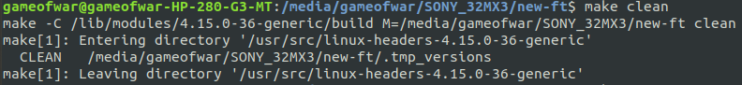

- Building the module inside a clean build directory using ‘make’ or ‘make modules’:

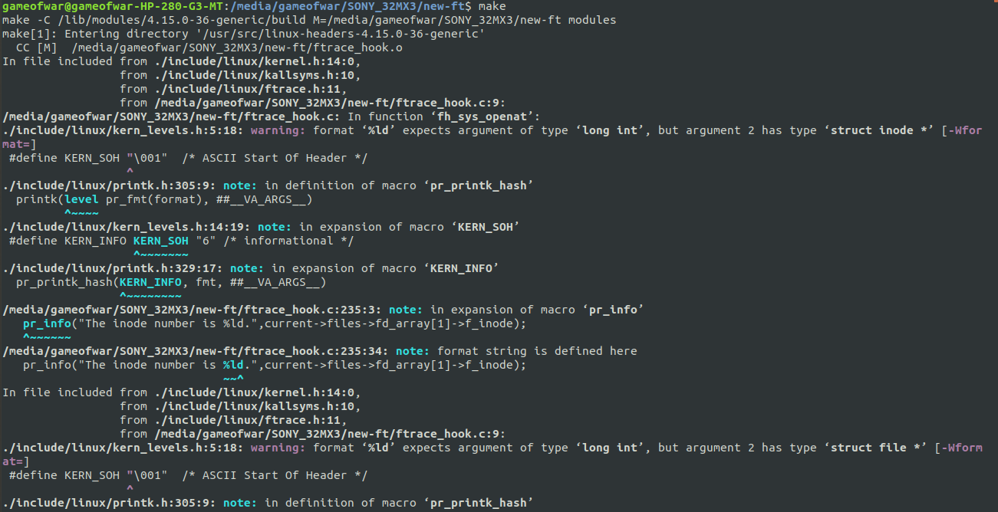

- Inserting the built module into the kernel with ‘sudo insmod ./ftrace_hook.ko’:
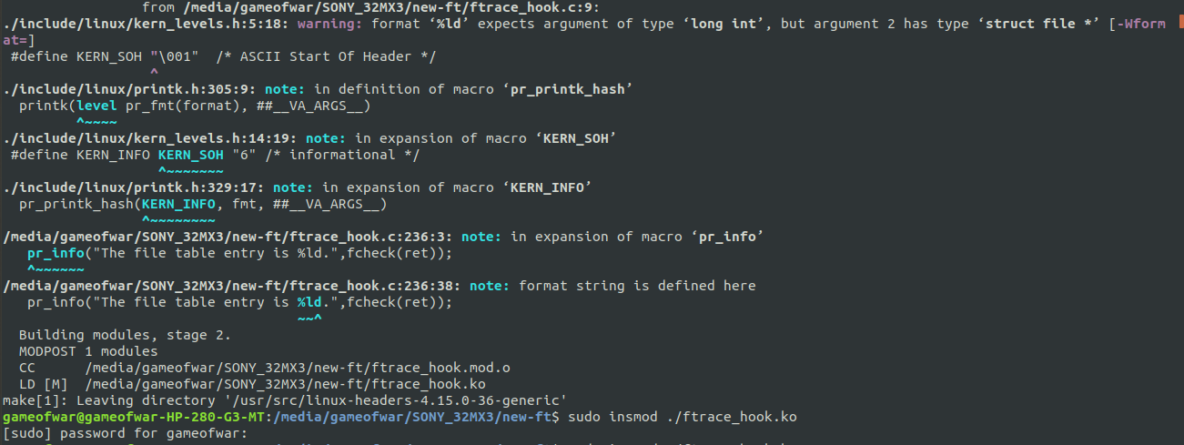

- Viewing the messages printed by the module using ‘dmesg’ or ‘dmesg –follow’:
(Refer to Section 4: Relevant dmesg output for the output)

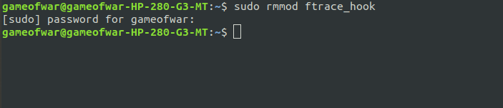
- Finally removing the module from the kernel with ‘sudo rmmod ftrace_hook’

- Relevant dmesg output:

[32m[ 622.849893] [0m[33mRIP[0m[7m[31m: fh_sys_openat+0xee/0x130 [ftrace_hook] RSP: ffffb4018410ff00[0m
[32m[ 622.849894] [0m[33mCR2[0m[1m: 0000000000000020[0m
[32m[ 622.849896] [0m[1m---[ end trace c6c390a23260dab9 ]---[0m
[32m[ 622.850112] [0m[33mftrace_hook[0m: The process details are given below:
[32m[ 622.850114] [0m[33mftrace_hook[0m: The PID of the process is 2115.
[32m[ 622.850115] [0m[33mftrace_hook[0m: The status of the process is R.
[32m[ 622.850115] [0m[33mftrace_hook[0m: The inode number is -113985678258624.
[32m[ 622.850116] [0m[33mftrace_hook[0m: The file table entry is 0.
[32m[ 622.850120] [0m[33mftrace_hook[0m: The process details are given below:
[32m[ 622.850121] [0m[33mftrace_hook[0m: The PID of the process is 2115.
[32m[ 622.850122] [0m[33mftrace_hook[0m: The status of the process is R.
[32m[ 622.850122] [0m[33mftrace_hook[0m: The inode number is -113985678258624.
[32m[ 622.850123] [0m[33mftrace_hook[0m: The file table entry is 0.
[32m[ 622.850125] [0m[33mftrace_hook[0m: The process details are given below:
[32m[ 622.850126] [0m[33mftrace_hook[0m: The PID of the process is 2115.
[32m[ 622.850127] [0m[33mftrace_hook[0m: The status of the process is R.
[32m[ 622.850127] [0m[33mftrace_hook[0m: The inode number is -113985678258624.
[32m[ 622.850128] [0m[33mftrace_hook[0m: The file table entry is 0.
[32m[ 622.850131] [0m[33mftrace_hook[0m: The process details are given below:
[32m[ 622.850132] [0m[33mftrace_hook[0m: The PID of the process is 2115.
[32m[ 622.850132] [0m[33mftrace_hook[0m: The status of the process is R.
[32m[ 622.850133] [0m[33mftrace_hook[0m: The inode number is -113985678258624.
[32m[ 622.850133] [0m[33mftrace_hook[0m: The file table entry is 0.
[32m[ 622.852077] [0m[33mftrace_hook[0m: The process details are given below:
[32m[ 622.852080] [0m[33mftrace_hook[0m: The PID of the process is 277.
[32m[ 622.852080] [0m[33mftrace_hook[0m: The status of the process is R.
[32m[ 622.852081] [0m[33mftrace_hook[0m: The inode number is -113985639002544.
[32m[ 622.852082] [0m[33mftrace_hook[0m: The file table entry is 0.
[32m[ 622.852125] [0m[33mftrace_hook[0m: The process details are given below:
[32m[ 622.852128] [0m[33mftrace_hook[0m: The PID of the process is 277.
[32m[ 622.852128] [0m[33mftrace_hook[0m: The status of the process is R.
[32m[ 622.852129] [0m[33mftrace_hook[0m: The inode number is -113985639002544.
[32m[ 622.852131] [0m[33mftrace_hook[0m: The file table entry is 0.
[32m[ 622.852147] [0m[33mftrace_hook[0m: The process details are given below:
[32m[ 622.852148] [0m[33mftrace_hook[0m: The PID of the process is 277.
[32m[ 622.852149] [0m[33mftrace_hook[0m: The status of the process is R.
[32m[ 622.852149] [0m[33mftrace_hook[0m: The inode number is -113985639002544.
[32m[ 622.852150] [0m[33mftrace_hook[0m: The file table entry is 0.
[32m[ 622.852164] [0m[33mftrace_hook[0m: The process details are given below:
[32m[ 622.852165] [0m[33mftrace_hook[0m: The PID of the process is 277.
[32m[ 622.852165] [0m[33mftrace_hook[0m: The status of the process is R.
[32m[ 622.852166] [0m[33mftrace_hook[0m: The inode number is -113985639002544.
[32m[ 622.852167] [0m[33mftrace_hook[0m: The file table entry is 0.
[32m[ 622.852180] [0m[33mftrace_hook[0m: The process details are given below:
[32m[ 622.852181] [0m[33mftrace_hook[0m: The PID of the process is 277.
[32m[ 622.852181] [0m[33mftrace_hook[0m: The status of the process is R.
[32m[ 622.852182] [0m[33mftrace_hook[0m: The inode number is -113985639002544.
[32m[ 622.852183] [0m[33mftrace_hook[0m: The file table entry is 0.
[32m[ 622.852229] [0m[33mftrace_hook[0m: The process details are given below:
[32m[ 622.852230] [0m[33mftrace_hook[0m: The PID of the process is 277.
[32m[ 622.852230] [0m[33mftrace_hook[0m: The status of the process is R.
[32m[ 622.852231] [0m[33mftrace_hook[0m: The inode number is -113985639002544.
[32m[ 622.852232] [0m[33mftrace_hook[0m: The file table entry is 0.
[32m[ 622.852335] [0m[33mftrace_hook[0m: The process details are given below:
[32m[ 622.852338] [0m[33mftrace_hook[0m: The PID of the process is 277.
[32m[ 622.852339] [0m[33mftrace_hook[0m: The status of the process is R.
[32m[ 622.852340] [0m[33mftrace_hook[0m: The inode number is -113985639002544.
[32m[ 622.852343] [0m[33mftrace_hook[0m: The file table entry is 0.
[32m[ 623.040202] [0m[33mftrace_hook[0m: The process details are given below:
[32m[ 623.040211] [0m[33mftrace_hook[0m: The PID of the process is 277.
[32m[ 623.040213] [0m[33mftrace_hook[0m: The status of the process is R.
[32m[ 623.040216] [0m[33mftrace_hook[0m: The inode number is -113985639002544.
[32m[ 623.040219] [0m[33mftrace_hook[0m: The file table entry is 0.
[32m[ 623.040299] [0m[33mftrace_hook[0m: The process details are given below:
[32m[ 623.040303] [0m[33mftrace_hook[0m: The PID of the process is 277.
[32m[ 623.040304] [0m[33mftrace_hook[0m: The status of the process is R.
[32m[ 623.040307] [0m[33mftrace_hook[0m: The inode number is -113985639002544.
[32m[ 623.040310] [0m[33mftrace_hook[0m: The file table entry is 0.
[32m[ 623.040391] [0m[33mftrace_hook[0m: The process details are given below:
[32m[ 623.040395] [0m[33mftrace_hook[0m: The PID of the process is 277.
[32m[ 623.040396] [0m[33mftrace_hook[0m: The status of the process is R.
[32m[ 623.040399] [0m[33mftrace_hook[0m: The inode number is -113985639002544.
[32m[ 623.040401] [0m[33mftrace_hook[0m: The file table entry is 0.
[32m[ 623.040450] [0m[33mftrace_hook[0m: The process details are given below:
[32m[ 623.040454] [0m[33mftrace_hook[0m: The PID of the process is 277.
[32m[ 623.040455] [0m[33mftrace_hook[0m: The status of the process is R.
[32m[ 623.040457] [0m[33mftrace_hook[0m: The inode number is -113985639002544.
[32m[ 623.040460] [0m[33mftrace_hook[0m: The file table entry is 0.
[32m[ 623.040508] [0m[33mftrace_hook[0m: The process details are given below:
[32m[ 623.040512] [0m[33mftrace_hook[0m: The PID of the process is 277.
[32m[ 623.040513] [0m[33mftrace_hook[0m: The status of the process is R.
[32m[ 623.040516] [0m[33mftrace_hook[0m: The inode number is -113985639002544.
[32m[ 623.040518] [0m[33mftrace_hook[0m: The file table entry is 0.
[32m[ 623.040564] [0m[33mftrace_hook[0m: The process details are given below:
[32m[ 623.040568] [0m[33mftrace_hook[0m: The PID of the process is 277.
[32m[ 623.040569] [0m[33mftrace_hook[0m: The status of the process is R.
[32m[ 623.040571] [0m[33mftrace_hook[0m: The inode number is -113985639002544.
[32m[ 623.040574] [0m[33mftrace_hook[0m: The file table entry is 0.
[32m[ 623.040632] [0m[33mftrace_hook[0m: The process details are given below:
[32m[ 623.040636] [0m[33mftrace_hook[0m: The PID of the process is 277.
[32m[ 623.040637] [0m[33mftrace_hook[0m: The status of the process is R.
[32m[ 623.040639] [0m[33mftrace_hook[0m: The inode number is -113985639002544.
[32m[ 623.040642] [0m[33mftrace_hook[0m: The file table entry is 0.
[32m[ 623.040689] [0m[33mftrace_hook[0m: The process details are given below:
[32m[ 623.040693] [0m[33mftrace_hook[0m: The PID of the process is 277.
[32m[ 623.040694] [0m[33mftrace_hook[0m: The status of the process is R.
[32m[ 623.040697] [0m[33mftrace_hook[0m: The inode number is -113985639002544.
[32m[ 623.040699] [0m[33mftrace_hook[0m: The file table entry is 0.
[32m[ 623.040748] [0m[33mftrace_hook[0m: The process details are given below:
[32m[ 623.040753] [0m[33mftrace_hook[0m: The PID of the process is 277.
[32m[ 623.040754] [0m[33mftrace_hook[0m: The status of the process is R.
[32m[ 623.040756] [0m[33mftrace_hook[0m: The inode number is -113985639002544.

