Systems Security Assignment 3
Section 2 - Report

1. The program is shown below:

#include <stdio.h>

void main() {
printf("Hello, world!");
}

The makefile is shown below:

COMP = gcc
OBJ = hello

default:
${COMP} ${OBJ}.c -o ${OBJ}

clean:
rm -rf ${OBJ}

2. The output of the command "readelf -h hello" is given below:

betrant@ubuntu-32-vm:~/Desktop/assn_three$ readelf -h hello
ELF Header:
Magic: 7f 45 4c 46 01 01 01 00 00 00 00 00 00 00 00 00
Class: ELF32
Data: 2's complement, little endian
Version: 1 (current)
OS/ABI: UNIX - System V
ABI Version: 0
Type: EXEC (Executable file)
Machine: Intel 80386
Version: 0x1
Entry point address: 0x8048310
Start of program headers: 52 (bytes into file)
Start of section headers: 6112 (bytes into file)
Flags: 0x0
Size of this header: 52 (bytes)
Size of program headers: 32 (bytes)
Number of program headers: 9
Size of section headers: 40 (bytes)
Number of section headers: 31
Section header string table index: 28

3. The output of the command "ldd hello" is given below:

betrant@ubuntu-32-vm:~/Desktop/assn_three$ ldd hello
linux-gate.so.1 => (0xb7f17000)
libc.so.6 => /lib/i386-linux-gnu/libc.so.6 (0xb7d47000)
/lib/ld-linux.so.2 (0xb7f19000)

4. The output of the command "file hello" is given below:

betrant@ubuntu-32-vm:~/Desktop/assn_three$ file hello
hello: ELF 32-bit LSB executable, Intel 80386, version 1 (SYSV), dynamically linked, interpreter /lib/ld-linux.so.2, for GNU/Linux 2.6.32, BuildID[sha1]=6ac4de6c72d6c2d9cc2123b80e648c62bd6573e0, not stripped

5. The strip command removes all the symbols from the executable. This is evident from the output of the readelf and file commands on the executable after execution of the strip command. The output of the readelf command shows the change in the byte offset of the section headers and the number of the section headers. This is also shown by the output of the file command, which now shows the message "stripped" instead of "not stripped".

betrant@ubuntu-32-vm:~/Desktop/assn_three$ readelf -h hello
ELF Header:
Magic: 7f 45 4c 46 01 01 01 00 00 00 00 00 00 00 00 00
Class: ELF32
Data: 2's complement, little endian
Version: 1 (current)
OS/ABI: UNIX - System V
ABI Version: 0
Type: EXEC (Executable file)
Machine: Intel 80386
Version: 0x1
Entry point address: 0x8048310
Start of program headers: 52 (bytes into file)
Start of section headers: 4428 (bytes into file)
Flags: 0x0
Size of this header: 52 (bytes)
Size of program headers: 32 (bytes)
Number of program headers: 9
Size of section headers: 40 (bytes)
Number of section headers: 29
Section header string table index: 28

betrant@ubuntu-32-vm:~/Desktop/assn_three$ file hello
hello: ELF 32-bit LSB executable, Intel 80386, version 1 (SYSV), dynamically linked, interpreter /lib/ld-linux.so.2, for GNU/Linux 2.6.32, BuildID[sha1]=6ac4de6c72d6c2d9cc2123b80e648c62bd6573e0, stripped

6. The code given below is successfully copied into the file named hello.asm:

SECTION .data
msg: db "Hi World", 10
len: equ $-msg
SECTION .text
global main:
mov edx, len
mov ecx, msg
mov ebx, 1
mov eax, 4
int 0x80
mov ebx, 0
mov eax, 1
int 0x80

7. Using the command "nasm -f elf hello.asm", the code compiles successfully. We get a file named hello.o as the output.

8. The program was compiled successfully, generating an executable which was then stripped successfully.

betrant@ubuntu-32-vm:~/Desktop/assn_three$ gcc -o hello hello.o -nostartfiles -nostdlib -nodefaultlibs
/usr/bin/ld: warning: cannot find entry symbol _start; defaulting to 00000000080480c0
betrant@ubuntu-32-vm:~/Desktop/assn_three$ strip -s hello

9. The executable has been analyzed with the hex editor, and the required operations have been completed; the output of which is seen below:

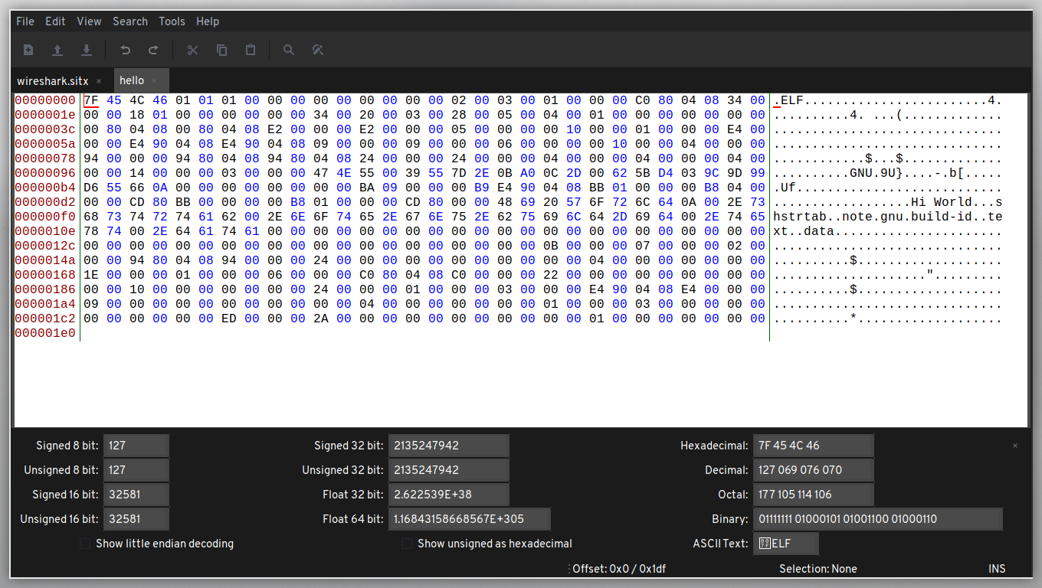

Fig 1. The hello world executable before modification

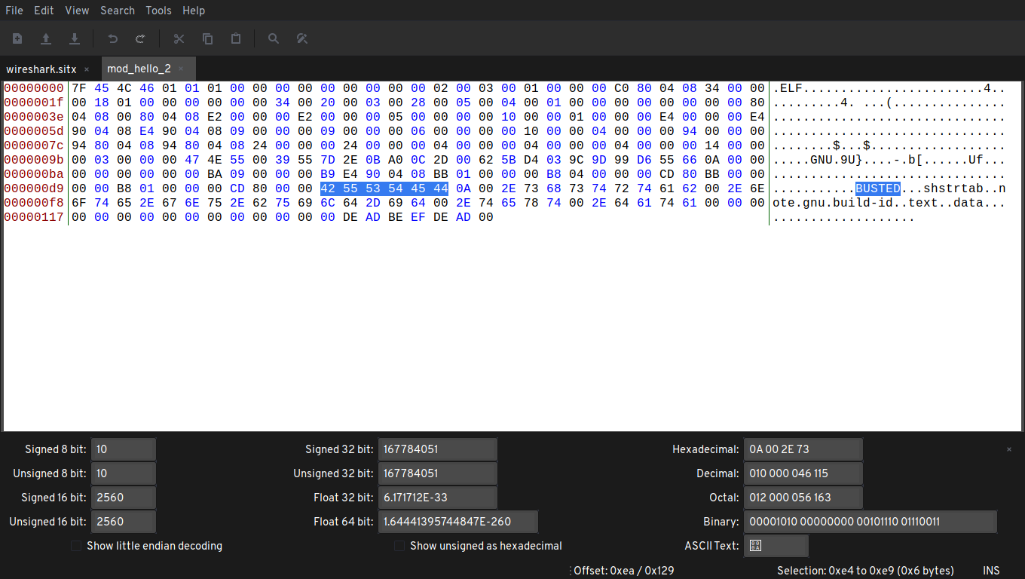
Fig 2. The hello world executable after modification, highlighting the new message that will be printed upon execution.

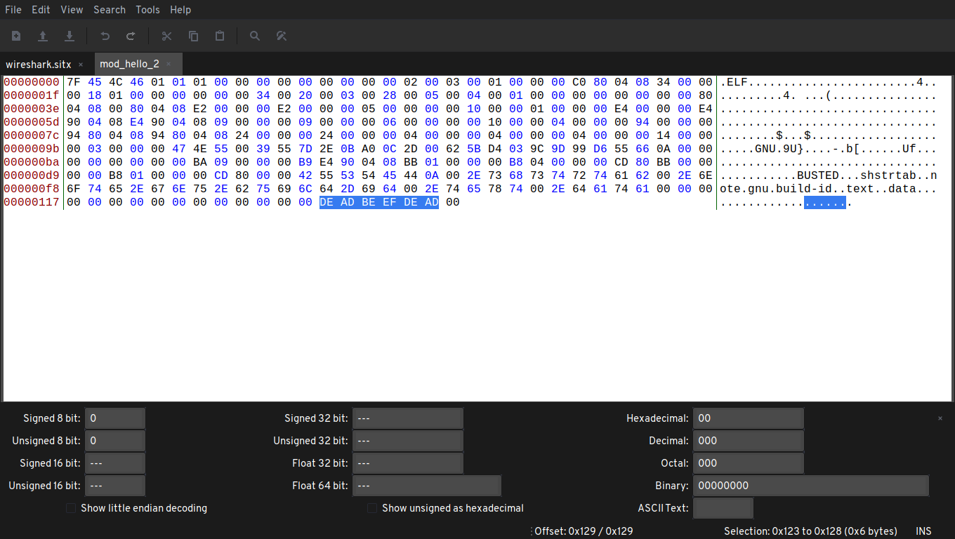
Fig 3. The hello world executable after modification, highlighting the signature embedded into the executable.

The additional output shows the execution of the modified executable:

Desktop/assn_three
➜ chmod +x ./mod_hello_2
mode of './mod_hello_2' changed from 0644 (rw-r--r--) to 0755 (rwxr-xr-x)

Desktop/assn_three
➜ ./mod_hello_2
BUSTED
.%

10. The size of the file has been reduced to 298 bytes, which is just under 300 bytes. The output of the "ls" command proves it:

Desktop/assn_three
➜ ls -al
total 36
drwxrwxr-x 2 betrant betrant 4096 Feb 22 19:40 .
drwxr-xr-x 4 betrant betrant 4096 Feb 22 19:33 ..
-rwxrwxr-x 1 betrant betrant 480 Feb 22 12:52 hello
-rw-rw-r-- 1 betrant betrant 169 Feb 21 16:53 hello.asm
-rw-rw-r-- 1 betrant betrant 65 Feb 21 11:44 hello.c
-rw-rw-r-- 1 betrant betrant 624 Feb 22 12:48 hello.o
-rw-rw-r-- 1 betrant betrant 84 Feb 21 11:44 Makefile
-rwxr-xr-x 1 betrant betrant 480 Feb 22 19:38 modded_hello
-rwxr-xr-x 1 betrant betrant 298 Feb 22 19:40 mod_hello_2

11. The program does show similar output to what is displayed in the hexdump and the hex editor command, since they both read the file in the binary mode, and output as such. The output of the program and the hexdump command is given below:

final-wk-ig/scanner
➜ ./bin/hex_dump_stub ../../assn_three/mod_hello_2
7f 45 4c 46 01 01 01 00 00 00 00 00 00 00 00 00 .ELF............
02 00 03 00 01 00 00 00 c0 80 04 08 34 00 00 00 ............4...
18 01 00 00 00 00 00 00 34 00 20 00 03 00 28 00 ........4. ...(.
05 00 04 00 01 00 00 00 00 00 00 00 00 80 04 08 ................
00 80 04 08 e2 00 00 00 e2 00 00 00 05 00 00 00 ................
00 10 00 00 01 00 00 00 e4 00 00 00 e4 90 04 08 ................
e4 90 04 08 09 00 00 00 09 00 00 00 06 00 00 00 ................
00 10 00 00 04 00 00 00 94 00 00 00 94 80 04 08 ................
94 80 04 08 24 00 00 00 24 00 00 00 04 00 00 00 ....$...$.......
04 00 00 00 04 00 00 00 14 00 00 00 03 00 00 00 ................
47 4e 55 00 39 55 7d 2e 0b a0 0c 2d 00 62 5b d4 GNU.9U}....-.b[.
03 9c 9d 99 d6 55 66 0a 00 00 00 00 00 00 00 00 .....Uf.........
ba 09 00 00 00 b9 e4 90 04 08 bb 01 00 00 00 b8 ................
04 00 00 00 cd 80 bb 00 00 00 00 b8 01 00 00 00 ................
cd 80 00 00 42 55 53 54 45 44 0a 00 2e 73 68 73 ....BUSTED...shs
74 72 74 61 62 00 2e 6e 6f 74 65 2e 67 6e 75 2e trtab..note.gnu.
62 75 69 6c 64 2d 69 64 00 2e 74 65 78 74 00 2e build-id..text..
64 61 74 61 00 00 00 00 00 00 00 00 00 00 00 00 data............
00 00 00 de ad be ef de ad 00 ..........

final-wk-ig/scanner
➜ hexdump ../../assn_three/mod_hello_2
0000000 457f 464c 0101 0001 0000 0000 0000 0000
0000010 0002 0003 0001 0000 80c0 0804 0034 0000
0000020 0118 0000 0000 0000 0034 0020 0003 0028
0000030 0005 0004 0001 0000 0000 0000 8000 0804
0000040 8000 0804 00e2 0000 00e2 0000 0005 0000
0000050 1000 0000 0001 0000 00e4 0000 90e4 0804
0000060 90e4 0804 0009 0000 0009 0000 0006 0000
0000070 1000 0000 0004 0000 0094 0000 8094 0804
0000080 8094 0804 0024 0000 0024 0000 0004 0000
0000090 0004 0000 0004 0000 0014 0000 0003 0000
00000a0 4e47 0055 5539 2e7d a00b 2d0c 6200 d45b
00000b0 9c03 999d 55d6 0a66 0000 0000 0000 0000
00000c0 09ba 0000 b900 90e4 0804 01bb 0000 b800
00000d0 0004 0000 80cd 00bb 0000 b800 0001 0000
00000e0 80cd 0000 5542 5453 4445 000a 732e 7368
00000f0 7274 6174 0062 6e2e 746f 2e65 6e67 2e75
0000100 7562 6c69 2d64 6469 2e00 6574 7478 2e00
0000110 6164 6174 0000 0000 0000 0000 0000 0000
0000120 0000 de00 bead deef 00ad
000012a

However one thing is to be noted, while the program represents the bytes in the big-endian format, the hexdump command represents it in the little-endian format, but in other aspects the output is similar.

