Cyber Forensics and Incident Response – Assignment 1

This report answers the questions below, with the screenshots of the packets that prove the same:

- What is the IP address of the Windows VM that gets affected?
- What is the host name of the Windows VM that gets affected?
- What is the MAC address of the infected VM?
- What is the IP address of the compromised web site?
- What is the domain name of the compromised web site?
- What is the IP address that delivered the exploit kit and malware?
- What is the domain name that delivered the exploit kit and malware?
- What is the redirect URL that points to the exploit kit (EK) landing page?
- Besides the landing page (which contains the CVE-2013-2551 IE exploit), what other exploit(s) were sent by the EK?
- How many times was the payload delivered?
- Submit the PCAP file to VirusTotal and find out what were the Snort alerts triggered. What are the EK names are shown in the Suricata alerts?
- Checking my website, what have I and others been calling this exploit kit?
- What file or page from the compromised website has the malicious script with the URL for the redirect?
- Extract the exploit files. What are the MD5 hashes?
- VirusTotal doesn't show all the VRT rules under the "Snort alerts" section for the PCAP analysis. If you run your own version of Snort with the VRT ruleset as a registered user, what VRT rules will be fired?

- The IP address of the Windows VM that is affected is 172.16.165.165.

After analyzing the HTTP streams, we can see one stream that stands out from the others, in which a Windows VM makes a GET request for a suspicious file, which under further examination turns out to be the EK payload.

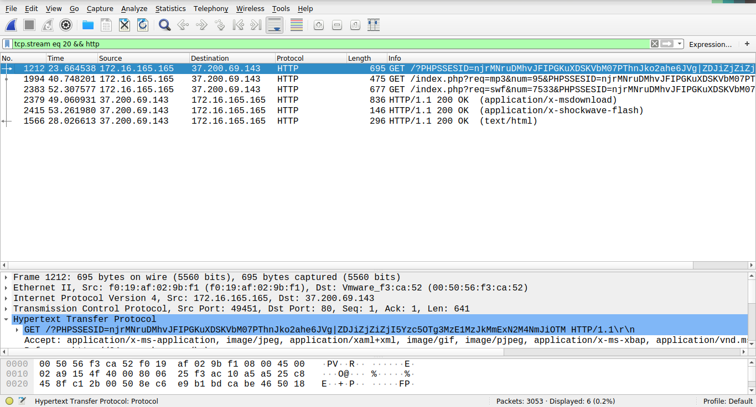

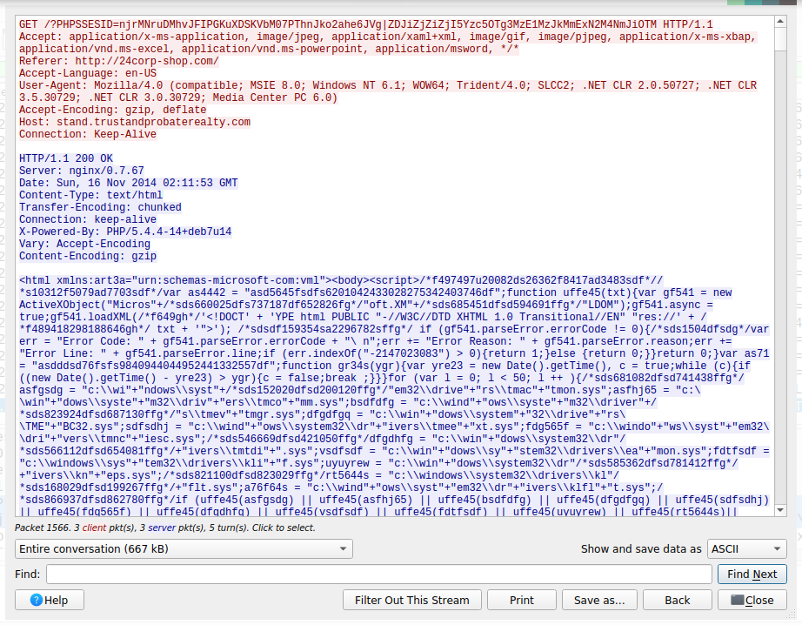

- The hostname of the Windows VM that is affected is K34EN6W3N-PC.

By now we have the IP address of the affected VM. But we can also see some traffic originating from the affected VM under the NetBIOS protocol, which easily provides the hostname of the affected VM.

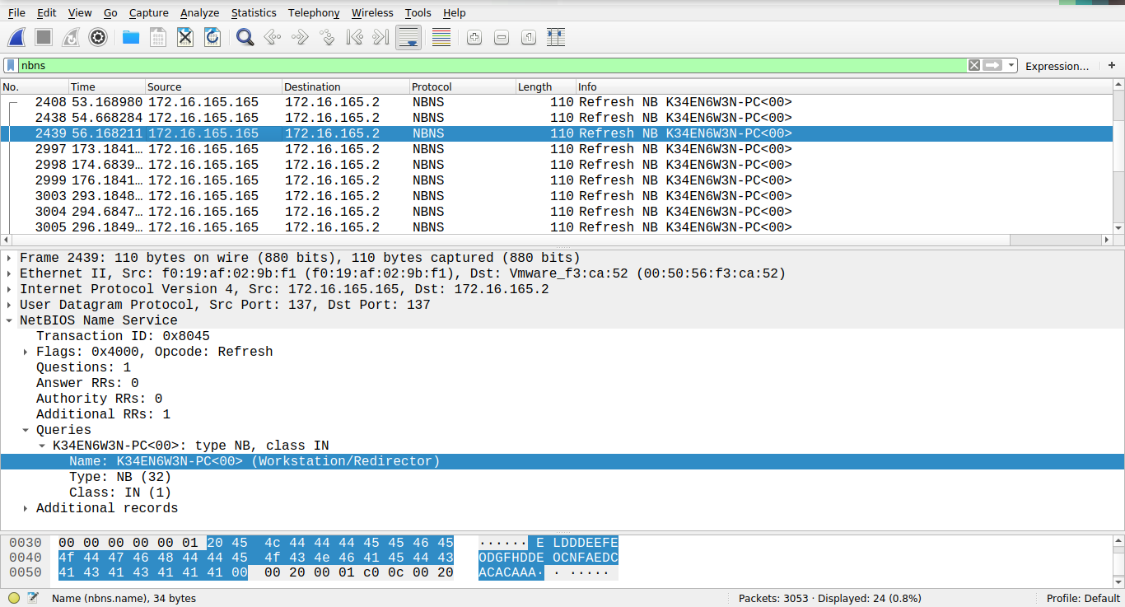

- The MAC address of the Windows VM that is affected is 00:50:56:f3:ca:52.

A lookup for the virtual MAC address that answers to the given IP address that we found earlier, will provide the answer.

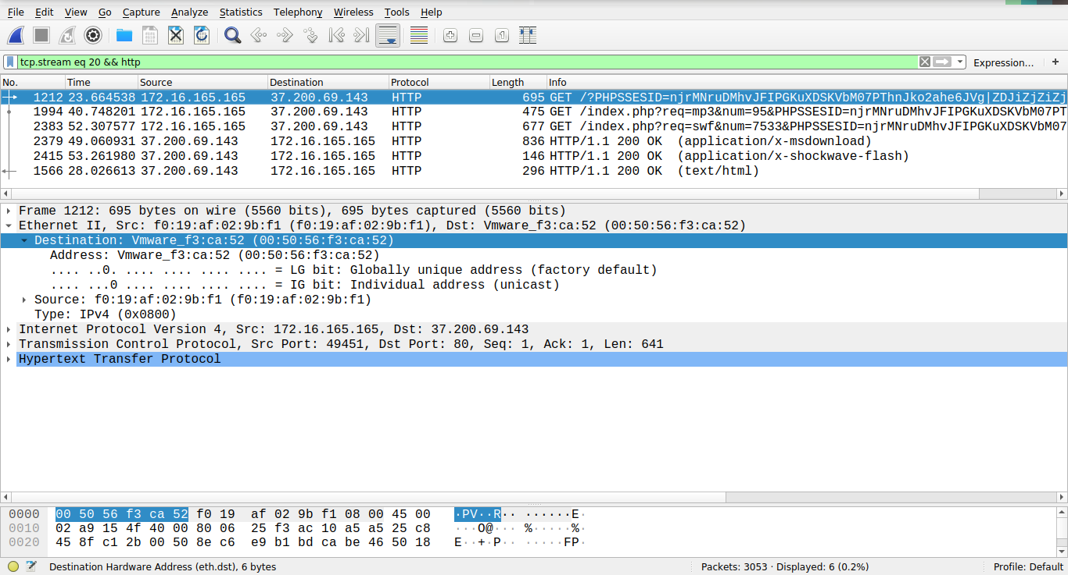

- There are several compromised websites in a chained-exploit fashion. The first entry point is the website pointed to by the domain name “www.ciniholland.nl”, which contains a redirect in an embedded JavaScript, which points to the website pointed to by the domain name “24corp-shop.com”. This website contains an IFrame element which displays an embedded frame to the website that delivers the EK, which is addressed by the domain name “http://stand.trustandprobaterealty.com”. Thus, the first two websites are the compromised websites.

The IP address for the first website is 82.150.140.30 and the IP address for the second website is 188.225.73.100, which is obtained by looking up the respective server IP address that hosts the websites.

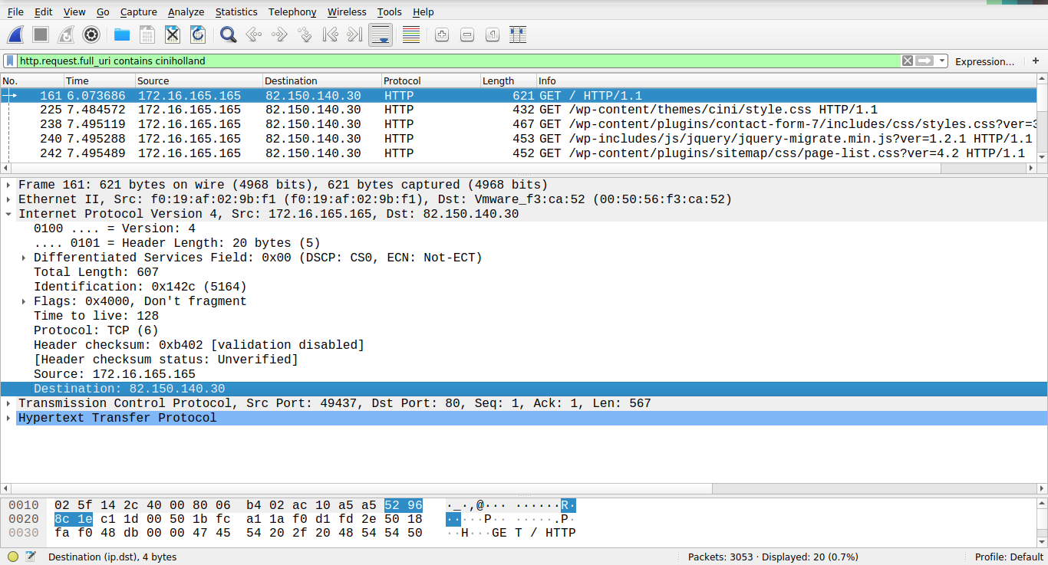
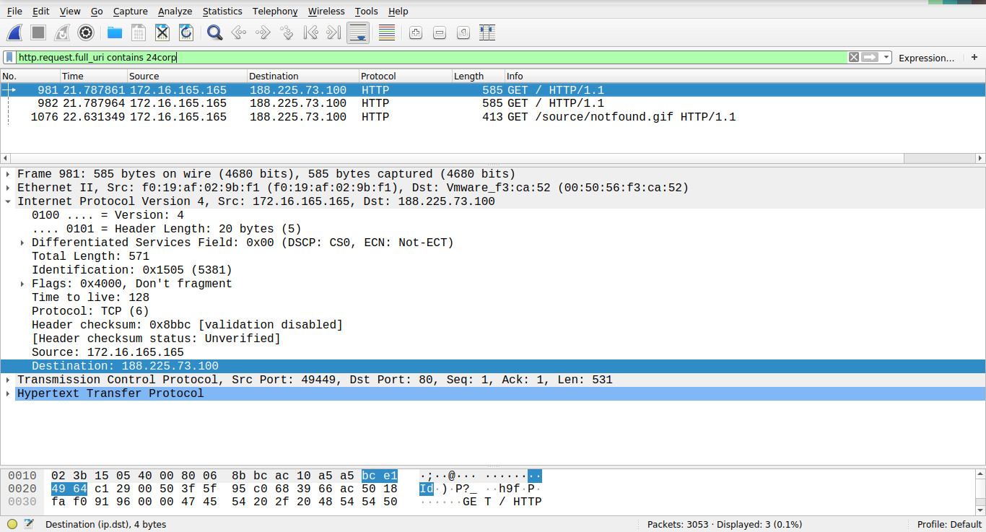

- The domain name of the compromised web sites are “www.ciniholland.nl” and “24corp-shop.com”.

The domain names are already found in the previous step, and they can be seen from the HTTP packets that are related to the redirect chain.

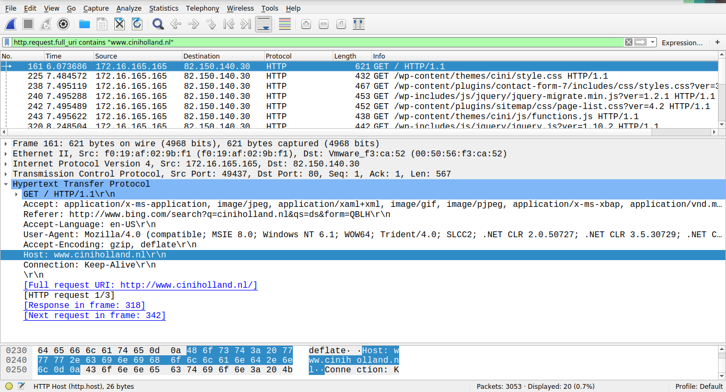

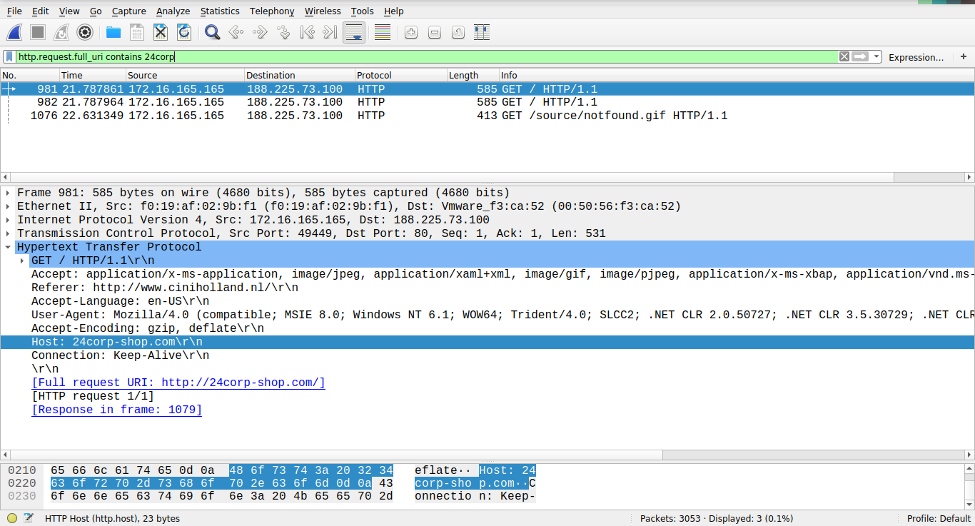

- The IP address of the website that delivers the EK and malware is 37.200.69.143.

The given IP address can be found from the looking up the IP address of the webserver that hosts the website that delivers the EK and malware.

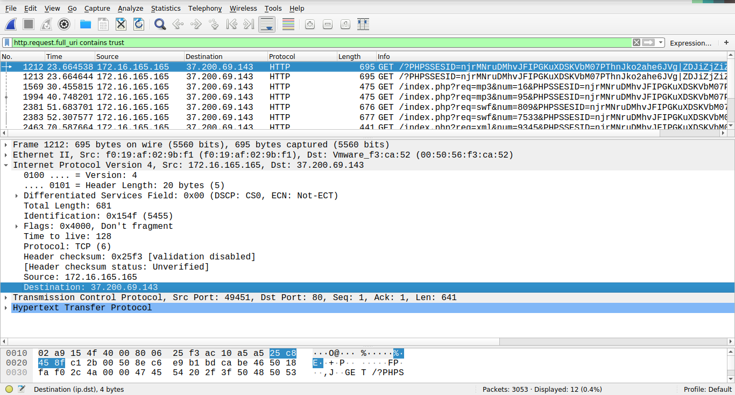

- The domain name of the website that delivered the EK and malware is “stand.trustandprobaterealty.com”.

The HTTP packets that orginate from the victim requesting the EK and malware can be inspected to reveal the domain name of the host that provides the EK and malware.

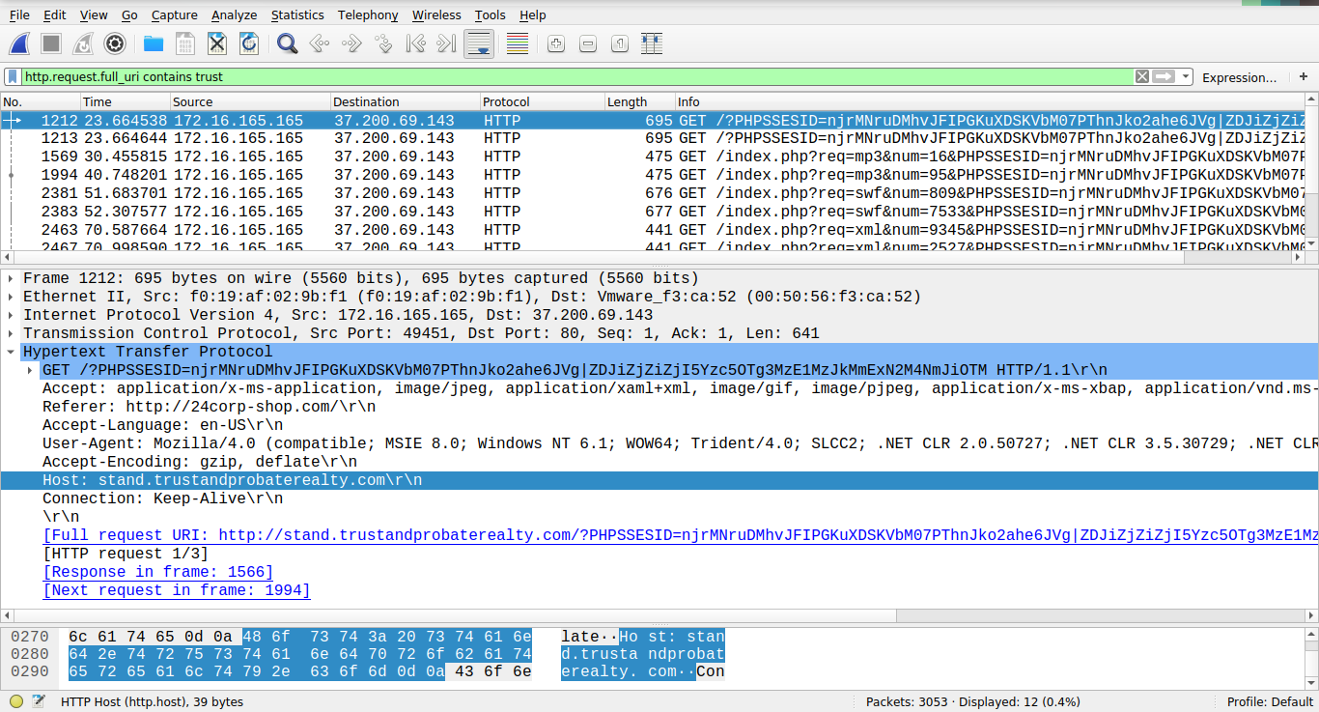

- The redirect URL that points to the EK landing page is ‘http://stand.trustandprobaterealty.com/?PHPSSESID=njrMNruDMhvJFIPGKuXDSKVbM07PThnJko2ahe6JVg|ZDJiZjZiZjI5Yzc5OTg3MzE1MzJkMmExN2M4NmJiOTM’

The redirect is from an IFrame element that is embedded in one of the compromised websites, and inspecting the content of the IFrame tag will reveal the redirect URL.

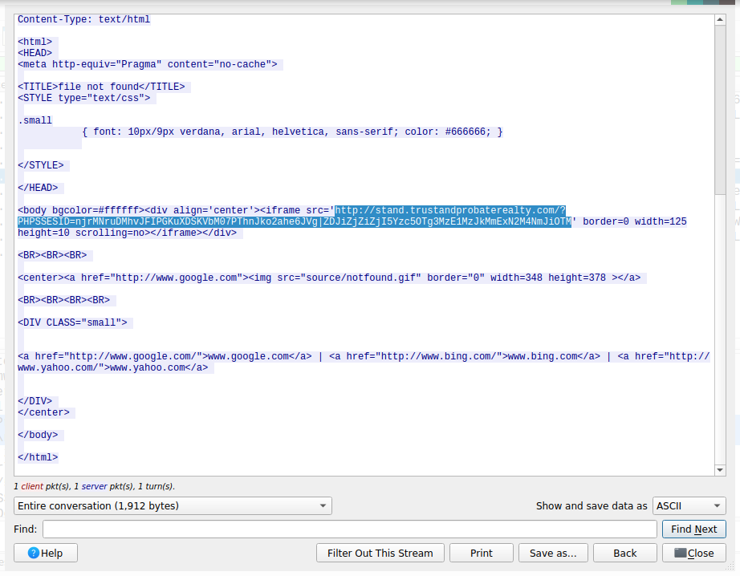

- Besides the webpage that contains the CVE-2013-2551 IE exploit which contains the main payload, the EK also sends a Java executable archive (a JAR file) in a separate TCP stream.

The analysis of the HTTP traffic in the TCP stream that sends the payloads show that the infected VM requests these files.

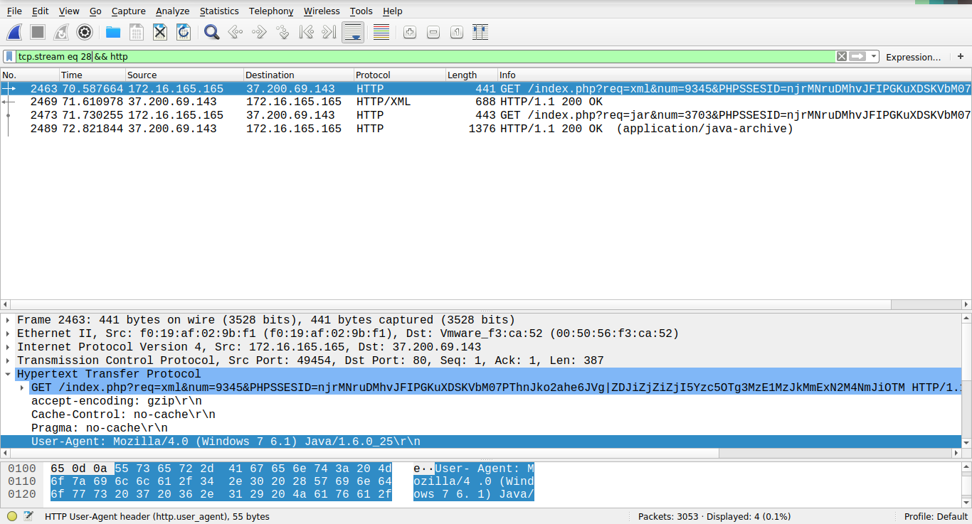

- The payload was delivered two times in total.

There are four TCP streams in total that are confirmed to be the communication streams that deliver the payloads. They are labeled as the 20th, 21st, 28th and 29th TCP streams in Wireshark. The 20th and the 28th stream sends the set of files of the payload over to the infected VM one time, then the 21st and the 29th stream sends the files over to the VM one more time.

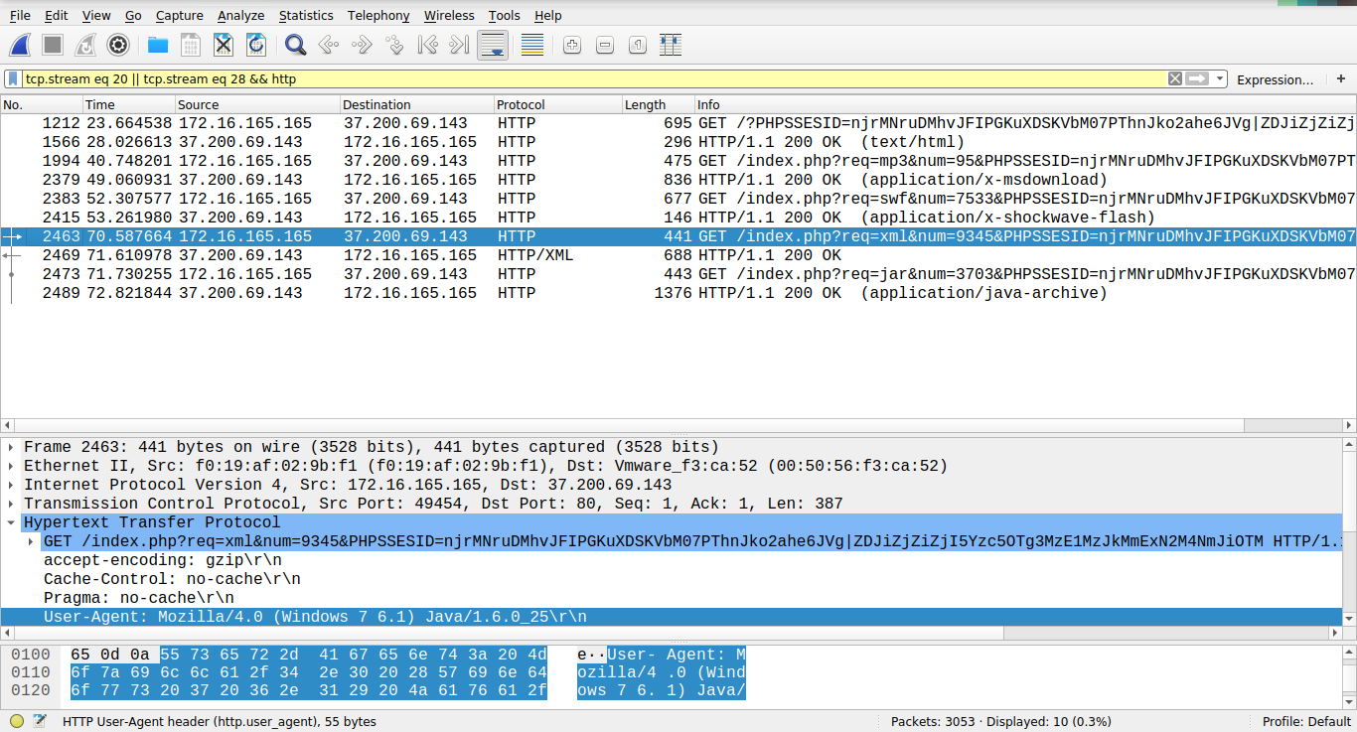
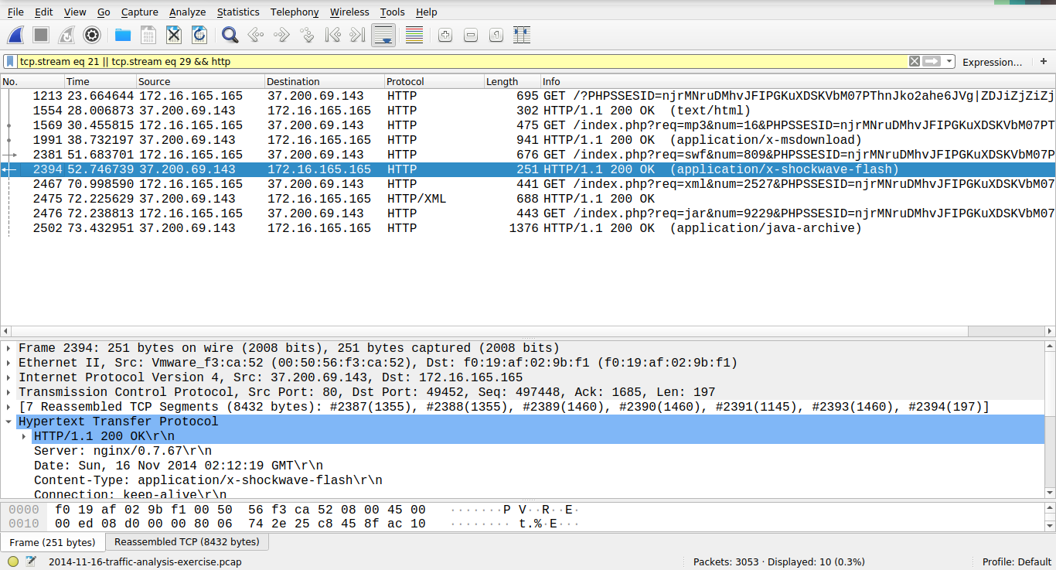

- The Snort alerts include:
- (spp_sdf) SDF Combination Alert [1]
- (http_inspect) LONG HEADER [19]
- (http_inspect) UNKNOWN METHOD [31]

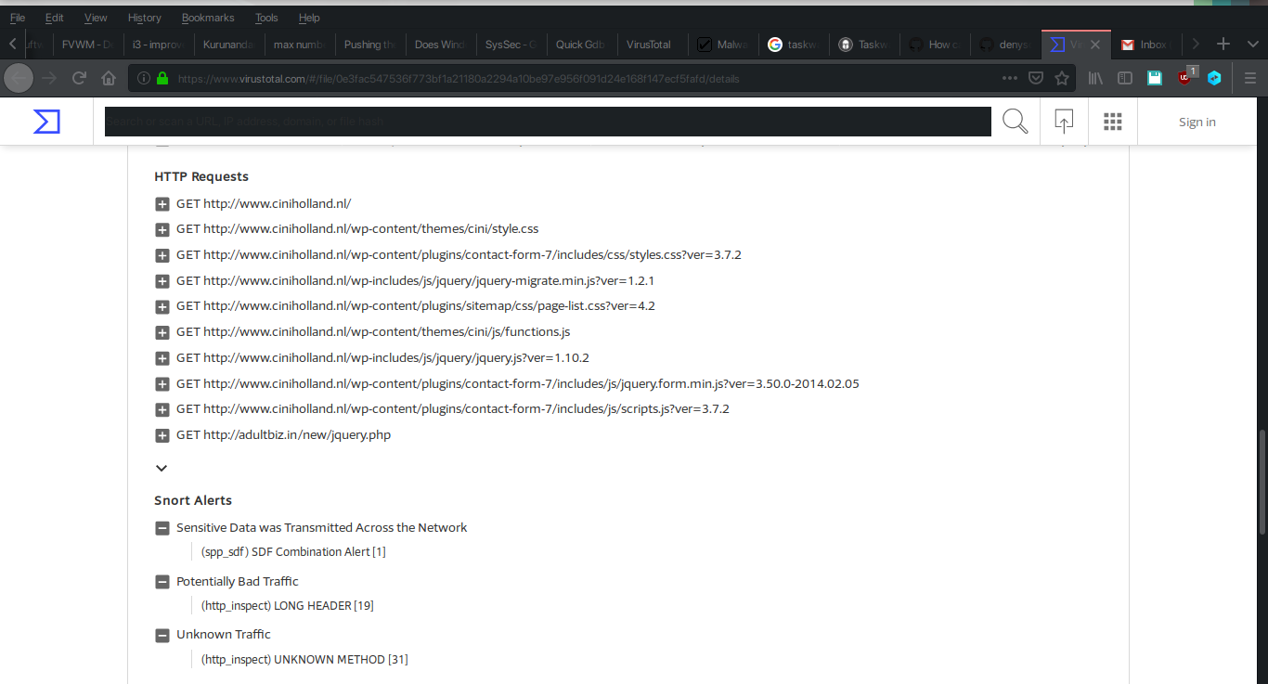

The Suricata alerts include the given EK names:
- RIG EK
- GoonEK
- Goon/Infinity URI Struct EK

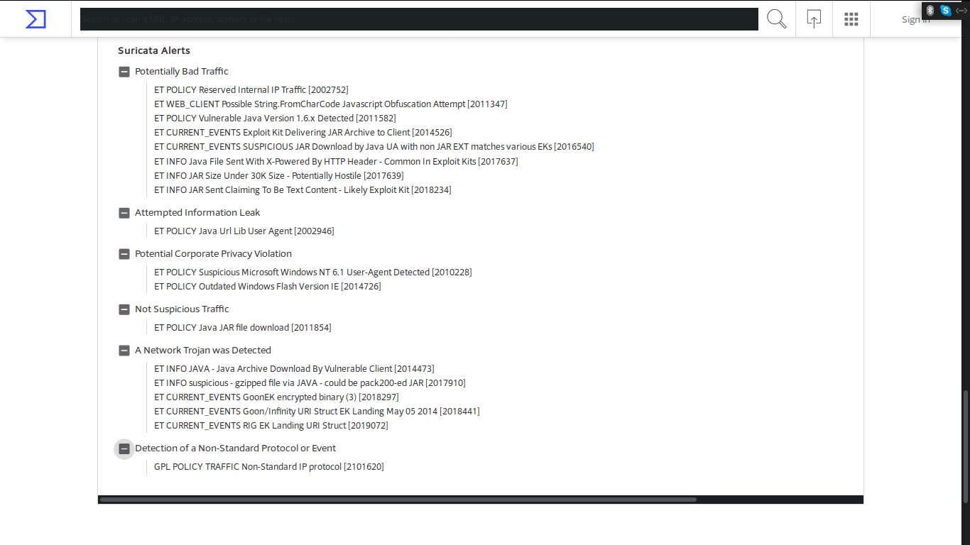

- The exploit has been named as the Goon/Infinity/RIG exploit kit.

Online searches, alongside the Suricata and Snort VPT entries reveal these names.

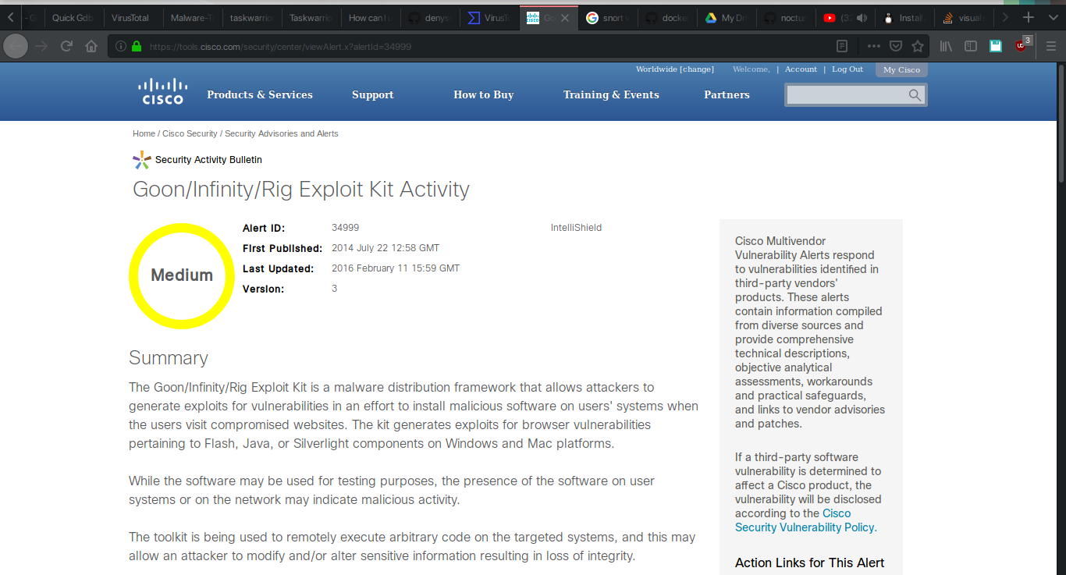

- The root HTML file of the compromised web site contains the script with the redirect URL for the landing page of the exploit kit.

The analysis of the HTML file of the compromised web site shows us a script that is written inside the same document that contains code to generate a hidden IFrame, which is then used to load the next webpage in the chain of redirects.

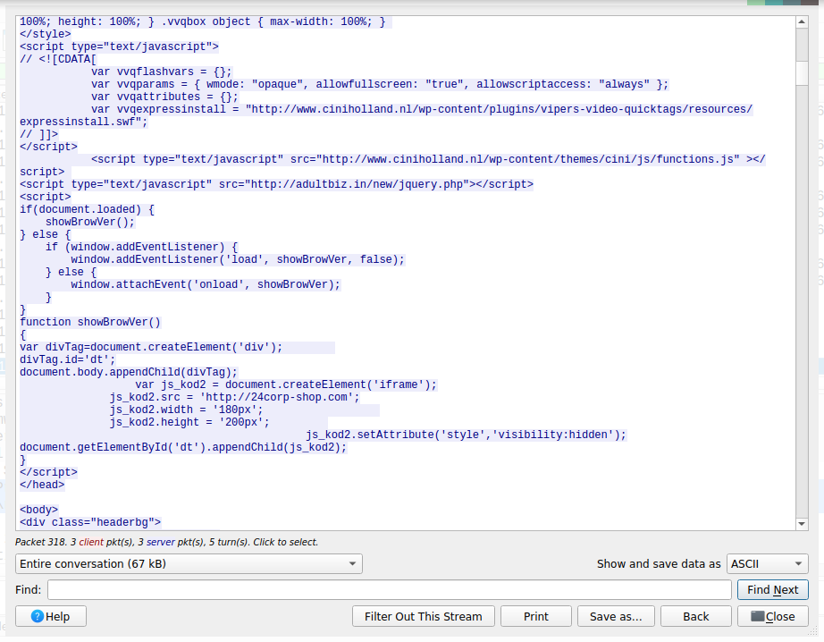

- The malicious files belonging to the payload were extracted and their MD5 hashes were calculated. They are as follows:

- Initial browser payload (two distinct files used during two iterations of sending the payload):

793b698a82d999f1eb75525d050ebe16
cdb2caff421a64643282e07c323d16ba
- Shockwave Flash payload file:

7b3baa7d6bb3720f369219789e38d6ab

- Executable file:

d276c86dcdbcdb6b74ee02496bc90d98

- XML file:

b781797da30f3a982268dd66ac36df74

- Java application archive:

1e34fdebbf655cebea78b45e43520ddf

The MD5 calculations are shown below.

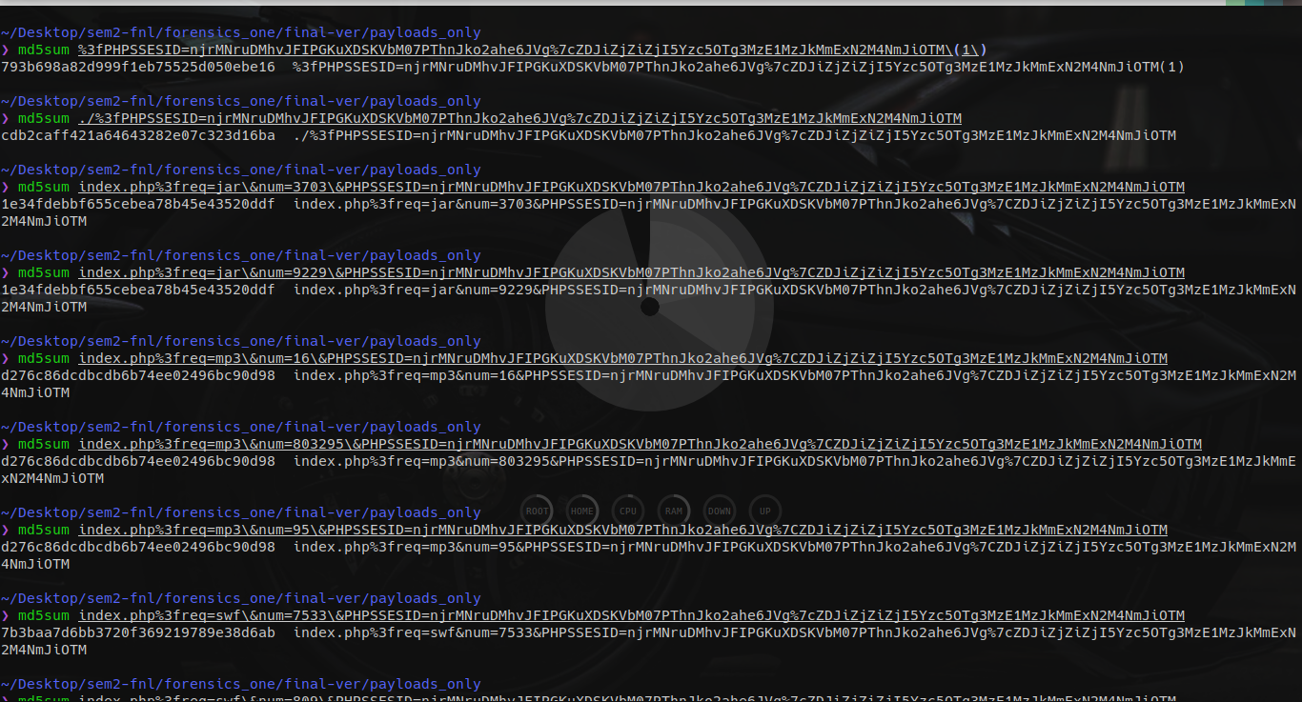
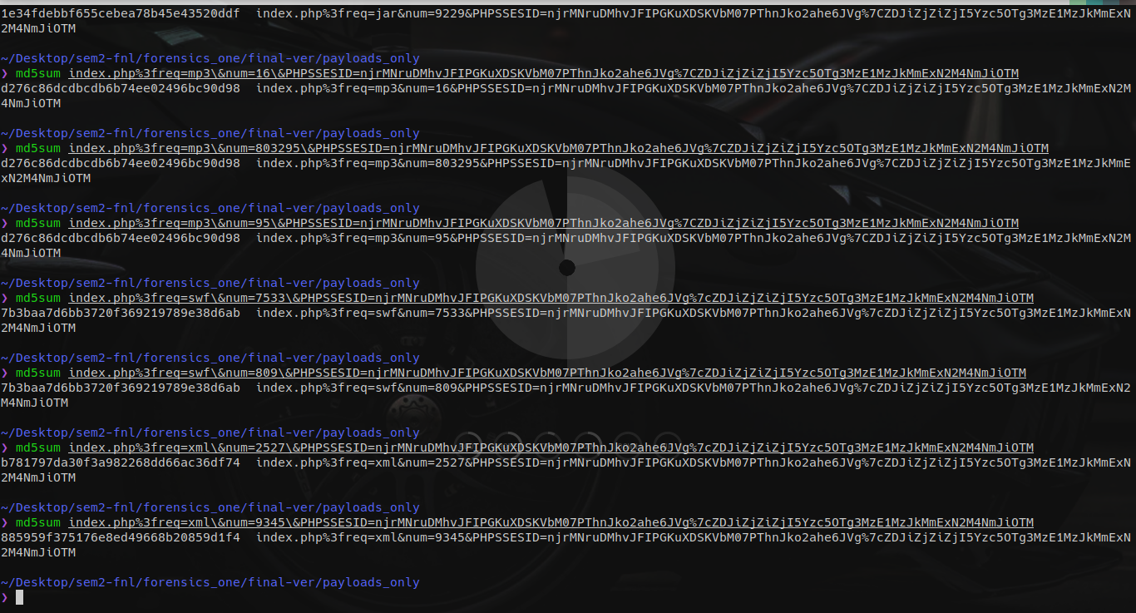

- A self-hosted installation of SNORT without the VRT rulesets will not trigger the following SNORT VRT detection rules:

- EXPLOIT-KIT Goon/Infinity/Redkit exploit kit short jar request
- EXPLOIT-KIT Goon/Infinity exploit kit iframe redirection
- EXPLOIT-KIT Multiple exploit kit binkey xored binary download attempt
- EXPLOIT-KIT iFRAMEr successful cnt.php redirection
- EXPLOIT-KIT Goon/Infinity exploit kit payload download attempt
- EXPLOIT-KIT Goon/Infinity exploit kit landing page
- EXPLOIT-KIT Goon/Infinity exploit kit encrypted binary download
- EXPLOIT-KIT Goon/Infinity exploit kit malicious portable executable file request
- EXPLOIT-KIT Goon/Infinity exploit kit landing page
- EXPLOIT-KIT Goon/Infinity exploit kit landing page
- EXPLOIT-KIT Goon/Infinity exploit kit mp3 requested by Java
- EXPLOIT-KIT Goon/Infinity/Rig exploit kit outbound uri structure
- EXPLOIT-KIT Goon/Infinity/Rig exploit kit landing page - specific structure
- EXPLOIT-KIT Goon/Infinity/Rig exploit kit encrypted binary download
- EXPLOIT-KIT Goon/Infinity exploit kit landing page

Refer to the accompanying file for the exact rule definitions.

