Systems Security Programming Assignment – 2

The report is divided into three parts:

- Submission details
- Instructions on running the program
- Sample Output

- Submission details:

The assignment was completed successfully and is is attached alongside this report. The program is structured in such a way that the user is able to toggle multiple modes of operation with command-line options which are better explained with the ‘unshadow --help’ command. The program contains modes in which a performance-boosting cache mechanism is also toggleable as well, should the user choose to utilize it. The program contains two kinds of cracking algorithms, one that performs a dictionary attack on the user list, and the other that extracts the names of the users and builds a list of all possible variants which then are tested against the user list. Concerning the performance, this solution also includes a caching mechanism as mentioned before. This will not only help in boosting the cracking speed of the cracker, it will also greatly reduce the time taken for subsequent executions. Additionally, this also contains a verbose-output mode which can be toggled by the ‘--verbose’ flag.

- Instructions on running the program

The instructions are listed below:

- Compile the program with the make command.
- Invoke the command with ‘./bin/unshadow’ with required command-line options. If help is needed with the command-line options, then invoke the command with the ‘--help’ flag to view the options that can be used.
- Alternatively, modify the variables pointing to the input and output in the makefile and use those with the ‘make run’ command.
- After execution, if the executable isn’t needed ‘anymore, then remove it with the ‘make clean’ command.
- Additionally, if the user decides to remove the cached database, then use the ‘make freshen’ command to remove all the cached entries. However, this is not recommended unless the program is never to be executed anymore.

- Sample Output

The output of the program is illustrated below:

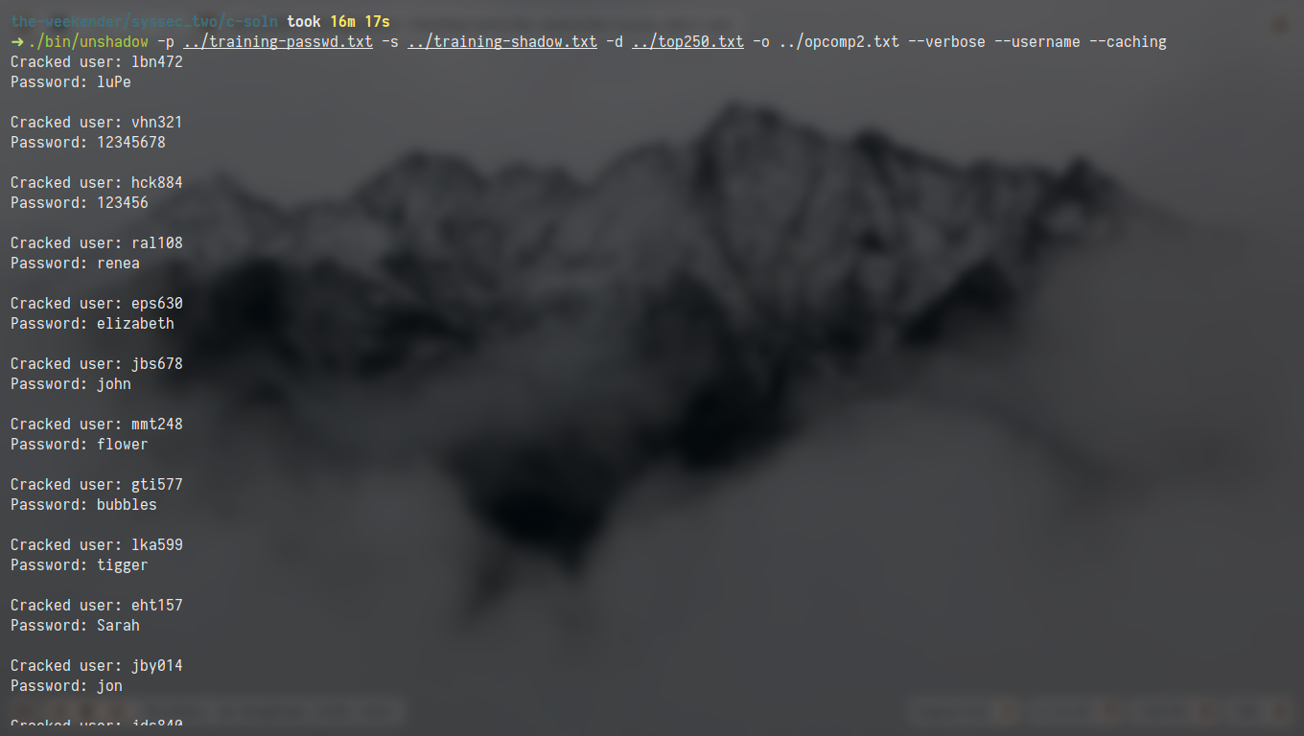

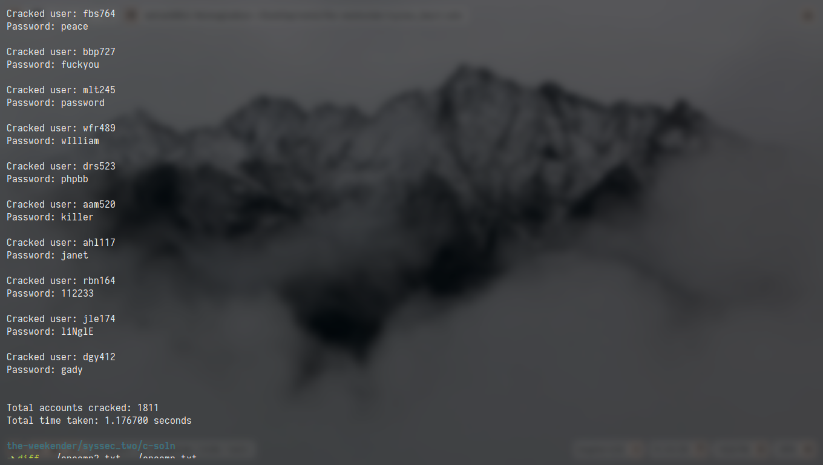

The cracker with caching mode enabled (on second execution)

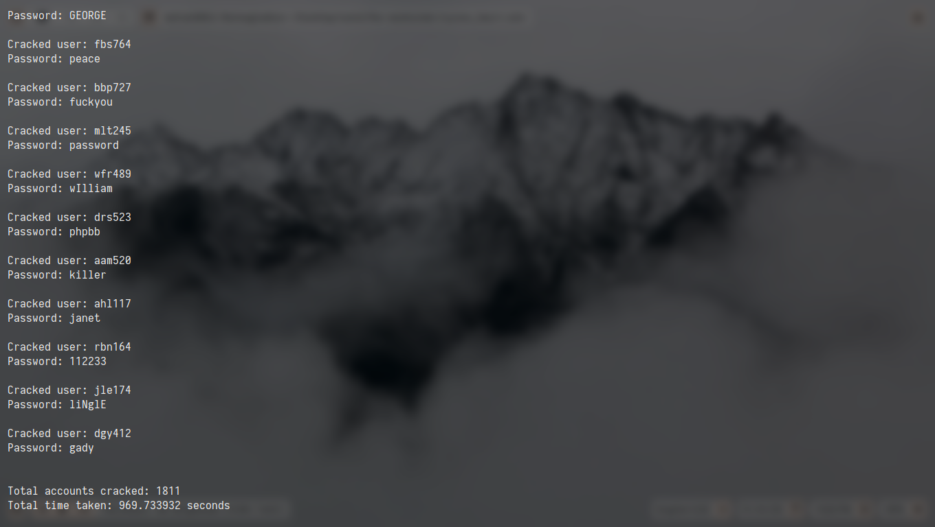

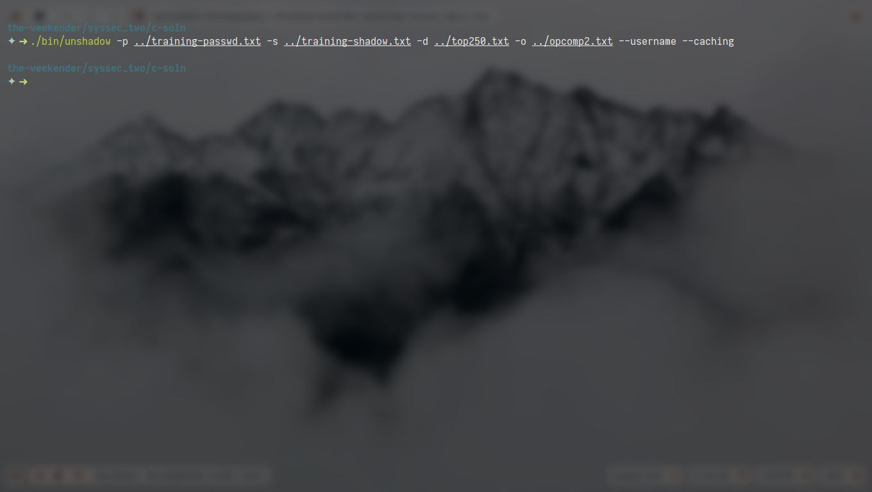
The cracker with caching mode disabled

The cracker with verbosity disabled

