Cyber Forensics and Incident Reponse – Periodical 1

Part D

- The IP address of the anonymous adversary is 10.42.42.253. This can be found in multiple ways, one is to go through the packets and find from which IP address is the flow of connection setup requests coming. The other is to just analyze the IO graphs with the filters on each IP address and find which one has the most packets originating from the given IP. This can also be done using tshark, with the command “tshark -r ReconCase.pcap -2 -T fields -e ip.dst_host | sort -n | uniq -c | sort -n” which lists the number of packets originating from each host.

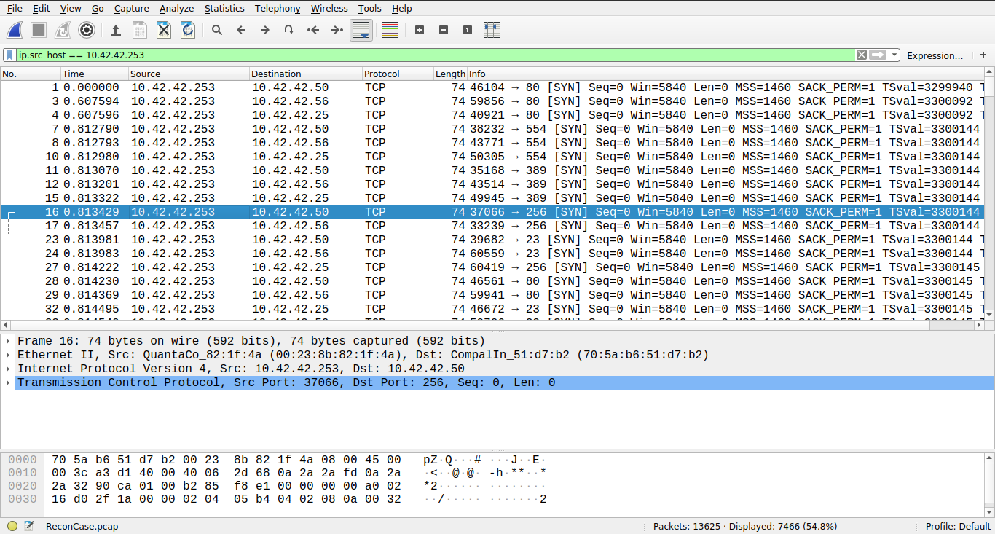

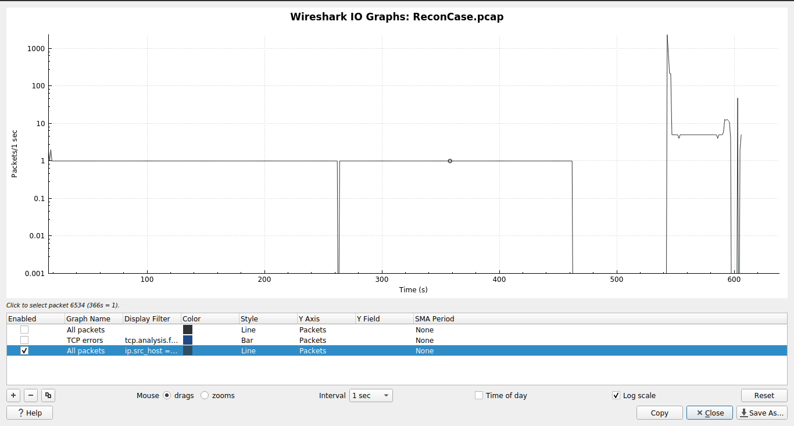

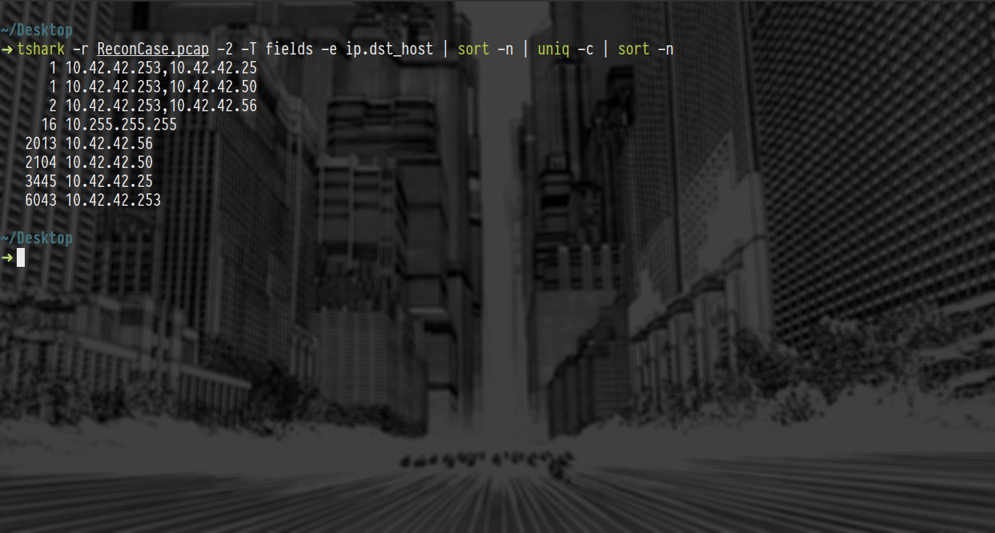

- The first type of port scan was the TCP SYN port scan. This is clearly understood from the first few packets that originate from the anonymous adversary. Checking these packets, we see that the adversary tries to setup connections using a SYN packet, but does not really proceed with connection setup in case the port is open, suggesting that the adversary is running a TCP SYN port scan.

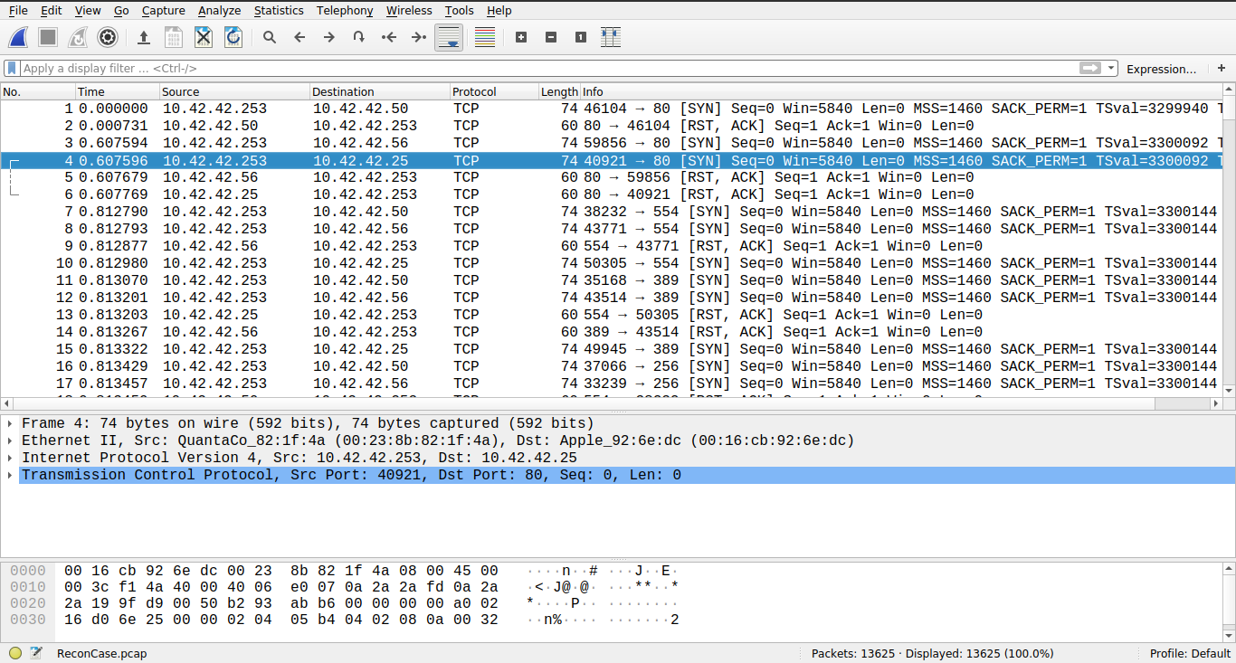

- The IP addresses that the adversary discovered are 10.42.42.25, 10.42.42.50 and 10.42.42.56. These can be seen by a TShark command to list all the packets originating from the adversary, and then sort and count the unique entries of destination IP addresses. The TShark command used in this case is “tshark -r ReconCase.pcap -2 -T fields -R “ip.src_host==10.42.42.253” -e ip.dst | sort -n | uniq -c | sort -n”.

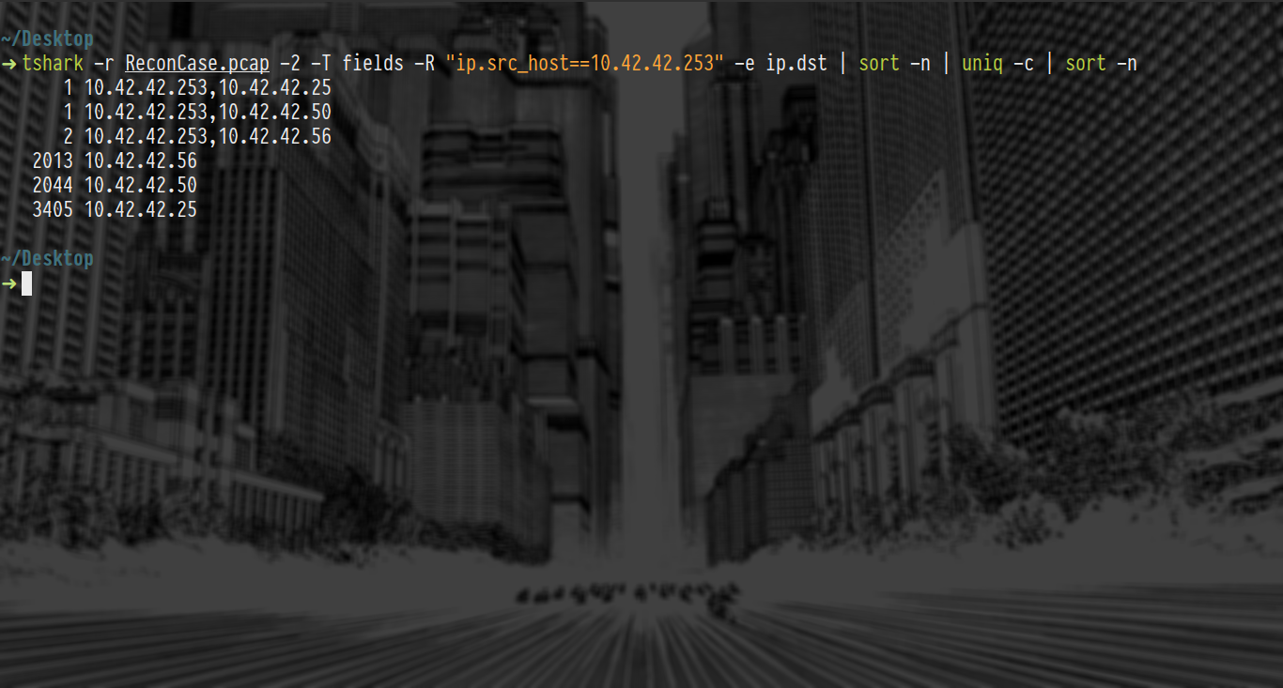

- The MAC address of the Apple system that the adversary found is 00:16:cb:92:6e:dc. This is visible from filtering the resolved MAC addresses and listing them using the tshark command “tshark -r ReconCase.pcap -2 -R "ip.src_host==10.42.42.253" -T fields -e eth.dst_resolved -e ip.dst | sort -n | uniq -c | sort -n “. Additionally, the grep command can also be used to filter the output to only the entry containing Apple’s devices.

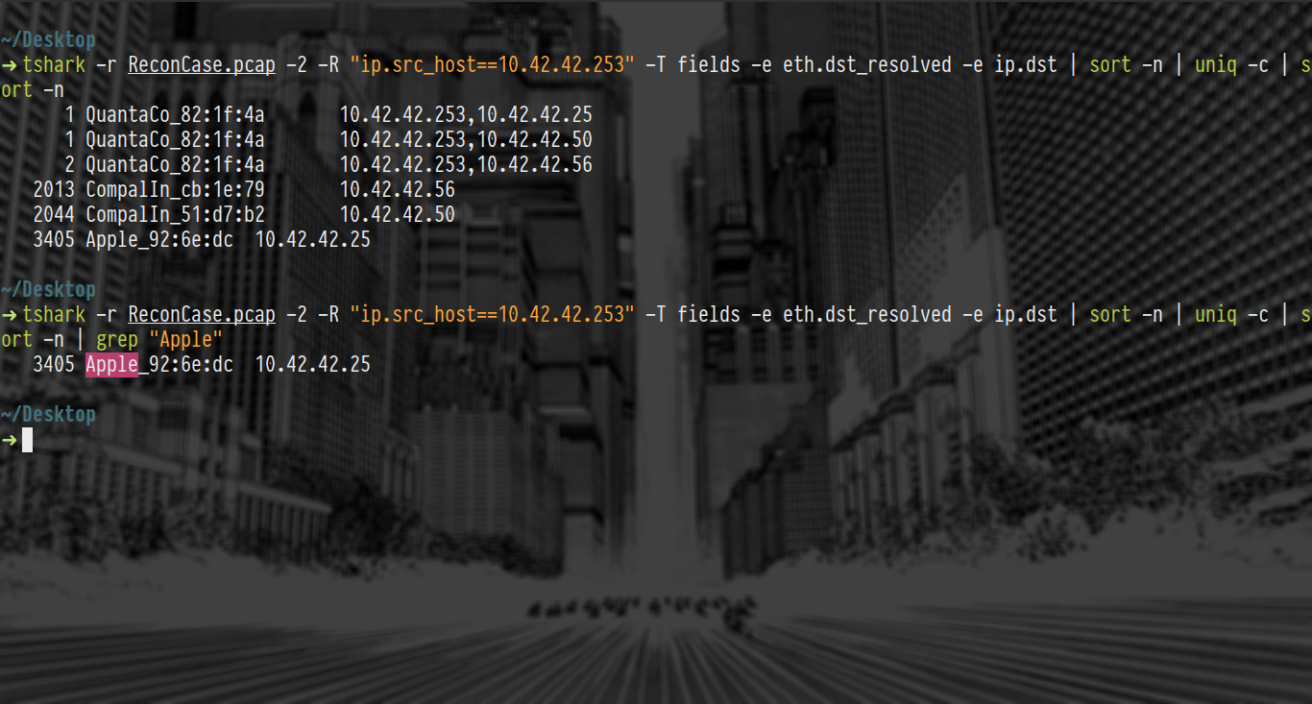
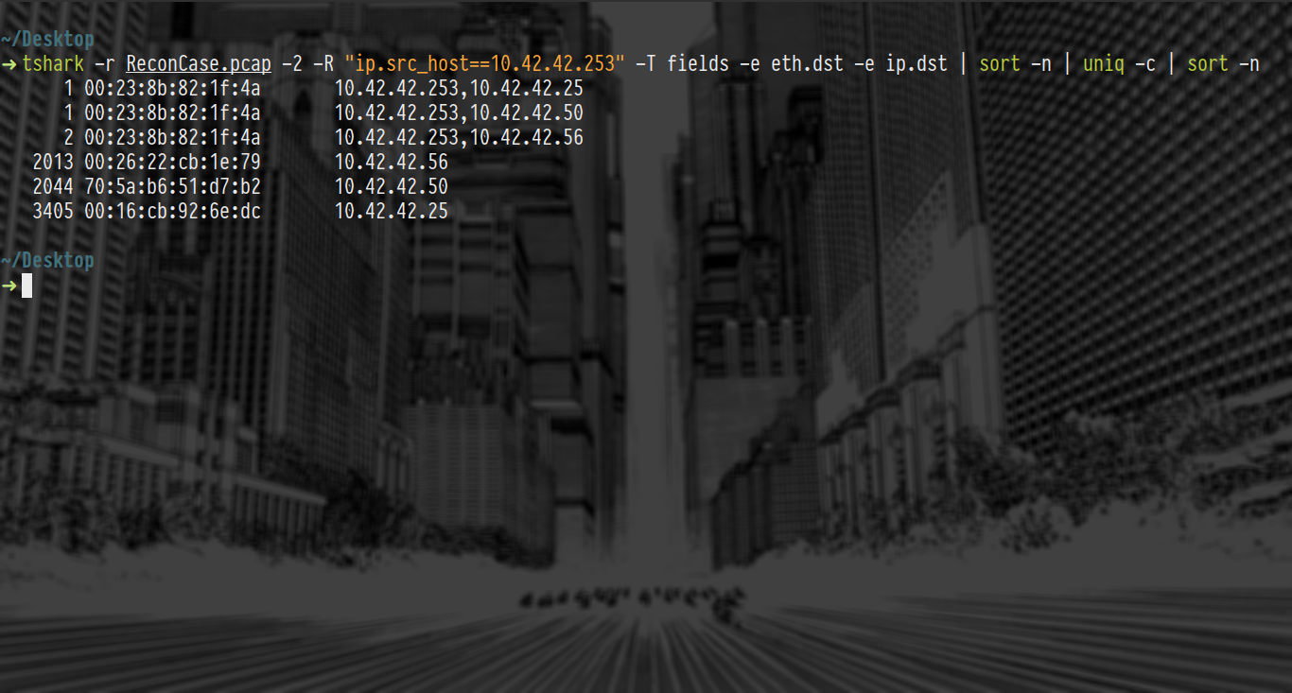

- The IP address of the Windows system that the adversary found is 10.42.42.50. This is quite visible from the NetBIOS traffic that is captured. Using the command “tshark -r ReconCase.pcap -2 -T fields -R “nbns” -e ip.src -e ip.dst | sort -n | uniq -c | sort -n”, we can see the nodes that use NetBIOS protocol. Then filtering the IP becomes easy, since only two possible IP addresses are present. Finally we can use the command “tshark -r ReconCase.pcap -2 -T fields -R “nbns.flags.response == 1” -e ip.src | sort -n | uniq -c | sort -n”, we can filter out the Windows machine and thereby its IP address as well.

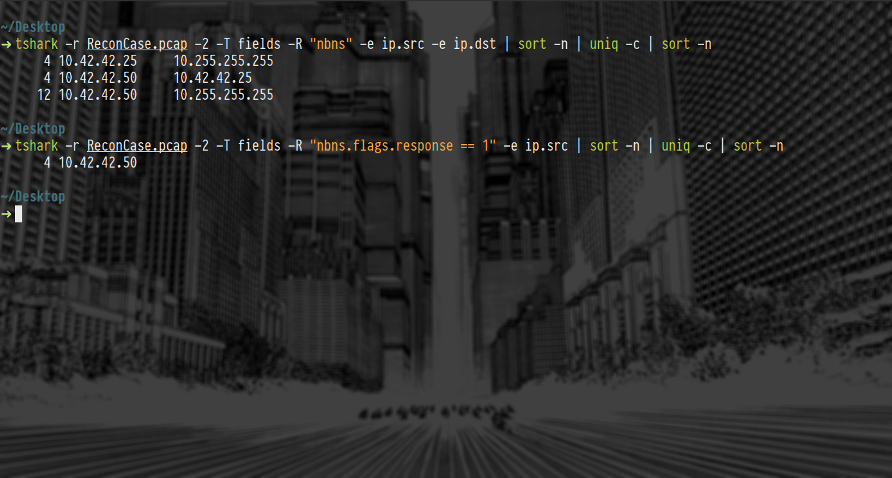
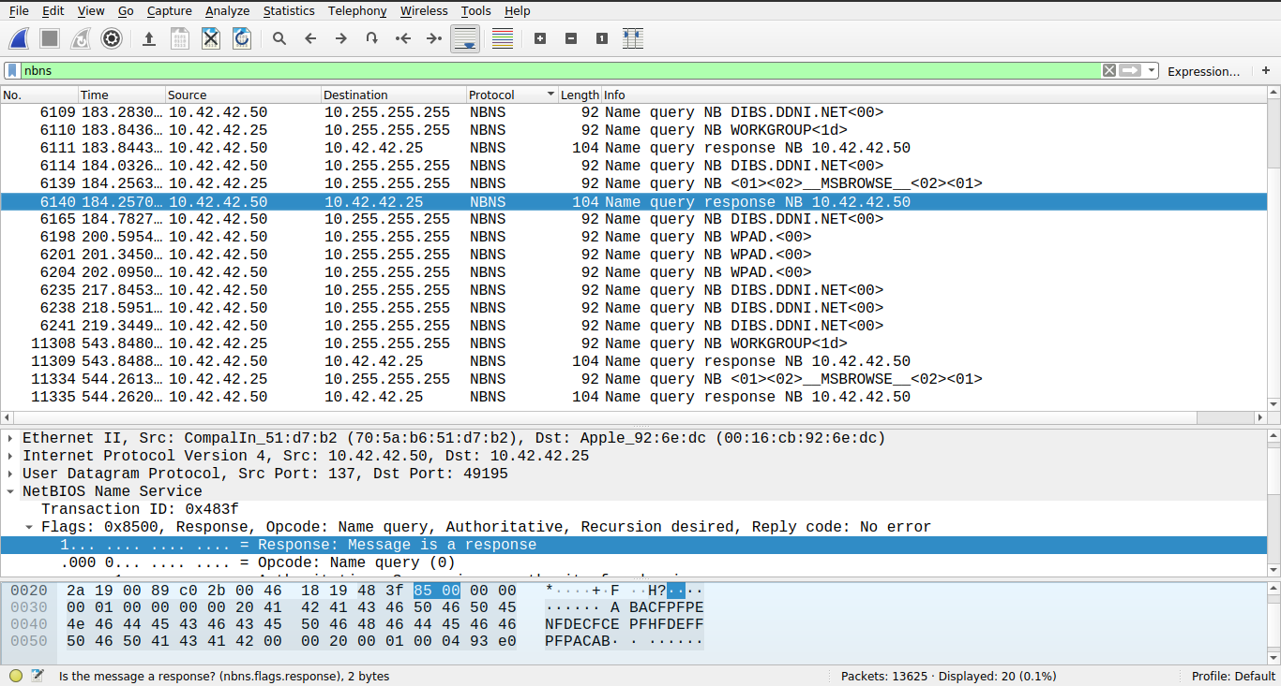

- The TCP ports that were open on the Windows system are 135 and 139. This is filtered out from the packet trace using the filter “tcp.flags == 0x012 && ip.src == 10.42.42.50” which essentially means to filter out SYN-ACK packets originating from the Windows machine, with which we can see the open ports of the machine. This is done both on Wireshark and TShark, as shown below.

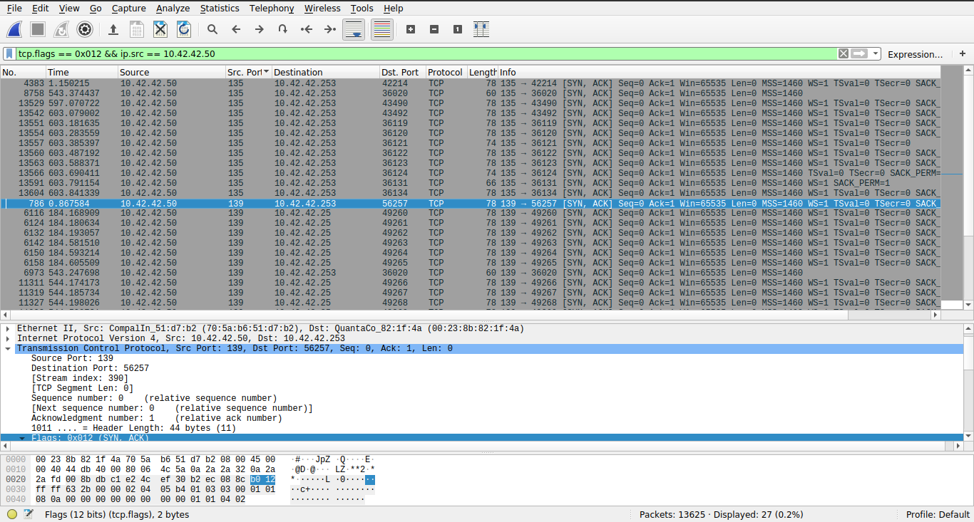
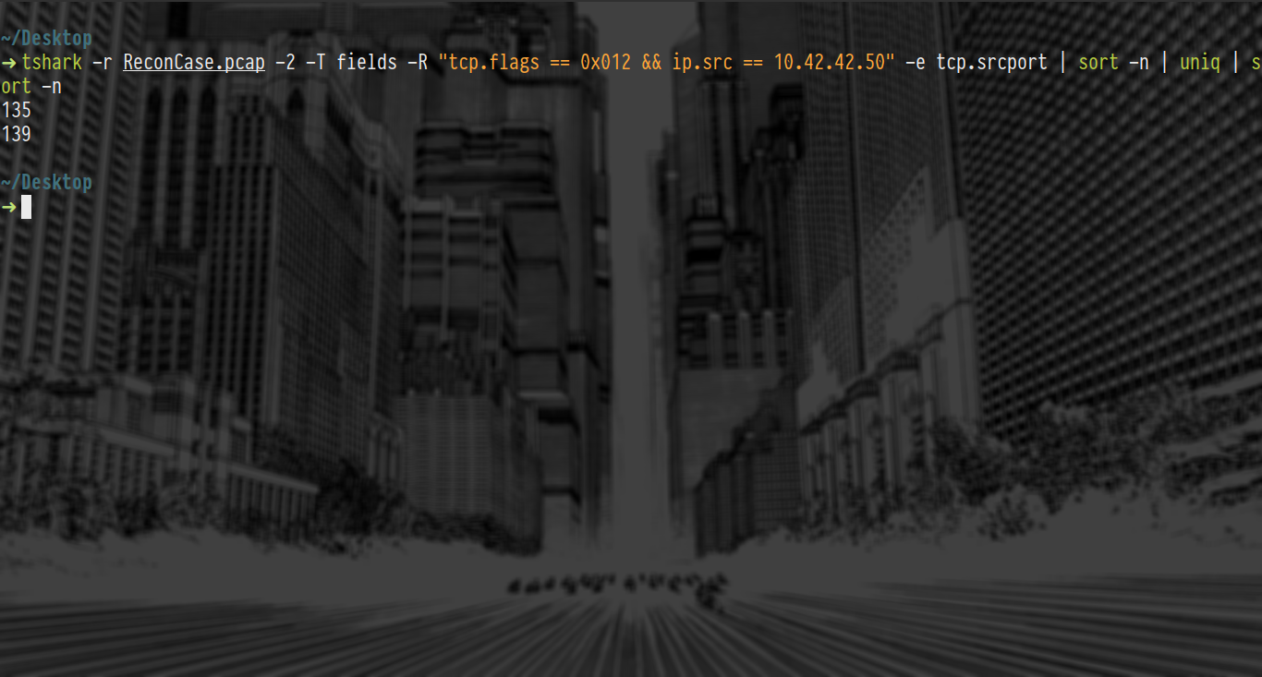

- The tool that the adversary used is nmap. It is evident from the fact that the adversary does different network scans including the SYN scan, the NULL scan, the FIN scan and even the XMAS scan with OS profiling involved, which is a capability that nmap offers. This reasoning is also supported by the fingerprinting analysis done by NetworkMiner.

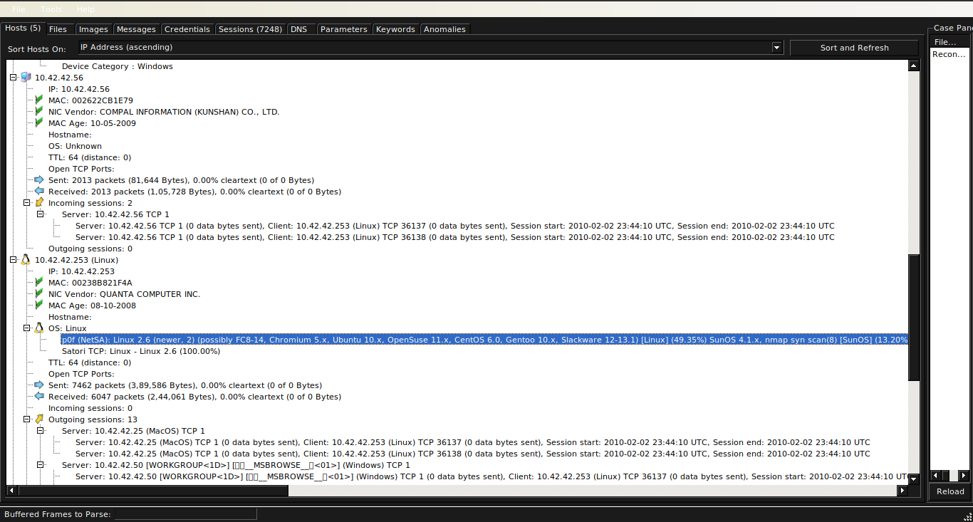

- The timeline of the network trace is this; the adversary runs a TCP SYN scan first, followed by a TCP NULL scan and then a TCP FIN and a TCP XMAS scan, with these scans having OS profiling turned on. Thus the output would be roughly like so:

Starting Nmap 4.11 ( http://www.insecure.org/nmap/ ) at 2018-01-01 00:00 EST
Interesting ports on 10.42.42.50:
Not shown: 1677 closed ports
PORT STATE SERVICE
135/tcp open unknown
137/tcp open unknown

