Needs

-login

-register

-claim form

-confirmation page

-database

Language: ASP .Net, HTML, Javascript, CSS, SQL Database

Log into the insurance website or sign up for an account, fill out the claim form then review the conformation page.

Step 1: Sign Up

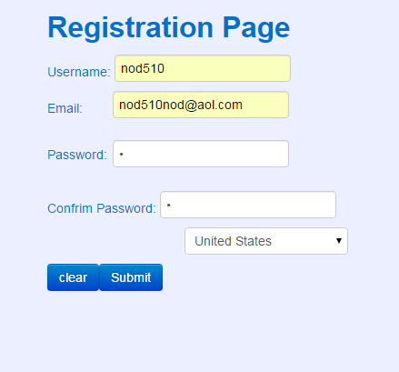

Saves into the database



Step 2: Login

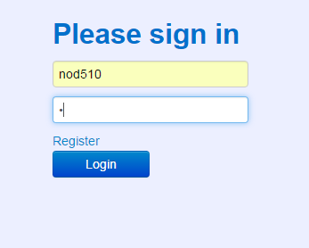

Step 3: Fill out form and upload pic

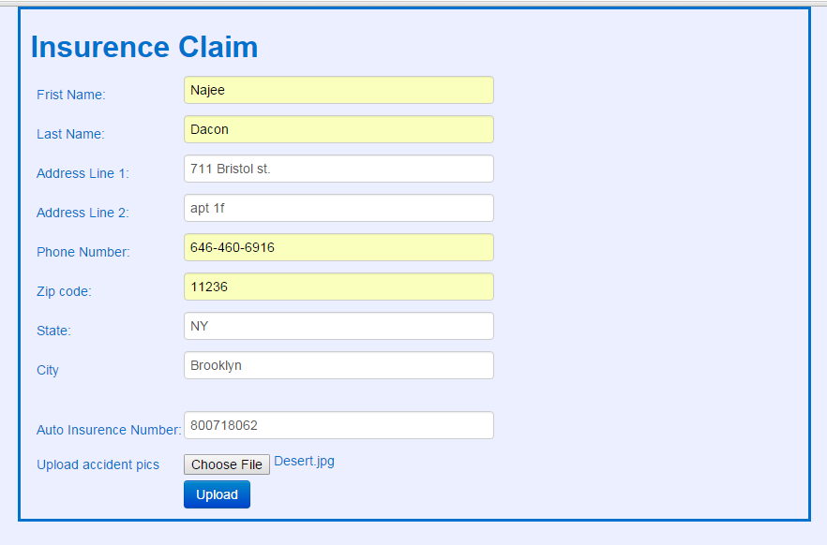

Database:



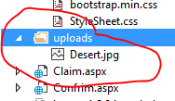

Step 4: When you click upload this is the final page.

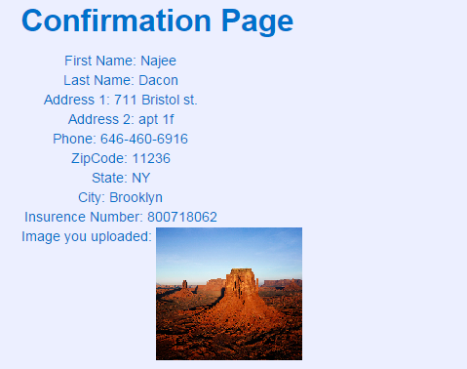

**Code:**

**Login Page**

<%@ Page Language="C#" AutoEventWireup="true" CodeFile="Login.aspx.cs" Inherits="Login" UnobtrusiveValidationMode="None"%>﻿

<!DOCTYPE html>

<html xmlns="http://www.w3.org/1999/xhtml">

<head runat="server">

<meta name="viewport" content="width=device-width, initial-scale=1">

<link rel="stylesheet" type="text/css" href="css/StyleSheet.css" />

<link rel="stylesheet" type="text/css" href="css/bootstrap.min.css" />

<title>Lab 4</title>

</head>

<body>

<div class ="test">

<form id="form1" runat="server" class="form-signin">

<h2 class="form-signin-heading">Please sign in</h2>

<asp:TextBox ID="TextBoxUser" runat="server" placeholder="User Name"></asp:TextBox>

<asp:RequiredFieldValidator ID="RequiredFieldValidatorUser" runat="server" ControlToValidate="TextBoxUser" CssClass="auto-style7" ErrorMessage="Enter username." ForeColor="Red"></asp:RequiredFieldValidator>

<asp:TextBox ID="TextBoxPW" runat="server" TextMode="Password" placeholder="Password"></asp:TextBox>

<br />

<a href="Registration.aspx">Register</a>

<asp:RequiredFieldValidator ID="RequiredFieldValidatorPass" runat="server" ControlToValidate="TextBoxPW" CssClass="auto-style7" ErrorMessage="Enter password." ForeColor="Red" style=" margin-right: 100px;"></asp:RequiredFieldValidator>

<asp:Button class="btn btn-primary" ID="ButtonLog" runat="server" OnClick="ButtonLog_Click" Text="Login" Width="109px" />

</form>

</div>

</body>

</html>

**Registration Page**

<%@ Page Language="C#" AutoEventWireup="true" CodeFile="Registration.aspx.cs" Inherits="Registration" UnobtrusiveValidationMode="None"%>﻿

<!DOCTYPE html>

<html xmlns="http://www.w3.org/1999/xhtml">

<head runat="server">

<title>sign up!</title>

<link rel="stylesheet" type="text/css" href="css/bootstrap.min.css" />

<link rel="stylesheet" type="text/css" href="css/StyleSheet.css" />

</head>

<body>

<div class="test2">

<form id="form2" runat="server" class="form-signin">

<h2 class="form-signin-heading">Registration Page</h2>

Username: <asp:TextBox ID="TextBoxUN" runat="server" Width="180px"></asp:TextBox>

<asp:RequiredFieldValidator ID="RequiredFieldValidator1" runat="server" ControlToValidate="TextBoxUN" CssClass="auto-style12" ErrorMessage="User Name is required "></asp:RequiredFieldValidator>

<br />

Email: <asp:TextBox ID="TextBoxEmail" runat="server" Width="180px"></asp:TextBox>

<asp:RequiredFieldValidator ID="RequiredFieldValidator2" runat="server" ControlToValidate="TextBoxEmail" CssClass="auto-style12" ErrorMessage="Email is required "></asp:RequiredFieldValidator>

<br />

<asp:RegularExpressionValidator ID="RegularExpressionValidator1" runat="server" ErrorMessage="You must enter vaild Email" ForeColor="Red" ControlToValidate="TextBoxEmail" ValidationExpression="\w+([-+.']\w+)*@\w+([-.]\w+)*\.\w+([-.]\w+)*"></asp:RegularExpressionValidator>

<p>Password:</p>

<asp:TextBox ID="TextBoxPass" runat="server" TextMode="Password" Width="180px"></asp:TextBox>

<asp:RequiredFieldValidator ID="RequiredFieldValidator3" runat="server" ControlToValidate="TextBoxPass" CssClass="auto-style12" ErrorMessage="Password is required "></asp:RequiredFieldValidator>

<br />

Confrim Password:

<asp:TextBox ID="TextRPass" runat="server" TextMode="Password" Width="180px"></asp:TextBox>

<asp:RequiredFieldValidator ID="RequiredFieldValidator4" runat="server" ControlToValidate="TextRPass" CssClass="auto-style12" ErrorMessage="Password is required "></asp:RequiredFieldValidator>

<br />

<asp:CompareValidator ID="CompareValidator1" runat="server" ControlToCompare="TextBoxPass" ControlToValidate="TextRPass" CssClass="auto-style12" ErrorMessage="Passwords don't match"></asp:CompareValidator>

<asp:DropDownList ID="DropDownCountry" runat="server" Width="180px">

<asp:ListItem>Select Country</asp:ListItem>

<asp:ListItem>United States</asp:ListItem>

<asp:ListItem>UK</asp:ListItem>

<asp:ListItem>Germany</asp:ListItem>

<asp:ListItem>France</asp:ListItem>

</asp:DropDownList>

<asp:RequiredFieldValidator ID="RequiredFieldValidator5" runat="server" ControlToValidate="DropDownCountry" CssClass="auto-style12" ErrorMessage="Select a Country" InitialValue="Select Country"></asp:RequiredFieldValidator>

<br />

<input id="Reset1" type="reset" value="clear" class="btn btn-primary" /><asp:Button ID="Button1" runat="server" OnClick="Button1_Click" Text="Submit" class="btn btn-primary" />

</form>

</div>

</body>

</html>

**Insurance Claim:**

<%@ Page Language="C#" AutoEventWireup="true" CodeFile="Claim.aspx.cs" Inherits="Claim" UnobtrusiveValidationMode="None"%>﻿

<!DOCTYPE html>

<html xmlns="http://www.w3.org/1999/xhtml">

<head runat="server">

<link rel="stylesheet" type="text/css" href="css/bootstrap.min.css" />

<link rel="stylesheet" type="text/css" href="css/StyleSheet.css" />

<title>Clain</title>

</head>

<body>

<form id="formIn" runat="server">

<h2 class="form-signin-heading">Insurence Claim</h2>

<table class="auto-style2">

<tr>

<td class="auto-style3">&nbsp;</td>

<td class="auto-style3">Frist Name:</td>

<td class="auto-style8">

<asp:TextBox ID="TextBox1" runat="server" Width="317px"></asp:TextBox>

</td>

<td>

<asp:RequiredFieldValidator ID="RequiredFieldValidator1" runat="server" ControlToValidate="TextBox1" ErrorMessage="Enter First Name" ForeColor="Red"></asp:RequiredFieldValidator>

</td>

<td>&nbsp;</td>

</tr>

<tr>

<td class="auto-style4">&nbsp;</td>

<td class="auto-style4">Last Name:</td>

<td class="auto-style9">

<asp:TextBox ID="TextBox2" runat="server" Width="317px"></asp:TextBox>

</td>

<td class="auto-style5">

<asp:RequiredFieldValidator ID="RequiredFieldValidator2" runat="server" ControlToValidate="TextBox2" ErrorMessage="Enter Last Name" ForeColor="Red"></asp:RequiredFieldValidator>

</td>

<td class="auto-style5"></td>

</tr>

<tr>

<td class="auto-style4">&nbsp;</td>

<td class="auto-style4">Address Line 1:</td>

<td class="auto-style9">

<asp:TextBox ID="TextBox3" runat="server" Width="317px"></asp:TextBox>

</td>

<td class="auto-style5">

<asp:RequiredFieldValidator ID="RequiredFieldValidator3" runat="server" ControlToValidate="TextBox3" ErrorMessage="Enter Address" ForeColor="Red"></asp:RequiredFieldValidator>

</td>

<td class="auto-style5"></td>

</tr>

<tr>

<td class="auto-style3">&nbsp;</td>

<td class="auto-style3">Address Line 2:</td>

<td class="auto-style8">

<asp:TextBox ID="TextBox4" runat="server" Width="317px"></asp:TextBox>

</td>

<td>&nbsp;</td>

<td>&nbsp;</td>

</tr>

<tr>

<td class="auto-style4">&nbsp;</td>

<td class="auto-style4">Phone Number:</td>

<td class="auto-style9">

<asp:TextBox ID="TextBox5" runat="server" Width="317px"></asp:TextBox>

</td>

<td class="auto-style5">

<asp:RequiredFieldValidator ID="RequiredFieldValidator4" runat="server" ControlToValidate="TextBox5" ErrorMessage="Enter Phone Number" ForeColor="Red"></asp:RequiredFieldValidator>

<br />

<asp:RegularExpressionValidator ID="RegularExpressionValidator1" runat="server" ControlToValidate="TextBox5" ErrorMessage="Not a vild phone number" ForeColor="Red" ValidationExpression="((\(\d{3}\) ?)|(\d{3}-))?\d{3}-\d{4}"></asp:RegularExpressionValidator>

</td>

<td class="auto-style5"></td>

</tr>

<tr>

<td class="auto-style3">&nbsp;</td>

<td class="auto-style3">Zip code:</td>

<td class="auto-style8">

<asp:TextBox ID="TextBox6" runat="server" Width="317px"></asp:TextBox>

</td>

<td>

<asp:RequiredFieldValidator ID="RequiredFieldValidator5" runat="server" ControlToValidate="TextBox6" ErrorMessage="Enter Zipcode" ForeColor="Red"></asp:RequiredFieldValidator>

<br />

<asp:RegularExpressionValidator ID="RegularExpressionValidator2" runat="server" ControlToValidate="TextBox6" ErrorMessage="Not a vaild Zipcode" ForeColor="Red" ValidationExpression="\d{5}(-\d{4})?"></asp:RegularExpressionValidator>

</td>

<td>&nbsp;</td>

</tr>

<tr>

<td class="auto-style3">&nbsp;</td>

<td class="auto-style3">State:</td>

<td class="auto-style8">

<asp:TextBox ID="TextBox7" runat="server" Width="317px"></asp:TextBox>

</td>

<td>

<asp:RequiredFieldValidator ID="RequiredFieldValidator6" runat="server" ControlToValidate="TextBox7" ErrorMessage="Enter State" ForeColor="Red"></asp:RequiredFieldValidator>

</td>

<td>&nbsp;</td>

</tr>

<tr>

<td class="auto-style3">&nbsp;</td>

<td class="auto-style3">City</td>

<td class="auto-style8">

<asp:TextBox ID="TextBox8" runat="server" Width="317px"></asp:TextBox>

</td>

<td>

<asp:RequiredFieldValidator ID="RequiredFieldValidator7" runat="server" ControlToValidate="TextBox8" ErrorMessage="Enter City" ForeColor="Red"></asp:RequiredFieldValidator>

</td>

<td>&nbsp;</td>

</tr>

<tr>

<td class="auto-style3">&nbsp;</td>

<td class="auto-style3">&nbsp;</td>

<td class="auto-style8">&nbsp;</td>

<td>&nbsp;</td>

<td>&nbsp;</td>

</tr>

<tr>

<td class="auto-style6"></td>

<td class="auto-style6">Auto Insurence Number:</td>

<td class="auto-style10">

<asp:TextBox ID="TextBox9" runat="server" Width="317px"></asp:TextBox>

</td>

<td class="auto-style7">

<asp:RequiredFieldValidator ID="RequiredFieldValidator8" runat="server" ControlToValidate="TextBox9" ErrorMessage="Enter Auto Insurence Number" ForeColor="Red"></asp:RequiredFieldValidator>

</td>

<td class="auto-style7"></td>

</tr>

<tr>

<td class="auto-style3">&nbsp;</td>

<td class="auto-style3">Upload accident pics</td>

<td class="auto-style8">

<asp:FileUpload ID="FileUpload" runat="server" Width="315px" />

</td>

<td>&nbsp;</td>

<td>&nbsp;</td>

</tr>

<tr>

<td class="auto-style3">&nbsp;</td>

<td class="auto-style3">&nbsp;</td>

<td class="auto-style11">

<asp:Button ID="Button1" runat="server" OnClick="Button1_Click" Text="Upload" class="btn btn-primary" />

</td>

<td>&nbsp;</td>

<td>&nbsp;</td>

</tr>

</table>

</form>

</body>

</html>

**Confirmation Page**

<%@ Page Language="C#" AutoEventWireup="true" CodeFile="Confrim.aspx.cs" Inherits="Confrim" %>

<!DOCTYPE html>

<html xmlns="http://www.w3.org/1999/xhtml">

<head runat="server">

<title>Confirmation Page</title>

<style type="text/css">

.auto-style1 {

text-align: center;

}

</style>

<link rel="stylesheet" type="text/css" href="css/bootstrap.min.css" />

<link rel="stylesheet" type="text/css" href="css/StyleSheet.css" />

</head>

<body>

<form id="confrim" runat="server">

<div>

<asp:SqlDataSource ID="SqlDataSource1Reg" runat="server" ConnectionString="<%$ ConnectionStrings:RegConnectionString %>" SelectCommand="SELECT [FName], [LName], [Address1], [Address2], [Phone], [ZipCode], [State], [City], [InsurenceNum], [uImg] FROM [Uploas]"></asp:SqlDataSource>

<h2 class="form-signin-heading">Confirmation Page</h2>

</div>

<div class="auto-style1">

<asp:DataList ID="DataList1" runat="server" DataSourceID="SqlDataSource1Reg">

<ItemTemplate>

First Name:

<asp:Label ID="FNameLabel" runat="server" Text='<%# Eval("FName") %>' />

<br />

Last Name:

<asp:Label ID="LNameLabel" runat="server" Text='<%# Eval("LName") %>' />

<br />

Address 1:

<asp:Label ID="Address1Label" runat="server" Text='<%# Eval("Address1") %>' />

<br />

Address 2:

<asp:Label ID="Address2Label" runat="server" Text='<%# Eval("Address2") %>' />

<br />

Phone:

<asp:Label ID="PhoneLabel" runat="server" Text='<%# Eval("Phone") %>' />

<br />

ZipCode:

<asp:Label ID="ZipCodeLabel" runat="server" Text='<%# Eval("ZipCode") %>' />

<br />

State:

<asp:Label ID="StateLabel" runat="server" Text='<%# Eval("State") %>' />

<br />

City:

<asp:Label ID="CityLabel" runat="server" Text='<%# Eval("City") %>' />

<br />

Insurence Number:

<asp:Label ID="InsurenceNumLabel" runat="server" Text='<%# Eval("InsurenceNum") %>' />

<br />

Image you uploaded:

<asp:Label ID="uImgLabel" runat="server" Text='<%# Eval("uImg") %>' />

<br />

<br />

</ItemTemplate>

</asp:DataList>

</div>

</form>

</body>

</html>