This website is used for Najee’s hospital, there are two login pages one for admin one for regular users.

Step 1: login as Admin

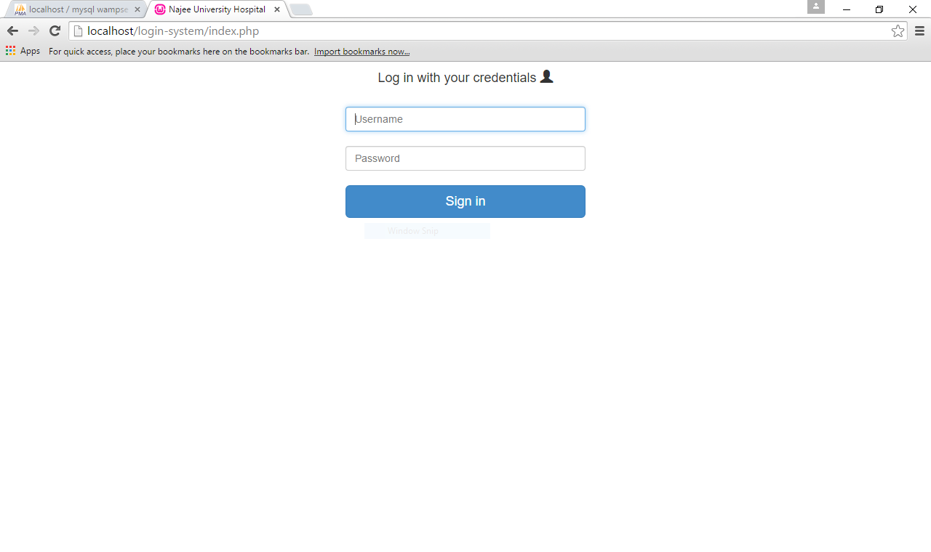

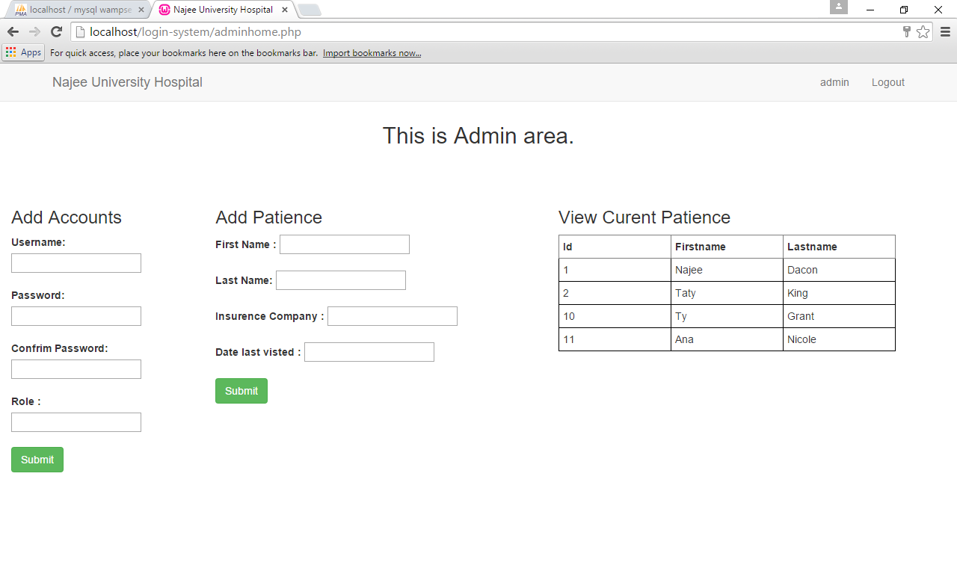

As an admin you can add accounts to the database. You can also add patience to the database and view the current patience in the database.

If you log in as in a regular user you only view the database.

