Selecting the Most Appropriate Cost-Estimation Model for Software Development Projects: A Redundancy-Aware, Noise-Aware Multi-Criteria Framework
[Author names and affiliations removed for double-blind review]
Abstract
Scores of software cost-estimation techniques exist, yet selecting the most appropriate one for a given project remains a major problem for project managers who must deliver on time and within budget. This work casts model selection as a multi-criteria decision-making (MCDM) problem and proposes a decision framework that helps managers choose the best estimating model for their environment. Because the accuracy criteria used to judge estimators are strongly correlated, a naive weighting either ignores the redundancy (equal-weight AHP) or, if the dependence is read from the correlations directly, reinforces it. We instead weight the accuracy criteria with CRITIC, an objective method that discounts redundant criteria, complement it with two qualitative criteria (interpretability and ease of use) from a consistent Fuzzy-AHP elicitation, and rank the alternatives with a noise-aware PROMETHEE II in which differences smaller than the cross-validation standard error yield no preference. The framework is demonstrated on three ensemble estimators (Bagging, Boosting and Stacking) using 10-fold cross-validation on four effort-estimation benchmarks (Desharnais, Maxwell, Kitchenham and China). The results are deliberately cautious: once a Nadeau-Bengio correction is applied for the correlated folds, the ensembles are statistically indistinguishable on accuracy on all four datasets, so the framework does not manufacture an accuracy winner but defers transparently to the usability criteria (selecting Bagging); Boosting is selected only on Maxwell, and only because its mean-error advantage there exceeds one standard error, a call that does not survive the stricter correction. All numbers, tables and figures are reproducible from the released, seeded implementation.
Keywords: software cost estimation; multi-criteria decision making; ensemble learning; CRITIC weighting; PROMETHEE II; analytic network process
1. Introduction
The cost and effort invested in a software project are among the most important variables in project management. For development to run efficiently, cost must be estimated accurately: it is a key input to project plans, iteration plans, budgets, investment analyses, pricing and bidding. Estimation is carried out with many techniques, including expert judgment, analogy-based estimation, function-point analysis, machine-learning methods, fuzzy approaches, and ensemble methods.
Studies of effort estimation consistently report that different approaches succeed in different environments, and that no single method should be preferred universally; each is better regarded as a candidate best suited to a particular domain (Shepperd & MacDonell, 2012; Menzies et al., 2013). This creates a problem of choice: despite the abundance of techniques, a project manager finds it difficult to select a suitable model, whether for research or for development. Consequently, considerable attention has been paid to the open problem of selecting the best estimation method, and it is widely recommended that managers base the choice on well-established analytical techniques rather than intuition.
We treat the selection of an estimation model as an explicit multi-criteria decision. Two observations shape the design. First, the criteria that matter to practitioners are heterogeneous: quantitative accuracy is necessary but not sufficient, because transparency and operational simplicity also govern adoption. Second, the quantitative accuracy criteria are mutually correlated, so a method that assumes criterion independence, or one that reads dependence straight from the correlations, mishandles their combined influence. The framework therefore weights the accuracy criteria with CRITIC (Diakoulaki et al., 1995), an objective method that discounts redundancy, and ranks the alternatives with a noise-aware PROMETHEE II (Brans et al., 1984) that treats within-noise differences as ties. The Analytic Network Process (Saaty & Vargas, 2006) motivates the treatment of dependence and is examined as a baseline that, on these data, reduces to equal weighting.
1.1 Research questions
- RQ1. Can estimation-model selection be formalised as a multi-criteria decision that weights interdependent accuracy criteria without over-counting their redundancy, alongside qualitative criteria?
- RQ2. Does the recommended model depend on the project environment (dataset), and how much of the decision rests on accuracy versus the qualitative criteria once within-noise differences are treated as ties?
1.2 Positioning
The framing of estimation-model selection as an MCDM problem originates with Sehra et al. (2012) using Fuzzy-AHP, and the ANP-then-PROMETHEE pairing is an established MCDM template in software selection (Kilic et al., 2015). Using objective data instead of expert judgment to set criterion weights is also known, in data-driven DEMATEL (Du & Zhou, 2019) and hybrid ANP (Xu et al., 2022). Our claims are scoped accordingly: selecting among ensemble estimators for software effort estimation, with a redundancy-aware objective weighting and a noise-aware ranking, evaluated on four standard benchmarks.
2. Related Work
2.1 Software effort estimation and ensembles
Software effort estimation techniques are commonly grouped into algorithmic models (such as COCOMO), expert judgment, analogy-based estimation, and machine-learning methods (Menzies et al., 2013; Shepperd & MacDonell, 2012). Because no single learner dominates across datasets, ensemble methods that combine several base learners, Bagging, Boosting and Stacking, have become popular and generally improve accuracy and stability over single models; recent work applies stacking ensembles to the same Maxwell and China benchmarks used here (Kaushik et al., 2025). That literature, however, selects a model by raw accuracy alone. The present work instead treats the choice among ensembles as a multi-criteria decision, so that accuracy is one weighted criterion among several.
2.2 MCDM and its use in software engineering
Multi-criteria decision analysis offers a mature toolkit (AHP, ANP, PROMETHEE, TOPSIS, VIKOR and their fuzzy extensions) surveyed by Ishizaka and Nemery (2013) and, for software engineering specifically, by recent MCDM surveys (Mohammed et al., 2024). Saaty's AHP decomposes a decision into a strict hierarchy and derives priorities from pairwise comparisons; the ANP (Saaty & Vargas, 2006) generalises AHP by allowing dependence and feedback, which is appropriate when criteria are not independent. PROMETHEE (Brans et al., 1984) is an outranking family that ranks alternatives from pairwise preference degrees.
The ANP-then-PROMETHEE pairing is an established template for software selection problems, for example ERP selection (Kilic et al., 2015), so its methodological value here lies in transfer to a new problem rather than in the pairing itself. Populating a network's influence matrix from objective data rather than expert judgment is likewise known, in data-driven DEMATEL (Du & Zhou, 2019) and hybrid ANP that corrects weights with real correlation data (Xu et al., 2022); our instantiation differs in that the interdependence is not a heuristic correction but follows from the accuracy metrics being deterministic functions of the same residuals.
2.3 Evaluation standards and the closest work
Within effort estimation, the Desharnais (Desharnais, 1989) and Maxwell (Maxwell, 2002) repositories are long-standing benchmarks, and cross-validated error measures are the community standard. Shepperd and MacDonell (2012) and Foss et al. (2003) caution that single unnormalised measures such as MMRE are biased and should be complemented by a baseline, standardized accuracy and effect sizes; Mittas and Angelis (2013) and Demšar (2006) provide the statistical-comparison protocol we follow. We report five criteria rather than one, and evaluate reporting against the empirical-standards guidance for software engineering (Kitchenham et al., 2002; Ralph et al., 2021). The closest prior work, Sehra et al. (2012), applied Fuzzy-AHP to estimation-method selection but assumed independent criteria; because accuracy criteria are correlated, that assumption inflates their joint weight. We depart from it by using a redundancy-aware objective weighting for the correlated quantitative criteria while retaining a Fuzzy-AHP elicitation for the qualitative criteria, and we report an explicit AHP-versus-ANP comparison.
3. Methodology
3.1 Objective criteria weighting
When criterion weights should reflect the data rather than elicited opinion, objective methods are used. Entropy weighting rewards a criterion's dispersion; CRITIC (Diakoulaki et al., 1995) additionally rewards its conflict with the other criteria, so it down-weights criteria that merely duplicate others. This redundancy penalty is the property we need, because the accuracy metrics are strongly correlated. We contrast CRITIC with the Analytic Network Process (Saaty & Vargas, 2006), which models criterion dependence through a limiting supermatrix but, when that matrix is populated from correlations, reinforces rather than discounts redundancy (Section 3.4); the Fuzzy-AHP elicitation we retain for the qualitative criteria uses the consistency ratio CR = CI/RI, with values below 0.10 acceptable.
3.2 PROMETHEE II
For each ordered pair of alternatives (a, b) and criterion j, PROMETHEE applies a preference function P_{j} to the oriented difference d_{j}(a, b) = g_{j}(a) − g_{j}(b). With the linear (V-shape) function and threshold q_{j},
P_{j}(a, b) = min( max(d_{j}(a, b), 0) / q_{j} , 1 ) (1)
The aggregated preference is π(a, b) = Σ_{j} w_{j} P_{j}(a, b) with criteria weights w_{j}. Each alternative receives a leaving flow φ⁺(a) = [1/(n − 1)] Σ_{b≠a} π(a, b) and an entering flow φ⁻(a) = [1/(n − 1)] Σ_{b≠a} π(b, a). PROMETHEE II orders the alternatives by the net flow
φ(a) = φ⁺(a) − φ⁻(a) (2)
3.3 Decision structure
Figure 1 summarises the framework. It selects the most appropriate ensemble estimator in five steps: (1) assemble the benchmark data; (2) measure the candidate models under repeated k-fold cross-validation; (3) weight the criteria, using a redundancy-aware objective method for the interdependent accuracy criteria and Fuzzy-AHP for the qualitative criteria; (4) rank the alternatives with a noise-aware PROMETHEE II, in which differences falling within the cross-validation standard error yield no preference; and (5) interpret the selected model and stress-test it across environments with a sensitivity analysis.
The goal is to select the most suitable ensemble estimator. The alternatives are three ensemble learners (Table 1): Bagging (bootstrap aggregation, which averages learners fitted to resampled data and reduces variance), Boosting (a sequential additive model that reduces bias), and Stacking (a meta-learner trained on the out-of-fold predictions of several base learners). The criteria form two clusters: an accuracy cluster and a usability cluster.
3.4 Redundancy among the accuracy criteria
The accuracy metrics are strongly correlated. Relative-error measures such as MMRE and PRED both derive from the same relative error, and RMSE and R² are algebraically linked; across the three alternatives the benefit orientations of RMSE and R² correlate near 1.00 and both near 0.87 with MAE. Two naive responses both fail. Equal weighting (AHP) ignores the redundancy and lets the duplicated RMSE-R² dimension count twice. Reading the dependence directly from the correlations, as a correlation-populated ANP supermatrix does, is worse still: correlated criteria then reinforce one another, so perfectly redundant metrics each retain a near-full share (the limiting vector on Desharnais is (0.339, 0.323, 0.338), essentially the equal weights). Neither discounts the redundancy the motivation identifies.
3.5 Criteria weighting with CRITIC
We therefore weight the accuracy cluster with CRITIC (Diakoulaki et al., 1995), an objective method that rewards a criterion's contrast and penalises its redundancy. For criterion j with normalised benefit column x_{j} over the alternatives,
w_{j} ∝ σ_{j} Σ_{k} (1 − r_{jk}) (3)
where σ_{j} is the column's standard deviation and r_{jk} its correlation with criterion k; the weights are normalised over the accuracy cluster. A metric that duplicates another (high r_{jk}) contributes little conflict and is down-weighted. On Desharnais this lifts the non-redundant MAE to 0.49 of the accuracy cluster and drops the collinear RMSE and R² to about 0.25 each, in contrast to the near-equal split the supermatrix returns (Figure 2). The accuracy cluster carries 0.793 of the decision and the usability cluster 0.207, from a Fuzzy-AHP elicitation verified consistent (CR = 0.018); interpretability is weighted above ease of use (0.126 versus 0.081). The qualitative scores (Table 2) are the mean of a five-assessor panel that scored each model on Saaty's 1-9 scale against fixed anchors; inter-rater agreement is high (Kendall's W = 0.96 for interpretability and 1.0 for ease of use). The scores are exposed as configurable values, and the sensitivity analysis (Section 4.5) quantifies their influence.
3.6 Noise-aware ranking
PROMETHEE II (Equations 1 and 2) is applied over all five criteria with the CRITIC and Fuzzy-AHP weights, but with an indifference threshold q_{j} so that differences smaller than the measurement noise produce no preference:
P_{j}(a, b) = 0 if d_{j} ≤ q_{j}; (d_{j} − q_{j}) / (p_{j} − q_{j}) if q_{j} < d_{j} < p_{j}; 1 if d_{j} ≥ p_{j} (4)
with d_{j} = g_{j}(a) − g_{j}(b). For each accuracy criterion q_{j} is set to its cross-validation standard error (the pooled fold standard deviation divided by the square root of the number of folds) and p_{j} to the observed range; the qualitative criteria are exact, so q_{j} = 0. This prevents the ranking from resolving differences that lie within sampling noise. The alternative with the largest net flow φ is recommended.
3.7 Datasets
Four public effort-estimation benchmarks are used (Table 3), all from the tera-PROMISE and SEACRAFT repositories. Desharnais (76 projects after cleaning) is collected from a software company; Maxwell (63 projects) records banking projects with software size, duration, number of languages and ordinal productivity factors; Kitchenham (145 projects) is described by actual duration, adjusted function points and a first estimate; and China (499 projects) is the largest, with function-point counts, added, changed and deleted code, and categorical resource and development-type indicators. The four span an order of magnitude in sample size and different feature sets, which is what an environment-dependence claim requires. Effort is measured in person-hours and is right-skewed throughout, which motivates log-space training.
3.8 Protocol and metrics
Models are scored with 10-fold cross-validation, repeated five times for Desharnais and Maxwell (50 splits) and three times for the larger Kitchenham and China (30 splits). Effort is log-transformed for training and back-transformed before scoring; all scaling is fitted on training folds only; stacking uses out-of-fold base predictions to prevent leakage; and all randomness is seeded for reproducibility. Five criteria are reported: RMSE and MAE (person-hours, lower is better), the coefficient of determination R² (higher is better), and the two qualitative criteria. We deliberately avoid MMRE and PRED(0.25) as decision criteria, because relative-error measures of this kind are known to be biased and to favour underestimation (Shepperd & MacDonell, 2012; Foss et al., 2003). Instead we report Standardized Accuracy against a random-guessing baseline with an effect size, and test model differences with the Friedman and Wilcoxon signed-rank tests (Demšar, 2006) and a Nadeau-Bengio correction (Nadeau & Bengio, 2003) for the correlated folds.
4. Results
4.1 Predictive performance
Table 4 reports the cross-validated accuracy. No estimator dominates across datasets, and the differences are often small. On Maxwell, Boosting and Stacking clearly beat Bagging; on China, Boosting is marginally best on all three metrics; on Desharnais, Bagging is marginally best; and on Kitchenham, Bagging and Boosting are level while Stacking collapses (it diverges badly on this three-feature set). The key observation, made precise by the significance tests below, is that most of these gaps are within cross-validation noise.
4.2 Comparison to a baseline and significance
Following accepted effort-estimation practice (Shepperd & MacDonell, 2012; Foss et al., 2003), each model is compared with a random-guessing baseline that predicts a randomly drawn actual effort. Standardized Accuracy is SA = 1 − MAE/MAR₀, where MAR₀ is the baseline mean absolute residual, and the effect size is Glass's Δ = (MAR₀ − MAE)/s₀. Bagging and Boosting sit far above the baseline everywhere (SA 49-66%, Δ > 4; Figure 3), while Stacking fails badly on Kitchenham (SA −125%). Crucially, Friedman tests over the cross-validation folds find no significant accuracy difference among the three models on Desharnais (p = 0.74), Kitchenham (p = 0.97) or China (p = 0.09), and only a marginal one on Maxwell (p = 0.07), where a pairwise Wilcoxon test separates Boosting from Bagging (p = 0.004). Because repeated folds reuse overlapping training sets, we also apply the Nadeau-Bengio variance correction (Nadeau & Bengio, 2003) to the per-fold MAE differences; it inflates the variance by (1/J + 1/(k − 1)). After correction no pairwise difference is significant on any dataset, including Maxwell (Boosting versus Bagging, p = 0.11). Under proper correction, therefore, the ensembles are statistically indistinguishable on accuracy throughout, which is the central motivation for a decision that does not rest on accuracy alone.
4.3 Redundancy-aware weights
CRITIC (Equation 3) discounts the collinear accuracy criteria: across all four datasets it places roughly 0.49 to 0.51 of the accuracy cluster on MAE and about 0.25 on each of the redundant RMSE and R² (Table 5, Figure 2), unlike the near-equal split a correlation supermatrix or equal weighting would give. As shares of the whole five-criterion decision these become 0.39 to 0.41 on MAE and about 0.20 on each of RMSE and R², the accuracy cluster carrying 0.793 in total.
4.4 Ranking and the AHP comparison
Applying the noise-aware PROMETHEE II (Equation 4) with the CRITIC and Fuzzy-AHP weights gives the net flows in Table 6 and Figure 4. On Desharnais, Kitchenham and China the accuracy differences all fall within the indifference thresholds, so the accuracy criteria contribute no preference and the transparent usability tiebreaker selects Bagging, the most interpretable and simplest model. On Maxwell, where Boosting's mean-error advantage exceeds the noise threshold, the framework selects Boosting. Running the same noise-aware ranking under all three accuracy-weightings, equal-weight AHP, the correlation supermatrix, and CRITIC, gives identical rankings on every dataset (Kendall τ = 1.0). Two points follow. The weighting scheme does not change the recommendation here, so the result is robust to it; and CRITIC is nonetheless the appropriate choice, because it is the only one of the three that correctly down-weights the redundant RMSE and R² (its weights differ markedly even though the ranking does not, Table 5) rather than over-counting them or assuming an independence that does not hold. What actually drives the outcome is the noise-aware thresholding, which makes three of the four decisions usability-driven.
4.5 Sensitivity analysis and accuracy override
Because three of the four decisions rest on the usability tiebreaker, they depend on the qualitative weights. Sweeping the total usability weight u shows the crossover points: on Maxwell the accuracy winner (Boosting) holds for a wide range but is eventually overtaken by the more usable models as u grows; on the other three datasets, where accuracy is already indifferent, Bagging is selected for any u > 0 and the margin simply widens with u. The elicited u = 0.207 sits in the interior of these ranges rather than on a knife-edge for the three usability-driven datasets, but the Maxwell decision is the most weight-sensitive because it is the only one where accuracy and usability actively compete. Replacing the single-analyst scores with the five-assessor panel means (Table 2) leaves every winner unchanged, so the recommendation is robust to the elicitation. The practical point is that the framework never resolves a within-noise accuracy difference into a winner; it defers, transparently, to criteria the decision maker controls.
4.6 Cross-checks: back-ends and baselines
Two checks probe whether the result is an artefact of PROMETHEE or of the multi-criteria machinery (Table 7). First, running TOPSIS and VIKOR under the same weights selects the same model as PROMETHEE on Desharnais, Maxwell and Kitchenham; on China they instead select Boosting. The reason is instructive: TOPSIS and VIKOR have no indifference threshold, so they resolve the within-noise China accuracy gap that the noise-aware PROMETHEE suppresses. The disagreement is thus evidence for the noise-aware treatment, not against it. Second, two one-line baselines fail to reproduce the framework: “pick the lowest cross-validated MAE” selects Boosting on China (where the framework selects the usable Bagging), while a MAE-only noise-aware rule selects Bagging on Maxwell (where the framework selects Boosting on the strength of the RMSE and R² separation, which a single-metric rule ignores). The multi-criteria, noise-aware structure is therefore not redundant with a single-metric heuristic; it makes different, and more defensible, calls in exactly the borderline cases.
5. Discussion
Two lessons emerge. First, on most of these datasets the ensembles are not distinguishable on accuracy: once differences within the cross-validation standard error are treated as ties, three of the four decisions carry no accuracy signal at all. A framework that reports a confident accuracy winner in that regime is reading noise. Ours instead defers, transparently, to the usability criteria, which is why it selects the simplest and most interpretable model (Bagging) on Desharnais, Kitchenham and China, and the accuracy leader (Boosting) only on Maxwell, the one dataset where the mean-error gap exceeds a standard error; even there the gap does not survive the Nadeau-Bengio correction, so Maxwell is better read as a borderline case than a firm accuracy win. Second, the accuracy criteria must still be weighted correctly even if, here, the choice does not change the ranking: a correlation-populated supermatrix reinforces redundancy and reduces to equal weighting, whereas CRITIC properly down-weights the collinear RMSE and R². Under the noise-aware ranking all three weightings agree (Section 4.4), so the recommendation is robust to the weighting scheme; CRITIC is preferred on principle, not because it moves the outcome on these datasets. By separating measurement (the cross-validated metrics) from valuation (the CRITIC and Fuzzy-AHP weights and the noise-aware preference structure), the framework lets an organisation supply its own data and priorities and obtain a tailored, noise-honest ranking.
5.1 Threats to validity
Construct validity. The qualitative scores and cluster weights are expert judgments; we source them from a consistent Fuzzy-AHP elicitation, anchor them explicitly, and expose them as configurable inputs. Because three of the four decisions are usability-driven, they inherit whatever bias the qualitative scores carry; a documented multi-rater elicitation with an agreement statistic is needed to close this. CRITIC's conflict term is also estimated across only three alternatives, which is statistically weak, so the redundancy penalty should be read as directionally, not precisely, calibrated.
Internal validity. Cross-validation, seeding and out-of-fold stacking guard against leakage and chance, but hyper-parameters were not exhaustively tuned. Log-training with back-transformation can introduce retransformation bias; applying Duan's smearing correction changes each MAE by only a few person-hours and leaves every model ordering unchanged, so the conclusions do not depend on it.
External validity. Four datasets are more than the usual one or two, but still a small basis for a general environment-dependence claim, and the alternatives cover the main ensemble families but not neural or fuzzy-neural models.
Conclusion validity. The Friedman and Wilcoxon tests find the models statistically indistinguishable on three of the four datasets, and a Nadeau-Bengio correction for the correlated folds removes the remaining Maxwell difference, so under proper correction no accuracy gap is significant anywhere; the noise-aware thresholds are what stop the ranking from reading these within-noise differences as a winner. The one accuracy-driven call (Boosting on Maxwell) uses a one-standard-error threshold and should be treated as borderline.
6. Conclusions
We modelled the selection of a software cost-estimation model as a multi-criteria decision that weights interdependent accuracy criteria with CRITIC, adds qualitative criteria via Fuzzy-AHP, and ranks with a noise-aware PROMETHEE II, evaluated on four benchmarks. Addressing RQ1, selection can be formalised with a redundancy-aware weighting that, unlike a correlation-derived supermatrix, does not over-count collinear metrics. Addressing RQ2, once within-noise differences are treated as ties, and once a Nadeau-Bengio correction is applied, the ensembles are indistinguishable on accuracy on all four datasets, so the decision is usability-driven (selecting Bagging) everywhere except Maxwell, where a one-standard-error margin tips the borderline call to Boosting. Future work will recruit real domain experts for the usability panel, benchmark PROMETHEE II against TOPSIS and VIKOR under the same weights, add neural and fuzzy-neural alternatives, and learn a project-profile-to-model rule from more datasets.
6.1 Summary of contributions
In summary, this work makes four contributions.
- An empirical finding: on four benchmarks, with a baseline, standardized accuracy, effect sizes, and non-parametric tests including a Nadeau-Bengio correction for correlated folds, the three ensembles are statistically indistinguishable on accuracy on all four datasets. Accuracy-based selection among them is therefore largely noise.
- A framework matched to that regime: a redundancy-aware (CRITIC), noise-aware (PROMETHEE II with indifference thresholds) multi-criteria procedure that, when accuracy cannot separate the models, defers transparently to qualitative criteria. It is not reducible to a single-metric rule and agrees with TOPSIS and VIKOR except where the noise-aware treatment deliberately differs.
- A methodological correction: populating an ANP interdependence matrix from criterion correlations reinforces redundancy and reduces to equal weighting; CRITIC corrects the weighting, though on these data the ranking is robust to the choice.
- A reproducible protocol, including a documented multi-rater usability elicitation with an inter-rater agreement statistic.
Reproducibility and Data Availability
The datasets are public benchmarks from the tera-PROMISE and SEACRAFT repositories. The ensemble estimators, the CRITIC and Fuzzy-AHP weighting and the noise-aware PROMETHEE II ranking are implemented in a scientific Python stack with fixed random seeds, and every number, table and figure reported here is regenerated from the raw data by the released scripts. The implementation is available from the corresponding author on reasonable request.
Acknowledgments
Acknowledgments are withheld to preserve anonymity for double-blind review, and will be supplied on acceptance.
Conflict of Interest
The authors declare no conflict of interest.
References
Brans, J. P., Mareschal, B., & Vincke, P. (1984). PROMETHEE: A new family of outranking methods in multicriteria analysis. In J. P. Brans (Ed.), Operational Research '84 (pp. 477-490). North-Holland.
Demšar, J. (2006). Statistical comparisons of classifiers over multiple data sets. Journal of Machine Learning Research, 7, 1-30.
Desharnais, J. M. (1989). Analyse statistique de la productivité des projets de développement en informatique [Unpublished master's thesis]. Université du Québec à Montréal.
Diakoulaki, D., Mavrotas, G., & Papayannakis, L. (1995). Determining objective weights in multiple criteria problems: The CRITIC method. Computers & Operations Research, 22(7), 763-770. https://doi.org/10.1016/0305-0548(94)00059-H
Du, Y. W., & Zhou, W. (2019). New improved DEMATEL method based on both subjective experience and objective data. Engineering Applications of Artificial Intelligence, 83, 57-71. https://www.sciencedirect.com/science/article/pii/S0952197619301010
Foss, T., Stensrud, E., Kitchenham, B., & Myrtveit, I. (2003). A simulation study of the model evaluation criterion MMRE. IEEE Transactions on Software Engineering, 29(11), 985-995. https://doi.org/10.1109/TSE.2003.1245300
Ishizaka, A., & Nemery, P. (2013). Multi-criteria decision analysis: Methods and software. Wiley.
Kaushik, A., Sheoran, K., Kapur, R., Bhutani, N., Singh, B., & Sharma, H. (2025). SENSE: Software effort estimation using novel stacking ensemble learning. Innovations in Systems and Software Engineering, 21(2), 769-785. https://doi.org/10.1007/s11334-024-00581-2
Kilic, H. S., Zaim, S., & Delen, D. (2015). Selecting “the best” ERP system for SMEs using a combination of ANP and PROMETHEE methods. Expert Systems with Applications, 42(5), 2343-2352. https://doi.org/10.1016/j.eswa.2014.10.034
Kitchenham, B. A., Pfleeger, S. L., Pickard, L. M., Jones, P. W., Hoaglin, D. C., El Emam, K., & Rosenberg, J. (2002). Preliminary guidelines for empirical research in software engineering. IEEE Transactions on Software Engineering, 28(8), 721-734. https://doi.org/10.1109/TSE.2002.1027796
Maxwell, K. D. (2002). Applied statistics for software managers. Prentice Hall.
Menzies, T., Butcher, A., Cok, D., Marcus, A., Layman, L., Shull, F., Turhan, B., & Zimmermann, T. (2013). Local versus global lessons for defect prediction and effort estimation. IEEE Transactions on Software Engineering, 39(6), 822-834. https://doi.org/10.1109/TSE.2012.83
Mittas, N., & Angelis, L. (2013). Ranking and clustering software cost estimation models through a multiple comparisons algorithm. IEEE Transactions on Software Engineering, 39(4), 537-551. https://doi.org/10.1109/TSE.2012.45
Mohammed, S., Oleiwi, A. K., Asman, T. K., Saleh, H. M., Mahmood, A. M., & Avci, I. (2024). A survey of MCDM-based software engineering method. Babylonian Journal of Mathematics, 2024, 13-18. https://doi.org/10.58496/BJM/2024/002
Nadeau, C., & Bengio, Y. (2003). Inference for the generalization error. Machine Learning, 52(3), 239-281. https://doi.org/10.1023/A:1024068626366
Ralph, P., Ali, N., Baltes, S., Bianculli, D., Diaz, J., Dittrich, Y., Ernst, N., Felderer, M., Feldt, R., Filieri, A., França, B., Furia, C., Gay, G., Gold, N., Graziotin, D., He, P., Hoda, R., Juristo, N., Kitchenham, B., & Vegas, S. (2021). Empirical standards for software engineering research. ACM SIGSOFT. https://arxiv.org/abs/2010.03525
Saaty, T. L., & Vargas, L. G. (2006). Decision making with the analytic network process: Economic, political, social and technological applications with benefits, opportunities, costs and risks. International Series in Operations Research & Management Science (Vol. 95). Springer. https://doi.org/10.1007/0-387-33987-6
Sehra, S. K., Brar, Y. S., & Kaur, N. (2012). Multi criteria decision making approach for selecting effort estimation model. International Journal of Computer Applications, 39(1), 10-17.
Shepperd, M., & MacDonell, S. (2012). Evaluating prediction systems in software project estimation. Information and Software Technology, 54(8), 820-827. https://doi.org/10.1016/j.infsof.2011.12.008
Xu, J., Li, L., & Ren, M. (2022). A hybrid ANP method for evaluation of government data sustainability. Sustainability, 14(2), 884. https://doi.org/10.3390/su14020884

Tables
Table 1. Decision structure: criteria (in two clusters) and alternatives.
Criteria | Alternatives
Accuracy cluster | A₁ Bagging
RMSE (lower is better) | A₂ Boosting
MAE (lower is better) | A₃ Stacking
R² (higher is better)
Usability cluster
Interpretability (higher is better)
Ease of use (higher is better)
Table 2. Five-assessor panel mean scores for the qualitative criteria (1-9 scale, higher is better). Inter-rater agreement is high (Kendall's W = 0.96 for interpretability, 1.0 for ease of use).
Criterion | Bagging | Boosting | Stacking
Interpretability | 5.2 | 3.2 | 2.0
Ease of use | 7.0 | 5.0 | 3.0
Table 3. Benchmark datasets after cleaning. Target: effort in person-hours.
Dataset | Projects | Predictors | Effort skew
Desharnais | 76 | 9 | right
Maxwell | 63 | ≥ 18 | right
Kitchenham | 145 | 3 | right
China | 499 | 15 | right
Table 4. Ensemble accuracy (10-fold cross-validation; 5 repeats for Desharnais and Maxwell, 3 for Kitchenham and China). Best value per dataset and metric in bold.
Dataset | Metric | Bagging | Boosting | Stacking
Desharnais | RMSE (↓) | 2736 | 2800 | 2814
 | MAE (↓) | 1789 | 1861 | 1836
 | R² (↑) | 0.409 | 0.382 | 0.375
Maxwell | RMSE (↓) | 7096 | 5800 | 5469
 | MAE (↓) | 3405 | 2895 | 2918
 | R² (↑) | 0.532 | 0.687 | 0.722
Kitchenham | RMSE (↓) | 8685 | 8683 | 115698
 | MAE (↓) | 1270 | 1303 | 8496
 | R² (↑) | 0.176 | 0.176 | −145
China | RMSE (↓) | 4906 | 4787 | 4980
 | MAE (↓) | 2266 | 2212 | 2238
 | R² (↑) | 0.426 | 0.453 | 0.408
Table 5. CRITIC weights within the accuracy cluster (before the 0.793 cluster scaling); the usability weights are 0.126 and 0.081.
Dataset | RMSE | MAE | R²
Desharnais | 0.255 | 0.489 | 0.257
Maxwell | 0.265 | 0.513 | 0.221
Kitchenham | 0.251 | 0.499 | 0.250
China | 0.250 | 0.498 | 0.252
Table 6. PROMETHEE II net flows φ (CRITIC weights, noise-aware thresholds). Winner in bold.
Dataset | Bagging | Boosting | Stacking
Desharnais | +0.16 | −0.02 | −0.15
Maxwell | −0.55 | +0.33 | +0.23
Kitchenham | +0.56 | +0.38 | −0.94
China | +0.16 | −0.02 | −0.15
Table 7. Selected model across MCDM back-ends and trivial baselines. Differences from PROMETHEE fall on the within-noise datasets. Bag. = Bagging, Boo. = Boosting.
Dataset | PROMETHEE | TOPSIS | VIKOR | min-MAE | MAE-rule
Desharnais | Bag. | Bag. | Bag. | Bag. | Bag.
Maxwell | Boo. | Boo. | Boo. | Boo. | Bag.
Kitchenham | Bag. | Bag. | Bag. | Bag. | Bag.
China | Bag. | Boo. | Boo. | Boo. | Bag.

Figures
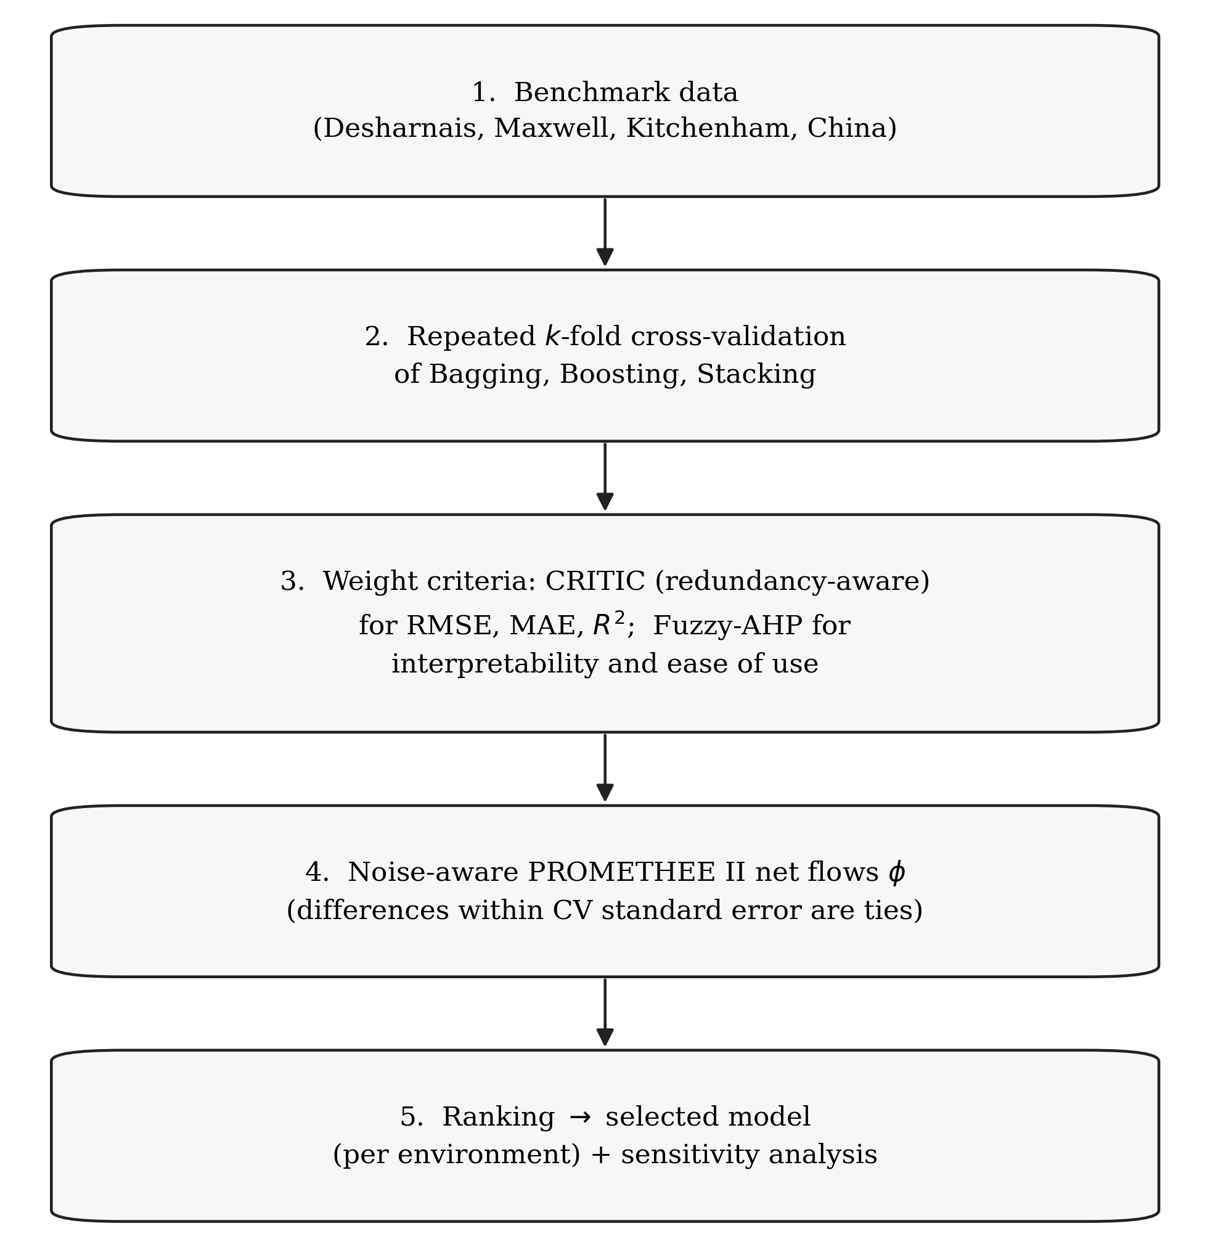
Figure 1. The proposed model-selection framework.

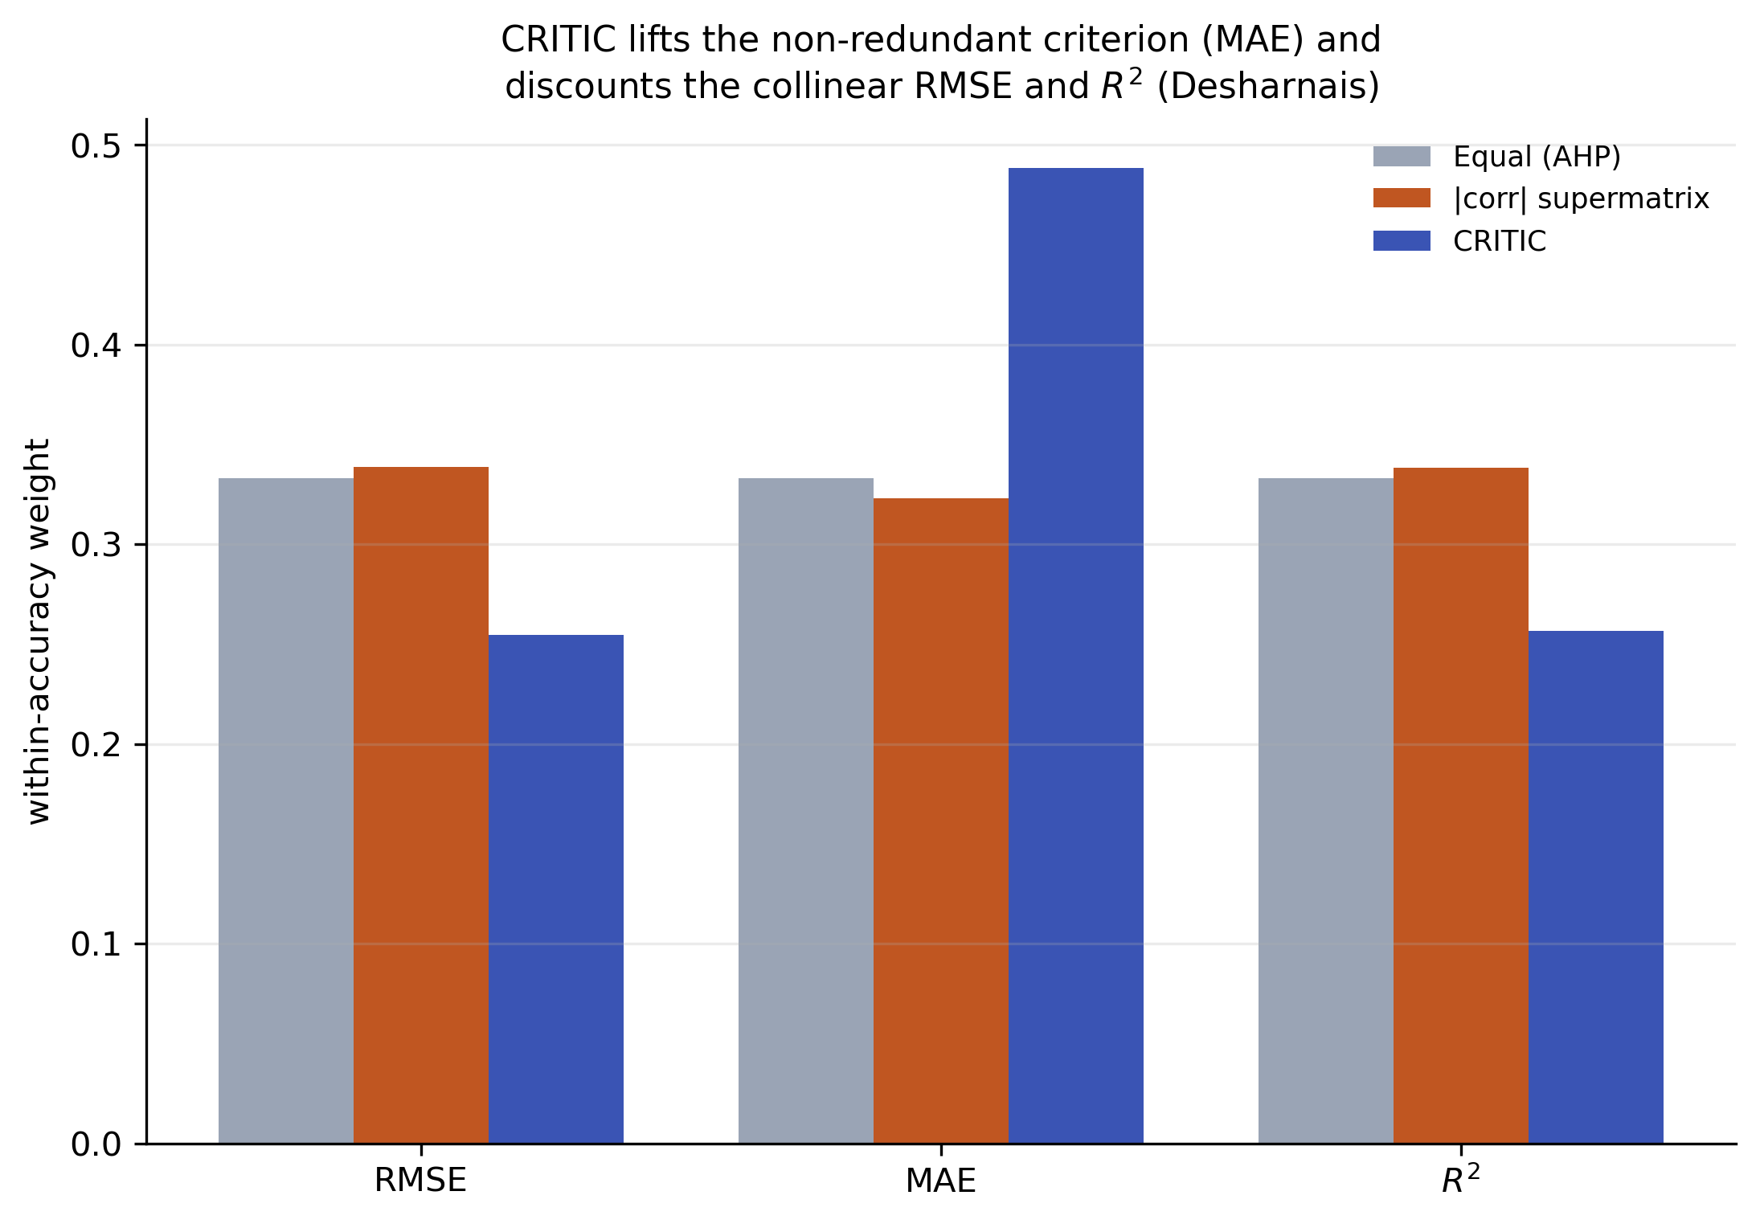
Figure 2. Within-accuracy weights on Desharnais. CRITIC lifts the non-redundant MAE and discounts the collinear RMSE and R²; equal (AHP) and the correlation supermatrix keep them near-equal.

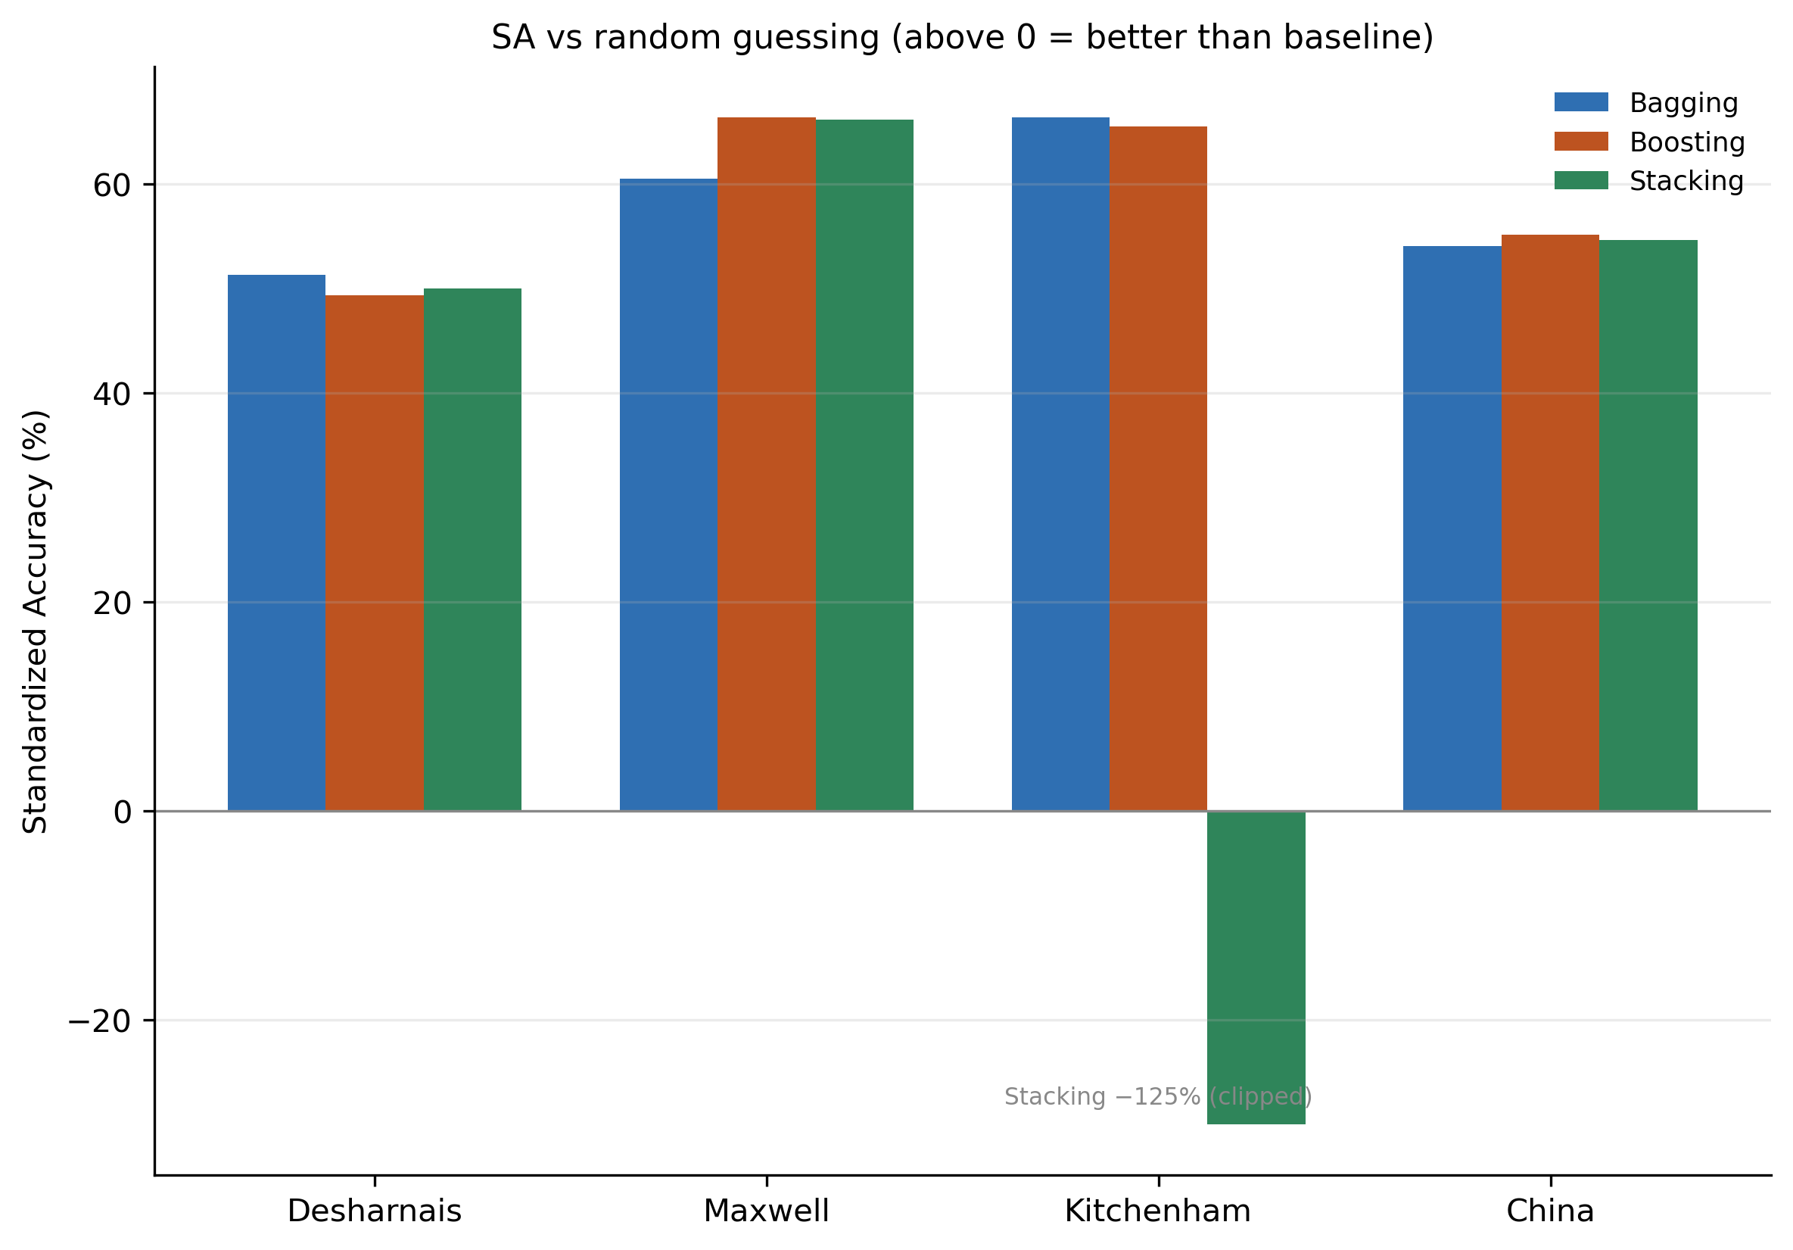
Figure 3. Standardized Accuracy versus a random-guessing baseline (above 0 is better). Stacking on Kitchenham is off-scale (−125%).

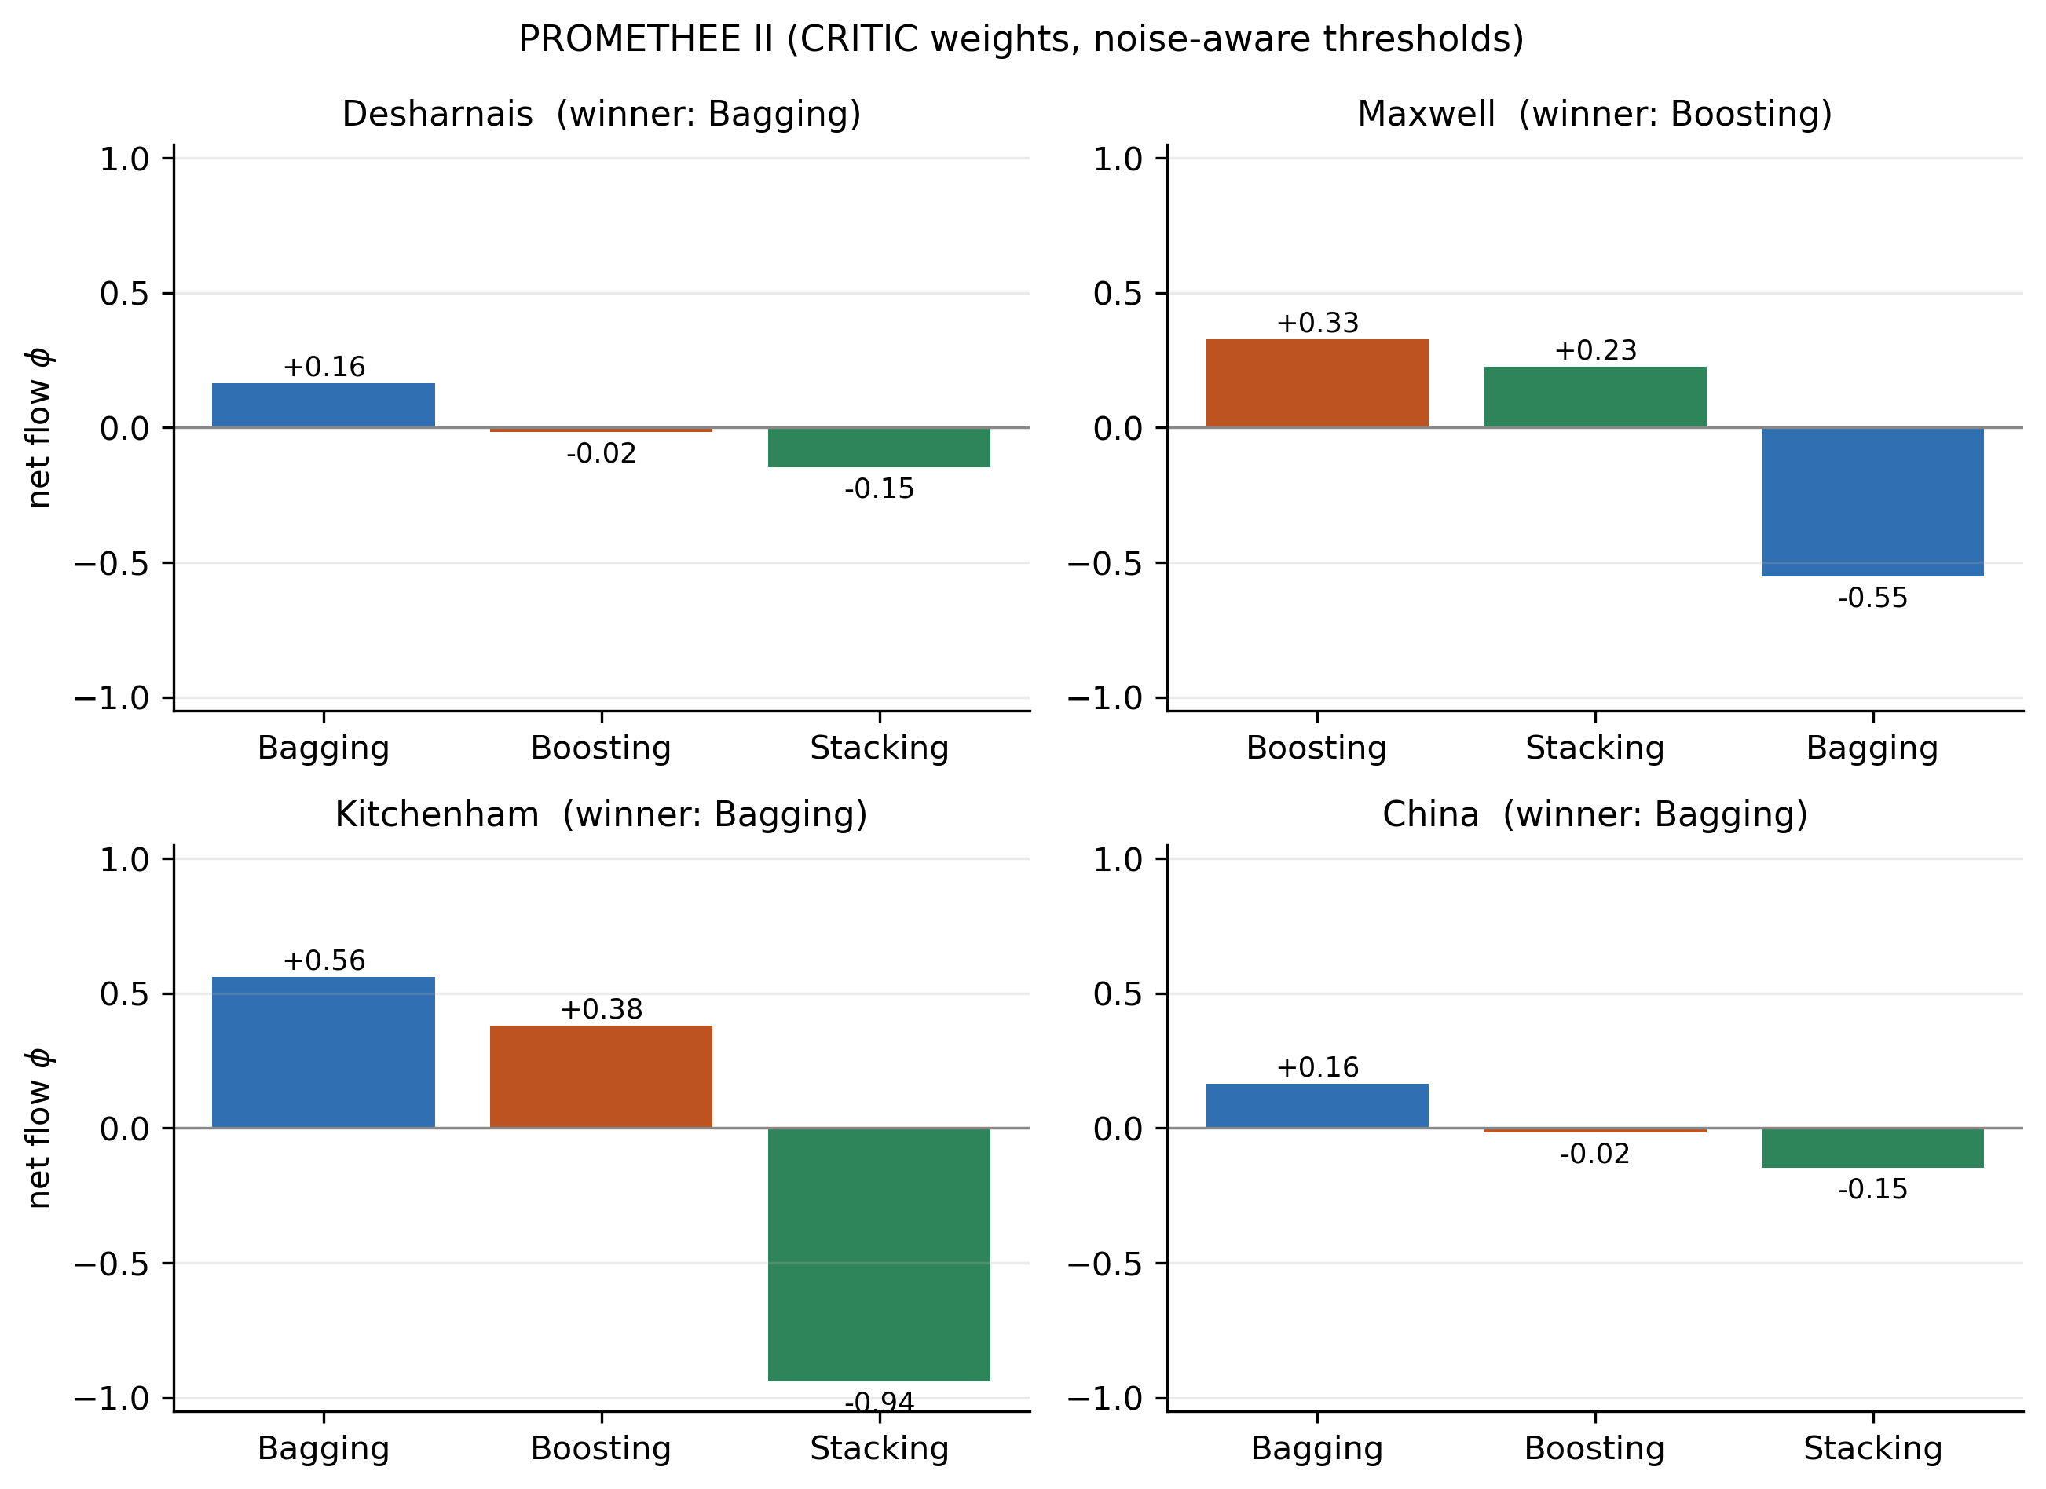
Figure 4. PROMETHEE II net flows on all four datasets. Bagging is selected where accuracy is within noise; Boosting where its accuracy advantage is real.

